CHEMICAL ENGINEERING TRANSACTIONS  VOL. 76, 2019 | A publication of
The Italian Association
of Chemical Engineering
Online at www.aidic.it/cet
Guest Editors: Sauro Pierucci, Jiří Jaromír Klemeš, Laura Piazza
Copyright © 2019, AIDIC Servizi S.r.l.
ISBN 978-88-95608-73-0; ISSN 2283-9216

Novel Equipment for Food Quality Control: an IoT Nanowire Gas Sensors Array
Marco Abbatangelo^{a,*}, Estefanía Núñez-Carmona ª, Veronica Sberveglieri ^{b}
ªUniversity of Brescia, Dep. Information Engineering, Via Branze 38, 25123 Brescia, Italy.
^{b}CNR-IBBR, Institute of Bioscience and Bioresources, Via Madonna del Piano 10, 50019 Sesto Fiorentino (FI), Italy.
corresponding author: m.abbatangelo@unibs.it
Chemical sensors are tools able to detect organic and inorganic molecules in the three states of matter with different mechanisms of interaction. Each molecule interacts in a different way with sensing materials, producing dissimilar changes in its intrinsic properties. In recent years, chemical sensors have been widely used in arrays for devices known as electronic noses (ENs). They showed great potentiality to be applied in various fields, like health, environmental monitoring and food quality and identity. One of these devices, called Small Sensors System (S3) produced by NASYS, a spin-off of University of Brescia, is equipped with innovative chemical sensors that analyse volatile compounds. They are designed and constructed at SENSOR Laboratory (University of Brescia) and are different from the other metal oxide semiconductor (MOX) sensors available on the market because of their nanometric dimensions. This brings numerous advantages since nanomaterials have an extraordinary length-to-width ratio, that enhances sensing capability and long-term stability for prolonged operation. In addition, the three-dimensional network formed by the nanowires increases the adsorption surface and the catalytic activity, improving the response and decreasing the threshold up to few ppm concentrations. The ability to connect to Internet makes S3 an Internet of Thing (IoT) device. This allows to send and storage data in the cloud and to use S3 remotely. Indeed, S3 has a dedicated user-friendly Web App whereby users can analyse data on-line using different techniques, from univariate and multivariate statistical analysis to Artificial Neural Networks. S3 system has shown the capability to be a useful tool in agri-food field. Among the whole applications, it has been successfully used to recognize the authenticity of food and to individuate food pathogens and microbiological contamination as described in the following sections.
  - Introduction
In recent years, researches regarding chemical sensors and their possible fields of application multiplied. This phenomenon is due to the fact that this kind of sensors showed great potentiality to be applied for different tasks to improve the quality of human life. Chemical sensors are divided in different classes based on transduction principle: electrochemical, optical, mass sensitive, magnetic, thermometric and electrical (A. Hulanicki et al., 1991). In this work, attention will be focused on electrical sensors; in particular metal oxide (MOX) gas sensors will be described.
MOX sensors are characterized by changes in conductivity when they interact with molecules. Variation of this property is caused by release of electrons from the interacting molecule to sensing material or vice versa. Generally, electron transfer happens when MOX is heated at high temperature, in the order of hundreds of degrees Celsius, that is called working temperature. Optimal working temperature varies based on the material used in the sensor and the target molecules. MOX gas sensors are non-specific sensors: this means that they respond to different types of volatile compounds (VCs), but with a different sensitivity to each one. Hence, it could happen that a sensor could give the same response to different gases at different concentration, due this lack of specificity. To overcome this issue, tools that use an array of different chemical sensors were developed in the last 40 years (J.W. Gardner, P.N Bartlett, 1994).
These devices are the so-called “Electronic Noses” (ENs). They mimic human olfaction since chemical sensors behave like olfactory neurons. The recognition of the volatile fingerprint of the analysed sample is delegated to machine learning algorithms. They must be trained over a dataset that has taken into consideration all the variability of a specific problem. That is necessary because the final aim is to analyse unknown samples in order to discover what they are. One of the most popular machine learning methods is the use of Artificial Neural Networks (ANNs). ANNs are computer programs based on a simplified model of the brain; they reproduce its logical operation using a collection of neurone-like entities forming networks to perform processing. ENs have been widely used in different fields, such as environmental monitoring (S. Deshmukh et al. 2018), health (T. Saidi et al., 2018) and food quality control (A. Loutfi et al., 2015). Many encouraging results have been obtained and this has given the push to continue the research on these devices to make reliable tools to use in everyday life in order to improve it.
In Section 2, an example of EN will be shown, with its peculiar characteristics, while in Sections 3 and 4 few examples of food applications will be described.
  - Small Sensor System (S3)
Small Sensor System (S3) is an EN-like device designed and constructed at SENSOR Laboratory (University of Brescia, Brescia, Italy) in collaboration with NASYS S.r.l., a spin-off of the same university. S3 architecture reflects the way modern EN are built; it is mainly composed of three parts:
- pneumatic components, that carry VCs from the sample under analysis to the sensing chamber. Generally, samples are placed in 20 ml vials hermetically closed in order to form the headspace, that then is aspirated and transported to sensors. During VCs exposition, sensors resistances change because of chemical interaction between molecules and sensing material; after that, sensors are exposed to filtered ambient air in order to restore the baseline;
- electronic boards, that manage the acquisition and transmission of the data from the device to the dedicated Web-App and allow the synchronization between S3 and the auto-sampler. The connection to the Web App through Internet makes S3 a system fully integrated in the Internet of Things (IoT) perspective. Nowadays, on-line connection is an important requirement for many devices, since this allows to control and activate them remotely, and at the same time to obtain easily data. Moreover, the Web App has been conceived to be a user-friendly tool in such a way that anyone can learn to use it in a short time. It provides the possibility store data and analyze them on-line using different techniques, from univariate and multivariate statistical analysis (i.e. scatter plot, boxplot and Principal Component Analysis) to ANNs;
- sensing chamber, that is the core of the device and can host up to ten different MOX sensors and is thermostatically isolated in order to avoid any influence of the surrounding environment. To function properly, sensors need a reference value that has been obtained by filtering the ambient air with a small metal cylinder (21.5 cm in length, 5 cm in diameter) filled with activated carbons. In Figure 1, a detail of the sensing chamber (on the left) and S3 (on the right) are shown.

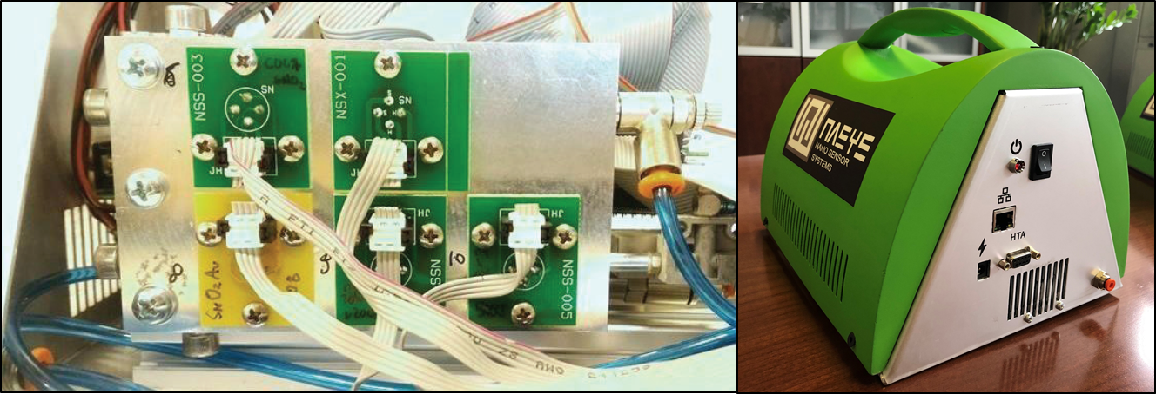
Figure 1: Detail of the sensing chamber with 5 visible sensors (on the left) and full S3 device (on the right).
Sensor used in S3 are made in the SENSOR Laboratory, too. They are characterized by two different production processes that make their final properties very different. The first type is obtained with Rheotaxial Growth and Thermal Oxidation (RGTO) thin film technology (G. Sberveglieri, 1995). They are thin films sensors with high surface area and nanosized crystallites. Nanowire sensors are the second type. Their growth is obtained according to the evaporation–condensation technique. The MOX semi-conductor precursor powder was placed at the center of an alumina tube and then temperature was raised above the limit of decomposition for the oxide into a vapor transport furnace able to achieve 1500 °C. They exhibit physical properties that are significantly different from their polycrystalline counterpart. The nanowires have a high degree of crystallinity, atomically sharp terminations and an extraordinary length-to-width ratio, resulting in enhanced sensing capability as well as long-term material stability for prolonged operation. In addition, the three-dimensional network formed by the nanowires increases the adsorption surface and the catalytic activity, improving the response and decreasing the limit of detection (E. Comini et al., 2009).
  - Food identity
Parmigiano Reggiano (PR) is a typical Italian product known all over the world. Appreciated for its qualities, it is also one of the most counterfeit foods. Frauds consist of both imitation of the product by non-authorized dairies in some countries (M. Abbatangelo et al., 2018a) and the marketing of products that do not comply with consortium guidelines (M. Abbatangelo et al., 2018b). To find a solution to this problem, an innovative and rapid method that does not destroy the sample under analysis has been developed using S3.
In the first case, 57 cheese shapes of three different categories were chosen to assess the ability of S3 to recognize PR from competitors: PR cheese, European competitors and US competitors. Samples were prepared using a little drilling tool with a diameter of 1 cm and taking an aliquot of length of 2 cm; two different measurement sessions were performed. Sensors used in each session for the analysis are in Table 1. Commercial sensors, like TGS and MQ series, were used in order to compare performances of sensors produced at the University of Brescia with the ones already present on the market.
Table 1: List of sensors used for PR cheese recognition from competitors
Type | Composition | Morphology | Operating Temperature (°C) or Voltage (V)
Session 1
SnO2Au | SnO2 grown with Au | Nanowire | 400°C
SnO2Au+Au | SnO2 grown with Au and functionalised with gold clusters | Nanowire | 400°C
ZnO | ZnO | Nanowire | 400°C
TiO2 | TiO2 | Nanotubes | 400°C
TGS2611 | D1 | Polycrystal | 180°C
 |  | Session 2
MQ3 | SnO2 | Polycrystal | 5V
MQ8 | SnO2 | Polycrystal | 5V
MQ9 | SnO2 | Polycrystal | 5V
SnO2 | SnO2 | RGTO | 400°C
SnO2Au | SnO2 on a gold catalyst | RGTO | 400°C
SnO2Au+Au | SnO2 grown with Au and functionalised with gold clusters | Nanowire | 350°C
SnO2Au | SnO2 grown with Au | Nanowire | 350°C
CuO | CuO | Nanowire | 350°C
SnO2+Au | SnO2 functionalised with Au clusters | RGTO | 350°C
TGS2611 | D1 | Polycrystal | 180°C

After a period of sample conditioning (30 °C for 10 min), samples’ head space was flowed in the sensor chamber for 61 seconds (it is the actual analysis time); then filtered air is flowed into the sensors chamber for 600 seconds. Data were analysed using Partial Least Squares Discriminant Analysis (PLS-DA) method that indicates the best sensors for recognition tasks, allows to visualize how different groups cluster and classify samples. It has been highlighted that new nanowire gas sensors side by side with commercial MOX could be useful for this specific application. Particularly in this application, some commercial sensors such as TGS2611 and MQ3 had similar performance of SnO2, ZnO and TiO2-based sensors. This resulted from an algorithm for selecting the best parameters, known as “Sequential Forward Selection”, to be extracted and considered from sensors for having optimal classification rates. Finally, the system has reached percentages of correct classification higher than 80% both in the discrimination between competitors and between PR produced by different diaries.
The aim of the second study was to determine the rind percentage of the sample under analysis since consortium guidelines establish that it must be lower than 18%. An approach similar to the previous one was used, using a different array configuration (Table 2). In this case, the best classification performances were reached using different ANNs in cascade in order to identify seasoning degree (12 months or 24 months), rind working process (washed rind or scraped rind) and rind percentage (lower than 18%, between 18% and 26%, higher than 26%). Each of these properties was evaluated in one step of the cascade in the order presented above. The architecture used was the one present in Abbatangelo et al. (2018b). Once the number of analysed samples have increased, ANN architectures was optimized in terms of an increase of the number of neurons since the problem became more complex. 452 samples were used to train and test ANNs and it turned out that the system reached a classification rate equal to 92.7%.
Table 2: List of sensors used for grated PR cheese rind percentage identification
Materials (Type) | Composition | Morphology | Operating Temperature (°C)
SnO2Au (n) | SnO2 functionalized  with Au clusters | RGTO | 400 °C
SnO2 (n) | SnO2 | RGTO | 300 °C
SnO2 (n) | SnO2 | RGTO | 400 °C
SnO2Au+Au (n) | SnO2 grown with Au  and functionalized with gold clusters | Nanowire | 350 °C
SnO2Au (n) | SnO2 grown with Au | Nanowire | 350 °C
CuO (p) | CuO | Nanowire | 400 °C
  - Food safety
Preventing the spread of contaminated food is one of today's main challenges to avoid foodborne illness. MOX sensors can help a lot to solve this task. In many researches, the ability of ENs systems has been highlighted; here, two case studies are shown. In both, array of nanowire and RGTO gas sensors was used.
Microbial contamination, either before or during food production phases, is one of the major concerns of food manufacturers. S3 was successfully used for early screening of Campylobacter jejuni. Using Principal Component Analysis (PCA), it has been found that the S3 was able to follow C. jejuni growth and to distinguish from the control samples uncontaminated. (E. Núñez Carmona et al., 2019). That result was due to changes in head space composition because of bacteria metabolism. Indeed, Gas-Chromatography Mass-Spectrometry (GC-MS) with a Solid-Phase Micro Extraction (SPME) technique highlighted that after 20 h differences between control and contaminated samples was mainly due to alcohol compounds, produced by fermentation.
Second research aim was to find a method able to detect different blends of microorganisms and follow their growth inside the blends (E. Núñez Carmona et al., 2017). Different mixes were prepared, and details are listed in Table 3. A concentration of 5 × 10⁶ CFU/ml for each selected microorganism was considered. Once microbial blends were ready, a total volume of 2 mL for each Mix was placed individually in a sterilized chromatographic vial of 20 mL. Control samples were prepared just pouring 2 mL of chemical sweat solution. Concerning the result obtained with the microbial blends in the PCA score plot (Figure 2), it is possible to observe that the subspace of PC1 and PC2 can be divided into two parts separated by the vertical line PC1 = 0. Whit negative value of PC1, there are data corresponding to the control sample, Blends A, C and, for Blend B, just the first measured sample, which has been incubated for a negligible time in solution (t = 0 h). Conversely, in the right part of the subspace we have only data points corresponding to Blend B. It’s interesting to note that Blend B data moves towards the upper-right portion according to the increasing incubation time. As for other samples, a drift is observed too, but it’s mainly occurring along the PC2. The general picture suggests that the EN is tracking the temporal evolution of phenomena related to microbiota behavior in solution.
Table 3: Microbial blend samples components.
Materials (Type) | Composition | Morphology | Operating Temperature (°C)

Blend kinds | Microbial components
 | Bacteria | Yeast | Fungi
Mix A | Listeria monocytogenes | Trichosporon spp. | MMSI
Mix B | Escherichia coli | Rhodotorula spp. | FGO3
Mix C | Salmonella enteritidis | Candida albicans | FGB2

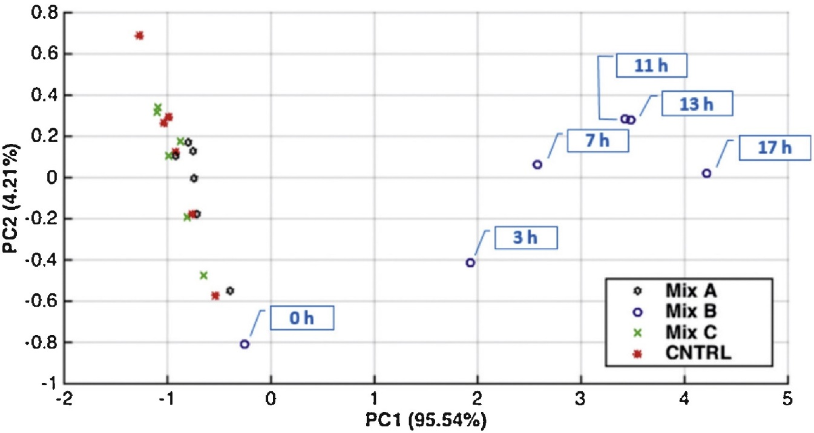
Figure 2: PCA score plot of the samples performed for the microbial blend results in the 20 h of analysis.
To better investigate this, EN analysis has been carried out in parallel with chemical and microbiological characterization techniques. From microbial plate count, it resulted that Listeria monocytogenes, Salmonella tiphymurium and Candida albicans, the values at 20 h were higher than 1010 CFU/ml. The GC–MS-SPME analysis showed the qualitative and quantitative differences, from 0 to 20 h and with the control sample. A change in the samples head-space is observed. During their metabolism microorganism produce specific compounds absent in the composition of the sample that contain microbial species. One of the most important compounds that is present just in the Blend B is indole. It is not present in the control and its concentration increase along time. Indole is an aromatic heterocyclic organic compound. It can be produced by a variety of bacteria through the metabolisms of the amino acid tryptophan being widely distributed in the natural environment. As an intercellular signal molecule, indole regulates various aspects of the bacterial physiology.
  - Conclusions
This overview has the aim to show the potentiality of a novel equipment for food quality control that exploit an IoT electronic nose. The novelty of this device respect to other is the nanotechnology of the equipped sensors. Moreover, the development of an easy and user-friendly Web App widens the spectrum of people who are potentially able to use it. Some application examples have suggested the ability of the device to fit the required tasks: food identity and security. With high percentages of classification rate, S3 was able to identify counterfeit PR, both imitation from other countries and recognition of higher rind percentage than those allowed by law. Furthermore, the system correctly identified contaminated matrices with different microorganism that are the main cause of foodborne illness.
Results obtained for each task show how S3 could be useful inside food factory in order to check the presence of contaminations and for the final user, providing him information about the possible presence of microorganism and counterfeits.
Acknowledgments
Authors are grateful to NASYS S.r.l. for providing S3 systems able to carry on accurate analyses on different food matrices.
References
Abbatangelo M., Núñez Carmona E., Sberveglieri V., 2018a, Application of a novel S3 nanowire gas sensor device in parallel with GC-MS for the identification of Parmigiano Reggiano from US and European competitors, Journal of Food Engineering 236, 36-43. DOI: 10.1016/j.jfoodeng.2018.05.009
Abbatangelo M., Núñez Carmona E., Sberveglieri V., 2018b, Application of a novel S3 nanowire gas sensor device in parallel with GC-MS for the identification of rind percentage of grated Parmigiano Reggiano, Sensors 18, 1617. DOI:10.3390/s18051617
Comini E., Baratto C., Faglia G., Ferroni M., Vomiero A., Sberveglieri G., 2009, Quasi-one-dimensional metal oxide semiconductors: Preparation, characterization and application as chemical sensors, Progress in Materials Science 54, 1-67. DOI: 10.1016/j.pmatsci.2008.06.003
Deshmukh S., Bhattacharyya N., Jana A., Bandyopadhyay R., Pandey R.A., (Ed.) 2018, Electronic Nose Technologies and Advances in Machine Olfaction, IGI Global, Hershey, Pennsylvania, USA.
Gardner J.W., Bartlett P.N., 1994, A brief history of electronic noses, Sens. Actuators B-Chem. 18, 211-220. DOI: 10.1016/0925-4005(94)87085-3
Hulanicki A., Glab S., Ingman F., 1991, Chemical sensors: definitions and classification, Pure Appl. Chem. 63, 1247-1250.
Loutfi A., Coradeschi S., Mani G.K., Shankar P., Rayappan J.B.B., 2015, Electronic noses for food quality: A review, Journal of Food Engineering 144, 103-111. DOI: 10.1016/j.jfoodeng.2014.07.019
Núñez Carmona E., Sberveglieri V., Ponzoni A., Galstyan V., Zappa D., Pulvirenti A., Comini E., 2017, Detection of food and skin pathogen microbiota by means of an electronic nose based on metal oxide chemiresistors, Sens. Actuators B-Chem. 238, 1224-1230. DOI: 10.1016/j.snb.2016.09.086
Núñez Carmona E., Abbatangelo M., Sberveglieri V., 2019, Innovative Sensor Approach to Follow Campylobacter jejuni Development, Biosensors 9, 8. DOI: 10.3390/bios9010008
Saidi T., Zaim O., Moufid M., El Bari N., Ionescu R., Bouchikhi B., 2018, Exhaled breath analysis using electronic nose and gas chromatography–mass spectrometry for non-invasive diagnosis of chronic kidney disease, diabetes mellitus and healthy subjects, Sens. Actuators B-Chem. 257, 178-188. DOI: 10.1016/j.snb.2017.10.178
Sberveglieri G., 1995, Recent developments in semiconducting thin-film gas sensors, Sens. Actuators B-Chem. 23, 103–109. DOI: 10.1016/0925-4005(94)01278-P

