|  |  |
| --- | --- |
| cetlogo ***CHEMICAL ENGINEERING TRANSACTIONS***  ***VOL. 76, 2019*** | A publication of  aidiclogo_grande |
| The Italian Association  of Chemical Engineering  Online at www.aidic.it/cet |
| Guest Editors: Sauro Pierucci, Jiří Jaromír Klemeš, Laura Piazza  Copyright © 2019, AIDIC Servizi S.r.l. **ISBN** 978-88-95608-73-0; **ISSN** 2283-9216 | |

Characterization of mixed fatty-starchy soils for cleaning studies in food industry

Mireya Serrano-Haro, Manuel Tirado-Delgado, Otilia Herrera-Márquez\*, José M. Vicaria, Encarnación Jurado-Alameda

Department of Chemical Engineering, University of Granada. Avda. Fuentenueva, s/n, 18071. Granada (Spain)

\*[oherrera@ugr.es](mailto:oherrera@ugr.es)

A protocol for the preparation of mixtures of fat (pork lard) and soluble potato starch have been developed in order to standardized model soils for detergency studies. Different mixtures have been prepared and used as a soiling agent of stainless steel fibres. Cleaning tests have been carried out in a laboratory device reproducing a Cleaning-In-Place system, using phosphate buffer pH 7.0 as a cleaning solution. Individual detergencies referred to the fat and starch have been obtained analytically, as well as total detergency measured by weighing. Analytical and weighed detergencies have coincident results. Cleaning results constitute a first step for the development of a cleaning map for different grades of fat-starch mixed soils.

* 1. Introduction

Quality and hygiene standards in food industry require that special attention be paid to cleaning and disinfection processes, assuring the surfaces in food equipment are physically and microbiologically clean (Liu et al., 2002). CIP (Cleaning-In-Place) systems are commonly applied to clean effectively without the need for any disassembly and reassembly. Nevertheless, these procedures are generally standardized and do not take into account the differences in the type and composition of the different soils.

On the other hand, cleaning operations are expensive and entails a high environmental impact. Efforts to minimise the use of time, water, chemicals and energy are currently made in order to improve plant sustainability (Fryer et al., 2011). The development of specific and precise cleaning formulations for different soils and substrates can contribute significantly to this objective, besides optimizing the performance of cleaning processes (Suárez et al., 2012).

While CIP protocols for protein-based fouling deposits has been thoroughly studied in the literature, carbohydrate-based deposits have received little attention so far (Khalid et al., 2016). Cleaning protocols specifically designed for starchy soils have been tested on Jurado-Alameda et al. (2015) and Jurado-Alameda et al. (2016) using microparticles and ozone, respectively. On the other hand, fatty soils pose a particular challenge because of their hydrophobicity and tendency to wet hard surfaces preferentially to water (Detry et al., 2007).

In this work different mixtures of fat (pork lard) and soluble potato starch have been prepared in order to standardize model soils for its later use on washing assays. Stainless steel fibres have been used as a substrate. Total detergency have been determined by weighing and analytical tests have been carried out for separate determination of carbohydrates and fat in the remaining soil, obtaining separate detergency figures that can help in the study of the cleaning mechanisms of complex soils.

* 1. Materials and methods

**2.1. Materials**

Soluble potato starch (analytical grade, Panreac) and a commercial pork lard (local supplier) were used as soiling agents. A fat-soluble pigment, Sudan III (Panreac), was used as a fat dye. Washing tests were carried out using Sørensen’s phosphate buffer pH 7.0 (Sørensen, 1909) as a cleaning solution.

**2.2. Preparation of soil**

Different mixtures of fatty-starchy soils were prepared with different fat percentages. For each mixture, 100 g of pork lard was melted heating at 50ºC and colored with Sudan III in a concentration of 0.02% w/w, stirring until complete dissolution. Afterwards filtration with kitasatos was made. After cooling at room temperature, coloured fat was mixed with the appropriate amount of potato starch and stirred manually until a homogeneous mixture was obtained. Nevertheless, only mixtures with fat percentage higher than 60% were finally chosen because of the difficulty to produce reproducible soils with such high powder content. Thus, fat percentages selected for the mixed soils were 60, 80 and 100% w/w.

As an example, Figure 1 shows the appearance of three of the mixtures prepared. As it can be seen, when starch percentage is high (picture (a)), the texture of the soil is too powdery to be used as a soiling agent susceptible to adhering to hard surfaces.

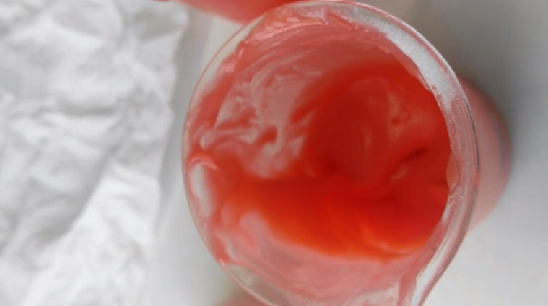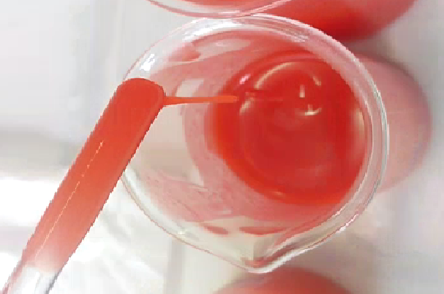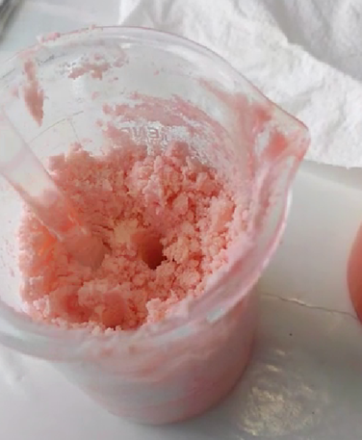



(a) (b) (c)

**Figure 1**. Mixtures of fatty-starchy soils with a fat percentage of 10% w/w (a), 60% w/w (b) and 80% w/w (c).

**2.3. Cleaning tests**

Spherical wads (average diameter of 2 cm) of stainless steel AISI 410 fibers are called substrate in this work. These wads were uniformly soiled by rolling them over each type of mixed soil. The total amount retained in each sphere was 2.0 ± 0.5 g. Eight wads was used in each washing test, which means a total mass of soil to be cleaned in each test of 16 ± 1g. Each group of soiled spheres were maintained at 4 ºC during 30 minutes before being used. Figure 2 shows an example of the soiled substrate.

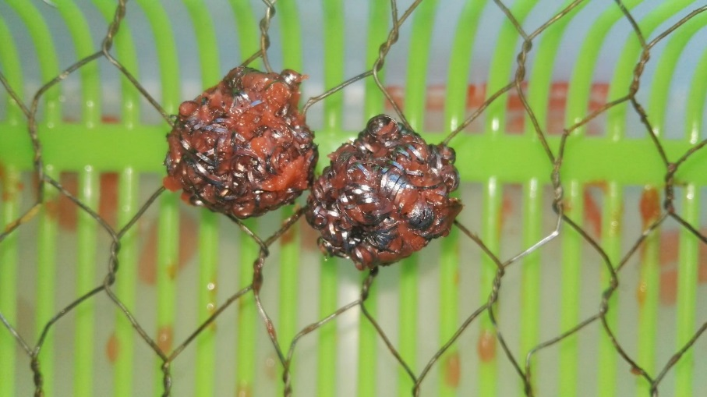

Figure 2. Soiled substrate with mixed fat-starch soil (80% w/w fat – 20% w/w starch)

Washing tests were carried out in the BSF (Bath-Substrate-Flow) device proposed by Jurado-Alameda et al. (2003), which reproduces a CIP (Cleaning-In-Place) system. The BSF device has been used in studies testing different detergent formulations for cleaning different types of soil and substrates in the food industry (Jurado-Alameda et al., 2014; Jurado Alameda et al., 2011). Figure 3 shows a simplified diagram. This system is based on a tank (1) (1000 mL) where the cleaning solution is stored and a packed column (2), where soiled spheres are deposited (50 ml of capacity; 2.5 cm in diameter; 8.5 cm in height). Both of them are jacketed to keep the temperature constant throughout the experiments by a thermostatically controlled bath (3). A peristaltic pump (4) is used to circulate the washing solution at a constant flow rate. The tank is also equipped with a paddle stirrer (5), although no agitation was applied in these washing tests.

**Figure 3.** Scheme of the BSF device.

The BSF device allows the modification of all influencing factors on cleaning efficiency: type of soil and substrate, cleaning solution, temperature, flow rate, and cleaning time. Cleaning tests were carried out using mixed soils with a fat percentage of 60%, 80% and 100%. All the assays were performed at the same experimental conditions, using phosphate buffer pH 7.0 as cleaning solution. The rest of the cleaning parameters were fixed at the following values: temperature 40ºC, time 10 min, flow rate 120 L/h, and volume of the washing solution 1.2 L. All cleaning tests were made in triplicate.

The washing procedure was made as follows: (1) Prepare the washing solution and the soiled spheres; (2) introduce the washing solution in the tank and wait until achieving suitable temperature; (3) add the soiled spheres into the packed column; (4) turn on the pump to begin with the cleaning process; (5) after 10 minutes the soiled spheres are taken off from the column and introduced in the oven. The spheres will be dried for 24 h at 60 ºC before detergency evaluation.

2.4 Detergency evaluation

In each washing test three detergency values ​​were obtained: detergency referred to the starch and referred to the fat, both obtained by analytical determination, and detergency referred to the total mass of soil. The detergency values ​​obtained analytically were added in each test to compare the total detergency by analysis (Dt, %) with the total detergency by weighing.

The total detergency (De, %) by weighing or cleaning effectiveness was calculated according to:

$D_{e}\left(\%\right)=\frac{m_{i}-m_{f}}{m_{i}}.100$ (1)

Where mi is the mass of soiled retained in the spheres before the washing process and mf is the mass of soil remaining afterwards.

To complete the evaluation study of the cleaning efficiency, the detergency of the fat fraction and starchy fraction of the mixed soil were evaluated separately. The residual fatty soil was extracted from the washed spheres once dried and weighted. For the extraction, 50 mL of *i*-octane was used as a solvent, making it circulate through the total surface of the spheres until no colored deposit was observed. The analysis was made by triplicate. Absorbance was measured at 500 nm in a spectrophotometer (Cary 100 Bio UV–Visible, Varian), evaluating the concentration using a calibration line. To take into account the possible differences in coloration a calibration line was made for each fatty soil prepared. Fat detergency (Df, %) was calculated according to Eq(1), where mi was the initial mass of fat and mf the mass of fat remaining in the spheres after the washing test.

On the other hand, the starch concentration was evaluated by the phenol-sulphur colorimetric method (DuBois et al., 1956) after fat extraction. 250 mL of distilled water are added to the washed wads and introduced in a thermostatically controlled bath at 60-70ºC during one hour~~.~~ To dissolve it, 15 minutes of stirring was needed at the same temperature range. To hydrolyze the starch 1 mL of starch solution was added to test tubes with 1 mL of sulphuric acid (96%) 2N. Then the tubes were introduced in a digestor (Digital Dry Bath, AccuBlock) during 30 min at 100ºC. After cooling in an ice bath, 0.5 mL were taken and 0.5 mL of a phenol solution (5% w/v) and 2.5 mL of 96% sulphuric acid are added. After cooling at room temperature, absorbance was measured at 490 nm. The starch concentration was established from a calibration line, although it was also taken into account the starch extraction efficiency which was determined by an experimental factor of 0.81. Starch detergency (Ds, %) was calculated according to Eq(1), where mi was the initial mass of starch and mf the mass of starch remaining in the spheres after the washing test.

* 1. Results and discussion

The results of the cleaning tests using the different mixed soils prepared as described in 2.2 are shown in Figure 4. On the other hand, the relationship between total detergency values obtained analytically (Dt) and by weighing (De) is shown in Table 1. It is verified that the detergency results obtained for the starch and the fat fraction individually correspond to those obtained for the total mass of soil, which confirms the consistency of the detergency evaluation method proposed in this work. The maximum difference found between the total detergency values ​​obtained analytically and by weighing has been 7%.

*Table 1: Comparison between total detergency values obtained analytically and by weighing*

|  |  |  |  |
| --- | --- | --- | --- |
|  | **60% w/w fat** | **80% w/w fat** | **100% w/w fat** |
| Dt (%) | 64.96 | 62.61 | 73.95 |
| De (%) | 63.47 | 58.67 | 69.74 |
| Dt/De | 1.02 | 1.07 | 1.06 |



*Figure 4.* *Detergency of mixed fatty-starchy soils as a function of fat percentage. Tendency lines represent detergency referred to starch (Ds), to fat (Df) and the sum of both (Dt). Cleaning tests with pH 7.0 phosphate buffer as a cleaning solution, 40 ºC, flow rate 120 L/h, 10 min.*

The results show that total detergency is higher than 60% for all the mixtures assayed. According to Cuckston et al. (2019), cleaning at mild pH values (6-8) provides faster soil removal than alkaline pH when deposits are complex mixtures, due to fat hydrolysis or the inhibition of the mobile fat phase in alkaline conditions. With respect to the starch fraction, detergency increases notably when its percentage is lower. This can be due to the dragging effect by the mobile fat phase, with reduced viscosity at 40 °C, this effect being favoured when the proportion of starch is lower.

Fat detergency, nevertheless, undergoes a slight decrease when its percentage increases in the mixed soil. The increasing presence of oil can change the cleaning mechanism of a complex soil (Magens et al., 2017), reducing its cohesive strength and thus leaving small chunks adhered to the substrate surface because of the fat hydrophobicity.

The results of this work constitute a starting point for a deeper study on the detergency of mixed fat-starch soils, expanding the typology of soils as well as the study of the effect of different parameters (cleaning composition, time, flow rate, temperature) on cleaning efficiency.

* 1. Conclusions

The mixtures of fat and starch prepared according to the protocol defined in this work constitute suitable model soils for detergency studies. Difference between total detergency obtained by weighing and by analytical methods for carbohydrates and fats individually is maximum 7%, which confirms the consistency of the evaluation method. Total detergency is higher than 60% for all the mixtures assayed. Great differences can be found in fat and starch detergency depending on their concentration on the mixed soil.

Acknowledgments

This work has been financed by the Ministerio of Economía y Competitividad, Spain (Research Project ref. CTQ2015-69658-R). We also want to thank to University of Granada, Regional Government of Andalusia and European Social Fund for the financing of contracts for technicians who have worked in this research.

References

Cuckston, G.L., Alam, Z., Goodwin, J., Ward, G., Wilson, D.I., 2019, Quantifying the effect of solution formulation on the removal of soft solid food deposits from stainless steel substrates, Journal of Food Engineering, 243, 22–32. https://doi.org/10.1016/j.jfoodeng.2018.08.018

Detry, J.G., Rouxhet, P.G., Boulangé-Petermann, L., Deroanne, C., Sindic, M., 2007, Cleanability assessment of model solid surfaces with a radial-flow cell, Colloids Surfaces A: Physicochemical and Engineering Aspects, 302, 540–548. https://doi.org/10.1016/J.COLSURFA.2007.03.027

DuBois, M., Gilles, K.A., Hamilton, J.K., Rebers, P.A., Smith, F., 1956, Colorimetric Method for Determination of Sugars and Related Substances, Analytical Chemistry, 28, 350–356. https://doi.org/10.1021/ac60111a017

Fryer, P.J., Robbins, P.T., Cole, P.M., Goode, K.R., Zhang, Z., Asteriadou, K., 2011, Populating the cleaning map: can data for cleaning be relevant across different lengthscales?, Procedia Food Science, 1, 1761–1767. https://doi.org/10.1016/j.profoo.2011.09.259

Jurado-Alameda, E., Altmajer-Vaz, D., García-Román, M., Jiménez-Pérez, J.L., 2014, Study of heat-denatured whey protein removal from stainless steel surfaces in clean-in-place systems, International Dairy Journal, 38, 195–198. https://doi.org/10.1016/j.idairyj.2014.01.006

Jurado-Alameda, E., Vicaria, J.M., Herrera-Márquez, O., Olivares, V., Sosa, G., 2016, Study on the use of ozonation catalyzed by nanoparticles for ecological cleaning processes, Chemical Engineering Transactions, 47, 259-264. https://doi.org/10.3303/CET1647044

Jurado-Alameda, E., Bravo-Rodriguez, V., Bailón-Moreno, R., Núñez-Olea, J., Vaz, D.A., 2011, Fatty Soils Removal From Hard Surfaces in a Clean-in-Place System, Journal of Food Process Engineering, 34, 1053–1070. https://doi.org/10.1111/j.1745-4530.2009.00527.x

Jurado-Alameda, E., Bravo-Rodríguez, V., Bailón, R., Núñez, J., Altmajer, D., 2003, Bath - Substrate - Flow Method for Evaluating the Detersive and Dispersant Performance of Hard-Surface Detergents. Industrial and Engineering Chemistry Research, 42, 4303–4310.

Jurado-Alameda, E., Herrera-Márquez, O., Plaza-Quevedo, A., Vicaria, J.M., 2015, Interaction between non-ionic surfactants and silica micro/nanoparticles. Influence on the cleaning of dried starch on steel surfaces. Journal of Indindustrial and Engineering Chemistry, 21, 1383–1388. https://doi.org/10.1016/j.jiec.2014.06.011

Khalid, N.I., Nordin, N., Chia, Z.Y., Ab Aziz, N., Nuraini, A.A., Taip, F.S., Ahmedov, A., 2016, A removal kinetics approach for evaluation of economic cleaning protocols for pink guava puree fouling deposit, Journal of Cleaner Production, 135, 1317–1326. https://doi.org/10.1016/j.jclepro.2016.06.095

Liu, W., Christian, G.K., Zhang, Z., Fryer, P.J., 2002, Development and Use of a Micromanipulation Technique for Measuring the Force Required to Disrupt and Remove Fouling Deposits, Food and Bioproducts Processing, 80, 286–291. https://doi.org/10.1205/096030802321154790

Magens, O.M., Liu, Y., Hofmans, J.F.A., Nelissen, J.A., Ian Wilson, D., 2017, Adhesion and cleaning of foods with complex structure: Effect of oil content and fluoropolymer coating characteristics on the detachment of cake from baking surfaces, Journal of Food Engineering, 197, 48–59. https://doi.org/10.1016/j.jfoodeng.2016.11.004

Sørensen, S.P.L.,1909, Enzyme Studies. II. The Measurement and Importance of the Hydrogen Ion Concentration in Enzyme Reactions, Biochemische Zeitschrift, 21, 131-304.

Suárez, L., Díez, M. A., García, R., Riera, F. A., 2012, Membrane technology for the recovery of detergent compounds: A review, Journal of Industrial and Engineering Chemistry, 18, 1859–1873. https://doi.org/10.1016/j.jiec.2012.05.015