|  |  |
| --- | --- |
| cetlogo CHEMICAL ENGINEERING TRANSACTIONS  ***VOL. 76, 2019*** | A publication of  aidiclogo_grande |
| The Italian Association  of Chemical Engineering  Online at www.aidic.it/cet |
| Guest Editors: Sauro Pierucci, Jiří Jaromír Klemeš, Laura Piazza  Copyright © 2019, AIDIC Servizi S.r.l. **ISBN** 978-88-95608-73-0; **ISSN** 2283-9216 | |

Microencapsulation by spray-drying of Stevia fraction with antidiabetics effects

Maria Rosa T. Zorzenona, Fabiane Hodasb, Paula G. Milanib, Maysa Formigonia,Antonio S. Dacomeb, Antonio R.G. Monteiroc\*, Cecíla E. Mareze-Costad, Silvio C. Costab.

aPostgraduate Program in Food Science - State University of Maringá (UEM); Av. Colombo 5790; CEP 87020-900; Maringá – Paraná – Brazil.

bBiochemistry Department - State University of Maringá (UEM); Av. Colombo 5790; CEP 87020-900; Maringá – Paraná – Brazil.

cFood Engineering Department – State University of Maringá (UEM); Av. Colombo 5790; CEP 87020-900; Maringá – Paraná – Brazil.

dPhysiological Sciences Department, State University of Maringá (UEM), Av. Colombo 5790; CEP 87020-900; Maringá – Paraná – Brazil.

argmonteiro@uem.com

Stevia leaves (*Stevia rebaudiana* Bert.), that present high-intensity natural sweeteners (steviol glycosides), also has a series of secondary metabolites for which have been reported biological effects such as antioxidants, antihyperglycemic and insulinotropic. A recent study showed that a fraction of Stevia rich in phenolic compounds, with low solubility in aqueous systems, presented significant improvements in altered parameters of diabetes, especially in relation to hyperglycemia and oxidative stress. In order to allow the use of the Stevia fraction at higher doses, it was microencapsulated in a maltodextrin matrix by spray dryer process. The following parameters were evaluated: microencapsulation efficiency, solubility, moisture content and hygroscopicity of the microcapsules and also structural aspects by scanning electron microscopy (SEM). The Stevia fraction and maltodextrin (DE 17-19) was added in water, stirred in shaker and dried in Spray Dryer (Buchi, model B-191). The efficiency of the microencapsulation process was 84%. The microcapsules presented solubility three times higher than the free fraction, the increase of hygroscopicity values ​​and reduction of moisture values ​​in relation to the non-encapsulated Stevia fraction was observed. The images captured from the SEM show microcapsules with well defined spherical surfaces. The microencapsulation process showed to be an important alternative to increase the solubility of this fraction and consequently increases the incorporation of the stevia rich fraction in phenolic compounds into functional foods and beverages with antidiabetic properties.

* 1. Introduction

*Stevia rebaudiana* (Bert.) is a plant known worldwide for containing steviol glycosides in its leaves (Chranioti et al., 2015). Among them, rebaudioside A and stevioside are used as high-intensity (non-nutritive) natural sweeteners and can safely replace sucrose, fructose and synthetic sweeteners, such as aspartame and sucralose (Alupului 2009).

Stevia extracts have been successfully used in the prevention and treatment of metabolic diseases such as diabetes, with anti-hyperglycemic and insulinotropic effects (Rojas et al., 2018). These effects are related to the presence of a number of bioactive substances present in leaves and in the raw and semi-purified Stevia extracts, such as phenolic compounds, flavonoids, alkaloids, xanthophylls, hydroxycinolyl derivatives (caffeine derivatives and chlorogenic acid), oligosaccharides soluble, free sugars, amino acids, lipids, essential oils and trace elements (Formigoni et al., 2017).

Milani et al., (2017A) demonstrated that diabetic animals treated for 30 days with 0.2% of a stevia fraction (FA) with high antioxidant activity, obtained from Stevia leaves, significantly reduced the altered physiological parameters in diabetes. This fact indicates that even at low concentration (0.2%), the FA fraction may present important therapeutic effects in individuals affected by this pathology, suggesting that better results could be achieved at higher doses. However, the low solubility of the FA fraction in aqueous systems represents a barrier that may limit its use in many formulations of food and medicines. An alternative to making formulations viable with higher concentrations of FA is via the encapsulation process. This process is based on incorporating substances into a matrix in order to increase its stability and application (Rezende et al., 2018). Some methods are commonly used to encapsulate food ingredients, such as extrusion, spray drying, freezing drying and coacervation (Shishir and Chen 2017) . Spray drying is the most common and economically feasible method used for microencapsulation of powdered ingredients (Edris et al., 2016).

The selection of the encapsulating agent (matrix) is of extreme importance for efficient encapsulation. In foods, maltodextrins are widely used as an encapsulating agent because they present low cost, high efficiency and decrease the exposure of the encapsulation to oxygen (Raja et al., 1989). In addition, it has been shown to be efficient and stable in the encapsulation of natural products, as constituents of Stevia (Chranioti et al., 2015).

The objective of this work was to microencapsulate the FA fraction in order to increase its solubility, using as an encapsulating agent the maltodextrin and spray as a drying method. In addition, it was to evaluate the efficiency of microencapsulation and microcapsules through solubility, humidity, hygroscopicity and scanning electron microscopy.

* 1. Material and Methods Equations
     1. Samples and reagents

*Stevia rebaudiana* leaves were obtained from the Nucleus of Studies on Natural Products (NEPRON) located at the State University of Maringá (23 ° 24'25 "S 51 ° 56'22" W), Maringá, Brazil. Shrubs of the seminal variety, Stevia UEM-13, were at the highest stage of vegetative growth (approximately 50-60 days after pruning). These shrubs were previously dried in an oven at 60 °C and the leaves were subsequently separated from stems, placed in polyethylene bags and stored prior to being extracted. The chemical reagents used were of the Sigma-Aldrich brand. Maltodextrin (DE 17-19) was kindly provided by Ingredion Incorporated. The FA fraction was obtained according to Milani et al., 2017.

* + 1. Quantification of bioactive compounds and antioxidant activity in vitro

The content of total phenolic compounds and antioxidant activity of the FA fraction (0.5 mg / mL) was determined. Total phenolic compounds were quantified according to Singleton et al., 1999. Gallic acid was used as the standard compound. The fraction sequestering activity was measured by the ability to eliminate DPPH radicals (Blois 1958). Data were expressed as percentages of inhibition.

* + 1. Chemical characterization of FA fraction by UPLC-MS/MS

For analysis of the fractions, aliquots of 80 mg/ml extracts were analyzed with UHPLC-MS/MS using a liquid chromatography system, Nexera X2, with LC-30AD pump and Shimadzu XR-ODSIII150 x 2 mm column maintained at 40 °C with a linear gradient of elution using water (0.1% formic acid) (A) and acetonitrile (0.1% formic acid) (B) as solvent with LC-MS purity. Chromatographic separation was performed in 20 minutes, using from 1 to 10 minutes 95 % solvent A and 5 % B. From 10 to 16 minutes 60 % A and 40 % B. From 16 to 18 minutes, 10 % A and 90 % B. From 18 to 20 minutes, 5 % A and 95 % B. The last two minutes were 95 % solvent A and 5 % B. The mass spectrometer used was the Q-TOF type (Bruker, Germany), with an electrospray ionization source operated in AutoMS/MS acquisition mode where the 3 most intense ions of each chromatographic peak were selected with 5 Hz (MS and MS / MS) and equipment tune in the range of m/z 70-1300. The analyses were performed in positive ionization mode with a capillary voltage of 4.50 kV. The temperature of the source was 200 °C, and the desolvation gas flow was 8 l.min-1.

The experiments were performed using collision-induced dissociation (DIC) obtained using a collision energy ramp in the range of 15-40 eV and collision gas pressure of 3.06 and 10-3 mBar in the collision chamber. The ion chromatogram and the obtained MS and MS/MS spectra were visualized with DataAnalysis 4.1 software, compared to the literature and analyzed using free access mass spectrometry databases, such as Massbank, Metlin and Human Metabolome Database.

* + 1. Microencapsulation by Spray Dryer

1 g of Tween 80 was added in 100 mL of deionized water under constant stirring. Then, 2.5 g of FA and 10 g of maltodextrin were added. The mixture was subjected to the shaker apparatus at 200 rpm, 35 °C for 30 minutes. The mixture was then dried by Mini Spray Dryer (Buchi, model B-191), with an inlet temperature of 175 °C and an outlet temperature of 103 °C. The microcapsules obtained (MFA) were stored for further analysis.

* + 1. Microcapsules characterization

**2.4.1 Microencapsulation efficiency (%EE)**

The microencapsulation efficiency of the FA fraction was performed according to Chranioti et al. (2016).

**2.4.2 Solubility**

The FA fraction (1 g) and microcapsules (MFA) (1 g) were added to 100 mL of deionized water and shaken at 110 rpm for 30 minutes, followed by centrifugation at 4000 rpm for 5 minutes. Aliquots of 5 mL each supernatant was removed, transferred to pre-weighed petri dishes and dried to constant weight in an incubator at 100 ° C Chranioti et al., 2016. The plates were weighed and the solubility was calculated from the difference in weight.

**2.4.3 Hygroscopicity**

The FA fraction (0.2 g) and MFA (0.2 g) were uniformly spread over Petri dishes and kept in a desiccator at 25°C at a relative humidity of 74% generated by saturated NaCl solution. The samples were weighed daily until the mass was constant. The increase in weight was determined and hygroscopicity was expressed per milligram of absorbed water per gram of sample (Chranioti et al., 2015).

**2.4.4 Moisture Content**

The moisture content of the FA fraction and MFA was determined by oven drying at 105 ºC until constant weight, according to the methodology of Adolfo Lutz Institute (2005).

**2.4.5 Scanning electron microscopic (SEM)**

The MFA and the FA fraction were maintained for approximately 48 hours in hermetically sealed containers, containing silica, to ensure total moisture absorption. The dried samples were fixed to a metal support with double carbon tape and covered with a thin layer of gold, followed by metallization for the 60s. The morphological visualization was performed at the Research Support Center Complex of the State University of Maringa, using a scanning electron microscope (SEM) JEOL JSM-6060 LV, operating at 10 kV of excitation voltage, using increments of 100 to 1.500 times for viewing.

* + 1. Statistical analysis

All analyzes were performed in duplicate. The results were presented with a mean ± standard error of the mean. Statistically analyzed using ANOVA and Tukey's test with significance level p <0.05 by the statistical program Prism 7.0.

* 1. Results and Discussion

Studies have shown that extracts of Stevia leaves may exhibit high antioxidant activity (Periche et al., 2015). Table 1 presents a quantification composed of ingredients and an antioxidant activity present in the FA fraction of Stevia.

Table 1: Bioactive compounds and antioxidant activity in vitro of FA fraction

|  |  |  |  |
| --- | --- | --- | --- |
| Analyses | FA Fraction |  |  |
| Phenolic compounds (g/100g) | 31.39 ± 10.6 |  |  |
| Antioxidant activity (%) | 94.7 ± 3.50 |  |  |

The FA fraction was analyzed by UHPLC-MS / MS as described in the Materials and Methods section. Figure 1 shows the total-ion chromatogram obtained from FA analysis in positive ionization mode.

Table 2 shows the possible identification of 21 compounds with precision error below 5 ppm. Among the classes of compounds found are flavonoids, phenolics and derivatives of quinic acid and caffeic acid. The composition of FA determined by UHPLC-MS / MS is compatible with content of phenolic compounds and high value of antioxidant activity as ​​shown in Table 1.



Figure 1: MS total ion chromatograms from the FA fraction in positive ionization modes.

Table 2: Identification of compounds and main parameters of identification in FA fraction

|  |  |  |  |  |  |  |
| --- | --- | --- | --- | --- | --- | --- |
| Compounds | Formula | Retention time |  | *m/z* | Fragments | Error |
| Caffeic acid | C9H8O4 | 8.27 |  | 181.0470 | 121, 163 | 2.76 |
| Apigenin | C15H10O5 | 12.38 |  | 271.0561 | 271 | 3.68 |
| Kaempferol | C15H10O6 | 10.15 |  | 287.0518 | 287 | 1.39 |
| Kaempferol-3-rhamnoside | C21H20O10 | 9.55 |  | 433.1081 | 271, 303 | 1.84 |
| Kaempferol-3-deoxyhexosyl hexoside | C27H30O15 | 8.88 |  | 595.1556 | 85, 287 | 2.41 |
| Quercetin | C15H10O7 | 9.52 |  | 303.0462 | 285, 303 | 0.93 |
| Quercetin 4'-O-glucoside | C21H20O12 | 8.86 |  | 465.0967 | 163, 303 | 1.93 |
| Quercetin rhamnoside | C21H20O11 | 9.45 |  | 449.1024 | 85, 303 | -3.11 |
| **Quercetin 7-rutinoside** | C27H30O16 | 8.52 |  | 611.1536 | 85, 303 | -1.64 |
| Luteolin-7-glucoside | C21H20O11 | 8.99 |  | 449.1024 | 163, 287 | 1.62 |
| Rosmarinic acid | C18H16O8 | 13.34 |  | 361.0878 | 361 | 1.57 |
| Chlorogenic acid | C16H18O9 | 7.52 |  | 355.1047 | 145, 163 | 2.53 |
| Dicaffeoylquinic acid | C25H24O12 | 9.43 |  | 517.1255 | 145, 163 | -0.97 |
| 1,5 Dicaffeoylquinic acid | C25H24O12 | 9.78 |  | 517.1255 | 179, 353 | -1.75 |
| 1,3 Dicaffeoylquinic acid | C25H24O12 | 10.42 |  | 517.1255 | 161, 173 | -1.36 |
| Dicaffeoylquinic acid dimer | C50H48O24 | 9.79 |  | 1033.2470 | 163, 517 | 2.22 |
| Caffeoylquinic acid | C16H18O9 | 10.40 |  | 355.1047 | 163, 233 | 2.25 |
| Tricaffeoyl quinic acid | C34H30O15 | 10.97 |  | 679.1563 | 135, 163 | 2.79 |
| Butein | C15H12O5 | 12.57 |  | 273.0716 | 137, 273 | 4.02 |
| Retinal | C20H28O | 14.05 |  | 285.2234 | 119, 187 | 3.15 |
| Steviol | C20H30O3 | 10.71 |  | 319.2222 | 95, 301 | 3.13 |

Several studies with extracts and fractions of Stevia report the presence of compounds with antioxidant properties suggesting a preventive role in the development of cardiovascular diseases, cancer and diabetes (Formigoni et al., 2017) (Karaköse et al., 2015). Besides that, for the derivatives of quinic and caffeic acids, properties antimutagenic, neuroprotective and antiviral are described (Molina-Calle et al., 2017).

The content of phenolic compounds and the high antioxidant activity determined for FA were similar to those obtained by Milani et al. (2017), which also demonstrated the potential of the FA fraction in the treatment of diabetic animals, indicating, among others, the possibility of using this fraction in the fortification of functional foods. However, the application of the FA fraction to foods is limited due to its low solubility in aqueous systems.

In order to increase the solubility of the FA fraction, it was coated with maltodextrin by drying in a spray dryer. The efficiency of the microencapsulation process was 84%, with an expressive increase of solubility. Chranioti et al. (2016), obtained similar encapsulation efficiency for steviol glycosides using maltodextrin as an encapsulating agent, and also, in comparison to other drying methods tested, observed that Spray Drying presented higher efficiency of microencapsulation. The solubility of MFA was 87.93 % versus 20.77 % for the FA fraction. Therefore, the encapsulation process was effective in promoting increased solubility of FA.

The microencapsulated fraction (MFA), although presented lower moisture value than FA, exhibited higher hygroscopicity, which may negatively interfere with the shelf life of MFA or products formulated therewith.

Table 3: Solubility, hygroscopicity and moisture content of FA and MFA

|  |  |  |  |  |
| --- | --- | --- | --- | --- |
| Analyses | FA fraction | MFA |  |  |
| Solubility (%) | 20.77 ± 0.06 | 81.93\* ± 0.07 |  |  |
| Moisture content (%) | 7.87 ± 0.04 | 2.59\* ± 0.02 |  |  |
| Hygroscopicity (mgH2O/g) | 28.0 ± 1.41 | 132.5\* ± 2.12 |  |  |

Figure 2 shows the captured images of the SEM in the 10000x magnification. The images revealed the predominance of microcapsules with a diameter of approximately 10 μm with well defined spherical surfaces and some slightly wrinkled.

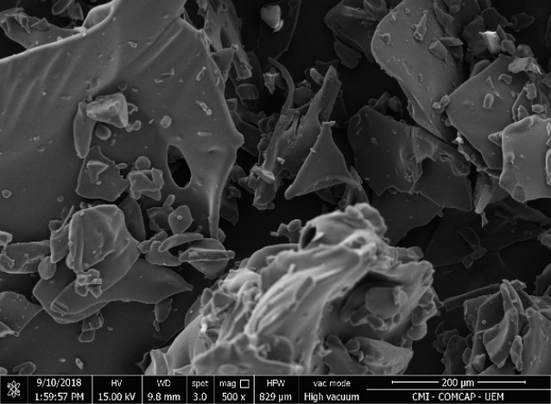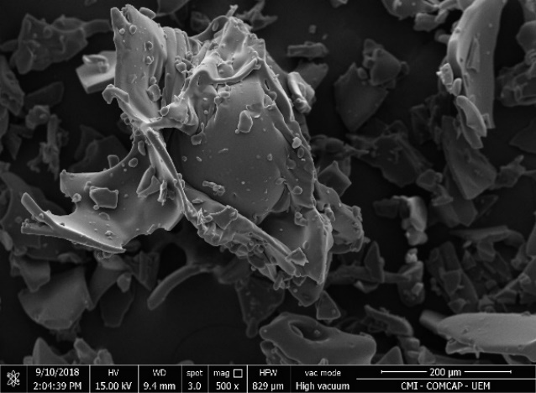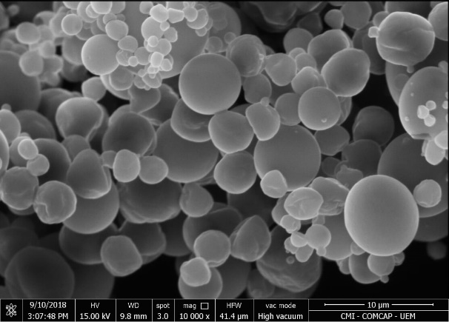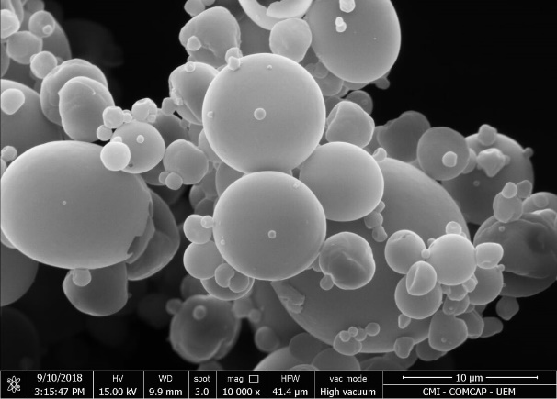

**A**

**A**

**B**

**B**

Figure 2: Morphological analysis of the FA fraction (A) and MFA (B).

The wrinkled surface of some microcapsules may be due to the rapid shrinkage of the emulsion droplets of the FA fraction in the initial stages of spray drying, which can hardly be avoided (Edris et al., 2016). However, few clusters were observed in the MFA. This fact is extremely important because as lower the level of agglomeration as higher the level of dispersion and homogeneity of FA in the formulated foods in the form of powders and consequently, the greater the solubility in aqueous systems (Çam et al., 2014).

* 1. Conclusions

The analysis of the FA fraction through UHPLC-MS / MS allowed the identification of 21 compounds, predominantly phenolic compounds, flavonoids, quinic acid derivatives and caffeic acid, which have been related to important functional effects, however, many of them with low solubility in aqueous systems.The microencapsulation process of the FA fraction in maltodextrin was very efficient resulting in an expressive increase of MFA solubility, with low agglomeration level, allowing functional foods to be formulated with higher doses and a higher level of dispersion of the compounds present in the FA fraction.

Acknowledgments

This study was funded by Brazilian National Council for Scientific and Technological Development (Conselho Nacional de Desenvolvimento Científico e Tecnológico - CNPq) and the Fundação de Apoio ao Desenvolvimento Científico (Foundation for the Support of Scientific Development) (FADEC).

References

Adolfo Lutz Institute, 2005, Analytical Standards of the Adolfo Lutz Institute: chemical and physical methods for food analysis, v. 1, 4ªed., Cap. IV, p. 98-105, IMESP, São Paulo.

Alupului A., Calinescu I. and Lavric V., 2009, Ultrasonic vs. Microwave extraction intensification of active principles from medicinal plants, Chemical Engineering Transactions, 17, 1023-1028.

Blois, M.S, 1958, Antioxidant determinations by the use of a stable free radical, Nature 26, 1199– 1200.

Chranioti C., Chanioti S., Tzia C., 2015, Microencapsulation of steviol glycosides (*Stevia rebaudiana* Bertoni) by a spray drying method - Evaluation of encapsulated products and prepared syrups, International Journal of Food Studies, 4, 212-220.

Chranioti C., Chanioti S., Tzia C., 2016, Comparison of spray, freeze, and oven drying as a means of reducing bitter aftertaste of steviol glycosides (derived from *Stevia rebaudiana* Bertoni plant) – Evaluation of the final products, Food Chemistry, 190, 1151-1158.

Çam M., Içyer N.C., Erdogan F., 2014, Pomegranate peel phenolics: Microencapsulation, storage stability and potential ingredient for functional food development, LWT - Food Science and Technology, 55, 117-123.

Edris A.E., Kalemba D., Adamiec J., Piątkowski M., 2016, Microencapsulation of Nigella sativa oleoresin by spray drying for food and nutraceutical applications, Food Chemistry, 204, 326-33.

Formigoni M., Milani P.G., da Silva Avíncola A., dos Santos V.J., Benossi L., Dacome A.S., Pilau E.J., da Costa S.C., 2017, Pretreatment with ethanol as an alternative to improve steviol glycosides extraction and purification from a new variety of stevia, Food Chemistry, 15, 452-459.

Karaköse H., Müller A., Kuhnert N., 2015, Profiling and Quantification of Phenolics in *Stevia rebaudiana* Leaves, J. Agric. Food Chem, 63, 9188–9198.

Milani P.G., Formigoni M., Dacome A.S., Benossi L., Costa C.E.M., Costa S.C., 2017, New seminal variety of *Stevia rebaudiana*: Obtaining fractions with high antioxidant potential of leaves, Annals of the Brazilian Academy of Sciences, 89, 1841-1850.

Molina-Calle M., Priego-Capote F., Castro M.D.L., 2017, Characterization of Stevia leaves by LC–QTOF MS/MS analysis of polar and non-polar extracts, Food Chemistry, 219, 329-338.

Periche A., Castelló M.L., Heredia A. and Escriche I., 2015, Influence of Extraction Methods on the Yield of Steviol Glycosides and Antioxidants in *Stevia rebaudiana* Extracts, Plant Foods Hum Nutr, 70, 119-127.

Raja K. C. M., Sankarikutty B., Sreekumar M., Jayalekshmy A., Narayanan C. S., 1989, Material Characterization Studies of Maltodextrin Samples for the Use of Wall Material, Starch starke, 41, 298–303.

Rezende Y.R.R., Nogueira J.P., Narain N., 2018, Microencapsulation of extracts of bioactive compounds obtained from acerola (Malpighia emarginata DC) pulp and residue by spray and freeze drying: Chemical, morphological and chemometric characterization, Food Chemistry, 254, 281-291.

Rojas E., Bermúdez V., Motlaghzadeh Y., Mathew J., Fidilio E., Faria J., Rojas J., De Bravo M.C., Contreras J., Mantilla L.P., Angarita L., Sepúlveda P.A., Kuzmar I., 2018, *Stevia rebaudiana* Bertoni and Its Effects in Human Disease: Emphasizing Its Role in Inflammation, Atherosclerosis and Metabolic Syndrome, Current Nutrition Reports.

Singleton V.L., Orthofer R., Lamuela-Raventos R. M., 1999, Analysis of total phenols and other oxidation substrates and antioxidants by means folin-ciocalteu reagents, Methods Enzymol, 299, 152–178.

Shishir M.R.I., Chen W., 2017, Trends of spray drying: A critical review on drying of fruit and vegetable juices, Trends in Food Science & Technology, 65, 49-67.