CHEMICAL ENGINEERING TRANSACTIONS  VOL. | A publication of
The Italian Association
of Chemical Engineering
Online at www.aidic.it/cet
Guest Editors:
Copyright © AIDIC Servizi S.r.l.
ISSN 2283-9216

Stability of Volatile Compounds Recovered During the Winemaking Process
Lorenzo Guerriniª, Piernicola Masellaª, Giulia Angeloniª, Fabio Baldiª, Luca Calamaiª, Alessandro Parentiª
ªDipartimento di Scienze e Tecnologie Agrarie, Alimentari, Ambientali e Forestali, Università degli Studi di Firenze, Piazzale delle Cascine 16, 50144, Firenze
lorenzo.guerrini@unifi.it
The alcoholic fermentation has a marked impact on wine aroma. During this phase, several compounds are produced by yeasts, and they overall constitute the so called “wine secondary aroma”. However, several of these compounds, mainly the esters responsible for the fruity flavour, are lost during the process. The preservation of beverage aroma and the loss recovery during processing is a key issue that is becoming extremely important in the winemaking technology. Thus, in a previous experiment, the aroma fermentation losses were recovered and added back to the wine. The effect of this practice was measured with chemical analysis, and the flavour difference was perceived at a panel test. Hence, a device was developed to recover these compounds by condensation was developed and patented. The condensation device avoids the escape of aroma compounds from the grape juice during the fermentation. Immediately after the production, the wines made were different from the control wines. However, there is a lack of information about the stability of the recovered compounds during the wine aging. Hence, this study evaluates the aroma of 3 wines produced with the condensation technology during 1 year of storage.
In this trial, three fermentations on different grapes (cv. Sangiovese, Merlot, and Cabernet Sauvignon) were conducted with and without the condensation device. The fermentations were conducted at industrial scale, using 750 kg of grapes in each one. The produced wines were analysed immediately after the production, after 8 months of storage and after 1 year. The differences were assessed chromatographically (HS-SPME-GC-MS) and with dedicated discriminant sensory test (i.e. a triangular test). Data were statistically treated with a 2-ways ANOVA, using the treatment (condensed or not) and the storage time as factors. Cultivars were used as blocks.
Immediately after the fermentation, in the condensed wines significantly higher concentrations of esters were found. The interested key esters were: ethyl acetate, ethyl hexanoate, ethyl octanoate, and hexyl acetate. All these compounds are considered positive in wines and responsible for the fruity flavour. Furthermore, alcohols (i.e. 1-propanol, and 1-hexanol) were found to increase as well as the hexanoic acid. The differences were perceived at the sensory test immediately after the wines production. During the storage, no significant interaction between treatment and time was assessed; the compounds higher immediately after the fermentation remain higher after 1 year of storage. Furthermore, after 1 year, the differences were still perceived at the sensory test. These results highlights that the recovery of fermentation losses could be an instrument to modulate the wine aroma profile.
In conclusion, these compounds are stable during the wine aging, and the produced differences are perceivable by tasters after 1 year of storage.
1. Introduction
Wine aroma is composed by a large number of compounds deriving from 3 main sources. The so-called “primary aroma” derived directly from the grapes, the secondary aroma is mainly produced by yeasts during the alcoholic fermentation, and the tertiary aroma is produced during the wine aging (Torrens et al., 2008).
A large part of the secondary aroma derives from the yeasts’ amino acids metabolism. These pathways lead to the formation of hundreds of aroma active compounds belonging to the classes of higher alcohols, esters, aldehydes, organic acids, volatile fatty acids and carbonyl compounds (Gonzalez and Moralez, 2017). Thus, the aroma active compounds produced by yeasts have a strong impact on the final wine aroma.
A large number of studies focused on the modulation of the secondary aroma. Post-harvest degradation of grapes (Moreno et al., 2008), yeasts inoculum (Styger et al., 2011), fermentation temperature control (Guerrini et al., 2017a), stem contact fermentation (Guerrini et al., 2018a) can all be considered traditional oenological practices aimed to change the final wine aroma. More recently, other new techniques have been developed, for example, the recovery of aroma losses during fermentation (Guerrini et al. 2016; Lezaeta et al. 2018).
During the alcoholic fermentation the carbon dioxide plays a key role for the wine flavour. On the one hand, it has an important role in grape skins maceration and in pomace cap buoyancy, resulting in different extraction of compounds from berry skins (Guerrini et al., 2017b). On the other hand, the carbon dioxide escape from the fermentation tank affects the final quantity of volatiles (Bach, 2001). Particularly, during the tumultuous phase of alcoholic fermentation the carbon dioxide causes a stripping of volatile compounds, according to the CO₂ flow rate and to the concentrations of these compounds (Mouret et al., 2014). Volatile compounds escaping from the fermentation tank can be recovered by condensation. The result is a water-ethanol solution accounting for roughly the 0.13 % of the fermenting mass and containing odour active compounds belonging to several chemical classes (Guerrini et al., 2016). Esters, acids, terpenes, alcohols, and lactones can be recovered with a condensation device. Furthermore, the simultaneous presence of organic acids and ethanol on the condenser surface led to the production of large amounts of ethyl esters. Thus, the condensation of the gasses escaping during the fermentation could be used as a tool to modulate the wine final aroma (Guerrini et al., 2018b). In fact, the addition-back to the wine of the recovered compounds can be perceived by tasters resulting in a flavour difference.
However, to be suited in the winemaking process, the recovered compounds and the perceived differences have to be stable during the wine aging. Hence, the test is conducted based on chemical analysis and sensory tests.

2. Materials and Methods
2.1 Experimental procedure
The aim of the trails was the comparison between a traditional red grape fermentation, namely “Control”, and a fermentation during which the volatile compounds escaping from the tank were recovered and condensed back into the wine, namely “Condensed”. Fermentations were conducted in stainless steel tanks of nominal capacity of 1000 l. On the top of the tanks of the Condensed samples, heat exchangers were placed to recover the volatiles (Figure 1).

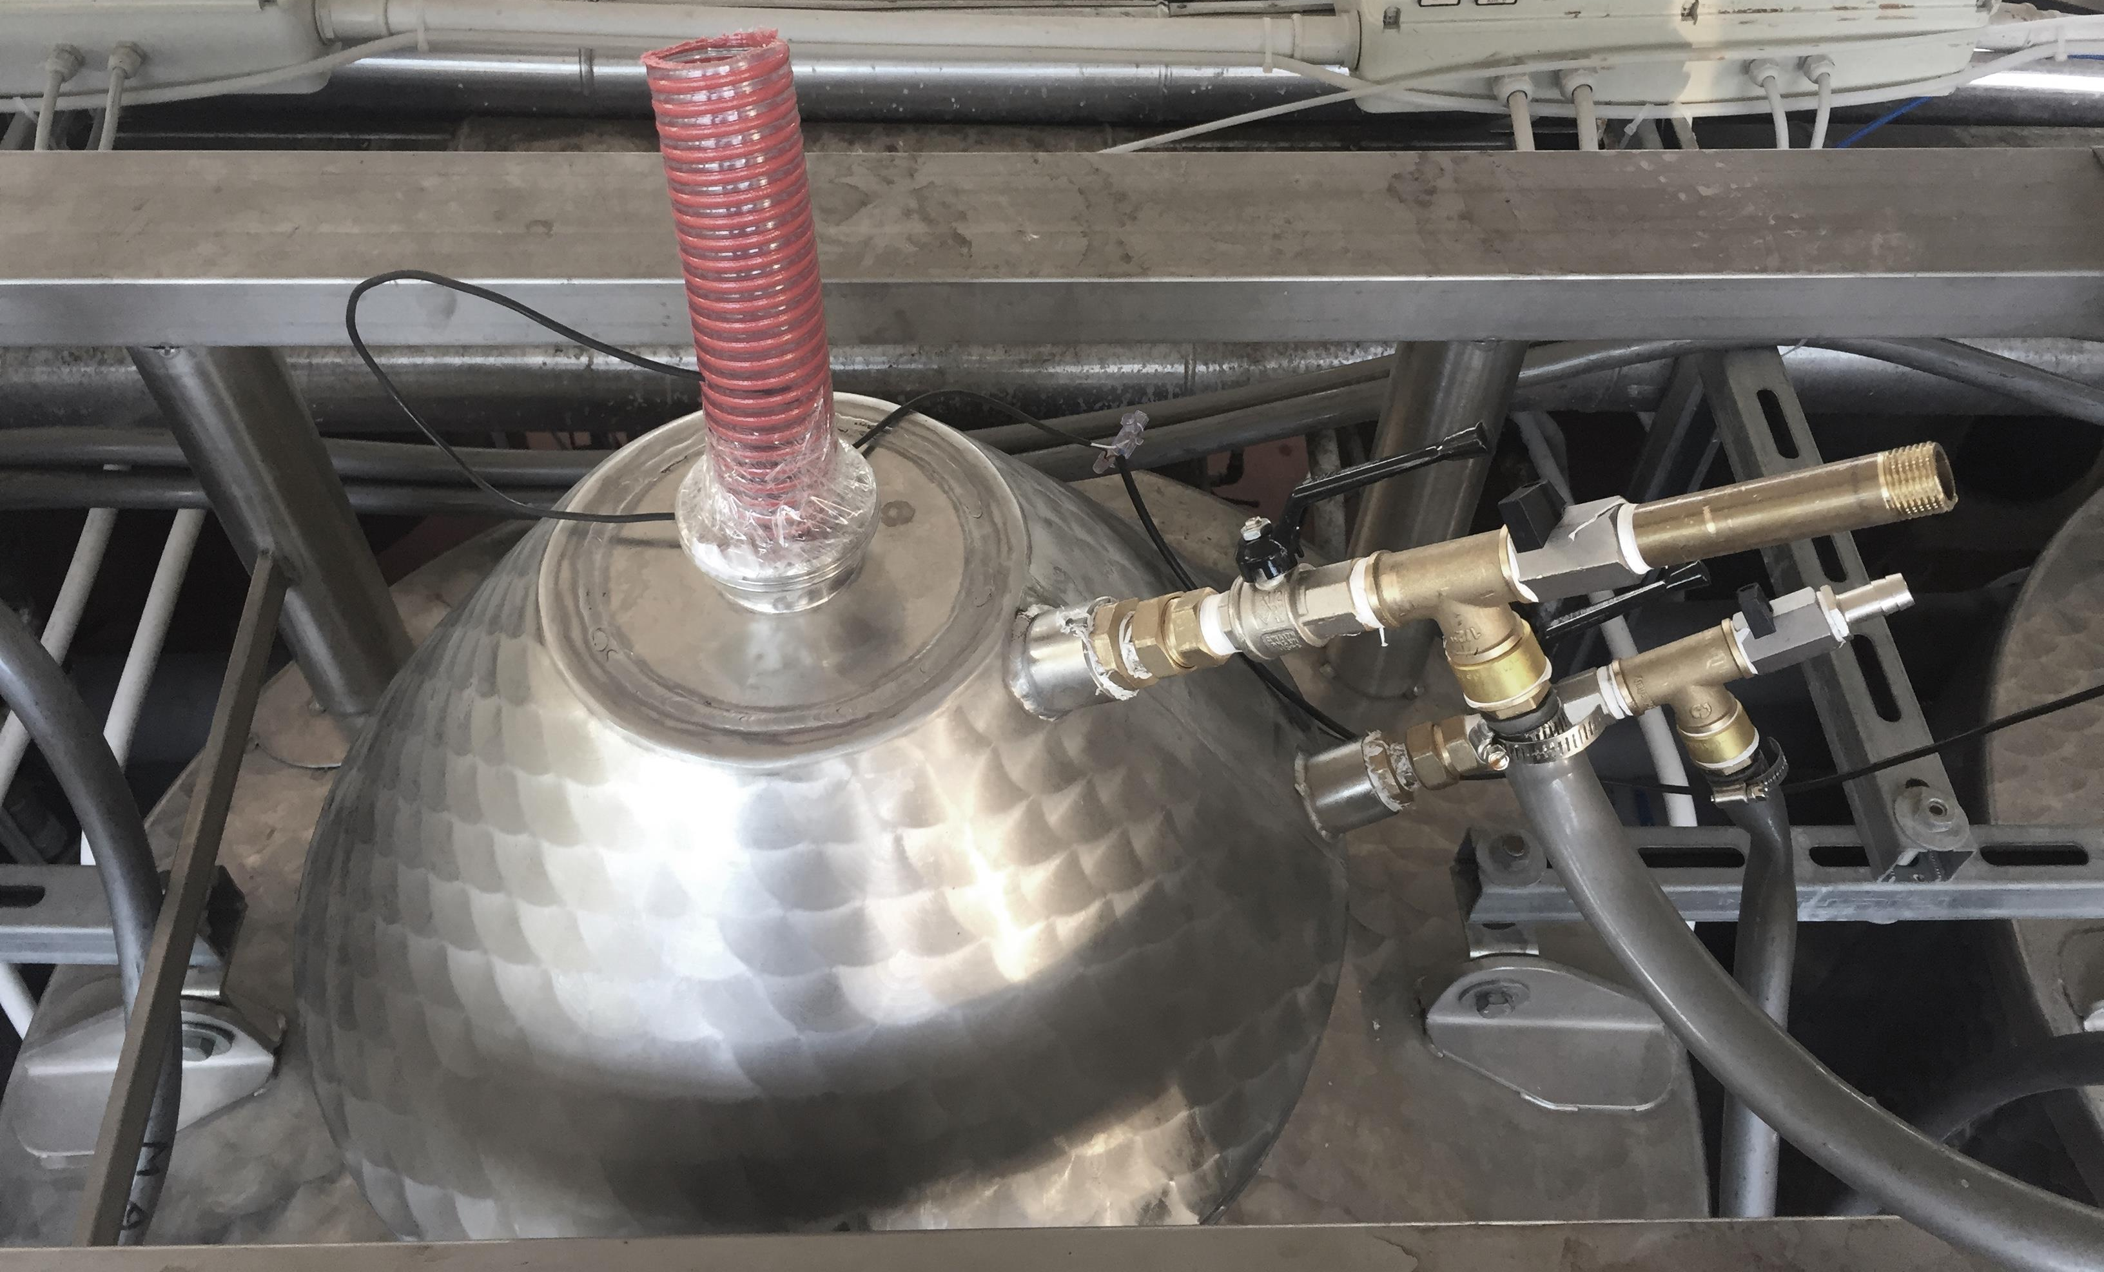
Figure 1: Condensation system above a fermentation tank.

Each fermentation tank was filled with 540 kg of grapes. During the trials Sangiovese, Cabernet Sauvignon, and Merlot grapes were used for a total of 6 fermentations (i.e. 3 Control and 3 Condensed). The musts were inoculated with 20 g/ 100 kg of grapes of a commercial yeast (Red Fruit, Enartis, Italy), and 10 g/100 kg of grapes of potassium metabisulphite were added. During the fermentations, the temperature all tanks were controlled at 32 °C, while in the Condensed samples, the condensed temperature was fixed to 5 °C. The cooling fluid was propylene glycol. Two pump-overs every day, of 5 min each were done to all tanks.
The obtained wines were stored for 11 months in 100 l stainless steel tanks. The head space of the tanks was blanketed with nitrogen to avoid oxidations. Analyses were done immediately after the fermentations, after 6 months, and after 11 months of storage.
2.2 Chemical analyses
Wines were measured for total ethanol content (OIV-MA-AS312-01A R2016 method), pH, total acidity (OIV-MA-AS313-15 R2011), volatile acidity (OIV-MA-AS313-02 R2015), free and total sulphur dioxide (OIV-MA-AS323-04B R2009), residual sugars (OIV-MA-AS311-02 R2009). Furthermore, wines were measured for volatiles using the HS-SPME-GC-MS method described in Domizio et al. (2018).
2.3 Sensory analyses
The differences between the Condensed and the Control samples for each grape cultivar were assessed using a triangular test (UNI 0590 A2520 2001).
2.4 Statistical analysis
Data were treated with a two way ANOVA considering the condensation treatment (2 levels, Condensed and Control) and the storage time (3 levels, 0-6-11 months) as independent variables. The grape cultivar has been used as random variable in the final mixed effect model as described in Pinero and Bates (2000). Data was tested for the two main effects and for their interaction. When p<0.05 a Tukey HSD post-hoc test was used.

3. Results and discussion
Immediately after the production, no significant difference was found in wines for total ethanol, pH, total acidity, volatile acidity, free and total sulphur dioxide, and residual sugars (Table 1).
Table 1: mean and standard deviation of wine parameters immediately after the production. Ns=not significant
Parameter | Condensed | Control | p | Condensed/Control ratio
Ethanol (%w/w) | 14.0 (1.1) | 14.1 (1.1) | ns | 0.99
pH | 3.2 (0.1) | 3.2 (0.2) | ns | 0.98
Total acidity (g/l) | 6.4 (0.3) | 6.3 (0.8) | ns | 1.01
Volatile acidity (g/l) | 0.6 (0.1) | 0.5 (0.1) | ns | 1.11
Free SO₂ (mg/l) | 10.7 (8.1) | 10.0 (8.9) | ns | 1.07
Total SO₂ (mg/l) | 82.3 (19.5) | 79.7 (19.9) | ns | 1.03
Residual sugars (g/l) | 0.6 (0.5) | 0.5 (0.2) | ns | 1.29

During the wine storage, no significant difference in the above reported parameters was found (data not shown). Thus, the condensation treatment has not influenced these parameters.
The volatile profile has been analyzed for 18 compounds considered important on the basis of the previous works (Guerrini et al., 2016 and 2018b). Among these, 7 increased significantly in the Condensed samples, while no compound was found at higher concentration in the control.
Table 2: mean and standard deviation of selected wine volatile compounds immediately after the production. Ns=not significant, * = p < 0.05, ** = p < 0.01, *** = p < 0.001.
Compound (mg/kg) | Condensed | Control | p | Condensed/Control ratio
Acetic acid hexil ester | 0.06 (0.02) | 0.05 (0.02) | * | 1.18
Ethyl octanoate | 19.07 (13.33) | 16.58 (9.78) | * | 1.15
Ethyl hexanoate | 3.41 (0.31) | 3.00 (0.45) | * | 1.14
Ethyl acetate | 66.19 (19.68) | 59.05 (14.26) | * | 1.12
Propanol | 26.95 (5.93) | 22.30 (3.55) | *** | 1.21
Hexanol | 1.37 (0.37) | 1.17 (0.25) | ** | 1.17
Hexanoic acid | 2.18 (0.23) | 1.79 (0.23) | *** | 1.22
The volatile concentration immediately after the wine production is reported in Table 2. The concentration of four esters, namely acetic acid hexyl ester, ethyl octanoate, ethyl hexanoate, and ethyl acetate, were found to be significantly increased by the condensation. These compounds can be considered positive for the wine flavor since they are usually related to fresh, sweet, and fruity flavors (the good scent company database).
Two alcohols (i.e. propanol and hexanol) were found at significant higher concentrations in Condensed wines than in the Control. As well as the above discussed esters, both these alcohols are related to fruity flavors. Thus, the recovered alcohols and esters can enhance the fruity flavor of the tested wines. Finally, the hexanoic acid was higher in Condensed samples than in the Control. Hexanoic acid is related to the “cheese” flavor and its occurrence in wines at higher concentrations can be considered negative for the wine flavor.
Being the difference measured with the chemical analysis small (the ratios between Condenser and Control ranged from 1.12 to 1.21) we performed a panel test to understand if they can be perceived by wine tasters. Immediately after the wines production, tasters were able to found the difference in Sangiovese and in Merlot (p<0.05), while in Cabernet Sauvignon Condenser and Control were perceived as equal.
Table 3 reports the ANOVA results for the volatile compounds. First of all, the interactions between the treatment and the storage time were not significant. Thus, the changes in chemical composition due to the condensation treatment are stable during the wine aging. The difference in the volatile profile found immediately after the wine production can be find after 18 months of storage.
Table 3: Two-way ANOVA results. Ns=not significant, * = p < 0.05, ** = p < 0.01, *** = p < 0.001.
Compound | p Condensation | p storage time | p interaction
Ethyl acetate | * | *** | ns
1-propanol | *** | ns | ns
Ethyl octanoate | * | *** | ns
Ethyl hexanoate | * | ns | ns
Acetic acid hexyl ester | * | ** | ns
1-hexanol | ** | ns | ns
Hexanoic acid | ** | * | ns

Compounds with statistically significant difference in storage time describe the evolution of all the tested wines. The compounds with significant changes in both treatment and storage time are reported in Figure 2.
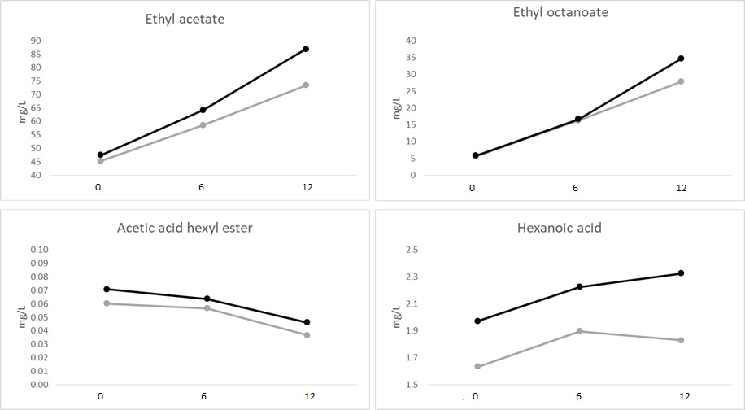
Figure 2: Change in concentrations of volatile compounds. Black lines represent the Condensed theses, while grey lines the Control. On the x-axis the storage time in months is reported.
Ethyl acetate, ethyl octanoate and hexanoic acid increased during the storage time, while the acetic acid hexyl ester decreased. On the other hand, the concentrations of 1-propanol, ethyl hexanoate and1-hexanol are higher in the Condensed wines, but not change during the storage time. These changes during the first year of wine aging are well documented in literature (Riberau Gayon et al., 2006).
After 12 months of storage, all the 3 varieties were perceived as different by the panel test (p < 0.05), confirming that the difference perceived by tasters immediately after the wine production are stable during the wine aging and can be detected after 1 year.
4. Conclusions
The condensation devices placed on the top of the fermenter were able to recover some of the volatile compounds escaping from the tanks during the alcoholic fermentation. The recovered compounds are mainly yeasts metabolites related to the secondary aroma of wines, and particularly to the fruity flavour. The differences were perceived immediately after the wines production. Both the chromatographic analysis and the panel test were able to detect the differences. During the wine aging, the differences in volatile concentrations remain stable for 12 months. In fact, after the storage there were detectable with both chromatography and sensory analyses. Hence, the recovery of volatile compounds during the alcoholic fermentation can be considered a valuable tool to change the wine aroma profile.
Acknowledgments
The authors want to thanks the Consorzio Tuscania srl to host the trials and the Trecieffe Company to make the condensers.

References
Bach H. P., 2001, Recovery of fermentation aromas. Australian Journal of Grapegrower and Winemaker, 454, 73-78.
Domizio, P., Lencioni, L., Calamai, L., Portaro, L., Bisson, L. (2018). Evaluation of the Yeast Schizosaccharomyces japonicus for Use in Wine Production. Am. J. Enol. Vitic 1–37.
Gonzalez R., Morales P., 2017, Wine secondary aroma: understanding yeast production of higher alcohols. Microbial Biotechnology, 10, 1449-1450.
Guerrini, L., Masella, P., Spugnoli, P., Spinelli, S., Calamai, L., Parenti, A., 2016, A Condenser to Recover Organic Volatile Compounds during Vinification. American Journal of Enology and Viticulture 67, 163–168.
Guerrini, L., Angeloni, G., Baldi, F., Parenti, A., 2017a, Thermal effects of pump-overs during red wine fermentation. Applied Thermal Engineering, 112, 621–626.
Guerrini, L., Masella, P., Angeloni, G., Cini, E., Parenti, A., 2017b, A Device for the Monitoring of the Cap Buoyancy during the Red Grapes Fermentation. Chemical Engineering Transactions, 58, 427-432.
Guerrini, L., Masella, P., Angeloni, G., Calamai, L., Spinelli, S., Di Blasi, S., Parenti, A., 2018a, Harvest of Sangiovese grapes: the influence of material other than grape and unripe berries on wine quality. European Food Research and Technology, 244, 1487-1496.
Guerrini, L., Angeloni, G., Masella, P., Calamai, L., Parenti, A., 2018b, A Technological Solution to Modulate the Aroma Profile during Beer Fermentation. Food and Bioprocess Technology, 11, 1487 - 1496.
Lezaeta, A., Bordeu, E., Agosin, E., Pérez-Correa, J. R., Varela, P., 2018, White wines aroma recovery and enrichment: Sensory-led aroma selection and consumer perception. Food Research International 108, 595–603.
Moreno, J. J., Cerpa-Calderón, F., Cohen, S. D., Fang, Y., Qian, M., Kennedy, J. A., 2008, Effect of postharvest dehydration on the composition of pinot noir grapes (Vitis vinifera L.) and wine. Food Chemistry, 109, 755–762.
Mouret J. R., Perez M., Angenieux M., Nicolle P., Farines V., Sablayrolles J. M., 2014, Online-based kinetic analysis of higher alcohol and ester synthesis during winemaking fermentations. Food and Bioprocess Technology, 7, 1235-1245.
OIV-MA-AS312-01A R2016 Compendium of International methods of wine and must analysis. Alcoholic strength by volume (pycnometry, frequency oscillator, hydrostatic balance).
OIV-MA-AS323-04B Compendium of international method of analysis. Method for sulfur dioxide determination. Resolution Oeno 377 2009.
OIV-MA-AS313-02 Compendium of international method of analysis. Method OIV-MA-AS313-02 for volatile acidity determination. Resolution Oeno 377 2009.
OIV-MA-AS313-15 R2011 Compendium of international method of analysis. Method for total acidity determination.
OIV-MA-AS311-02 R2009 Compendium of international method of analysis. Method for reducing sugar determination.
Pinero, J., Bates, D. (2000). Mixed-effects models in S and S-PLUS (statistics and computing).
Ribâereau-Gayon P, Glories Y, Maujean A. Handbook of Enology: The Chemistry of Wine: Stabilization and Treatments. John Wiley & Sons 2006.
Styger, G., Prior, B., Bauer, F. F., 2011, Wine flavor and aroma. Journal of industrial microbiology & biotechnology, 38, 1145.
Torrens J., Urpí P., Riu-Aumatell M., Vichi S., López-Tamames E., Buxaderas S., 2008, Different commercial yeast strains affecting the volatile and sensory profile of cava base wine. International Journal of Food Microbiology, 124, 48-57.
UNI U590A2520. 2001. Analisi Sensoriale. Metodo Triangolare. [Regulation in Italian]. Italian Unification Institute ed., Milano, Italy.

