|  |  |
| --- | --- |
| cetlogo ***CHEMICAL ENGINEERING TRANSACTIONS***  ***VOL. 76, 2019*** | A publication of  aidiclogo_grande |
| The Italian Association  of Chemical Engineering  Online at www.cetjournal.it |
| Guest Editors: Sauro Pierucci, Jiří Jaromír Klemeš, Laura Piazza  Copyright © 2019, AIDIC Servizi S.r.l. **ISBN** 978-88-95608-73-0; **ISSN** 2283-9216 | |

Use of Ultrasound and Pulsed Electric Fields Technologies Applied to the Olive Oil Extraction Process

Roberto Romanielloa, Antonia Tamborrinob, Alessandro Leonea

aDepartment of the Science of Agriculture, Food and Environment, University of Foggia, Via Napoli, 25, 71122, Foggia, Italy

bDepartment of Agricultural and Environmental Science, University of Bari Aldo Moro, Via Amendola 165/A, 70126, Bari, Italy

roberto.romaniello@unifg.it

In this work, ultrasound (US) and pulsed electric fields (PEF) were tested in an industrial olive oil mill. Olives of the cultivar Coratina were processed in a comparative mode, between a traditional process and an innovative process (involving US and PEF).

The use of US in addition to the traditional malaxation process led to a significant improvement in extraction yield. PEF also showed a positive effect on extraction yield.

The experiments showed the ability of US and PEF to modify the medium, with a consequent increase in the release of oil from cellular vacuoles. The results suggest that research should continue in this direction, by planning other several tests to optimise the machines’ functionality to improve the whole olive oil extraction process.

* 1. Introduction

An important parameter in the oil extraction process, alongside oil quality, is oil yield.

Generally, using the current technologies and despite continuous innovations, the extractability ranges between 80%–90%, as part of the oil is lost into the pomace and waste water, i.e. approximately 10%–20% Altieri et al. (2013) performed tests on a decanter modifying the discharge levels of oil and water to optimize the extractability. Tamborrino et al. (2015) studied the influence of the differential rotation between bowl and screw of a decanter on the extractability. Other studies were performed to assess the influence of the crushing phase on the olive oil extraction, in the way to improve the yield and quality of oil (Leone et al., 2015).

To reduce oil loss in by-products, recently, several studies on the extra virgin olive oil (EVOO) extraction process have focused on treatment of olive paste by mild physical technologies, such as low-frequency US, high-frequency US, and PEF, to achieve a positive impact on the extractability of the decanter.

Low-frequency US was proposed for olive paste conditioning (Jimenez et al., 2006; Jimenez et al., 2007). The authors observed that the oil quality parameters were not affected, and that there was an improvement of the oil extractability.

Bejaoui et al., 2016 and Bejaoui et al., 2017 demonstrated that a sonication treatment improved the oil yield, and did not cause alteration of oil quality indexes or volatile compounds.

The application of high-frequency US has been studied in Juliano et al. (2017a). In (Juliano et al. 2017b), a megasonic prototype was installed in a small olive oil extraction plant to treat a conditioned paste post-malaxation, working at 300 kg h-1. The extractability value increased up to 1.7%.

Guderjan, Töpfl, Angersbach, and Knorr (2005) studied the application of a PEF to assist in olive oil extraction, working at a laboratorial scale to perform preliminary tests on the potential of this system, and increased the oil extraction yield to 7.4%.

Abenoza et al. (2013) remarked on the potential of a PEF on the olive oil extraction yield and oil quality, using a laboratory-scale olive oil extraction system.

Recently, Puértolas et al. (2015) asserted that PEF technology yielded an additional 2.66 kg of olive oil per 100 kg of processed olives, improving the oil extraction yield by 13.3%, with respect to a control experiment. In parallel, studies on qualitative aspects of olive oil were carried out, considering different points of view. Giovenzana et al. (2015) studied a system based on Vis/nir technology to assess the olive quality in continuous mode before the processing. Caleca et al. (2017) investigated on a quality limits of the olive oil produced by olives attacked by Bactrocera Olivae.

The aim of this study regards the introduction of US and PEF technologies in an industrial olive oil mechanical extraction plant, and the evaluation of their influence on the yield and rheological characteristics of olive paste.

* 1. Materials and Methods

For the experiment, plain olives of the Coratina cultivar were used. The olives were mechanically harvested near Foggia in the Puglia region. A maturity index (MI) was determined according to the method by Uceda et al. in 1975, based on a skin colour evaluation. The MI of the olives used for the US trials was 2.8, and the MI used for the PEF trials was 2.6. The olives were processed in an industrial extraction plant constituted by a leaf removing machine, washing machine, partial destoner machine (mod. Moliden; Pietro Leone e Figli s.n.c., Foggia, Italy), a group of six open malaxers, a 3-phase decanter (mod. NX X32; Alfa Laval Corporate AB), and two vertical plate centrifuges (mod. UVPX 507; Alfa Laval Corporate AB). To this standard configuration, two innovative machines were added in the process: a) a low-frequency US machine; and b) a PEF machine. These machines were placed between the partial destoner machine and the malaxers, working alternately from one another.

* + 1. Specifications of the ultrasound (US) machine

The US machine used for the experiments was developed by Hielscher Ultrasonics GmbH (Teltow, Germany). A stainless-steel cabinet encloses the system, which comprises a power supply, a US generator, and a transducer (CascatrodeTM Hielscher Ultrasonics GmbH) having a titanium tip connected to it. The generator and transducer were placed vertically in a stainless-steel tube, which the olive paste also moves through (Fig. 1). The total power applied to the system was 4 kW. A programmable logic controller (PLC) controlled all of the machine’s parameters: pressure, temperature, frequency, and amplitude. The latter can be set from 60 to 100 %, corresponding to 18 and 30 μm, by acting on the touch screen of the PLC (Fig. 2). During the trials, the amplitude value was set to 100%. The pressure value was set to approximately 3.1 bar. A pneumatic valve placed at the outlet of the US machine controlled the pressure value in a CascatrodeTM cell.

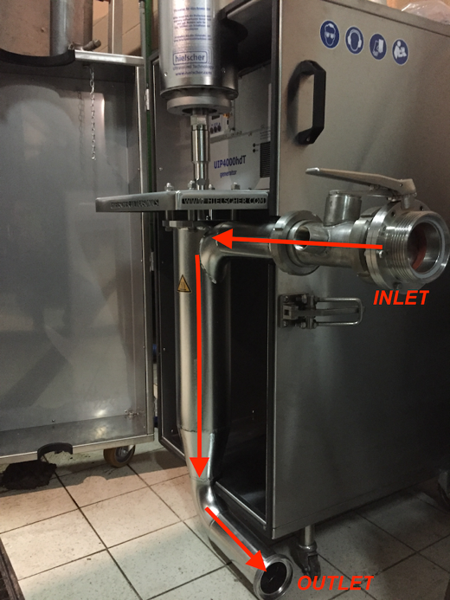

Figure 1: Ultrasound (US) machine, detail of cell flow, US probe and flow direction.

* + 1. Specifications of the pulsed electric field (PEF) machine.

The PEF machine was an industrial prototype version, developed by KEA-TEC Gmbh (Fig. 3). The cell was composed of a tube in which an electrode was placed. The olive paste passed through the tube, and was subjected to the PEF. The parameters of PEF machine were:

Electric power: 0.2 kJ/pulse x 25 Hz = 5 kJ/sec = 5 kW;

pulse duration (50 %): 100 µsec;

pulse voltage: 16 kV (max.);

Pulse power: 2.3 MW; and

Nominal mass flow rate: 2200 kg h-1.

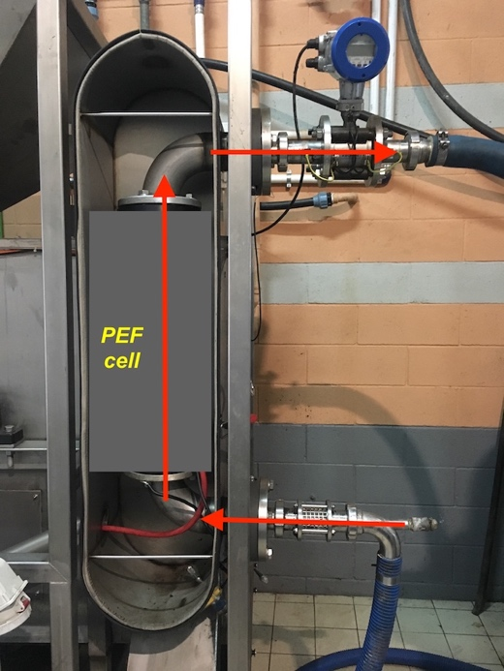

*Figure 2: Details of the pulsed electric field (PEF) cell and flow direction*

* + 1. Rheological determinations

The olive paste samples, obtained using two different crushing machines, were subjected to rheological analysis through a Brookfield rotational remoter model DV2-HBT (Brookfield Engineering Laboratories, INC, Stoughton, MA, USA) equipped with interchangeable disc spindles, 2–7 (model RV/HA/HB; Brookfield DVII + Brookfield Engineering laboratories).

Three replicate trials were performed for each sample.

* + 1. Quantitative index determinations

The oil content in the processed olives was determined by taking aliquots of olive paste from each olive batch.

The oil extractability (*E*) was calculated using the following equation:

 (1)

In the above, Woil is the mass of the extracted oil (kg), and Wtotal oil is the oil mass present in the processed olive batch (kg).

**2.5. Experimental design**

Each trial was replicated four times, using a homogenous olive batch divided into different sub-batches of 600 kg each. The trials were denoted as follows:

Control: olive oil extraction using the traditional technology;

US: olive oil extraction using low-frequency US treatment after olive crushing, followed by the traditional operations; and

PEF: olive oil extraction using PEF treatment after olive crushing, followed by the traditional operations.

An equal number of trials were executed for the control test and US/PEF treatments.

The process parameters for each test were: (1) malaxation time = 30 min; (2) malaxation temperature = 27 °C;  (3) plant mass flow rate = 2200 kg h-1; and (4) water added to the decanter = 10 % of the processed olives’ weight.

2.6. Statistical analysis

Statistical analysis was performed using the statistical toolbox of Matlab (The Matworks inc., MA, USA). ANOVA and Tuckey test was used to determine the significance in difference between groups of experimental data at *p*<0.05.

* 1. Results and Discussion

Prior to the experimental test, the machine was tested to understand its behaviour during olive paste processing. The electric power resulted in stability over time, including in the pressure around the CascatrodeTM. This confirms that the US machine used herein fits perfectly in an industrial extraction line.

The mean electric power adsorbed by the generator was approximately 4.0 kW, relative to an operative pressure of 3.1 bar. The US treatments showed significant differences in terms of extraction yield (Y) and E (Tab. 1) with respect to the control test. This confirms the positive effect of the low-frequency US on the olive pastes as reported in Taticchi et al. 2019 where the impact of a high-power ultrasound technology on the oil quality and yield were studied using olives at three different ripening stages. At the same maturity index ultrasound system showed an increase of the same level of yield. This result is also in accordance with Bejaoui et al. (2016). In addition, the use of the CascatrodeTM permitted a homogeneous contact with the olive paste, and represents a good solution for US treatments.

Tab. 1 Mean quantitative data of the experimental tests

|  |  |  |  |  |
| --- | --- | --- | --- | --- |
| Treatment | Y (%) | | E (%) | |
|  | Control | Treatment | Control | Treatment |
| US | 10.11 ± 0.19 *b* | 10.65 ± 0.45 *a* | 82.98 ± 0.41 *b* | 86.52 ± 0.98 *a* |
| PEF | 8.20 ± 0.14 *b* | 8.58 ± 0.10 *a* | 78.38 ± 1.54 *b* | 82.09 ± 1.98 *a* |

*Different letters in the row, for each of the two parameters Y and E, denote statistically significant differences at p<0.05*

As in the US trials, PEF technology was applied in addition to the standard technology. Using the PEF technology, resulted in significant differences in Y and E from those obtained by the traditional process. The comparison of the two sets of data (control and PEF) showed a lower standard deviation in the Y and E measurements, evidencing the effectiveness of the differences between the PEF-treated pastes and traditional pastes. These results confirm as reported in Puértolas et al. 2018 where the authors found that pulsed electric field technology yielded an additional 2.66 kg of olive oil per 100 kg of processed olives, improving the oil extraction yield by 13.3 %, respect to the control.

This confirms that the mechanical waves and electric pulses provided by US and PEF, respectively, have a positive effect on olive paste, permitting an increase in the oil released from vacuoles.

In Fig. 4, the apparent viscosities of the olive pastes obtained after the treatment with the two different technologies, as compared to the control, are shown. The apparent viscosity shows a similar trend for the crushed olive paste (control) and the pastes after the US and PEF treatments. As shown in Fig. 4, although the trend of apparent viscosity of US- and PEF-treated pastes resulted in a lower value than the value of non-treated olive paste, the values didn’t show statistical differences at p<0.05. This probably caused by the small amount of time for treatment (approximately 3 sec).



Figure 3: Effect of shear rate on apparent viscosity, plotted in log–log scale, for the two trials (US and PEF), as compared with non-treated olive paste. Different letters denote significant differences (analysis of variance (ANOVA) and honestly significant difference (HSD) test, p < 0.05).

This confirms that the mechanical waves and electric pulses provided by US and PEF respectively have a positive effect on olive paste, permitting an increased oil released from vacuoles.

Finally, the application of ultrasounds with a linear probe system (CascatrodeTM) placed in a flow cell, permitted a homogeneous contact with the olive paste, and represents a good solution for US treatments.

* 1. Conclusions

This research concerned the evaluation of high-power US and PEF technology applied to the virgin olive oil extraction process to increase plant efficiency. Both technologies showed good capabilities for integration in an industrial extraction plant proving very reliable in use.

The use of US system before malaxation permitted a significant improvement in the oil extractability of 3.57 % and an increase of the yield of 0.54%. When PEF system was used before the malaxation an increase of the extractability of 3.71% and yield of 0.38% were shown.

Rheology analysis although shows a slight decrease in viscosity when both US and PEF were used. No significant differences were found, probably due to the low residence time of the paste into the flow cell.

The result confirms the feasibility on introducing US and PEF technology for olive oil extraction. In addition, these conclusions give useful information about further improvements of the tested machine to meet the needs of millers, mainly in terms of mass flow rate.

Further studies will be carried out to validate the present results and to assess the use of these innovative technologies considering olives of different cultivars harvested at different maturity indexes.

References

Abenoza, M., Benito, M., Saldaña, G., Álvarez, I., Raso, J., & Sánchez-Gimeno, A. C., 2013, Effects of pulsed electric field on yield extraction and quality of olive oil. Food and Bioprocess Technology, 6, 1367–1373.

Balieiro A.L., Osorio N.M., Silva Lima A., Soares C.M.F., Valero F., Ferreira-Dias S., 2018, Production Of Dietetic Triacylglycerols From Olive Oil Catalyzed By Immobilized Heterologous Rhizopus Oryzae Lipase. Chemical Engineerin Transactions, 64, 385-390.

Bejaoui, M.A., Beltran, G., Aguilera, M.P., Jimenez, A., 2016, Continuous conditioning of olive paste by high power ultrasounds: response surface methodology to predict temperature and its effect on oil yield and virgin olive oil characteristics. LWT - Food Sci. Technol. 69, 175–184.

Caleca, V., Antista, G., Campisia, G., Caruso, T., Lo Verde, G., Maltesea, M., Rizzo, R., Planeta, D. High Quality Extra Virgin Olive Oil from Olives Attacked by the Olive Fruit Fly, Bactrocera Oleae (Rossi) (Diptera Tephritidae): Which Is the Tolerable Limit? Data from Experimental ‘Nocellara Del Belice’ and ‘Cerasuola’ Olive Groves in Sicily. Chemical Engineering Transactions, 58, 451-456.

Altieri, G., Di Renzo, G. C., & Genovese, F., 2013, Horizontal centrifuge with screw conveyor (decanter): Optimization of oil/water levels and differential speed during olive oil extraction. Journal of Food Engineering, 119(3), 561-572.

Giovenzana V., Beghi R., Civelli R., Marai S., Guidetti R., 2015, Postharvest Characterization of Olive Oil Fruits Texture by Nir and Vis/nir Spectroscopy. Chemical Engineerin Transactions, 64, 385-390.

Guderjan, M., Töpfl, S., Angersbach, A., & Knorr, D., 2005, Impact of pulsed electric field treatment on the recovery and quality of plant oils. Journal of Food Engineering, 67, 281–287.

Jimenez, A., Beltran, G., Uceda, M., & Aguilera, M. P, 2006, Empleo de ultrasonidos de potencia en el proceso de elaboracio n del aceite de oliva virgen, Resultados a nivel de planta de laboratorio. Grasas y Aceites, 57(3), 253-259.

Jimenez, A., Beltran, G., & Uceda, M., 2007, High-power ultrasound in olive paste treatment: Effect on process yield and virgin olive oil characteristics. Ultrasonics Sonochemistry, 14(6), 725-731.

Juliano, P., Augustin, M.A., Mawson, R., Xu, X-Q, Knoerzer, K., 2017a, Advances in high frequency ultrasound separation of particulates from biomass. Ultrasonics Sonochemistry, 577-590.

Juliano, P., Bainczyk, F., Swiergon, P., Supriyatna, M.I.M., Guillaume, C., Ravetti, L., Canamasas, P., Cravotto, G., Xu, X., 2017b, Extraction of olive oil assisted by high-frequency ultrasound standing waves. Ultrasonics Sonochemistry, In press.

Leone, A., Romaniello, R., Zagaria, R., Sabella, E., De Bellis, L. & Tamborrino, A., 2015, Machining effects of different mechanical crushers on pit particle size and oil drop distribution in olive paste. European Journal of Lipid Science and Technology*,* 117, 8, 1271-1279.

Puértolas, E., Martínez de Marañón, I., 2015, Olive oil pilot-production assisted by pulsed electric field: Impact on extraction yield, chemical parameters and sensory properties. Food Chemistry,167, 497-502.

Tamborrino, A., Leone, A., Romaniello, R., Catalano, P., Bianchi, B., 2015, Comparative experiments to assess the performance of an innovative horizontal centrifuge working in a continuous olive oil plant. Biosystems Engineering, 129, 160–168.

Tamborrino, A., Squeo, G., Leone, A., Paradiso, V.M., Romaniello, R., Summo, C., Pasqualone, A., Catalano, P., Bianchi, B. & Caponio, F. 2017, Industrial trials on coadjuvants in olive oil extraction process: Effect on rheological properties, energy consumption, oil yield and olive oil characteristics. Journal of Food Engineering, 205, 34-46.

Taticchi, A., Selvaggini, R., Esposto, S., Sordini, B., Veneziani, G., Servili, M., 2019, Physicochemical characterization of virgin olive oil obtained using an ultrasound-assisted extraction at an industrial scale: Influence of olive maturity index and malaxation time. Food Chemistry, 289, 7-15.

Uceda, M., Frias, L., 1975, Harvest dates: evaluation of the fruit oil content, oil composition and oil quality, In Proceedings of the Second International Meeting of Olives Oil, Cordoba, 125-128.