CHEMICAL ENGINEERING TRANSACTIONS  VOL. 76, 2019 | A publication of
The Italian Association
of Chemical Engineering
Online at www.aidic.it/cet
Guest Editors: Sauro Pierucci, Jiří Jaromír Klemeš, Laura Piazza
Copyright © 2019, AIDIC Servizi S.r.l.
ISBN 978-88-95608-73-0; ISSN 2283-9216

Bioactive and Biodegradable Film Packaging Incorporated with Acca sellowiana Extracts: Physicochemical and Antioxidant Characterization
William G. Sganzerla¹*, Bruna B. Paes¹, Mônia S. Azevedo¹, Jocleita P. Ferrareze¹, Cleonice G. da Rosa², Michael R. Nunes¹, Ana P. L. Veeck¹
¹ Federal Institute of Education, Science and Technology of Santa Catarina – IFSC, Lages, Brazil.
² University of Planalto Catarinense – UNIPLAC, Lages, Brazil.
sganzerla.william@gmail.com
In this work a new biodegradable film was developed, and bioactive compounds from Acca sellowiana were incorporated. Film packaging production was carried out from an aqueous filmogenic solution, with a blend of Brazilian pine seeds starch, citric pectin, glycerol and aqueous extract from pulp and husk of Acca sellowiana. In all the films produced were evaluated the physicochemical and antioxidant properties. The films produced presented lower moisture content, and extracts from pulp and husk affect the moisture content and the water solubility of the films. Evaluating the light transmittance, films with husk extract addition presented (p<0.05) a reduction of luminosity and an increase of opacity. Films produced with husk extract presented a higher content of total phenolic and flavonoids compounds, and this fact promoted a high antioxidant activity by DPPH, ABTS and FRAP assay. Bioactive and biodegradable films produced with Brazilian pine seed starch, citric pectin and Acca sellowiana extracts presented good physicochemical and antioxidant parameters, and may be an alternative to packaging in food systems.
  - Introduction
The food industry constant needs innovative packages to reduce the use of non-biodegradable plastics in the environment (Allen et al., 2004; Arquelau et al., 2019). Although, to maintain the food quality, extensive researches have been developing to discover a new natural antioxidant, which promote food benefits (Veeck et al., 2013). An active food packaging maintains the food safety by the use of antioxidant compounds, because phenolic compounds, flavonoids and carotenoids present a high applicability to increase the shelf life of perishable food, as natural additives. In general, bioactive and biodegradable plastics are the future of the food industry to maintain the food quality.
Several materials can be used to produce biodegradable polymers, such as natural polysaccharides (Eça et al., 2015), starch (Fidelis et al., 2017; Takahashi et al., 2017; Arquelau et al., 2019), chitosan (Yong et al., 2019), methylcellulose (Nunes et al., 2018) and others. Bioplastics properties are determined mainly by the type of the material applied in the production, time of heating and the use of plasticizers (Yong et al., 2019). However, the food industry needs a polymer that presents satisfactory properties as a low gas barrier, suitable color, good appearance, high mechanical and antioxidant properties, because the material applicability in a food matrix depends directly by their properties (Arquelau et al., 2019).
Antioxidant compounds from plants are a new alternative to create bioactive food packaging. Acca sellowiana (O. Berg) Burret (synonym, Feijoa sellowiana), is a native fruit from southern Brazil, and presents a high commercialization spread all over the world (Pasquariello et al., 2015). A genetic improvement was conducted to increase the production and develop new cultivars (Santos et al., 2017). This fruit has a smooth green skin and soft and white flesh. The fruit (feijoa) is sweet and the flavour is very aromatic. The skin is sour and bitter but the feijoa skin can be eaten with the pulp, as the skin balances the sweetness of the pulp (Weston, 2010; Santos et al., 2017). Studies demonstrate that this fruit presents antimicrobial, anticancer, anti-inflammatory and antioxidant properties, but technological studies was not developed with this fruit (Weston, 2010; Pasquariello et al., 2015; Kessin et al., 2018).
Thus, the aim of this work was to develop a new bioactive and biodegradable film packaging, using Brazilian pine seeds starch, citric pectin and antioxidant compounds from Acca sellowiana, and evaluate the physicochemical characteristics and antioxidant properties.
  - Materials and Methods
    - Plant Material
Samples of Acca sellowiana were collected at the species maturation point in Santa Catarina State, Brazil (27°37.12’S; 50°43.12’W; 838 meters of altitude). After the harvest, samples were washed and sanitized using NaClO (2 ppm), and the pulp was manually separated from the husk. Extracts from pulp and husk were carried out using 1 g of Acca sellowiana and 10 mL of deionized water as solvent (1:10 w/v) (Sganzerla et al., 2018a). Brazilian pine seeds were collected in Santa Catarina State, Brazil (28°04.34’S; 49°59.77’W; 1,114 meters of altitude) of Araucaria angustifolia (synonym, Araucaria brasiliensis), and the starch was extracted according to Bello-Pérez et al. (2006).
    - Film Packaging Production
The films were produced from an aqueous filmogenic solution, with Brazilian pine seeds starch (2% w/w), citric pectin (3 % w/w) and glycerol as plasticizer (2 % w/v). All the components were heat (85 °C) under magnetic stirring until starch gelatinization and subsequent formation of a film forming solution. After this, the filmogenic solution was cooled and it was added to a previously prepared aqueous extract (25 % v/v) of pulp and husk of Acca sellowiana. In the control packaging deionized water (25 % v/v) was added. Films were transferred to petri dish and then oven dried at 35 °C for 48 hours to evaporate water, and were then kept in desiccator for subsequent analyses. The films produced were coded as: Film Packaging Control (FPC); Film Packaging with Pulp extract (FPPe); and Film Packaging with Husk extract (FPHe).
    - Film Packaging Characterization
FPC, FPPe and FPHe were characterized by physicochemical and antioxidant parameters. Films thickness (mm) was determined using an electronic paquimeter (COSA 111.101 EB), with 5 random sites in 10 different films. The moisture (%) and water solubility content (%) of the films was determined according to the methodology described by Colla et al. (2016). Films color parameters L* (lightness/brightness), a* (redness/greenness), b* (yellowness/blueness), C* (chroma value) and H° (Hue) values were determined using a digital colorimeter (Delta Color 71421, Delta Vista, Brazil). The transmittance (%) of each film packaging was determined in a spectrophotometer (UV-Vis 752D, Labman, China) using the wavelength in UV and Vis (250, 280, 380, 450, 600 and 750 nm). The opacity was calculated according to Wang et al. (2013) using a wavelength of 380 nm, and expressed as Absorbance unit per millimeter (A mm⁻¹). Brazilian pine seeds starch, citric pectin and the packaging produced were evaluated by Fourier Transform Infrared Spectroscopy (FTIR) (Perkin Elmer FTIR/NIR, Waltham, MA, USA) and Differential Scanning Calorimetry (DSC) (Multi Cell DSC, TA Instrument). Films extracts were prepared according to Siripatrawan & Harte (2010), to quantify the Total Phenolic Compounds (TPC) (Swain & Hillis, 1959), Total Flavonoids Compounds (TFC) (Zhishen et al., 1999), and antioxidant activity by DPPH (Brand-Williams et al., 1995), ABTS (Re et al., 1999) and FRAP assay (Benzie & Strain, 1996). All the methodologies of bioactive compounds and antioxidant activity quantification are described in a previously work published by authors (Sganzerla et al., 2018a).
    - Statistical analysis
All the data of film packaging characterization was analysed by one-way ANOVA, with Tukey’s multiple comparison tests at 95 % confidence level (p<0.05).
  - Results and Discussion
Using a blend of Brazilian pine seeds starch and citric pectin was possible to produce a biodegradable polymer. Extracts from Acca sellowiana (pulp and husk) promoted antioxidant properties to these films, and the appearance of the biopolymer developed in this study can be considered as satisfactory (Figure 1). In general, a food packaging needs a lower thickness and water solubility content, to promote an efficacy on the gas migration. Acca sellowiana extracts addition, did not change (p>0.05) film thickness (Figure 2a), but increased moisture content (Figure 2b) and decreased (p<0.05) water solubility in FPPe and FPHe. The film thickness obtained in this work is similar comparing it to other studies (Colla et al., 2006; Eça et al., 2015), and can be consider to be as close as possible to the ideal value for application. A further favourable property for industrial application of this packaging is the water solubility lowering effect, especially when using feijoa extracts. The solubility decreased from 7.97 % in the FPC, to 4.03 % and 3.55 %, respectively to FPPe and FPHe (Figure 2c). This fact can be explained because some antioxidant compounds present an interaction with the polymer (blend of starch and pectin), preventing their solubilisation in water, and thus promoting a decreasing in the water solubility. However, the addition of the extracts to the blends caused a statistically significant increase of film opacity: FPC presented a lower opacity (6.15 ± 0.67 A mm⁻¹), and has increasing using pulp (FPPe, 11.31 ± 2.22 A mm⁻¹) and husk extract (FPHe, 27.16 ± 4.11 A mm⁻¹) (Figure 2d).
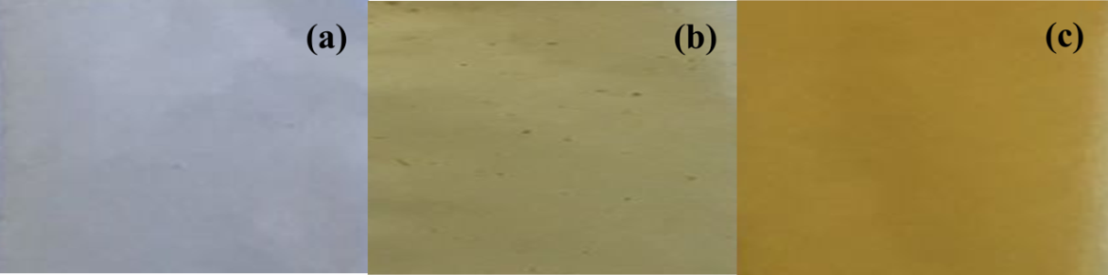
Figure 1: Film packaging appearance produced with Brazilian pine seeds starch, citric pectin and Acca sellowiana extracts; (a) FPC; (b)FPPe; (c) FPHe.
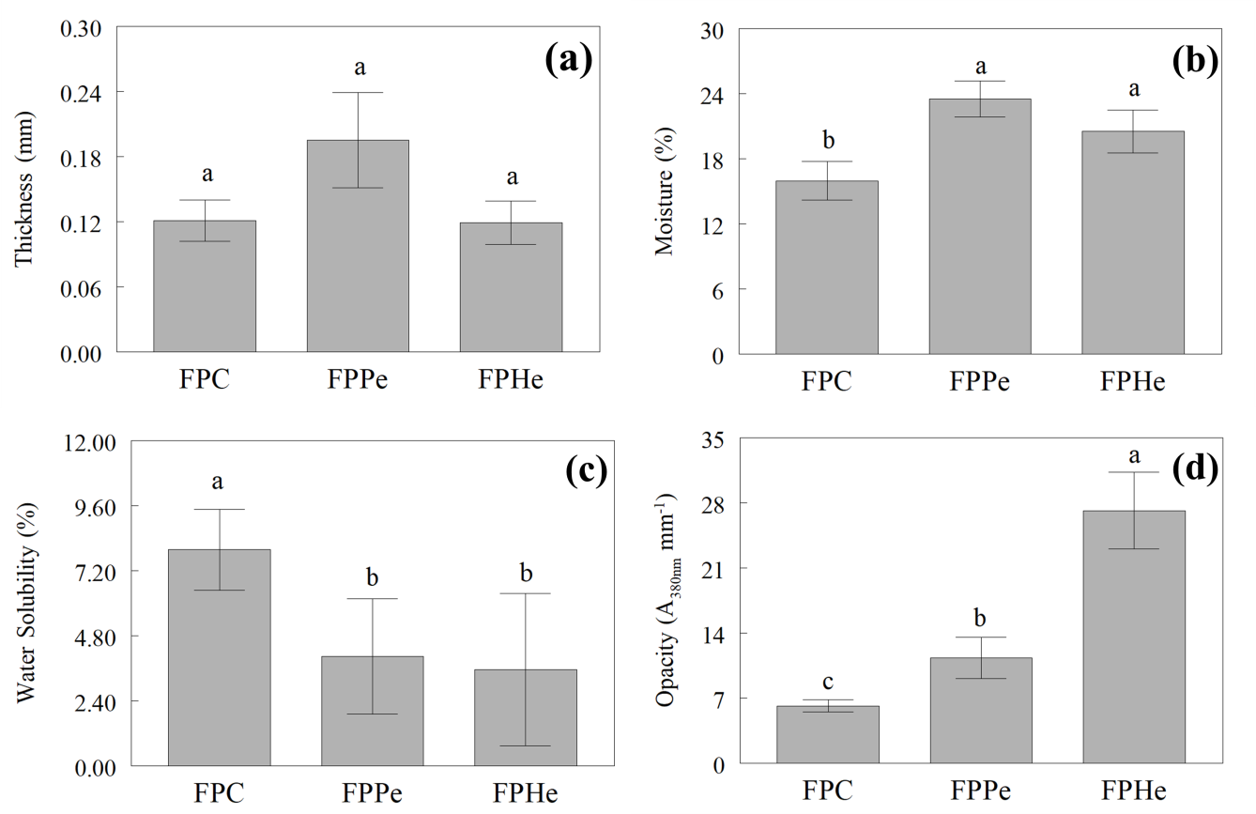
Figure 2: Physicochemical properties of the film packaging produced with Acca sellowiana extracts; (a) Film thickness; (b)Moisture content; (c) Water solubility; (d) Opacity.

Another property that imparts pleasant visual aspect to a food packaging material is light transmittance (Table 1) and its color parameters (Table 2). A statistical difference (p<0.05) was obtained to all analyzed spectral wavenumbers. In the UV region, the bio-polymers produced are able to absorb the energy. An absorbance increase was obtained with FPPe and FPHe, because the presence of double bonds and the cyclic structures of phenolic compounds act as UV light absorbers (Eça et al., 2015). A food packaging that absorb UV light presents a high potential in preservation, because the compounds that promote this characteristic have the potential to protect both the packaging material and its content against photo-oxidation (Allen et al, 2004; Norajit et al., 2010). In the visible region, similar evidence was obtained with regard to UV radiation: packaging transmittance decreased upon addition of feijoa extracts. This finding confirms many earlier reports that evaluated the properties of films with fruits extracts (Eça et al., 2015). Indeed, the clearer appearance of the control packaging (FPC) compared to the packaging with feijoa extract addition (FPPe and FPHe) is easily notice (Figure 1).
Table 1: Light transmittance of the film packaging produced with Acca sellowiana extracts.
Parameters | Light Transmittance (%)
 | 250 nm | 280 nm | 380 nm | 450 nm | 600 nm | 750 nm
FPC | 55.88 ± 5.16ª | 34.41 ± 3.67ª | 18.85 ± 5.45ª | 50.92 ± 6.77ª | 62.81 ± 6.16ª | 70.30 ± 5.39ª
FPPe | 37.36 ± 8.67^{c} | 22.50 ± 5.30^{c} | 1.16 ± 1.07^{b} | 23.47 ± 9.47^{b} | 43.26 ± 10.51^{b} | 52.12 ± 10.98^{b}
FPHe | 46.23 ± 3.49^{b} | 28.13 ± 2.01^{b} | 0.10 ± 0.11^{b} | 20.22 ± 6.79^{b} | 54.46 ± 4.94ª | 65.48 ± 3.16ª
The results are expressed as mean ± standard deviation (n=10). Different letters in each column after standard deviation represent a significant difference by Tukey’s test (p<0.05).

In the CIELAB system the L * parameter is reported as the sample brightness and ranges from 0 (black) to 100 (white); a * represents the color variations between the green (-) and red (+); b * represents the color variations between (-) blue and (+) yellow; C * is reported as saturation and represents the gray difference; and H ° (hue angle) represents the color variations between red (0 °), yellow (90 °), green (180 °) and blue (360 °) (Hunter Lab, 2012). The film packaging produced in this work presented (p<0.05) a reduction in luminosity using extracts (FPPe and FPHe) (Table 2). Analyzing a * and b * parameters, it was observed an increasing of the values when incorporated feijoa extracts, showing a tendency to green and yellow coloration. The H ° presented values lower around 90 °, characterizing the films as yellow tonality.
Table 2: Color parameters of the film packaging produced with Acca sellowiana extracts.
Parameters | Color Values
 | L * | a * | b * | C * | H °
FPC | 86.88 ± 0.53ª | 0.15 ± 0.06^{b} | 6.77 ± 0.88^{c} | 6.77 ± 0.88^{c} | 88.74 ± 0.47^{b}
FPPe | 79.31 ± 1.45^{b} | -0.45 ± 0.49^{b} | 34.92 ± 3.22^{b} | 34.92 ± 3.22^{b} | 90.79 ± 0.92ª
FPHe | 74.96 ± 0.99^{c} | 2.68 ± 0.68ª | 60.14 ± 0.67ª | 60.21 ± 0.69ª | 87.44 ± 0.63^{b}
The results are expressed as mean ± standard deviation (n=5). Different letters in each column after standard deviation represent a significant difference by Tukey’s test (p<0.05).

FPC, FPPe, FPHe, Brazilian pine seeds starch and citric pectin were evaluated by Fourier Transform Infrared Spectra (FTIR) (Figure 3a) and Differential Scanning Calorimetry (Figure 3b). In general, there was no difference between packaging FTIR spectra, and the starch and pectin presented a standard spectrum, reported by other authors (Daudt et al., 2016). There were no chemical structural changes between packaging with Acca sellowiana extracts addition. In the analyses of DCS, an endothermic peak was noted (-18 ± 1°C), and it is related to the use of glycerol in the formulation of the blends (Nunes et al., 2018). FPC presented an endothermic peak at 60 ± 1°C, and none explanations were found to this fact. However, FPPe and FPHe did not present this peak, and a possible explanation to this fact is might be found in the promotion of resistance against packaging degradation imported by the bioactive compounds on feijoa extract, since there are no additional degradation peaks.

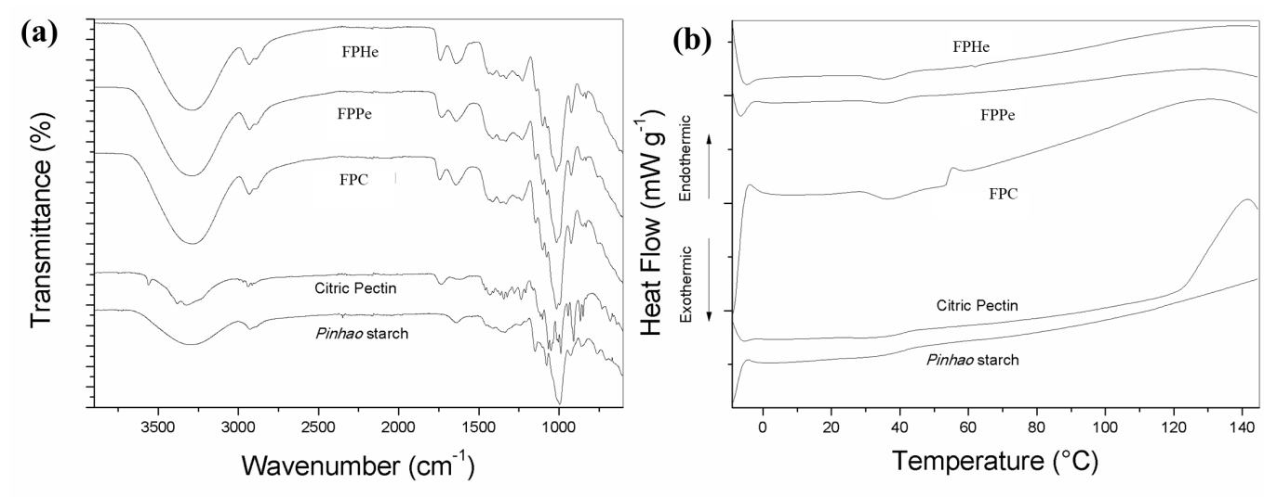
Figure 3: (a) FTIR and (b) DSC analyses of the food packaging produced with Acca sellowiana extracts.

The presence of plant secondary metabolites in a biofilm suggests its classification into a new category of packaging materials, which is ‘bioactive food packaging’. These compounds present a biological importance to the human health, promoting the inhibition of reactive species in the metabolism (Liu, 2004). However, once incorporated in a bio-polymer these natural compounds can acts as potential food preservative. In this study, FPHe presented a higher content of total phenolic (10.92 ± 0.29 mg GAE g⁻¹) and total flavonoid compounds (9.73 ± 0.21 mg QE g⁻¹) comparing to the control film and to the film with pulp extract addition (Table 3). In general, this fact can be explained because the aqueous extract of feijoa husk presented higher content of phenolic compounds (0.87 ± 0.02 mg GAE mL⁻¹) and flavonoids (0.78 ± 0.02 mg QE mL⁻¹). In general, the fruit husk contains more metabolites comparing to the edible part, because the plant needs a protection against ultraviolet radiations, bacteria, insects and viruses (Thilakarathna & Rupasinghe, 2012; Heleno et al., 2015; Sganzerla et al., 2018b). The presence of polyphenol is correlated with a high antioxidant action, being effective against reactive oxygen species, and control the damage caused by free radicals. Besides, many studies have been isolated and quantified these compounds and related with antifungal, antiviral and antibacterial activity (Thilakarathna & Rupasinghe, 2012; Oladeji and Adelowo, 2017). In the current work, the bioactive food packaging produced presented a high antioxidant activity, tested by DPPH, ABTS and FRAP assay. The packaging with husk extracts (FPHe) presented more antioxidant activity in both methods, and the Ferric Reduction Antioxidant Power (FRAP) was the method that better expressed the antioxidant activity.
Table 3: Bioactive compounds (TPC and TFC) and antioxidant activity (DPPH, ABTS and FRAP) of the food packaging produced with Acca sellowiana extracts.
Parameters | Bioactive Compounds |  | Antioxidant Activity
 | TPC¹ | TFC² | DPPH³ | ABTS³ | FRAP³
FPC (mg g⁻¹) | 2.24 ± 0.29^{c} | 0.82 ± 0.16^{c} | 0.72 ± 0.52^{c} | 3.26 ± 0.34^{c} | 12.38 ± 6.30^{c}
FPPe (mg g⁻¹) | 4.91 ± 0.36^{b} | 2.57 ± 0.14^{b} | 8.14 ± 0.62^{b} | 14.46 ± 2.76^{b} | 49.25 ± 11.60^{b}
FPHe (mg g⁻¹) | 10.92 ± 0.29ª | 9.73 ± 0.21ª | 30.55 ± 2.63ª | 53.61 ± 2.40ª | 274.29 ± 21.09ª
Fejoa pulp extract 1:10 (mg mL⁻¹) | 0.38 ± 0.01^{B} | 0.25 ± 0.01^{B} | 1.08 ± 0.03^{B} | 3.04 ± 0.02^{B} | 6.32 ± 1.43^{B}
Feijoa husk extract 1:10 (mg mL⁻¹) | 0.87 ± 0.02^{A} | 0.78 ± 0.02^{A} | 3.42 ± 0.20^{A} | 6.15 ± 0.21^{A} | 22.29 ± 0.92^{A}
The results are expressed as mean ± standard deviation (n=3). Different letters in each column after standard deviation represent a significant difference by Tukey’s test (p<0.05). Lowercase compare the packaging and capital letter compare the extracts. ¹ mg Galic Acid Equivalent (GAE) g⁻¹ film or mL⁻¹ extract; ² mg Quercetin Equivalent (QE) g⁻¹ film or mL⁻¹ extract; ³ mg Trolox Equivalent Antioxidant Capacity (TEAC) g⁻¹ film or mL⁻¹ extract.

  - Conclusion
A new bioactive and biodegradable food packaging was developed in this work, using a blend of Brazilian pine seeds starch, citric pectin and Acca sellowiana extracts. The food packaging produced presented satisfactory appearance, thin thickness, lower water solubility, UV protection, good color parameters, presence of bioactive compounds and high antioxidant activity. Based on these evidences, this novel film packaging material can be proposed as an effective alternative to packaging materials in common use in food processing systems.
Acknowledgments
The authors acknowledge the Federal Institute of Education of Santa Catarina (IFSC, Campus Lages, Brazil) and National Council for Scientific and Technological Development (CNPq, Brazil) to financial support.
References
Allen N.S., Edge M., Ortega A., Sandoval G., Liauw C.M., Verran J., Stratton J., Mcintyre R.B., 2004, Degradation and stabilisation of polymers and coatings: nano versus pigmentarytitania particles, PolymDegrad Stab, 85, 3, 927–946.
Arquelau P.B.F., Silva V.D.M., Garcia M.A.V.T., de Araújo R.L.B., Fante C.A., 2019, Characterization of edible coatings based on ripe “Prata” banana peel flour, Food Hydrocolloids, 89, 570-578.
Bello-Perez L.A., García-Soarez F.J., Mendez-Montealvo G., Nascimento J.R.O., Cordenusi B.R., 2006, Isolation and characterization of starch from seeds of Araucaria brasiliensis: A novel starch for application in food industry, Starch/Starke, 58, 283-291.
Benzie I., Strain J., 1996, The Ferric Reducing Ability of Plasma (FRAP) as a Measure of “Antioxidant Power”: The FRAP Assay, Analytical Biochemistry, 239, 70-76.
Brand-Williams W., Cuvelier M., Berset C., 1995, Use of a free radical method to evaluate antioxidant activity, LWT - Food Science and Technology, 28, 25-30.
Colla E., Sobral P.J.A., Menegalli F.C., 2006, Amaranthus cruentus flour edible films, influence of stearic acid addition, emulsification stirring speed and plasticizer concentration in amaranth flour based film forming solutions on barrier and mechanical properties of its films, Journal of Agricultural and Food Chemistry, 54, 6645-6653.
Daudt R., Avena-Bustillos R., Williams T., Wood D., Külkamp-Guerreiro I., Marczak L., McHugh T., 2016, Comparative study on properties of edible films based on pinhão (Araucaria angustifolia) starch and flour. Food Hydrocolloids, 60, 279-287.
Eça K.S., Machado M.T.C., Hubinger M.D., Menegalli F.C., 2015, Development of active films from pectin and fruit extracts: light protection, antioxidant capacity, and compounds stability, Journal of Food Science, 80(11), 2389-2396.
Fidelis J., Marchi L., Marques D.R., Scapim M., Madrona G., Monteiro C.C.F., Yamashita F., Monteiro A.R.G., 2017, Development of biodegradable films of cassava starch and poly (butylene adipate co-terephthalate): effects of oregano essential oil and potassium sorbate in films characterization, Chemical Engineering Transactions, 57, 1969-1974.
Heleno S.A., Martins A., Queiroz M.R.P., Ferreira I.C.F., 2015, Bioactivity of phenolic acids: Metabolites versus parent compounds: a review, Food Chemistry, 173, 501-513.
Hunter Lab. CIE L*a*b* color scale. Application Note Archive, v. 8, n. 7. 2012
Kessin J.P., Pigozzi L., Hahn P.C., Dias G.V., Nunes M.R., Costa M.D., Veeck A.P.L., 2018, Atividade antioxidante de compostos fenólicos presentes em polpa e casca de goiabeira serrana, Brazilian Journal of Food Research, 9, 141-153.
Liu R.H., 2004, Potential Synergy of Phytochemicals in Cancer Prevention: Mechanism of Action, The Journal of Nutrition, 134, 3479-3485.
Norajit K., Kim K.M., Ryu G.H., 2010, Comparative studies on the characterization and antioxidant properties of biodegradable alginate films containing ginseng extract, Journal of Food Engineering, 98, 3, 377–384.
Nunes M., de Souza Maguerroski Castilho M., de Lima Veeck A., da Rosa C., Noronha C., Maciel M., Barreto P., 2018, Antioxidant and antimicrobial methylcellulose films containing Lippia alba extract and silver nanoparticles, Carbohydrate Polymers, 192, 37-43.
Oladeji O., Adelowo F., 2017, Plant phenolic compounds and health benefits, Communications in Plant Sciences, 7, 20-26.
Pasquariello M., Mastrobuoni F., Di Patre D., Zampella L., Capuano L., Scortichini M., Petriccione M., 2015, Agronomic, nutraceutical and molecular variability of feijoa (Acca sellowiana (O. Berg) Burret) germplasm, Scientia Horticulturae, 191, 1-9.
Re R., Pellegrini N., Proteggente A., Pannala A., Yang M., Rice-Evans C., 1999. Antioxidant activity applying an improved ABTS radical cation decolorization assay, Free Radical Biology and Medicine, 26, 1231-1237.
Santos K.L., Ciotta M.N., Nodari R.O., 2017, Melhoramento genético da goiabeira-serrana (Acca sellowiana) em Santa Catarina, Agropecuária Catarinense, 30, 40-42.
Sganzerla W.G., Beling P.C., Ferrareze J.P., Komatsu R.A., Nunes M.R., Veeck A.P.L., 2018a, Nutritional, physicochemical and antimicrobial properties of uvaia pulp (Eugenia pyriformis Cambess), Communications in Plant Sciences, 8, 1-7.
Sganzerla W.G., Melo M.D., Ferrareze J.P., Veeck A.P.L., Ferreira P.I., Girardi C.L., 2018b, Postharvest treatment with 1-MCP in apple ‘Gala’ mutants: physicochemical characterization, bioactive compounds and antioxidant activity, Communications in Plant Sciences, 8, 40-47.
Siripatrawan U., Harte B.R., 2010, Physical properties and antioxidant activity of an active film from chitosan incorporated with green tea extract, Food Hydrocolloids, 24, 8, 770-775.
Swain T., Hillis W., 1959, The phenolic constituents of Prunus domestica. I. - The quantitative analysis of phenolic constituents, Journal of the Science of Food and Agriculture, 10, 63-68.
Takahashi G., Barbosa H.D., Bergamasco R., Madrona G., Tonon L.C., Yamashita F., Scapim M., 2017, Development and active biodegradable film evaluation incorporated with oregano essential oil and nanoclay, Chemical Engineering Transactions, 57, 403- 408.
Thilakarathna S.H., Rupasinghe H.P.V., 2012, Anti-atherosclerotic effects of fruit bioactive compounds: A review of current scientific evidence, Canadian Journal of Plant Science, 92, 407-419.
Veeck A.P.L., Klein B., Ferreira L.F., Becker A.G., Heldwein C.G., Heinzmann B.R., Baldisserotto B., Emanuelli T., 2013, Lipid stability during the frozen storage of fillets from silver catfish exposed in vivo to the essential oil of Lippia alba (Mill.) NE Brown, Journal of the Science of Food and Agriculture, 93, 955-960.
Wang L., Dong Y., Men H., Tong J., Zhou J., 2013, Preparation and characterization of active films based on chitosan incorporated tea polyphenols, Food Hydrocolloids, 32, 35-41.
Weston R., 2010, Bioactive products from fruit of the feijoa (Feijoa sellowiana, Myrtaceae): A review, Food Chemistry, 121(4), 923-926.
Yong H., Wang X., Bai R., Miao Z., Zhang X., Liu J., 2019, Development of antioxidant and intelligent pH-sensing packaging films by incorporating purple-fleshed sweet potato extract into chitosan matrix, Food Hydrocolloids, 90, 216–224.
Zhishen J., Mengcheng T., Jianming W., 1999. The determination of flavonoid contents in mulberry and their scavenging effects on superoxide radicals, Food Chemistry, 64, 4, 555-559

