CHEMICAL ENGINEERING TRANSACTIONS  VOL. 76, 2019 | A publication of
The Italian Association
of Chemical Engineering
Online at www.aidic.it/cet
Guest Editors: Sauro Pierucci, Jiří Jaromír Klemeš, Laura Piazza
Copyright © 2019, AIDIC Servizi S.r.l.
ISBN 978-88-95608-73-0; ISSN 2283-9216

Bioactive Compounds and Pectin from Residues of the Passion Fruit Processing: Extraction using Green Technology and Characterization
Thais A. Moiaª, Tatiana C. Pimentel^{b}, Carlos Eduardo Barão^{b}, Andresa C. Feihrmann^{c}, Rogerio Favareto^{d}, Adriano V. Reis^{e}, Lúcio Cardozo-Filho^{a,*}
ªUniversidade Estadual de Maringá, Programa de Pós-Graduação em Agronomia, Avenida Colombo, 5790, Zona 7, Maringá, Paraná, 87020-900, Brasil.
^{b}Instituto Federal do Paraná (IFPR) – Campus Paranavaí, Rua José Felipe Tequinha, 1400, Jardim das Nações, Paranavaí, Paraná, 87703-536, Brasil.
^{c}Universidade Estadual de Maringá, Departamento de Engenharia de Alimentos, Avenida Colombo, 5790, Zona 7, Maringá, Paraná, 87020-900, Brasil.
^{d}Instituto Federal Goiano (IFGO), Rodovia Sul Goiania Km 1, Zona Rural, Rio Verde, Goiás, 75901970, Brasil.
^{e}Universidade Estadual de Maringá, Departamento de Farmácia, Avenida Colombo, 5790, Zona 7, Maringá, Paraná, 87020-900, Brasil.
*lucio.cardozo@gmail.com

The objective of the study was to extract (using pressurized liquid extraction (PLE)) and characterize the bioactive compounds and pectin from the residue of the passion fruit processing. The extract of the passion fruit peel was obtained with ethanol (99.5%) in different temperature (80-100 ºC), flow rate (0.5-1 mL/min) and pressure (50-100 bar) conditions (2³ factorial design). The highest yield (32.13%) was obtained employing 50 bar, 80 ºC and 0.5 mL/min. The lipid fraction of the extract was composed of palmitic acid, linoleic acid and oleic acid. From the residual pie (after the obtention of the extract), pectin extraction was carried out with water as extraction solvent, in pressurized (50-100 ºC, 50-100 bar, 0.5-1 mL/min, 2³ factorial design) and non-pressurized (50-100 ºC, 0.5-1 mL/min, 2² factorial design) processes. With the pressurized system, the highest yield (27.67%) was obtained using 50 bar, 100 °C, and 0.5 mL/min, resulting in esterification percentage of 89.32%. With the non-pressurized system, the highest yield (20.77%) was obtained using 75 ºC and 0.75 mL/min, resulting in esterification percentage of 86.54%. The pectin showed high purity, confirmed by ¹H NMR analysis and absence of contaminant signals. Through gel permeation chromatography (GPC) analysis, it was possible to verify that pectin with different mean molar mass (¯Mw) and Polydispersity Index (PI) can be obtained, depending on the process parameters. The oil of the passion fruit seed was extracted under different conditions of temperature (40-80 ºC), pressure (50-100 bar) and flow rate (0.5-1 mL/min) using ethanol as extraction solvent and rotating composite central design (CCRD). The best condition (50 bar, 80 ºC and 0.5 mL/min) showed 25.8% yield. The concentration of piceatannol present in the oil (0.05-1.3 µg/mL) was higher than that found in commercial oil samples obtained by conventional methods (not detected). It can be concluded that the passion fruit residue can be used to obtain bioactive compounds and pectin. PLE proved to be efficient and very promising, because it is a green methodology and resulted in products with high quality (pectin with high purity and oils with higher concentration of piceatannol).
  - Introduction
The processing of passion fruit results in the generation of large amounts of by-products, such as peels and seeds (Toledo et al., 2018). The passion fruit peel is rich in pectin and the passion fruit seed is rich in oil with a high content of unsaturated fatty acids, with predominance of linoleic acid (Toledo et al., 2018, Melo Filho et al., 2018). Furthermore, the oil has high levels of the piceatannol compound, a phenolic compound of the class of stilbenes that is characterized by the high antioxidant activity (Kim et al., 2017). Therefore, these bio-compounds have potential to be used as ingredients in functional foods or as phytochemical pharmaceutical substances (Albuquerque et al., 2019).
In recent years, there was a growing interest in the efficient use of the agro-industrial by-products (Rivero et al., 2018), as well as in alternative extraction technologies (Leyva-Jiménez et al., 2018). The pressurized liquid extraction (PLE) is an innovative methodology and it has some advantages when compared to the conventional techniques: higher yield, shorter processing time, and less solvent consumption. Furthermore, the use of food-grade solvents (water and ethanol) is considered a green approach (Tripodo et al., 2018). However, little attention has been paid to the optimization of the extraction method. Extraction parameters (temperature, flow rate and pressure) can be optimized in order to obtain the highest yield and selectivity of the compounds of interest (Tripodo et al., 2018). Therefore, the objective of the present study was to extract (using PLE) and characterize the bioactive compounds and pectin from the residue (peel and seed) of the passion fruit processing.
  - Material and methods
2.1 Material
The by-product (peels + seeds) of passion fruit (Passiflora edulis) processing was supplied by the PolpaNorte Fruit Pulp Industry (Japurá, Paraná, Brazil). Ethanol (99,5º, Casa da Química®) was used in the experiment.

2.2 Processing of the by-product
The peels and seeds were washed separately under running water and dried in an oven at 70 °C until constant weight. Then, they were ground ("Mesh" <0.85mm) in a rotor mill (SP Labor - Model SP-30).

2.3 Equipment
The experimental apparatus is shown in Figure 1, being (1) solvent feed container, (2) syringe or HPLC pump controller, (3) valve, (4) preheater, (5) extractor vessel, (6) preheater temperature controller, (7) temperature controller of the extractor vessel, (8) valve, (9) cooling system, (10) back pressure valve, (11) pressure indicator and (12) collecting vessel.
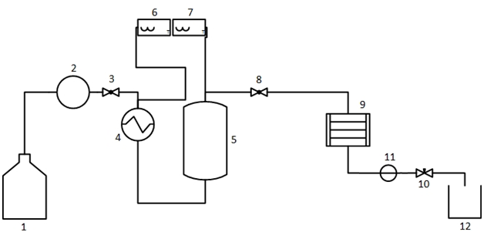
Figure 1: Scheme of the equipment used for the PLE extraction of passion fruit components.

2.4 Extraction of the bioactive compounds from passion fruit peel
The extractions were carried out according to Moia (2014). The extract of the passion fruit peel was obtained with ethanol (99.5%) in different temperature (80-100 ºC), flow rate (0.5-1 mL/min) and pressure (50-100 bar) conditions (2³ factorial design with triplicates at the central point, 11 experiments) (Table 1). The temperature of the preheater was approximately 60 °C and each extraction lasted 3 h. At the end of the extraction, the solvent was evaporated at 50 °C in an oven until constant weight, and thus, the extract was obtained. The yield was calculated considering the initial mass of the dried peels and the mass of extract.

2.5 Extraction of the pectin from passion fruit peel
The residual pie (after the obtention of the extract) was dried at 70 ºC until constant weight, and pectin extraction was carried out with water as extraction solvent, in pressurized (50-100 ºC, 50-100 bar, 0.5-1 mL/min, 2³ factorial design, with triplicates at the central point, 11 experiments) and non-pressurized (50-100 ºC, 0.5-1 mL/min, 2² factorial design, with triplicates at the central point, 7 experiments) processes (Table 1). The temperature of the preheater was approximately 40 °C and each extraction lasted 1 h. The material was collected in glass flasks containing ethanol (1: 2, v/v) for pectin precipitation. Pectin was separated and dried at 50 ºC until constant weight. The yield was calculated considering the initial mass of the dried peels and the mass of pectin.
2.6 Extraction of the oil from passion fruit seed
The oil of the passion fruit seed was extracted under different conditions of temperature (40-80 ºC), pressure (50-100 bar) and flow rate (0.5-1 mL/min) using ethanol as extraction solvent and rotating composite central design (CCRD, with triplicates at the central point, 16 experiments) (Table 2). The temperature of the preheater was approximately 40 °C for the extractions with temperature higher than 40 ºC and the preheater was not activated in the other extractions. Each extraction lasted 3 h. At the end of the extraction, the solvent was evaporated at 50 °C in an oven until constant weight, and thus, the oil was obtained. The yield was calculated considering the initial mass of the dried seeds and the mass of oil.

2.7 Analysis
The major chemical compounds present in the extract were qualitatively identified by GC-MS (Gas chromatography-Mass spectrometry) in a system composed of an Agilent-7890A gas-phase chromatograph coupled to a mass spectrum Agilent-5975C according to Moia (2018). The program used to analyze the chromatograms was the OpenChrom® with NIST MSD library. The operating conditions were: helium as entrainment gas (1.0 mL/min), initial column temperature of 60 °C for 1 min, temperature gradient from 6 °C/min to the final temperature of 250 °C maintained by 5 min and injector temperature of 260 °C.
In pectin, ¹H NMR analysis was performed (Varian Mercury Plus BB, 300 MHz spectrometer). A sample from the pressurized system extraction and a sample from the non-pressurized system extraction were chosen. They were solubilized separately in 1.0 mL of D₂O (deuterated water). The spectra obtained were compared with apple and citrus pectin spectra (Sigma-Aldrich). The percentage of esterification (E%) of the pectin was determined by the potentiometric titration method. The Mw distribution of the pectin was determined by gel permeation chromatography (GPC) using a ViscotekGPCMax VE2001 equipment equipped with RI-Viscotek VE3580 detector. Two Phenomenex GCF Shodex OH pak® 13 μm SB-806M HQ columns (300mm x 8mm), connected in series and under flow of 1.0 mL/ min of mobile phase at 40 °C were used. The mobile phase was aqueous solution of NaNO₃ (0.1 mol/L). For analysis, 200 uL of a sample with concentration of 3.0 mg/mL, previously solubilized in water, was injected for 24 h. The results obtained were analyzed based on a calibration curve generated with the poly (ethylene oxide) - PEO standard polymer.
The piceatannol quantification in oils was determined according to Moia (2018). A liquid chromatography coupled to tandem mass spectrometry (LC-ESI-MS/MS) was used, using an Alliance e2695 chromatograph coupled to a QuattroPremier XE Waters triple quadrupole mass spectrometer (Milford, MA, USA) and equipped with an electron-ionization chamber (Milford, MA, USA).

2.8 Statistical analysis
Data were analyzed by Analysis of Variance and Tukey test for comparison of means (p ≤ 0.05) using Statistica 10 software (Statsoft, Inc. 2011). All experiments were conducted in duplicates.
  - Results and Discussion
3.1 Extract of the passion fruit peel
The yield of the extracts from the passion fruit peel was between 13.31 (extraction 2) and 32.12 % (extraction 1) (Table 1). It was possible to verify that the increase in the process temperature resulted in higher extraction yields (p=0.003). On the contrary, the increase in pressure and flow rate reduced the amount of extract (p=0.002 and 0.009, respectively). Interactions between the variables were also significant (p<0.05). In order to estimate the values of the parameters that allow the highest yield, the response desirability profile section was used in the software. The best extraction yield (32.13%) was estimated at 50 bar, 80 ºC and 0.5 mL/min. The lipid fraction of the extract was composed of palmitic acid, linoleic acid and oleic acid (data not shown).

3.2 Pectin from passion fruit peel
The yield of pectin from the passion fruit peel was between 8.71 (extraction 2) and 20.77 % (extraction 5) for the non-pressured system (Table 1). It was possible to verify that the increase in the process temperature resulted in higher pectin yields (p=0.004) and lower E% (p=0.032). On the contrary, the increase in flow rate reduced the amount of pectin (p=0.03) but increased the E% (p=0.004) (Figure 2A). The highest yield (20.77%) was estimated at 75 ºC and 0.75 mL/min, resulting in E% of 86.54%.
The yield of pectin from the passion fruit peel was between 16.30 (extraction 5) and 27.67% (extraction 3) for the pressurized system (Table 1). It was possible to verify that the increase in the process temperature resulted in higher pectin yields (p=0.002) and higher E% (p=0.002). On the contrary, the increase in flow rate reduced the amount of pectin (p=0.006) with non-significant impact on E% (p> 0.05). The pressure did not have a significant impact on the pectin yield (p>0.05) but contributed negatively to the E% (p=0.005) (Figure 2B). The highest yield (27.67%) was estimated at 50 bar, 100 °C, and 0.5 mL/min, resulting in E% of 89.32%.
The extracted pectin showed high purity, confirmed by ¹H NMR analysis and absence of contaminant signals (Figure 3). Through gel permeation chromatography (GPC) analysis, it was possible to verify that pectin with different mean molar mass (¯Mw) and Polydispersity Index (PI) can be obtained, depending on the process parameters (data not shown).

Table 1: Yield of the bioactive compounds from passion fruit peel
Component | Extraction | Temperature (ºC) | Pressure (Bar) | Flow rate (mL/min) | Yield (%) | Esterification percentage (%)
Extract | 01 | 80 | 50 | 0.50 | 32.13 | -
 | 02 | 80 | 100 | 0.50 | 13.31 | -
 | 03 | 100 | 50 | 0.50 | 28.02 | -
 | 04 | 100 | 100 | 0.50 | 31.64 | -
 | 05 | 80 | 50 | 1.00 | 23.37 | -
 | 06 | 80 | 100 | 1.00 | 21.38 | -
 | 07 | 100 | 50 | 1.00 | 25.55 | -
 | 08 | 100 | 100 | 1.00 | 23.76 | -
 | 09C | 90 | 75 | 0.75 | 25.95 | -
 | 10C | 90 | 75 | 0.75 | 25.26 | -
 | 11C | 90 | 75 | 0.75 | 25.80 | -
Pectin (non-pressurized) | 01 | 80 | - | 0.50 | 13.33 | 85.22
 | 02 | 80 | - | 1.00 | 8.71 | 88.12
 | 03 | 140 | - | 0.50 | 19.84 | 85.44
 | 04 | 140 | - | 1.00 | 18.69 | 86.14
 | 05C | 110 | - | 0.75 | 20.77 | 86.54
 | 06C | 110 | - | 0.75 | 19.37 | 86.54
 | 07C | 110 | - | 0.75 | 19.06 | 86.54
Pectin (pressurized) | 01 | 50 | 50 | 0.50 | 19.44 | 85.36
 | 02 | 50 | 100 | 0.50 | 18.84 | 84.74
 | 03 | 100 | 50 | 0.50 | 27.67 | 89.32
 | 04 | 100 | 100 | 0.50 | 22.89 | 83.13
 | 05 | 50 | 50 | 1.00 | 16.30 | 87.50
 | 06 | 50 | 100 | 1.00 | 18.26 | 74.24
 | 07 | 100 | 50 | 1.00 | 19.75 | 88.23
 | 08 | 100 | 100 | 1.00 | 23.04 | 93.26
 | 09C | 75 | 75 | 0.75 | 22.26 | 88.46
 | 10C | 75 | 75 | 0.75 | 21.88 | 89.18
 | 11C | 75 | 75 | 0.75 | 22.50 | 88.89
- Not applicable. C-repetition at central point

3.3 Oil from passion fruit seed
The yield of oil from the passion fruit seed was between 18.74 (extraction 11) and 25.88 % (extraction 12) (Table 2). It was possible to verify that the increase in the process temperature resulted in higher oil yields (p=0.01). At the same time, the increase in flow rate reduced the amount of oil (p=0.044). Only the quadratic term of the pressure was significant (p=0.045) (Figure 2C). The optimum value predicted from the proposed empirical model was 27.298% for the conditions of 75 bar, 93.6 °C and 1.17mL/min. However, a yield of 25.653% (predicted by the model) or 25.80% (experimental) was obtained with 50 bar, 80 °C and 0.5mL/ min, which is more advantageous from an industrial point of view, as the temperature and flow rate were lower.
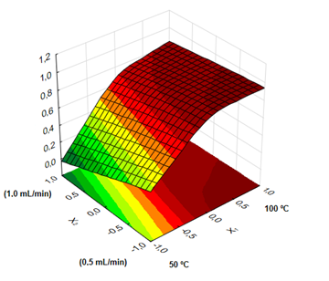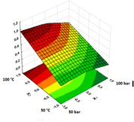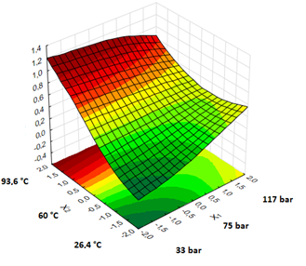
- (B) (C)
Figure 2: Response Surface (RS) of desirability for pectin: (A) in non-pressurized system and (B) and pressurized system (B); for oil (C)

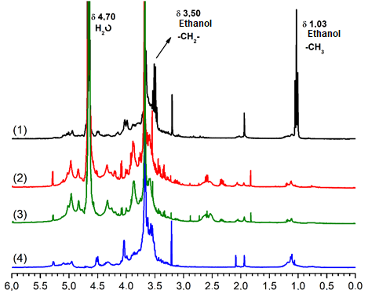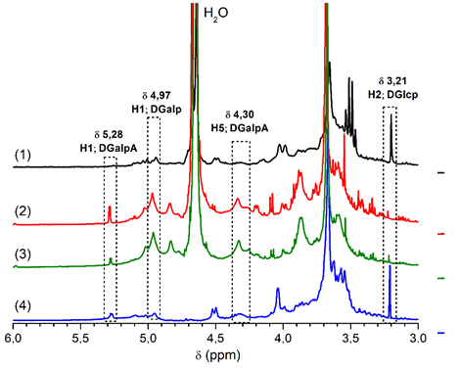

Figure 3: ¹H NMR spectra. (1) Apple pectin, (2) Pectin from passion fruit peel (extraction 1, non-pressurized), (3) Pectin from passion fruit peel (extraction 1, pressurized) and (4) Citrus pectin.

Table 2: Yield of the oil from passion fruit seed
Extraction | Temperature (ºC) | Pressure (Bar) | Flow rate (mL/min) | Yield (%)
01 | 40 | 50 | 0.50 | 19.55
02 | 40 | 50 | 1.00 | 19.18
03 | 80 | 50 | 0.50 | 25.80
04 | 80 | 50 | 1.00 | 24.67
05 | 40 | 100 | 0.50 | 21.75
06 | 40 | 100 | 1.00 | 21.16
07 | 80 | 100 | 0.50 | 24.64
08 | 80 | 100 | 1.00 | 23.24
09 | 60 | 33 | 0.75 | 20.74
10 | 60 | 117 | 0.75 | 20.59
11 | 26.4 | 75 | 0.75 | 18.74
12 | 93.6 | 75 | 0.75 | 25.88
13 | 60 | 75 | 0.33 | 23.11
14 C | 60 | 75 | 1.17 | 21.22
15 C | 60 | 75 | 0.75 | 21.49
16 C 11C 75 75 0.75 22.50 88.89 | 60 | 75 | 0.75 | 21.31
C-repetition at central point
The concentration of piceatannol in the oil from passion fruit seed was between 0.05 and 1.3 µg/mL, which was higher than that found in the commercial oils obtained by the conventional methods (Figure 4).

Figure 4: Piceatannol content (µg/mL) in the oil from passion fruit (E1-E16) and commercial oil samples (C1-C4). In C1-C4 piceatannol was not detected.

  - Conclusion
It can be concluded that the passion fruit residue can be used to obtain bioactive compounds and pectin. The PLE proved to be efficient and very promising, because it is a green methodology and resulted in products with high quality (pectin with high purity and oils with higher concentration of piceatannol [0.05-1.3 µg/mL]). There was no use of acids, bases and toxic organic solvents. All the proposed methods used only water or ethanol, considered as green solvents.

References
Albuquerque M.A.C., Levit R., Beres C., Bedani R., de LeBlanc A.D.M., Saad S.M.I., LeBlanc J.G., 2019, Tropical fruit by-products water extracts of tropical fruit by-products as sources of soluble fibres and phenolic compounds with potential antioxidant, anti-inflammatory, and functional properties, Journal of Functional Foods, 52, 724-733.
Kim D., Ahn T., Jung H., Pan J., Yun C, 2017, Generation of the human metabolite piceatannol from the anticancer-preventive agent resveratrol by bacterial cytochrome P450 BM3, Drug Metabolism and Disposition, 37, 932 – 936.
Leyva-Jiménez F.J., Lozano-Sánchez J., Borrás-Linares I., Arráez-Román D., Segura-Carretero A., 2018, Comparative study of conventional and pressurized liquid extraction for recovering bioactive compounds from Lippia citriodora leaves, Food Research International, 109, 213-222.
Melo Filho A.A., Kamezaki A.K., Ribeiro P.E., De Melo A.G.R., Fernandez I.M., Dos Santos R.C., Chagas, E.A., Chagas P.C., 2018, Chemical composition, antioxidant and biological activity of leaves Passiflora foetida, Chemical Engineering Transactions, 64, 241-246.
Moia T.A., 2014, Extração e caracterização do óleo e da pectina da casca de banana utilizando tecnologia verde, Master in Agronomy, State University of Maringá, Maringá.
Moia T.A., 2018, Extração e caracterização de compostos bioativos e pectina a partir de resíduos do processamento de maracujá-azedo utilizando tecnologia verde, Doctor in Agronomy, State University of Maringá, Maringá.
Rivero D.S., Mahecha O.M., Torres D.M., Rivero M.S., Ballesteros L.C., Aguilar J.O., 2018, Potential evaluation of agroindustrial waste from three Passifloraces as a source of usable biomass, Chemical Engineering Transactions, 65, 643-648.
Toledo N., de Camargo A., Ramos P., Button D., Granato D., Canniatti-Brazaca S., 2018, Potentials and pitfalls on the use of passion fruit by-products in drinkable yogurt: Physicochemical, technological, microbiological, and sensory aspects, Beverages, 4, 47.
Tripodo G., Ibáñez E., Cifuentes A., Gilbert‐López B., Fanali C., 2018, Optimization of pressurized liquid extraction by response surface methodology of Goji berry (Lycium barbarum L.) phenolic bioactive compounds, Electrophoresis, 39, 1673-1682.

