|  |  |
| --- | --- |
| cetlogo ***CHEMICAL ENGINEERING TRANSACTIONS***  ***VOL. 76, 2019*** | A publication of  aidiclogo_grande |
| The Italian Association  of Chemical Engineering  Online at www.aidic.it/cet |
| Guest Editors: Sauro Pierucci, Jiří Jaromír Klemeš, Laura Piazza  Copyright © 2019, AIDIC Servizi S.r.l. **ISBN** 978-88-95608-73-0; **ISSN** 2283-9216 | |

QUINOA (*Chenopodium quinoa Willd*.) Flour as Novel and Safe Ingredient in Bread Formulation

Annalisa Romanoa,b\*, Paolo Masia,b, Maria Adalgisa Nicolaia, Aniello Falcianob, Pasquale Ferrantia

aDipartimento di Agraria, Università di Napoli FEDERICO II, Via Università 100, 80055, Portici (Na), Italy

bCAISIAL, Università di Napoli FEDERICO II, Via Università 133, 80055, Portici (Na), Italy

annalisa.romano@unina.it

Quinoa (*Chenopodium quinoa Willd*.) has a great agronomic potential across the world and its seeds and flour may represent a source of functional ingredient for novel food production, because its high protein content with all essential amino acids, absence of gluten, high dietary fiber content and abundance of natural antioxidants such as fenolic compounds. In particular, quinoa flour has been receiving an increasing attention as a substitute for wheat flour in bread formulations due to immunutritional features (Laparra and Haros, 2018).

Aims of this study were to investigate the protein fraction of quinoa flour and to evaluate its in-vitro digestibility for bread formulation. The chemical composition of quinoa protein isolate and flour were investigated. Quinoa flour showed an excellent nutritional profile, including a high protein (about 14%), lipid (about 7%) and ash (about 2%) content. Proteomic and R5 ELISA analyses showed absence of gluten, confirming quinoa as a naturally gluten-free crop. The microstructure of flour and protein isolate, dough and quinoa bakery product were observed through Scanning Electron Microscopy (SEM). Furthermore, we studied the protein fraction of quinoa flour and protein isolate and to evaluate their in-vitro digestibility for a functional bread development using a static in vitro model of protein gastrointestinal digestion Romano et al. (2017). MS/MS analysis of gastrointestinal digests had a high degree of digestibility and survival of only few resistant peptides, none of which recognized by western blotting with sera of individuals allergic to cereals nor by in silico screening on allergenic sequence databases. Bakery product exclusively based on quinoa flour was prepared with valid nutritional properties. Results indicated that quinoa flour had a high degree of digestibility, supporting its excellent nutritional value and the use of quinoa as ingredient in substitutive dough formulations.

* 1. Introduction

The potential health benefits of quinoa (*Chenopodium quinoa Willd*.) have been extensively reviewed in recent years (Pellegrini et al., 2018; Romano and Ferranti, 2019). It was reported that one serving of quinoa (about 40 g) meets an important part of daily requirements for essential nutrients and health-improving compounds (Graf et al., 2015). The raising interest in quinoa, due to its nutritional value, has promoted a demand for this pseudo – cereal, that produces seeds that can be milled into flour and used as a [cereal](https://www.sciencedirect.com/topics/biochemistry-genetics-and-molecular-biology/cereal) crop ([Vilcacundo and Hernández-Ledesma, 2017](https://www.sciencedirect.com/science/article/pii/S0308814618321721" \l "b0120)). Quinoa seeds are an exceptionally nutritious food source, owing to their high protein content rich in all essential amino acids, absence of gluten, high level of important minerals, such as calcium and iron, and health-promoting compounds such as flavonoids. Moreover quinoa flour has been receiving an increasing attention as a substitute to wheat flour in bread formulations due to its immuno-nutritional features, such as improving intestinal absorption of iron or modulating the hepatic production of inflammatory biomarkers (Laparra and Haros, 2018). Thus, the quinoa provides a promising crop towards ensuring novel and safe food, e.g. nutritionally balanced products at affordable costs and a low impact on the environment and gluten-free foods (Romano and Ferranti, 2019).

Aim of this study was to investigate the protein fraction of quinoa flour and to evaluate its in-vitro digestibility for bread formulation.

The present study was subdivided into two parts. Firstly, the chemical composition and the microstructure of quinoa flour and quinoa protein isolate were evaluated. Secondly, we have investigated the microstructural characteristics of quinoa flour during bread makingand *in -vitro* digestibility of quinoa proteins.

* 1. Materials and Methods
     1. Materials

White quinoa seeds from a local industry were desaponified according to the procedure reported by Romano et al., (2018). Desaponified seeds were dried in an oven at 60 °C for 4 hours and ground using a variable speed laboratory blender (LB20ES, Waring Commercial, Torrington, Connecticut, USA), so that the flour would pass through a 425 m stainless steel sieve (Octagon Digital Endecotts Limited, Lombard Road, London, UK). The flour samples were collected and stored in polyethylene bags at 4 °C until used for analysis. Quinoa protein isolate was prepared from defatted quinoa flour by adapting the process commonly used for production of soybean protein isolates (Tang et al., 2006) with the following modifications. Defatted quinoa flour was mixed at room temperature with 20-fold (w/v) deionized water at 35 °C, and the mixture was adjusted to pH 10.0 with borate buffer. After 4 h extraction under continuous stirring, samples were centrifuged at 8000g for 30 min at 20 °C. The supernatant was adjusted to pH 5.0 with 2 N HCl, and the precipitate was collected by centrifugation (8000g, 10 min). To improve protein solubility, the isoelectric precipitate was resuspended in deionized water, homogenized, then the suspension was adjusted to about pH 6.8 with 1 N NaOH. Finally, the suspension was freeze-dried to obtain dry HPI.

**2.2 Bread making process**

Dough was prepared in a Brabender farinograph (O. H. Duisburg, Germany) using a 50 g bowl. Dough was prepared by weighting 50g of quinoa flour by means of a analytical balance (Sartorius BL 1500, Germany) and by adding them the deionised water (56%), yeast (3%), salt (2%), sugar (1%), vanillin (0.05%). Mixing time and temperature were kept constant and equal to 10 minutes and 25°C respectively. Dough was incubated at 36 ± 4°C, 70 % U.R. for 45 min of leavening as already reported by Romano et al. (2018). Baking took place inside a conventional electric oven (Moretti Forni S.p.A., Pesaro, Italy) where temperature was kept under control at 190°C for 40 min.

2.3 Chemical analysis and ELISA gluten assay

Quinoa flour and quinoa protein isolate were analyzed for their moisture (gravimetric Method 44-19), lipid (Soxhlet Method 30-20), ash (gravimetric Method 08-01), protein (Kjeldahl Method 46-30) (Nx5.96) and total carbohydrates (enzymatic-gravimetric Method 985-29) according to AACC methods (2000).

Gluten content of quinoa samples was determined using the R5 assay kit (R7001 Ridascreen Gliadin), according to manufacturer’s instructions. A standard curve was built with gliadin at various dilutions (0−120 ng/mL). Quinoa samples were subjected to an extraction step with the ‘cocktail solution’ as suggested by the kit provider. Afterward, aliquots were diluted (1:50−1:200) in the dilution buffer (room temperature) and assayed in triplicate. Statistical analyses were carried out with the Excel 2010 software (Microsoft Co., WA,USA).

2.4 Microstructural analysis: Scanning Electron Microscopy (SEM)

Samples were prepared according to the method described by Romano et al. (2016). Microstructure of quinoa flour, protein isolate, dough and bakery product was examined by means of Scanning Electron Microscopy (LEO EVO 40, Zeiss, Germany) with a 20 kV acceleration voltage and a specific magnification for sample.

**2.5 SDS–PAGE analysis**

Digested protein fraction (>6 kDa) purified with Econopac 10DG (Bio-Rad, Milan, Italy) by elution in 25 mM ammonium bicarbonate, pH 7.8, and urea-extracted proteins were loaded onto a precast 12% polyacrylamide gel (Bio-Rad) under either reducing (2% β-mercaptoethanol) or non-reducing conditions. The running buffer was 192 mM glycine, 25 mM Tris and 0.1 % SDS. Analysis was carried out at room temperature and constant voltage (100 V). Proteins were visualized with blue silver (Coomassie G250) staining. The gel was imaged with a scanner and processed using the LABScan software 3.00 (Amersham Bioscience, Uppsala, Sweden).

**2.6 Two-dimensional electrophoresis**

For two-dimensional electrophoresis (2-DE) analysis, aliquots of the protein isolate were quantified with the Bradford assay and precipitated in 1 mL of −20°C cold acetone. The protein pellets (100 μg/400 μL) were dissolved in IPG strip rehydration buffer [8 M urea, 2% (w/v) CHAPS, 20 mM DTT, 2% v/v Pharmalytes pH 4.0–10.0 and traces of bromophenol blue]. Immobiline Dry Strips (pH 4–7, 11 cm) were rehydrated overnight in an Immobiline Dry-Strip Reswelling Tray (Amersham Pharmacia). Isoelectrofocusing (IEF) was carried out using the Multiphor II system (Pharmacia Biotech, Uppsala, Sweden). IEF was carried out at pI 4–10. The program run was 1000 V for 1 h and 3500 V for 16 h. After focusing, proteins were reduced for 15 min in equilibration buffer (6 M Urea, 30% glycerol, 2% SDS, 2% DTT), and alkylated for 15 min with 2.5% iodacetamide (Bjellquist et al., 1993). SDS-PAGE in the second dimension was carried out as previously described but using both 12% or a 15% acrylamide concentration, in this latter case to enhance the resolution of the low mass region.

2.7 In vitro digestion model

For in vitro simulation of protein digestion process, samples were submitted to simulated in vitro digestion as previously reported by Romano et al. (2017).

* + 1. Nano LC-ESI-MS/MS analysis

The peptide solution was analyzed by nano LC-ESI-MS/MS using a Orbitrap XL instrument (Thermo Fisher) equipped by a nano-ESI source coupled with a nano- ACQUITY capillary UPLC (Waters): peptide separation was performed on a capillary C18 column (0.075 mm × 100 mm ;m, Waters) using aqueous 0.1% formic acid (A) and ACN containing 0.1% formic acid (B) as mobile phases. Peptides were eluted by means of a linear gradient from 5% to 50% of B in 45 min and a 300 nL/min flow rate. Mass spectra were acquired over m/z range from 400 to 1800; the ten most intense doubly-,triply- or quadruply-charged ions detected in each spectrum underwent CID fragmentation (dependent scan acquisition mode) and MS/MS spectra were acquired over a m/z range from 50 to 2000.

* + 1. Statistical analysis

All experiments were performed in triplicate samples and values are expressed as mean values ± SD. Statistical analyses were performed using SPSS version 19.0 (SPSS Inc., Chicago, IL, USA).

* 1. Results and Discussion
     1. Chemical composition of quinoa flour and protein isolate

As for the chemical properties, moisture, protein, carbohydrate, lipid, ash and gluten content were investigated. The examined parameters are shown in Table 1.

Table 1: Chemical composition (%) of quinoa flour and protein isolate.

|  |  |  |
| --- | --- | --- |
| Composition | Quinoa Flour | Protein Isolate |
| Moisture content (%) | 8.11 ± 0.08 | 4.9± 0.01 |
| Proteins (% db) | 13.72 ± 0.18 | 85.0± 0.26 |
| Carbohydrates (% db) | 78.10 ± 0.20 | 8.0± 0.12 |
| Lipids (% db) | 6.54 ± 0.12 | - |
| Ash (% db) | 1.60 ± 0.13 | 1.7± 0.01 |
| Gluten content (mg/Kg) | < 3 | < 3 |

Data are expressed as mean ± standard deviation (n=3)

Desaponified quinoa flour showed an excellent nutritional profile, especially a high protein, lipid and ash content (Tab. 1). These results were in accordance with the literature. In particular, protein content was between 11.8 and 15.47% ([F](https://www.sciencedirect.com/science/article/pii/S0733521016300376" \l "bib10)öste et al., 2014; Turkut et al., 2016). By comparison between flour and protein isolate composition, the protein isolate did not present lipids, while the ash contents were similar and less than to seeds (about 2.7%, Pereira et al., 2019). The lowest ash contents of flour and protein isolate were caused by the operation of removal of saponins.

The gluten was not found in protein isolate and in flour at level higher than 3  mg gluten/Kg (Tab. 1) by means of the ELISA assay R5. This means that quinoa flour provides a promising ingredient towards ensuring safe foods, e.g. gluten-free bakery products.

* + 1. Microstructural analysis

The microstructure of quinoa flour and quinoa protein isolate were observed through Scanning Electron Microscopy (SEM). Representative SEM images of quinoa flour and protein isolate are shown in Figure 1.

Figure 1: SEM images of quinoa flour and quinoa protein isolate (2000x).

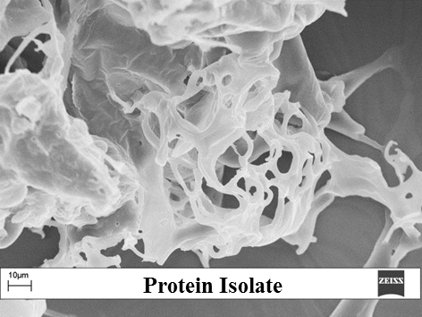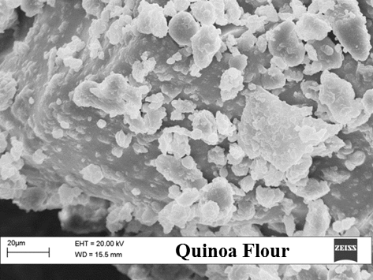

Morphological features of quinoa flour showed starch granules, varying in shape from polygonal, angular to irregular (Fig. 1). The dimensions of quinoa starch granules was mostly in the range of 0.4– 2.0 μm (Fig. 1), as reported also by other authors (Li and Zhu, 2018). Spherical or oblong shaped aggregates of quinoa starch were between 10–30 μm in size (Fig. 1). The formation of these aggregates may be largely due to the presence of protein because adding pepsin facilitated their disaggregation (Ruales and Nair, 1994).

As showed in Figure 1, the protein isolate appears as an bulky network of protein strands. In fact, the microstructure of protein isolate was aggressively interacted and large entanglements were formed (Fig. 1).

The microstructure analysis of the quinoa sample after leavening and baking processes by means of SEM are shown in Figure 2.

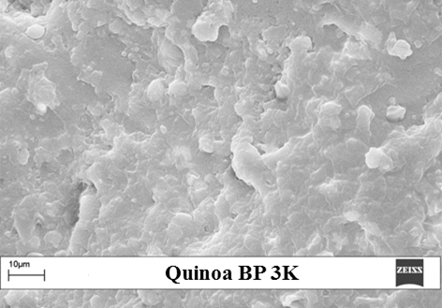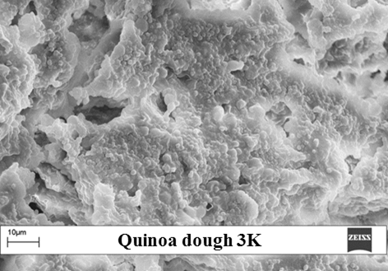

Figure 2: Scanning electron micrographs (SEM) of dough and bakery product (BP) at 3.0x.

As expected starch granules were less well visible and discernible in microstructure of dough (Fig. 2) than initial quinoa flour (Fig. 1). The quinoa dough in fact exhibits a pronounced protein matrix with embedded starch granules. This appearance agreed with Romano et al., (2013) description of a developed dough. During mixing, proteins start to interact with each other through hydrogen, ionic, hydrophobic and covalent bonds which lead to the formation of a cross linked network (Jekle and Becker, 2011). SEM image of quinoa bakery product (BP) showed gelatinized starch granules coated by a continuous protein matrix as observed previously by Romano et al. (2018).

* + 1. Chromatographic and electrophoretic analysis of quinoa flour proteins

In Figure 3 the HPLC chromatogram of proteins isolated from quinoa is reported, showing the high complexity of its composition. Due to the high heterogeneity, to achieve more detailed structural information, proteomic analysis was carried out by 1D-- and 2D- electrophoresis.

In Figure 4 the SDS electrophoretic profiles of proteins extracted from quinoa flour, dough and BP and 2-D electrophoresis of quinoa seed protein isolate were reported.



Figure 3. HPLC chromatogram of quinoa protein isolate.

The most abundant polypeptide components presented a molecular mass in the range 30-40 kDa and 20-25 kDa (Fig. 4A), which corresponded respectively to the acid and basic subunits of 11S globulins. The polypeptides of molecular weight of about 15 KDa corresponded to 2S albumins as also reported by other studies (Abugoch, 2009). In quinoa protein isolate, profile the intensity of the bands increased and that confirmed its high grade of purity. The protein fraction soluble at pH 5 contained 11S globulin chains, but especially 2S albumins. Data at higher molecular detail were provided by 2D electrophoretic analysis (Fig. 4B) that revealed an extremely complex proteomic pattern which deserve further investigation. The protein fraction soluble at pH 5 contained 11S globulin chains, but especially 2S albumins.

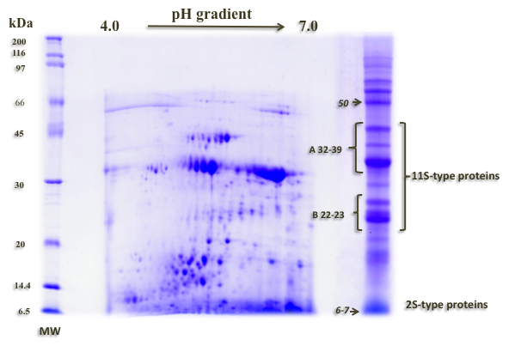

Figure 4: (A) SDS-PAGE analysis of: 1) quinoa flour; 2) dough of quinoa flour; 3) bakery product of quinoa; (B) 2-D Electrophoresis (SDS 12% acrylamide; IPG range 4.0-7.0) of quinoa seed protein isolate.

**3.7. Simulated gastrointestinal digestion**

LC-MS/MS analysis of peptide gastrointestinal digests of either flour and bakery product showed that only a few peptides survived simulated digestion process indicating the high digestibility of quinoa protein. The MS/MS spectrum with the partial sequence of one of peptides having the C-terminal sequence, Pro-His-Val-Lys-His-Lys, identified in both flour and bakery product is reported in Figure 5.

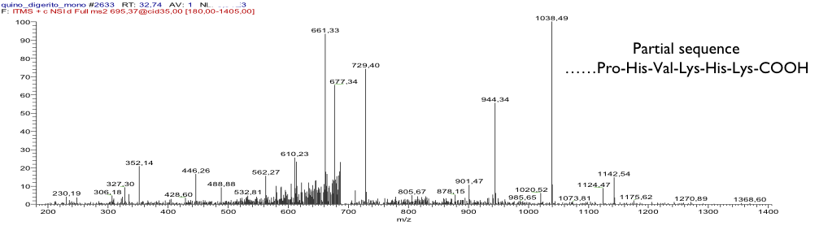

Figur*e 5: Fragmentation spectrum of one of the peptides identified by nano LC-ESI-MS/MS analysis of peptide gastrointestinal digests of quinoa flour and bakery product.*

This peptide derives from the parent protein fructan 6-exohydrolase-like of quinoa. None of resistant peptides was recognized by western blotting with sera of individuals allergic to cereals nor by in silico screening on allergenic sequence databases. Further investigation on the identity, bioavailability and on potential bioactivity of this and of the other resistant peptides might add more information on quinoa nutritional properties.

* 1. Conclusions

Bakery product exclusively based on quinoa flour, with a developed microstructure and valid nutritional properties was obtained. Data collected indicated that quinoa flour and bakery product had a high degree of digestibility and survival of only few resistant peptides. Besides, proteomic and R5 ELISA analyses showed absence of gluten, confirming the potential use of quinoa flour as novel and safe ingredient in substitutive dough formulations, e.g. in gluten-free bread making.

A more detailed knowledge on the allergenic properties of the product obtained needs to be acquired.

Acknowledgments

Thanks to Dr. A. Aiello for technical help and Giovanna Ameno for help in retrieving bibliographic references.

References

A.A.C.C., 2000, Approved methods of the AACC,10th ed., St. Paul, MN: American Association of Cereal Chemists (Methods 44-19, 46-30).

Abugoch J.L.I., 2009. Quinoa (Chenopodium quinoa Willd.): composition, chemistry, nutritional, and functional properties. Advances in Food and Nutrition Research, 58, 1 – 31.

Föste, M., Nordlohne, S.D., Elgeti D., Linden M.H., Heinz V., Jekle M., Becker T., 2014, Impact of quinoa bran on gluten-free dough and bread characteristics, [European Food Research and Technology](https://link.springer.com/journal/217), 239, 767 -775.

Graf B.L., Rojas-Silva P., Rojo L.E., Delatorre-Herrer J., Baldeón M.E., Raskin I., 2015, Innovations in health value and functional food development of quinoa (Chenopodium quinoa Willd.), Comprehensive Reviews in Food Science and Food Safety, 14, 431 – 445.

Jekle M., Becker T., 2011, Dough microstructure: novel analysis by quantification using confocal laser scanning microscopy, Food Research International, 44, 984 – 991.

Laparra, J.M., Haros, M., 2018, Inclusion of whole flour from Latin-American crops into bread formulations as substitute of wheat delays glucose release and uptake, Plant Foods for Human Nutrition, 73, 13 - 17.

Li G., Zhu F., 2018, Quinoa starch: Structure, properties, and applications, Carbohydrate Polymers, 181, 851 – 861.

Pellegrini M., Lucas-Gonzales R., Ricci A., [Fontech](https://www.sciencedirect.com/science/article/pii/S0926669017306829" \l "!) J., Fernández-López J., Pérez-Álvarez J.A., Viuda-Martos M., 2018, Chemical, fatty acid, polyphenolic profile, techno-functional and antioxidant properties of flours obtained from quinoa (Chenopodium quinoa Willd) seeds, [Industrial Crops and Products](https://www.sciencedirect.com/science/journal/09266690), [111](https://www.sciencedirect.com/science/journal/09266690/111/supp/C), 38 – 46.

[Pereira](https://www.sciencedirect.com/science/article/pii/S0308814618321721" \l "!) E., Encina-Zelada C., [Barrosa](https://www.sciencedirect.com/science/article/pii/S0308814618321721" \l "!) l., Gonzales-Barrona U., Cadavez V., Ferreira I. C.F.R., 2019, Chemical and nutritional characterization of Chenopodium quinoa Willd (quinoa) grains: A good alternative to nutritious food, Food Chemistry, [280](https://www.sciencedirect.com/science/journal/03088146/280/supp/C), 110 - 114.

Romano A., Cesarano L., Sarghini F., Masi P., 2013, The influence of arabinogalactan on wheat dough development during mixing and leavening process, Chemical Engineering Transactions, 32, 1765 - 1770.

Romano A., Giosafatto V., Di Pierro P., Romano R., Masi P., Mariniello L., 2016, Impact of transglutaminase treatment on properties and in vitro digestibility of white bean (Phaseolus vulgaris L.) flour, Food Research International, 88, 239 – 246.

Romano A., Masi P., Bracciale A., Aiello A., Nicolai M.A., Ferranti P., 2018, Effect of added enzymes and quinoa flour on dough characteristics and sensory quality of a gluten-free bakery product. European Food Research and Technology, 244(9), 1595 - 1604.

Romano A., Masi P., Pucci E., Oliviero V., Ferranti P., 2017, Encapsulated proanthocyanidins as novel ingredients, Chemical Engineering Transactions, 57, 1885 - 1890.

Romano, A., Ferranti, P., 2019, Sustainable Crops for Food Security: Quinoa (Chenopodium quinoa Willd.). In: Ferranti, P., Berry, E.M., Anderson, J.R. (Eds.), Encyclopedia of Food Security and Sustainability, vol. 1, pp. 399–402. Elsevier. ISBN: 9780128126875.

Ruales J., Nair B.M., 1994, Properties of starch and dietary fibre in raw and processed quinoa (Chenopodium quinoa, Willd) seeds, Plant Foods for Human Nutrition, 45, 223 – 246.

Turkut G.M., Cakmak H., Kumcuoglu S., [Tavman](https://www.sciencedirect.com/science/article/pii/S0733521016300376#!) S., 2016, Effect of quinoa flour on gluten-free bread batter rheology and bread quality, Journal of Cereal Science 69, 174 – 181.

Vilcacundo R., Hernández-Ledesma B., 2017, Nutritional and biological value of quinoa (Chenopodium quinoa Willd.),Current Opinion in Food Science, 14, 1 – 6.