CHEMICAL ENGINEERING TRANSACTIONS  VOL. 76, 2019 | A publication of
The Italian Association
of Chemical Engineering
Online at www.aidic.it/cet
Guest Editors: Sauro Pierucci, Jiří Jaromír Klemeš, Laura Piazza
Copyright © 2019, AIDIC Servizi S.r.l.
ISBN 978-88-95608-73-0; ISSN 2283-9216

Thermogravimetric Analysis of Different Semolina Doughs: Effect of Mixing Time and Gluten Content
Fabio Fanariª, Gianluca Carboni^{b}, Massimiliano Grosso^{a,*}, Francesco Desogusª
ªUniversity of Cagliari – Department of Mechanical, Chemical and Materials Engineering – Piazza d’Armi, 09123 Cagliari, Italy
^{b}Agris Sardegna - Agricultural Research Agency of Sardinia, Cagliari, Italy – Cagliari, Italy massimiliano.grosso@dimcm.unica.it

The thermal properties of different kinds of dough were investigated after different kneading times by means of Thermogravimetric Analysis (TGA). Two varieties of durum wheat semolina were used in this study: Alemanno and Cappelli. The doughs were prepared using a mixograph. The gelatinized flour fraction plays an important role on the thermal properties’ definition, while the mixing time influences the dough network building and consequently the starch gelatinization phenomena. Also, the amount of free water in the dough could be influenced by the mixing time. Thus, the TGA technique was applied in order to evidence the mass loss as a function of the increasing temperature and, from this, the free water content, the residual weight (related to the protein kind and content), and the weight loss rate, i.e. the peaks of the first derivative of the thermogravimetric curve (DTG), which appear at different temperatures and present different heights and positions, depending on the dough network force and extension. In such a way, it was possible to find some correlations between the dough characteristics, like the semolina composition (e.g. the gluten content and quality) and the mixing time, and the thermogravimetric analysis outputs. The results showed that the ratio between free and bond water is strongly dependent on both the mixing time and the semolina variety, and a clear evidence of the protein content in the dough is found because of the position and the size of the peaks in the DTG curve, in combination with the residual mass at fixed temperatures.
  - Introduction
Proteins, starch and water are the main components of semolina dough. When the ingredients are mixed, several kinds of interactions take place. Understanding the interactions among proteins, starch and water is useful to improve the dough characteristics and, consequently, the final product quality.
Thermal analysis is an interesting tool that allows to study the interactions among the dough components in terms of bond formation. Starch gelatinization and protein coagulation phenomena are the main responsible for the thermal properties of wheat doughs. These structures show an effect on the thermal behavior approximately in the same temperature range (55-80 °C) and moisture level. Regarding the proteins, the main role is played by gluten, which is composed by two fractions: the alcohol soluble gliadins, which mainly contribute to the viscosity, extensibility, and cohesiveness of the dough, and the alcohol insoluble glutenins, which are responsible for the dough elasticity (Drabińska et al., 2016). The ratio between gliadin and gluten is also important, as if it increases, the elasticity of gluten decreases. The gluten proteins are characterized by a temperature dependent equilibrium between two phases: a semi-solid one, prevailing at high temperatures, and a glassy solid one, prevailing at low temperatures; the physical change between these two phases is considered as a “glass transition”. The glass transition temperature (Tg) is the main parameter for understanding the mechanical properties of gluten proteins (Leòn et al., 2003). Starch, the major component of wheat flour, making up about 80% of its dry weight, influences the dough rheological properties, especially upon heating in the presence of water when starch gelatinizes (Li and Yeh, 2001). The gelatinization process causes the transition of insoluble starch granules to a solution composed of individual molecules (León et al., 2003). Gelatinization of starch is a cooperative process, in such a way that structural relations between amorphous and crystalline regions within the starch granules are responsible for the sharpness of thermal transition and the temperature at which it occurs (Romano et al., 2015).
The quality of semolina doughs is related to the interactions between starch and proteins in the presence of water (Güler et al., 2002). Starch gelatinization is influenced by the presence of other ingredients that affect the water activity. Some ingredients, such as sugar, salt, and proteins, compete with starch for the available water in the system and affect its gelatinization (Avramenko et al., 2018). Protein and gluten influence the gelatinization parameters of starch and the water behaviour (Romano et al., 2015). Furthermore, starch gelatinization and protein coagulation are competitive and antagonistic (Huault et al., 2019). The interactions between starch and proteins are a consequence of the attraction between positively and negatively charged colloids in an acidic environment, and the modification of wheat proteins due to heating result in a loss of protein binding to the starch and in a decrease of the interactions (Mohamed and Rayas-Duarte, 2003). So the starch gelatinization peak temperature increases and the enthalpy decreases, in the presence of gluten proteins. In addition, the peak temperature increases as the ratio between gluten and starch increases (Mohamed and Rayas-Duarte, 2003). The thermal stability of the gluten decreases with increasing in the level of gliadins and their transition also shifts to lower temperatures; the changes in the starch gelatinization parameters are believed to be due to the less amount of available water in the presence of gluten (Khatkar et al., 2013)
Water is added to hydrate the flour, for the gluten formation and to hydrate the starch so that it can gelatinize. These events result in the formation of the basic structure of a baked product. Starch and gluten are complex chemical polymers and hence their interaction with water is complex (Li and Yeh, 2001). Both the amount and the mobility of water are recognized to have a crucial role in starch gelatinization, in the formation of the gluten network (Fessas and Schiraldi, 2001), in the thermal stability of proteins (Romano et al., 2015) and in the glass transition temperature (Khatkar et al., 2013). Also, the mixing process and its conditions are important to determine the amount of free and binding water, because all the interactions among the dough components are established during mixing. An insufficiently developed dough results in a higher free water content because the latter has no time enough to react with the flour proteins and with the soluble components in the system. Therefore, the thermal properties are influenced by these interactions and, consequently, by the free water amount. The time required for the optimum dough development is also positively correlated with the polymeric protein composition and the ratio between protein polymers and monomers (Angioloni and Dalla Rosa, 2005).
To summarize, the flour components influence the properties of the finished product. Also, the process conditions affect the quality of the final product. TGA measures the change in weight caused by the loss of water and by the product degradation due to the structural interactions breaking. The TGA can be a useful tool to characterize the dough and to understand which kind of bonds and consequently of structures were formed during kneading, and how the relative amount of the different components influences their building.
  - Materials and methods
Semolina and water were mixed in a mixograph (National Manufacturing, Lincoln, NB) with 10 g of flour capacity. The quantity of added water was 50% based on the semolina weight. Two kinds of semolina from Italian monovarietal durum grains, Alemanno (A) and Cappelli (C), were mixed with water taking into account three different times of kneading: the optimum time (2 min for C, 4 min for A), half of the optimum time and twice the optimum time. This choice was made to study the thermal properties of a well (optimally) developed, an undeveloped and an overdeveloped dough. The optimum time on mixograph corresponds to the optimal kneading time of the sample at which the mixing process and the building of the network are completed and the strength of the dough results to be the highest. The properties of the semolina under study (protein and gluten content, and gluten index) are reported in Table 1. The gluten index (GI) is a parameter that provides simultaneous information about the gluten quality and quantity and it expresses the weight percentage of the wet gluten remaining on a sieve after automatic washing with salt solution and centrifugation (Oikonomou et al., 2015). The main method applied in the measurement of GI is the AACC Int. 38-12A or ICC Standard method 137-1 (Williams et al., 2008). The gluten index works as a criterion defining whether the gluten quality is weak (GI < 30%), normal (GI between 30 and 80%), or strong (GI > 80%) (Cubadda et al., 1992). Different kinds of wheat with a similar protein content can be classified according to the GI value. In other words, the GI is related to the protein network strength.
For each sample, a small quantity (about 100 μg) of dough (prepared just before) was put into an alumina crucible and inserted into the TGA device (TA Instruments, SDT-Q600), then the sample was heated up to 600 °C with a temperature ramp of 5 °C/min. For each run, the weight loss of the sample was registered and then the percentage reduction and the derivative of the latter with respect to the temperature were calculated. After this, two main peaks in the derivative curve (DTG) were individuated and characterized with the following parameters: peak temperature, height and integral. For the first peak (peak 1) also the quantification of the left and right (with respect to the peak temperature) integrals was performed, while for the second one (peak 2) an estimation of the temperature range (considered for the integral computation) was done. Peak temperatures and heights were determined by means of a regression curve (second or third grade polynomial) in a strict range around the peak; integrals were determined as the total weight loss percentage between the considered temperature range limits; the temperature range was conventionally fixed in 25-200 °C for the first peak and determined for the second one from the intersections between the abscissa axis and the tangent passing for the inflection point of each (ascending and descending) part of the curve around the peak.

Table 1: Properties of semolina
 | Proteins (%) | Gluten (%) | Gluten Index (%)
Alemanno (A) | 11.8 | 9.3 | 47.12
Cappelli (C) | 11.2 | 8.5 | 37.32
  - Results and discussion
The results of TGA, i.e. the weight reduction calculated as of the percentage reduction with respect to the initial weight of the sample, and its derivative with respect to the temperature, are shown for Alemanno semolina dough (Figure 1) and Cappelli semolina dough (Figure 2). Furthermore, the height of the two main peaks and the peak temperature for each sample are shown in Figures 3 and 4. In addition, in Table 2, the other parameters of the two peaks for each sample are reported: the normalized (with respect to the optimum) kneading time (“Norm. time”), the upper (T_{up}) and the lower temperature integration limit (T_{low}) and the integral value and, only for peak 1, the percentage of the integral at left (left integral) and at right (right integral) with respect to the peak temperature; finally, also the weight reduction at the final temperature of 600 °C (“Fin. w. red.”) is shown in the last column.
By observing the DTG curves (Figures 1 and 2) and the data in Table 2, first, it can be noted that they present two main peaks: the first one (peak 1) is in the temperature range 105-115 °C, the second one (peak 2) in the range 290-300 °C. Moreover, looking at the weight reduction curves (Figures 1 and 2), it can be observed that the first reduction, between 50 and 120 °C, is faster for the samples which were obtained at the optimum kneading time, in fact, the absolute value of the slope of the curve is higher for these samples.
The peak 1 is linked to the water evaporation (Wang et al., 2018), that is due to the presence of free water, but also to the starch gelatinization that occurs at about 45 °C, but its effects are not completely visible up to gelatinization and gluten reticulation are almost complete, at about 85-90 °C, as shown by Blanco Canalis et al. (2019). For the A semolina dough, the peak 1 occurs at higher temperatures as the kneading time increases, varying from 106.2 to 110.3 °C (Figure 3a). In the case of the C semolina dough, instead, the maximum peak temperature (110.0 °C) showed for the optimum kneading time, and the minimum value (105.2 °C) is still that of the undeveloped dough (Figure 3a).
The peak 2 is linked to the sample destruction and in particular to protein and gluten denaturation that occurs at about 292 °C (Nawrocka et al., 2017). For this peak, the differences in the peak temperature for the different mixing times are smaller than those of the peak 1, moreover, the peak temperature tends to decrease as the kneading time increases (Figure 4a).
Analyzing the data of peak heights in Figure 3b, it can be noted that the samples kneaded till the optimum time shown the lower height of the peak 1, whilst the under-mixed sample presents a very higher peak height value if compared with the other two samples both for A and C semolina doughs. This phenomenon can be related to the higher presence of free water in the undeveloped dough, since the peak temperature is slightly higher than the water normal boiling point (Roozendaal et al., 2012). Regarding the second peak height values, reported in Figure 4b, these are much more stable with the mixing time, because the total protein content is not dependent on the kneading process.
Also, the value of weight reduction at 600 °C, reported in Table 2, is more stable, and so less indicative, as the mixing time was varied.
The peak integral values, reported in Figure 5, tend to decrease with the mixing time increasing for the peak 1; the peak 2 integral values, instead, present a minimum for the well-developed dough. Regarding the peak 1, the left portion of the integral (see Table 2) is maximum for the well-developed dough of both A and C semolina kinds, so confirming the higher strength of the gluten network in the case of optimum time mixed samples.
For the A semolina dough, the peak 2 occurs at higher temperatures than C semolina dough, probably due to the higher content of gluten in the A semolina. The peak 1 heights and temperatures are quite similar for the two kinds of semolina, showing that they are mainly influenced by the water content, with is the same in the two cases. The peak 2 heights are higher for C semolina samples, and this phenomenon is probably linked to the higher strength of the gluten network of A semolina doughs, that have also a slower weight reduction. The weight reduction at 600 °C is higher for A semolina doughs for its higher protein content. Regarding the integral values for the peak 1, A semolina samples showed a higher value of the integral and a bigger portion on the left. For the peak 2 integral, instead, the C semolina samples showed a slightly higher value.

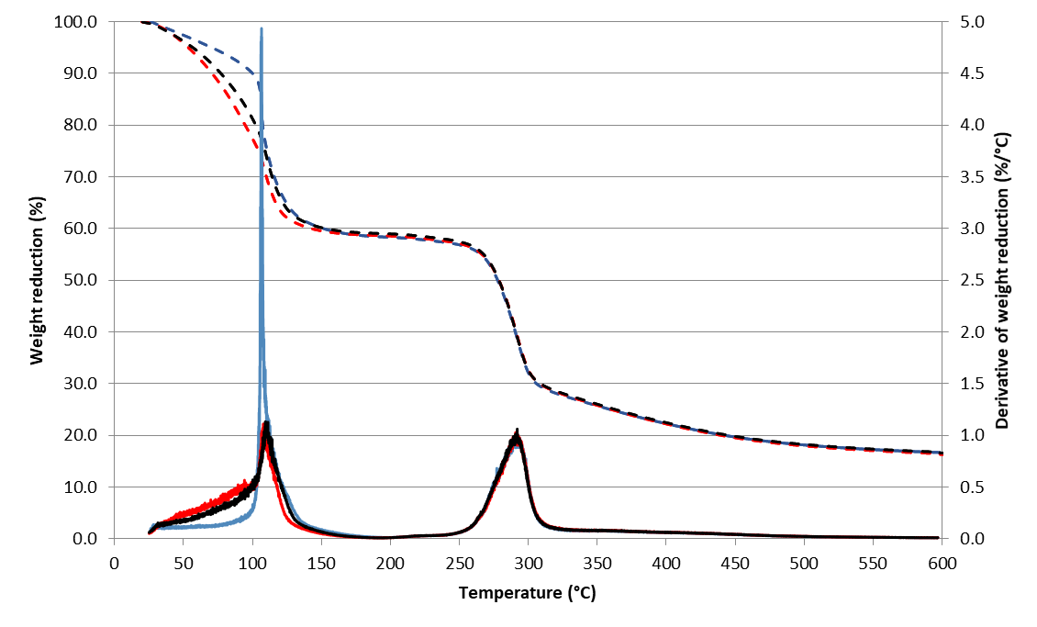
Figure 1: Weight reduction percentage (dashed lines) and derivative of weight reduction percentage with respect to the temperature (continuous lines) as a function of temperature for Alemanno semolina dough samples kneaded for 2 min (–), 4 min (–) and 8 min (–).

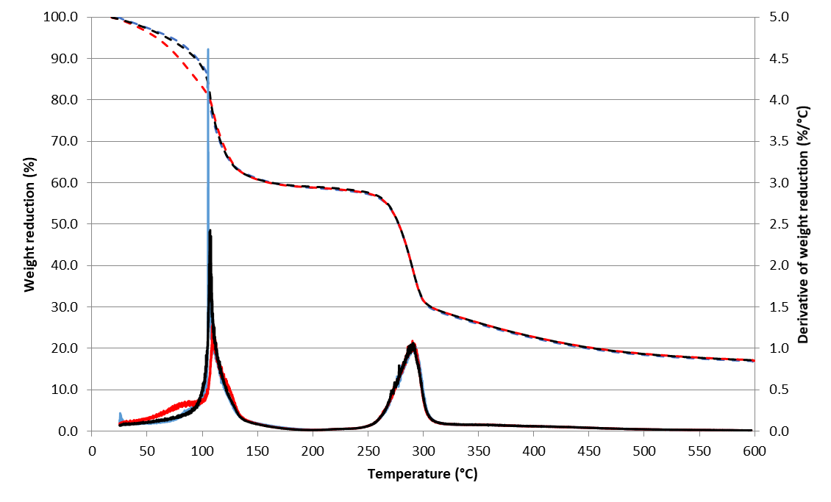
Figure 2: Weight reduction percentage (dashed lines) and derivative of weight reduction percentage with respect to the temperature (continuous lines) as a function of temperature for Cappelli semolina dough samples kneaded for 1 min (–), 2 min (–) and 4 min (–).

Table 2: DTG curve peak parameters
 |  | Peak 1 |  |  |  |  |  | Peak 2
Sample | Norm. time |  | T_{up} (°C) | Left integral | Right integral | Integral (total) | T_{low} (°C) |  | T_{up} (°C) | Integral | Fin. w. red. (%)
A - 2 min | 0.5 |  | 200 | 0.403 | 0.596 | 41.708 | 255.75 |  | 310.44 | 27.214 | 16.528
A - 4min | 1.0 |  | 200 | 0.684 | 0.315 | 41.456 | 257.64 |  | 310.64 | 26.872 | 16.295
A - 8 min | 2.0 |  | 200 | 0.638 | 0.362 | 41.058 | 255.86 |  | 309.70 | 27.175 | 16.586
C - 1 min | 0.5 |  | 200 | 0.456 | 0.544 | 41.242 | 255.57 |  | 308.00 | 27.302 | 16.787
C - 2 min | 1.0 |  | 200 | 0.561 | 0.439 | 41.151 | 255.70 |  | 306.94 | 26.956 | 17.024
C - 4 min | 2.0 |  | 200 | 0.470 | 0.529 | 40.970 | 255.36 |  | 307.70 | 27.307 | 16.982

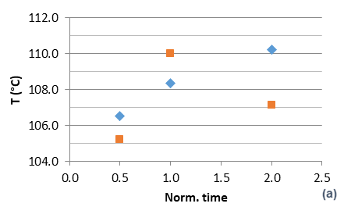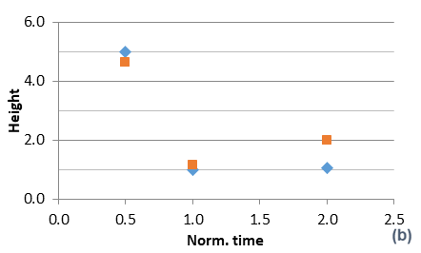
Figure 3: Peak 1 temperature (a) and height (b) as a function of the normalized kneading time for the Alemanno (♦) and Cappelli (■) semolina dough.

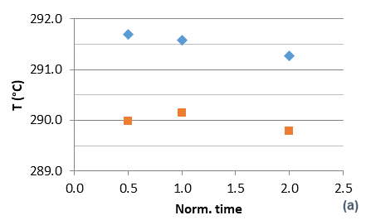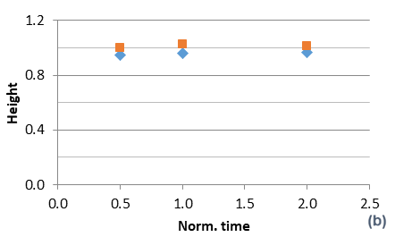
Figure 4: Peak 2 temperature (a) and height (b) as a function of the normalized kneading time for the Alemanno (♦) and Cappelli (■) semolina dough.

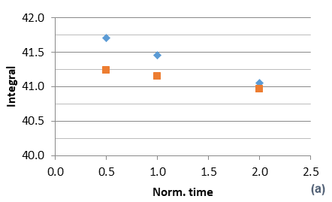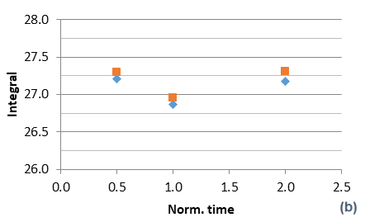
Figure 5: Peak 1 (a) and peak 2 (b) integral values reported as a function of the normalized kneading time for the Alemanno (♦) and Cappelli (■) semolina dough.
  - Conclusions
The thermogravimetric analysis, conducted on two different kinds of semolina dough with different gluten content, and on samples obtained after different kneading times, revealed to be an interesting tool to show the differences in the dough characteristics, mainly due to the different composition and availability of water, which changes during the molecular network building.
The mixing (kneading) time is mainly revealed in the peak 1 shape and position, as both the free water availability and the dough network building (starch gelatinization and gluten reticulation) status are changing during the kneading process. In particular, when the mixing time increases, the peak temperature increases and the height decreases, since the free water availability is decreasing.
On the other side, the gluten content and index mainly showed their influence on the peak 2, that presents the highest temperatures for the variety (A) with the higher values of the gluten parameters, and for which the highest differences were found depending on the semolina variety, while the contribution of the kneading time, even if detected, is almost negligible with respect to the previous one.
References
Angioloni A., Dalla Rosa M., 2005, Dough thermo-mechanical properties: influence of sodium chloride, mixing time and equipment, Journal of Cereal Science, 41(3), 327-331.
Avramenko N. A., Tyler R. T., Scanlon M. G., Hucl P., Nickerson M. T., 2018, The chemistry of bread making: The role of salt to ensure optimal functionality of its constituents, Food Reviews International, 34(3), 204-225.
Blanco Canalis M. S., León A. E., Ribotta P. D., 2019, Incorporation of dietary fiber on the cookie dough. Effects on thermal properties and water availability, Food Chemistry, 271, 309-317.
Cubadda R., Carcea M., Pasqui L. A., 1992, Suitability of the gluten index method for assessing gluten strength in durum wheat and semolina, Cereal Foods World, 37 (12), 866–869.
Drabińska N., Zieliński H., Krupa-Kozak U., 2016, Technological benefits of inulin-type fructans application in gluten-free products–A review, Trends in Food Science & Technology, 56, 149-157.

Fessas D., Schiraldi A., 2001, Water properties in wheat flour dough I: classical thermogravimetry approach, Food Chemistry, 72(2), 237-244.
Güler S., Köksel H., Ng P.K.W., 2002, Effects of industrial pasta drying temperatures on starch properties and pasta quality, Food Research International, 35, 421-427.

Khatkar B. S., Barak S., Mudgil D., 2013, Effects of gliadin addition on the rheological, microscopic and thermal characteristics of wheat gluten, International Journal of Biological Macromolecules, 53, 38-41.
Huault L., Vésinet M., Brogly M., Giampaoli P., Bistac S., Bosc V., 2019, Adhesion of Bread Dough to Solid Surfaces Under Controlled Heating: Balance Between the Rheological and Interfacial Properties of Dough, Journal of food science, 84(3), 499-506.
Li J.Y., Yeh A. I., 2001, Relationships between thermal, rheological characteristics and swelling power for various starches, Journal of Food Engineering, 50, 141–148.
León A., Rosell C. M., De Barber C. B., 2003, A differential scanning calorimetry study of wheat proteins, European Food Research and Technology, 217(1), 13-16.
Mohamed A.A., Rayas-Duarte P., 2003, The effect of mixing and wheat protein/gluten on the gelatinization of wheat starch, Food Chemistry, 81, 533–545.
Nawrocka A., Szymańska-Chargot M., Miś A., Wilczewska A. Z., Markiewicz K. H., 2017, Effect of dietary fibre polysaccharides on structure and thermal properties of gluten proteins–A study on gluten dough with application of FT-Raman spectroscopy, TGA and DSC, Food Hydrocolloids, 69, 410-421.
Oikonomou N. A., Bakalis S., Rahman M. S., Krokida M. K., 2015, Gluten index for wheat products: Main variables in affecting the value and nonlinear regression model, International journal of food properties, 18(1), 1-11.

Romano A., Di Luccia A., Romano R., Sarghini F., Masi P., 2015, Microscopic and thermal characteristics of experimental models of starch, gliadins, glutenins and gluten from semolina, Chemical Engineering Transactions, 43, 163-168.
Roozendaal H., Abu-hardan M., Frazier R. A., 2012, Thermogravimetric analysis of water release from wheat flour and wheat bran suspensions, Journal of Food Engineering, 111(4), 606-611.
Wang Y., Zheng Q., Li W., Ma Y., Zhao X., Zhang C., 2018, Measurement of free water in foods by secondary derivative thermogravimetry, CyTA-Journal of Food, 16(1), 438-443.

Williams P., Lindhauer M.G., Poms R.E., Wehling R.L., Bergthaller W., Gaines, C.S, 2008, The joint AACC InternationalICC Methods Harmonization project, Cereal Foods World, 53(2), 99–102.

