CHEMICAL ENGINEERING TRANSACTIONS  VOL. 76, 2019 | A publication of
The Italian Association
of Chemical Engineering
Online at www.aidic.it/cet
Guest Editors: Sauro Pierucci, Jiří Jaromír Klemeš, Laura Piazza
Copyright © 2019, AIDIC Servizi S.r.l.
ISBN 978-88-95608-73-0; ISSN 2283-9216

Influence of wheat varieties, mixing time and water content on the rheological properties of semolina doughs
Fabio Fanariª, Ilaria Frauª, Francesco Desogus^{a*}, Efisio Antonio Scano^{b}, Gianluca Carboni^{c}, Massimiliano Grossoª
ªUniversity of Cagliari – Department of Mechanical, Chemical and Material Engineering – Piazza d’Armi, 09123 Cagliari, Italy
^{b}University of Sassari – Department of Agricultural Sciences – Viale Italia 39, 07100 Sassari, Italy
^{c}Agris Sardegna - Agricultural Research Agency of Sardinia – Cagliari, Italy
f.desogus@dimcm.unica.it
In the present study, the rheological properties of doughs obtained from semolina produced by milling different wheat varieties of durum grains (Cappelli and Alemanno) were investigated. The dough was prepared by mixing the semolina with water in a mixograph. Rheological frequency sweep measurements were carried out by considering different mixing times and water amounts. The experimental data were analyzed by means of the weak gel model, whose parameters may be directly related to the force and the extension of the gluten network, that is developing during the mixing operation. It was found that the doughs obtained from the different wheat varieties showed a not trivial rheological behavior with the mixing time, that depends on the wheat variety. It was also found that the network force and extension appear to be negatively correlated to the water content, and doughs with higher water content present lower viscosities. The weak gel parameters were modelled as a function of mixing time using an exponential law which demonstrates to adequately describe and quantify the influence of kneading time and water content on the rheological properties of dough.
  - Introduction
Bakery products and pasta are common foods in the human diet, all over the world. Since the industrialization of these productions has taken care, the problem of understanding, controlling and modelling the process of baking has fostered the research about this topic (Zhang and Datta, 2006). In industrial production, acquiring knowledge of the dough properties is a very important procedure, useful to define the technological equipment, to optimize and set up the process (Ross et al., 2004). In particular, rheological measurements are fundamental to investigate the viscoelastic properties and simulate the material response to the complex flow and deformation conditions often found in practical processing situations (Dobraszczyk and Morgenstern, 2003). The rheological characterization allows to predict the dough behavior during its preparation and, in turn, control its suitability for the production process. In particular, the process of kneading is crucial in the definition of the rheological properties of dough since it promotes the gluten network building in addition to allowing the mixing of the ingredients and the formation of a homogeneous and coherent mass. In mixing and kneading, the dough is stretched through the application of mechanical energy (Zheng et al., 2000). Such energy allows different conformational arrangements of the key biopolymers (particularly gluten proteins) which are present in the system and promotes interactions among the constituents (proteins, starch, and water) of the dough (Maache-Rezzoug et al., 1998), leading to the three-dimensional gluten network, that is a cohesive structure in which the starch globules are embedded (Park et al., 2009). This network is responsible for the viscoelastic properties of the dough and determines its machining properties and the final quality of the product (Contamine et al., 1995; Mani et al., 1992). As a consequence, the quality of bread and bakery products dough strongly depends on the mixing conditions (mixer type, rotation speed, mixing time and water content) and on the characteristics of the used flour (Ortolan and Steel, 2017). Considerable work has been performed with the aim of studying the components of wheat flour and their influence on the dough rheological properties (Mani et al., 1992).
Many studies have been focused on the protein fractions of gluten, glutenin, and gliadin. Also, the interactions of the gluten proteins with other components, such as water and the water-soluble fraction of the flour, are important in developing the viscoelastic characteristics of the mixed dough (Romano et al., 2015). Indeed, there is a competition among the components to bind with water, which makes the quantity in the dough of the latter one a critical factor (Mani et al., 1992). Due to its polarity, water acts both as a solvent and as a medium for reactions among components. Since gluten itself is hydrophobic, the role of the water-soluble fraction is very important for the distribution of water and the production of dough with the desired elasticity. However, water also determines the conformation of the components based on hydrophobic interactions (Hoseney, 1986). Moreover, water is a mobility enhancer: according to its low molecular weight, as the water content is increased, the volume of inclusions increases and viscosity decreases (Levine and Slade, 1990). Bloksma (1990) claims that the final quality of bakery products depends on viscosity and extensibility of the dough. In particular, the dough should present a viscosity large enough to prevent the releasing of gas produced in the leavening process, and sufficient extensibility for a time long enough during baking to avoid an early rupture of membranes dividing the gas cells. Extensibility properties are depending on the quality and quantity of proteins in the flour (Uthayakumaran et al., 2000; Dobraszczyk and Roberts, 1994; Barak et al., 2014). Taking into consideration all these aspects, it is clear that a rheological characterization of dough during the kneading phase is difficult to be carried out. Indeed, despite the importance of mixing in the development of rheological properties and texture in doughs, there is very little information in the literature on these changes happening during the different stages of the mixing process, and most of the work has been focused on empirical measurements, even if connected with rheology, performed during mixing, such as the mixer motor torque, voltage or power consumption.
The aim of the present study is to characterize the dough at different steps of mixing through rheological fundamental measurements and, subsequently, to address an empirical modelling of the time changing rheological properties during the mixing process. The study is focused on two different kinds of durum wheat semolina used in the production of a typical Sardinian bread called “carasau”.
  - Dough Rheology
Dough is a viscoelastic, time-dependent material (Mani et al., 1992) which combines the properties of a Hookean solid with those of a non-Newtonian viscous fluid. Its viscoelastic behaviour is non-linear and stress is a function of both the applied strain and the strain rate (Faridi and Faubion, 2012). With this regard, there are several fundamental rheological tests proposed in the literature. The most common categories are: (i) small deformation dynamic shear oscillation; (ii) small and large deformation shear creep and stress relaxation; (iii) large deformation extensional measurements; (iv) flow viscometry (Dobraszczyk and Morgenstern, 2003). Dynamic oscillation measurements are certainly the most used fundamental rheological techniques to characterize cereal doughs and batters. These tests are usually operated in the linear viscoelastic region of deformation at small strains, in the order of up to 1% (Amemiya and Menjivar, 1992). Frequency sweep measurements can give useful insights on the force and extension of the gluten network, that is developing during the mixing operation.
    - Weak Gel Model
Gabriele et al. (2001) proposed a theoretical model that can be representative of the entire food class, consisting in the description of a three-dimensional network extending throughout the continuous medium and whose variations reflect on the rheological behavior. The model describes the performance of the viscoelastic food module according to the frequency and it results from the coupling of the Winter gels theories (Winter, 1987), descriptive of the behavior of materials such as gels and colloidal substances, and those of Bohlin (Bohlin, 1980; Mita, 1986) about the substances flow. The weak gel, due to its structural conformation, under conditions of low stresses or deformations, behaves predominantly as a solid (“strong gel”); on the contrary, at high deformations, the interactions are broken and the material flows like a liquid (Gabriele et al., 2006). According to this, foods at low frequencies (0.1 - 100 Hz) can be assimilated to weak gels, due to their linear behavior in this frequency range. Unlike gels, however, the rheological behavior of foods also presents an important viscous component. According to the model, the complex shear modulus can be described as a function of the frequency $ω$:

$$G^{*}\left(ω\right)=\sqrt{{G^{'}\left(ω\right)}^{2}+{G^{''}\left(ω\right)}^{2}}=A_{F} ω^{1/z}$$ | (1)
where A_{F} is a parameter related to the strength of the interactions among the flow units (i.e. the strength of the structure), whilst z is linked to the extension of the three-dimensional network (Gabriele et al., 2001). In the literature there are several examples of the application of the Weak Gel model to food rheology studies, for example, to describe the properties of fig molasses (Gabriele et al., 2006) or of chocolate (Baldino et al., 2010).
  - Materials and Methods
The experimental setup consisted in two main phases, as summarized in Figure 1: the dough preparation by a mixograph, trackable through the mixogram, and the rheological analysis, devoted to obtain the Weak Gel model parameters.

Figure 1: Scheme of the experimental setup and procedure: mixograph (a), mixogram (b), rheometer with parallel plate configuration (c), complex shear modulus experimental data collection (d).

For dough kneading, a mixograph (National Manufacturing, Lincoln, NB) with 10 g of flour capacity was used. Different quantities of 99.9% distilled added water were investigated: 50, 55, and 60% (based on the semolina weight). Two kinds of semolina from Italian monovarietal durum grains, Alemanno (A) and Cappelli (C), were selected and mixed with water. The rheological properties of the dough were investigated at 7 different times of kneading: 2, 4, 6, 10, 12, 15 and 20 minutes. The properties of semolina under study (protein content, gluten content and gluten index) are reported in table 1. The gluten index (GI) is a measurement that provides a simultaneous determination of the gluten quality and quantity (AACC, 2000). It can be used as a criterion defining whether the gluten quality is weak (GI < 30%), normal (GI = 30–80%), or strong (GI > 80%) (Cubadda et al., 1992). Wheat with similar protein contents can be classified according to GI values. In other words, GI has been correlated with protein strength variables.
Rheological measurements were performed on the doughs kneaded by the mixograph using an MCR 102 Anton-Paar rheometer (Anton Paar GmbH, Austria), equipped with a 25 mm parallel plate configuration. After kneading, a piece of dough was loaded to the rheometer and compressed to a thickness of 2 mm. Then the sample was left at rest for 15 minutes to allow the material relaxation (Phan-Thien and Safari-Ardi, 2006). A layer of silicon oil was applied to the edge of the sample in order to prevent the water evaporation and so the sample drying. The measurement temperature in the rheometer was kept constant to 25 °C by a Peltier technology based heating system. Frequency sweeps were performed varying frequency from 0.1 to 100 rad/s with a constant strain of 0.1% that is the estimated linear viscoelastic limit (LVE) according to preliminary amplitude sweep tests. Complex module data, obtained by the frequency sweep tests, were modelled as a function of frequency by means of the Weak Gel model, computing values of A and z parameters. The values of such parameters as a function of the mixing time were also modelled using the following empirical exponential law:

$$A\left(t\right)= K_{A∞}+(K_{A0}-K_{A∞})e^{\left(-\frac{t}{τ_{A}}\right)}$$ | (2)
$$z\left(t\right)= K_{z∞}+(K_{z0}-K_{z∞})e^{\left(-\frac{t}{τ_{z}}\right)}$$ | (3)

where $K_{A∞}$ and $K_{z∞}$ are the parameter values of A and z, respectively, for $t→∞$, $K_{0}$ for $t=0$, and $τ$ is the characteristic time.

Table 1: Properties of semolina
 | Proteins (%) | Gluten total (%) | Gluten Index (%)
Alemanno | 11.8 | 9.3 | 47.1
Cappelli | 11.2 | 8.5 | 37.3
  - Results
As shown in Figure 2a, the loss and storage modules change quite linearly with frequency in the considered interval. For sake of brevity, frequency sweep measurements for only two samples are reported, that correspond to the Alemanno semolina dough after 6 and 15 minutes of kneading. However, the same qualitative behaviour was found for all the samples collected during the experimental campaign. Taking into account this, it can be concluded that the Weak Gel model is appropriate to describe the complex modulus variation as a function of frequency, as confirmed by the regressions for the same samples, showed in Figure 2b. The parameters A and z and the exponential fitting curve obtained for each semolina are reported in Figures 3 and 4. The calculated values of the exponential law parameters are also reported in tables 2 and 3.
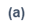
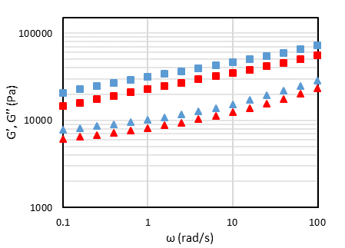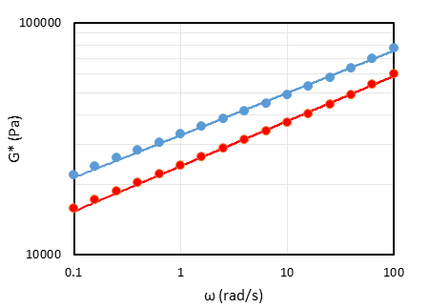Figure 2: Storage (squares) and loss (triangles) modulus (a), complex modulus (circles) and Weak Gel model curves (lines) (b) reported as a function of frequency for Alemanno semolina doughs. The blue colour represents the sample mixed for 6 minutes, while the red colour the sample mixed for 15 minutes.

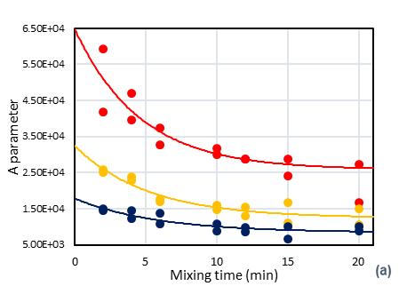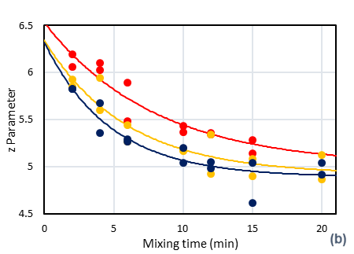Figure 3: Parameter A (a) and z (b) reported as a function of the mixing time for 50% (•), 55% (•) and 60% (•) of water for Alemanno semolina doughs. The lines of the same colour of the points represent the exponential law model for those data.

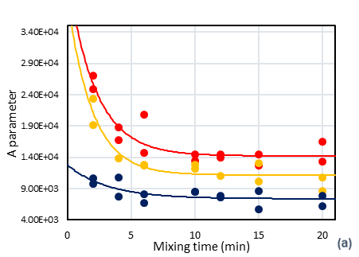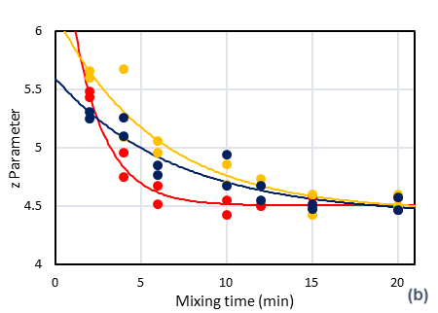Figure 4: Parameter A (a) and z (b) reported as a function of the mixing time for 50% (•), 55% (•) and 60% (•) of water for Cappelli semolina doughs. The lines of the same colour of the points represents the exponential law model for those data.

Table 2: Exponential law fitting parameters for the A parameter of the Weak Gel model for the Alemanno (A) and Cappelli (C) semolina doughs (the percentage next to the sample acronym represents the water content)
 | A 50% | A 55% | A 60% | C 50% | C 55% | C 60%
K∞ (∙10⁻⁴) | 2.581 | 1.242 | 0.837 | 1.422 | 1.117 | 0.738
K₀ (∙10⁻⁴) | 6.470 | 3.237 | 1.780 | 4.279 | 3.927 | 1.279
$$τ$$ | 4.581 | 5.191 | 5.842 | 2.214 | 1.942 | 3.199
R² adj | 0.776 | 0.852 | 0.739 | 0.817 | 0.862 | 0.376
Table 3: Exponential law fitting parameters for z parameter of the Weak Gel model for the Alemanno (A) and Cappelli (C) semolina dough (the percentage next to the sample acronym represents the water content)
 | A 50% | A 55 % | A 60 % | C 50% | C 55 % | C 60 %
K∞ | 5.011 | 4.919 | 4.899 | 4.503 | 4.452 | 4.421
K₀ | 6.531 | 6.342 | 6.319 | 7.297 | 6.146 | 5.595
$$τ$$ | 7.944 | 5.939 | 4.777 | 1.869 | 5.869 | 7.020
R² adj | 0.889 | 0.821 | 0.847 | 0.955 | 0.878 | 0.861
  - Discussion and Conclusions
The results in Figures 3 and 4 show a specific trend for the parameters of the Weak Gel model as a function of the mixing time. The trend is decreasing up to a value at which the parameter seems to stabilize at a constant value. This stabilization could be linked to the complete development of the glutinic network. The exponential law turned out as a good model to describe the A and z changes, with values of R² adj for the regression higher than 0.7, except for the A trend of the C 60% sample that presents a minor initial change. Regarding the influence of the water content, instead, it is observable from tables 1 and 2 that K∞ and K₀ decrease as the water content increases for both the semolina. The values of these parameters are higher for the Alemanno semolina, suggesting that the Alemanno dough network is stronger. $τ_{A}$ parameter increases for both semolina with an increasing in the water content. $τ_{z}$ parameter, on the contrary, decreases with the water content for the Alemanno semolina, whilst increases as the water content increases for the Cappelli semolina. These facts probably suggest that the optimal water quantity needed by the Cappelli semolina dough is smaller than that of the Alemanno one, probably due to the higher content of gluten of the Alemanno semolina that makes it able to bind a greater amount of water in a shorter time, and that an increase in the water quantity produces an increase in the characteristic time of the kneading process.
References
Approved methods of the American Association of cereal chemists, 2000, American Association of Cereal Chemists.
Amemiya J.I., Menjivar J.A., 1992, Comparison of small and large deformation measurements to characterize the rheology of wheat flour doughs, Journal of Food Engineering, 16, 91–108.
Baldino N., Gabriele D., Migliori M., 2010, The influence of formulation and cooling rate on the rheological properties of chocolate, European Food Research and Technology, 231(6), 821-828.
Barak S., Mudgil D., Khatkar B. S., 2014, Influence of gliadin and glutenin fractions on rheological, pasting, and textural properties of dough, International Journal of Food Properties, 17(7), 1428-1438.
Bloksma A. H., 1990, Rheology of the breadmaking process, Cereal Foods World, 2, 35, 228-236.
Bohlin L., 1980, A theory of flow as a cooperative phenomenon, Journal of Colloid and Interface Science, 74(2), 423-434.
Dobraszczyk B. J., Roberts C. A., 1994, Strain hardening and dough gas cell-wall failure in biaxial extension, Journal of Cereal Science, 20(3), 265-274.
Contamine A. S., Abecassis J., Morel M. H., Vergnes B., Verel A., 1995, Effect of mixing conditions on the quality of dough and biscuits, Cereal Chemistry, 72(6), 516-522.
Cubadda R., Carcea M., Pasqui L. A., 1992, Suitability of the gluten index method for assessing gluten strength in durum wheat and semolina, Cereal Foods World, 37 (12), 866–869.
Dobraszczyk B. J., Morgenstern M. P., 2003, Rheology and the breadmaking process, Journal of Cereal Science, 38(3), 229-245.
Faridi H., Faubion J. M., 2012, Dough rheology and baked product texture, Springer Science & Business Media.
Gabriele D., De Cindio B., D’Antona P., 2001, A weak gel model for foods, Rheologica Acta, 40, (2), 120-127.
Gabriele D., Migliori M., De Cindio B., 2006, Innovazione di processo nella produzione di melasse di fichi: approccio reologico, “Panta Rei” - Rivista della Società Italiana di Reologia. January-April.
Hoseney R.C., 1986, Yeast-leavened products, Chapter In: Principles of Cereal Science and Technology, American Association Cereal Chemists, St. Paul, MN, 203.
Levine H., Slade L., 1990, Influences of the glassy and rubbery states on the thermal, mechanical, and structural properties of doughs and baked products, Chapter In: Dough rheology and baked product texture, Springer, Boston, MA, 157-330.
Maache-Rezzoug Z., Bouvier J. M., Allaf K., Patras C., 1998, Study of mixing in connection with the rheological properties of biscuit dough and dimensional characterization of biscuits, Journal of Food Engineering, 35, 43–56.
Mani K., Tragardh C., Eliason A. C., Lindahl L., 1992, Water content, water soluble fraction, and mixing affect the fundamental rheological properties of wheat flour doughs, Journal of Food Science, 57, 1198–1200, 1209.
Mita T., 1986, Rheological and structural analysis of dispersion of foodstuffs, Journal of Texture Studies, 17(2), 113-139.
Ortolan F., Steel C. J., 2017, Protein characteristics that affect the quality of vital wheat gluten to be used in baking: A review, Comprehensive Reviews in Food Science and Food Safety, 16(3), 369-381.
Park S. H., Wilson J. D., Seabourn B. W., 2009, Starch granule size distribution of hard red winter and hard red spring wheat: Its effects on mixing and breadmaking quality, Journal of Cereal Science, 49(1), 98-105.
Phan-Thien N., Safari-Ardi M., 1998, Linear viscoelastic properties of flour–water doughs at different water concentrations, Journal of Non-Newtonian Fluid Mechanics, 74(1-3), 137-150.
Romano A., Di Luccia A., Romano R., Sarghini F., Masi P., 2015, Microscopic and thermal characteristics of experimental models of starch, gliadins, glutenins and gluten from semolina, Chemical Engineering Transactions, 43, 163-168.
Ross K. A., Pyrak-Nolte L. J., Campanella O. H., 2004, The use of ultrasound and shear oscillatory tests to characterize the effect of mixing time on the rheological properties of dough, Food Research International, 37(6), 567-577
Uthayakumaran S., Newberry M., Keentok M., Stoddard F. L., Bekes F, 2000, Basic rheology of bread dough with modified protein content and glutenin‐to‐gliadin ratios, Cereal Chemistry, 77(6), 744-749.
Winter H. H., 1987, Can the gel point of a cross‐linking polymer be detected by the G′–G ″crossover?, Polymer Engineering & Science, 27(22), 1698-1702.
Zhang J., Datta A. K., 2006, Mathematical modeling of bread baking process, Journal of Food Engineering, 75(1), 78-89.
Zheng H., Morgenstern M. P., Campanella O. H., Larsen N. G., 2000, Rheological properties of dough during mechanical dough development, Journal of Cereal Science, 32, 293–306.

