CHEMICAL ENGINEERING TRANSACTIONS  VOL. 76, 2019 | A publication of
The Italian Association
of Chemical Engineering
Online at www.aidic.it/cet
Guest Editors: Sauro Pierucci, Jiří Jaromír Klemeš, Laura Piazza
Copyright © 2019, AIDIC Servizi S.r.l.
ISBN 978-88-95608-73-0; ISSN 2283-9216

Biomaterial Based on Brewing Waste and Vegetable Resin: Characterization and Application in Product Design.
Claudia C F Monteiroª*, Bianca Malavazi^{b}, Maiara P Mendes^{c}, Kimberli, P Berwig^{c}, Ghiovani Z Raniero^{c}, Antonio R G Monteiro^{b}, Luis C Paschoarelli^{d}, Mike Clifford^{e}.
ªDesign Department, State University of Maringá, Av Colombo, 5790. 87020-900, Maringá-PR, Brazil
^{b}Food Engineer Department, State University of Maringá, Av Colombo, 5790. 87020-900, Maringá-PR, Brazil.
^{c}Food Science Post-Graduation Program, State University of Maringá, Av Colombo, 5790. 87020-900, Maringá-PR, Brazil.
^{d}Department of Design, São Paulo State University, Av. Eng. Luiz E. C. Coube, 14-01. 17033-360, Bauru-SP Brazil.
^{e}Faculty of Engineering, University of Nottingham, Room C52 Coates – University Park, NG7 2RD, Nottingham-UK
ccfmonteiro@uem.br

The beer industry produces more than 100 billion litres of waste a year worldwide; it is estimated to make more than 20 million tons of solid waste. This waste is destined mainly for animal feed. However, it is of low added value, and excessive use as a feed can be potentially dangerous for the health of the animals. An alternative is to develop consumer goods from the waste which adds value and could serve as advertising material for the beer. The objective of this work was to develop and characterise a biomaterial from the brewing residue and vegetable resin and to develop products for use in pub environments. Six formulations were tested, S1 as a control with 100% of vegetable resin, S2, S3 and S4, with respectively 10, 25 and 40% of brewing waste (milled between 28 and 60 mash tiler) replacing the vegetable resin. The formulations S5 and S6 were made with 40% of brewing waste but milled between 14 and 28 tiller and > 60 tiller respectively. The mixtures were placed in rectangular shape silicon moulds. Commercially available Medium Density Fireboard (MDF) (one of the most used materials in the furniture industry) was used as a control. The density was evaluated; mould width, length and sample thickness was measured by a digital micrometre. Mechanical resistance was analysed by Universal testing machine (model DL1000, EMIC, São Jose dos Pinhais, Brazil). Each sample was loaded to 100 kgf 1mm*s-1, with probe angled at 135°. Determination of Water Resistance (WR) of the samples was evaluated by inserting in distilled water. After 48h of submersion, samples were weighed. The Solubilization capacity in water (SCW) was performed by immersing specimens in distilled water for 48 h at 25°C and subsequently drying. Colour was evaluated using a Minolta Chroma Meter CR‐400 colourimeter and results were expressed by CIELAB system, in L*, a* and b* values. The acceptability test of the materials was made by 105 untrained testers. All seven samples were presented simultaneously and evaluated using a 9-point scale. Brainstorming was used as a Product development methodology to choose the best material to make a prototype in a silicon mould. The main results showed that the mechanical resistance of sample S5 was best, but their acceptance was the worst. The mechanical resistance for S2, S3, S4, S6 and MDF were the same indicating that the material could be used to make a table as well as a cup holder. Sample S6 had better acceptability and good mechanical proprieties than it was chosen as the best option. In conclusion, the method of mixing brewing waste with vegetable resin (castor bean) formed material with good mechanical and water resistance proprieties. It is an excellent alternative to increase the value of this industrial waste.
  - Introduction
With a production of more than 335 million tonnes of plastics a year, in a sector estimated to involve more than 1.5 million jobs in Europe, according to Plastics Europe (2017), plastic is a product with substantial importance, be it from the economic point of view, or the environmental impact generated throughout its life cycle.
According to Rutiaga et al. (2005), conventional plastics are obtained from synthetic polymers derived from petroleum and, for this reason, constitute an environmental problem because their high stability can lead to degradation taking more than 100 years.
The use of combinations of raw materials in the manufacture of polymers provides the manufacture of products that have characteristics derived from the synergistic effects of the constituents (Müller, Laurindo and Yamashita 2012).
Clifford and Wan (2010) also point out the synergistic effect of the raw materials on the characteristics of the polymers obtained. In their work, the authors achieved a significant increase in the resistance of the thermoformed materials with the addition of nanoparticles of modified clay.
Muller, Laurindo and Yamashita (2009) and Shah et al. (2012) showed that cellulose fibres contributed significantly to improve the mechanical properties of the biopolymers produced in their work.
Santos et al. (2012) indicate the need for diversification in the consumption of plastics, with the intensification of recycling, use of biodegradable materials and substitution by other materials.
In this way, the combined use of recycling, reuse and biopolymers of various origins can be contributing factors for the reduction in the environmental impact coming from the production, use and disposal of plastics.
The use of this by-product in the production of biopolymers can be an alternative that on the one hand adds value to the waste and, on the other hand, contributes to the reduction of the environmental impact caused by plastics.
In this context, this work aimed to develop a biomaterial based on castor bean resin and brewing industry residue and applied it in the construction of a bar table and cup holder.
  - Materials and methods
2.1 Materials
The malt brewing waste (from lautering process) was obtained from Pilsen beer production at Eden Brewing (Maringa, PR, Brazil). Vegetable resin (castor bean oil) used was AGT 1315 (Imperveg, Aguai SP, Brazil).

2.2 Specimen production
Six formulations were tested, S1 as a control with 100% of vegetable resin, S2, S3 and S4 with respectively 10, 25 and 40% of brewing waste milled at 28/60 mash replacing the vegetable resin. S5 and S6 were made with 40% of brewing waste with 14/28 and <60 mash respectively. Medium Density Fireboard (MDF) was tested as a control. The mixtures were placed in a silicon mould (a rectangular shape 100 x 10 x 2.5 mm) for 24 hours and afterwards they were conditioned for three days in a desiccator with anhydrous calcium chloride. The MDF was also conditioned in the same conditions.
Table 1. Specimens produced
Sample | Particle size milled malt waste (tiller) | Resin  (g/100g) | Malt waste (g/100g)
S1 | 28/60 | 100 | -
S2 | 28/60 | 90 | 10
S3 | 28/60 | 75 | 25
S4 | 28/60 | 60 | 40
S5 | 14/28 | 60 | 40
S6 | <60 | 60 | 40
MDF | - | - | -

2.3 Material characterisation

Density
Specimens thickness was determined using a digital micrometre (0.001 mm resolution, Mitutoyo, Japan). Five points of each specimen area were evaluated. The density was calculated with a mould width (10mm), length (100mm) and the sample thickness.

Mechanical resistance
The mechanical resistance was analysed using a Universal testing machine (model DL1000, EMIC, São Jose dos Pinhais, Brazil). Each sample was loaded by 100 kgf at 1mm*s⁻¹, with probe angled at 135° and analysed according to ASTM D1037-12 (ASTM, 2012), with some modifications.

Water Resistance (WR)
Determination of Water Resistance (WR) of the samples was evaluated according to Ayrilmis et al. (2009) with modifications. Three samples of each type of material (100 mm 10 mm 2,5 mm), were weighed and inserted in distilled water. After 48h of submersion, samples were drip-dried for 10 min, wiped clean of any surface water, and weighed. Water resistance of the samples was evaluated according to the test methods and requirements of EN 323 (1993) and EN317 (1993).

Solubilization Capacity in Water (SCW)
The Solubilization capacity in water (SCW) was performed as Oliveira et al. (2018), the specimens were weighed, immersed in distilled water (30:1 water/sample w/w) for 48 h at 25 °C, and dried at 105 °C for 4 h. The weight of the specimen after drying was used to calculate the% of mass solubilised in water (SCW). The tests were conducted in triplicate.

Colour
Colour was evaluated using a Minolta Chroma Meter CR‐400 colourimeter with D65 illuminate as the reference, with readings in three-point of each sample for each treatment. Results were expressed by the CIELAB system. With values of L *, a * and b * whose L * values (brightness or brightness) vary from black (0) to white (100), chroma a * values range from green (-60) to red (+ 60) and the chroma b * values vary from blue to yellow, i.e. from -60 to +60 respectively. Bible and Singha (1993)

Acceptability
The acceptability test of the materials was made according to DISCHSEN, 2013 and ZANQUI, 2014 in the Sensory Analysis Laboratory of UEM, by 105 untrained tasters. All seven samples were presented simultaneously, coded with random numbers, along with the evaluation sheet. To evaluate the overall acceptability of appearance, we used the 9- point structured hedonic scale where 9 represented the maximum score ‘liked extremely’ and 1, the minimum score ‘disliked extremely’. The evaluation of the hedonic scale was converted into numerical scores and statistically analysed to determine the difference in the degree of preference between the samples.

Product Development Methodology
Brainstorming was used for the development of the product, which, according to Baxter (1998), uses seven steps, i.e. orientation, preparation, analysis, ideation, incubation, synthesis and evaluation. For the product development, a simple wooden table was chosen as inspiration, in which it was defined in the brainstorming sessions, to replace the material used by the biomaterial resin base and developing malt bagasse. The composition of the material to be used considered its appearance and its mechanical characteristics, evaluated during the test phase of the composites. The assembly of beer cup holders was also defined, due to ease of manufacture and extensive use.

Prototypes
After the material was characterised, the best mixture was made into pub furniture and utensils. The final product was made by placing the best mixture in silicon die shaped to make the specific products (beer cup holder and pub table).

Statistical Analysis
All data were treated statistically from the analysis of variance (ANOVA) with subsequent analysis of the means by the Tukey tests at 5% probability and were indicated in the table of increasing form with letters indicative of significant differences between the samples.
  - Results and discussion
Table 2 shows the results of the mechanical characteristics of the materials developed, as well as the MDF (control).
The results obtained for density indicate that the resin (control sample (S1)) has a similar density to MDF, but higher than the other samples. The higher the inclusion of the brewery waste, the lower the density. There was also a reduction in the density of the material as the particle size of the brewing waste was reduced. The reduction of the density by the increase of the use of the brewery residue is explained by the low density of the residue. On the other hand, the reduction of the particle size contributed to the reduction of the density using a reaction in which the aeration of the material occurred during the drying of the same. In this way the S6 sample was the one with the lowest density, allowing the construction of lighter products and less use of material (quantity of resin per assembled product).

Table 2. Physical proprieties of the tested formulations: Density, mechanical proprieties, water resistance and solubilization capacity in water.
Sample | Density  (g/mL) | Mechanical resistance  (Kgf) | Water Resistance 48h (initial/final) | Solubilization Capacity in Water 48h (initial/final)
S1 | 0.81e | 43.7ª | 1.03ª | 0.99^{c}
S2 | 0.75^{d} | 61.1^{b} | 1.12^{b} | 0.98^{c}
S3 | 0.69^{bc} | 61.7^{b} | 1.27^{c} | 0.96^{bc}
S4 | 0.64^{b} | 67.5^{b} | 1.34^{c} | 0.94^{b}
S5 | 0.67^{b} | 80.9^{c} | 1.34^{c} | 0.91^{ab}
S6 | 0.59ª | 63.6^{b} | 1.32^{c} | 0.95^{b}
MDF | 0.78de | 61.9^{b} | 1.85^{d} | 0.87ª
Means with different letters in the same column are significantly different (P ≤ 0.05).

Regarding the mechanical strength of the materials, it was observed that only the S1 sample (pure resin) was significantly less resistant than the others, requiring 43.7 kgf for rupture of the specimen, while the sample with longer fibres needs 80.9 kgf for rupture, as occurred in the works of Müller, Laurindo and Yamashita (2009) and Shah et al. (2012). All other samples S1, S2, S3, S4, S6 and MDF showed no significant difference in mechanical strength (between 60.1 and 67.5 kgf for rupture of the specimen). The change of density of the materials did not affect the mechanical resistance, as occurred with Berwig et al. (2017), this is probably because, despite the decrease in the amount of material used, there were more fibres which compensated for the resistance.
The water resistance test, which shows how much the material absorbs water, i.e. the lower the absorption, the higher the resistance of the material exposed to water, pointed out that the resin is quite inert and has the best resistance to water, so the addition of residues increased the water uptake. On the other hand, particle size change did not interfere with absorption. It is worth mentioning that all the materials tested have water resistance much higher than that of MDF, which according to Drábik et al. (1996) is a material with low water resistance.
The water solubility of the material was small in all samples, and all had better performance than the MDF.
Table 3 presents the results regarding the evaluation of the appearance of the samples; that is, the colour and acceptance of the samples by the public.
Table 3. The appearance of the tested formulations: Colour e Acceptability.
Sample | L* | Colour  a* | b* | Acceptability
S1 | 50.43(0.27) | -1.51(0.13) | 31.39(0.03) | 4.71^{ab}
S2 | 52.31(1.10) | -0.22(0.26) | 27.33(0.72) | 5.74^{bc}
S3 | 44.43(0.81) | 2.09(0.38) | 18.89(1.14) | 6.38^{cd}
S4 | 41.89(0.72) | 2.11(0.69) | 17.79(0.32) | 5.15^{b}
S5 | 48.37(1.80) | 2.29(0.96) | 22.15(1.22) | 3.99ª
S6 | 35.86(1.30) | 3.07(0.19) | 14.45(0.61) | 6.86^{d}
MDF | 61.01(0.40) | 1.82(0.21) | 25.99(0.44) | 5.82^{bc}
Means with different letters in the same column are significantly different (P ≤ 0.05).

Table 3 and Figure 1 show that the samples presented different colours, being S3 and S4 the darker (lower values of L *) and the control sample S1 and MDF the clearest. Regarding the parameter a *, which varies from red to green, all samples have values close to zero as expected. In the parameter b * where positive values express yellow, all samples showed high values, i.e. yellowish, that came from the colour of the resin and brewing waste.
The appearance preference test showed that the colour difference of the samples had no direct relation with the option, as did the results of Patrignani et al. (2018). In the comments made by the evaluators, it was evidenced that the granulometry of the milling of the residue had a more significant impact on the acceptance. According to table 3, the sample S5 had the worst acceptance and S6 better acceptance.

 | 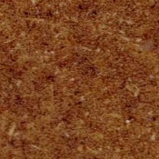 | 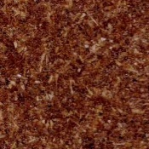 |  | 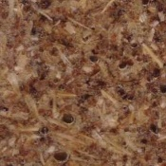
S1 | S2 | S3 | S4 | S5 | S6 | MDF
Figure 1. Pictures of the six samples and MDF

Figure 2 presents images of the bar table prototype developed with the material that presented the best acceptance. For the construction of the table, it was necessary to use a resistant material, and that had good acceptance of the consumers. Thus, the S6 mixture was chosen, although less resistant than S5, it presented better acceptance and a mechanical resistance equal to the MDF, which is usually used by the industry to produce furniture, in addition to characteristics of resistance and solubility in water much better than MDF.

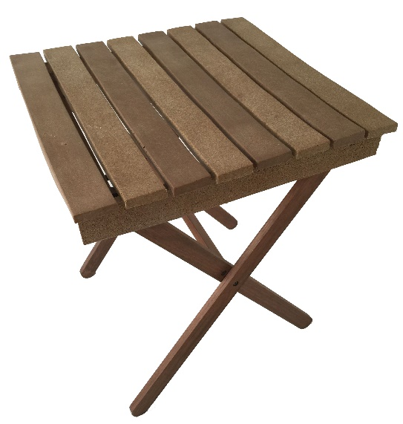 | 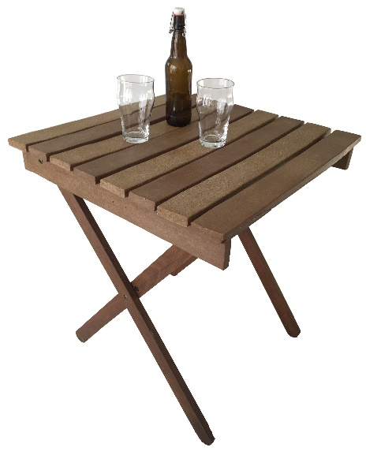
Figure 2. The prototype of the table developed

Since all the composites developed had higher water resistance than MDF, it would be possible to use these materials in products without the use of varnishes or other finishes that need protection against water.

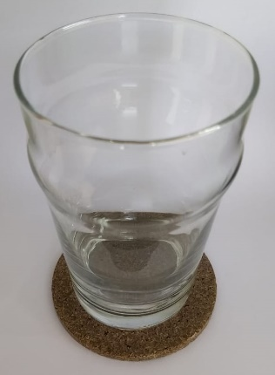 | 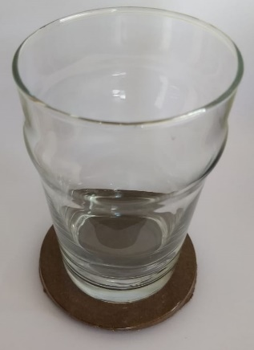 | 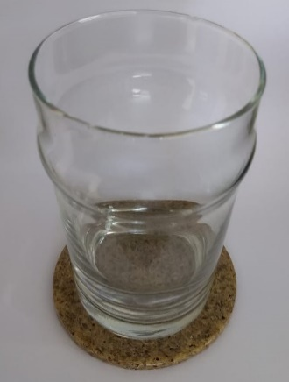
Figure 3. Prototypes of cup holders made with a different mash of milled brewing waste

  - Conclusions
In conclusion, combining brewing waste with vegetable resin produced materials with good mechanical properties, with water resistance proprieties better than MDF. The method is a good alternative use of brewing waste to increase value for this industrial waste stream. Also, this research showed that the lower the particle size of the milled malt wastes the higher was acceptable by tasters without loss in mechanical properties.
Acknowledgements
Financial support from Capes, CNPq and Fundação Araucária for grants, scholarships and support in promoting the results.
References
ASTM, 2012, D1037-12 Standard Test Methods for Evaluating Properties of Wood-Base Fiber and Particle Panel Materials, ASTM International, West Conshohocken, PA, USA, doi.org/10.1520/D1037-12.
Ayrilmis N., Buyuksari U., Avci E., Koc E., 2009, Utilization of pine (Pinus pinea L.) cone in manufacture of wood-based composite Forest Ecology and Management, 259 (1), 65–70, doi:10.1016/j.foreco.2009.09.043.
Baxter, Mike, 1998, Projeto de Produto: guia prático para o design de novos produtos, Editora Edgard Blücher, São Paulo, Brasil.
Berwig K.P., Marques D.R., Lima D.P., Mendes M.P., Raniero G.Z., Monteiro C.C.F., Monteiro A.R.G., 2017, Texture on Extruded Snack: Correlation between Instrumental and Sensory Analysis, Chemical Engineering Transactions, 57, 1723-1728.
Bible b.b., Singha S., 1993, Canopy position influences CIELAB coordinates of peach color. HorScience, 28, n. 10, p. 992-993.
Clifford M.J., Wan T., 2010, Fibre Reinforced Nanocomposites: Mechanical Properties of Pa6/Clay and Glass Fibre/Pa6/Clay, Nanocomposites Polymer, 51, n.2, 535-539.
Dischsen A.E., Monteiro A.R.G., Fukuda G.T., Marques D.R., 2013, Development of a breakfast cereal using waste from cassava processing industry, Acta Scientiarum Technology (Impresso), 35, 157-161.
Drábik M., Gáliková L., Sadleková Z., Kubranová M., 1996, Cross-linking of atoms and thermal stability of new MDF compositions, Journal of Thermal Analysis, 46, 479, doi.org/10.1007/BF02135025.
European Committee for Standardization, European Norm (EN). 1993, EN 323:1993, Wood-based panels; determination of density.
European Committee for Standardization, European Norm (EN), 1993, EN 317:1993, Particleboards and fiberboards; determination of swelling in thickness after immersion in water.
Müller C.M.O., Laurindo J.B., Yamashita F., 2012, Composites of thermoplastic starch and nanoclays produced by extrusion and thermopressing, Carbohydrate Polymers, 89, p. 504-510.
Müller C.M.O., Laurindo J.B., Yamashita F., 2009, Effect of cellulose fibres addition on the mechanical properties and water vapour barrier of starch-based films, Food Hydrocolloids, 23, 1328-1333.
Patrignani M., Ciappini M.C., Tananaki C., Fagúndez, G.A., Thrasyvoulou A., Lupano C.E., 2018, Correlations of sensory parameters with physicochemical characteristics of Argentinean honeys by multivariate statistical techniques, International Journal of Food Science and Technology, 53, 1176–1184, doi.org/10.1111/ijfs.13694.
Plastics Europe. 2017. Plastics - the Facts 2017: An analysis of European plastics production, demand and waste data, <www.plasticseurope.org/application/files/5715/1717/4180/Plastics_the_facts_2017_FINAL_for_website_one_page.pdf, accessed: 10.01.2019.
Reis M.O., Olivato J.B., Bilck A.P., Zanela J., Grossmann M.V.E., Yamashita F., 2018, Biodegradable trays of thermoplastic starch/poly (lactic acid) coated with beeswax. Industrial Crops and Products, 112, 481-487.
Rutiaga M.O., Galan L.J., Morales L.H., Gordon S.H., Imam S.H., Orts W.J., Glenn G.M., Niño K.A., 2005, Mechanical property and biodegradability of cast films prepared from blends of oppositely charged biopolymers, Journal of Polymers and the Environment, 13, n. 2, 185 – 191.
Santos A.S.F.E., Freire F.H.O., Costa B.L.N.E., Manrich S., 2012, Sacolas plásticas: destinações sustentáveis e alternativas de substituição, Polímeros, São Carlos, Brasil, <www.scielo.br/scielo.php?script=sci_arttext&pid=S0104-14282012005000036&lng=pt&nrm=iso> acessed 24.07.2017.
Shah D.U., Schubel P.J., Licence P., Clifford M.J., 2012, Hydroxyethylcellulose Surface Treatment Of Natural Fibres: The New 'Twist' In Yarn Preparation And Optimization For Composites Applicability, Journal of Materials Science, 47, n. 6, 2700-2711.
Zanqui A.B., Bastiani D., Souza A.H.P., Marques D.R., Gohara A.K., Matsushita M., Monteiro A.R.G., 2014, Developing of Mini Panettone Containing Omega-3 in Partial Substitution of Wheat Flour for Golden Linseed Flour ( Linum Usitatissimum L .), Revista Virtual de Química, 6, 968-976.

