CHEMICAL ENGINEERING TRANSACTIONS  VOL. 76, 2019 | A publication of
The Italian Association
of Chemical Engineering
Online at www.cetjournal.it
Guest Editors: Sauro Pierucci, Jiří Jaromír Klemeš, Laura Piazza
Copyright © 2019, AIDIC Servizi S.r.l.
ISBN 978-88-95608-73-0; ISSN 2283-9216

Development of an antimicrobial peptide-based biosensor for the monitoring of bacterial contaminations
Donatella Albaneseª, Francesca Garofalo^{b,}, Roberto Pilloton^{c}, Salvatore Capo^{b}, Francesca Malvano^{a*}
ª Department of Industrial Engineering, University of Salerno, Via Giovanni Paolo II, 132, Fisciano (SA), Italy
^{b} Istituto Zooprofilattico Sperimentale del Mezzogiorno, Dipartimento Ispezione degli Alimenti, via Salute 2, 80055 Portici (NA), Italy
^{c} Insititute of Crystallography of the National Council of Research (CNR), 00015 Monterotondo Scalo (RM), Italy
fmalvano@unisa.it

Nisin is a cationic amphiphilic peptide consisting of 34 amino acids with a cluster of hydrophobic residues at the N-terminus and hydrophilic residues at the C-terminus. The mechanism of its action is based on its ability to attach to the bacteria cell membrane before to then cause cell lysis. This antimicrobial peptide was used as biological molecule for the development of a novel impedimetric label-free biosensor for the monitoring of bacterial contamination. The binding affinities of Nisin immobilized with its N-terminus and C-terminus were compared, highlighting the capability of the last configuration to obtain the best analytical performance of the developed biosensor when non-pathogenic Escherichia Coli O157:H7 and Listeria innocua cells were investigated.
  - Introduction
More than 200 known diseases are transmitted through food by a variety of agents that include bacteria, fungi, viruses and parasites. According to food safety experts, each year millions of illnesses in the world can be traced to foodborne pathogens; the risk of foodborne illness has increased markedly over the last 30 years, with nearly a quarter of the population at higher risk for illness today (Wei Ling, 2018). Consequently, preventing illness and death associated with foodborne pathogens remains a major public health challenge.
Classical identification methods for pathogenic bacteria involve several steps: selective culture, Gram staining, as well as biochemical and/or serological tests. They are still considered as the best techniques for microbiological detection. However, these assays are labour-intensive and often require 4-7 days to obtain a confirmed result for a particular bacterial strain. The use of real-time PCR, loop-mediated isothermal amplification and Pulsed-Field Gel Electrophoresis makes it possible to obtain a rapid and sensitive analysis. However, these methods have some drawbacks, such as complexity of primer design and requirement of expensive instruments or reagents (Li et al., 2014).
In recent years, immunosensors have played increasingly important roles in pathogenic bacteria detection; many immunosensors have been developed exploiting the antigenicity of pathogens coupled with fluorescence (Heyduk et al., 2010), surface plasmon resonance (Maalouf et al., 2007; Baccar et al., 2010), quartz crystal microbalance (Guo et al., 2012) and electrochemical impedance (Malvano et al., 2018; Barreiros dos Santos et al., 2013; Maalouf et al., 2007) as transduction techniques. However, the instability of antibodies in harsh environment and the disposable nature of most immunosensors limit the practical application of these biosensors. By contrast, the ease of synthesis and intrinsic stability of antimicrobial peptides (AMPs) render them particularly interesting candidates for use as molecular recognition elements in electronic biosensing platforms. These peptides exhibit bacterial, fungicidal, virucidal and tumoricidal properties, attacking bacteria and destroying the cell membrane; based on this principle, several biosensors have been developed in the latest years (Etayash et a., 2014; Li et al. 2014; Lillehoj et al., 2014).
This paper reports preliminary studies for the development of a novel label-free antimicrobial peptide-based biosensor, based on the immobilization of Nisin on gold electrodes. Exploiting the advantages of the Electrochemical Impedance Spectroscopy transduction technique, which is able to provide quantitative and qualitative information about biomolecule/target interaction, the response of biosensors with non-pathogenic Escherichia Coli O157:H7 and Listeria innocua cells was investigated.

- Experimental Section
2.1 Reagents
Cysteamine (95%), Glutaraldehyde solution (50 wt% in H₂0), 2-(N-morpholino) ethanesulfonic acid (MES >99.5% purity), N-Hydroxysucciminide (NHS, 99%), N-(3- Dimethylaminopropyl)-N′-ethylcarbodiimide hydrochloride (EDC, >99%), Sulfuric acid ( 99.9% ), Ethanolamine (>99.5%), Potassium hexacyanoferrate (III) ( [Fe(CN)₆]³⁻, >99% ) were purchased from Sigma-Aldrich (Milano, Italy). Potassium ferrocyanide ([Fe(CN)₆]⁴⁻) was obtained from Carlo Erba reagent (Milano, Italy). Nisin (5 g) was purchased from MP Biochemicals (Santa Ana, USA). Non-pathogenic Escherichia Coli O157:H7 and Listeria innocua cells were provided by Istituto Zooprofilattico Sperimentale del Mezzogiorno in Portici (NA) Italy.

  - Apparatus
The impedimetric measurements were carried out with a PGSTAT 204 Potentiostat (Metrohm), equipped with an Impedance module (FRA32M); the experimental data were analysed with Nova software (Metrohm). The biosensor was developed on gold thin-film single-electrodes, purchased from Micrux Technologies (Oviedo, Spain), based on a common three-electrode layout (working/auxiliary/reference) with a working electrode of 1 mm.

  - Biosensor manufacturing
Gold electrodes were cleaned by an electrochemical treatment (6 min) at 1.7 V vs. Ag/AgCl as reference electrode in 0.05 M sulfuric acid (Malvano et al., 2015). After Two different immobilization techniques of Nisin molecules were adopted for the biosensor development:
- Immobilization of Nisin via amino (-NH₂) groups;
- Immobilization of Nisin via carboxylic (-COOH) terminal group.
For both techniques, cysteamine 20 mM water solution was dropped on gold electrodes and left to react overnight. After that, the immobilization with amine groups was carried out by dropping glutaraldehyde solution (5% v/v) on cysteamine – modified electrode. After 1 h, the electrode was covered with two different amounts of Nisin (5 μg/ml – 10 μg/ml) for 30 min. For the immobilization with carboxylic groups, Nisin was activated in a solution of EDC (75 mM) NHS (15 mM) in 100 mM MES buffer for 2 h and after was dropped on cysteamine-modified electrode. Two amounts of activated Nisin (5 μg/ml – 10 μg/ml) were dropped on the electrode for 30 min.

  - Experimental Measurements
For the impedimetric studies, used to characterize each step of the electrode modification and the bacteria interaction, a sinusoidal alternating current (AC) potential (10mV) in the frequency range from 0.1 to 10⁵ Hz was superimposed to 0.00 V direct current (DC) potential on working electrode vs reference electrode. The experimental impedimetric data were plotted in the form of Nyquist diagram, that plots the real component of impedance (Z^{I}) versus the imaginary one (Z^{II}). Experimental spectra were fitted with a proper equivalent circuit using the facilities of FRA32M (Nova Software).
Impedimetric and voltammetric measurements were performed in a solution of 1 mM ferri/ferrocyanide redox couple (K₃[Fe(CN)₆]/K₄[Fe(CN)₆], 1:1) in PB, as background electrolyte, at room temperature.
For bacteria measurements, 1 mL of solution at different concentrations was dropped onto the electrode surface and incubated for 90 min.
- Results and Discussions
3.1 Orientation of Nisin on gold electrode surface
The phospholipid head group charge on cell membranes and peptide charge distribution appears to play an important role in the peptide membrane interaction (Bahar et al., 2013). For this reason, the binding affinities of Nisin immobilized via cysteamine residues at the Carboxylic (C) terminus and free amine group (-NH₂) located at the end of peptide were compared. EIS was used to characterize each step of biosensors construction as well as their electrochemical responses with different concentrations of E.Coli cells.
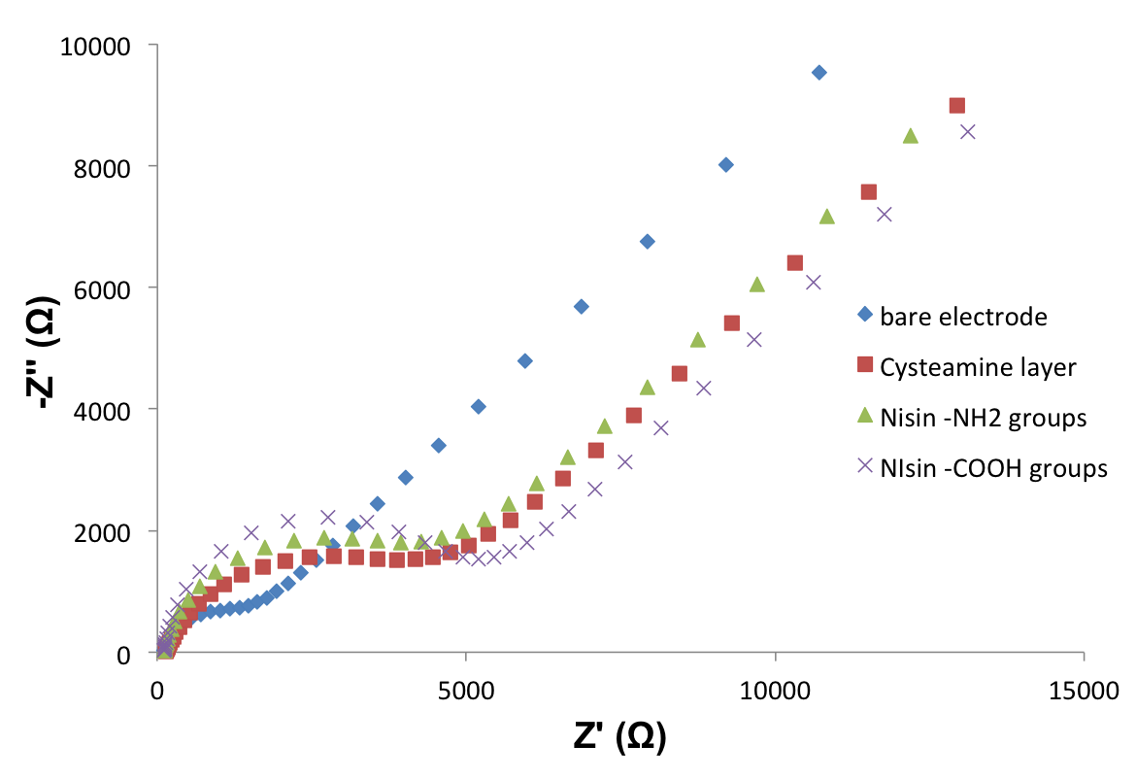
Figure 1: Nyquist’s plots of biosensors developed with Nisin immobilized with N-terminus and C-terminus.

The formation of cysteamine layer and the immobilization of Nisin cause an increase in the total impedance of the system for both immobilization procedures (Figure 1), due to the blocking layer coating on the electrode surface, which became thicker with the assembly procedure (Malvano et al., 2018; Malvano et al., 2017). Moreover, when the biosensors react with increasing concentrations of E.Coli cells, an increase in semicircle diameters of Nyquist plots was observed for both biosensors, which correspond to the Charge Transfer Resistance (R_{ct}) of Randle’s circuit used for data fitting (Figure 2a and b).

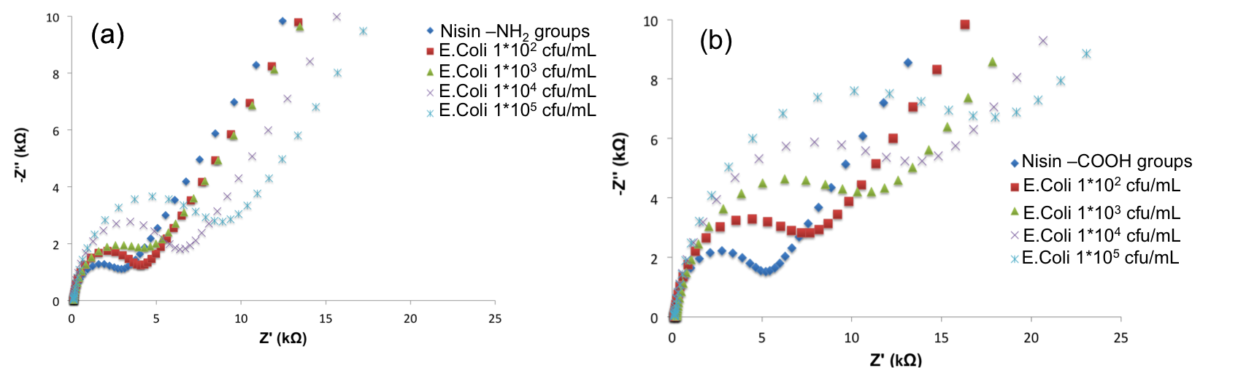
Figure 2: Nyquist’s plots of biosensors developed with Nisin immobilized with N-terminus and C-terminus.

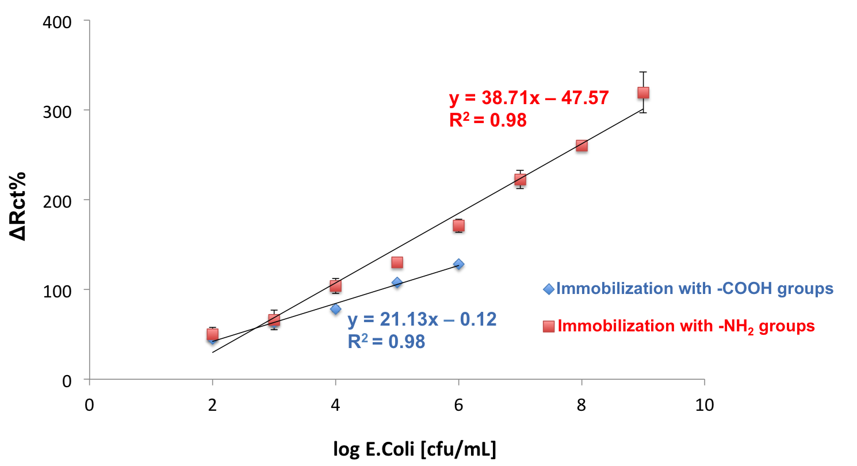
Figure 3: Calibration curves of developed biosensors.

The percentage variations of R_{ct} values (ΔR_{ct}%) versus the logarithmic value of E.Coli cells were used to calibrate the two biosensors developed; ΔR_{ct}% values were calculated by the following equation:

$∆R_{ct}\%=\frac{R_{ct\left(Nisin-E.Coli\right)}-R_{ct\left(Nisin\right)}}{R_{ct\left(Nisin\right)}}*100$ (1)

where R_{ct(Nisin)} is the value of the electron transfer resistance when Nisin is immobilized on the electrode surface and R_{ct(Nisin-E.Coli)} is the value after the Nisin/E.Coli interaction.
A considerably reduced binding activity was observed for Nisin immobilized via the N-terminus compared to C-terminus immobilization. This reduction in the binding affinity is likely due to the reduced exposure of the target bacteria to the Nisin residues containing N-terminus. According to Aveyard et al. (2017) this result confirms the hypothesis that the initial interaction of Nisin with the membrane of target bacteria occurs via electrostatic attraction of positively charged amino acids on the peptide with negatively charged phospholipids on the bacteria membrane.
This behaviour results in the best analytical performances of biosensor developed with Nisin immobilized via C-terminus, that shows a very wide linear range from 10² cfu/mL to 10⁹ cfu/mL, versus the biosensor with Nisin immobilized via N-terminus, with a closer linear range from 10² cfu/mL to 10⁶ cfu/mL (Figure 3).

3.2 Optimization of Nisin amount
Because the amount of biorecognition element affects the capability of a biosensor to detect the analyte in the range of interest, a comparison between two different concentrations of Nisin (5 μg/ml – 10 μg/ml), immobilized via C-terminus, was performed and the analytical parameter of developed biosensors were compared. The biosensors were tested with different concentrations of E.Coli and Listeria cells.
The process related to cells coupling with Nisin was monitored by single frequency impedance (SFI) that is able to monitor total impedance of the system in a single frequency versus time. As reported in our previous study (Malvano et al., 2107), SFI tests were carried out at to 0.1 Hz, that was the frequency at which was observed the maximum difference among the Bode plots at different cells concentration, for both E.Coli and Listeria innocua. A significant change in impedance was observed for an incubation time of 30 minutes for both microorganisms; then no change was registered. These results justified the incubation time of 30 min used for the calibration of biosensor with increasing concentration of E.Coli and Listeria innocua cells.
For both bacteria, the increase of the cells amount leads to an increase of the impedance of the system; in particular R_{ct} values change proportionally to the bacteria concentrations. Calibration curves of biosensors developed with 5 μg/ml and 10 μg/ml of Nisin for both bacteria were showed in Figure 4.

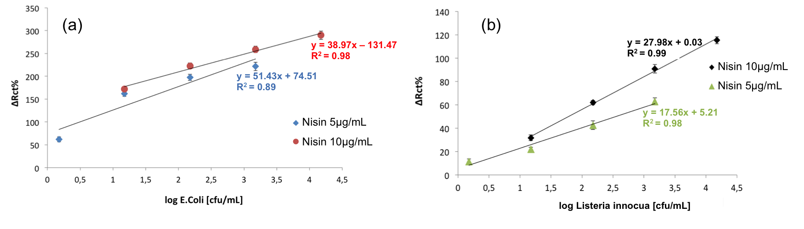
Figure 4: (a) Calibration curves of biosensors developed with 5 μg/ml and 10 μg/ml of Nisin tested with E.Coli; (b) Calibration curves of biosensors developed with 5 μg/ml and 10 μg/ml of Nisin tested with Listeria innocua.

As reported in our previous study (Malvano et al., 2016), lower biomolecule amount allows detecting lower target concentration. For both pathogens, in fact, even if the higher Nisin amount (10 μg/mL) results in higher signals, a lower concentration of Nisin (5 μg/mL) allow obtaining lower limit of detection (1.5 cfu/mL versus 1.5 *10¹ cfu/mL for both E.Coli and Listeria innocua), calculated as the sum of the average blank solution and three times the standard deviation.
Since no previous studies have been published on the Nisin – based biosensors for bacteria detection, we have compared the results with other label – free impedimetric antimicrobial peptide-based biosensors (Table 1).

Table 1: Comparison among label-free impedimetric antimicrobial peptide-based biosensors
Antimicrobial Peptide Used | Bacteria Analyzed | Linear Range  [cfu/mL] | LOD  [cfu/mL] | References
Magainin I | Escherichia Coli O157:H7 | 10⁴ - 10⁷ | 10⁴ | Li et al., 2014
Leucocin A | Listeria monocytogenes | 10³ – 10⁶ | 10³ | Etayash  et al., 2018
Clavanin A | Staphylococcus aureus | 10¹ – 10⁴ | 10 | de Miranda  et al., 2017
 | Enterococcus faecalis | 10¹ – 10⁴ | 10
 | Pseudomonas aeruginosa | 10¹ – 10⁴ | 10
 | Salmonella typhimurium | 10¹ – 10⁴ | 10
 | Escherichia Coli | 10¹ – 10⁴ | 10
Magainin I | Escherichia Coli O157:H7 | 10³ – 10⁷ | 10³ | Mannoor  et al., 2010
 | Salmonella | 10³ – 10⁷ | 10³
Nisin (5 μg/ml) | Escherichia Coli O147:H7 | 1.5 – 1.5*10³ | 1.5 | This work
Nisin (10 μg/ml) | Escherichia Coli O147:H7 | 1.5*10¹ – 1.5*10⁴ | 1.5*10¹ | This work
Nisin (5 μg/ml) | Listeria innocua | 1.5 – 1.5*10⁴ | 1.5 | This work
Nisin (10 μg/ml) | Listeria innocua | 1.5*10¹ – 1.5*10⁴ | 1.5*10¹ | This work

The comparison highlighted linear ranges of our biosensors comparable with the other ones, but the capability of our biosensor developed with lower amount of Nisin to detect the lowest concentration of E.Coli and Listeria innocua (1.5 cfu/mL).
The reproducibility, calculated on three different biosensors, showed a good relative standard deviation (R.S.D.) for both biosensors developed with two amounts of Nisin: 2.15% for Nisin 5 μg/ml and 3.12% for Nisin 10 μg/ml.
- Conclusions
Nisin antimicrobial peptide was used to develop an impedimetric label – free biosensors for the monitoring of bacterial contamination. The binding affinities of Nisin immobilized via cysteamine residues at the carboxylic terminus and NH₂ terminus were compared, by impedimetric transduction technique to investigate the electrochemical responses with different concentration of Escherichia Coli and Listeria innocua cells. The Nisin immobilization with its C-terminus and the optimization of peptide amount allowed the development of a biosensor with good analytical performances, able to detect a very low concentration of E.Coli and Listeria innocua cells equal to 1.5 cfu/ml. Although further investigations need to be done, in particular, the recognition of bacterial cells in real food matrices, the obtained results highlight the good potentiality of Nisin as AMP as a recognition element for the development of a fast method for the detection of bacterial contamination.

References
Avejard J., Bradley J.W., McKay K., McBride F., Donaghy D., Raval R., D’Sa R.A., 2017. Linker-free covalent immobilization of Nisin using atmospheric pressure plasma induced grafting, Journal of Materials Chemistry B, 5, 2500-2510.
Baccar H., Mejri M.B., Hafaiedh I., Ktari T., Aouni M., Abdelghani A., 2010. Surface plasmon resonance immunosensors for bacteria detection, Talanta, 82, 810-814.
Bahar A.A., Ren D., 2013. Antimicrobial Peptides, Pharmaceuticals, 6, 1543-1575.
Barreiros dos Santos M., Agusil J.P., Prieto-Simon B., Sporer C., Teixeira V., Samitier J., 2013. Highly sensitive detection of pathogens Escherichia Coli O157:H7 by electrochemical impedance spectroscopy, Biosensors and Bioelectronics, 45, 174-180
de Miranda J.L., Oliveira M.D.L., Oliveira I.S., Frias I.A.M., Franco O.L., Andrade C.A.S., 2017. A simple nanostructured biosensor based on clavanin A antimicrobial peptide for gram-negative bacteria detection, Biochemical Engineering Journal, 124, 108-114.
Etayash H., Jiang K., Thundat T., Kaur K., 2014. Impedimetric Detection of Pathogenic Gram-Positive Bacteria Using an Antimicrobial Peptide for Class lla Bacteriocins, Analytical Chemistry, 86, 1693-1700
Heyduk E., Heyduk T., 2010. Fluorescent homogeneous immunosensors for detecting pathogenic bacteria, Analytical Biochemistry, 396, 298-303.
Guo X., Lin C., Chen S., Ye R., Wu V., 2012. A piezoelectric immunosensors for specific capture and enrichment of variable pathogens by quartz crystal microbalance sensor, followed by detection with antibody-functionalized gold nanoparticles, Biosensors and Bioelectronics, 38, 177-183
Li Y., Afrasiabi R., Fathi F., Wang N., Xiang C., Love R., She Z., Kraatz H., 2014. Impedance based detection of pathogenic E.Coli O157:H7 using a ferrocene-antimicrobial peptide modified biosensor, Biosensor and Bioelectronics, 58, 193-199.
Lillehoj P.B., Kaplan C.W., He J., Shi W., Ho C., 2014. Rapid, Electrical Impedance Detection of Bacterial Pathogens Using Immobilized Antimicrobial Peptides, Journal of Laboratory Automation, 19, 42-49.
Lu L., Chee G., Yamada K., Jun S., 2013. Electrochemical impedance spectroscopic technique with a functionalized microwire sensor for rapid detection of foodborne pathogens, Biosensors and Bioelectronics, 42, 492-495.
Maalouf R., Fournier-Wirth C., Coste J., Chebib H., Saikali Y., Vittori O., et al., 2007.Label-Free Detection of Bacteria by Electrochemical Impedance Spectroscopy: Comparison to Surface Plasmon Resonance, Analytical Chemistry, 79, 4879-4886.
Malvano F., Pilloton R., Albanese D., 2018. Sensitive detection of Escherichia Coli O157:H7 in food products by impedimetric immunosensors, Sensors, 18, 2168, 9-11.
Malvano F., Albanese D., Pilloton R., Di Matteo M., 2017. A new label-free impedimetric aptasensor for gluten detection, Food Control, 79, 200-206.
Malvano F., Albanese D., Pilloton R., Di Matteo M., 2016. A highly sensitive impedimetric label free immunosensor for Ochratoxin measurement in cocoa beans, Food Chemistry, 212, 688-694.
Malvano F., Albanese D., Sannini A., Crescitelli A.,Pilloton R., Di Matteo M., 2015. Ethanol content in must grape by alcohol dehydrogenase biosensors based on doped - Polyaniline modified screen printed electrodes, Chemical Engineering Transactions, 43, 37-42.
Wei Ling, 2018. Risk Assessment of Chemical Pollution in Organic Food, Chemical Engineering Transactions, 67, 145-150.

