CHEMICAL ENGINEERING TRANSACTIONS  VOL. , 2023 | A publication of
The Italian Association
of Chemical Engineering
Online at www.cetjournal.it

Guest Editors: Laura Piazza, Mauro Moresi, Francesco Donsì
Copyright © 2023, AIDIC Servizi S.r.l.
ISBN 979-12-81206-01-4; ISSN 2283-9216

Dynamic Modelling of the Effects of Assimilable Nitrogen Addition on Aroma Synthesis during Wine Fermentation
F. Beaudeauª, C.A. Aceves Laraª*, C. Bideauxª
ª TBI, Université de Toulouse, CNRS, INRAE, INSA, Toulouse, France
aceves@insa-toulouse.fr]
Therefore, several biological studies have been done to understand and increase aroma production. They had shown that aroma metabolism is linked to nitrogen and central carbon metabolism of yeast and that nitrogen addition during fermentation has potentially a great impact on aromas synthesis. However, there are few publications on the optimisation of oenological bioprocess by the mean of control laws and on de facto aroma synthesis modelling. In this study, a dynamic model of aroma synthesis has been developed. This model integrates nitrogen addition during fermentation which has not been integrated in previous modelling work whereas it is a widespread practice. This model presents a good adequacy to experimental data for CO₂ and ethanol production and for four out of five considered aromas (mean values of NRMSE are between 0.0771 and 0.212).
Introduction
The oenological fermentation is a well-known biological process in which yeasts, mainly Saccharomyces cerevisiae strains, convert hexoses (glucose and fructose) principally to ethanol and carbon dioxide, secondarily to biomass and glycerol and weakly to metabolites produced in low concentrations with major impact on wines organoleptic properties. Oenological fermentation is a process which has several limitations whose main one is deficiency in nitrogen. In industrial conditions, nitrogen is totally consumed in the first two days of fermentation whose “normal” duration is one to two weeks (Monteiro et al., 1991). However nitrogen is an essential nutrient for yeast metabolism and growth during oenological fermentation (Agenbach, 1977; Bely et al., 1990) and its deficiency can induce sluggish or stuck fermentations (Mendes-Ferreira et al., 2004). Several studies have been conducted to understand and quantify nitrogen deficiency: Bisson (1999) related nitrogen deficiency to stuck and sluggish fermentations, Crépin et al. (2012) studied the sequential uptake of nitrogen sources by yeasts and Carrau et al. (2008) studies the impact of nitrogen deficiency on aroma compounds. Nitrogen addition during fermentation increases reaction kinetics but this increase depends on addition timing (Malherbe et al., 2004). That is why European legislation allows nitrogen addition at the beginning and during wine oenological fermentation (Commission, 2019).
Today consumers are looking for wines with a fruity aromatic profile (Swiegers et al., 2005). Aroma metabolism is linked to nitrogen metabolism and to central carbon metabolism (Styger et al., 2011) (Swiegers et al., 2005). However, there are few publications on aroma synthesis modelling:
- As aromas are volatile compounds, Morakul et al. (2011) modelled the gas-liquid partitioning of aroma compound and the aromas gaseous losses during fermentation. Therefore, the liquid concentration can be calculated as total production less gas losses.
- Mouret et al. (2014) established a link between aroma synthesis and sugar consumption and Mouret et al. (2015) modelled the conversion yield of sugar into aroma as a function of experimental conditions (initial nitrogen concentration and fermentation temperature).
However, Mouret’s model was not developed nor calibrated for fermentations with nitrogen addition during the fermentation process. Moreover, this model cannot consider nitrogen addition because it only depends of initial nitrogen concentration and fermentation temperature whereas nitrogen addition has potentially a great impact on aromas synthesis (Seguinot et al., 2018).

In this work a model is proposed to integrate nitrogen addition impact into an aroma synthesis model. This study focuses on five aromas (isoamyl alcohol (IAOH), isobutanol (IBOH), isoamyl acetate (IAA), ethyl hexanoate (EH) and ethyl octanoate (EO)) because of their importance in wine aromatic profile and because they are considered representative of wine aromas. The objective of this model is to be used in a control law that will help winemakers manage the fermentation (temperature profile and nitrogen addition) to reach a target aromatic profile.

MODEL FORMULATION
The aroma synthesis model is based on the fermentation main kinetics model that we developed previously (Beaudeau et al., 2022). First the main kinetics model is presently briefly then the aroma synthesis is developed.

2.1 Model of the main kinetics of alcoholic fermentation
The main kinetics model considers the consumption of sugar (S in g.L⁻¹) and assimilable nitrogen (N in g.L⁻¹) and the production of biomass (X in 10⁹cell.L⁻¹), ethanol (E in g.L⁻¹), CO₂ (in g.L⁻¹) and sugar transporters (N_{ST} in g/10⁹cell). Two state variables are introduced in this model: intracellular nitrogen (N_{intra} in g/10⁹) and cell activity (A dimensionless). The model equations are:
$$\frac{dX}{dt}=k_{1}\left(T\right)X\left(1-\frac{Q_{0}}{N_{intra}}\right)\left(1-\frac{E}{E_{max}}\right)A$$ | (1)
$$\frac{dS}{dt}=- ν_{ST}\left(S,E\right)N_{ST}X$$ | (2)
$$\frac{dE}{dt}=-\frac{1}{Y_{\frac{E}{S}}}\frac{dS}{dt}$$ | (3)
$$\frac{d{CO}_{2}}{dt}=-\frac{1}{Y_{\frac{CO2}{S}}}\frac{dS}{dt}$$ | (4)
$$\frac{dN}{dt}=-Xμ_{N}\left(N,E\right)A$$ | (5)
$$\frac{dN_{intra}}{dt}= μ_{N}\left(N,E\right)-\left(\frac{α_{1}}{X}+\frac{N_{intra}}{X}\right)\frac{dX}{dt}-\frac{1}{Y_{nst}}\left(k_{nst}\left(1-\frac{Q_{0nst}}{N_{intra}}\right)-k_{dnst}\frac{N_{ST}}{K_{NST}+N_{ST}}\right)$$ | (6)
$$\frac{dN_{ST}}{dt}=k_{nst}(T)\left(1-\frac{Q_{0nst}}{N_{intra}}\right)-k_{dnst}\frac{N_{ST}}{K_{NST}+N_{ST}}-\frac{N_{ST}}{X}\frac{dX}{dt}$$ | (7)
$$\frac{dA}{dt}= \frac{1}{X}\frac{dX}{dt} \left(1-A\right)-κ(T) A$$ | (8)

With $k_{1}\left(T\right)$ the maximum specific growth grate depending on temperature, $ν_{ST}\left(S,E\right)$ a function of ethanol and sugar describing the active transport of sugar per cell and $μ_{N}\left(N,E\right)$ a function of nitrogen and ethanol describing the active transport of nitrogen per cell. They are described by the following equations:
$$k_{1}\left(T\right)=α_{k1}T-β_{k1}$$ | (9)
$$ν_{ST}\left(S,E\right)= \frac{k_{2}(T)S}{S+ K_{s}+ K_{S1}SE^{α_{S}}}$$ | (10)
$$μ_{N}\left(N,E\right)= \frac{k_{3}(T)N}{N+ K_{N}+ K_{NI}NE^{α_{N}}}$$ | (11)
$Q_{0}$, $E_{max}$, $Y_{\frac{E}{S}}$, $Y_{\frac{CO2}{S}}$,$α_{1}$, $Y_{nst}$, $k_{nst}$, $Q_{0nst}$, $k_{dnst}$, $K_{NST}$, $κ$, $α_{k1}$, $β_{k1}$, $k_{2}$, $K_{s}$, $K_{S1}$, $α_{S}$, $k_{3}$, $K_{N}$, $K_{NI}$ and $α_{N}$ are the model parameters. $k_{2}$, $k_{3}$, $k_{nst}$ and $κ$ are temperature dependent by the following equations;
$$k_{2}=2.04.{10}^{-4}T^{2}-6.12.{10}^{-3}T+6.46.{10}^{-2}$$ | (12)
$$k_{3}=2.009.{10}^{-6}T^{2}-8.2177.{10}^{-5}T+1.9034.{10}^{-3}$$ | (13)
$$k_{nst}=7.45.{10}^{-3}T^{2}-4.27.{10}^{-1}T+6.63$$ | (14)
$$κ=1.2668.{10}^{-3}T-7.8394.{10}^{-3}$$ | (15)

2.2 Model of aroma synthesis
Mouret et al. (2014) highlighted a specific relationship between sugar consumption and total production of aromas. Therefore, this relation is kept in this model (cf. eq 2).
$$\frac{dAroma}{dt}=-Y_{aroma}\frac{dS}{dt}$$ | (16)
With $Aroma$ the concentration in one aroma considered (IBOH, IAOH, IAA, EH or EO) (in mg.L⁻¹), $S$ sugar concentration (in g.L⁻¹) and $Y_{aroma}$ the conversion yield of sugar into one aroma.
Mouret et al. (2014) showed that there are two successive linear phases of aroma production. The transition between the two linear phases depends on the aromatic compounds (Mouret et al., 2015) but it is closed to the nitrogen addition timing of this study for all aroma compounds considered. Therefore, we decided that the transition between the two production phases is set at the nitrogen addition timing for this model.
Mouret et al. (2015) defined the conversion yields of sugar into aromas by two linear regressions of the experimental conditions (initial nitrogen concentration and fermentation temperature) for the two phases of production. The equation of conversion yield for the first production phase is not modified because it is not affected by nitrogen addition but the conversion yield equation for the second phase is modified to introduced the added nitrogen concentration in the equation (cf. eq 3 and 4).
$$\ln\left(Y_{aroma,1}\right)=D_{1}+D_{2}N_{0}+D_{3}T+D_{4}N_{0}^{2}+D_{5}T^{2}+D_{6}N_{0}T$$ | (17)
$$\ln\left(Y_{aroma,2}\right)=D_{7}+D_{8}\left(N_{0}+N_{ad}\right)+D_{9}T+D_{10}{\left(N_{0}+N_{ad}\right)}^{2}+D_{11}T^{2}+D_{12}(N_{0}+N_{ad})T$$ | (18)
With $N_{0}$ the initial nitrogen concentration, $T$ the fermentation temperature, $N_{ad}$ the added nitrogen concentration and $D_{1}$, …, $D_{12}$the model’s parameters.
For isobutanol, the conversion yield is modified to integrate two terms of effect (linear and quadratic) of nitrogen addition (cf. eq 5).
$$\begin{aligned}\ln\left(Y_{aroma,2}\right)=D_{7}+D_{8}\left(N_{0}+N_{ad}\right)+D_{9}T+D_{10}{\left(N_{0}+N_{ad}\right)}^{2} \\ +D_{11}T^{2}+D_{12}\left(N_{0}+N_{ad}\right)T+D_{13}N_{ad}+D_{14}N_{ad}^{2}\end{aligned}$$ | (19)

3. MATERIALS AND METHODS

3.1 Computing
Matlab R2017b software was used for calibration and simulation of the models in particular ode15s function (Shampine et al., 1997) as differential equations solver and pattern search and Rosenbrock as optimization methods.

3.2 Statistical analysis
Models quality was analysed with experimental data using the normed root mean square error (NMRSE) (Armstrong et al., 1992) defined as :
$$NRMSE=\frac{\sqrt{\frac{\sum_{i=1}^{T}{{\left(x_{i}-y_{i}\right)}^{2}}}{n}}}{y_{max}-y_{min}}$$ | (20)
With $n$ the number of experimental data, $x_{i}$ the experimental data corresponding to time t_{i}, $y_{i}$ the data simulated by model for the same time t_{i}, $y_{min}$and $y_{max}$the minimum and maximum data values.

4. MODEL CALIBRATION
This model is calibrated with data from 15 fermentations done for a 3-factor Box-Behnken type experimental design. The variables are: initial nitrogen concentration (70, 140 and 210 mg.L⁻¹), temperature (18, 23 and 28°C) and added nitrogen concentration (50, 100 and 150 mg.L⁻¹). The nitrogen addition is carried out when CO₂ produced reaches 20 g.L⁻¹. The central point is made in triplicate. The fermentation name is defined by experimental conditions: fermentation MS70_50_23C presents an initial nitrogen concentration of 70 mg.L-1, an added nitrogen concentration of 50 mg.L⁻¹ and a fermentation temperature of 23°C. The three fermentations of the central point are numerated to distinguish them.
The parameters values are calibrated in two stages:
- First, the parameters (D₁, …, D₆) of the first production phase are calibrated.
- Secondly, the parameters (D₇, …, D₁₂) of the second production phase are calibrated.
The parameters were calibrated by separating the two production phases because the calibration of the twelve parameters simultaneously did not allow a correct determination of the parameters of the first production phase before the addition of nitrogen (D₁ to D₆). Indeed, the errors between experiment and simulation on this part of the curve were very low compared to the errors on the second part of the curve, which artificially put more weight on the determination of the parameters D₇ to D₁₂.
For most parameters, the calibrated values are closed to parameters values presented by Mouret et al. (2015). It is surprising because nitrogen addition is integrated by this model but not by Mouret’s model.

Table 1 Model parameters
Parameters | IBOH | IAOH | IAA | EH | EO
D1 | -2.9 | -1.5 | -6.3 | -14,6 | -11.8
D2 | -8.1.10⁻⁴ | -3.3.10⁻³ | 5.0.10⁻³ | -1.5.10⁻² | -7.2.10⁻⁴
D3 | 8.9.10⁻² | 1.5.10⁻¹ | -4.0.10⁻² | 8.9.10⁻¹ | -2.0.10⁻¹
D4 | -3.5.10⁻⁶ | 2.0.10⁻⁵ | 1.2.10⁻⁴ | 0 | 0
D5 | 0 | -3.5.10⁻³ | 1.3.10⁻³ | -2.3.10⁻² | 1.2.10⁻²
D6 | -3.5.10⁻⁵ | -1.1.10⁻⁴ | 2.2.10⁻⁶ | 9.1.10⁻⁴ | 4.6.10⁻⁴
D7 | -9.4 | -4.5 | -12.9 | -8.0 | -9.2
D8 | 2.1.10⁻² | 7.8.10⁻³ | 2.6.10⁻² | 5.0.10⁻³ | 7.4.10⁻³
D9 | 4.4.10⁻¹ | 3.2.10⁻¹ | 4.6.10⁻¹ | 1.5.10⁻¹ | 3.4.10⁻¹
D10 | -1.9.10⁻⁵ | -2.5.10⁻⁵ | -2.4.10⁻⁵ | 0 | -1.3.10⁻⁵
D11 | -4.8.10⁻³ | -6.7.10⁻³ | -7.5.10⁻³ | -2.4.10⁻³ | -9.1.10⁻³
D12 | -3.5.10⁻³ | 0 | -5.0.10⁻⁴ | -2.2.10⁻⁴ | -6.7.10⁻⁵
D13 | 3.5.10⁻³ | - | - | - | -
D14 | -4.5.10⁻⁵ | - | - | - | -

5. ACCURACY TO CALIBRATION DATA
Figures 1, 2, 3 and 4 show experimental data and simulated data of total production of isoamyl acetate for the 15 calibration fermentations.
The model simulates the kinetics of experimental production of isoamyl acetate well for all fermentations. Model underestimates the final production for two fermentations: relative deviation of the simulated value from the experimental value is 39% and 20% for MS70_100_18C and MS70_150_23C respectively. The fermentation MS70_100_18C presents an increase of isoamyl acetate production at the end of fermentation. This increase does not correspond to nitrogen addition or a temperature change and CO₂ is almost completely produced. So, for the fermentation MS70_50_18C, we suppose there is a problem in data acquisition. The model overestimates the final production for MS140_50_18C. The model correctly estimates the final production for the other fermentations. The average value of NRMSE is 0.0771. The model simulates isoamyle acetate very well.
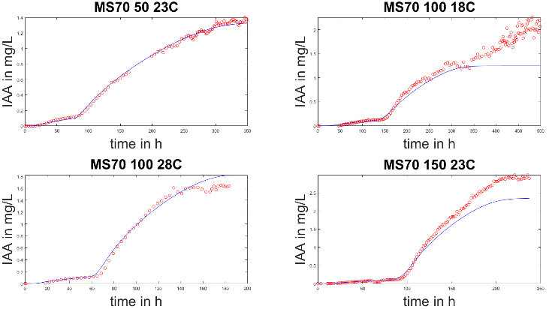 | 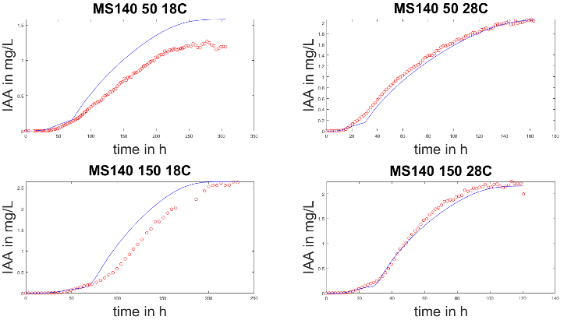
Figure 1. Experimental data (in red) and simulated data (in blue) for total production of isoamyle acetate for the four fermentations with an initial nitrogen concentration of 70 mg.L⁻¹. | Figure 2. Experimental data (in red) and simulated data (in blue) for total production of isoamyle acetate for the four fermentations with an initial nitrogen concentration of 140 mg.L⁻¹.
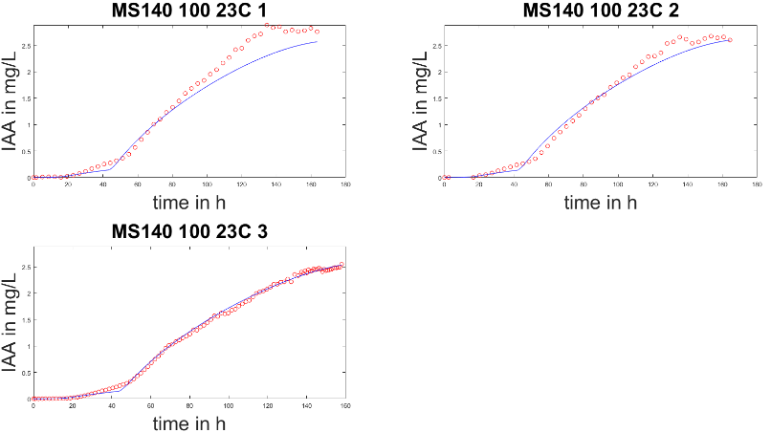 |  | 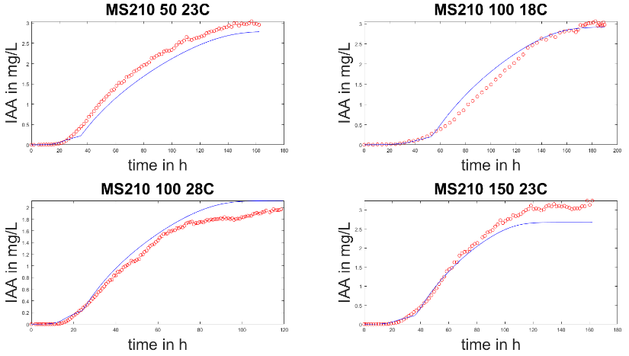
Figure 3. Experimental data (in red) and simulated data (in blue) for total production of isoamyle acetate for the triplicate fermentations (initial nitrogen concentration of 140 mg.L⁻¹, added nitrogen concentration of 100 mg.L⁻¹ and temperature of 23°C). |  | Figure 4. Experimental data (in red) and simulated data (in blue) for total production of isoamyle acetate for the four fermentations with an initial nitrogen concentration of 210 mg.L⁻¹.

For the ethyl hexanoate, the model simulates well the kinetics for all calibration fermentations. The final production is underestimates for one fermentation (relative deviation of the simulated value from the experimental value is 22% for MS70_100_18C) and overestimates for two fermentations (relative deviations between simulation and experimental data are 23% and 26% for MS140_100_23C_2 and MS210_150_23C respectively). The average value of NRMSE is 0.0920. The model has a good adequacy with experimental data.
For isobutanol, the production kinetics are accuratly simulated for all fermentations. The model overestimates the final production for 3 fermentations (relative deviations between simulation and experimental data are 41%, 50% and 32% for MS70_50_23C, MS70_100_28C et MS70_150_23C respectively) and underestimates the final production for 5 fermentations (relative deviations between simulation and experimental data are 29% and 31% for the fermentations of the triplicate MS140_100_23C, and it is 23% for both MS140_150_18C and MS140_150_28C respectively).The average value of NRMSE is 0.120. The model presents a good adequacy to calibration data.
For isoamyl alcohol, the final production is underestimated for two fermentations (relative deviations between simulation and experimental data are 31% and 21% for MS140_50_28C and MS210_50_23C respectively) and is well estimated for all other fermentation. The production kinetics is well simulated by the model for all fermentations except for MS70_100_28C and MS70_150_23C. The mean value of NRMSE is 0.135. Therefore, isoamyl alcohol is well simulated by the model.
For ethyl octanoate, model estimates badly the final production for seven out of fifteen fermentations: the model underestimates the final production for four fermentations (relative deviations between simulation and experimental data are 31%, 21%, 45% and 41% for MS70_50_23C, MS140_50_18C, MS140_50_28C and for MS210_50_23C respectively) and overestimates it for three fermentations (relative deviation of the simulated value from the experimental value is 73%, 22% and 145% for MS70_100_28C, MS70_150_23C and MS140_100_23C_2 respectively). Moreover, the production kinetics is well simulated only for three fermentations MS140_100_23C_3, MS140_150_18C and for MS210_100_18C. The mean value NRMSE is 0.212. Therefore, the ethyl octanoate is badly simulated by the model

6. CONCLUSIONS
In this study, a model of total aroma production is built. This model is derived on the works of Mouret (Mouret et al., 2014) (Mouret et al., 2015) and is the first model that considers nitrogen addition during alcoholic fermentation. The model presents good accuracy with experimental data for isobutanol (NRMSE = 0.120), isoamyl alcohol (NRMSE = 0.135), isoamyl acetate NRMSE = 0.0771) and ethyl hexanoate NRMSE = 0.0920) but simulates badly ethyl octanoate (NRMSE = 0.212). The predictions of aroma concentrations for isoamyl acetate, isobutanol, isoamyl alcohol and ethyl hexanoate during anisothermal fermentations are satisfactory. The quick temperature variations on the fermentation process certainly produce an effect on yeast secondary metabolism and the response time of microorganisms to these fluctuations could be considered to improve the model predictions.

REFERENCES
Agenbach, W. A. (1977). A study of must nitrogen content in relation to incomplete fermentations, yeast production and fermentation activity. In. Stellenbosch (ZA): South African Society for Enology and Viticulture.
Armstrong, J. S., & Collopy, F. (1992). Error measures for generalizing about forecasting methods: Empirical comparisons. International Journal of Forecasting, 8(1), 69-80. https://doi.org/https://doi.org/10.1016/0169-2070(92)90008-W
Beaudeau, F., & Aceves Lara, C. A., & Godillot, J., & Mouret, J. R., & Trelea, I., & Bideaux, C. (2022). Modeling the Effects of Assimilable Nitrogen Addition on Fermentation in Oenological Conditions (submitted). Food Science and Biotechnology.
Bely, M., & Sablayrolles, J. M., & Barre, P. (1990). Automatic Detection of Assimilable Nitrogen Deficiencies during Alcoholic Fermentation in Enological Conditions. Journal of fermentation and bioengineering, 70(4), 246-252. https://doi.org/Doi 10.1016/0922-338x(90)90057-4
Bisson, L. F. (1999). Stuck and sluggish fermentations. Américan Journal of enology and viticulture(50), 107-119.
Carrau, F. M., & Medina, K., & Farina, L., & Boido, E., & Henschke, P. A., & Dellacassa, E. (2008). Production of fermentation aroma compounds by Saccharomyces cerevisiae wine yeasts: effects of yeast assimilable nitrogen on two model strains. FEMS Yeast Res, 8(7), 1196-1207. https://doi.org/10.1111/j.1567-1364.2008.00412.x
Commission Delegated Regulation (EU) 2019/934 of 12 March 2019 supplementing Regulation (EU) No 1308/2013 of the European Parliament and of the Council as regards wine-growing areas where the alcoholic strength may be increased, authorized oenological practices and restrictions applicable to the production and conservation of grapevine products, the minimum percentage of alcohol for by-products and their disposal, and publication of OIV files, (2019).
Crépin, L., & Nidelet, T., & Sanchez, I., & Dequin, S., & Camarasa, C. (2012). Sequential use of nitrogen compounds by Saccharomyces cerevisiae during wine fermentation : a model based on kinetic and regulation characteristics of nitrogen permeases. Applied and Environmental Microbiology, 77, 8102-8111. https://doi.org/10.1128/AEM.02294-12
Malherbe, S., & Fromion, V., & Hilgert, N., & Sablayrolles, J. M. (2004). Modeling the effects of assimilable nitrogen and temperature on fermentation kinetics in enological conditions. Biotechnol Bioeng, 86(3), 261-272. https://doi.org/10.1002/bit.20075
Mendes-Ferreira, A., & Mendes-Faia, A., & Leão, C. (2004). Growth and fermentation patterns of Saccharomyces cerevisiae under different ammonium concentrations and its implications in winemaking industry. J Appl Microbiol, 97(3), 540-545. https://doi.org/https://doi.org/10.1111/j.1365-2672.2004.02331.x
Monteiro, F. F., & Bisson, L. F. (1991). Amino Acid Utilization and Urea Formation During Vinification Fermentations. American Journal of Enology and Viticulture, 42(3), 199-208. https://www.ajevonline.org/content/ajev/42/3/199.full.pdf
Morakul, S., & Mouret, J.-R., & Nicolle, P., & Trelea, I., & Sablayrolles, J.-M., & Athes, V. (2011). Modelling of the gas–liquid partitioning of aroma compounds during wine alcoholic fermentation and prediction of aroma losses. Process Biochemistry, 46}, 1125-1131. https://doi.org/10.1016/j.procbio.2011.01.034
Mouret, J. R., & Camarasa, C., & Angenieux, M., & Aguera, E., & Perez, M., & Farines, V., & Sablayrolles, J.-M. (2014). Kinetic analysis and gas–liquid balances of the production of fermentative aromas during winemaking fermentations: Effect of assimilable nitrogen and temperature. Food Research International, 62, 1-10. https://doi.org/10.1016/j.foodres.2014.02.044
Mouret, J. R., & Farines, V., & Sablayrolles, J. M., & Trelea, I. C. (2015). Prediction of the production kinetics of the main fermentative aromas in winemaking fermentations. Biochemical Engineering Journal, 103, 211 - 218. https://doi.org/https://doi.org/10.1016/j.bej.2015.07.017
Seguinot, P., & Rollero, S., & Sanchez, I., & J.-M., S., & Ortiz-Julien, A., & Camarasa, C., & Mouret, J.-R. (2018). Impact of the timing and the nature of nitrogen additions on the production kinetics of fermentative aromas by Saccharomyces cerevisiae during winemaking fermentation in synthetic media. Food Microbiology, 76, 29-39. https://doi.org/https://doi.org/10.1016/j.fm.2018.04.005
Shampine, L. F., & Reichelt, M. W. (1997). The MATLAB ODE Suite. SIAM Journal on Scientific Computing, 18(1), 1-22. https://doi.org/10.1137/s1064827594276424
Styger, H., & Prior, B., & Bauer, B. B. (2011). Wine flavor and aroma. Journal of Industrial Microbiology & Biotechnology, 38, 1145. https://doi.org/10.1007/s10295-011-1018-4
Swiegers, J. H., & Pretorius, I. S. (2005). Yeast and bacterial modulation of wine aroma and flavor. 57, 131 - 175. https://doi.org/https://doi.org/10.1016/S0065-2164(05)57005-9

