CHEMICAL ENGINEERING TRANSACTIONS  VOL. , 2023 | A publication of
The Italian Association
of Chemical Engineering
Online at www.cetjournal.it

Guest Editors: Laura Piazza, Mauro Moresi, Francesco Donsì
Copyright © 2023, AIDIC Servizi S.r.l.
ISBN 979-12-81206-01-4; ISSN 2283-9216
Real-time Continuous IoT-TT Spectrum as a Predictor of Plant Health and Fruit Quality in 'Soreli' kiwifruit
Micaela Lembo*, Shahla Asgharinia, Vanessa Eramo, Roberto Forniti, Riccardo Valentini, Rinaldo Botondi
Department for Innovation in Biological, Agro-food and Forest Systems (DIBAF), Tuscia University, Via San Camillo de Lellis snc 01100 Viterbo (VT), Italy.
* Corresponding author: micaela.lembo@unitus.it
The kiwifruit, for which Italy is the second largest producer in the world, is derived from a fruit vine that requires a significant amount of water for proper growth and the production of high-quality fruit. This study aims to investigate the ideal irrigation strategy to ensure an adequate water supply for robust root development, vibrant foliage, and successful fruit production. To achieve this goal, three experimental plots of Soreli kiwifruit vineyards were subjected to different water regimes: full irrigation (100%) and two plots with 80% and 60% irrigation. Each irrigation group was equipped with an Internet of Things (IoT) TT Spectrum, which measured reflected spectrometer data in 12 bands ranging from 450 to 860 nm in real time. Additionally, a soil sensor was used to determine moisture content. Fruit quality analysis, including weight loss, total soluble solid content, flesh color, flesh firmness, titratable acidity, ascorbic acid, total polyphenols, and flavonoids, was conducted to correlate productivity with water availability. By analyzing the IoT-TT Spectrum data for each kiwifruit plant, crucial indicators for assessing physiological status, health, and growth were examined. The results indicate that water availability significantly influences vineyards health. Maintaining a balance between leaf nitrogen content and photosynthetic capacity, with low AI and higher NDVI and CVI values, was used to determine the optimal irrigation level for each of the three plots. Furthermore, qualitative data obtained from fruits revealed that overwatering or underwatering kiwifruit plants affects yield production and fruit quality. Fruits subjected to full irrigation (100% water) exhibited lower sugar levels compared to those under deficit irrigation (80% and 60%). Overall, this study demonstrates that excessive or limited irrigation regimes negatively impact plant health, as indicated by vegetation indices derived from IoT-TT Spectrum data, as well as fruit quality.
  - Introduction
Kiwifruit is appreciated by consumers for its high content of bioactive compounds, which have health-beneficial effects. Consequently, the consumption of fresh kiwifruits is booming (Meena, Nirmal Kumar, et al. 2018). Yellow-fleshed kiwifruit (Actinidia chinensis 'Soreli'), known for its sweeter flavor, possesses numerous agronomic features, including early ripening, high productivity, and large fruit size with excellent taste and nutritional quality traits (Goffi, Magri, et al. 2020). However, this fruit is not suitable for long-term storage (Goffi, Modesti et al. 2018). The lack of proper maturity harvest indices poses a challenge in postharvest management, and several factors contribute to the deterioration of fresh fruit quality and storage life. Therefore, developing novel techniques to maintain fruit quality and prolong shelf life after harvesting is of utmost importance (Gwanpua, Jabbar et al. 2018). It has been observed that inefficient water use increases the cost of crop production, negatively affects the environment and the final product, and can induce changes in fruit yield and quality (Pinto, Valin et al. 2021). Moreover, reducing wastage benefits farmers, consumers, and society as a whole. In fact, kiwifruit plants have a fleshy, shallow root system that is sensitive to waterlogging stress, resulting in decreased crop yield or even plant death. Approximately 16% of cultivated land worldwide is affected by waterlogging, causing an estimated 20% decrease in yield (Liu et al. 2022). It has been established that a slight lack of water can benefit the post-harvest storage characteristics of the fruit (Reid et al. 1996). The technical approach to optimize irrigation programs is based on water moisture content and plant water status (Steduto et al. 2012), to check the plant's health and hydration status. The Internet of Things (IoT) can enhance agricultural and farming industry processes through automation, which involves collecting data using sensors and processing it using controllers (Hari Ram et al. 2015). The current use of smart agricultural systems primarily focuses on water management, crop management, and smart farming, aiming to automate processes by reducing human intervention, costs, power consumption, and water usage (hari Ram et al. 2015).
  - Materials and Methods
    - Experimental design
In the summer of 2022, three experimental plots of "Soreli" kiwifruit vineyards at the "Tre Colli" farm, located in Cisterna Campoleone (Velletri, Rome, Italy), were selected to study the impact of water deficit on plant health and the quality of the final product. Each of the three plots is characterized by the same mineral composition and cultivation practices. They are subjected to distinct irrigation treatments: default drip irrigation at a rate of 50-100 L per day, depending on seasonal and climatic conditions (referred to as 100% or full irrigation), and deficit irrigation at 80% and 60% of the full irrigation approach. Each experimental plot covers an area of approximately 1 ha of soil surface and contains around 700 vines per hectare, with plants spaced 4.0 m apart between rows and 3.0 m apart within rows.
    - TT Spectrum and soil sensors
To evaluate the effect of different irrigation methods on plants, three low-cost IoT-TT Spectrums and three soil sensors were used from June to September 2022. Each treatment employed these devices to obtain real-time observations of physical and biological parameters of the leaves and soil moisture. The nine spectrophotometers were placed on support poles of kiwifruit plants, projecting onto the foliage in a diagonal orientation. The selection of these devices was based on their field position and similar exposure to natural diurnal light. The IoT-TT Spectrum is specifically designed to measure canopy reflectance radiance across 12 spectral bands, including six in the visible range and six in the near-infrared range (Figure 1). The soil sensors, positioned horizontally at a depth of 30 cm, provide data on soil volumetric water content (Soil VWC %) for each individual tree. These soil sensors were provided by Nature 4.0 S.r.l (Viterbo, VT, Italy). The data collected is saved in the Cloud and can be accessed through portable software such as tablets, PCs, or phones. The soil sensors and spectrometers were used to collect data on soil water availability and vegetation indices.
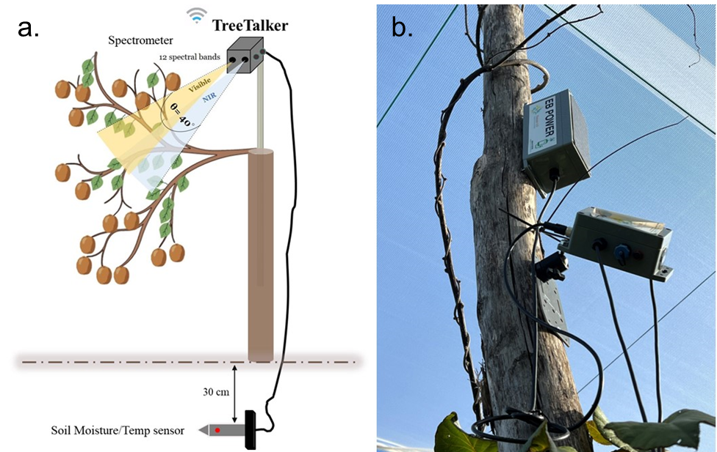
Figure 1. a. Schematic of TT-Spectrum measuring light reflectance data in 12 bands, b. Field installation of TT-Spectrum

TT Spectrum collects light reflectance data in 12 spectral bands, 610+, 680+, 730+, 760+, 810+, 860+ nm, 450*, 500*, 550*, 570*, 600*, 650* (* ±20 nm + ±40 nm). The reported data are digital numbers. Before converting the raw data to the physical units, basic quality assurance procedures are applied (i.e., outliers’ removal and basic gap filling). Then the data elaboration followed by the conversions from digital numbers to physical units, which are conducted according to the TreeTalkers’ user manual (User Manual-string type 59 and 49, March 2023). For further processing, four vegetation indices, Normalized Difference Vegetation Index (NDVI) (Tucker, 1979), Chlorophyll Vegetation Index (CVI) (Vincini et al. 2008), Leaf Nitrogen Balance Index (LNBI) (Fan et al. 2022) and Anthocyanin Index (AI) (Gitelson et al. 2001) are evaluated from TT Spectrum data.
The Normalized Difference Vegetation Index (NDVI) is obtained following the below formula (1):
$NDVI = \frac{NIR 810 - RED 650}{NIR 810 - RED 650}$ | (1)
Where:
NIR = reflectivity in the near-infrared spectrum (Band 810)
RED = reflectivity in the red of the spectrum (Band 650)

The Chlorophyll Vegetation Index (CVI) is estimated following the below equation (2):
$CVI = (NIR 810\frac{RED 650}{ {GREEN 550}^{2}})$ | (2)
Where:
NIR = reflectivity in the near-infrared spectrum (Band 810)
RED = reflectivity in the red of the spectrum (Band 650)
Green= reflectivity in the green of the spectrum (Band 550)

Anthocyanin index (AI) is a vegetation index that has been developed based on the reflectance measurements at 550 nm and 700 nm (3):
$AI = \frac{(R550 - R700)}{(R550 + R700)}$ | (3)
where R550 and R700 are the reflectance values at 550 nm and 700 nm, respectively.

The Leaf Nitrogen Balance Index (LNBI) is a vegetation index that is used as an indicator of nitrogen content in leaves. The spectrometer band that is most sensitive to LNBI is typically in the range of 700-800 nm, which is in the red edge part of the spectrum.
The applied formula for LNBI is (4):
$LNBI = \frac{(R750 - R705)}{(R750 + R705)}$ | (4)
where R705 and R750 are the reflectance values at 705 nm and 750 nm, respectively.
    - Kiwi fruit storage conditions
Soreli kiwi fruits were collected in September 2022 with a °Brix value of 6.8-7.4, ensuring uniform size, appearance, and the absence of defects and disease. These fruits were packed in single-layer trays and promptly transported to the Postharvest Laboratory of DIBAF (University of Tuscia, Viterbo, Italy). The kiwifruits were stored at room temperature for 24 hours and then cooled to 1 ± 0.5 ◦C with a Relative Humidity (RH) of 85 ± 5% in a normal atmosphere, utilizing an ethylene absorber. All analyses were performed at harvest time and every 15 days of cold storage, including 0, 15, 30, 45, 60, and 75 days.
    - Physical-Chemical Parameters
At harvest (0 d) and before storage, the same 20 kiwifruits were weighed using a digital balance (Adam Equipment Co., Ltd., Milton Keynes, UK) at each sampling time to monitor weight loss during cold storage. The total soluble solid content (SCC) of the fresh kiwifruit juice was measured using a digital refractometer (ATAGO, Palette PR-32, Tokyo, Japan) and expressed as °Brix (%). Flesh colour was evaluated on peeled fruits using a Minolta colorimeter (Minolta C2500; Konica Minolta, Ramsey, NY, USA) to assess the chromaticity values L* (Lightness), a* (green to red), and b* (blue to yellow). Chroma (C*) values were calculated as reported by McGuire (1992). Flesh firmness was assessed in two ways: firstly, with a destructive method by removing a 1 mm thick disc of skin from the equatorial section of each fruit and using a digital penetrometer (Mod. 53205; TR Turoni snc, Forlì, Italy). The results were expressed as N m⁻². Secondly, a non-destructive method was employed using an Instron Universal Tasting Machine (Mod. 4301 Instron Inc., Canton, MS, USA). The fruits (20) were compressed at a speed of 25 mm min⁻¹ and a load deformation of 5 N. The same twenty fruits were used at each sampling time and were numbered beforehand to ensure the analysis was performed on the same fruits throughout the entire duration of the test. The fruits were rewarmed to ambient temperature before conducting the Instron test and were then returned to the cold rooms afterward. Flesh hardness was expressed in N m⁻². The titratable acidity (TA) was measured in triplicate on the flesh juice obtained from five fruits following the protocol of Grasso et al. (2022).
    - Bioactive Compounds Content
Total phenols (TP), expressed as milligrams of gallic acid equivalent per 100 g FW, and flavonoids (TF), expressed as milligrams of catechin equivalent per 100 g FW, were analyzed following the protocol of Grasso et al. (2022).
The content of ascorbic acid (AA) was assessed according to Grasso et al. (2022), and it was expressed as milligrams of AA per 100 g FW.
Chlorophyll a, chlorophyll b, and β-Carotene in the sample were analyzed as described by Goffi et al. (2017). Pigments were extracted using acetone-hexane (v:v 4:6), and the optical density of the supernatant was measured at 663 nm, 645 nm, 505 nm, and 453 nm using a spectrophotometer (Perkin Elmer Instruments Ltd., Seer Green, Beaconsfield, U.K).
All the analyses were performed in triplicate.
    - Statistical Analyses
All results are expressed as the means ± standard deviation (SD). Statistical significances between different maturity stages of the fruit of different orchards and storage time were analysed by two-way analysis of variance (ANOVA), and Tukey’s test at 5% level was calculated to compare differences between means. Differences were deemed significant at a p-value of < 0.05 and are denoted by distinct letters.
  - Results and Discussion
3.1 Effects of Overwatering or Underwatering on Kiwifruit Plants
Soil sensors and spectrometers were utilized to collect data on soil water availability and vegetation indices during the days of the year 2022. We then correlated these two factors for each individual plant to better understand the relationship between soil moisture and plant health. By examining these correlations, we can gain insights into the optimal soil moisture conditions for promoting growth and overall plant health in the ecosystem. Adequate soil moisture is crucial for optimal nutrient uptake and root development in trees, but overwatering or underwatering can be detrimental. Therefore, we collected soil volumetric water content (Soil VWC %) data for each individual tree (Figure 2).
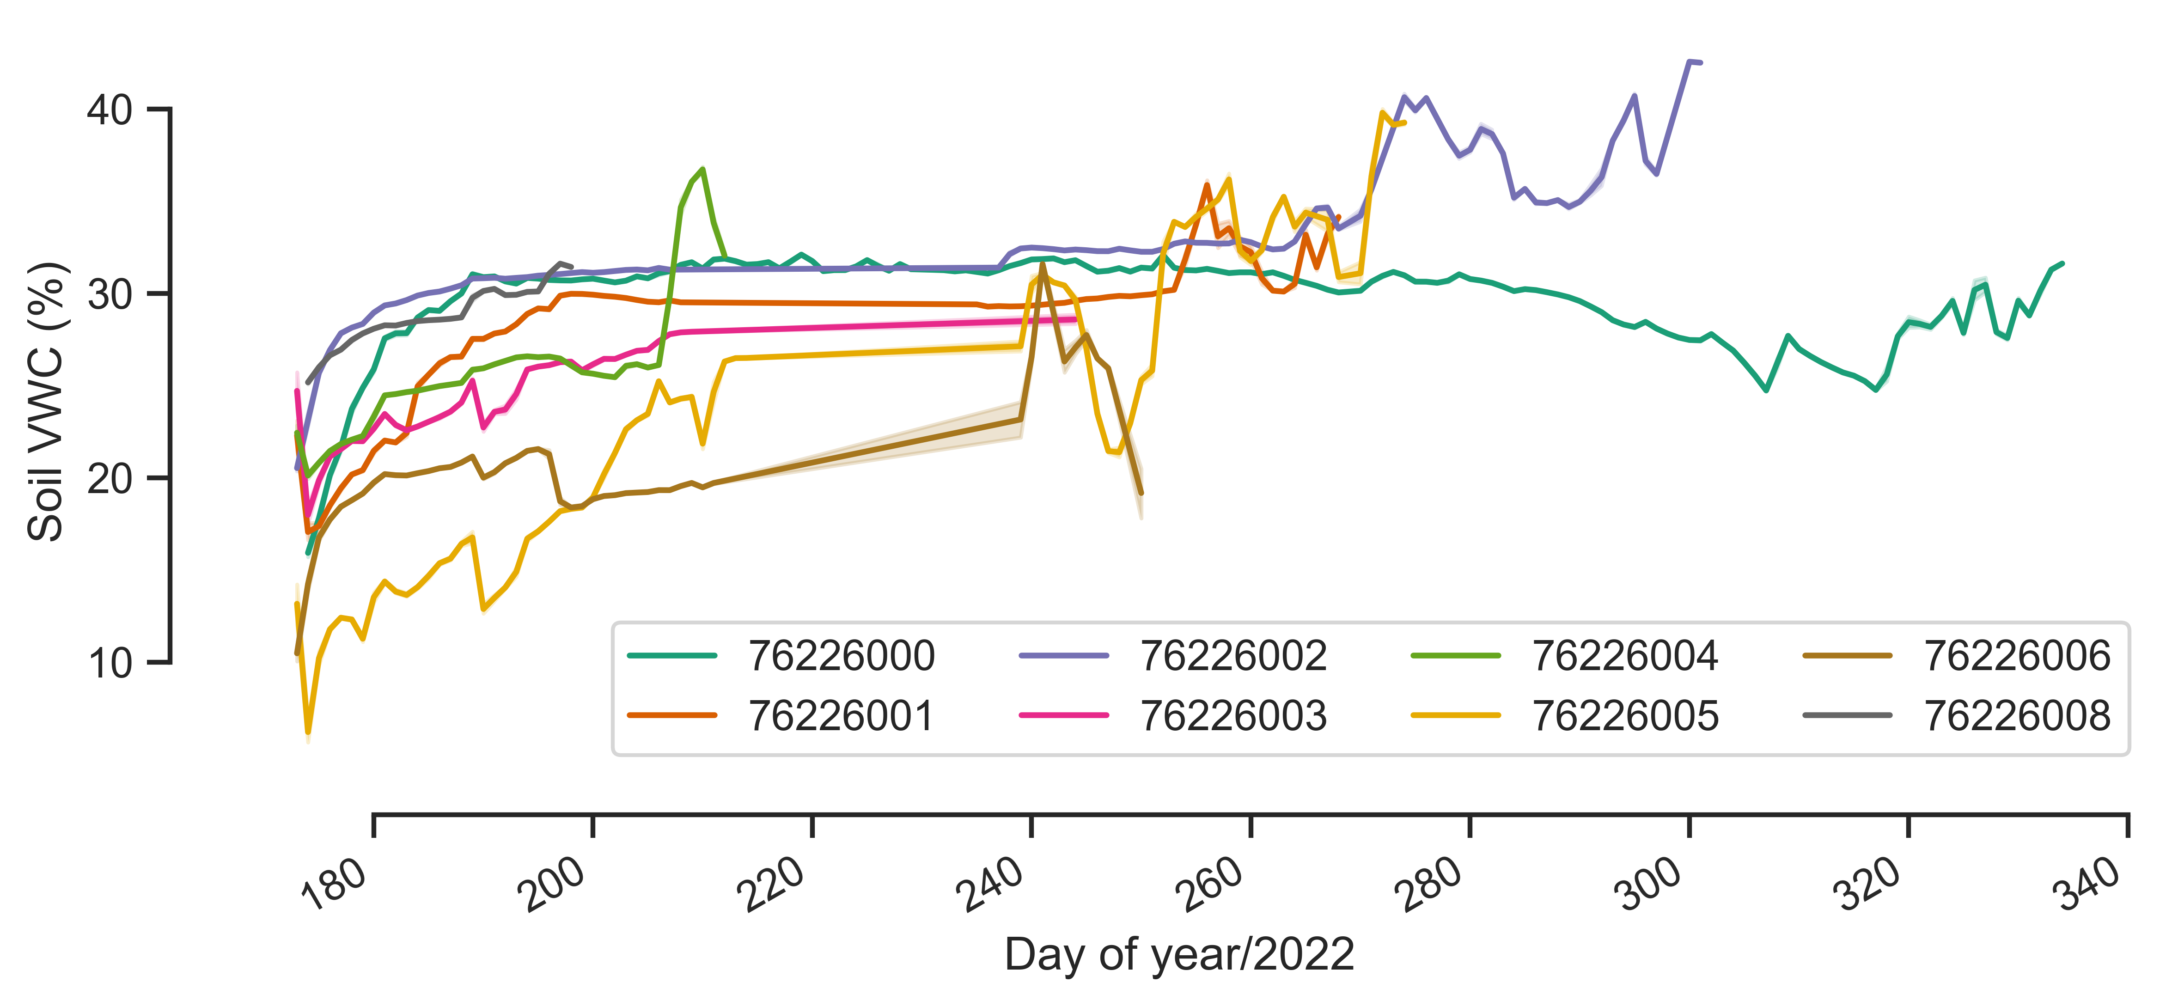
Figure 2. For each individual tree, the soil volumetric water content (Soil VWC %) data were collected using soil sensors placed at a depth of 30 cm. (The data for the sensor TT6226007 is missing)

In Figure 3, we present the TT-Spectrum output for the main vegetation indices (NDVI, CVI, LNBI, and AI) for each individual, based on the reflectance data from various reported bands (450 to 860 nm). The results demonstrate that different levels of soil moisture availability for kiwifruit plants (Figure 2) lead to distinct ecophysiological responses (Figure 3). The analysed vegetation indices (NDVI, CVI, LNBI, and AI) based on TT Spectrum data provide valuable insights into the ecophysiological responses of kiwifruit plants to different soil moisture levels. The soil moisture data revealed that each individual plant received different levels of water availability, resulting in varying health, growth, and productivity conditions. For example, Tree 76226005 received lower irrigation during the early season and maximum water availability during the dry period, which resulted in a very high NDVI and CVI, lower AI, and a balanced leaf nitrogen level (Figures 2 and 3). In contrast, Tree 76226000 received full irrigation during the early season, and underwatering during the dry period did not show high foliage health based on the results of the aforementioned indexes (Figures 2 and 3).
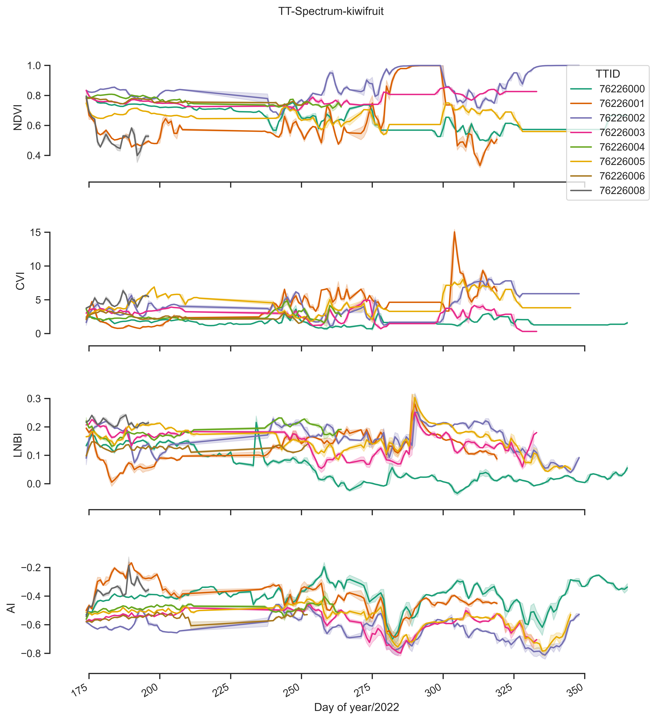
Figure 3. The TT-Spectrum output for the main vegetation indices (NDVI, CVI, LNBI, and AI) for each individual, using reflectance data from different reported bands
    - Effects of water deficit on Soreli kiwifruit Chemical-Physical Parameters and Bioactive Compounds
SSC of stored fruits showed a notable increase over time across all treatments (Table 1), while the percentage of weight loss in fruits increased over time. No significant differences were observed between the various irrigation treatments, as previously demonstrated in the work of Grasso et al. (2022). However, fruits subjected to full irrigation (100% water) exhibited lower sugar levels compared to those under deficit irrigation. There were no significant differences in Brix° values for the samples with 60% and 80% water irrigation. The firmness, measured by both destructive and non-destructive methods, progressively decreased for all harvested fruits during cold storage under all irrigation conditions. Throughout the storage period, all samples consistently showed a softening tendency, indicating a uniform trend overall. Concerning the color parameters, L*, a*, and b* values at harvest (0 d) were highest in fruits irrigated with 100% water compared to fruits irrigated with 80% and 60% water. However, the results revealed a decreasing and homogeneous trend until the end of the study, with no significant differences between the different irrigation levels. The chromaticity coordinate a* consistently exhibited negative values that remained nearly constant throughout the storage time for all harvested fruits. Titratable acidity values did not differ among the different fruit samples during cold storage (Table 1).
Table 1: Physio-chemical parameters in fruits harvested analysed at 0 days, 15 days, 30 days, 45 days, 60 days and 75 days cold storage at 1 °C. Three technical replicates were realized for each biological sample.
Parameter | Treatments | 0 d | 15 d | 30 d | 45 d | 60 d | 75 d
SSC (◦Brix) | 100% | 8,72 (iA) | 11,32 (ghA) | 12,21 (fgB) | 12,64 (efB) | 14,18 (bcB) | 14,34 (abB)
 | 80% | 9,16 (iA) | 11,44 (ghA) | 13,3 (cdeA) | 13,47 (cdA) | 14,95 (abA) | 14,80 (abA)
 | 60% | 9,15 (iA) | 11,08 (hA) | 13,18 (defA) | 13,65 (cdA) | 15,10 (abA) | 15,31 (aA)
FFP (kg cm⁻²) | 100% | 7,61 (aA) | 5,78 (bcA) | 4,96 (cdA) | 3,51 (deA) | 1,97 (fghA) | 0,706 (hA)
 | 80% | 7,656 (abA) | 5,75 (bcA) | 4,36 (cdeA) | 3,41 (efgA) | 1,80 (hA) | 0,95 (hA)
 | 60% | 6,83 (aA) | 5,80 (bcA) | 4,40 (cdeA) | 3,27 (efA) | 1,60 (ghA) | 0,81 (hA)
TA (mg citric  acid/100g FW) | 100%  80%  60% | 4,00 (abA)  3,85 (abA)  4,35 (abA) | 4,60 (abA)  3,40 (bB)  3,90 (bB) | 3,30 (bB)  4,30 (abAB)  4,00 (abA) | 4,15 (abA)  4,55 (abA)  4,4 (abA) | 4,10 (abA)  3,45 (abA)  3,75 (bA) | 4,45 (abA)  4,45 (abA)  5,4 (aA)
Capital letters indicate comparisons between the maturity stages of fruits subjected to different treatments at each specific time. Small letters reflect comparisons between different storage times for each sample fruit of the same treatment. According to the Tukey test (p < 0.05), there are no significant differences between means that share the same letter within the same column or row.

Analyzing the content of bioactive compounds, such as ascorbic acid (AA), carotenoids (CAR), chlorophyll a (Cl a), chlorophyll b (Cl b), flavonoids (FLAV), and polyphenols (POL), in fruits harvested and analyzed at 0 days, 15 days, 30 days, 45 days, 60 days, and 75 days of cold storage at 1 °C, the data provide evidence that a reduction in water does not negatively influence the bioactive compounds of yellow fruits. This observation aligns with another experiment conducted by Nora et al. (2012). However, the change in content remains consistent across all irrigation methods. The changes in bioactive compound during the ripening of kiwifruits do not appear to differ significantly between the various irrigation techniques.
  - Conclusions
In conclusion, this study highlights the significant impact of soil moisture availability on the ecophysiological responses of kiwifruit plants. The study demonstrates that excessive irrigation may not always be beneficial for plant performance, as evidenced by the combination of vegetation spectral indices and fruit quality. In fact, by utilizing soil sensors and a spectrometer, we were able to correlate soil moisture data with vegetation indices, revealing the influence of varying water availability on plant health, growth, and productivity. It was observed that the CVI and LNBI values for leaves were higher in deficit irrigation, particularly at 80% water availability, compared to full irrigation. For the fruit, the soluble solids content was higher in deficit irrigation than in 100% irrigation, enhancing the desirable quality of the fruit that is appreciated by consumers and is further accentuated when irrigation water is reduced. In terms of all the analyzed characteristics, including bioactive components and chemical and physical parameters of the fruit, no significant differences were found between the different irrigation conditions. This suggests that by reducing irrigation water, companies can achieve economic savings and reduce water waste while still obtaining high-quality final products. Based on the conducted study, it has been determined that employing 80% deficit irrigation yields superior results in terms of fruit quality and overall plant health. This could be a significant economic advantage for fruit and vegetable companies, as they can utilize IoT sensors to monitor the plant's condition and intervene as necessary. These insights can help inform targeted irrigation management practices, optimize water use, and promote sustainable growth in kiwifruit ecosystems. The study also emphasizes the importance of maintaining adequate soil moisture levels, especially during dry periods, to ensure optimal nutrient uptake, root development, and overall plant health.

Acknowledgments
Special thanks to the company ’Tre Colli Srl’ and ’Nature4.0’ for their technical and logistical support in this research.
References
Fan, K.L. et al. (2022) “Nitrogen Balance Index Prediction of Winter Wheat by Canopy Hyperspectral Transformation and Machine Learning,” Remote Sensing, 14(14), p. 3504. Available at: https://doi.org/10.3390/rs14143504.
Gitelson, A.A., Merzlyak, M.N. and Chivkunova, O.B. (2001) “Optical Properties and Nondestructive Estimation of Anthocyanin Content in Plant Leaves¶,” Photochemistry and Photobiology, 74(1), p. 38. Available at: https://doi.org/10.1562/0031-8655(2001)074.
Goffi, V. et al. (2020) “Response of antioxidant system to postharvest ozone treatment in ‘Soreli’ kiwifruit,” Journal of the Science of Food and Agriculture, 100(3), pp. 961–968. Available at: https://doi.org/10.1002/jsfa.10055.
Goffi, V., Modesti, M., Forniti, R. and Botondi, R. (2018). Quality of green (Actinidia chinensis var. deliciosa ““Hayward””) and yellow (A. chinensis var. chinensis[A1] [A2] ‘Soreli’) kiwifruit during cold storage at 0°C in normal atmosphere and with gaseous ozone. Acta Hortic. 1218, 473-480 10.17660/ActaHortic.2018.1218.65
Grasso, C., Forniti, R. and Botondi, R. (2022) “Post-Harvest Quality Evaluation of ‘Soreli’ Kiwifruit at Two Ripening °Brix Values from Vineyards of Different Age Under Hail Nets,” Foods, 11(3), p. 431. Available at: https://doi.org/10.3390/foods11030431.
Gwanpua, S.G. et al. (2018) “Investigating the potential of dual temperature storage as a postharvest management practice to mitigate chilling injury in kiwifruit,” International Journal of Refrigeration-revue Internationale Du Froid, 86, pp. 62–72. Available at: https://doi.org/10.1016/j.ijrefrig.2017.12.004.
Ram, V.V.H. et al. (2015) Regulation of water in agriculture field using Internet Of Things. Available at: https://doi.org/10.1109/tiar.2015.7358541.
Liu, Jiao et al. (2022) “Transcription factors AcERF74/75 respond to waterlogging stress and trigger alcoholic fermentation-related genes in kiwifruit,” Plant Science, 314, p. 111115. Available at: https://doi.org/10.1016/j.plantsci.2021.111115.
McGuire, R.R. (1992) “Reporting of Objective Color Measurements,” Hortscience, 27(12), pp. 1254–1255. Available at: https://doi.org/10.21273/hortsci.27.12.1254.
Postharvest Biology and Technology of Temperate Fruits (2018) Springer eBooks. Available at: https://doi.org/10.1007/978-3-319-76843-4.
Nora, L. et al. (2012) “Controlled Water Stress to Improve Fruit and Vegetable Postharvest Quality,” in InTech eBooks. Available at: https://doi.org/10.5772/30182.
Pinto, R. et al. (2021) "Influence of Irrigation and Nitrogen Fertilization on Kiwifruit Production." Agricultural Engineering AgEng2021: 707.
Reid, J.S. et al. (1996) “Improvement in kiwifruit storage life caused by withholding early‐season irrigation,” New Zealand Journal of Crop and Horticultural Science, 24(1), pp. 21–28. Available at: https://doi.org/10.1080/01140671.1996.9513931.
Tucker, C.J. (1979) “Red and photographic infrared linear combinations for monitoring vegetation,” Remote Sensing of Environment, 8(2), pp. 127–150. Available at: https://doi.org/10.1016/0034-4257(79)90013-0.
Vincini, M., Frazzi, E. and D’Alessio, P. (2008) “A broad-band leaf chlorophyll vegetation index at the canopy scale,” Precision Agriculture, 9(5), pp. 303–319. Available at: https://doi.org/10.1007/s11119-008-9075-z.

