CHEMICAL ENGINEERING TRANSACTIONS  VOL. , 2023 | A publication of
The Italian Association
of Chemical Engineering
Online at www.cetjournal.it

Guest Editors: Laura Piazza, Mauro Moresi, Francesco Donsì
Copyright © 2023, AIDIC Servizi S.r.l.
ISBN 979-12-81206-01-4; ISSN 2283-9216

In vitro analysis of the anti-inflammatory activity in dairy products containing Salicornia europaea
Sylvia Fasse*, Axel Gottschalk
Institute of Process Engineering, Bremerhaven University of Applied Sciences, An der Karlstadt 8, 27568 Bremerhaven, Germany
*sfasse@hs-bremerhaven.de
Novel solutions for ensuring food security have to be established in the context of a growing world population, and rising climate restrictions on agriculture and agriculturally usable lands. Simultaneously, there is a rising demand for healthy functional foods in today’s world population. Edible halophytes could be part of the solution, as they are capable to grow in saline environments and contain several bioactive compounds. The exploitation of these salt-tolerant plants in the formulation of novel functional dairy products is demonstrated. Therefore, the focus of this research is on the development of suited dairy products with the addition of different concentrations of Salicornia europaea biomass, while measuring the in vitro anti-inflammatory activity with the egg albumin denaturation method. The inhibition of protein denaturation observed is equivalent to the anti-inflammatory capabilities of the steroid reference drug hydrocortisone. Therefore, these initial results indicate that the formulation of cream cheese products with the addition of S. europaea biomass can be achieved.
  - Introduction
Global demand for food is rising. In addition to their caloric value, functional foods lead to health benefits. Therefore, they experience a huge compound annual growth rate (CAGR). The global nutraceutical market size is expected to grow at a CAGR of 9.4% from 2023 to 2030 (Grand View Research, 2023).
Halophytes are salt-tolerant plants and have traditionally been used as medical plants worldwide. Today they are regaining more interest, as they have been reported to contain several bioactive compounds (Qasim et al., 2017). As part of their defense mechanism against oxidative stress, induced by high salt concentrations, they synthesize bioactive secondary metabolites. These include phenolic acids, flavonoids, and tannins, which are considered health beneficial in foods (Jdey et al., 2017). A few halophytes, e.g. Aster tripolium and Salicornia europaea, were already used as a food or food ingredient before 15th May 1997, thus they do not need to be approved according to the Novel Food Regulation (CE) Nº 2015/2283 (Novel food catalogue, 2023). Therefore, this study examines the addition of S. europaea, as it is already widely available as a vegetable in the European market and should be considered for the formulation of innovative food products (Custódio et al., 2021).
The combination of dairy products with halophytes seems reasonable, as plant additives are already added to several products and their bioactivity has been analysed (Wajs et al., 2023). As the addition of halophyte biomass also increases the salinity in dairy products, cream cheese was chosen in this research. Weragama et al. (2021) reported the sensory acceptability of cream cheese products with 2 % (w/w) salt. With the addition of health-beneficial plant sterols, as they have been reported in Salicornia spp., infused dairy products such as cream cheeses can be recognized as functional foods (Choi et al., 2014; Jędrusek-Golińska et al., 2020). Further the sensory properties of cream cheeses with addition of herbs are already widely known. Thus, a green color and alteration of the texture through addition of ground plant materials is already accepted by numerous consumers, e.g. herb cream cheese with parsley or chives are on the market.
Nonetheless, to evaluate the functional properties of the formulated dairy products, the anti-inflammatory and anti-arthritic properties are investigated. Inflammation is a complex biological defense mechanism that enables the body to protect itself against pathogens and damaged cells, e.g. due to external stress factors (Giordano et al., 2021). To quantify the anti-inflammatory properties of plant materials and extracts, several methods have been described. There are albumin denaturation assays either using bovine serum albumin or egg albumin. The anti-inflammatory activity is compared to the activity measured in medicinal nonsteroidal anti-inflammatory drugs (NSAIDs) or steroid drugs on the market (Rahman et al., 2015; Dharmadeva et al., 2018). Further, there are also cell culture experiments analyzing the immune response, e.g. in murine macrophages, and then the suppressed synthesis of tumor necrosis factor in induced cells is quantified. Salicornia herbacea L. extracts have been described to exhibit anti-inflammatory activities. It was investigated to measure the suppression of the inflammatory response in lipopolysaccharide-induced RAW 264.7 macrophage cells (Kim et al., 2009; Giordano et al., 2021). Therefore, it is likely that also S. europaea included in food is health beneficial.
In the scope of this research, an in vitro albumin denaturation assay using egg albumin is performed with the formulated products, as described by Rahman et al. (2015). This assay has been described to evaluate the anti-inflammatory activity of plant extracts against protein denaturation. In this study, the assay will be adapted to assess the properties of cream cheese samples.
  - Material and Methods
On the one hand, the scope of this research was to assess the feasibility of cream cheese formulation with different levels of S. europaea and on the other hand to perform the laboratory anti-inflammatory analysis of the products.
    - Fresh material and preparation of S. europaea biomass
The fresh, food-grade S. europaea biomass was produced in hydroponic systems and obtained from Alpha-Aqua in Denmark (DK). This fresh biomass was stored frozen until the biomass was dried at 50°C for 20 h in a convection dryer. Afterward, the biomass was ground. The dry matter content was measured in a KERN Dab 100-3, in which 5 g of biomass were spread on the tray and heated to 120°C to evaporate the residual moisture. Measurement was performed in triplicate
    - Dairy product formulation
The cream cheese used in the experiments was commercially available double cream cheese with the following macronutrient composition: 25 g/100g fats, 3 g/100g carbohydrates, and 4.5 g/100g proteins. In a reactor, the ground S. europaea was mixed into cream cheese in concentrations of 0.5 %, 1.0 %, and 1.5 %. Thereafter the mixture was heated to 70°C and kept at the temperature for 30 s (see figure 1), as this is a standard procedure for the heat treatment of dairy products in the industry. This heat treatment was performed to eliminate the potential contamination through the S. europaea biomass, as majority of the bioactive compounds are phenolics the bioactivity is presumably not impacted (Friedman and Jürgens, 2000). A further measurement performed was the detection of the pH value over time (after preparation, after 5 days, and after 8 days) and was measured in triplicate. Additionally, the water activity was measured in the Novasina LabMaster-aw, where the sample is heated to 25°C. Also, the dry matter content was measured as described above.

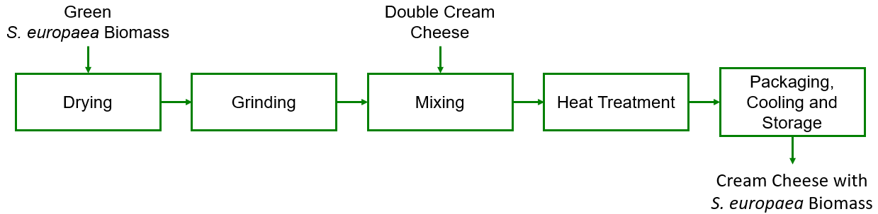Figure 1: Product formulation of cream cheese with the addition of dried and ground green S. europaea biomass. Heat treatment was performed by heating the cream cheese to 70°C for 30 s.
    - Chemicals and reference drug
The following chemicals were used in the analysis: Phosphate buffered saline (PBS, pH 6.7) consisting of 1.79 g di-sodium hydrogen phosphate (ROTH, Karlsruhe, Germany), 1.36 g potassium dihydrogen phosphate (ROTH, Karlsruhe, Germany) and 7.02 g sodium chloride (ROTH, Karlsruhe, Germany) in 1,000 mL of distilled water. The commonly used steroid anti-inflammatory drug hydrocortisone (Soventol®, Iserlohn, Germany) was chosen as a reference (positive control) to quantify the anti-inflammatory properties. The hydrocortisone was diluted with distilled water to yield solutions with 1,000 µg/mL, 100 µg/mL, 10 µg/mL, and 1 µg/mL of active ingredient.
    - In vitro anti-inflammatory activity
Several methods have been described to estimate the anti-inflammatory activity by in vitro measurements. This described method is used for in vitro determination of the anti-inflammatory activity of S. europaea infused cream cheese products using the albumin denaturation method based on Rahman et al. (2015) with minor adjustments. For the cream cheese, samples are prepared by diluting the cream cheese with distilled water (1:10) and keeping it in a thermoshaker (Cell Media Thermoshaker Pro) at 50°C for 15 min at 500 rpm. Afterwards, the liquid was separated via centrifugation at 3,500 rpm for 15 min. The supernatant was diluted with distilled water to yield a concentration of 10 mg/mL. Further, cream cheese without the addition of S. europaea biomass was taken as control, following the same procedure. Also, a control with distilled water instead of the above-described solutions, was prepared for the reference drug measurements.
Reaction mixtures were prepared by adding 2.5 mL of PBS (pH=6.7), 0.5 mL of albumin from fresh hens’ egg, and 2 mL of sample (reference drug, control, cream cheese control, and cream cheese sample). After mixing, the mixture was kept at 37°C for 15 min and shaken at 400 rpm. Then the mixture was heated to 70°C and kept for 5 min at 400 rpm. Before the absorbance measurement, the reaction mixture was stored at room temperature for 20 min. All measurements were taken in triplicates.
The absorbance was measured in triplicates at 680 nm (VWR UV-3100PC). The calculation of the denaturation inhibition is based on Rahman et al. (2015):
$$Denaturation \left(\%\right)= \left(\frac{Absorbance of sample/reference}{Absorbance of control}\right) ∙100$$ | (1)
The anti-inflammatory activity was measured after the cooling of the product and 5 days after the product packaging, while the sample was stored at 4°C.
    - Statistical analysis
To evaluate the statistical significance a one way analysis of variance (ANOVA) in Excel was performed, as described by Quirk (2012), to evaluate the results. The p-value was considered significant with p < 0.05.
  - Results and Discussion
    - Analysis of cream cheese and S. europaea biomass
The dry matter content in the cream cheese amounts to 67.7 % ± 0.5 %. Water activity in the cream cheese is determined to be 0.94. Meanwhile, the dry matter content of the fresh S. europaea biomass was determined to be 91.9 % ± 0.9 %. After drying the dry matter content increased to 93.9 % ± 0.4 %.
    - Cream cheese formulation
The cream cheese products have been prepared and the pH value was measured directly after cooling, after 5 days, and after 8 days. The pH values are displayed in figure 2. Therein a slight shift towards an alkaline pH value can be observed. The one-way ANOVA statistical analysis calculated a p = 0.0032, which is evaluated statistically significant.
A possible explanation is the entry of molds in the samples (Goldfarb and Herrmann, 1956), therefore the anti-inflammatory activity was also measured after 5 days. The microbiological examination of the samples should be performed. Herein the possible contamination with molds or bacteria most likely happened due to the processing performed, as the cream cheese was commercially available. Also, the contamination could be due to the addition of the biomass, which is possibly contaminated by molds.
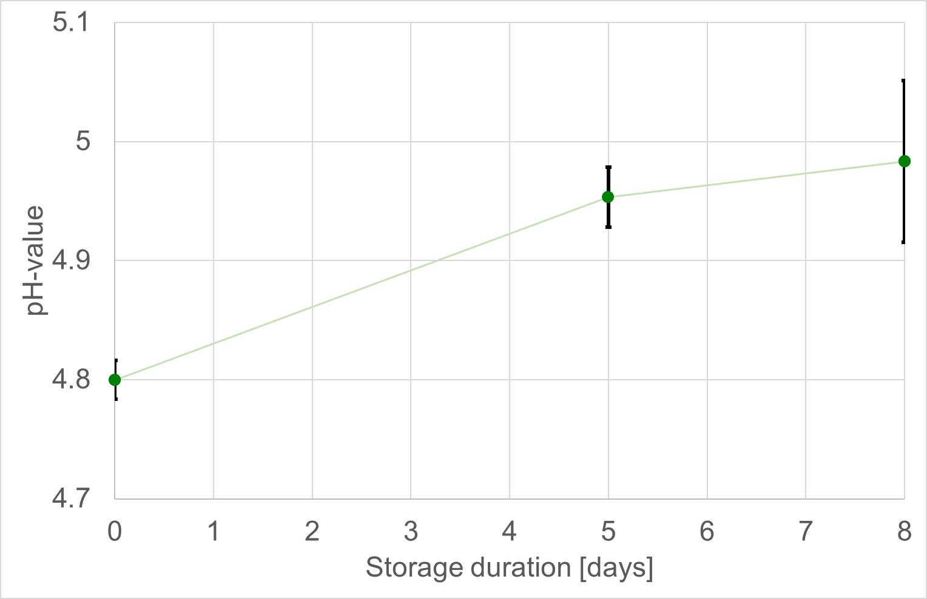
Figure 2: Development of pH value of S. europaea infused cream cheese samples on the day of preparation, after 5 days, and after 8 days of storage at 4°C.
    - In vitro anti-inflammatory activity
The egg albumin denaturation assays with the reference drug hydrocortisone show an increase in anti-inflammatory activity with increasing concentration of the drug, as displayed in figure 3. Approx. 10-30 % of protein denaturation is inhibited in the measurements including the hydrocortisone solutions. This is analog to the results Chandra et al. (2012) reported for diclofenac sodium as a NSAID reference drug and the measured differences are considered statistically significant (p = 0.0015).

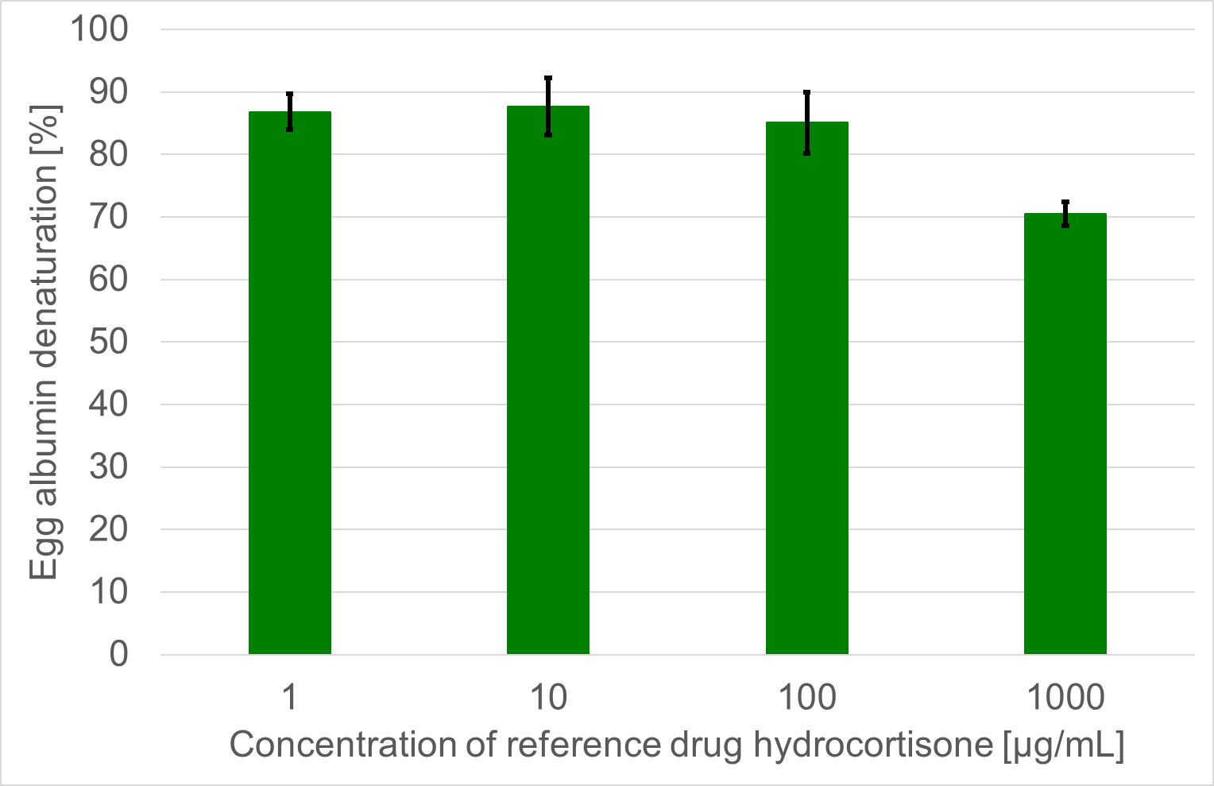
Figure 3: Egg albumin denaturation with different concentrations of hydrocortisone (1 µg/mL – 1,000 µg/mL) in the reaction mixture
The results of the protein denaturation experiments are displayed in figure 4. The egg albumin denaturation is increasingly inhibited in the samples with increasing S. europaea concentration in comparison to the control. After 5 days of storage, the inhibition is still detected in similar quantities. Both direct measurement and measurement after 5 days are statistically significant with p = 0.0014 and p = 0.0031, respectively. From this, it can be concluded that the anti-inflammatory properties of the formulated cream cheese products are stable during the storage period, although a shift in pH value was detected. If this is also valid for longer storage periods has to be examined further.
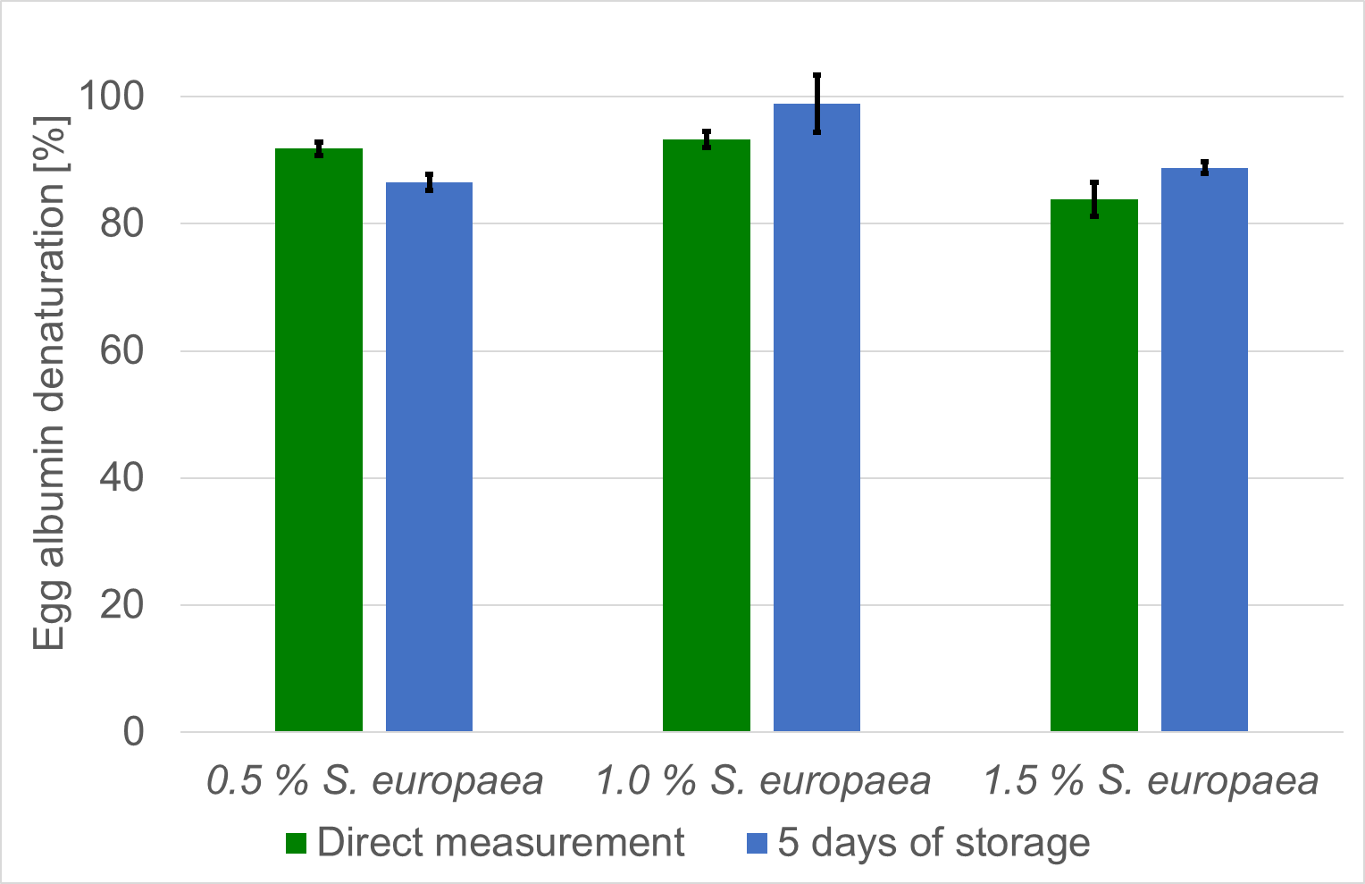
Figure 4: Egg albumin denaturation in 10 mg/mL concentrations of cream cheese with the addition of different concentrations of S. europaea (0.5 %; 1.0 %; 1.5 %) in reference to the control of cream cheese without the addition of S. europaea. The first measurement was taken directly after cooling (■) and the second was taken after 5 days of storage at 4°C (■).
The denaturation inhibition is also summarized in table 1. Measured inhibition rates are comparable with those of plant extracts as reported by Dharmadeva et al. (2018) to be between 10-20 %.
Table 1: Protein denaturation inhibition in cream cheese samples with 0.5 %, 1.0 %, and 1.5 % addition of dried S. europaea biomass in reference to cream cheese without the addition of biomass (control). Measurements were taken directly and after 5 days of storage.
 | Control | 0.5 %  S. europaea | 1.0 %  S. europaea | 1.5 %  S. europaea
Denaturation inhibition [%] direct measurement ± SD | - | 8.16 ± 1.05 | 6.70 ± 1.28 | 16.17 ± 2.65
Denaturation inhibition [%] after 5 days of storage ± SD | - | 13.43 ± 1.25 | 1.06 ± 4.48 | 11.16 ± 0.92

  - Conclusions
The analysis of the different levels of halophyte concentration in dairy products showed great potential as additive for functional food development. The measured anti-inflammatory activity proved to be comparable to those of prescribed anti-inflammatory drugs. This is supported by the traditional use of halophytes as medical plants. Therefore, bringing these S. europaea infused dairy products to the market becomes inherent. Further research should focus on evaluating the additional nutraceutical properties of these products. These assessments should include the estimation of antioxidant activity, anti-microbial activity and the assessment of shelf-life. Also, a larger scale sensory assessment is recommended as the salt concentration, as well as other changed sensory properties in the dairy products might affect the consumer acceptance.

Nomenclature
CAGR – compound annual growth rate
PBS – phosphate buffered saline
NSAID – nonsteroidal anti-inflammatory drug
Acknowledgments
This work is part of the European Horizon 2020 project AQUACOMBINE, which aims to demonstrate a biorefinery that includes the production of food and additionally extraction of bioactive compounds, production of feed, cosmetics, biogas, and biochar in combination with the use of aquaponics for the co-production of fish. This project has received funding from the European Union’s Horizon 2020 research and innovation programme under Grant Agreement No 862834. Any results of this project reflect only this consortium’s view and the European Research Executive Agency is not responsible for any use that may be made of the information it contains. Further the authors thank Frederike Reimold and Imke Lang for supporting the experiments and giving access to the laboratory and Sanketkumar Raval and Tutku Taşçı Çilak for proofreading the manuscript.

References
Chandra S., Chatterjee P., Dey P., Bhattacharya S., 2012, Evaluation of in vitro anti-inflammatory activity of coffee against the denaturation of protein, Asian Pacific Journal of Tropical Biomedicine, 2, S178-S180.
Choi D., Lim G.-S., Piao Y.L., Choi O.-Y., Cho K.-A., Park C.-B., Chang Y.-C., Song Y.-I., Lee M.-K., Cho H., 2014, Characterization, stability, and antioxidant activity of Salicornia herbaciea seed oil, Korean Journal of Chemical Engineering, 31, 2221–2228.
Custódio M., Lillebø A.I., Calado R., Villasante S., 2021, Halophytes as novel marine products – A consumers’ perspective in Portugal and policy implications, Marine Policy, 133, 104731.
Dharmadeva S., Galgamuwa L.S., Prasadinie C., Kumarasinghe N., 2018, In vitro anti-inflammatory activity of Ficus racemosa L. bark using albumin denaturation method, Ayu, 39, 239–242.
Friedman M., Jürgens H.S., 2000, Effect of pH on the stability of plant phenolic compounds, Journal of Agricultural and Food Chemistry, 48, 2101–2110.
Giordano R., Saii Z., Fredsgaard M., Hulkko L.S.S., Poulsen T.B.G., Thomsen M.E., Henneberg N., Zucolotto S.M., Arendt-Nielsen L., Papenbrock J., Thomsen M.H., Stensballe A., 2021, Pharmacological Insights into Halophyte Bioactive Extract Action on Anti-Inflammatory, Pain Relief and Antibiotics-Type Mechanisms, Molecules (Basel, Switzerland), 26, 3140.
Goldfarb N.J., Herrmann F., 1956, A study of pH changes by molds in culture media, The Journal of investigative dermatology, 27, 193–201.
Grand View Research, 2023, Global Nutraceuticals Market Size & Trends [2023 Report] ‹grandviewresearch.com›. accessed 06.05.2023.
Jdey A., Falleh H., Ben Jannet S., Mkadmini Hammi K., Dauvergne X., Magné C., Ksouri R., 2017, Anti-aging activities of extracts from Tunisian medicinal halophytes and their aromatic constituents, EXCLI Journal, 16, 755–769.
Jędrusek-Golińska A., Górecka D., Buchowski M., Wieczorowska-Tobis K., Gramza-Michałowska A., Szymandera-Buszka K., 2020, Recent progress in the use of functional foods for older adults: A narrative review, Comprehensive reviews in food science and food safety, 19, 835–856.
Kim Y.A., Kong C.-S., Um Y.R., Lim S.-Y., Yea S.S., Seo Y., 2009, Evaluation of Salicornia herbacea as a potential antioxidant and anti-inflammatory agent, Journal of medicinal food, 12, 661–668.
Novel food catalogue, 2023 ‹webgate.ec.europa.eu#›. accessed 21.06.2023.
Qasim M., Abideen Z., Adnan M.Y., Gulzar S., Gul B., Rasheed M., Khan M.A., 2017, Antioxidant properties, phenolic composition, bioactive compounds and nutritive value of medicinal halophytes commonly used as herbal teas, South African Journal of Botany, 110, 240–250.
Quirk T.J., 2012, One-Way Analysis of Variance (ANOVA) In: Excel 2007 for Educational and Psychological Statistics, Springer, New York, NY, 163–179.
Rahman H., Chinna Eswaraiah M., Dutta H.M., 2015, In-vitro Anti-inflammatory and Anti-arthritic Activity of Oryza sativa Var. Joha Rice (An Aromatic Indigenous Rice of Assam).
Wajs J., Brodziak A., Król J., 2023, Shaping the Physicochemical, Functional, Microbiological and Sensory Properties of Yoghurts Using Plant Additives, Foods, 12, 1275.
Weragama D., Weerasingha V., Jayasumana L., Adikari J., Vidanarachchi J.K., Priyashantha H., 2021, The physicochemical, microbiological, and organoleptic properties and antioxidant activities of cream cheeses fortified with dried curry leaves (Murraya koenigii L.) powder, Food science & nutrition, 9, 5774–5784.

