CHEMICAL ENGINEERING TRANSACTIONS  VOL. , 2023 | A publication of
The Italian Association
of Chemical Engineering
Online at www.cetjournal.it

Guest Editors: Laura Piazza, Mauro Moresi, Francesco Donsì
Copyright © 2023, AIDIC Servizi S.r.l.
ISBN 978-88-81206-01-4; ISSN 2283-9216

Purification and Characterisation of a Fungal β-1,6-glucanase for the Production of Gentio-oligosaccharides from Brewer’s Spent Yeast
Anastasia Klemanska^{a,b}*, Italo Pisanoª, Kelly Dwyer^{b}, Gary Walshª
ªBernal Institute, University of Limerick, Castletroy, Limerick City, Ireland
^{b}Monaghan Mushrooms, Tyholland, Co. Monaghan, Ireland
anastasia.klemanska@ul.ie
Gentio-oligosaccharides (GnOS) are an emerging class of prebiotics derived from β-1,6-glucan, a polysaccharide found within the cell walls of fungi such as Saccharomyces cerevisiae, or Brewer’s yeast (BSY). The generation of GnOS from BSY by enzymatic hydrolysis could create functional food additives, as well as minimize waste and waste-disposal costs, thereby contributing to the circular economy. In this study, a β-1,6-glucanase from the mycoparasitic fungus Trichoderma virens was cloned and expressed in Pichia pastoris, and subsequently purified and characterized in order to assess its suitability for the production of GnOS from BSY. Tvir30 was purified by IMAC to a yield of 47.5% with a purification factor of 5.63. The pH and temperature optima of Tvir30 were determined to be 5.0 and 45ºC respectively. The enzyme was found to be glycosylated, and substrate specificity analysis revealed it to be specific to β-1,6-linkages only. Tvir30 was relatively heat sensitive, with 50% relative activity remaining after 15 min incubation at 50ºC. However, at 40ºC the stability of Tvir30 was improved, with activity reaching 80% at 100 h of incubation. Kinetic analysis revealed classic Michaelis-Menten kinetics, with a Vmax of 214.4 μmol mg⁻¹ min⁻¹, a Km of 1.873 mg mL⁻¹, and a Kcat of 161 sec⁻¹. Finally, analysis of hydrolysis products revealed Tvir30 to have an endolytic mode of action, capable of generating GnOS with DP>2, including from yeast β-glucan.
  - Introduction
Prebiotics are an emerging class of health-promoting food additives that function primarily as energy sources for probiotic micro-organisms. The International Scientific Association for Probiotics and Prebiotics (ISAPP) defines the term prebiotic as “a substrate that is selectively utilised by host microorganisms conferring a health benefit” (Gibson et al., 2017). Health-promoting effects include inhibition of pathogenic microorganisms, production of short-chain fatty acids, immune cell activation, and even anti-tumorigenic activity (Kim et al., 2006). Poly- and oligosaccharides are an important class of prebiotics, with well-characterised examples such as inulin, whereas oligosaccharides derived from β-1,6-glucan are considered an emerging class (Wang et al., 2020).

A polymer of D-glucose units joined by β-1,6-branching, β-1,6-glucan is found within the cell walls of fungi such as Saccharomyces cerevisiae, or Brewer’s yeast, and can be enzymatically digested to generate short-chain oligosaccharides called gentio-oligosaccharides (GnOS). GnOS have been found to be more resistant to digestion than oligosaccharides with β-1,4- or β-1,3-linkages, which means they may be able to reach more distal parts of the colon (Ferreira-Lazarte et al., 2019). As such, spent Brewer’s yeast (BSY) represents a large untapped source of lucrative β-1,6-glucans. In the production of 10,000 hL of beer, approximately 15-18 tons of S. cerevisiae is discarded as Brewer’s spent yeast (BSY) (Kunze, 1999). The yeast cell wall makes up 20-30% of the total cell weight, approx. 85% of the cell wall is polysaccharide, and a further 10-15% of that is β-1,6-glucan (Aimanianda et al., 2009). Therefore, at a conservative estimate, the amount of β-1,6-glucan present in 15 tons of BSY is ~260 kg. The generation of GnOS from BSY by enzymatic hydrolysis could create functional food additives, as well as minimize waste and waste-disposal costs, thereby contributing to the circular economy. In this study, a β-1,6-glucanase from the mycoparasitic fungus Trichoderma virens was cloned and expressed in Pichia pastoris, and subsequently purified and characterized in order to assess its suitability for the production of GnOS from BSY.
  - Materials and Methods
The fungal β-1,6-glucanase gene Tvir30 from Trichoderma virens was transformed into Pichia pastoris via electroporation and the reaction was plated on YPD agar containing 100-1000 μg mL⁻¹ Zeocin antibiotic. Resultant clones were expressed in BMGY/BMMY media over 72 h in 2 mL cultures and screened for the presence of active, His-tagged protein. Proteins were visualised using a 10% (w/v) SDS-PAGE gel in a vertical electrophoretic system using 1X Tris-Glycine running buffer. Gels were stained using a Coomassie stain for 1 hr at RT and destained with distilled water. The highest expressing clone was chosen for large-scale (150 mL) culture with 1% methanol induction every 24 h over a period of 48 h. The crude enzyme was harvested by centrifugation, equilibrated with IMAC equilibration buffer (50mM sodium phosphate, 300mM sodium chloride; pH 7.4), and applied onto a HisPur Cobalt resin packed column. Bound enzyme was eluted using 50 mM sodium phosphate, 300 mM sodium chloride, 150 mM imidazole; pH 7.4, diafiltered with 50 mM citrate buffer pH 5.0, and used in characterisation studies. Each characterisation was performed at least twice. Enzyme activity during characterisation studies (optimum pH, temperature, and substrate specificity) was assessed by the amount of reducing sugar liberated during the incubation of enzyme with substrate via the 3,5-dinitrosalicylic acid (DNS) assay (Miller, 1959). A standard assay involved the addition of 0.25 mL of enzyme to 0.25 mL of 0.5% (w/v) substrate, pre-equilibrated to the desired temperature, and incubation of the reaction at that temperature for 15 min. The reaction was stopped by the addition of 0.75 mL DNS reagent and heated to 95ºC for 5 min, then placed on ice for 10 min. Once at room temperature, the absorbance of the reaction was recorded at 540 nm using a spectrophotometer. Every assay was performed in triplicate with an appropriate blank (n=3). The products of hydrolysis were analysed by High-Performance Anion-Exchange chromatography with Pulsed Amperometric Detection (HPAE-PAD) using a CarboPac PA200 column, 90% 0.1M NaOH and 10% 0.1 M NaOH in 0.5 M NaOAc, at 30ºC with a flow rate of 0.35 mL/min, and thin layer chromatography (TLC). During TLC, 0.5 mL of 1% (w/v) substrate was incubated with 0.5 mL of enzyme at specified reaction conditions. The hydrolysis reaction was then concentrated to 0.1 mL by evaporation and 0.5 µL was spotted onto silica-coated TLC plates which were placed into a chamber containing ethyl acetate: acetic acid: water (2:2:1) (Kumar et al., 2020). The TLC plates were developed in a 100ºC oven after spraying with 10% (v/v) sulfuric acid.
  - Results and Discussion
A 150 mL sample of crude enzyme was collected 48 h post-induction and purified by IMAC. The purified enzyme was then characterised to determine its optimum temperature, pH, substrate specificity, thermal stability, kinetic properties, and products of substrate hydrolysis.
    - IMAC purification
Tvir30 was purified using a one-step IMAC technique using HisPur Cobalt resin. The chromatogram (Figure 1) shows that the elution of Tvir30 occurred over two fractions, as evidenced by the peak in absorbance at 280 nm and the corresponding peak in β-1,6-glucanase activity. The protein-containing elution fractions show a pattern of two protein bands in the SDS-PAGE gel in the correct size range for Tvir30, which has a predicted molecular mass of 51.7 kDa, with no contaminants (Figure 1 B, lanes 2 and 3). The final yield of Tvir30 after purification was 47.5%, with a final specific activity of 47.65 μmol min⁻¹.mg⁻¹ and a purification factor of 5.63.
The banding pattern of purified Tvir30 can be explained by heterologous glycosylation. Bioinformatic analysis of Tvir30 using the Eukaryotic Linear Motif resource revealed two potential N-linked glycosylation sites at Asn140 and Asn282 in the amino acid sequence. Pichia pastoris is known to glycosylate and occasionally hyperglycosylate recombinant enzymes. Incubation of Tvir30 with PNGase F, an amidase capable of cleaving most N-linked oligosaccharides from proteins, revealed that the heavier 60 kDa band was a glycosylated version of the enzyme, as it could not be resolved post-digestion (Figure 1, lane 4).
In nature, the purpose of differential glycosylation in fungi is to expand the diversity of enzymes secreted by a particular strain. For example, Saccharomyces cerevisiae was shown to produce two different exo-β-glucanases, both products of the same gene, with different molecular masses and biochemical properties (Soler et al., 1999). It was proposed that this heterogeneity arose from divergent protein folding, which could in turn mask certain glycosylation sites and alter the level of glycosylation at each site.

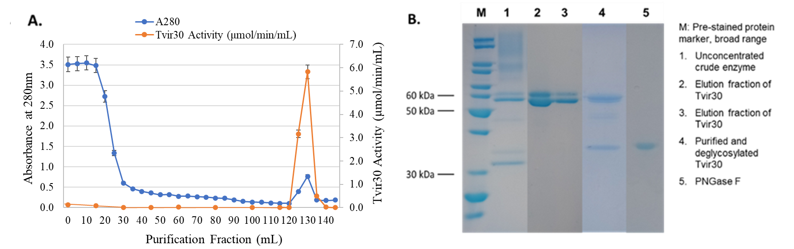Figure 1: A. Chromatogram of Tvir30 one-step IMAC purification. Absorbance at 280 nm is represented by blue points and enzyme activity against pustulan at 30ºC, pH 6.0 by orange points. B. 10% SDS-PAGE gel of corresponding Tvir30 purification fractions and deglycosylation analysis.
    - Determination of temperature and pH optima
The optimum temperature for activity of Tvir30 was initially determined in 50 mM potassium phosphate buffer, pH 6.0, against 0.5 % (w/v) pustulan in a standard assay. The enzyme had >80 % mean relative activity between 40 and 50ºC, with an optimum temperature of 45ºC (Figure 2 A). Activity dropped sharply outside of this range, and at 65ºC the enzyme was completely deactivated, as expected for an enzyme from a mesophilic organism. The optimum pH value of Tvir30 was determined in 100 mM phosphate-citrate buffer, pH 2.5 – 8, under standard assay conditions. The enzyme displayed >80% activity in a narrow pH range of 4.5 to 5.5, with an optimal pH value of 5.0 (Figure 2 B).
These optima are common among fungal β-1,6-glucanases. For example, BGN16.1, a glycoside hydrolase family 30 β-1,6-glucanase from Trichoderma harzianum, has temperature and pH optima of 50ºC and pH 5.5 respectively (Cruz and Llobell, 1999). Similarly, BGN16.3, also from T. harzianum (a well characterised mycoparasite), displays optimum activity at 50ºC and pH 5.0 (Montero et al., 2005). Interestingly, Tvir30 is the only recombinant fungal β-1,6-glucanase that appears to be glycosylated. Volkov et al., (2021) reported a β-1,6-glucanase from T. harzianum expressed in Penicillium verruculosum with one predicted N-glycosylation site but did not detect any carbohydrate moieties within the recombinant protein (Volkov et al., 2021).

B.
A.

Figure 2: A. Temperature profile of purified Tvir30 showing an optimum temperature of 45ºC ±SD, n = 3. B. pH profile of Tvir30, showing optimal activity at pH 5.0 ±SD, n = 3.

    - Substrate specificity and thermal stability
Substrate specificity analysis was performed to confirm the activity of Tvir30. Results revealed that at optimum assay conditions of pH 5.0 and 45ºC, Tvir30 had the highest activity on pustulan, a polysaccharide of D-glucose units joined by β-1,6-branching. As expected, the enzyme had negligible activity on β-1,3- and β-1,4-linked substrates, such as curdlan and cellulose. It did however exhibit 11.9 % activity on laminarin, a β-1,3-linked polysaccharide with β-1,6-branching (Figure 3). These results confirm Tvir30 is specific to β-1,6-linkages only.

C.
B.

Figure 3: A. Substrate specificity of Tvir30 at 50ºC, pH 5.0, on 0.5% (w/v) substrate. B. Thermal stability of Tvir30 assessed at 50ºC in 100 mM phosphate-citrate buffer pH 5.0 over 1 hour and C. 40ºC over 100 hr.

The thermal stability of Tvir30 was assessed by incubation at 50ºC in 100 mM phosphate-citrate buffer pH 5.0 over 1 hour. It was revealed that at 15 min of incubation at 50ºC, the enzyme retained 50 % of its original activity under standard assay conditions (Figure 3B). The D-value, i.e., the time it takes for the enzyme to be reduced to 10% of its original activity, was calculated to be 18.4 min. This small D-value indicates that Tvir30 is highly liable to heat inactivation at 50ºC. Conversely, at 40ºC the activity of Tvir30 dropped below 90% after 72 h of incubation only (Figure 3C). For the enzyme to effectively hydrolyse yeast cell walls, the reaction temperature must be below 50ºC, and 40ºC is suitable as the enzyme maintains high activity for a period of ~ 72 h at this temperature.
    - Enzyme kinetics
Assessment of Tvir30 kinetics was carried out on pustulan at a range of concentrations from 0.5 to 10 mg mL⁻¹ via the DNS assay, as described in the Materials and Methods section. The assay was performed at optimal conditions over 10 minutes, during which the hydrolysis reaction was in the linear phase. GprahPad Prism 9 was used to plot the reaction and to determine the kinetic parameters for Tvir30.
The Michaelis-Menten constant (Km) was determined to be 1.87 mg mL⁻¹, the maximal velocity (Vmax) was calculated as 214.4 μmol min⁻¹.mg⁻¹, and Kcat as 161 s⁻¹, indicating that a single Tvir30 enzyme can convert 161 substrate molecules per second at saturation under optimal conditions. Finally, the specificity constant, or Kcat/Km, was determined to be 85.85 mL mg⁻¹.s⁻¹.
The relatively low Km of Tvir30 indicates that the enzyme has high affinity for its substrate, a common feature of enzymes that exist in environments with a low abundance of their substrates (Nelson and Cox, 2008). In the degradation of BSY, the high affinity of Tvir30 for β-1,6-glucan could be advantageous as it accounts for only 10-15% of total polysaccharide within the S. cerevisiae cell wall, and is in complex with other cell wall components (Aimanianda et al., 2009). The Kcat values of other fungal glucanases have been found to be as low as 0.016 s⁻¹ and as high as 15,601 s⁻¹ (Boyce and Walsh, 2007; Yang et al., 2014). The catalytic efficiency of Tvir30 is therefore within the normal range and is acceptable for industrial application.
    - Products of hydrolysis
Tvir30 was incubated with 1% (w/v) pustulan and 1% (w/v) alkali-soluble yeast β-glucan (YBG) for 1 hour and 18 h respectively at 40ºC at an appropriate dilution. The products of hydrolysis were resolved by high HPAE-PAD visualised by TLC as described in Materials and Methods.

Hydrolysis of pustulan determined that Tvir30 has an endolytic mode of action, as it can liberate a range of sugars with a DP > 2. HPAEC analysis revealed the main products of hydrolysis as glucose (peak 2) and gentiobiose (peak 3) (Figure 4A). The peak with the largest area, peak 1, likely arises from the elution of glycerol within the enzyme sample. Besides glucose and gentiobiose, five additional distinct peaks are visible, and the TLC plate in Figure 4B indicates that these may be gentiotriose, gentiotetraose, gentiopentaose, and so on.
B.
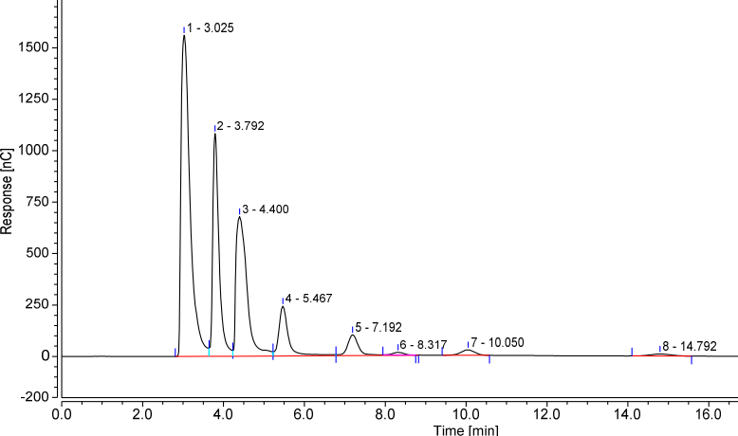
A.
- Glucose
- Gentiobiose
- Pustulan hydrolysis, 1 h
- Pustulan hydrolysis Blank
1 2 3 4

Figure 4: A. HPAE-PAD analysis and B. TLC analysis of a sample of pustulan hydrolysed by Tvir30 for 1 h at 40ºC.
To determine if Tvir30 could be used to generate GnOS from Brewer’s spent yeast, the enzyme was incubated with 1% (w/v) alkali-soluble yeast β-glucan. The reaction was analysed by HPAEC and TLC as shown in Figure 5.
1 2 3 4
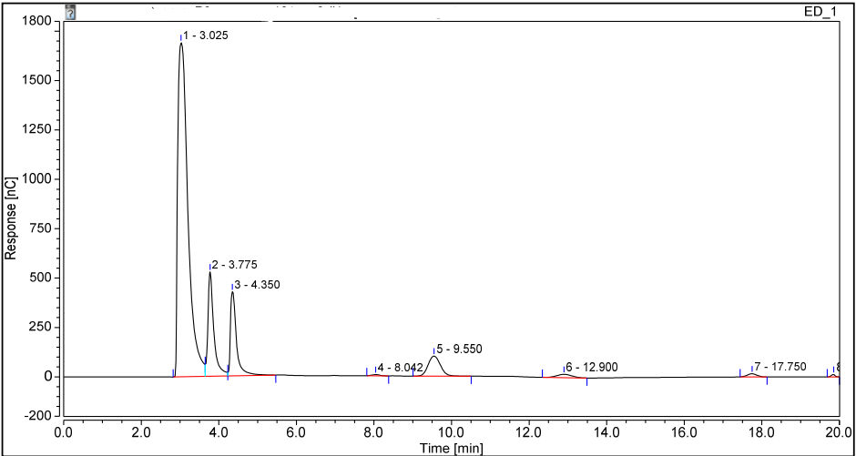
Figure 5: A. HPAE-PAD analysis and B. TLC analysis of a sample of yeast β-glucan hydrolysed by Tvir30 for 18 h at 40ºC.
- YBG spiked with glucose
- YBG spiked with gentiobiose
- YBG hydrolysis, 18 h
- YBG hydrolysis blank
B.
A.
Peak 1 in Figure 5A is presumed to be glycerol within the sample eluting from the column. Peaks 2 and 3 are glucose and gentiobiose respectively. There is one more distinct peak, labelled peak 5, as well as additional smaller peaks. These are presumed to be larger oligosaccharides generated by Tvir30 digestion as TLC analysis indicated the presence of sugars larger than gentiobiose (in the boxed region of Figure 5B). The poor resolution of oligosaccharides DP>2 on the TLC plate is likely the result of their low concentration. These results demonstrate that Tvir30 may be employed in the utilisation of BSY by generating value-added products in the form of prebiotic GnOS.
  - Conclusions
In conclusion, a fungal β-1,6-glucanase from the glycoside hydrolase 30 family was successfully cloned, expressed, and purified. The enzyme, Tvir30, exhibited predicted substrate specificity to β-1,6-linkages only and had kinetic properties similar to those of other purified fungal β-1,6-glucanases. A unique feature of Tvir30 is its expression as two isoforms, one of which appears glycosylated. Whether native expression in Trichoderma virens would produce a glycosylated variant is unclear, but the amino acid sequence does encode for two N-linked glycosylation sites, and fungal mycoparasites are known to produce a diverse range of hydrolytic enzymes, often in one glycoside hydrolase family, to efficiently break down the cell walls of their hosts. For an industrial application, resolution of isoforms may be unnecessary if batch-to-batch variability is negligible. Tvir30 demonstrates both high affinity and activity against β-1,6-linkages, as well as an endolytic mode of action, making it a favourable candidate in the degradation of BSY for the production of GnOS. The enzyme is thermally inactivated by only 30 min incubation at 50ºC but was found to be highly stable at 40ºC. From the characterisation performed in this study, a novel and efficient method for the enzymatic degradation of BSY could be developed to generate value-added oligosaccharides, while reducing waste and waste-disposal costs.
Acknowledgments
This study was funded by the Irish Research Council and Monaghan Mushrooms.
References
Aimanianda, V., Clavaud, C., Simenel, C., Fontaine, T., Delepierre, M., Latgé, J.-P., 2009. Cell wall beta-(1,6)-glucan of Saccharomyces cerevisiae: structural characterization and in situ synthesis. J Biol Chem 284, 13401–13412. https://doi.org/10.1074/jbc.M807667200
Boyce, A., Walsh, G., 2007. Production, purification and application-relevant characterisation of an endo-1,3(4)-beta-glucanase from Rhizomucor miehei. Appl Microbiol Biotechnol 76, 835–841. https://doi.org/10.1007/s00253-007-1058-x
Cruz, J. de la, Llobell, A., 1999. Purification and properties of a basic endo-β-1,6-glucanase (BGN16.1) from the antagonistic fungus Trichoderma harzianum. European Journal of Biochemistry 265, 145–151. https://doi.org/10.1046/j.1432-1327.1999.00698.x
Ferreira-Lazarte, A., Gallego-Lobillo, P., Moreno, F.J., Villamiel, M., Hernandez-Hernandez, O., 2019. In Vitro Digestibility of Galactooligosaccharides: Effect of the Structural Features on Their Intestinal Degradation. J. Agric. Food Chem. 67, 4662–4670. https://doi.org/10.1021/acs.jafc.9b00417
Gibson, G.R., Hutkins, R., Sanders, M.E., Prescott, S.L., Reimer, R.A., Salminen, S.J., Scott, K., Stanton, C., Swanson, K.S., Cani, P.D., Verbeke, K., Reid, G., 2017. Expert consensus document: The International Scientific Association for Probiotics and Prebiotics (ISAPP) consensus statement on the definition and scope of prebiotics. Nat Rev Gastroenterol Hepatol 14, 491–502. https://doi.org/10.1038/nrgastro.2017.75
Kim, K.-H., Kim, Y.-W., Kim, H.B., Lee, B.J., Lee, D.S., 2006. Anti-apoptotic activity of laminarin polysaccharides and their enzymatically hydrolyzed oligosaccharides from Laminaria japonica. Biotechnol Lett 28, 439–446. https://doi.org/10.1007/s10529-005-6177-9
Kumar, K., Rajulapati, V., Goyal, A., 2020. In vitro prebiotic potential, digestibility and biocompatibility properties of laminari-oligosaccharides produced from curdlan by β-1,3-endoglucanase from Clostridium thermocellum. 3 Biotech 10, 241. https://doi.org/10.1007/s13205-020-02234-0
Kunze, W., 1999. Technology Brewing and Malting.
Miller, G.L., 1959. Use of Dinitrosalicylic Acid Reagent for Determination of Reducing Sugar. Anal. Chem. 31, 426–428. https://doi.org/10.1021/ac60147a030
Montero, M., Sanz, L., Rey, M., Monte, E., Llobell, A., 2005. BGN16.3, a novel acidic β-1,6-glucanase from mycoparasitic fungus Trichoderma harzianum CECT 2413. The FEBS Journal 272, 3441–3448. https://doi.org/10.1111/j.1742-4658.2005.04762.x
Nelson, D.L., Cox, M.M., 2008. Lehninger Principles of Biochemistry, 4th ed. Palgrave Macmillan.
Soler, A., de la Cruz, J., Llobell, A., 1999. Detection of β-1,6-glucanase isozymes from Trichoderma strains in sodium dodecyl sulphate–polyacrylamide gel electrophoresis and isoelectrofocusing gels. Journal of Microbiological Methods 35, 245–251. https://doi.org/10.1016/S0167-7012(99)00021-4
Volkov, P.V., Rubtsova, E.A., Rozhkova, A.M., Sinitsyna, O.A., Zorov, I.N., Kondratyeva, E.G., Sinitsyn, A.P., 2021. Properties of recombinant endo-β-1,6-glucanase from Trichoderma harzianum and its application in the pustulan hydrolysis. Carbohydr Res 499, 108211. https://doi.org/10.1016/j.carres.2020.108211
Wang, S., Xiao, Y., Tian, F., Zhao, J., Zhang, H., Zhai, Q., Chen, W., 2020. Rational use of prebiotics for gut microbiota alterations: Specific bacterial phylotypes and related mechanisms. Journal of Functional Foods 66, 103838. https://doi.org/10.1016/j.jff.2020.103838
Yang, S., Xiong, H., Yan, Q., Yang, H., Jiang, Z., 2014. Purification and characterization of a novel alkaline β-1,3-1,4-glucanase (lichenase) from thermophilic fungus Malbranchea cinnamomea. Journal of Industrial Microbiology and Biotechnology 41, 1487–1495. https://doi.org/10.1007/s10295-014-1494-4

