CHEMICAL ENGINEERING TRANSACTIONS  VOL. , 2023 | A publication of
The Italian Association
of Chemical Engineering
Online at www.cetjournal.it

Guest Editors: Laura Piazza, Mauro Moresi, Francesco Donsì
Copyright © 2023, AIDIC Servizi S.r.l.
ISBN 978-88-81206-01-4; ISSN 2283-9216

Supercritical CO₂ pasteurization of solid products: a case study on fresh-cut potatoes
Riccardo Zulliª*, Fabio Santiª, Pietro Andrigoª, Alessandro Zambon^{a,b}, Sara Spilimbergoª
ªDepartment of Industrial Engineering, University of Padova, Via Marzolo 9, 35131, Padova, Italy
^{b}Department of Civil, Chemical, Environmental, and Materials Engineering (DICAM), University of Bologna, Via Terracini 28, Bologna 40131, Italy
riccardo.zulli@unipd.it
During the last decades, supercritical carbon dioxide (scCO₂) pasteurization has been intensively studied as a potential technology to increase the safety and shelf-life of fresh food. However, the high risk of post-process contamination still represents a barrier to its industrialization.
This study reports a proof of concept study in order to demonstrate the applicability of a novel method that combines scCO₂ and Modified Atmosphere Packaging (MAP) for fresh-cut potatoes. The process was investigated by a full-factorial design of experiment, studying the effect of temperature (35 - 45 °C), pressure (8 – 12 MPa), and treatment time (5 – 35 min) on the microbial inactivation of E. coli and the color of the processed product. The method was able to reduce up to 1.50 Log CFU/g the load of inoculated E. coli at 45°C, 8.0 MPa and 35 min, without excessively modifying the product color. Moreover, the color did not significantly change during storage at 4 °C for 7 days.
  - Introduction
The ready-to-eat/ready-to-cook (RTE) food market is expected to reach USD 172 million by the end of 2023, with an annual growth rate of 7.3% (Research Nester, 2021). In recent years, fresh-cut fruits and vegetables have gained great popularity among consumers worldwide, leading to an increased consumption and research investment (Ma et al., 2017).
Besides the advantages of consuming these products, such as freshness, high nutritional content, and convenience, they usually have a relatively short shelf-life. Indeed, the different preparation steps, like peeling, coring, cutting, and/or slicing can lead to accelerated ripeness and senescence due to higher respiration rate and ethylene (C₂H₄) production concerning whole fruits and vegetables (Wu et al., 2012). Changes in aspect are also caused by hydroxylation and oxidation of polyphenols due to the action of active tissue enzymes, such as polyphenol oxidases (PPOs) and peroxidases (PODs) (Marszałek et al., 2019). Moreover, microbial growth (including pathogenic bacteria) is facilitated due to the increment of the exposed surface and the consequent release of nutrients. Many foodborne disease outbreaks are associated with different RTE food, such as leafy green vegetables (Stephan et al., 2015) and tubers (Da Silva Felício et al., 2015), becoming a serious problem for public health. In the majority of the cases, the diffusion of pathogenic microorganisms, such as Listeria monocytogenes (Montero et al., 2015; Stephan et al., 2015), Salmonella enterica (Vestrheim et al., 2016), Norovirus (Callejón et al., 2015) and Yersinia enterocolitica (MacDonald et al., 2012) has been caused by incorrect preparation procedures of the products.
One of the most effective techniques that have been widely studied and successfully applied to increase the safety and the shelf life of fresh produce is the Modified Atmosphere Packaging (MAP), which consists on the control of the composition of the gas that surrounds the product inside sealed packaging. Carbon dioxide (CO₂) is one of the most used gases in MAP thanks to its bacteriostatic action during the storage of the products, prolonging their shelf-life (Ma et al., 2017). However, the exclusive use of a MAP in RTE food might not guarantee microbial inactivation of spoiling and pathogen microorganisms.
On the contrary, effective methods of microbial inactivation are achieved by thermal processes, which are worldwide used to increase the shelf-life and safety of a great variety of food products by using high temperatures. In particular, fresh produce is usually quickly immersed in hot water (blanching) and then rapidly cooled in order to pasteurize the surface of the product and reducing the enzymes activity. However, blanching is usually adopted only prior to further processing, such as drying, canning and freezing (Teixeira, 2014).
In the last decades, many novel low-temperature pasteurization technologies have been widely studied to extend the shelf-life and safety of fresh products without compromising their organoleptic qualities.
The use of supercritical fluids, especially CO₂, is one of the promising novel technologies for the low-temperature pasteurization of food, being effective at temperatures below 50 °C and pressures lower than 20 MPa. Regarding fruits and vegetables, many works have underlined the effectiveness of supercritical CO₂ (scCO₂) in ensuring microbial and enzymatic inactivation in different matrices, such as carrots, coconut, almonds and spinach leaves, also ensuring the inactivation of different pathogenic bacteria (Escherichia coli, Salmonella enterica, Listeria monocytogenes) (Chen et al., 2022; Spilimbergo et al., 2013; Zhong et al., 2008).
However, direct pasteurization methods, like scCO₂, present some obstacles for their industrial application for solid food products. In particular, the major one is the risk of cross-contamination during the post-process operation, especially packaging, which requires expensive aseptic systems. To mitigate this obstacle, Barberi et al. (2021) and Zambon et al. (2022) investigated a new patented process (scCO₂-MAP) (Spilimbergo et al., 2017) which exploit the power of supercritical fluids by pressurizing products packaged in a CO₂ MAP. The method has already been demonstrated effective on fresh-cut carrots, coconut and coriander at lab scale, with performance in terms of microbial stability similar to scCO₂ but with less detrimental effects on the products quality.
Fresh-cut potatoes are easily susceptible to microbial spoilage and loss of quality especially due to the high moisture content and respiration rate (Rashid et al., 2021). For this reason, they are usually treated by the use of chemical compounds and blanching processes or packaged under aseptic conditions and/or frozen.
This study aimed at preliminary investigating the possibility to apply the scCO₂-MAP method for the treatment of fresh-cut potatoes in order to reduce their microbial contamination risk while maintaining their fresh-like aspect. In particular, the process parameters of the method (temperature, pressure and time) have been studied in function of the inactivation of a fecal indicator bacterium (Escherichia coli) and the aspect of the product, right after the process and after 7 days.
  - Materials and method
    - Sample preparation and bacteria inoculation
Fresh potatoes (Solanum tuberosum) were purchased from a local market (Padova, Italy), peeled and cut into cubes with a side of 1.5 cm. All the samples were prepared and processed on the same day of purchase. For the measurement of the inactivation capacity of the process, some samples were inoculated with a clinically isolated Escherichia coli strain (NCTC 9001) as a fecal indicator microorganism. The strain was resuscitated from a frozen culture at -80 °C by overnight incubation at 37 °C in 10 mL of Luria-Bertani (LB) broth (Sacco system, Como, Italy) until reaching the stationary phase. The microbial suspension was centrifuged (Rotina 380, Hettic, Treviso, Italy) at 6000 rpm for 8 min; the supernatant was removed, and the pellet was re-suspended in Ringer solution (Merck KGaA, Darmstadt, Germany) reaching a final concentration of around 1.0 x 10⁸ CFU/mL. Fresh-cut potato samples were immersed in the bacterial solution for 15 min under constant agitation and then dried after a laminar flow safety cabinet (BioAir, Pavia, Italy) for 60 min. The inoculated products were then packaged/treated or directly analyzed to measure the initial load (see §2.4).
    - MAP packaging and storage
Each sample was packed within a MAP filled with 100% CO₂ (carbon dioxide 4.0, purity > 99.8%, Nippon Gases Italia, Milano, Italy) at atmospheric pressure. 10x10 cm pouches of recyclable multi-material (coextruded PE/EVOH/PE) high-barrier film (Niederwieser, Modena, Italy) were made using an electrical sealer (FS300, Plastic Film Sealer, China). A volume of 100 ± 10 mL was guaranteed for each sample. For the measurement of the color overtime, some packages (treated and untreated) were stored at 4 ± 1 °C up to 7 days.
    - High-pressure system
The treatment was carried out in a high-pressure system as shown in Figure 1. Samples were inserted inside a stainless-steel vessel with an internal volume of 4 dm³, which was preheated before each test at the desired temperature thanks to an external heating cable system. Water is stored in a stainless-steel storage tank where it is preheated thanks to an immersion thermostat (M900-TI, MPM Instruments, Italy) and then pumped to the high-pressure vessel by the use of an air-driven hydraulic pump (G35LVE, Maximator, Italy). The system was designed to work at a maximum temperature and pressure of 50 °C and 20 MPa, respectively.
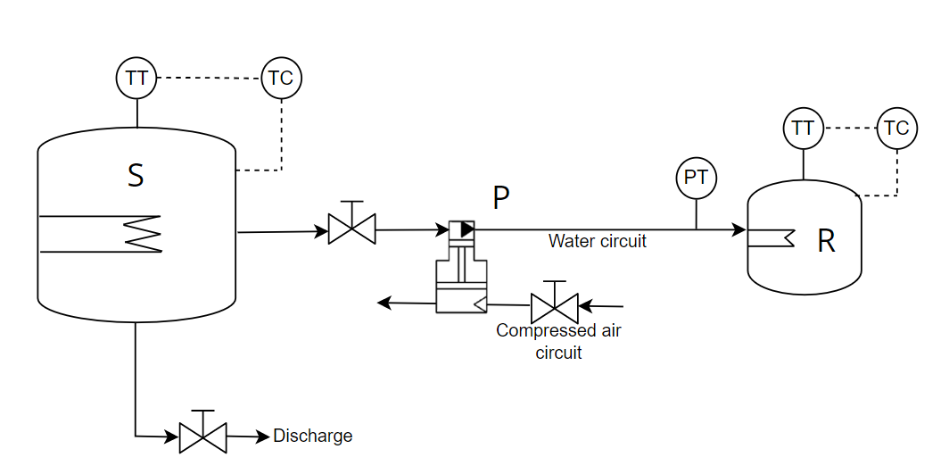
Figure 1: Scheme of the used high-pressure system (S: storage tank, P: pressure intensifier (air-driven pump), R: pasteurization vessel, TT. temperature transmitter, TC: temperature controller, PT: pressure transmitter)
    - Microbial inactivation assessment
Standard plate count technique was used to analyze the E. coli microbial load before and after the treatment. Samples were placed in a 50 mL falcon tubes in sterility conditions, diluted 1:10 in Ringer solution and vortexed at 2400 rpm for 90 s. The solution was serially diluted (1:10) in Ringer solution and 100 μL of the appropriate dilutions were spread-plated on MacConkey agar (Microbiol, Italy). Plates were then incubated at 37 °C for 24 h. At least three independent analysis were carried out for each condition.
    - Color measurement
The color of each sample was determined using the CIELab color space, largely used for food analysis. L* represents the lightness component, while a* and b* respectively represent redness and yellowness (+a* and −a* indicate the direction of red and green, +b* and −b* indicate the direction of yellow and blue). The color was measured for each sample, before and after the treatment using a precision colorimeter (NR100, 3nh Technology Co., Ltd., China), with a D65 light source and CIE 10° standard observer at 8/d illuminating geometry and a 4 mm aperture. Color was also measured for both treated and untreated products (packaged in CO₂) and stored at 4 °C. Total color difference (ΔE) was calculated by the equation:
$$∆E=\sqrt{{\left(L_{2}^{*}-L_{1}^{*}\right)}^{2}+{\left(a_{2}^{*}-a_{1}^{*}\right)}^{2}+{\left(b_{2}^{*}-b_{1}^{*}\right)}^{2}}$$ | (1)
where the subscripts 1 and 2 represents the untreated and treated samples, respectively. The total color difference could be classified as very distinct (ΔE>3), distinct (1.5<ΔE<3) and small (ΔE<1.5) (Pathare et al., 2013)
    - Design of Experiment and statistical analyses
The samples have been treated following a 2³ Design of Experiment (DoE). The entire set of treatment conditions was carried out in triplicates. The range of the selected parameters, temperature, pressure, and treatment time, are shown in Table 1.

Table 1: Design of experiment parameter range
Parameter | Min value | Central point | Max value
Temperature (°C) | 35.0 | 40.0 | 45.0
Pressure (MPa) | 8.0 | 11.0 | 14.0
Treatment time (min) | 5.0 | 20.0 | 35.0
Analysis of variance (ANOVA) was carried out for the statistical interpretation of response variables between treated and untreated products in function of the selected process parameters. Both Design of Experiment and ANOVA analyses were conducted by using Minitab® statistical software.
  - Results
Table 2 shows the achieved results in terms of microbial inactivation and total color change of the samples right after the treatment. The total color change was also monitored after a 7-days storage at each condition tested following the selected DoE. In order to test the inactivation capacity of the method at different process conditions, a large amount of bacteria load was inoculated on the surface of the products. E. coli NCTC 9001 was selected as a target bacterium, being a surrogate of the pathogenic strains E. coli O157:H7 and Salmonella enterica (Hu and Gurtler, 2017). The bacterial load inoculated on the surface of each sample was 7.188 ± 0.060 Log CFU/g.

Table 2: E. coli inactivation after the treatment and total color difference (ΔE) with respect to the fresh untreated product at day 0 (day of processing) and at day 7 of storage at 4 °C. Results are expressed as mean ± standard deviation. Means with different superscript letters in the same column are statistically different (p-value < 0.05).
Temperature (°C) | Pressure (MPa) | Treatment time (min) | E. coli inactivation  (Log CFU/g) | ΔE day 0 (-) | ΔE day 7 (-)
Non-treated |  |  | - | - | 5.384 ± 0.087^{b}
35.0 | 8.0 | 5.0 | 0.604 ± 0.264^{ab} | 1.713 ± 1.131ª | 2.294 ± 0.047ª
35.0 | 8.0 | 35.0 | 0.561 ± 0.233^{ab} | 2.789 ± 0.221ª | 3.939 ± 0.535^{ab}
35.0 | 14.0 | 5.0 | 0.519 ± 0.143ª | 1.713 ± 1.037ª | 3.891 ± 1.034^{ab}
35.0 | 14.0 | 35.0 | 0.748 ± 0.229^{ab} | 2.210 ± 0.766ª | 2.472 ± 0.527ª
40.0 | 11.0 | 20.0 | 0.687 ± 0.172^{ab} | 2.274 ± 0.290ª | 4.183 ± 1.062^{ab}
45.0 | 8.0 | 5.0 | 0.825 ± 0.353^{ab} | 3.784 ± 1.451^{ab} | 5.151 ± 1.171^{b}
45.0 | 8.0 | 35.0 | 1.498 ± 0.125^{b} | 4.879 ± 0.285^{abc} | 5.656 ± 0.218^{b}
45.0 | 14.0 | 5.0 | 1.151 ± 0.153^{ab} | 7.149 ± 0.808^{c} | 4.203 ± 0.221^{ab}
45.0 | 14.0 | 35.0 | 1.471 ± 0.361^{ab} | 6.907 ± 0.029^{bc} | 6.261 ± 0.073^{b}

The larger inactivation was reached at higher temperature (45 °C) and longer time (35 min). Specifically, such result was not significantly different at the probability level p=0.05 from the maximum inactivation observed (1.498 ± 0.125 Log CFU/g) at 45 °C, 8.0 MPa and 35 min. The Pareto chart in Figure 2a shows indeed how temperature and, in minor contribution, time significantly influenced the microbial inactivation of the method. Pressure, instead, was not significant on the microbial inactivation.

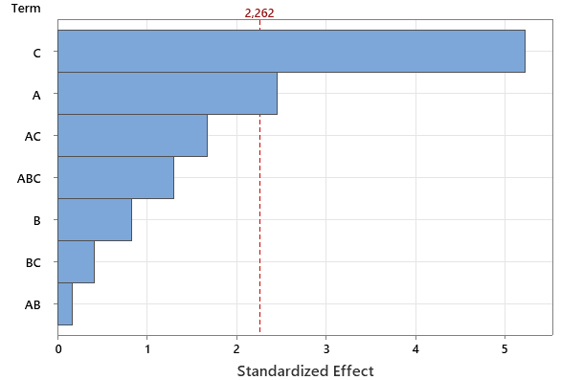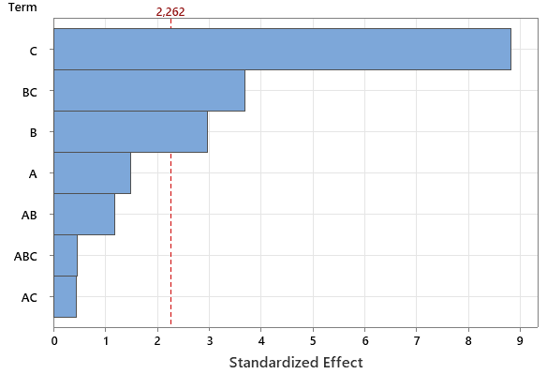
(a) (b)
Figure 2: Pareto chart of the standardized effects of the process variable (A: time, B: pressure, C: temperature) and their linear interaction (example AB: time * pressure) on the E. coli inactivation (a) and the total color difference (b). The level of confidence was set at 95%.
On the best of our knowledge, no research studies have been conducted on the microbial inactivation efficiency of supercritical carbon dioxide on fresh-cut potatoes. Other non-thermal technologies have been investigated, with particular attention to the natural microflora of the products. Selma et al. (2006), for instance, were able to inactivate around 1.5 and 1.0 Log CFU/g of coliform bacteria and total mesophilic bacteria, respectively, by applying ozone or ozonated water for 6 min. Only a few studies investigated the inactivation of inoculated microorganisms on fresh-cut potatoes, principally by applying aqueous sanitizers. Park et al. (2008) reached an inactivation of E. coli O157:H7 equal to 0.89 Log CFU/g by washing potatoes with a chlorine dioxide (9 ppm) solution for 5 min. Luu et al. (2020), however, observed that the inactivation of the same pathogen achieved by a chlorine dioxide solution (5 ppm) for 30 min was equal to the inactivation achieved by only washing the products with water. Moreover, these methods should provide an aseptic packaging procedure after the treatment, which can represent a barrier to their industrialization.
The inactivation data with the scCO₂-MAP method suggest that a higher inactivation could be obtained by treating the samples at higher temperature and for longer time. However, harsher treatment conditions could also affect the aspect of the product and its stability during storage, being a crucial factor for the consumer acceptance. For this reason, the color modification of the products was monitored right after the treatment and during a 7-days storage.
The obtained results showed that the treatment led to a slight modification of the product color, except for the conditions at 45 °C and 14 MPa, where the color change was 7.149 ± 0.808 and 6.907 ± 0.029, for 5-min and 35-min treatment respectively, due to a reduction of the lightness parameter (L*). Regarding the color, indeed, temperature, pressure and the combination of the two, were the most influencing parameters as shown by the Pareto chart in Figure 2b. Moreover, the color of the samples remained stable when stored at 4 °C for 7 days, demonstrating that none of the treated products showed a color difference significantly higher than the non-treated product. These data support the fact that the scCO₂-MAP pasteurization method does not strongly impact the visual quality of potato products at mild conditions.
Only few studies reported the color difference of fruits and vegetables subjected to scCO₂ pasteurization methods. Recently, Zambon, et al. (2022) obtained similar results for fresh-cut carrots and coconut treated with the scCO₂-MAP method. The total color difference was 6.45 for carrots treated at 12 MPa, 40 °C for 20 min and 1.20 for coconut treated at 12 MPa, 45 °C for 30 min. Even if the color change was strongly dependent on the process conditions and the matrix, these results were significantly lower than the color changes obtained by direct scCO₂ pasteurization, while the microbial inactivation was similar. Also other studies reported a strong influence of the direct scCO₂ method on the aspect of different products, such as coconut (Ferrentino et al., 2012b) and pears (Valverde et al., 2010), especially influenced by the treatment time. Other studies focused on non-thermal technologies achieved similar results on the color change of fresh-cut potatoes. Liu et al. (2022), for instance, applied electron beam irradiation at a maximum dose of 15 kGy to increase the stability of potatoes, and observed a maximum total color difference of 5.46 ± 1.68 which remained stable also during the storage.
  - Conclusions
A 2³ factorial design was applied to investigate the effect of a novel scCO₂ method on the microbial load and color of fresh-cut potatoes using a small-scale plant. Temperature and time positively influenced the microbial inactivation of E. coli inoculated on the samples surface, while temperature and pressure influenced the color change after the treatment. The results suggest that the method could improve the microbial safety of fresh-cut potatoes from possible contamination of pathogenic bacteria. However, a deeper investigation should be addressed in order to maximize the performance, for instance by increasing the treatment time or combining the method with other non-thermal technologies, such as the addition of antimicrobial substances. Moreover, even if the color plays an important role in terms of consumer acceptance, other sensorial attributes, such as texture or taste should be considered to determine the process applicability range. Studies on the activities of enzymes (i.e. PPO and POD) responsible for the product browning should be also considered.
The proposed technology has the potential to be a useful method to increase the safety and the shelf life of fresh cut fruits and vegetables, avoiding the use of chlorinated solutions and/or expensive aseptic packaging methods. Moreover, the novel process utilizes pressures at least 10-times lower than the comparable HHP processes, already adopted in the food industry, having in this way the possibility to be less expensive and to be applied to a larger variety of products. Life Cycle Cost analysis should be performed to confirm this hypothesis and compare the process to ones already adopted.
Acknowledgment
The authors acknowledge the financial support for this project provided by transnational funding bodies, partners of the H2020 ERA-NETs SUSFOOD2 and CORE Organic Cofunds, under the Joint SUSFOOD2/CORE Organic Call 2019.
Reference
Barberi, G., González-Alonso, V., Spilimbergo, S., Barolo, M., Zambon, A., and Facco, P. (2021). “Optimization of the Appearance Quality in CO2 Processed Ready-to-Eat Carrots through Image Analysis.” Foods, Multidisciplinary Digital Publishing Institute, 10(12), 2999.
Callejón, R. M., Rodríguez-Naranjo, M. I., Ubeda, C., Hornedo-Ortega, R., Garcia-Parrilla, M. C., and Troncoso, A. M. (2015). “Reported Foodborne Outbreaks Due to Fresh Produce in the United States and European Union: Trends and Causes.” Foodborne Pathogens and Disease, Mary Ann Liebert, Inc., publishers, 12(1), 32–38.
Chen, H., Guan, Y., Wang, A., and Zhong, Q. (2022). “Inactivation of Escherichia coli K12 on raw almonds using supercritical carbon dioxide and thyme oil.” Food Microbiology, 103, 103955.
Da Silva Felício, M. T., Hald, T., Liebana, E., Allende, A., Hugas, M., Nguyen-The, C., Johannessen, G. S., Niskanen, T., Uyttendaele, M., and McLauchlin, J. (2015). “Risk ranking of pathogens in ready-to-eat unprocessed foods of non-animal origin (FoNAO) in the EU: Initial evaluation using outbreak data (2007–2011).” International Journal of Food Microbiology, 195, 9–19.
Ferrentino, G., Balzan, S., and Spilimbergo, S. (2012). “On-line color monitoring of solid foods during supercritical CO2 pasteurization.” Journal of Food Engineering, 110(1), 80–85.
Hu, M., and Gurtler, J. B. (2017). “Selection of Surrogate Bacteria for Use in Food Safety Challenge Studies: A Review.” Journal of Food Protection, 80(9), 1506–1536.
Liu, J., Zhao, S., Wang, F., Long, T., Chen, B., Wang, D., and Gao, P. (2022). “The effect of electron beam irradiation on the microbial stability and quality characteristics of vacuum-packaged ready-to-eat potato.” Journal of Food Processing and Preservation, 46(10), e16829.
Luu, P., Chhetri, V. S., Janes, M. E., King, J. M., and Adhikari, A. (2020). “Effectiveness of Aqueous Chlorine Dioxide in Minimizing Food Safety Risk Associated with Salmonella, E. coli O157:H7, and Listeria monocytogenes on Sweet Potatoes.” Foods, Multidisciplinary Digital Publishing Institute, 9(9), 1259.
Ma, L., Zhang, M., Bhandari, B., and Gao, Z. (2017). “Recent developments in novel shelf life extension technologies of fresh-cut fruits and vegetables.” Trends in Food Science & Technology, 64, 23–38.
MacDonald, E., Heier, B. T., Nygård, K., Stalheim, T., Cudjoe, K. S., Skjerdal, T., Wester, A. L., Lindstedt, B.-A., Stavnes, T.-L., and Vold, L. (2012). “Yersinia enterocolitica Outbreak Associated with Ready-to-Eat Salad Mix, Norway, 2011.” Emerging Infectious Diseases, 18(9), 1496–1499.
Marszałek, K., Doesburg, P., Starzonek, S., Szczepańska, J., Woźniak, Ł., Lorenzo, J. M., Skąpska, S., Rzoska, S., and Barba, F. J. (2019). “Comparative effect of supercritical carbon dioxide and high pressure processing on structural changes and activity loss of oxidoreductive enzymes.” Journal of CO2 Utilization, 29, 46–56.
Montero, D., Bodero, M., Riveros, G., Lapierre, L., Gaggero, A., Vidal, R. M., and Vidal, M. (2015). “Molecular epidemiology and genetic diversity of Listeria monocytogenes isolates from a wide variety of ready-to-eat foods and their relationship to clinical strains from listeriosis outbreaks in Chile.” Frontiers in Microbiology, 6, 384.
Park, E.-J., Gray, P. m., Oh, S.-W., Kronenberg, J., and Kang, D.-H. (2008). “Efficacy of FIT Produce Wash and Chlorine Dioxide on Pathogen Control in Fresh Potatoes.” Journal of Food Science, 73(6), M278–M282.
Pathare, P. B., Opara, U. L., and Al-Said, F. A.-J. (2013). “Colour Measurement and Analysis in Fresh and Processed Foods: A Review.” Food and Bioprocess Technology, 6(1), 36–60.
Rashid, M. H., Khan, M. R., Roobab, U., Rajoka, M. S. R., Inam-ur-Raheem, M., Anwar, R., Ahmed, W., Jahan, M., Ijaz, M. R. A., Asghar, M. M., Shabbir, M. A., and Aadil, R. M. (2021). “Enhancing the shelf stability of fresh-cut potatoes via chemical and nonthermal treatments.” Journal of Food Processing and Preservation, 45(6), e15582.
Research Nester. (2021). “Ready to Eat Food: Market Demand, Size & Growth Forecast 2023.”
Selma, M. V., Beltrán, D., Chacón-Vera, E., and Gil, M. I. (2006). “Effect of Ozone on the Inactivation of Yersinia enterocolitica and the Reduction of Natural Flora on Potatoes.” Journal of Food Protection, 69(10), 2357–2363.
Spilimbergo, S., Komes, D., Vojvodic, A., Levaj, B., and Ferrentino, G. (2013). “High pressure carbon dioxide pasteurization of fresh-cut carrot.” The Journal of Supercritical Fluids, Special Issue – 10th International Symposium on Supercritical Fluids, 79, 92–100.
Spilimbergo, S., Zambon, A., Michelino, F., and Polato, S. (2017). “Method for food pasteurization.”
Stephan, R., Althaus, D., Kiefer, S., Lehner, A., Hatz, C., Schmutz, C., Jost, M., Gerber, N., Baumgartner, A., Hächler, H., and Mäusezahl-Feuz, M. (2015). “Foodborne transmission of Listeria monocytogenes via ready-to-eat salad: A nationwide outbreak in Switzerland, 2013–2014.” Food Control, 57, 14–17.
Teixeira, A. A. (2014). “Thermal Food Preservation Techniques (Pasteurization, Sterilization, Canning and Blanching).” Conventional and Advanced Food Processing Technologies, John Wiley & Sons, Ltd, 115–128.
Valverde, M. T., Marín-Iniesta, F., and Calvo, L. (2010). “Inactivation of Saccharomyces cerevisiae in conference pear with high pressure carbon dioxide and effects on pear quality.” Journal of Food Engineering, 98(4), 421–428.
Vestrheim, D. F., Lange, H., Nygård, K., Borgen, K., Wester, A. L., Kvarme, M. L., and Vold, L. (2016). “Are ready-to-eat salads ready to eat? An outbreak of Salmonella Coeln linked to imported, mixed, pre-washed and bagged salad, Norway, November 2013.” Epidemiology & Infection, Cambridge University Press, 144(8), 1756–1760.
Wu, Z. S., Zhang, M., and Wang, S. (2012). “Effects of high pressure argon treatments on the quality of fresh-cut apples at cold storage.” Food Control, 23(1), 120–127.
Zambon, A., González-Alonso, V., Lomolino, G., Zulli, R., Rajkovic, A., and Spilimbergo, S. (2022). “Increasing the Safety and Storage of Pre-Packed Fresh-Cut Fruits and Vegetables by Supercritical CO2 Process.” Foods (Basel, Switzerland), 12(1), 21.
Zhong, Q., Black, D. G., Davidson, P. M., and Golden, D. A. (2008). “Nonthermal Inactivation of Escherichia coli K-12 on Spinach Leaves, Using Dense Phase Carbon Dioxide.” Journal of Food Protection, Allen Press, 71(5), 1015–1017.

