CHEMICAL ENGINEERING TRANSACTIONS  VOL. , 2023 | A publication of
The Italian Association
of Chemical Engineering
Online at www.cetjournal.it

Guest Editors: Laura Piazza, Mauro Moresi, Francesco Donsì
Copyright © 2023, AIDIC Servizi S.r.l.
ISBN 979-12-81206-01-4; ISSN 2283-9216

Polyphenols extraction from hazelnut skin using water as solvent: equilibrium studies and quantification of the total extractable polyphenols
Alice Bertino^{a,}*, Leone Mazzeoª, Valeria Gallo^{b}, Susanna Della Posta^{b}, Chiara Fanali^{b} and Vincenzo Piemonteª
ªFaculty of Science and technology for sustainable Development and One Healt, Unit of Chemical-physics Fundamentals in Chemical Engineering, University Campus Bio-medico of Rome, Via Alvaro del Portillo, 21, 00128 Rome, Italy;
^{b}Faculty of Science and technology for sustainable Development and One Healt, Unit of Food and Nutrition Sciences, University Campus Bio-medico of Rome, Via Alvaro del Portillo, 21, 00128 Rome, Italy;
* alice.bertino@unicampus.it
In this work, a system for the extraction of antioxidant agents from waste vegetal matrices was studied. To this end, the extraction of polyphenols from food waste hazelnut skins was taken into consideration as a case study and a continuous set-up using distilled water at 70 °C as a solvent has been developed. Various extraction cycles were performed at different solid/liquid ratios (ranging from 2 to 5.7 g/l) in order to study the effect of this parameter on extraction efficiency. Through a mass balance, data obtained from the various cycles were used to calculate the total extractable polyphenols, and a value of 0.114 g of polyphenols per g of hazelnut skin was evaluated. Moreover, for two selected cycles the polyphenols concentration in the aqueous solution was measured at different time intervals in order to determine the extraction time, and in both tests it reached a plateau within the first hour. Finally, equilibrium concentrations of polyphenols in liquid and solid phases of the six tests were correlated by a linear isotherm equation, and a partition coefficient of 0.0368 l/g was evaluated through a fitting of experimental data.
  - Introduction
The unsustainable nature of the traditional linear economic model, driven by population growth and resource exploitation, has led to an urgent need for a viable alternative. The Circular Economy offers a solution by decoupling economic growth from the consumption of new resources and by emphasizing the valorisation of waste as secondary raw materials.
In line with this concept, hazelnut skin, a waste product generated by various food industry processes, holds significant potential. The Food and Agriculture Organisation of the United Nations (FAO) estimates that the world production of hazelnuts was almost 1.1 million tons in 2020, with Turkey and Italy as the leading producers (www.Fao.Org).
Hazelnut skin, constituting about 2% of the fruit's weight, is rich in polyphenols, which are natural antioxidants with numerous beneficial properties. According to Tsao (2010), polyphenols are able to complement the functions of vitamins and enzymes against oxidative stress. This protective action plays an important role in the prevention and treatment of inflammatory pathologies such as cancer, cardiovascular and neurodegenerative diseases, as reported by Silva and Pogačnik (2020). Spagnuolo et al. (2021) also explored the ability of polyphenols to inhibit formation and accumulation of advanced glycation-end products (AGEs).
Extracting polyphenols from vegetable matrices opens up opportunities for their inclusion in food supplements, topical drugs, and cosmetics. Common solvents include water (Capparucci et al., 2011), ethanol (Zhou & Yu, 2004), water-ethanol mixtures (Savic et al., 2018), acetone (Zhou et al., 2004) and ethyl acetate (Hayouni et al., 2007).
In this work, six extraction tests were performed at different solid/liquid ratios in a continuous set-up using distilled water at 70 °C as a solvent. Water was chosen for its sustainability, safety and non-toxicity, together with its low cost and high availability.
The scopes of this work are the following:
- to quantify the total extractable mass of polyphenols from hazelnut skin and to determine the extraction time;
- to correlate the equilibrium concentrations of polyphenols in solid and liquid phases at 70 °C; in particular, a linear equilibrium isotherm was used, and a linear partition coefficient $k$ was evaluated from the fitting of experimental data.
The results of this paper can be used as a starting point for further experiments on extraction processes of polyphenols from the same solid matrix and with different solvents.

  - Materials and Methods
    - Solid preparation
Experiments were performed on samples of 3-year-old hazelnut skins obtained from a local food industry that uses hazelnuts as a raw material for its products. The solid matrix was ground and sieved in order to obtain solid with a grain size < 0.5 mm before being inserted in the extraction system.
    - Experimental set-up
Extraction runs were performed in a closed loop using a continuous set-up (Figure 1) consisting of: a fixed-bed glass column (1) 6 cm long and with 1.5 cm diameter; an heating jacket (2) filled with water coming from a thermostat set at T = 70 °C; a VELP peristaltic pump (3) for the continuous liquid flow recirculation; a collection drum (4) with 0.250 l capacity for product accumulation; a three-ways valve (5) for sampling.
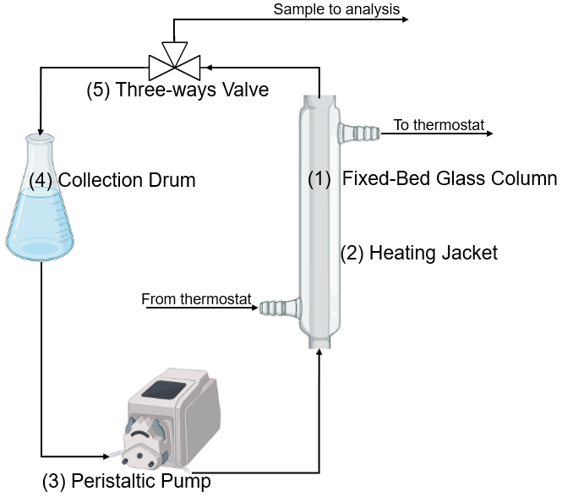
Figure 1: Experimental set-up
    - Experimental tests
The extraction tests were performed at a constant flow rate of 0.025 l/min. On the whole, six tests were performed by varying the solid mass and the liquid volume, and consequently the solid-liquid ratio $α$ (Table 1).
Table 1: Experimental conditions of extraction tests (T=70 °C, flow rate = 0.025 l/min)
Test | Number of cycles | $α$ (g/l) | $M_{S}$ (g) | $V_{L}$ (l)
1 | 2 | 3.1 | 0.31 | 0.10
2 | 2 | 3.3 | 0.50 | 0.15
3 | 2 | 5.0 | 0.45 | 0.09
4 | 3 | 5.7 | 0.40 | 0.07
5 | 5 | 4.0 | 0.40 | 0.10
6 | 6 | 2.0 | 0.20 | 0.10

Before each test, the volume of liquid solvent and the mass of solid matrix were measured and subsequently loaded in the collection drum and in the glass column, respectively. Within the column, glass spheres were placed above the solid in order to keep it confined and packed in a fixed bed.
In each test, several extraction cycles were performed on the same solid sample. The number of cycles performed for each test is reported in Table 1. Each cycle started by activating the peristaltic pump (3), allowing a constant flow of liquid solvent to continuously leave the collection drum (4), pass through the extraction column (1), and be recirculated back into the accumulation drum in a closed loop. During the first extraction cycles of tests 1 and 3, samples of the liquid stream were collected at fixed time intervals through the three-ways valve (5) and then analyzed as described in the following section (Section 2.4) in order to determine the extraction time of the system.
At the end of each cycle, having a duration ranging from 20 min to 520 min, the liquid product containing the extracted polyphenols was removed, analyzed as described in Section 2.4, and replaced with fresh solvent in the same amount of that loaded at the beginning of the test. On the other hand, the solid remained confined in the column and was removed and replaced only at the end of each test.
    - Analyticals
The concentration of polyphenols in the liquid samples collected from experimental tests was determined by oxidation of phenolic compounds using the Folin-Ciocalteau (F-C) assay. The details regarding the analytical procedure are reported by Everette et al. (2010). Briefly, 20 µL of each experimental sample were mixed with 1580 µL of distilled water and 100 µL of Folin-Ciocalteu’s reagent, purchased from Sigma Aldrich (Milan, Italy) and used without any further purification. The mixture was stirred and kept in the dark for 8 min. Then, 300 µL of an aqueous solution containing 20% w/w of sodium carbonate (Na₂CO₃) was added and the mixture was put back in the dark for 2 h. Finally, 200 µL of the prepared sample was put in a Greiner 96 flat transparent microplate. The absorbance of the sample was measured through the Infinite M200 PRO Tecan microplate spectrophotometer (Tecan Trading AG, Switzerland) at 765 nm. The concentration was calculated by interpolating the result in a calibration curve obtained by measuring the absorbance of solutions of known composition of gallic acid, used as analytical standard. For this reason, the concentration of polyphenols is calculated in terms of equivalent Gallic Acid.

  - Results
    - Quantification of total extractable polyphenols from hazelnut skins and of extraction time
The total amount $q_{tot}$ of extractable polyphenols per mass of solid matrix was calculated through a mass balance extended to all the extraction cycles of each test as follows:
$$q_{tot}= \frac{V_{L}}{M_{S}}\sum_{i=1}^{N}{C_{i}}= \frac{1}{α}\sum_{i=1}^{N}{C_{i}}$$ | (1)
where $V_{L}$ and $M_{S}$ are the liquid volume and the solid mass loaded at the beginning of the test, respectively, and $C_{i}$ is the concentration of polyphenols in the aqueous solution at the end of the $i$-th cycle of the test; the ratio between $V_{L}$ and $M_{S}$ coincides with the reciprocal of the solid liquid ratio $α.$
The calculation of $q_{tot}$ was repeated for all tests, each characterized by a different number $N$ of cycles. Finally, by calculating the mean of the results summarized in Table 2, an average value of 0.114 g/g of extractable polyphenols per mass of hazelnut skins was obtained. This result is in the same order of magnitude as that reported by Fanali et al. (2021).
Table 2: Experimental data of $q_{tot}$, $C_{e}$, $q_{e}$ for each test at a different solid-liquid ratio $α$ (T = 70 °C, flow rate = 0.025 l/min)
Test | $α$ (g/l) | $q_{tot}$ (g/g) | $C_{e}$ (g/l) | $q_{e}$ (g/g)
6 | 2.0 | 0.132 | 0.215 | 0.0062
1 | 3.1 | 0.120 | 0.320 | 0.0104
2 | 3.3 | 0.108 | 0.342 | 0.0101
5 | 4.0 | 0.112 | 0.390 | 0.0162
3 | 5.0 | 0.107 | 0.476 | 0.0184
4 | 5.7 | 0.103 | 0.533 | 0.0207

Among the six tests performed, tests 1 and 3 were dedicated to the determination of the extraction time. In this regard, Figures 2a and 2b show the concentration of polyphenols versus time during the first cycle of tests 1 and 3, respectively. In both cases, the concentration reaches a plateau at the second sampling (made 15 and 60 min from the beginning of the cycle, respectively).

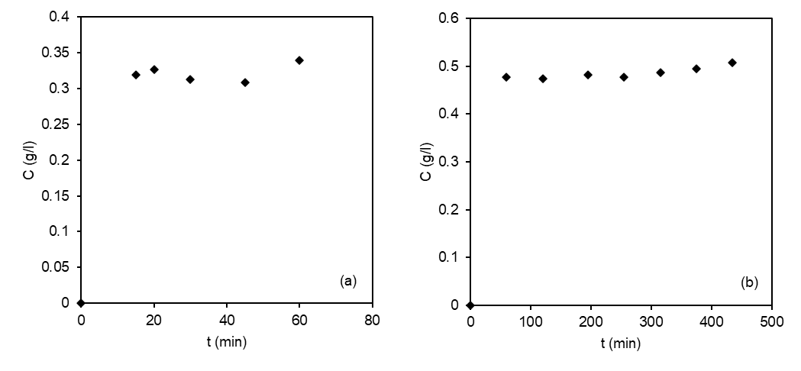
Figure 2: Concentration of polyphenols versus time; (a): first cycle of test 1, (b): first cycle of test 3
These results shows that the process is very fast, since most of the polyphenols are extracted within the first few minutes. Industrially, cycles of up to one hour (also including the solid loading and unloading) would therefore be sufficient to achieve the optimum yield of polyphenols. Hence, when taking into account an industrial extractor operating during an 8-hour work shift, the productivity of the extractor in terms of grams of extracted polyphenols per shift would be eightfold greater than that of a single cycle.

    - Equilibrium studies
Table 2 summarizes the experimental equilibrium data $C_{e}$ and $q_{e}$ of polyphenols in liquid and solid phases, respectively, obtained for the tests 1-6 by varying the solid-liquid ratio 𝛼. As shown in the previous Section 3.2, equilibrium in the liquid phase is observed to be reached already after the first few minutes of the extraction. For this reason, the various concentrations $C_{e}$ were taken after a maximum of 65 min from the beginning of each test, and then analyzed as described in Section 2.4. In Figure 3a, the data of $C_{e}$obtained are plotted versus the solid-liquid ratio 𝛼. In particular, a linear proportionality between the concentration of extracted polyphenols and 𝛼 is clearly shown.

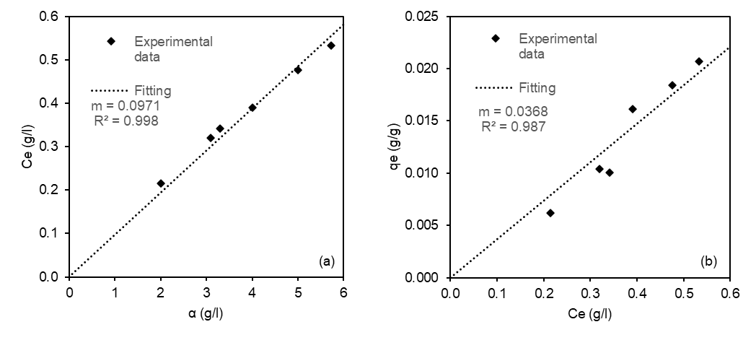
Figure 3: Equilibrium of extraction of polyphenols at 70 °C (tests 1-6); (a): Equilibrium concentration of polyphenols in water versus $α$, (b): Equilibrium concentration of polyphenols in solid matrix versus in water

On the other hand, for each test, the equilibrium concentrations of polyphenols in the solid phase $q_{e}$ were calculated through the following material balance:
$${M_{S}(q}_{tot,a}-q_{e} )= V_{L}C_{e}$$ | (2)
where $V_{L}$ and $M_{S}$ are the liquid volume and the solid mass loaded at the beginning of the test, respectively, and $q_{tot,a}$ is average total amount of extractable polyphenols per mass of solid matrix obtained in Section 3.1. In Equation 2, the average value $q_{tot,a}$ was employed rather than the individual sample values reported in the third column of Table 2 to reduce the fluctuation in error linked to each experimental value.
By introducing 𝛼 and by isolating $q_{e}$, the following equation for the calculation of $q_{e}$ is finally obtained:
$$q_{e}{=q}_{tot,a}- \frac{C_{e}}{α}$$ | (3)
In Figure 3b, the data of $q_{e}$ obtained from Equation 3 are plotted with the respective values of $C_{e}$, and a linear proportionality between the equilibrium concentrations of polyphenols in the two phases is observed. In particular, the angular coefficient m resulting from the fitting of the data shown in Figure 3b represents the partition coefficient $k$, with a value of 0.0368 l/g. The partition coefficient gives information on how the polyphenols are distributed in the two solid and liquid phases at equilibrium, according to the following equilibrium isotherm at 70 °C:
$$q_{e}{=kC}_{e}$$ | (4)
However, it is important to underline that this equation is valid only for solid-liquid ratios lower than or equal to 5.7 g/l, which coincides with the maximum solid-liquid ratio obtainable with the experimental set up used in this work and presented in Section 2.2. In fact, with the same solid matrix loaded in the column, higher solid-liquid ratios could only be achieved with a lower liquid volume than the plant holdup.

  - Conclusions
This paper presents the results of six experimental tests, performed in order to evaluate the feasibility of using water as a solvent for extracting polyphenols from waste hazelnut skins. The six tests involved varying the solid-liquid ratio within the range of 2-5.7 g/l while maintaining a constant temperature of 70 °C and a liquid flow rate of 0.0025 l/min. The use of a closed-loop fixed-bed set-up allowed to perform multiple cycles in the same test, by maintaining the same solid bed while fresh solvent was replaced at the end of each cycle. The a posteriori analysis of the experimental data focused on two key aspects, aligning with the primary objectives of this study:
- quantification of total extractable polyphenols from hazelnut skins and of extraction time;
- equilibrium isotherm determination.
Initially, a mass balance approach was used to evaluate the average total extractable polyphenol content per mass of solid matrix ($q_{tot,a}$), and the value of 0.114 g/g obtained is confirmed by literature.
Then, the extraction time was determined by analysing the samples taken at fixed time intervals during two of the six tests. The results revealed a rapid extraction process, reaching a plateau within the first hour. This finding is significant for potential industrial applications, as it allows for multiple short cycles to be carried out in a single working shift, offering significant economic advantages.
Finally, the equilibrium concentrations of polyphenols in the liquid and solid phases were obtained for the various tests. In particular, the concentration in water was obtained by sampling analysis, while the concentration in the solid matrix was calculated through a mass balance between the amount of polyphenols leaving the hazelnut skins and that entering the aqueous solution. The correlation between solid and liquid equilibrium concentrations was described by a linear isotherm, and a linear partition coefficient $k$ = 0.0368 l/g was evaluated through a fitting of the equilibrium data. However, further experiments at higher solid-liquid ratios are necessary to confirm the linearity of the equilibrium isotherm and the obtained value of $k$.
In conclusion, the significance of this study lies in its pioneering investigation of hazelnut skin polyphenol extraction from an engineering perspective. While previous research predominantly focused on engineering descriptions of polyphenol extraction using different solid matrices, and only analytically calculated the extractable mass of polyphenols from hazelnut skins, this work aimed to replicate a laboratory-scale extraction setup, providing insights into potential future industrial applications. However, it should be noted that this study represents a preliminary investigation with ample room for further improvements. In addition to expanding the range of validity for the equilibrium isotherm, another crucial step in this ongoing research will involve comparing the performance of water extraction with that of other natural solvents. Nevertheless, the results presented in this paper confirm the considerable added value of hazelnut skins as waste material, owing to their abundant polyphenol content. Furthermore, water extraction emerges as a promising process for the recovery of these valuable waste materials, undoubtedly sparking further comprehensive studies in the field.

Nomenclature
$C$ – concentration of polyphenols in water, g/l
$C_{e}$ – equilibrium concentration of polyphenols in water, g/l
$C_{i}$ – concentration of polyphenols in water at the end of the $i$-th cycle, g/l
$k$ – linear partition coefficient, l/g
$M$ – mass of solid matrix, g
$q_{e}$ – equilibrium concentration polyphenols in solid mass of hazelnut skins, g/g
$q_{tot}$ – total amount of extractable polyphenols in solid mass of hazelnut skins, g/g
$V$ – volume of solvent, l
$α$ – solid-liquid ratio , g/l
References
Capparucci, C., Gironi, F., & Piemonte, V. (2011). Equilibrium and extraction kinetics of tannins from chestnut tree wood in water solutions. Asia-Pacific Journal of Chemical Engineering, 6, 606–612. https://doi.org/10.1002/apj
Everette, J. D., Bryant, Q. M., Green, A. M., Abbey, Y. A., Wangila, G. W., & Walker, R. B. (2010). Thorough Study of Reactivity of Various Compound Classes toward the Folin - Ciocalteu Reagent. Journal of Agricultural and Food Chemistry, 58, 8139–8144. https://doi.org/10.1021/jf1005935
Fanali, C., Gallo, V., Della Posta, S., Dugo, L., Mazzeo, L., Cocchi, M., Piemonte, V., & De Gara, L. (2021). Choline Chloride – Lactic Acid-Based NADES As an Extraction Medium in a Response Surface Methodology-Optimized Method for the Extraction of Phenolic Compounds from Hazelnut Skin. Molecules, 26(2652), 1–15.
Hayouni, E. A., Abedrabba, M., Bouix, M., & Hamdi, M. (2007). Food Chemistry The effects of solvents and extraction method on the phenolic contents and biological activities in vitro of Tunisian Quercus. Food Chemistry, 105, 1126–1134. https://doi.org/10.1016/j.foodchem.2007.02.010
Savic, I. M., Nikolic, I. L., Savic-gajic, I. M., & Kundakovic, T. D. (2018). Modeling and optimization of bioactive compounds from chickpea seeds ( Cicer arietinum L ). Separation Science and Technology, 1–10. https://doi.org/10.1080/01496395.2018.1520720
Silva, R. F. M., & Pogačnik, L. (2020). Polyphenols from Food and Natural Products: Neuroprotection and Safety. Antioxidants, 9(61), 1–13.
Spagnuolo, L., Della Posta, S., Fanali, C., Dugo, L., & De Gara, L. (2021). Antioxidant and Antiglycation Effects of Polyphenol Compounds Extracted from Hazelnut Skin on Advanced. Antioxidants, 10(424), 3–14.
Tsao, R. (2010). Chemistry and Biochemistry of Dietary Polyphenols. Nutrients, 2, 1231–1246. https://doi.org/10.3390/nu2121231
www.fao.org. (n.d.). https://doi.org/10.1016/j.seppur.2005.03.007
Zhou, K., Laux, J. J., & Liangli, Y. L. (2004). Comparison of Swiss Red Wheat Grain and Fractions for Their Antioxidant Properties. Journal of Agricultural and Food Chemistry, 52, 1118–1123.
Zhou, K., & Yu, L. (2004). Effects of extraction solvent on wheat bran antioxidant activity estimation. LWT - Food Science and Technology, 37, 717–721. https://doi.org/10.1016/j.lwt.2004.02.008

