CHEMICAL ENGINEERING TRANSACTIONS  VOL. , 2023 | A publication of
The Italian Association
of Chemical Engineering
Online at www.cetjournal.it

Guest Editors: Laura Piazza, Mauro Moresi, Francesco Donsì
Copyright © 2023, AIDIC Servizi S.r.l.
ISBN 979-12-81206-01-4; ISSN 2283-9216

Honey Production with Remote Smart Monitoring System
Mariangela Vallone*, Santo Orlando, Maria Alleri, Massimo V. Ferro, Pietro Catania
University of Palermo, Department of Agricultural, Food and Forest Sciences, viale delle Scienze ed. 4, 90128 Palermo, Italy
mariangela.vallone@unipa.it
The innovative technologies of precision agriculture can be applied to beekeeping, a very important sector both from an environmental and production point of view. Bees are responsible, through pollination, for the reproduction of numerous plants guaranteeing biodiversity and providing a final product, honey, highly energetic and with high health properties. Today, sensors applied to the hives can be used to obtain information on the colony phenology in the field, disturbing them as little as possible, allowing the construction of forecast models to control their health state and production increase. The Department of Agricultural, Food and Forest Sciences of the University of Palermo developed a WNS-type system for continuously monitoring and controlling the main environmental factors, both inside and outside the hive, in order to evaluate their influence on daily honey production. The novel system allows to identify any critical points in honey production recording environmental, sound and production data and real time transmitting them to the operators, accessing a specifically created web interface. The results of the study represent the basis for a precision hive management model that can be applied in different environmental conditions to optimize honey production.
  - Introduction
Precision Beekeeping (BP) is a continuously evolving sector that aims to provide ever more reliable and efficient solutions to help monitor bee colonies.
In the past, monitoring of honey bee activities relied heavily on manual inspection (Bujok et al., 2002; Danka and Beaman, 2007; Dukku et al., 2013). Opening the hive, however, introduces some stress into the colony by changing the microclimate within the hive. Furthermore, beehives are influenced by external weather conditions (Flores et al., 2019) so it is important to monitor climatic conditions.
The parameters mainly analysed in the studies published on this topic are: mass, internal and external temperature and internal and external relative humidity, often considered together, while the other parameters such as sound emitted by the bees, flight or influence of meteorological factors such as wind and rain are often analysed individually.
In the last decade, the most used monitoring system consists of Wireless Sensor Networks (WSN), which can detect not only parameters both inside and outside the hive, but also provide long-term data on the honeybee in and out foraging activities at high temporal resolution (Jiang et al., 2016).
A WSN consists of embedded devices that can acquire data from different sensors, process them and communicate with a computer and a cloud database. These devices are known as nodes or motes and are the core of the Internet of Things (IoT) (Zhao et al., 2010). The WSN can also be used to monitor bee colonies. In particular, the nodes of a WSN can give data from sensors monitoring the environmental conditions of a hive (temperature, relative humidity, CO₂, etc.) and also its mass (Zacepins et al., 2015).
Different technologies can be applied for hive monitoring (Meikle and Holst, 2015). Another system has been described by Phillips et al. (2014) where the WSN was used to predict the swarming using temperature sensors. The proposed system was effective only in hot climates and the apparatus interfered with the beekeeper's access to the hive. The b+WSN system (Edwards-Murphy et al., 2016) collected valid data in all weather conditions and did not prevent beekeeping activities for the maintenance of the hive.
Recently a study conducted by Cecchi et al. (2020) developed a multisensor platform capable of monitoring in real time and in the long term some parameters related to the conditions of the hives, such as weight, sounds emitted by the bees, temperature, relative humidity and CO₂ inside the hive, thus such as the weather conditions outside.
The aim of this study was to introduce a WNS-type system, developed by the authors, capable of monitoring the main environmental factors in real time, both inside and outside the hive, and honey production, recording, transmitting and displaying the acquired data. The objective was to show a preliminary on-site validation of the system to create a tool to support beekeeper's decisions in evaluating swarm behaviour and honey production in Sicily.
  - Materials and methods
This section describes the characteristics of the experimental sites under study, the monitored parameters and the remote smart monitoring system developed by the authors.
    - Study sites
The study was carried out in Sicily (Italy) by identifying three different sites of application of the system (Figure 1):
- Site A, located at the Department of Agricultural, Food and Forest Sciences of the University of Palermo;
- Site B, located at the Basile farm in the province of Palermo (municipality of Ventimiglia di Sicilia);
- Site C, located at the Stabile farm in the province of Trapani (municipality of Castellamare del Golfo).

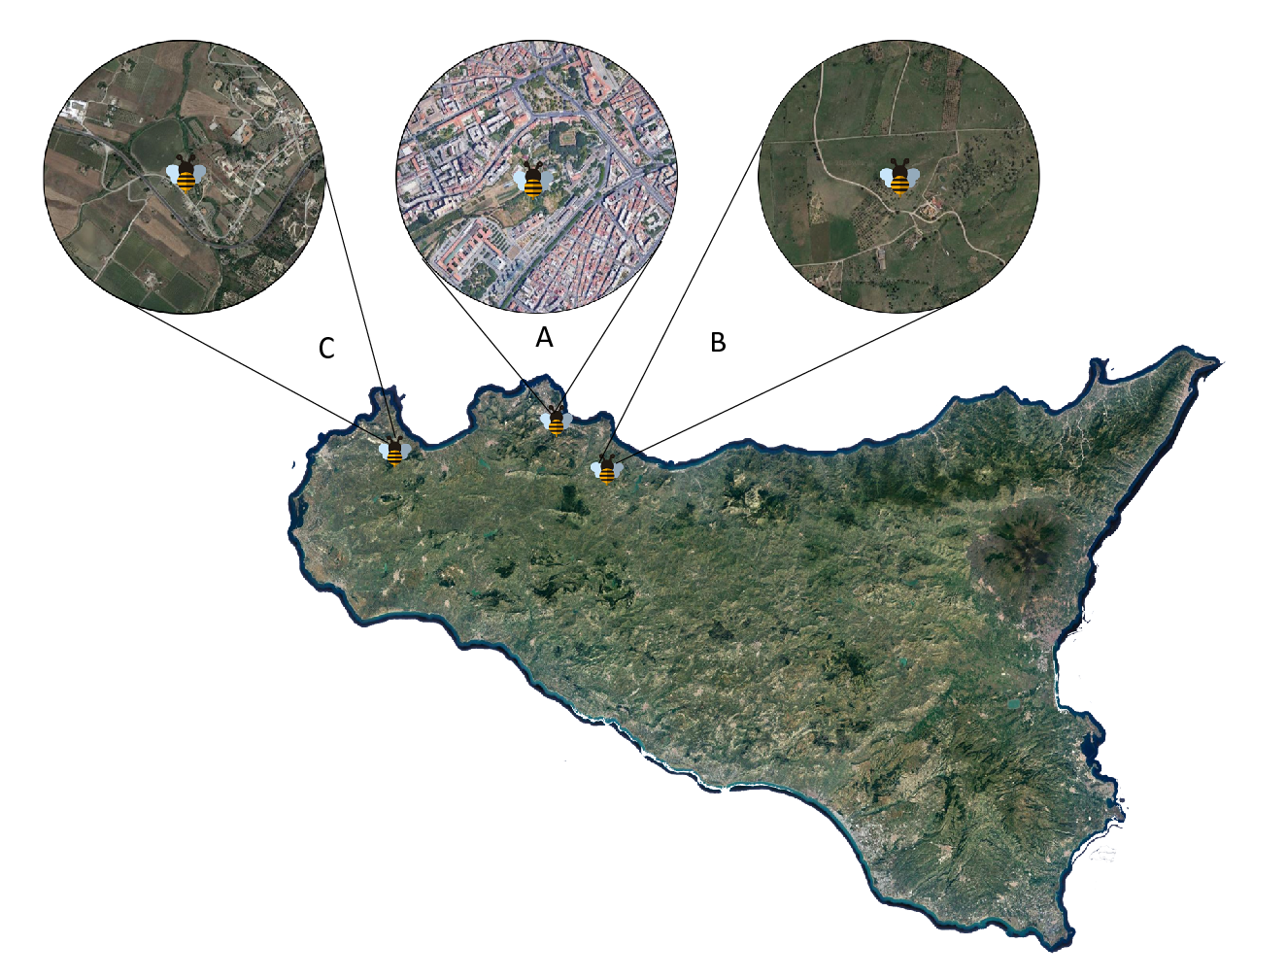
Figure 1: Study areas with indication of the three sites named A, B and C.
The study areas were different from each other. Site A is located within the urban perimeter and has an altitude of 160 m a.s.l. Site B is located at an altitude of 550 m a.s.l.; it is characterized by steeply sloping land towards the east and is furrowed by numerous valleys and watersheds, which sometimes deeply cut into the land. The area is largely occupied by uncultivated land, while the less steep areas are covered by arable land. Site C, located at an altitude of 197 m a.s.l., is positioned in a hilly agricultural area where olive groves, vineyards and little arable land predominate. In sites B and C on the roadside there are also Eucalyptus (Eucalyptus spp) and ailanthus (Ailanthus altissima).
The study was carried out on 9 hives, 3 per site. The positioning of the intelligent hives, which are described below, was carried out in November 2022. Monitoring is still ongoing.
Before positioning the hives, a preliminary study on the three sites was carried out to evaluate the climate and vegetation present in the study areas.
As far as the climate is concerned, it is always important to have climatic data available, such as minimum and maximum daily temperatures, relative humidity, total rainfall, solar radiation, prevailing wind speed and direction.
Furthermore, for a correct positioning of the hives it is also essential to evaluate their exposure. It is preferable that the hives face southeast: in this way, the entrance to the hives will be exposed to the sun from the early hours of the morning, favouring the start of the flights on the blooms and the activity inside the hives.
A careful analysis of the vegetation is interesting both in the area involved in the positioning of the hives and in the neighbouring area, so that sufficient nectariferous resources are available for the development and growth of the colonies.
    - Identification of the spontaneous plant species
The study carried out in the three different sites made it possible to identify the plant species and their development over the course of the year.
In the winter months, the land was poor in vegetation, but the first spontaneous species begin to appear as early as the first months of spring. Several samples of the plant species were taken in order to identify them.
The following plant species were observed: Galactites tomentosa, Hedisarium coronarium, Hirschfeldia incana, Picris echioides, Sonchus oleraceus.
    - Climate study
The trend of the main weather-climatic parameters was studied: temperature, relative humidity, precipitation, and solar radiation, wind direction and speed, both in the ten years before the positioning of the hives and during the experimentation. The historical data were obtained from the Sicilian Agrometeorological Information System (SIAS) of the Sicilian Region, Department of Agricultural and Food Resources, with reference to the stations closest to the sites being studied.
    - Hive monitoring system
The hives used are of the Dadant Blatt type (Figure 2) with small porch, equipped with 10 frames, the most used in Italy; the raised bees are local crossbreeds of the Apis mellifera species.

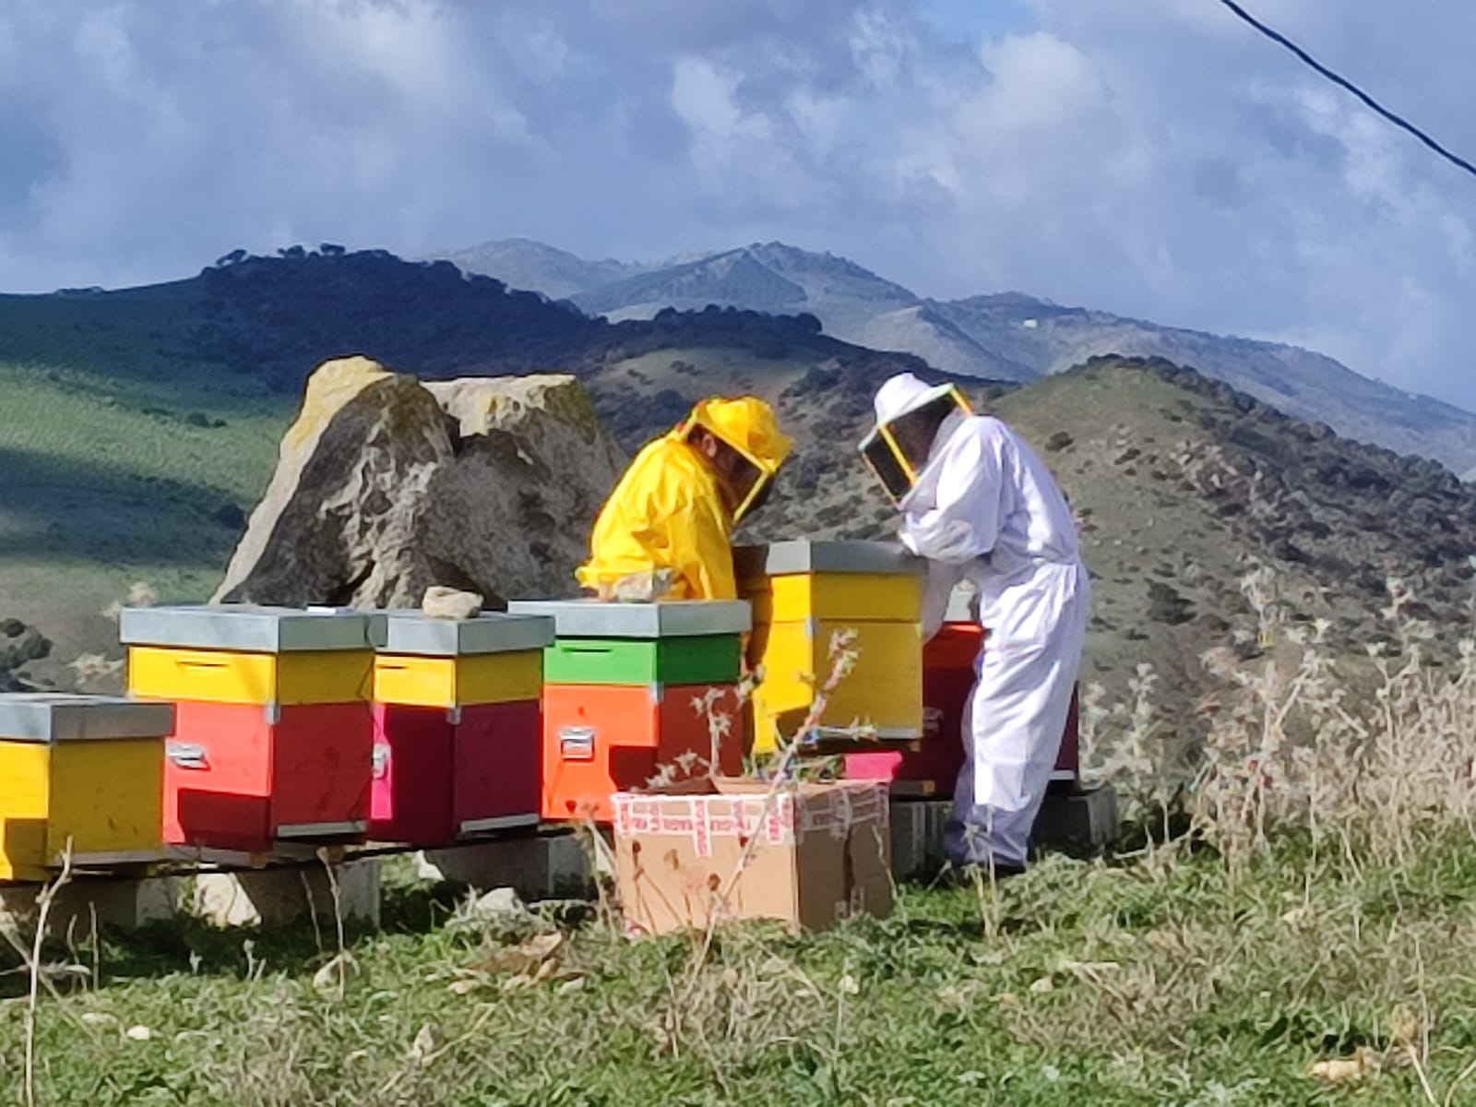
Figure 2: Dadant Blatt type hives during positioning in site B.
The developed system consisted of a series of sensors connected to a microcontroller, which acquires the data and periodically sends them to a server via modem. The sensors external to the hive were:
- four load cells, arranged at the base of the hive in correspondence with the vertices (Figure 3), measuring the weight. The maximum capacity of each load cell was 75 kg, therefore the overall system was capable of weighing up to 300 kg for each hive;
- a thermocouple which allowed the measurement of the ambient temperature.
- sensors within the hive placed inside a small plastic container (2x2x1 cm), specifically consisting of a thermometer, a hygrometer and a microphone. In this way it was possible to monitor temperature and relative humidity inside the hive, as well as the noise level. These sensors collectively provided insight into the family's activity status.

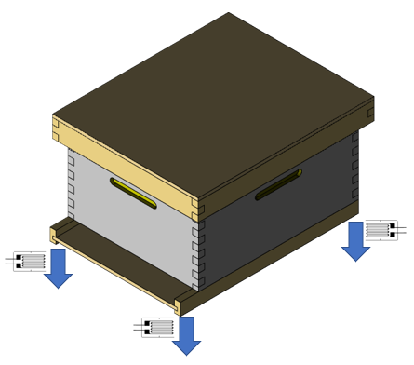
Figure 3: Load cells positioning in the hive represented by the blue arrow.
The microcontroller collected the acquired data, sending them to a cloud every 15 minutes via a multiband GSM modem (2G, 3G and 4G); in addition to archiving the data, it allowed for initial processing and its graphical representation. The graphs can be viewed by accessing a specifically created web interface where the trend of temperatures (internal and external), relative humidity, weight and noise level is visible.
The system was powered by solar energy.
  - Results
The first results obtained in the initial stages of the experimentation are reported in this section in order to perform a preliminary validation of the system in the three sites under study.

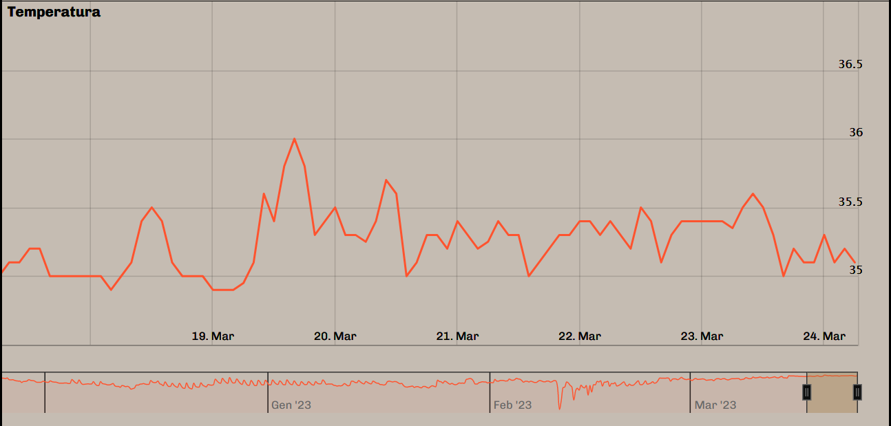  (a) | 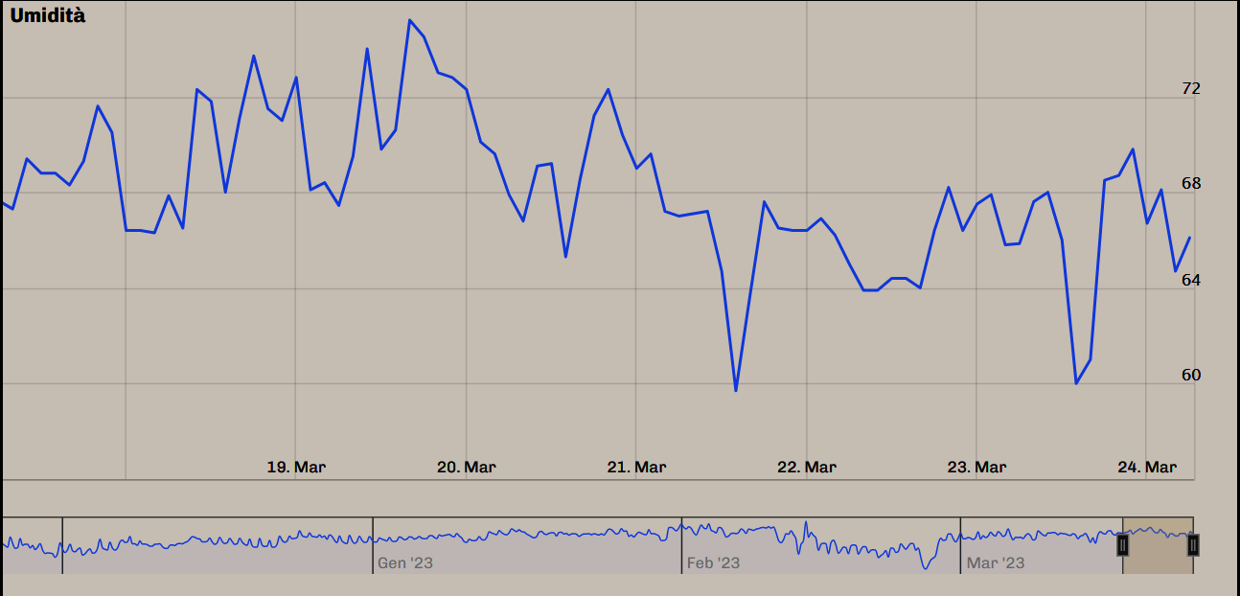  (b)
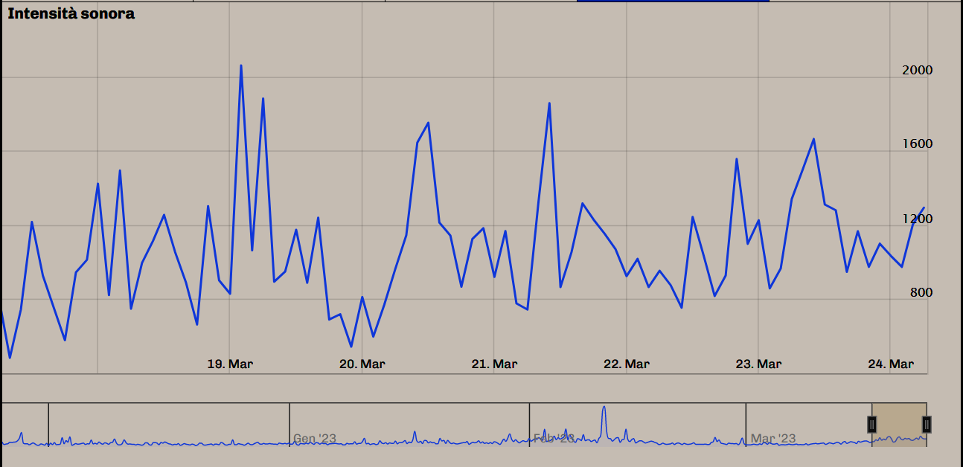  (c) | 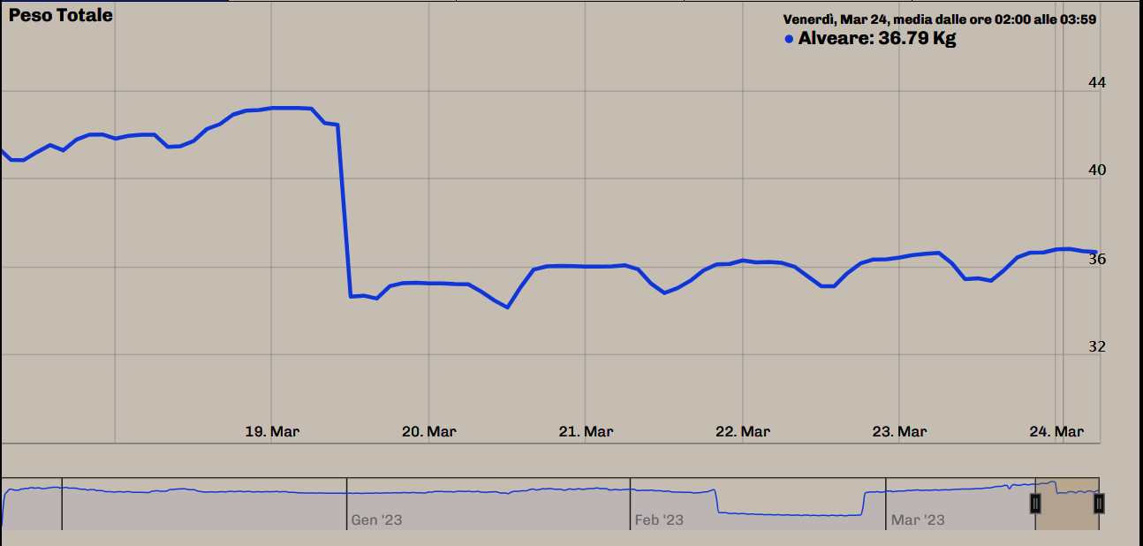  (d)
Figure 4: Examples of the data acquired by the system and their arrangement through the specifically created web interface. (a) internal temperature, (b) internal relative humidity, (c) noise level inside the hive, (d) weight of the hive.
Figure 4 shows some examples of the data acquired by the system and their arrangement through the specifically created web interface. Data are referred to one of the hives placed in site A, over a 6 days period. In particular, Figure 4(a) shows temperature values monitored inside the hive and Figure 4(b) shows relative humidity values inside the hive. In Figure 4(c) the sound level measured inside the hive is reported while in Figure 4(d) the weight of the hive is represented.
Figure 5 shows some of the data acquired by the system after processing for the three experimental sites in April 2023.
In site A, temperature is between 9 and 27 °C. The rainfall events of greatest intensity were concentrated in the first days of the month, with a maximum peak of 69.1 mm/h on 4 April. The monthly average wind speed is 6.6 km/h, with peaks during the day and higher average values in the first half of the month (maximum peak of 24 km/h). Although the initial weight of the hives is similar (35 ± 1 kg), at the end of the period considered there is a difference of about 10 kg between the most productive hive (hive 2) and the least productive (hive 1). The greatest increase occurs in the second half of the month at the same time as the increase in outside temperature. Some weight variations are due to operator interventions, in particular the insertion of the pollen traps (April 14), pollen trap removal (April 3 and 19) and the removal of 2 brood frames in the hive 2 on 19 April.

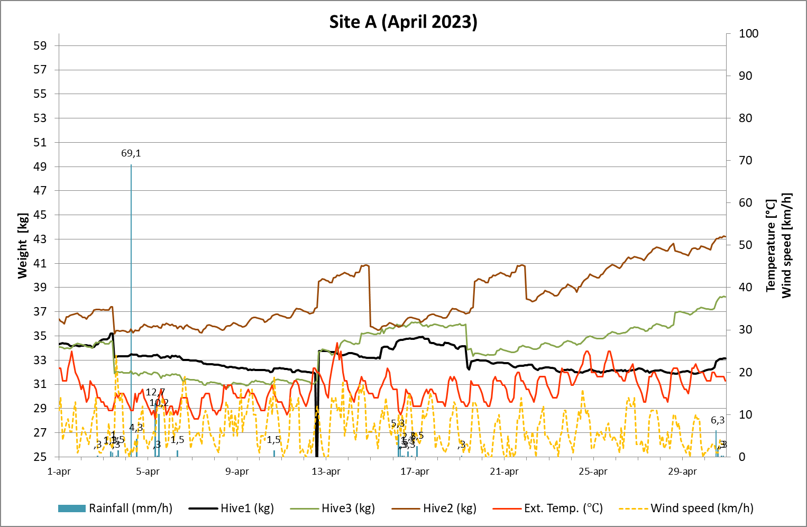
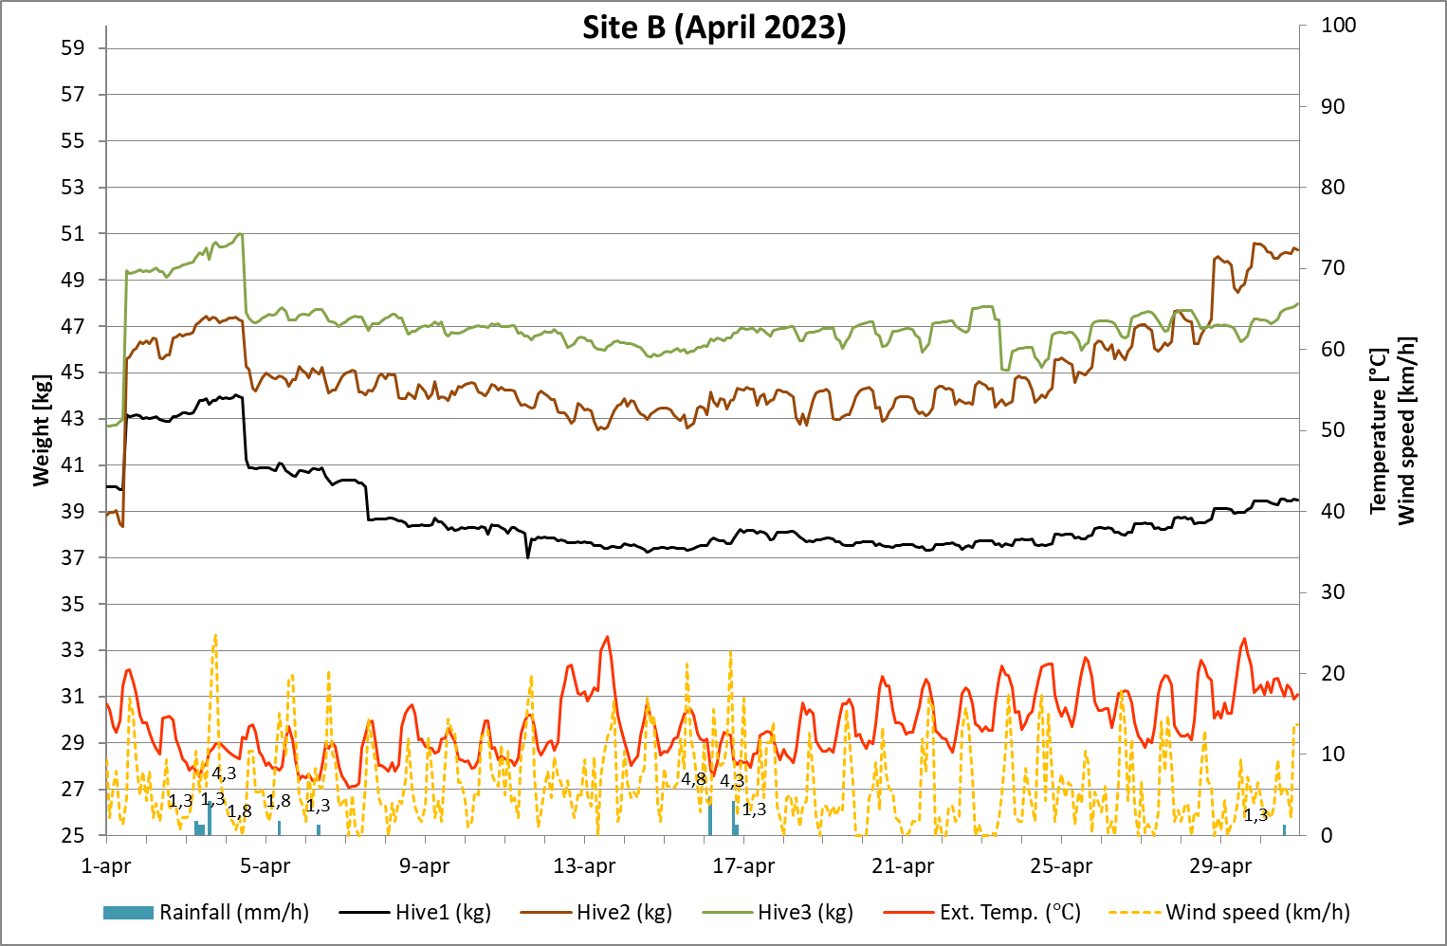
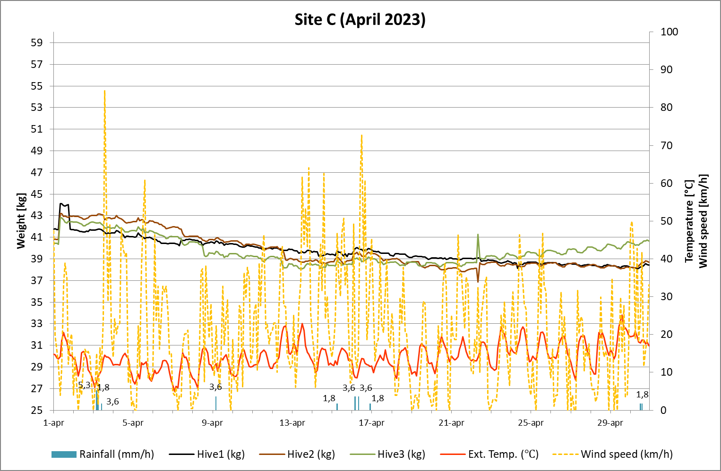
Figure 5: Data processed for the three experimental sites named A, B, and C in April 2023.
In site B, although the hives had the same nectariferous pasture, the three hives show different weigth due to the different strength and development of the families. Production activity begins on 1 April when the pollen traps are placed. On April 4, a weight variation was noted due to the removal of the pollen traps. Furthermore, from 20 April an increase of 8 kg was recorded for hive 2, going from 42 to 50 kg, while for the other two hives the weight remained almost constant, approximately 38 kg for hive 1 and 47 kg for hive 3. The ambient temperature ranged from 6 to 20°C, with two daily peaks of 24.6 and 24.3°C on April 13 and 29, respectively. As regards the wind, the values are between 1 and 18 km/h with few peaks above 20 km/h. Furthermore, few rainfall events were recorded with a maximum rainfall intensity value of 4.8 mm/h on 16 April.
In site C, honey production begins on 1 April and the pollen traps are inserted together with the bees. A decrease in weight for all three hives was observed during the month. On April 23, the frame was placed in hives 2 and 3 and the fecund queen was inserted. Since the same date, an increase in weight has been noted only for hive 3. External temperature showed values between 5 and 22 °C, with a peak of 25 °C on 29 April. During the monitoring period, several wind peaks above 40 km/h were recorded, such as 72.7 and 84.6 km/h. Few rainy events were observed, with a maximum rainfall intensity value of 5.3 mm/h on April 3.
  - Conclusions
This study describes the development of a novel WNS-type system capable of monitoring in real time the main environmental factors, both inside and outside the hive, and honey production. The system records, transmits and displays the acquired data through a specifically created web interface. The three experimental sites chosen to install the system, allow comparing the monitoring system results when applied in different ambient and climatic conditions, here represented by three different Sicilian environments. This study represents a preliminary on-site validation of the system to create a tool to support beekeeper's decisions in evaluating swarm behaviour and honey production in Sicily.
Acknowledgments
This work was supported by the Ministero delle politiche agricole, alimentari e forestali, Italy. [Bando Miele 2021, Project title: Prototipo di arnia intelligente per migliorare la produzione di miele. CUP: J79J21013190008].
The authors are grateful to Basile farm (Ventimiglia di Sicilia, Palermo, Italy) and Stabile farm (Castellammare del Golfo, Trapani, Italy) for giving the hives and hosting the experimentation.
References
Bujok B., Kleinhenz M., Fuchs S., Tautz J., 2002, Hot spots in the bee hive, Naturwissenschaften, 89, 299–301.
Cecchi S., Spinsante S., Terenzi A., & Orcioni S., 2020, A smart sensor-based measurement system for advanced bee hive monitoring, Sensors, 20, 2726.
Edwards-Murphy F., Magno M., Whelan P. M., O’Halloran J., Popovici E. M., 2016, b+ WSN: Smart beehive with preliminary decision tree analysis for agriculture and honey bee health monitoring, Computers and Electronics in Agriculture, 124, 211-219.
Flores J. M., Gil-Lebrero S., Gámiz V., Rodríguez M. I., Ortiz M. A., Quiles F. J., 2019, Effect of the climate change on honey bee colonies in a temperate Mediterranean zone assessed through remote hive weight monitoring system in conjunction with exhaustive colonies assessment, Science of the Total Environment, 653, 1111-1119.
Danka R.G., Beaman L.D., 2007, Flight activity of USDA-ARS Russian honey bees (Hymenoptera: Apidae) during pollination of lowbush blueberries in Maine, Journal of Economic Entomology,100, 267–272.
Dukku U.H., Russom Z., Domo A.G., 2013, Diurnal and Seasonal Flight Activity of the Honey bee, Apis Mellifera L, and its Relationship with Temperature, Light Intensity and Relative Humidity in the Savanna of Northern Nigeria, Global J. Sci. Front. Res. Biol. Sci, 13, 1-7.
Jiang J. A., Wang C. H., Chen C. H., Liao M. S., Su Y. L., Chen W. S.,Chuang C. L., 2016, A WSN-based automatic monitoring system for the foraging behavior of honey bees and environmental factors of beehives, Computers and Electronics in Agriculture, 123, 304-318.
Meikle W.G., Holst N., 2015, Application of continuous monitoring of honeybee colonies, Apidologie, 46, 10–22.
Phillips R.D., Brown M.A., Blum J.M., Baurley S.L., 2014, Testing a grassroots citizen science venture using open design, the Bee Lab Project. In: 32nd Annual ACM Conference on Human Factors in Computing Systems, CHI EA 2014. Association for Computing Machinery, Toronto, ON, 1951–1956.
Zhao J., Zhang Y., Feng J., Guo, 2010, “The Study and Application of the lOT Technology in Agriculture,” in Computer Science and Information Technology (ICCSIT), 462–465.
Zacepins A., Brusbardis V., Meitalovs J., Stalidzans E., 2015, Challenges in the development of Precision Beekeeping, Biosystems Engineering, 130, 60-71.

