CHEMICAL ENGINEERING TRANSACTIONS  VOL. , 2023 | A publication of
The Italian Association
of Chemical Engineering
Online at www.cetjournal.it

Guest Editors: Laura Piazza, Mauro Moresi, Francesco Donsì
Copyright © 2023, AIDIC Servizi S.r.l.
ISBN 978-88-81206-01-4; ISSN 2283-9216

Use of vegetable proteins for stabilization of hazelnut paste
Chiara Lobuonoª, Cecilia Fiorentiniª, Roberta Dordoniª, Andrea Bassaniª, Giorgia Spigno^{a,}*
ªDepartment for Sustainable Food Process (DiSTAS), Università Cattolica del Sacro Cuore, Via Emilia Parmense, 84, 29122 Piacenza, Italy
*giorgia.spigno@unicatt.it
Plant proteins are attracting much interest as an ingredient in the food sector due to their functional properties. These products are, in fact, widely studied to improve the quality of food products and to develop new types of bio packaging. This paper aims to study and investigate the potential of adding vegetable proteins (specifically soybean and sunflower) to improve the physicochemical stability of hazelnut pastes which are widely used in the food sector as a product itself or as an ingredient for many products, such as pastry, confectionery, and ice-cream. To investigate the effect of protein incorporation, hazelnut paste samples were stored under temperature accelerated conditions to simulate at least 10 months of shelf-life under normal storage conditions, and periodically analyzed for water activity, lipid oxidation, tocopherols content and oil separation. The study showed promising results for both added proteins, especially in terms of the physical stabilization of the product.
  - Introduction
Hazelnut paste (or butter) is a food ingredient used in various processed food products such as ice cream, confectionery, and baked goods (Spigno et al., 2013). Hazelnut pastes anhydrous creams, that is fatty creams whose main element is the fat content, which varies according to use. In this type of cream, the nut is the most valuable ingredient and, as with the fat content, can vary in quantity and quality (Carrega, 2019).
Hazelnut pastes, like all pastes derived from nuts, face two typical problems over time: oil separation and oxidative rancidity. Since most nut-based spreads and pastes are rich in oil, separation of the oil is one of the main problems since it compromises the quality and appearance of the products. Stabilization versus oil separation is of utmost importance to improve the acceptability and marketability of these products. Although manufacturers have used various commercially available food additives alone or in combinations to solve this problem, it has not yet been completely overcome, with the addition of monoglycerides and saturated fat being the best and most used solution to overcome it (Shakerardekani et al., 2013). The other main problem is oxidative rancidity, against which antioxidant additives could be used but it is uncommon to add synthetic additives to these products. The protective effects of various antioxidants on the oxidative stability of oils and fats of plant origin have been the subject of intensive research, showing great potential for protecting oils and fats from oxidation (Shakerardekani et al., 2013).
At the same time, consumers’ demand for high-protein food products has been increasing in the last decade and this has also contributed to the increasing market share of nut buttes which can be rich in proteins depending on the specific nut. For example, peanut butter is naturally very high in protein, up to 30%, while hazelnut butter has a lower content, 15% on average. Plant proteins are widely studied and used to increase protein content, substitute animal proteins, or replace additives. Depending on the target, plant proteins can be selected or functionalized for specific techno-functional properties, such as water solubility, emulsification, foaming, gelation and digestibility (de Paiva Gouvêa et al., 2023). The demand for natural food products is driving the growth of these bio-polymer alternatives, including polypeptides, to synthetic emulsion stabilizers (Tamang et al., 2022). Various studies have shown that, when used singly or in combination, biopolymers (proteins) can play as excellent stabilizers in different matrixes.
Following these considerations, this work investigated the potential addition of plant proteins to a nut paste (hazelnut butter) to evaluate the effect on oil separation and oxidation. Soy proteins were selected as consolidated plant proteins in the food industry, while sunflower proteins were selected because emerging proteins extracted from the residual cake of sunflower seed oil extraction and because in preliminary tests (data not shown) they revealed that these proteins show a higher oil holding capacity even with lower protein content.
  - Materials and methods
Two different hazelnut pastes were purchased from the Nutman Group company (Italy): one stabilized with palm oil (1%) and one non-stabilized or “natural” (only hazelnut paste). Two types of powder vegetable proteins, soybean and sunflower (89 % and 48 % protein content on dry matter, respectively), kindly provided by Prodotti Gianni S.r.l. (Italy) were selected for incorporation into the paste. Following preliminary trials (data not shown), a protein dosage level of 5% w/w (based on the weight of protein formulation) was applied. Protein incorporation was applied to the natural paste to compare it with the stabilized one. The addition was done manually using a kitchen mixer to facilitate the homogenization of the plant proteins into the hazelnut paste.
Since the commercial shelf-life of the hazelnut paste can be even longer than 1 year, it was set up an accelerated storage study. In agreement with the literature, the activation energy of oxidative rancidity reactions can be assumed to vary between 10 and 25 kcal/mol (Spigno et al., 2013). Considering the lowest value (10 kcal/mol), a duration test of 15 weeks at 40 °C was calculated to simulate about 10 months of storage at 21 °C, based on the Arrhenius model Eq(1).
$kT=A*\exp{(-\frac{Ea}{RT})}$ (1)
Samples of stabilized paste, non-stabilized paste, non-stabilized paste with soy proteins or sunflower proteins were distributed into plastic jars (60 g of paste each) and into Falcon tubes (6 g of paste each). All the samples were placed, opened (to further promote lipid oxidation), in an oven at 40 °C. Analyses were performed almost every 2 weeks until 105 days with the following analyzed times (subscript number indicates the week): t₀, t₂, t₄, t₆, t₈, t₁₀, t₁₄ and t₁₅. The samples were analyzed for water activity (a_{w}), peroxide value, tocopherols content and oil separation. Duplicate samples were prepared and stored for each time.
    - Analyses
Plant proteins were characterized by assessing protein content, fiber, OHC and WHC values. Analyses were done in triplicate and were performed according to the AOAC method for protein (method 976.05) and fiber (Megazyme CAT. NO. K-TDFR-200A).
For the WHC analyses, 0.25 g of sample were weighed in a Falcon tube to which 5 mL of distilled water was added (Nguyen et al., 2015). The mixture was vortexed for 30 s and left at room temperature (20-25 °C) for 15 min. Falcons were then centrifuged (SL 16R, Thermo Fisher Scientific, Waltham, MA, USA) at 25 °C for 15 min at 10000 rpm (rotor diameter of 33.6 cm). After centrifugation, the supernatant was removed, and the precipitate was weighed to give the WHC. For OHC analyses, the analysis was carried out in the same way but with sunflower oil.
The a_{w} value was measured with HygroPalm HP23-AW (Rotronic, Italy) at 25 °C. The samples were well mixed with a glass wand to homogenize any oil separated over time and then placed in small aliquots inside the instrument-specific plastic containers.
The peroxide value (PV) was assessed as indication of the lipid oxidation state. The lipid fraction was cold extracted to avoid further oxidation. For each sample, 6 g of hazelnut paste were extracted with 30 mL of hexane, vortexed for a few seconds and then centrifuged at 5000 rpm (rotor diameter 33.6 cm), at 4 °C for 15 min. The separated hexane fraction was filtered through Filter-Lab pleated paper filters (110 mm) and the hexane was evaporated under vacuum at about 35-40 °C to get the lipid phase. For the PV analysis, 1 g of the extracted oil was poured into 100 mL Erlenmeyer flasks and added with 25 mL of acetic acid and chloroform solution (3:2 v/v) and 0.5 mL of saturated potassium iodide solution. The flasks were then closed, covered with aluminum foil and placed in the dark for 2 min after which 25 mL of distilled water were added together with about 0.5 mL of a 1 % starch salt solution as indicator. In case of pink colour indicating the presence of peroxides, the solution was titrated with Na₂S₂O₃ 0.01 N and the PV was calculated from the mL of Na₂S₂O₃ (S) by Eq(2).
$\frac{meqO_{2}}{kg oil}=\frac{S*0.01*1000}{g of sample}$ (2)

The cold extracted lipid phase was used to evaluate the tocopherols content by High-Performance Liquid Chromatography (HPLC) analysis. An aliquot of 20 μL of the extracted oil was diluted (1:500) with the mobile phase eluent (hexane:isopropanol:ethanol, 98.5:1:0.5) and then injected (20 μL) into the HPLC system consisting of a Jasco PU-2080 pump equipped with a Perkin-Elmer 650-10S fluorescence detector (Oklahoma City, OK, USA), a Jasco LC-Net II/ADC communication module and ChromNAV Control Center software. Chromatographic separation of the tocopherols was carried out through a LiChrosorb Si 60-5 C18 250-millimeter x 4.6 millimeter, 5 μm column (Supelco, Bellefonte, PA, USA), with a mobile phase flow rate of 1 mL/min. The fluorescence detector was set at an excitation wavelength of 290 nm and an emission wavelength of 330 nm. The results of the analyzed tocopherols (α-, γ- and δ-tocopherol) were expressed in μg/L through calibration curves obtained with the following standard: α-tocopherol (Sigma-Aldrich, 10-2000 ppt, R²: 0.9997); δ-tocopherol (Sigma-Aldrich, 10-2000 ppt, R²: 0.9984); γ-tocopherol (Sigma-Aldrich, 5-1000 ppt, R²: 0.9979).
Oil separation was evaluated on the samples prepared in the falcon tubes starting from t₂. After being taken out from the oven at 40 °C, the layer of oil separated on the top was taken manually with a glass pasteur pipette and weighed.
    - Statistical analysis
All the analyses were carried out at least in triplicate on each sample and the values reported in this paper are the averages of the replicates ± relative standard deviation (s.d.). Statistical analysis was carried out to assess the influence of time for the same paste sample and the influence of paste type at the same time on the evaluated parameters based on one-way analysis of variance (ANOVA), using the software IBM SPSS Statistics (SPSS inc., Chicago, IL, USA, version 25) at a 95 % confidence level (p < 0.05). In the case of statistically significant influence, homogeneity of variances was verified with Levene's Test, and the mean values were discriminated through Tukey's Post-Hoc test (always at p < 0.05).
  - Results and discussions
The results of the protein characterization analysis are reported in Table 1. The values are all expressed on a dry matter. The results show that the percentage value of protein and WHC value was higher in the soy protein sample than in the sunflower one. The OHC was the same for both plant protein samples.
Table 1: Results of protein characterization analysis
 | % Protein | % Fiber | WHC | OHC
Sunflower proteins | 47.91 ± 1.51 | 21.11 ± 1.32 | 2.58 ± 0.04 | 1.45 ± 0.06
Soy proteins | 88.89 ± 1.52 | 3.42 ± 0.16 | 5.18 ± 0.19 | 1.45 ± 0.12

The a_{w} of initial hazelnut pastes was around 0.3 and the addition of sunflower proteins reduced it (Figure 1). During storage at 40°C in open containers, the a_{w} showed a certain increase, especially after 70 days, achieving values in the range of 0.390 to 0.405. The high percentage of fiber in the sunflower protein product could explain the higher a_{w}.
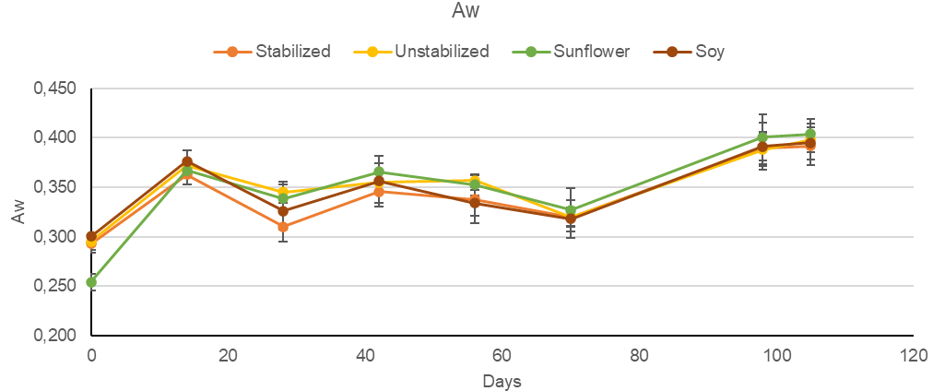
Figure 1: Trend of water activity (a_{w}) for different hazelnut paste samples (stabilized, unstabilized, added with sunflower or soy proteins) during storage at 40°C in open containers.
Statistical analysis showed that a_{w} significantly varied over time. In detail, there was a significant increase of a_{w} at 14 days and then after 70 days for all the recipes. Furthermore, except for time zero, the a_{w} of the hazelnut paste with sunflower protein was significantly higher than the other formulations.
The increase in a_{w} might have been due to two phenomena: hazelnut paste structure modification and moisture absorption from the environment. In the first hypothesis, maintenance at 40°C might lead to structural changes in the hazelnut pastes with consequent release of bound water detected as "free water" in the a_{w} measurement. This hypothetical change in structure was also experimentally perceived during the test since all pastes appeared more fluid when the samples had to be homogenized for analysis (this apparent thixotropic behavior should deserve further investigation). The second hypothesis is related to the absorption of moisture from the environment (since the containers were open) and the hygroscopicity of some components, such as the fibers present in the hazelnut paste. Various studies show that the addition of dietary fiber led to increased water content in the samples due to the water holding capacity of the fiber. The study by Verde et al. (2021) reports an increase in water content by fiber addition to milk chocolate stored packed up to 270 days. This seems to support the present study where the highest values of water activity were measured in the samples supplemented with sunflower protein: this is composed of 50 % protein and the remainder is rich in fiber.
Throughout the storage test, the peroxide analysis was always negative for all the samples. This, contrary to what was expected, revealed a high oxidative stability of the hazelnut paste at 40°C up to 105 days even though in open containers to have oxygen exposure. The oxidative stability might have been supported by the absence of light inside the oven and by the antioxidant effect of the natural content in tocopherols of the hazelnut paste (Crews et al., 2005).
As explained in materials and methods, an energy activation of 10 kcal/mol was used to calculate the equivalence of 15 weeks at 40°C to 10 months at 21°C. The observed stability would suggest an even longer shelf-life of the product or a not appropriate E_{a} selection.
The analysis of tocopherols content revealed the presence of α-tocopherol, γ-tocopherol and δ-tocopherol, while the presence of β-tocopherol was negligible. The concentration trend was similar for all the samples (Figures 2 and 3) showing a general decrease over time. This decrease was probably due to the antioxidant power of the tocopherols, which, by reacting with oxygen and radicals over time, could preserve the fat fraction of the hazelnut paste avoiding an increase in PV and supporting the previous hypothesis to explain the observed oxidative stability.
Some difference was observed for the different tocopherols. The α-tocopherol proved to be the main tocopherol with no significant difference between the different paste samples (Figure 2). In all the samples α -tocopherol decreased over time up to day 56, then increased until 70 days and finally decreased after 98 days. The intermediate increase could be due to the increase in the fluidity of the samples previously commented and that could have allowed to a higher extractability of tocopherol in the analytical protocol.
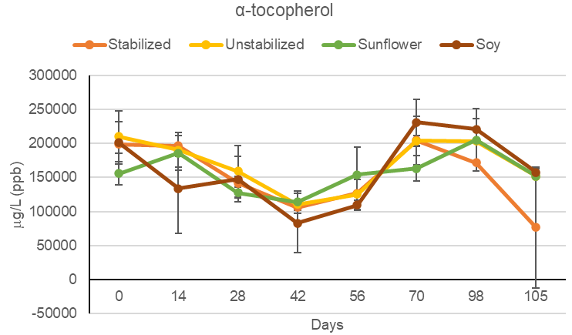
Figure 2: Trend of α-tocopherol content in the oil phase (μg/L fat) of hazelnut paste samples (stabilized, unstabilized, added with sunflower or soy proteins) during storage at 40°C in open containers.
In the case of γ-tocopherol, a more limited reduction (about 30 %) was observed (Figure 3) in all the samples. This was also present at a lower concentration than α- and δ- tocopherol. The latter was the tocopherol detected at the highest average concentrations at t₀ and the one that more rapidly degraded (Figure 3). Even though less evident, also for δ-tocopherol there was an apparent increase in concentration after some time, probably due to easier extraction.
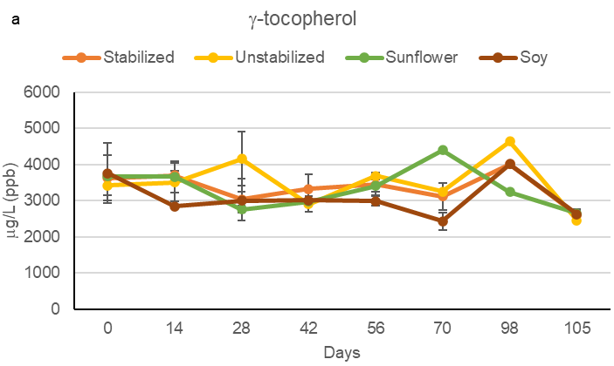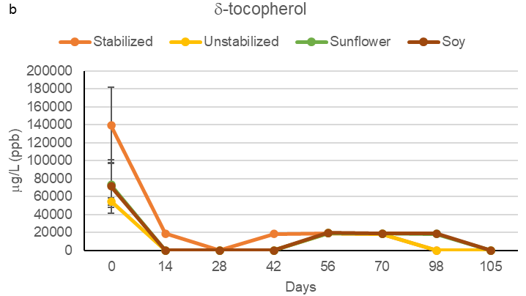
Figure 3: Trend of γ-tocopherol (a) and δ-tocopherol (b) content in the oil phase (μg/L of fat) of hazelnut paste samples (stabilized, unstabilized, added with sunflower or soy proteins) during storage at 40°C in open containers.

The results of many published studies show that the effectiveness of each tocopherol isomer in lipid dispersion systems or in bulk oil is unpredictable because it depends on many side reactions involving neighboring molecules. The fate of the radicals will depend on various parameters leading to different chemical pathways and, consequently, different degrees of efficiency of tocopherols as antioxidants depending on the products in which they are present or used. Results reported in the literature vary between synergistic or antagonistic effects, and the chemical interactions involved are complex (Barouh et al., 2022).
Since it is complex to define and predict the interactions between the tocopherols, the fat fraction and other chemical compounds present in the matrix (in our case, vegetable proteins), it is difficult to assess the reason why the stability of pastes with added soybean and sunflower proteins was higher than both the stabilized and natural paste: this could be due to either the natural presence of the tocopherols or the addition of the proteins themselves. The most likely hypothesis concerns the chemical interactions between the tocopherols and the added proteins: these possible chemical interactions between tocopherols and proteins are consistent with what is present in the data of Krol et al. (2020).
The oil separation was measured as a parameter to evaluate the physical stability of the hazelnut pastes. Oil separation significantly increased for the whole duration of the storage test and for all the samples (Figure 4). The OHC values make it possible to explain the behavior of these proteins toward oil separation in hazelnut pastes fortified with these products.
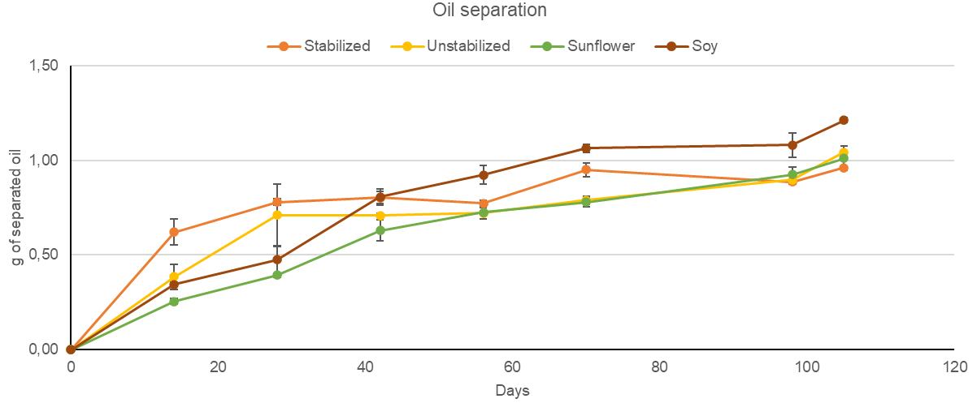
Figure 4: Oil separation in hazelnut paste samples (stabilized, unstabilized, added with sunflower or soy proteins) during storage at 40°C in open containers.
However, the increasing trend was slightly different for the protein-added pastes. For the paste added with soy protein, the separation of oil occurred more slowly in the first days of storage at 40°C than in the other pastes, but it reached the highest level among all samples after 42 days. In the case of paste added with sunflower protein, the separation of oil was the lowest among all samples at the beginning and then reached values like those of either stabilized and unstabilized pasta. Statistical analysis showed a significant difference between all the samples until 56 days. After 8 weeks, oil separation was significantly different only for soy protein-paste.
The positive effect of sunflower protein and, even though at a less extent of soy protein in reducing oil separation in the first weeks of storage could be due to the good emulsifying capacities and the oil holding capacity of the protein ingredients.
However, it is important to point out that, contrary to what was expected, there was no significant difference in physical stability between natural and stabilized paste. It might be that the selected storage temperature (40°C) to accelerate fat oxidation may have been too high leading, after the first 6 weeks, to an apparent same behavior between the different samples. There is no data in the literature on phase separation kinetics in nut pastes and dependence on temperature. For next investigation, it could be selected a different shape of containers, with a lower height and larger diameter to enhance sedimentation.
In the future, it would be interesting to investigate the composition of the proteins used in terms of bioactive compounds. Considering their plant-based origin, it might be important to investigate the presence of any antioxidant compounds in the proteins that would allow better preservation of hazelnut pastes over time.
  - Conclusions
Plant proteins added to hazelnut pastes could be an interesting ingredient for improving their chemical and physical stability. In this research soy and sunflower proteins were added to hazelnut paste for this purpose and the results showed that in terms of oil separation over time, the addition of these proteins may provide an advantage. The results related to oxidation over time are also interesting, but further investigation is needed to betterer understand the interaction of different types of plant proteins with hazelnut paste oil and tocopherols fraction and the consequences on texture change and stability.
References
Barouh N., Bourlieu-Lacanal C., Figueroa-Espinoza M.C., Durand E., Villeneuve P., 2022, Tocopherols as antioxidants in lipid-based systems: The combination of chemical and physicochemical interactions determines their efficiency, Comprehensive Reviews in Food Science and Food Safety, 21(1), pp. 642-688.
Carrega, E. G., 2019, Cacao, cioccolato e affini. Manuale di produzione per tecnici dell’industria alimentare, PVI Edizioni.
Crews C., Hough P., Godward J., Brereton P., Lees M., Guiet S., Winkelmann W., 2005, Study of the Main Constituents of Some Authentic Hazelnut Oils, Journal of Agricultural Food Chemistry, 53, 12, 4843–4852.
De Paiva Gouvêa L., Caldeira R., de Lima Azevedo T., Galdeano M.C., Felberg I., Ribeiro Lima J., Grassi Mellinger C., 2023, Physical and techno-functional properties of a common bean protein concentrate compared to commercial legume ingredients for the plant-based market, Food Hydrocolloids, 137,108351.
Krol K., Gantner M.J., 2020, Morphological Traits and Chemical Composition of Hazelnut from Different Geographical Origins: A Review, Agriculture, 10(9): 375.
Nguyen D.Q., Mounir S., Allaf K., 2015, Functional Properties of Water Holding Capacity, Oil Holding Capacity, Wettability, and Sedimentation of Swell-Dried Soybean Powder, Scholars Journal of Engineering and Technology (SJET), 3(4B), 402-412.
Shakerardekani A., Karim R., Ghazali H. M., Ling Chin N., 2013, Textural, Rheological and Sensory Properties and Oxidative Stability of Nut Spreads—A Review, International Journal of Molecular Sciences, 14, 4223-4241.
Spigno G., Donsì F., Amendola D., Sessa M., Ferrari G., De Faveri D. M., 2013, Nanoencapsulation systems to improve solubility and antioxidant efficiency of a grape marc extract into hazelnut paste, Journal of Food Engineering, 114, pag. 207-214.
Tamang N., Shrestha P., Khadka B., Mondal M.H., Saha B., Bhattarai A., 2022, A Review of Biopolymers’ Utility as Emulsion Stabilizers, Polymers 14(1),127.
Verde A.B., Alvim I. D., Luccas V., Vercelino Alvesa R.M., 2021, Stability of milk chocolate with hygroscopic fibers during storage, Lebensmittel-Wissenschaft und Technologie, volume 137, 110477.

