|  |  |
| --- | --- |
| cetlogo ***CHEMICAL ENGINEERING TRANSACTIONS***  ***VOL. , 2023*** | A publication of  aidiclogo_grande |
| The Italian Association  of Chemical Engineering  Online at www.cetjournal.it |
| Guest Editors: Laura Piazza, Mauro Moresi, Francesco Donsì  Copyright © 2023, AIDIC Servizi S.r.l. **ISBN** 979-12-81206-01-4; **ISSN** 2283-9216 | |

Active coated PLA-PHB film with formulations containing a commercial olive leaf extract to improve quality preservation of fresh pork burgers

Cecilia Fiorentinia, Andrea Bassania,\*, Marta Zacconeb, Maria Luana Montalbanob, Elena Díaz de Apodacac, Giorgia Spignoa

aDepartment for Sustainable Food Process (DiSTAS), Università Cattolica del Sacro Cuore, Via Emilia Parmense, 84, 29122 Piacenza, Italy.

bProplast, Via Roberto di Ferro, 86, 15122 Alessandria, Italy.

cTECNALIA, Basque Research and Technology Alliance (BRTA), Parque Tecnológico de Álava, Leonardo Da Vinci, 11, 01510, Miñano, Álava, Spain.

[andrea.bassani@unicatt.it](mailto:andrea.bassani@unicatt.it)

Since fresh meat is often subject to several degradation reactions that decrease its safety and quality until it is considered unacceptable, the release of bioactive compounds into meat products may be a good option to slow down oxidation and extend its shelf-life by a few days. Therefore, this study aimed to test the application on fresh pork burgers of a PLA-PHB film coated with two different coating formulations (methylcellulose, MC and chitosan, CT), both containing a commercial olive leaf extract OL, to evaluate their effect on meat quality preservation. Samples were tested at 0, 2, 5, 7, 9, 12, and 14 days after packing for microbial, chemical, and sensory evaluations. Except for the chitosan-only formulation, all tested formulations (MC, MC+OL and CT+OL) adhered well to the PLA-PHB base without the use of specific treatments. Meat packed with the different coatings maintained a slightly brighter red colour than the control samples and, as a result, deteriorated more slowly. In the evaluation of lipid oxidation, the CT+OL coating showed lower mean values of mg MDA/kg meat, which were significantly different from the other samples, especially on the 7th and 9th day of storage. Moreover, the CT+OL coating showed a slight slowdown in *Enterobacteriaceae* growth, revealing promising results in maintaining the meat quality longer.

* 1. Introduction

During the distribution and storage process, fresh meat is often subject to several chemical, physical, and biological reactions that decrease its safety and quality until it is considered unacceptable, such as lipid oxidation (Ribeiro et al., 2019). In the last years, great attention has been given to active packaging, in which bioactive agents (e.g., antioxidant or antimicrobial substances) are added to the packaging material to be gradually released to the food surface to keep its properties unchanged (Vilela et al, 2018).

Among the active packaging manufacturing techniques, coating techniques are the most studied because they allow the incorporation of heat-sensitive active agents (such as natural extracts) without using high temperatures, such as surface coating (Fu and Dudley, 2021).

More and more studies are focusing on the production of chitosan-based thin films with the addition of active compounds coated directly on the surface of food, like vegetables, fruits, and meat products (Ortiz-Duarte et al., 2019) or indirectly on the surface of the packaging material (Fiore et al., 2021). This allows for extending food shelf-life by reducing water vapour and oxygen permeability and slowing microbial growth and lipid oxidation (Díaz-Montes and Castro-Muñoz, 2021). Active compounds can be obtained from different natural sources, including agri-food by-products such as orange peel (Merino et al., 2023), grape pomace, grapefruit seeds, green tea and olive leaves (Faustino et al., 2019). Olive leaves can be found in large quantities as a residue in olive oil industries, and due to a large number of phenolic compounds, this matrix has attracted increasing interest for the production of active extracts (Borjan et al., 2020).

Based on these promises, the purpose of this study was to test the application on fresh pork meat of two different coatings formulations (methylcellulose or chitosan based) both containing a commercial olive leaf extract and coated on a PLA-PHB film, to evaluate their effect on meat quality and evolution during shelf-life.

* 1. Materials and methods
     1. Coating preparation

Two different coating formulations were produced using the following procedures:

* Chitosan (CT) coating from a 1 % wt. chitosan (Trades, S.A., Spain) solution in a 1 % acetic acid aqueous solution, stirred at room temperature until it was completely dissolution.
* Methylcellulose (MC) coating by dispersing and solubilizing 1.5 %wt. of methylcellulose (E-461, Epsa, Spain) in water at 80 °C with magnetic stirring and then cooled to room temperature.

In both formulations, a commercial olive leaf extract (OL) (EVRA, Italia.) was added at a concentration < 50 mg/mL. Each formulation (CT+OL and MC+OL) was coated onto PLA-PHB films (average thickness 40-50 µm) using a lab bar coater. Films coated with a solution of only MC or CT were prepared as control samples. All the coated films thus prepared were dried at room temperature and stored in the dark at 4 °C until use.

* + 1. Experimental plan

Samples of 80-gram minced pork meat (burgers) were bought from a local butcher’s shop in Piacenza (Italy) on the preparation day and transported in a cooled bag to the University’s laboratory in 20 min. Disks of approximately 8 cm in diameter were cut from each coated film, sterilized under UV lamps for 2 h, and placed both above and below the burger, with the coated surface touching the meat. The samples were then placed inside sterile Petri dishes and stored at 4 °C for 14 days. Uncoated PLA-PHB films and a meat sample without discs (named CONTROL) were used as control samples. Samples were tested at 0, 2, 5, 7, 9, 12, and 14 days after packing for chemical, sensory, and microbial quality evaluations.

* + 1. Meat analyses

A HygroPalm HP23-AW-A (Rotronic Italia, Milano, Italy) was used at 25 °C to measure water activity (aw) for each replicate.

The pH was measured directly in the meat (Tiralab AT 1000 Series) at three different points for each replicate. The colour analysis at five different points on each burger surface was performed with colorimeter (Chroma Meter CR-400 Konica Minolta, Tokyo, Japan) to register the colour values of *L\** (lightness), *a\** (redness and greenness) and *b\** (yellowness and blueness).

Thiobarbituric acid reactive substances (TBARS) measurement was determined using the acid precipitation technique described by Descalzo et al. (2005). The results were expressed as mg of malondialdehyde (MDA) equivalents/kg of fresh meat, using a calibration curve obtained with standard 1,1,3,3-tetraethoxypropane in TCA-TBA 1:1 v/v solution (Sigma-Aldrich, 0.05-0.5 µM, R2: 0.991).

For the microbiological analysis, approximately 20 g of sample, taken randomly from each burger, were weighed and diluted with 200 mL sterile saline solution (1:10 dilution) in plastic bags (BagMixer® 400). They were then homogenised in a stomacher type homogenizer (BagMixer, Interscience) for 2 min. Total bacterial count, *Enterobacteriaceae* count, and yeasts count were evaluated for each sample. Serial decimal dilutions were made with the same diluent. For total bacterial count (ISO 4833:2003), 1 mL of each dilution was inoculated onto Petri dishes for inclusion in 15 mL of Plate Count Agar (PCA, Oxoid Ltd, Hampshire, UK) medium with the addition of cycloheximide (16 mg/L) to inhibit yeast growth, and then the plates were incubated at 30 °C for 48 h. For *Enterobacteriaceae* count, the inclusion was done in Violet Red Bile Glucose Agar (VRBGA, Oxoid Ltd, Hampshire, UK) medium, and all the plates were incubated at 37 °C for 24 h (ISO 21528-2:2017). For yeast count, the dilutions were included in Malt Extract Agar (MEA, Oxoid Ltd, Hampshire, UK) with chloramphenicol (0.6 mg/L) as culture medium, and then all plates were incubated at 25 °C for 5 days (ISO 21527-2:2008). Then, all the results were expressed as the logarithm of CFU (colony-forming units) per g of fresh meat sample.

All samples were also evaluated by sensory analysis (appearance and odour) using the simplified 3-class evaluation scheme reported by Nieminen et al. (2016). The evaluation was performed by five non-trained panellists considering: class 1, equal to started sample (no defects); class 2, slight defects but still acceptable; class 3, strong and recognizable defects (unacceptable).

* + 1. Statistical analysis

Statistical analysis was conducted using IBM SPSS Statistics software (Version 25). All the data obtained from each analysis were reported as mean values ± the standard deviation (SD) of at least three replicates. The significance of the influence of coating film and storage time was assessed by ANOVA analysis, with subsequent Tukey's significant difference test (p-value of 0.05).

* 1. Results and Discussions

During the deposition of the formulations onto the surface of the PLA-PHB film, only three of the four planned formulations could be coated. In fact, the chitosan-based formulation (CT) did not adhere to the surface of the polymer film, probably due to too strong difference in surface tension between the film and the coating solution.

Water activity (aw) oscillated in all samples with few statistical differences (Figure 1A). The only coating that tended to be statistically different from the other samples was MC, which had lower values at both the 12th and 14th storage days. The slight increase in the aw value may be due to changes in the meat structure during storage time, caused by protein degradation and progressive breakdown of muscle fibres (Pearce et al., 2011).



Figure 1: Aw (A) and pH (B) evolution of fresh pork burgers packaged in contact with PLA-PHB coated with different coatings (MC, MC+OL, and CT+OL) and stored at 4 °C for 14 days. PLA-PHB: burger covered with uncoated film. CONTROL: uncoated burger. Error bars indicate ± standard deviation of mean values.

The pH (Figure 1B) increased after 7 days, but with no statistical differences among samples. This trend is probably due to partial degradation of proteins into volatile alkaline nitrogen molecules (Tabatabaee Bafroee et al., 2020). A similar pH trend over time was observed in other studies. For example, Venkatachalam and Lekjing (2020) reported that the pH of fresh pork burgers, packed in a chitosan-based film with clove essential oil and nisin at different concentrations, increased from 5.31 to values above 6 during 15 days of storage at 4 °C.

As shown in Table 1 the colour of the meat changed during the storage period.

*Table 1: Trend of a\*-, L\*- and b\*-coordinates of fresh pork burgers packaged in contact with PLA-PHB coated with different coatings (MC, MC+OL, and CT+OL) and stored at 4 °C for 14 days. PLA-PHB: burger covered with uncoated film. CONTROL: uncoated burger. Values expressed as mean ± standard deviation. Different lowercase letters indicate significant differences between samples in the same analysis time. Different capital letters indicate significant sample differences over time.*

|  |  |  |  |  |  |
| --- | --- | --- | --- | --- | --- |
| Time (days) | *a\** | | | | |
| MC | MC+OL | CT+OL | PLA-PHB | CONTROL |
| 0 | 12.36 ± 2.20aA | 12.36 ± 2.20aA | 12.36 ± 2.20aA | 12.36 ± 2.20aA | 12.36 ± 2.20aA |
| 2 | 10.67 ± 2.54aAB | 8.89 ± 2.13aA | 9.86 ± 2.07aA | 9.09 ± 1.61aA | 8.87 ± 1.74aAB |
| 5 | 9.81 ± 1.85aAB | 9.57 ± 2.43aA | 10.66 ± 1.29aA | 9.25 ± 1.96aA | 7.73 ± 1.37aB |
| 7 | 10.59 ± 1.28aAB | 10.46 ± 0.87aA | 9.48 ± 1.79aA | 9.82 ± 1.67aA | 8.93 ± 0.97aAB |
| 9 | 8.46 ± 1.69aB | 8.38 ± 2.83aA | 9.33 ± 1.60aA | 9.78 ± 2.42aA | 9.24 ± 1.49aAB |
| 12 | 9.41 ± 2.40aAB | 8.94 ± 1.49abA | 8.46 ± 1.67abA | 10.08 ± 1.89aA | 7.30 ± 1.84bB |
| 14 | 10.10 ± 1.08aAB | 9.82 ± 1.49aA | 9.54 ± 1.87aA | 10.58 ± 2.56aA | 6.89 ± 1.98aB |
|  | *L\** | | | | |
| 0 | 58.64±3.79aA | 58.64±3.79aA | 58.64±3.79aA | 58.64±3.79aA | 58.64±3.79aA |
| 2 | 56.31±3.98aA | 55.14±3.90aA | 57.48±3.70aA | 55.53±2.62aA | 56.43±3.65aAB |
| 5 | 56.39±3.30abA | 55.49±2.78aA | 58.16±3.23abA | 56.02±2.33abA | 54.27±2.62bB |
| 7 | 55.33±2.77aA | 56.48±4.29aA | 57.74±5.10aA | 55.54±3.16aA | 53.16±2.00aB |
| 9 | 57.02±4.17aA | 56.84±2.98aA | 57.93±3.41aA | 57.60±2.55aA | 55.37±2.43aAB |
| 12 | 57.24±3.15aA | 54.73±2.95aA | 54.86±2.42aA | 56.58±2.64aA | 55.50±2.84aAB |
| 14 | 57.13±2.37abA | 57.09±2.32abA | 57.01±3.14abA | 57.55±3.22aA | 54.61±2.69bB |
|  | *b\** | | | | |
| 0 | 11.73±2.05aA | 11.73±2.05aA | 11.73±2.05aA | 11.73±2.05aA | 11.73±2.05aA |
| 2 | 9.79±0.82aAB | 12.07±1.65bA | 11.85±0.95bA | 9.93±1.36aAB | 10.57±1.39abAB |
| 5 | 8.71±0.88aB | 10.99±1.99bA | 11.33±0.98bA | 9.57±0.75aAB | 9.61±0.88aAB |
| 7 | 9.05±0.82aAB | 10.55±1.00aA | 10.69±0.53aA | 9.09±1.12aAB | 9.53±1.16aAB |
| 9 | 8.70±1.53aB | 10.25±1.54abA | 10.99±1.16bA | 9.22±0.84abAB | 9.32±1.14abB |
| 12 | 9.27±1.67aAB | 10.44±2.05aA | 10.91±2.07aA | 9.12±1.23aAB | 9.29±2.19aB |
| 14 | 8.59±1.08aB | 9.94±1.66aA | 10.10±1.38aA | 8.40±1.53aB | 8.38±2.41aB |

The red colour of the meat is described by the positive values of the *a\**-coordinate. The higher the value of the *a\**-coordinate, the redder the meat and the more desirable to the consumer. The trend remains rather stable in all samples during the storage period and always shows positive values (red colour index). The lowest value was found in the control sample, which statistically differs from the other samples at the 12th day of storage. This shows that the meat packed with the different coatings retained a slightly brighter red colour than the control sample and, consequently, deteriorated more slowly.

Regarding the *L\**-coordinate (brightness), the values remained almost constant over time, without significant statistical differences between samples.

The *b\**-coordinate values of all samples tend to decrease slightly during storage, with the poor statistical difference between samples. Only on the 5th day of storage, the samples in contact with the MC+OL and CT+OL coatings showed statistically higher values than the other samples. This could be due to the partial detachment of these coatings at day 5 from the PLA-PHB film on the burger surface, causing the meat to turn into a slightly yellowish colour.

In this study, the lipid oxidation, measured with TBARS assay, increased slightly during storage time at 4 °C in all tested samples (Figure 2).



Figure 2: TBARS assay results for fresh pork burgers packed in contact with PLA-PHB coated with different coatings (MC, MC+OL, and CT+OL) and stored at 4 °C for 14 days. PLA-PHB: burgers covered with an uncoated film. CONTROL: not covered burger. Error bars indicate ± standard deviation of mean values.

Sheard et al. (2000) suggested that a TBARS value of 0.5 mg MDA/kg meat could be set as a threshold for consumer-detectable rancidity. The values of the control samples constantly increased until a maximum value of 0.543 ± 0.024 and 0.529 ± 0.033 mg MDA/kg meat, respectively after 14 days, slightly exceeding the threshold value (Figure 2). In contrast, for all the other samples the TBARS values increased more slowly and remained below the detectable rancidity threshold, indicating a lower degree of lipid oxidation. The CT+OL coating gave the lowest mean values of mg MDA/kg meat, which were significantly different, especially at the 7th and 9th days of storage. The trend obtained is in line with those obtained in the study by Cao et al. (2019) reporting that the mg MDA/kg values of fresh pork loin coated with a 2 % chitosan solution alone or with 0.2 % gallic acid, 0.2 % nisin or 0.2 % nisin and 0.2 % gallic acid increased more slowly than for uncoated meat and values were below the detectable rancidity threshold at day 20.

The initial total bacteria count (TBC) value was 4.64 log CFU/g meat on the first day for the control sample which showed the suitable quality of the meat. The highest microbiological level for meat with good quality is 7 logCFU/g (Tabatabaee Bafroee et al., 2020). As shown in Figure 3*,* after 5 days of refrigerated storage, the coated films tested seem to slightly delay microbial growth compared to the control sample.

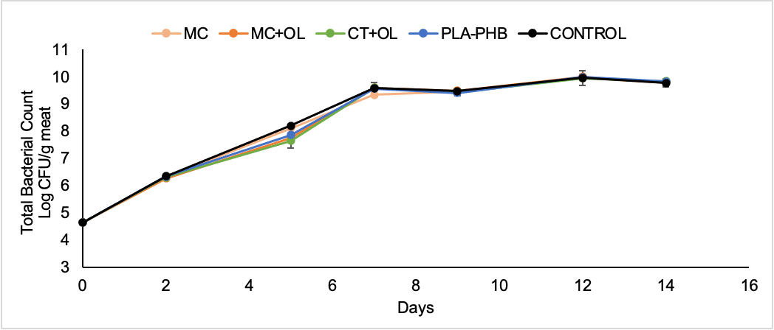

Figure 3: Total bacterial counts results for fresh pork burgers packed in contact with PLA-PHB coated with different coatings (MC, MC+OL, and CT+OL) and stored at 4 °C for 14 days. PLA-PHB: burger covered with uncoated film. CONTROL: uncoated burger. Error bars indicate ± standard deviation of mean values.

However, the data obtained with CT+OL sample did not differ significantly from those obtained with the PLA-PHB, MC+OL and MC ones, so the lower microbial growth on day 5 compared with the control sample is probably due to a greater barrier effect of the film and not due to a bacteriostatic effect of the coatings containing the OL extract. From day 7, the TBC values, regardless of the material used, increased to approximately 9 logCFU/g meat for all samples (including the CONTROL sample) until the end of the study (day 14) without statistical difference.

Based on the obtained results, the concentration of *Enterobacteriaceae* tended to increase in all samples until the 9th day and then stabilized starting from an initial value of 3.02 logCFU/g meat to a value of approximately 7.82 logCFU/g meat on day 14 for all samples (Figure 4A). The greatest differences between the samples were observed between days 5 and 7, when the CT+OL sample showed statistically lower values than the controls. The positive effect of the CT+OL coating is probably due to the combined antimicrobial effects of the olive leaf extract and the chitosan.

However, the incorporation of olive extract into the coating did appear to have any activity against yeast growth compared to all the other samples (Figure 4B).

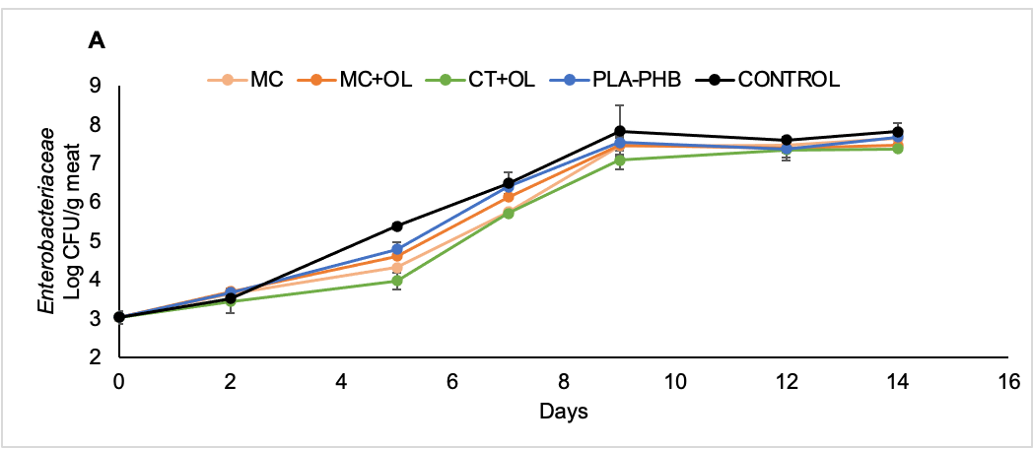 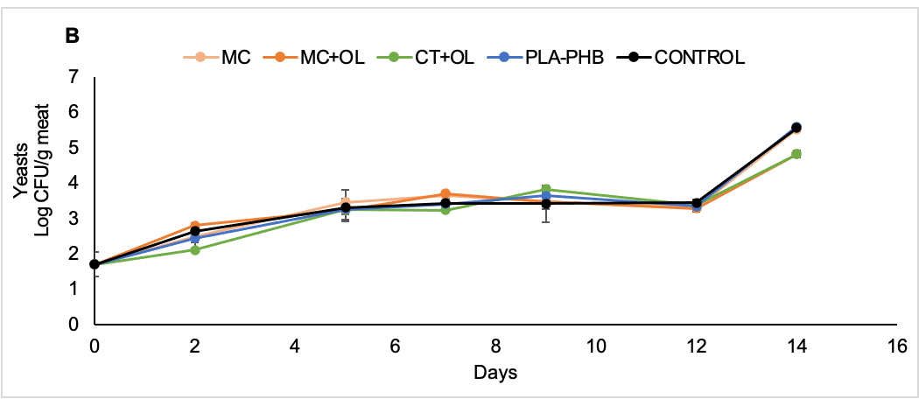

Figure 4: Enterobacteriaceae (A), and Yeasts (B) counts results for fresh pork burgers packed in contact with PLA-PHB coated with different coatings (MC, MC+OL, and CT+OL) and stored at 4 °C for 14 days. PLA-PHB: burger covered with uncoated film. CONTROL: uncoated burger. Error bars indicate ± standard deviation of mean values.

Regarding the sensory evaluation of the burgers (appearance and odour), in the first days the meat maintains its original appearance (class 1), while from the 5th day onwards, regardless of the type of sample, all of them started to show partial loss of the red colour, although the meat still looked acceptable (class 2). From day 7 only the control burgers began to have an unacceptable aspect; the meat in fact began to show a grey/brownish colour and a slimy aspect (class 3). A clear alteration started to occur on day 12 in all the other samples, except for CT+OL. From day 14 onwards, all samples started to show an unacceptable aspect.

Likewise, the odour of the meat samples displayed a similar trend. From day 7, a slight smell of ammonia started to develop, increasing in the control sample until day 14. A similar odour was detected from all the other samples, especially starting from day 12.

Since no big differences were found between the different samples, in the future it might be necessary to use a wider scale of values to better appreciate the difference between the samples analysed.

* 1. Conclusions

Two different coating formulations based on methylcellulose and chitosan in which a commercial olive leaf extract was added (at a concentration < 50 mg/mL), were coated onto PLA-PHB film, and tested directly in contact with fresh pork burgers for 14 days to evaluate a possible bacteriostatic and antioxidant effect of the different formulations on the surface of the meat. Even though 14 days is a longer period than the realistic shelf-life for such products, this period of time was chosen to highlight any effects of the coated films on meat.

Based on the obtained results, the coating CT+OL showed a slight slowdown in both lipid oxidation and *Enterobacteriaceae* growth. Therefore, if it is placed as a layer in contact with fresh meat, it could have a positive effect in slowing lipid oxidation and maintaining the meat quality longer.

However, in the future, it might be interesting to test these coated films in contact with the surface of meat packaged in a modified atmosphere within the normal packaging systems that are commercially available to date. In this way, it could be evaluated whether the combined effect of the active coatings and the modified atmosphere could extend the shelf-life of this food product by a few days. Moreover, in future studies, it will be necessary to improve the formulation distribution technique on the polymer film to have a more homogeneous deposition, especially for the chitosan-only one.

Acknowledgements

Bio-Based Industries Joint Undertaking under the European Union's Horizon 2020 Research and Innovation programme (NewPack project - grant agreement No 792261) and Doctoral School on the Agro-Food System, Università Cattolica del Sacro Cuore financially supported this research.

References

Borjan D., Leitgeb M., Knez Ž., & Hrnčič M. K., 2020, Microbiological and Antioxidant Activity of Phenolic Compounds in Olive Leaf Extract, Molecules, 25(24), 5946.

Cao Y., Warner R. D., & Fang Z., 2019, Effect of chitosan/nisin/gallic acid coating on preservation of pork loin in high oxygen modified atmosphere packaging, Food Control, 101, 9-16.

Descalzo A. M., Insani E. M., Biolatto A., Sancho A. M., García P. T., Pensel N. A., & Josifovich J. A., 2005, Influence of pasture or grain-based diets supplemented with vitamin E on antioxidant/oxidative balance of Argentine beef, Meat science, 70(1), 35-44.

Díaz-Montes E., & Castro-Muñoz R., 2021, Trends in chitosan as a primary biopolymer for functional films and coatings manufacture for food and natural products, Polymers, 13(5), 767.

Domínguez R., Barba F. J., Gómez B., Putnik P., Kovačević D. B., Pateiro M., Santos E. V., & Lorenzo J. M., 2018, Active packaging films with natural antioxidants to be used in meat industry: A review, Food research international, 113, 93-101.

Faustino M., Veiga M., Sousa P., Costa E. M., Silva S., & Pintado M., 2019, Agro-food byproducts as a new source of natural food additives, Molecules, 24(6), 1056.

Fiore A., Park S., Volpe S., Torrieri E., & Masi P., 2021, Active packaging based on PLA and chitosan-caseinate enriched rosemary essential oil coating for fresh minced chicken breast application, Food Packaging and Shelf Life, 29, 100708.

Fu Y., & Dudley E. G., 2021, Antimicrobial‐coated films as food packaging: A review, Comprehensive Reviews in Food Science and Food Safety.

ISO 21527-2:2008. Microbiology of food and animal feeding stuffs — Horizontal method for the enumeration of yeasts and moulds — Part 2: Colony count technique in products with water activity less than or equal to 0.95.

ISO 21528-2:2017. Microbiology of the food chain — Horizontal method for the detection and enumeration of Enterobacteriaceae — Part 2: Colony-count technique.

ISO 4833:2003. Microbiology of food and animal feeding stuffs — Horizontal method for the enumeration of microorganisms — Colony-count technique at 30 degrees C.

Merino D., Bellassi P., Paul U. C., Morelli L., & Athanassiou A., 2023, Assessment of chitosan/pectin-rich vegetable waste composites for the active packaging of dry foods, Food Hydrocolloids, 108580.

Nieminen T. T., Dalgaard P., & Björkroth J., 2016, Volatile organic compounds and Photobacterium phosphoreum associated with spoilage of modified-atmosphere-packaged raw pork, International journal of food microbiology, 218, 86-95.

Ortiz-Duarte G., Pérez-Cabrera L. E., Artés-Hernández F., & Martínez-Hernández G. B., 2019, Ag-chitosan nanocomposites in edible coatings affect the quality of fresh-cut melon, Postharvest Biology and Technology, 147, 174-184.

Pearce K. L., Rosenvold K., Andersen H. J., & Hopkins D. L., 2011, Water distribution and mobility in meat during the conversion of muscle to meat and ageing and the impacts on fresh meat quality attributes—A review, Meat science, 89(2), 111-124.

Ribeiro J. S., Santos M. J. M. C., Silva L. K. R., Pereira L. C. L., Santos I. A., da Silva Lannes S. C., & da Silva M. V., 2019, Natural antioxidants used in meat products: A brief review, Meat science, 148, 181-188.

Sheard P. R., Enser M., Wood J. D., Nute G. R., Gill B. P., & Richardson R. I., 2000, Shelf life and quality of pork and pork products with raised n-3 PUFA, Meat science, 55(2), 213-221.

Tabatabaee Bafroee A. S., Khanjari A., Teimourifard R., & Yarmahmoudi F., 2020, Development of a novel active packaging film to retain quality and prolong the shelf life of fresh minced lamb meat, Journal of Food Processing and Preservation, 44(11), e14880.

Venkatachalam K., & Lekjing S., 2020, A chitosan-based edible film with clove essential oil and nisin for improving the quality and shelf life of pork patties in cold storage, Rsc Advances, 10(30), 17777-17786.

Vilela C., Kurek M., Hayouka Z., Röcker B., Yildirim S., Antunes M. D. C., Nilsen-Nygaard J., Pettersen M. K., & Freire C. S., 2018, A concise guide to active agents for active food packaging, Trends in Food Science & Technology, 80, 212-222.