CHEMICAL ENGINEERING TRANSACTIONS  VOL. , 2023 | A publication of
The Italian Association
of Chemical Engineering
Online at www.cetjournal.it

Guest Editors: Laura Piazza, Mauro Moresi, Francesco Donsì
Copyright © 2023, AIDIC Servizi S.r.l.
ISBN 979-12-81206-01-4; ISSN 2283-9216

Antifungal Potential of Hibiscus Tea and Fermented Kombucha
Andressa Caroline Ferreira De Souza; Eliane Sloboda Rigobello; Flávia Aparecida Cardoso Reitz; Leila Larisa Medeiros Marques; Caroline De Oliveira Pereira; Márcia Regina Ferreira Geraldo Perdoncini*
Federal University of Technology - Paraná, Brazil Food Engineering and Technology
*Corresponding author: geraldo@professores.utfpr.edu.br
Kombucha is a beverage fermented by a symbiosis of bacteria and yeast from teas. Secondary fermentations can be made using vegetables, such as hibiscus for example. In addition to providing a different flavor, the kombucha fermented with hibiscus can provide functional properties such as antimicrobial and antioxidant action. Botrytis cinerea causes gray rot in fruits and is difficult to control due to resistance to chemicals. The objective of this work was to evaluate the antifungal activity of the 1st fermentation of kombucha (F1), the 2nd fermentation of kombucha with hibiscus (F2H) and hibiscus tea against the fungus Botrytis cinerea for a possible alternative for fungal control in strawberries. B. cinerea was inoculated in PDA medium at concentrations of 50 %, 25 %, 12.5 %, and 6.25 % of hibiscus tea and fermented kombucha and evaluated after seven days for mycelial growth, verified by its diameter. PDA without added tea or kombucha was used as a control. Strawberries were steeped in an aqueous solution of hibiscus tea and fermented into kombucha. The results showed inhibition of the mycelial growth of B. cinerea in the media with concentrations of 50 % and 25 % of kombucha (F1 and F2H) and hibiscus tea, where the inhibition for F1 was 88.9 % and 46.7 %. For F2H, it was 58.9 % and 20 %. And for hibiscus tea, it was 21.1 % and 12.2 %, respectively. When these pure compounds were applied by immersion on strawberries and stored at 15 °C, there were signs of reduced external deterioration, with hibiscus tea showing better control.
  - Introduction
Kombucha is a beverage fermented by the symbiosis of bacteria and yeasts (SCOBY: Symbiotic Culture of Bacteria and Yeasts) in sweetened black tea or green tea (Hohmann et al., 2020). It has antimicrobial, antioxidant, anticancer, and antidiabetic effects and has been used in the treatment of gastric ulcers and high cholesterol, showing actions in the immune response and liver detoxification (Bruschi et al., 2018; Chakravorty et al., 2016). In the production of the drink, a second fermentation can be carried out where vegetables, fruits, juices, teas, or spices are added, providing flavor and other properties. Kombucha has been studied for its inhibitory activity on pathogenic microorganisms (Jayabalan et al., 2014; Villarreal-Soto et al., 2018), including Gram-positive and negative bacteria (Battikh et al., 2012; Bhattacharya et al., 2016; Lynch et al., 2019), and antifungal activity (Yuniarto et al., 2016; Mazuchi-Brizzotti et al., 2021). The compounds that act as antifungal agents are probably organic acids, among them acetic acid, lactic acid, ethanol, and glucuronic acid, resulting from fermentation. Hibiscus sabdariffa L. is a plant known for its deep red color, aroma, and unique acidic taste. It has been used in studies in the production of food, beverages, and pharmaceutical products (Monteiro et al., 2017). It has compounds with antimicrobial properties, phytochemicals, such as anthocyanins and other phenolics (Khamsan et al., 2011), with a probable correlation between their quantity and inhibitory effects (Chao & Yin, 2009). Aqueous and ethanolic hibiscus extracts have been used in food systems to prevent bacterial contamination (Farombi & Fakoya, 2005; Liu et al., 2005). The food industry is looking for effective, safe, and easy-to-produce antimicrobial agents that are sustainably developed. Compounds produced in kombucha are obtained simply and without aggressive chemical substances, making them promising as antimicrobials to be applied in the food industry. The search for antimicrobials from natural processes has become relevant, believing in the minimization of undesirable effects due to toxic by-products from artificial chemical processes, which can cause damage to food, health, and the environment (Savvaidis & Ayala-Zavala, 2021). Deterioration by fungi causes undesirable food changes and may pose health risks. Botrytis cinerea is a plant pathogenic fungus that can reach more than 200 species, attacking leaves, stems, fruits, and flowers, in the pre-and post-harvest period, causing economic losses. It is genetically variable, acquiring resistance to the chemicals used for control (Sansone et al., 2018). Strawberry is sensitive to B. cinerea, which deteriorates, forming a gray mold (Jia et al., 2016). Techniques such as applying natural compounds and physical treatments have been sought to prevent gray mold disease as an alternative measure (Freitas et al., 2015). This work aimed to evaluate the antifungal activity of primary fermented kombucha, fermented kombucha with Hibiscus sabdariffa L (hibiscus) in secondary fermentation, and hibiscus tea against the fungus B. cinerea and application in the conservation of strawberries, presenting as a novelty the possible use as antifungals in strawberries and other foods.

2. Materials and Methods
2.1 Production of kombucha and hibiscus tea
The first fermentation (F1) was prepared by infusing green tea (5 g/L) in chlorine-free filtered water at 93 ºC. After sifting, sugar (50 g/L) and 10 % starter (ready kombucha) with SCOBY (Symbiotic Culture of Bacteria and Yeasts) were added. The packaging was done in glass containers, covered with a paper towel held by an elastic band, and left for seven days in a dark and dry place for fermentation. At the end of the period, the second fermentation (F2H) was carried out, where after removing the SCOBY from the fermented product, 2.5 % of dehydrated flowers of Hibiscus sabdariffa L. (hibiscus) were added and packaged in covered glass bottles. The green tea used (dehydrated leaves of Camellia sinensis), crystal sugar, and the dried flowers of Hibiscus sabdariffa L. were purchased at the local market. For the tea of dehydrated flowers of Hibiscus sabdariffa L., infusion (2.5 %) was performed in filtered water without chlorine heated to 93 ºC.
2.2 Production of culture media with tea and fermented kombucha F1 and F2H (test culture media) and fungus inoculation
The PDA (potato dextrose agar) culture medium was prepared according to the instructions, partially replacing water with F1, F2H, and hibiscus tea in 4 concentrations (50 %, 25 %, 12.5 %, and 6.25 %) separately. After sterilization in an autoclave, the F1 media were placed in sterile Petri dishes. Sterilization was performed using a filtering membrane for media containing Hibiscus sabdariffa L. (F2H). The fungus was Botrytis cinerea CCT 1251 from the André Toselo collection stored in the UTFPR-CM microbiology laboratory. The PDA culture medium prepared according to the manufacturer's instructions, without additional compounds, was used as a control medium. From a colony of Botrytis cinerea cultivated in PDA for seven days, a mycelium disc of 5 mm in diameter was inoculated in the center of the Petri dish with the test media to evaluate its mycelial growth. The same procedure was performed in the control PDA medium.
2.3 Application of tea and fermented kombucha on strawberries
Strawberries with uniform color, maturation, and size were selected for surface treatment with hibiscus tea, F1, and F2H by immersion for 30 seconds in each treatment. To compare the development of spoilage, untreated strawberries were used as a control. After immersion, the strawberries were rested on sterile sieves for 35 minutes at room temperature inside the laminar flow chamber to completely dry the surface. They were then transferred to polyethylene terephthalate plastic boxes with lids and stored at 12 °C for seven days.
2.4 Evaluation of fungal inhibition and deterioration in strawberries
To determine the inhibitory action of F1, F2H, and hibiscus tea at different concentrations (50 %, 25 %, 12.5 %, and 6.25 %) on B. cinerea, the mycelial diameter of the fungus developed in the respective media was measured and compared to the control. To express the percentage of mycelial growth inhibition, the following equation (1)
was used:

$Inhibition percentage (\%)=100-\left(100*\frac{mycellial growth diameter}{control diameter}\right)$ (1)

The strawberries were visually evaluated for the appearance of fungal deterioration at three-day intervals for six days to verify the action of the treatments in the process, comparing them to the control (untreated) strawberries.

3. Results and discussion
After seven days of incubation of the fungus in PDA control and PDA test medium (F1, F2H, and Hibiscus Tea), the mycelial diameter of the fungi developed in each treatment was measured and compared to the mycelial diameter of the control. The results of mycelial inhibition of Botrytis cinerea in a PDA medium with F1, F2H, and hibiscus tea are shown in Table 1.

Table 1: Diameter of mycelial growth and percentage of inhibition in hibiscus tea and kombucha ferments
Diameter (cm)* and Percentage of inhibition**(%)
 | 50 % |  | 25 % |  | 12.50 % |  | 6.25 % |  | Control
 | cm | % | cm | % | cm | % | cm | % | cm | %
F1 | 1 | 88.9 | 4.8 | 46.7 | 7.4 | 17.8 | 7.8 | 13.3 | 9 | 0
F2H | 3 | 58.9 | 7.2 | 20 | 7.8 | 13.3 | 8.2 | 8.9 | 9 | 0
Hib | 7 | 21.1 | 7.9 | 12.2 | 8.8 | 2.2 | 9 | 0 | 9 | 0
Notes: PDA medium with primary fermented kombucha (F1), with secondary fermented kombucha and hibiscus (F2H), and with hibiscus tea (Hib) at concentrations of 50 %, 25 %, 12.5 %, and 6.25 %; (*) Mycelial diameter of B. cinerea in centimeters; (**) Percentage of inhibition about the control.

Figure 1a and 1b demonstrates the mycelium of Botrytis cinerea in PDA (control) in its frontals, and reverse views, respectively, where the fungus fills the entire plate (9 cm in diameter).
2b
2a

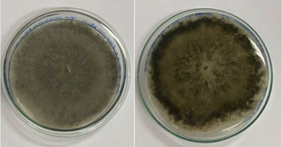
Figure 1: Front and back of Botrytis cinerea colony in PDA

Figures 2a, and 2b show the frontal and reverse views of Botrytis cinerea, respectively, developed in different concentrations of PDA with F1.
2b
2a
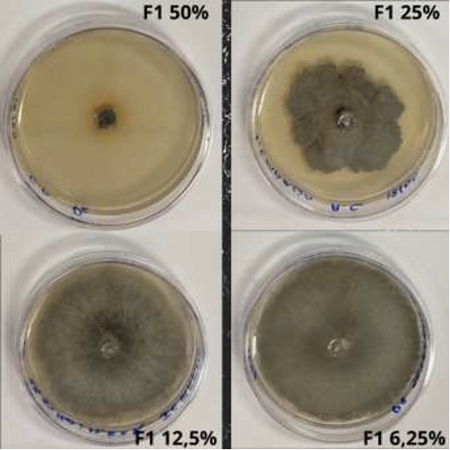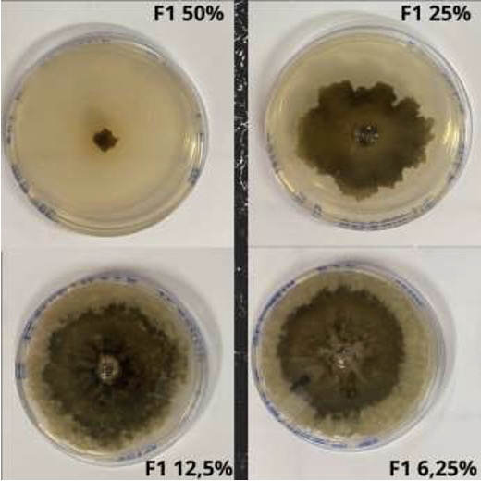
Figure 2a: Front of Botrytis cinerea colony in PDA and 2b: Reverse of Botrytis cinerea colony in PDA with F1 at concentrations of 50 %, 25 %, 12.5 %, and 6.25 %.

It is observed that the concentration of 50 % produced the most significant inhibitory effect on the mycelial growth of the fungus, this being 88.9 % (Table 1), followed by the concentrations of 25 % inhibiting 46.7 %. The 12.5 % and 6.25 % concentrations had less inhibitory power, 17.8 %, and 13.3 %, respectively. The antimicrobial effect of kombucha has been studied, with phenolics, flavonoids, organic acids, and ethyl acetate being the likely compounds responsible for such inhibition (Bhattacharya et al., 2016). Yuniarto et al. (2016) evaluated, using the disk diffusion technique, the antifungal activity of kombucha made with black tea at different fermentation times against fungi and found promising inhibition halos, concluding that the antimicrobial activity of kombucha is inversely proportional to the time of fermentation. Cetojevic-Simin et al. (2008), and Vukmanović et al. (2022) showed kombucha inhibition results against Gram-positive and Gram-negative bacteria, concluding that the acetic acid present in kombucha is one of the main compounds with antimicrobial action. Battikh et al. (2012) compared the antifungal activity of kombucha with green tea and black tea, observing inhibition over a wide range of pathogenic candida, with more significant antifungal potential being seen in kombucha produced with green tea. They also pointed out that, in addition to acetic acid and other organic acids, the presence of biologically active components, such as bacteriocins, proteins, enzymes, and phenolic compounds derived from tea may be responsible for the antimicrobial activity. Figures 3 A and 3 B show the front and reverse view, respectively, of B. cinerea inoculated in PDA with F2H, where the most significant inhibition occurred at a concentration of 50 %, with a percentage of inhibition of 58.9 % (Table 1) when compared to the control, followed by the concentration of 25 %, which obtained 20 % inhibition of mycelial growth. The 12.5 % and 6.25 % concentrations showed less mycelial inhibition, 13.3 %, and 8.9 %, respectively.

3b
3a
A
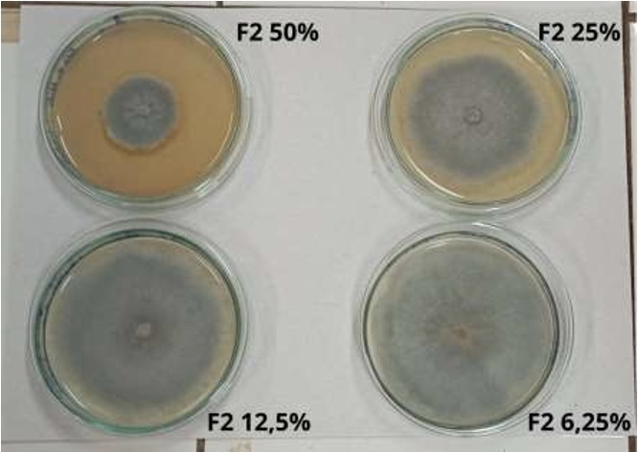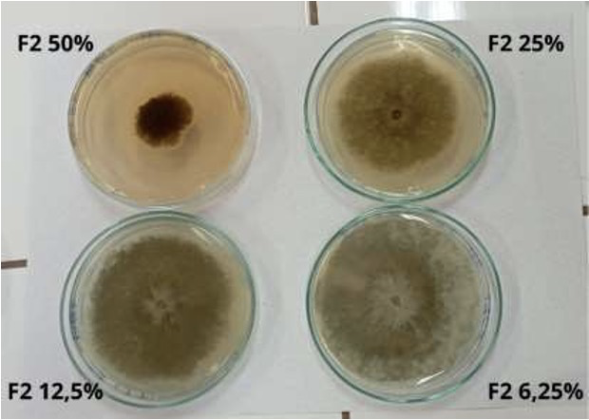
Figure 3a: Front of the colony of B. cinerea in PDA and 3b: Reverse of the colony of B. cinerea in F2H of kombucha at concentrations of 50 %, 25 %, 12.5 %, and 6.25 %

Studies carried out with hibiscus revealed the presence of probable active compounds in the antimicrobial activity. Chao and Yin (2009) used the alcoholic and aqueous extract of hibiscus calyx and protocatechuic acid against bacteria, reporting a possible relationship between the number of phenolic compounds, anthocyanins, and the antimicrobial activity of hibiscus, suggesting their efficiency as antibacterials in foods. Figures 4 A and 4 B show the frontal and reverse view of B. cinerea, respectively inoculated in PDA with hibiscus tea, where according to the results shown in table 1, the concentrations of 50 %, 25 %, 12.5 % showed inhibition of 21.1 %, 12.2 %, 2.2 % respectively and the concentration of 6.25 % did not show inhibitory activity when compared to the control.
4b
4a

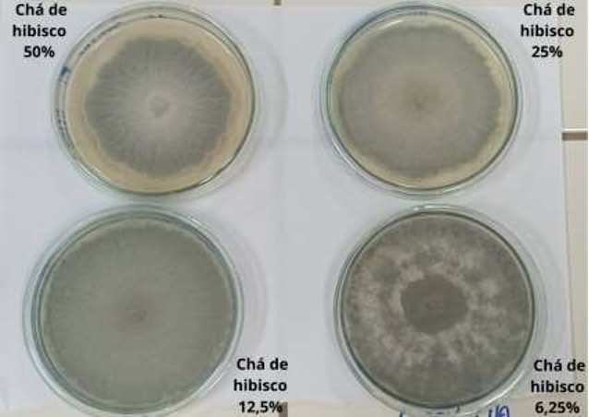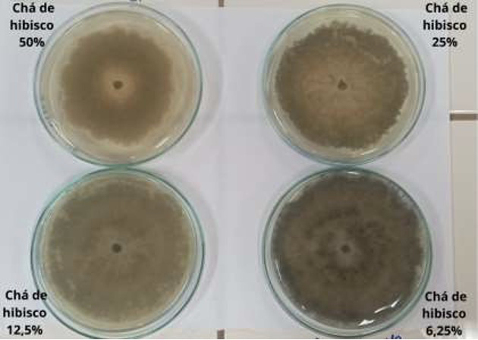
Figure 4a: Front of the colony of B. cinerea in PDA and 4b: Reverse of the colony of B. cinerea in hibiscus tea at concentrations of 50 %, 25 %, 12.5 %, and 6.25 %

When comparing the antimicrobial activity of F1, F2H, and hibiscus tea, it is observed that the best inhibition occurred in F1, followed by F2H, with hibiscus tea showing the lowest inhibition. Hibiscus with kombucha (F2H) had its potentiated inhibition effect. Mazuchi-Brizzotti et al. (2021), when evaluating the minimum inhibitory concentration and minimum fungicidal concentration of kombucha extract with hibiscus on the fungus T. rubrum, found results of 62.5 μg/mL and 125 μg/mL, respectively. Reis et al. (2021) demonstrated the minimum inhibitory concentration, and antifungal activity of the Hibiscus cannabinus extracts on Candida albicans, comparing the efficacy with fluconazole. Hemaiswarya et al. (2009), and Goussous et al. (2010) reported total in vitro inhibition of the mycelial growth of Aspergillus niger, and Alternaria solani by the aqueous extract of H. tiliaceus and H. sabdariffa, respectively. Studies have evaluated the antibacterial activity of hibiscus in alcoholic solution on Gram-positive and negative bacteria strains (Liu et al., 2005; Maciel et al., 2012). The effect of applying treatments directly on strawberries, stored at 12 ºC for six days, was observed at intervals of three days. For this, F1, F2H, and hibiscus tea were applied directly to the surface of the strawberries. Strawberries did not show any visible signs of deterioration immediately after the treatments were applied (zero time). On the third day after treatment, the strawberries began to show the first signs of fungal deterioration. In those treated with F1, an average of 3 points of deterioration was identified; with F2H, around 2 points of deterioration were observed; with hibiscus tea, 1 point of deterioration and in control strawberries (untreated), 3 to 4 signs of deterioration. After six days of storage at 12 ºC, there was an increase in the deterioration process in all strawberries, represented by the growth of the points initially visualized. Comparing all treated samples and the control, it is observed that strawberries treated with hibiscus tea showed less deterioration, followed by those treated with F2H. Strawberries treated with F1, on the other hand, showed little inhibition of deterioration, similar to what happened with strawberries called control. Such results were obtained visually, with the naked eye, and that future quantitative studies may be carried out. Ventura-Aguilar et al. (2018) concluded that Hibiscus sabdariffa L. was effective against Colletotrichum fragariae and when applied to strawberries, it maintained its appearance and properties, in addition to increasing its antioxidant capacity. The visual study demonstrated that the hibiscus presented greater control of fruit deterioration in this work. Studies carried out with other compounds, and different strawberry application methods showed antimicrobial activity. Borges et al. (2013) found a more significant conservation of strawberries coated with xanthan gum and sage essential oil, indicating that their association increases shelf life. Leite et al. (2022) carried out a study on the control of fungal deterioration in strawberries using crude vegetable extracts against the fungus B. cinerea, where the results showed the synergy of the extracts with the refrigeration method in strawberry conservation since they have inhibitory substances to the fungus B. cinerea that causes fruit deterioration and loss.

4. Conclusion
The inhibition of B. cinerea was demonstrated by the reduction of mycelial growth in PDA with concentrations of 50 %, 25 %, 12.5 %, and 6.25 % of F1, since the concentrations of 50 % and 25 % showed more excellent antifungal activity in which they obtained percentages of inhibition about the control of 88.9 % and 46.7 %, respectively. PDA medium with concentrations of 50 %, 25 %, 12.5 %, and 6.25 % of kombucha with hibiscus (F2H) inhibited B. cinerea, and the most expressive inhibition was demonstrated by the concentration of 50 %, inhibiting mycelial growth in 58.9 % about the control. Hibiscus tea at the same concentrations showed less inhibitory power, and at a concentration of 50 %, it showed a mycelial inhibition of 21.1 % about the control. It is concluded that of the treatments tested, B. cinerea has significantly inhibited mycelial growth when cultivated in PDA with kombucha (F1) and kombucha with hibiscus (F2H), depending on the concentration. Therefore, these natural compounds showed antifungal action against B. cinerea, potential antifungal agents to be applied in foods. Complementary studies need to be carried out so that this alternative can become a reality in the food industry. When strawberries were directly treated with F1, F2H, and hibiscus tea, those treated with hibiscus tea showed less visual deterioration than those treated with F2H and F1. Other methods for applying kombucha to strawberries, such as film coatings, could be analyzed to verify the effects on the conservation of these fruits, seeking the effectiveness of the antifungal action of these compounds on strawberries.

References

Battikh, H., Bakhrouf, A., & Ammar, E. (2012). Antimicrobial effect of Kombucha analogues. LWT, 47(1), 71–77. https://doi.org/10.1016/j.lwt.2011.12.033
Bhattacharya, D., Bhattacharya, S., Patra, M. M., Chakravorty, S., Sarkar, S., Chakraborty, W., Koley, H., & Gachhui, R. (2016). Antibacterial Activity of Polyphenolic Fraction of Kombucha Against Enteric Bacterial Pathogens. Current Microbiology, 73(6), 885–896. https://doi.org/10.1007/s00284-016-1136-3
Borges, C. D., Mendonça, C. R. B., Zambiazi, R. C., Nogueira, D., Pinto, E. M., & Paiva, F. F. (2013). Conservação de morangos com revestimentos à base de goma xantana e óleo essencial de sálvia. Bioscience Journal, 29(5), 1071–1083.
Bruschi, J. dos S., Sousa, R. C. dos S., & Modesto, K. R. (2018). O Ressurgimento do Chá de Kombucha. Revista de Iniciação Científica E Extensão, 1(Especial), 166–168.
Cetojevic-Simin, D. D., Bogdanovic, G. M., Cvetkovic, D. D., & Velicanski, A. S. (2008). Antiproliferative and antimicrobial activity of traditional Kombucha and Satureja montana L. Kombucha. Journal of B.U.ON., 13(3), 395–401.
Chakravorty, S., Bhattacharya, S., Chatzinotas, A., Chakraborty, W., Bhattacharya, D., & Gachhui, R. (2016). Kombucha tea fermentation: Microbial and biochemical dynamics. International Journal of Food Microbiology, 220, 63–72. https://doi.org/10.1016/j.ijfoodmicro.2015.12.015
Chao, C. Y., & Yin, M. C. (2009). Antibacterial effects of roselle calyx extracts and protocatechuic acid in ground beef and apple juice. Foodborne Pathogens and Disease, 6(2), 201–206. https://doi.org/10.1089/fpd.2008.0187
Farombi, E. O., & Fakoya, A. (2005). Free radical scavenging and antigenotoxic activities of natural phenolic compounds in dried flowers of Hibiscus sabdariffa L. Molecular Nutrition and Food Research, 49(12), 1120–1128. https://doi.org/10.1002/mnfr.200500084
Freitas, P. M., López-Gálvez, F., Tudela, J. A., Gil, M. I., & Allende, A. (2015). Postharvest treatment of table grapes with ultraviolet-C and chitosan coating preserves quality and increases stilbene content. Postharvest Biology and Technology, 105, 51–57. https://doi.org/10.1016/j.postharvbio.2015.03.011
Goussous, S. J., Abu el-Samen, F. M., & Tahhan, R. A. (2010). Antifungal activity of several medicinal plants extracts against the early blight pathogen (Alternaria solani). Archives of Phytopathology and Plant Protection, 43(17), 1745–1757. https://doi.org/10.1080/03235401003633832
Hemaiswarya, S., Poonkothai, M., Raja, R., & Anbazhagan, C. (2009). Comparative study on the antimicrobial activities of three Indian medicinal plants. Egyptian Journal of Biology, 11, 52–57.
Hohmann, F., Kunz, M. D., & Vandresen, D. F. (2020). Análise da atividade antibacteriana da kombucha em chá preto e verde analysis of antibacterial activity of kombucha in black and green tea. Revista de Iniciação Científica E Extensão, 3(2), 505–510.
Jayabalan, R., Malbaša, R. V., Lončar, E. S., Vitas, J. S., & Sathishkumar, M. (2014). A review on kombucha tea-microbiology, composition, fermentation, beneficial effects, toxicity, and tea fungus. In Comprehensive Reviews in Food Science and Food Safety (Vol. 13, Issue 4, pp. 538–550). https://doi.org/10.1111/1541-4337.12073
Jia, H., Zhao, P., Wang, B., Tariq, P., Zhao, F., Zhao, M., Wang, Q., Yang, T., & Fang, J. (2016). Overexpression of Polyphenol Oxidase Gene in Strawberry Fruit Delays the Fungus Infection Process. Plant Molecular Biology Reporter, 34(3), 592–606. https://doi.org/10.1007/s11105-015-0946-y
Khamsan, S., Liawruangrath, B., Liawruangrath, S., Teerawutkulrag, A., Pyne, S. G., & Garson, M. J. (2011). Antimalarial, Anticancer, Antimicrobial Activities and Chemical Constituents of Essential oil from the Aerial Parts of Cyperus kyllingia Endl. Records of Natural Products, 5(4), 324–327.
Leite, Ana Rita Zulim Cardoso, F. A. R., Gardenal, Amanda Correia Mello, J. C. P. de, Marques, L. L. M., & Perdoncini, M. R. F. G. (2022). Control of fungal spoilage in strawberries using crude plant extracts against the fungus Botrytis cinerea. Natural Product Research, 7, 1–14. https://doi.org/10.1080/14786419.2022.2142220
Liu, K. Sen, Tsao, S. M., & Yin, M. C. (2005). In vitro antibacterial activity of roselle calyx and protocatechuic acid. Phytotherapy Research, 19(11), 942–945. https://doi.org/10.1002/ptr.1760
Lynch, K. M., Zannini, E., Wilkinson, S., Daenen, L., & Arendt, E. K. (2019). Physiology of Acetic Acid Bacteria and Their Role in Vinegar and Fermented Beverages. In Comprehensive Reviews in Food Science and Food Safety (Vol. 18, Issue 3, pp. 587–625). https://doi.org/10.1111/1541-4337.12440
Maciel, M. J., Paim, M. P., Carvalho, H. H. C., & Wiest, J. M. (2012). Avaliação do extrato alcoólico de hibisco (Hibiscus sabdariffa L. ) como fator de proteção antibacteriana e antioxidante. Revista Do Instituto Adolfo Lutz, 71(3), 462–470.
Mazuchi-Brizzotti; Lemes, N. S.;Siqueira, T. H.; Ribeiro, J. P. Z.; Maschio-Lima, M. D.;Almeida, T.; Polaquini, B. G.; Regasini, C. R.; Castilho, L. O.; Almeida, E. M.; Gottardo, M. T. (2021). Atividade antifúngica do extrato da infusão de Hibiscus sabdariffa com kombucha contra Trichophyton rubrum. Simpósio de Microbiologia de Rondônia: Saúde, Ambiente E Inovação.
Monteiro, M. J. P., Costa, A. I. A., Fliedel, G., Cissé, M., Bechoff, A., Pallet, D., Tomlins, K., & Pintado, M. M. E. (2017). Chemical-sensory properties and consumer preference of hibiscus beverages produced by improved industrial processes. Food Chemistry, 225, 202–212. https://doi.org/10.1016/j.foodchem.2016.11.127
Reis, C. M. dos, Azevedo, L. M. S., & Casteluber, M. C. da F. (2021). Ruta graveolens, Pelargonium graveolens e Hibiscus cannabinus como inibidores naturais do crescimento de Candida albicans. Revista Uningá, 58(1), eUJ4124. https://doi.org/10.46311/2318-0579.58.euj4124
Sansone, G., Lambrese, Y., Calvente, V., Fernández, G., Benuzzi, D., & Sanz Ferramola, M. (2018). Evaluation of Rhodosporidium fluviale as biocontrol agent against Botrytis cinerea on apple fruit. Letters in Applied Microbiology, 66(5), 455–461. https://doi.org/10.1111/lam.12872
Savvaidis, I. N., & Ayala-Zavala, J. F. (2021). Editorial for special issue of food natural antimicrobials. In International Journal of Food Microbiology (Vol. 358). https://doi.org/10.1016/j.ijfoodmicro.2021.109414
Ventura-Aguilar, R. I., Bautista-Baños, S., Flores-García, G., & Zavaleta-Avejar, L. (2018). Impact of chitosan based edible coatings functionalized with natural compounds on Colletotrichum fragariae development and the quality of strawberries. Food Chemistry, 262, 142–149. https://doi.org/10.1016/j.foodchem.2018.04.063
Villarreal-Soto, S. A., Beaufort, S., Bouajila, J., Souchard, J. P., & Taillandier, P. (2018). Understanding Kombucha Tea Fermentation: A Review. In Journal of Food Science (Vol. 83, Issue 3, pp. 580–588). https://doi.org/10.1111/1750-3841.14068
Vukmanović, S., Vitas, J., Ranitović, A., Cvetković, D., Tomić, A., & Malbaša, R. (2022). Certain production variables and antimicrobial activity of novel winery effluent based kombucha. LWT, 154. https://doi.org/10.1016/j.lwt.2021.112726
Yuniarto, A., Anggadiredja, K., & Aqidah, R. A. N. (2016). Antifungal activity of kombucha tea against human pathogenic fungi. Asian Journal of Pharmaceutical and Clinical Research, 9(5), 253–255. https://doi.org/10.22159/ajpcr.2016.v9i5.13432

