CHEMICAL ENGINEERING TRANSACTIONS  VOL. , 2023 | A publication of
The Italian Association
of Chemical Engineering
Online at www.cetjournal.it
Guest Editors: Laura Piazza, Mauro Moresi, Francesco Donsì
Copyright © 2023, AIDIC Servizi S.r.l.
ISBN 979-12-81206-01-4; ISSN 2283-9216
Study of heat resistance of extra virgin olive oil – based oleogels by Differential Scanning Calorimetry

Francesca Malvano^{a*}, Arianna Lavorgnaª, Rossella Francesca Lanzaª, Francesco Marraª, Donatella Albaneseª
ªDepartment of Industrial Engineering, University of Salerno, Fisciano (SA), Italy
fmalvano@unisa.it
Abstract
In the present study, the oxidative stability of extra virgin olive oil-based oleogels developed with beeswax, glycerol monostearate and ethylcellulose as gelators was determined using DSC in non-isothermal mode. Samples were heated at different heating rates (5, 7.5, 10, 12.5, 15 °C/min) and, by using the Ozawa-Flynn-Wall method, oxidation kinetics parameters such as activation energy, pre-exponential factor and oxidation rate constant were evaluated. The results highlighted that glycerol monostearate-based oleogels have the highest oxidative stability, followed by ethylcellulose-based oleogel. However, bulk extra virgin olive oil showed higher stability than beeswax-based oleogel, probably due to the presence in the wax of minor components with prooxidant activity.
- Introduction
Fats and oils are fundamental ingredients in the human diet thanks to their nutritional and sensory contributions. In addition, they are the main ingredients in several food products. One of the main causes of fats and oils deterioration is represented by the oxidation of lipids, a chain reaction of free radicals that determines the development of unpleasant tastes, loss of nutrients and the formation of toxic compounds, such as aldehydes, ketones, alcohols and hydrocarbons (Martinez-Monteagudo et al., 2012). Commonly, oxygen reacts with the double bonds present in lipids, following free radical mechanisms known as autoxidation. Autoxidation reactions are characterized by three basic steps: initiation, propagation and termination. During the first step, the presence of active oxygen species leads to the formation of free radicals through the thermolysis process. During the propagation step, these radicals react with the molecular oxygen present to produce unstable primary products, such as hydroperoxides. Such compounds further react through free radical mechanisms and form by-products that propagate oxidation. The resulting compounds polymerize into materials as oxidation proceeds. These polymers are insoluble in oil and represent the end stage of oxidation (Pardauil et al., 2011).
The complexity of oxidation kinetics makes it difficult to obtain reliable quantitative measurements. Over the years, the evaluation of oxidation phenomena by lipids has been carried out through various excellent methodologies, including the Rancimat method, the peroxide value (PV), infrared spectroscopy (IR), nuclear magnetic resonance spectroscopy (NMR) and chemiluminescence measurements. However, these analytical techniques have proved to be very sensitive to interferences deriving from oxidation products as well as secondary products, making these techniques inadequate for the rapid determination of kinetic parameters (Ulkowski et al., 2005).
In more recent years, the characterization of fats and oils, as well as the study of their thermal autoxidation process, has largely been achieved through thermoanalytical methods. Because oxidation is a process that releases heat, thermal analysis through differential scanning calorimetry (DSC) is a fast and simple analytical method that could be used to follow the reaction and monitor the total thermal effect of lipid oxidation occurring under oxygen flow. In particular, non-isothermal DSC (linear heating rate, β) has been applied in several studies of edible oils oxidation (Qi et al., 2016; Martinez-Monteagudo et al., 2012; Adhvaryu et al., 2000; Ostrowska-Ligeza et al., 2010). Using the Ozawa-Flynn-Wall method (OFW), non-isothermal DSC techniques may be exploited to obtain kinetic parameters of lipid oxidation, including the activation energy (E_{a}), the Arrhenius constant (k) and the pre-exponential factor (z). This can be made, after determining start, onset and maximum heat flow temperatures which are taken as a parameter characterizing the oxidation susceptibility of fats and oils (Ulkowski et al., 2005).
During the last decade, oleogelation has emerged as a new and effective strategy to structure liquid oils into solid-like systems, by influencing positively product performances in terms of texture, sensory as well as oxidative stability properties (Puscas et al., 2020). Several authors attest that oleogelator structures play an important role in retarding oxidation by limiting the contact of the bulk oil with oxygen (Silva et al., 2022; Zhao et al., 2022; Hwang et al., 2018). However, it should be noted that the application of oleogels in food products has as its main objective the replacement of solid fats, rich in saturated fatty acids, with healthier oils rich in unsaturated fatty acids which, based on their nature, are much more prone to the oxidation process compared to saturated fatty acids. Thus, it is necessary to examine oleogels, as well as oleogel-containing food products, on the basis of their oxidative stability.
Therefore, in this study an evaluation and a comparison of the oxidation stability of extra virgin olive oil and extra virgin olive oil-based oleogels developed with beeswax, glycerol monostearate and ethylcellulose as gelator, using a non-isothermal DSC method, were performed. Oxidation kinetic parameters, such as activation energy, pre-exponential factor and oxidation rate constant were evaluated using the Ozawa-Flynn-Wall method.

2. Materials and Methods
2.1 Materials
Beeswax (BW) was purchased from ACEF (Piacenza, Italy), pure Glycerol Monostearate (GMS, pure power with 99.99% total monoglycerides) was obtained from Axenic Health Solutions (Plano, Texas, USA), ethylcellulose (EC) was bought by Sigma Aldrich (St. Louis, USA). Commercial extra virgin olive oil (EVOO) was obtained from a local market.
2.2 Oleogel preparation
Accurately weighed samples of oleogelators (BW, GMS, EC) were dispersed in EVOO to reach a concentration of 6 % for BW and GMS and 14 % for EC. The dispersions were heated at a temperature above the melting point of oleogelators under mild agitation (200 rpm) by a magnetic stirrer (C-Mag HS 7, Ika, Germany). After the complete oleogelator dissolution, the mixtures were placed in a refrigerated bath at 5 °C for 30 min until the samples reached room temperature (25±2 °C). Oleogels were stored at room temperature for at least 24 h before the analysis.
2.3 Differential scanning calorimetry analysis
The oxidation kinetics of oleogels were carried out in a Q series Differential Scanning Calorimetry (TA Instruments, New Castle, Delaware, USA). Samples of 5-7 mg were placed into an open aluminum pan while an empty pan was used as a reference. The experiments were performed under oxygen as the purge gas at a flow rate of 20 ml/min and nitrogen as the protective gas at a flow rate of 50 ml/min. Samples were initially equilibrated at 100 °C for 2 min and then heated until 350 °C under a linear increased program rates (5, 7.5, 10, 12.5, 15 °C/min) to generate the oxidative profile. All thermograms were analyzed by TA Universal Analysis (TA Instruments, New Castle, Delaware, USA) software to identify the start temperature (T_{s}), the onset temperature (T_{onset}) and the maximum heat flow temperature (T_{p}).
T_{s} is calculated when the first derivative of the signal shows an inflexion point between a maximum and a minimum point of the signal and the second derivative has reached a maximum point on the heat flow signal; T_{p} is calculated when the first derivative of the signal intersects with the x-axis and the second derivative has reached a maximum point on the signal; T_{onset} values were determined as the intersection of the extrapolated baseline and the tangent line (figure 1).

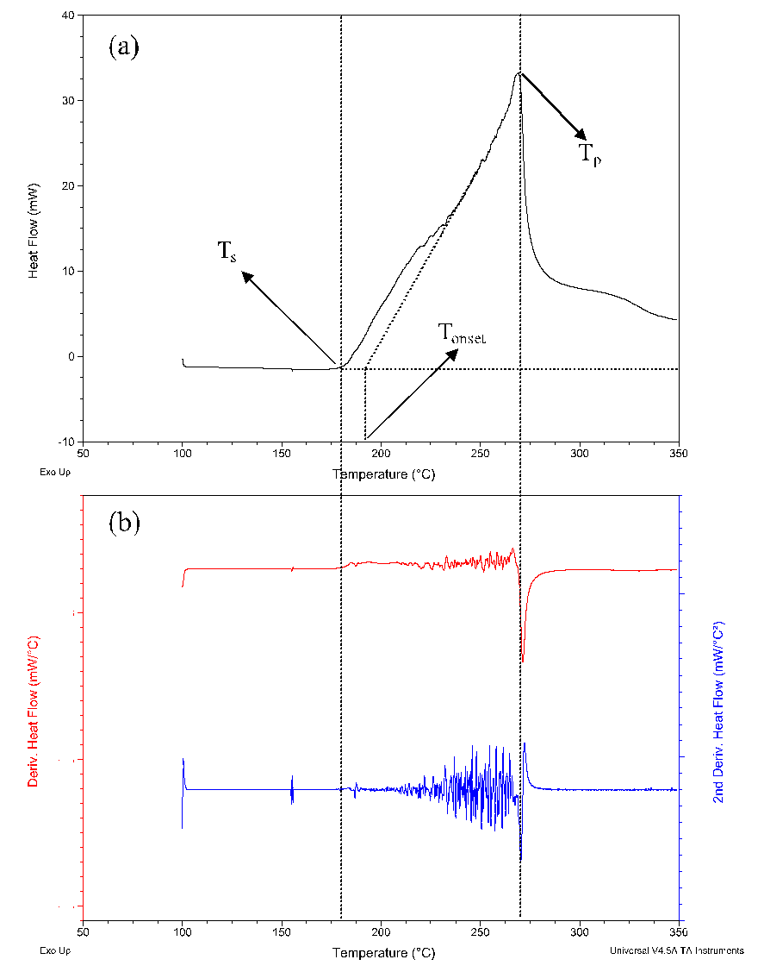
Figure 1: DSC oxidation curve of EVOO at a rate of 5°C/min. (a) Determination of start temperature (Ts), onset temperature (Tonset) and maximum heat flow temperature (Tp). (b) First and Second derivatives of EVOO DSC curve.

2.4 Oxidation Kinetic Study
The characteristic temperatures identified on DSC curves were used to calculate the effective activation energy (E_{a}) and the pre-exponential factor (z) of the Ozawa-Flynn-Wall method. Using this method, T_{s}, T_{onset} and T_{p} values calculated for each heating rate ($β$), were used to calculate the kinetic parameters as follows:
$logβ=a\frac{1}{T}+b$ (1)
where $β$ is the heating rate (K/min) and T are the temperatures T_{s} (K), T_{onset} (K) and T_{p} (K). By plotting $logβ$ versus 1/T, the effective activation energy E_{a} and the pre-exponential factor z can be determined directly from the slope and the intercept, according to the equation (2) and (3):
$a= -0.4567\frac{E}{R}$ (2)
$b= -2.315+log\left(z\frac{E}{R}\right)$ (3)
where a e b are the slope and the intercept from equation (1) respectively, R is the universal gas constant (8.31 J mol⁻¹ K⁻¹). Values E_{a} and z were used to calculate the constant rate (k) at 200°C from the following Arrhenius equation:
$k=zexp^{\left(\frac{-E}{RT}\right)}$ (4)
2.5 Statistical analysis
All analyses were conducted in triplicates. The analysis of variance (ANOVA) was used to analyze all experimental thermal data, expressed as mean and standard deviation. The significant differences (p<0.05) among samples were determined by Duncan test with JMP statistical software (SAS Institute. Inc. Cary, NC, USA).

- Results and Discussion
  - Oxidative Profiles
Typical non-isothermal DSC spectra during the heating of EVOO and EVOO-based oleogels samples at different heating rates (5, 7.5, 10, 12.5, 15 °C/min) under oxygen flow were reported in figure 2.
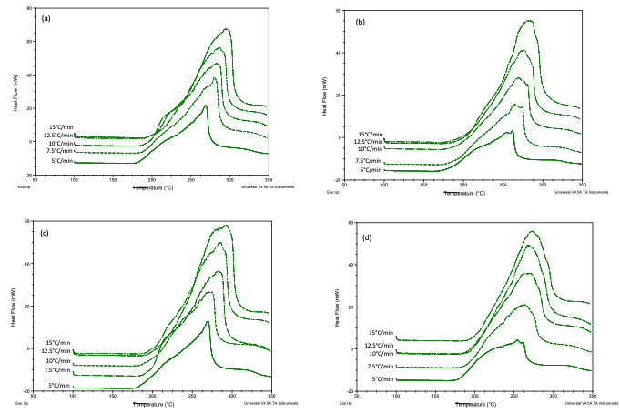
Figure 2: DSC curves of non-isothermal of EVOO (a), BW-based oleogel (b), GMS-based oleogel (c), EC-basedoleo gel (c).
As mentioned above, three characteristic temperatures can be evaluated: the start temperature (T_{s}), the onset temperature (T_{onset}) and the maximum heat flow temperature (T_{p}). T_{s} indicate the initiation stage and it is related to the reaction between the radical, formed during the induction time, and the unsaturated fatty acid. T_{onset} represents the temperature at which a rapid increase in heat flow occurs, closely associated with the production of peroxides. For this reason, this temperature is commonly considered the most appropriate parameter to describe lipid oxidation process in non-isothermal conditions. Moreover, T_{p}, which is the temperature at which the heat flow has reached the maximum point on the DSC spectra, was indicative of the termination stage of autoxidation phenomena (Kowalski et al., 2004). The DSC thermograms of EVOO and oleogels showed similar flat profiles in the initial heating phase (from 100 to 170 °C) before a sudden increase in the heat was recorded (figure 1). In detail, the changes in T_{s}, T_{onset} and T_{p} for EVOO and oleogel as a function of the heating rates are summarized in table 1. As can be seen, at the heating rate increasing, the temperatures increase for all samples according to several previous studies (Qi et al., 2016; Micic et al., 2015; Martinez-Monteagudo et al., 2012). This behavior can be explained considering that, during a slow heating rate, the primary oxidation products generated during the initial phase react with the excess oxygen producing low molecular weight intermediate oxidation products (aldehydes and acids) which, remaining in solution, accelerate the degradation process. Instead, a sudden increase in temperature results in an evaporation of these intermediate products before they start to react further, moving to high values in the DSC threshold signal (Adhvaryu et al., 2000).
Table 1: Start (T_{s}), onset (T_{on}) and maximum heat flow (T_{p}) temperature of EVOO, BW-, GMS- and EC-based oleogels under the five heating rates.
$$β$$  [°C/min] | EVOO |  | BW-EVOO oleogel |  | GMS-EVOO oleogel |  | EC-EVOO oleogel
Start temperature of oxidation (T_{s})
5 |  | 170.61±0.02^{aA} |  | 173.69±0.02^{bA} |  | 176.32±0.03^{cA} |  | 168.06±0.10^{dA}
7.5 |  | 178.03±0.01^{aB} |  | 174.50±0.10^{bB} |  | 179.86±0.05^{cB} |  | 172.18±0.08^{dB}
10 |  | 182.23±0.09^{aC} |  | 180.52±0.05^{bC} |  | 183.31±0.08^{cC} |  | 176.24±0.06^{dC}
12.5 |  | 184.55±0.03^{aD} |  | 180.63±0.03^{bD} |  | 188.99±0.10^{cD} |  | 177.13±0.04^{dD}
15 |  | 187.01±0.02^{aE} |  | 182.68±0.07^{bE} |  | 189.32±0.09^{cE} |  | 181.01±0.03^{dA}
Onset temperature of oxidation (T_{onset})
5 | 181.79±0.07^{aA} |  | 180.91±0.15^{bA} |  | 181.97±0.09^{cA} |  | 181.00±0.11^{bA}
7.5 | 182.18±0.85^{aA} |  | 183.77±0.11^{bB} |  | 190.32±1.94^{cB} |  | 190.28±0.07^{cB}
10 | 188.22±0.01^{aB} |  | 191.41±1.82^{bC} |  | 195.27±0.62^{cC} |  | 192.64±0.89^{dC}
12.5 | 195.23±0.14^{aC} |  | 200.44±0.56^{bD} |  | 201.21±0.40^{cD} |  | 197.81±2.23^{dD}
15 | 200.82±0.60^{aD} |  | 201.93±0.46^{bE} |  | 202.83±0.13^{cE} |  | 200.08±0.24^{aE}
Maximum heat flow temperature of oxidation (T_{p})
5 | 265.70±1.01^{aA} |  | 265.35±0.13^{aA} |  | 260.03±1.05^{bA} |  | 250.26±0.64^{cA}
7.5 | 280.85±0.97^{aB} |  | 268.55±0.78^{bB} |  | 265.86±0.57^{bB} |  | 258.40±0.55^{cB}
10 | 280.17±0.77^{aB} |  | 271.19±0.56^{bC} |  | 273.10±0.83^{cC} |  | 267.59±0.44^{dC}
12.5 | 282.81±0.23^{aC} |  | 288.18±1.01^{bD} |  | 277.63±1.11^{cD} |  | 268.97±1.17^{dC}
15 | 300.12±1.13^{aD} |  | 295.45±0.45^{bE} |  | 278.72±0.88^{cD} |  | 275.16±0.28^{dD}
Different letters (a, b, c, d) reveal significant differences (p < 0.05) among the samples for each heating rate, and different letters (A, B, C, . . .) reveal significant differences (p < 0.05) among heating rate for each sample.

By comparing the investigated samples, the highest T_{onset} values, at each heating rate, were identified for the GMS-based oleogels, highlighting a greater oxidative stability. On the other hand, the lowest values were recorded for control sample (EVOO).
  - Kinetic parameters
The DSC approach, both isothermal and non-isothermal, relies on exposing the sample to a constant flow rate of excess oxygen. This condition allows peroxide formation to be independent of oxygen concentration, meaning that autoxidation is a first-order reaction. This is an essential prerequisite for calculating kinetic parameters, such as the effective activation energy E_{a}, the pre-exponential factor z and the reaction rate k. Using the onset and the maximum heat flow temperatures of oxidation for each heating rate, the kinetic parameters were calculated according to equations 1 – 4 and the values are reported in table 2.

Table 2: Kinetic parameters calculated from T_{s,} T_{onset} and T_{p} at each heating rate
 | EVOO | BW-oleogel | GMS-oleogel | EC-oleogel
Start temperature of oxidation (T_{s})
E_{a} [kJ/mol] | 102.99 | 103.42 | 117.82 | 118.24
z [1/min] | 4.67 x 10¹¹ | 4.37 x 10¹¹ | 4.27 x 10¹³ | 4.32 x 10¹³
k [1/min] | 1.97 | 1.65 | 4.13 | 3.76
Onset temperature of oxidation (T_{onset})
E_{a} [kJ/mol] | 82.71 | 75.21 | 87.02 | 97.61
z [1/min] | 1.29 x 10⁹ | 1.67 x 10⁸ | 3.15 x 10⁹ | 5.50 x 10¹⁰
k [1/min] | 0.95 | 0.82 | 0.77 | 0.91
Maximum heat flow temperature of oxidation (T_{p})
E_{a} [kJ/mol] | 78.47 | 71.60 | 125.33 | 99.54
z [1/min] | 1.21 x 10⁷ | 3.13 x 10⁶ | 5.81 x 10¹¹ | 2.46 x 10⁹
k [1/min] | 0.03 | 0.04 | 0.01 | 0.02
E_{a} [kJ/mol] | 88.06 | 83.41 | 110.06 | 105.13
z [1/min] | 1.56 x 10¹¹ | 1.46 x 10¹¹ | 1.44 x 10¹³ | 1.44 x 10¹³

The activation energy of investigated samples has been determined as the mean of three E_{a} values (evaluated at T_{s}, T_{onset} and T_{p}), as well as the pre-exponential factor has been calculated as the mean of z factors determined at T_{s}, T_{onset} and T_{p},
The oxidation kinetic parameters indicated that GMS-based oleogel was the most stable among investigated samples, exhibiting the highest E_{a} value which, as expected, corresponds to the lowest value of k (0.01 1/min).
According to the E_{a} values, the stability scale for the tested samples could be proposed as GMS-oleogel>EC-oleogel>EVOO>BW-oleogel.
The results obtained in this study should not surprise if we consider that oleogels, based on the immobilization of oil in a gel structure, were found to oxidize slower than bulk oil and, therefore, the oleogel technology is often used as a method to prevent oil oxidation (Willet and Akoh, 2019; Vellido-Perez et al., 2019; Hwang et al., 2018).
However, in our study, bulk EVOO showed greater oxidative stability than BW-based oleogel. This behaviour could be due to the prooxidant activity of different oleogelators, in particular carnauba and bees waxes, as reported in different sudies (Hwang, 2020; Yi et al., 2017; Ogütcü et al., 2015). In particular, as highlighted by Hwang et al. (2020), the minor components in the waxes could exert prooxidant activity and the contradictory results obtained in the literature could be due to the different purity of the waxes due to different sources and/or purification processes.
In conclusion, the obtained results showed that DSC technique, as a fast and reliable method can be successfully applied to the study of the autoxidation of lipids . A careful interpretation of the shape of non-isothermal oxidation curves allowed one to determine Arrhenius kinetic parameters and to use the results for calculation of the rate constant of oxidation.
- Conclusions
A non-isothermal thermal analysis by DSC was performed to evaluate and compare the oxidative stability of extra virgin olive oil and extra virgin olive oil-based oleogels made with beeswax, glycerol monostearate and ethyl cellulose as olegelators. A careful interpretation of the shape of non-isothermal oxidation curves allows to determine the activation energy E_{a}, the pre-exponential factor z and the Arrhenius reaction rate k: T_{s}, T_{onset} and T_{p} were the reference temperatures used in this study to calculate the kinetic parameters of the oxidation process in non-isothermal conditions.
The results indicated that GMS-based oleogel was the most stable among investigated samples, exhibiting the highest E_{a} value and the lowest k value (0.01 1/min). According to the E_{a} values, the stability scale for the tested samples could be proposed as GMS-oleogel>EC-oleogel>EVOO>BW-oleogel.
Moreover, in conclusion, this study has highlighted the ability of the DSC to be successfully applied to the study of the autoxidation of oils and fats.

References
Adhvaryu A., Ershan S.Z., Liu Z., Perez J.M., 2000, Oxidation kinetic studies of oils derived from unmodified and genetically modified vegetables using pressurized differential scanning calorimetry and nuclear magnetic resonance spectroscopy, Thermochimica Acta, 364, 87-97.
Hwang H.S., 2020, A critical review on structures, health effects, oxidative stability, and sensory properties of oleogels, Biocatalysis and Agricultural Biotechnology, 26, 101657.
Hwang H.S., Fhaner M., Winkler-Moser J.K., Liu S.X., 2018, Oxidation of fish oil oleogels formed by natural waxes in coparison with bulk oil, European Journal of Lipid Science and Technology, 120, 1700378.
Kowalski B., Ratusz K., Kowalska D., Bekas W., 2004. Determination of the oxidative stability of vegetable oils by differential scanning calorimetry and rancimat measurements, European Journal of Lipid Science and Technology, 106, 165–169.
Martinez-Monteagudo S.I., Saldana M.D.A., Kennelly J.J., 2012, Kinetics of non-isothermal oxidation of anhydrous milk fat rich in conjugated linoleic acid using differential scanning calorimetry, 107, 973-981.
Micic D.M., Ostojic S.B., Simonovic M.B., Krstic G., Pezo, L.L., Simonovic B.R., 2015, Kinetics of blackberry and raspberry seed oils oxidation by DSC, Thermochimica Acta, 601, 39-44.
Ogütcü M., Arifoglu N., Yılmaz E., 2015, Storage stability of cod liver oil organogels formed with beeswax and carnauba wax. International Journal of Food Science and Technology 50, 404–412.
Ostrowska-Ligeza E., Bekas W., Kowalska D., lobacz M., Wroniak M., Kowalski B., 2010, Kinetics of commercial olive oil oxidation: Dynamic differential scanning calorimetry and Rancimat studies, European Journal of Lipid Science and Technology, 112, 268-274.
Pardauil J.J.R., Souza, L.K.C., Molfetta, F.A., Zamian, J.R., Filho G.N.R., 2011, Determination of the oxidative stability by DSC of vegetable oils from the Amazonian area, Bioresource Technology, 102, 5873-5877.
Puscas A., Muresan V., Socaciu C., Muste S., 2020, Oleogels in Food: A review of current and potential applications, Foods, 9, 70.
Qi B., Zhang Q., Sui X., Wang Z., Li Y., Jiang L., 2016, Differential scanning calorimetry study – Assessing the influence of composition of vegetable oils on oxidation, Food Chemistry, 194, 601-607.
Silva P.M.M., Cerqueira A., Martins A.J., Fasolin L.H., Cunha R.L., Vicente A.A., 2022, Oleogels and bigels as alternatives to saturated fats: A review on their application by the food industry, Journal of the American Oil Chemists’ Society, 99, 911-923.
Ulkowski M., Musiali, M., Litwinienko G., 2005, Use of Differwential Scanning Calorimetry to study lipid oxidation. 1. Oxidative stability of Lecithin and Linolenic Acid, Journal of Agricultural and Food Chemistry.
Vellido-Perez J.A., Rodriguez-Remachgo C., Rodriguez-Rodriguex J., Ochando-Pulido J.M., Brit-de la Fuente, E., Martinez-Fetrez A., 2019. Optimization of oleogel formulation for curcumin vehiculization and lipid oxidation stability by multi-response surface methodology. Chemical Engineering Transaction, vol.75, 427-432.
Willett S.A., Akoh C.C., 2019. Physicochemical characterization of yellow cake prepared with structured lipid oleogels. Journal of Food Science, 84 (6), 1390–1399.
Yi B., Kim M.J., Lee S.Y., Lee J., 2017, Physicochemical properties and oxidative stability of oleogels made of carnauba wax with canola oil or beeswax with grapeseed oil. Food Science and biotechnology, 26 (1), 79–87.
Zhao W., Wei Z., Xue C., 2022, Recent advances on food-grade oleogels: Fabrication, application and research trends. Critical reviews in food science and nutrition, 62, 7659-7676.

