CHEMICAL ENGINEERING TRANSACTIONS  VOL. , 2023 | A publication of
The Italian Association
of Chemical Engineering
Online at www.cetjournal.it

Guest Editors: Laura Piazza, Mauro Moresi, Francesco Donsì
Copyright © 2023, AIDIC Servizi S.r.l.
ISBN 979-12-81206-01-4; ISSN 2283-9216

Coextrusion film blowing of PHB, PLA and PBAT-based blends for the production of biodegradable food packages
Annalisa Apicella*, Antonio Barbato, Margherita Grimaldi, Paola Scarfato, Loredana Incarnato
Università degli Studi di Salerno, Via Giovanni Paolo II, 134, 84084
anapicella@unisa.it

In this work, melt blending and co-extrusion techniques have been investigated as functionalization strategies to realize bilayer biodegradable films suitable for food packaging applications, combining enhanced barrier performance, good heat sealability and ductility. The ductile, heat sealable inner layer was realized by mixing Ecovio, a commercial blend based on polylactide (PLA) and polybutylene adipate terephthalate (PBAT) with an amorphous PLA grade; the outer barrier layer, on its side, was realized by blending poly(hydroxybutyrate) (PHB) with a semicrystalline PLA grade. Three different structures were realized changing the relative thicknesses of the two layers, and were characterized for their surface wettability, O₂ barrier, heat-sealability and tensile properties. The results highlighted the impact of the bilayer films layout on the functional performance, and pointed out the attractiveness of the developed structures for food packaging applications where barrier to oxygen is critical to reduce oxidative processes.
  - Introduction
In recent years, the packaging industry has shown increasing interest in the development of new biopolymer-based packaging solutions and innovative processing technologies, aimed at reducing the dependence on fossil resources and shifting to a sustainable materials base (Rhim et al., 2013). However, a food packaging material with good performance must be able to prevent microbial contamination and act as a barrier against permeation of water vapor, oxygen, carbon dioxide and other volatile compounds, in addition to provide good mechanical, optical, and thermal properties (Apicella et al., 2018a; Apicella et al., 2018b). To this end, biodegradable polymers must be properly functionalized including fillers, antioxidants (Leneveu-Jenvrin et al., 2021), antimicrobials (Apicella et al., 2018c) or processing aids. They can also be modified via polymer–polymer blending or multilayer assembly; these latter routes, in particular, allow the creation of multifunctional systems with unique properties through easier, faster and cheaper techniques than other functionalization methods, such as copolymerization. Among biodegradable polymers, biopolyesters, including polyhydroxybutyrate (PHB), polylactide (PLA) and polybutylene adipate terephthalate (PBAT) are of great interest to researchers and they have proven to be attractive alternatives for potential applications (Padovani et al., 2016). PLA exhibits great processability, mechanical strength and heat sealability, for the amorphous grades (Olejnik et al., 2021), while PHB displays better barrier properties thanks to its high crystallinity degree (Amabile et al., 2022). However, both are known for their brittleness. PBAT is instead a flexible and very ductile material, however it has very low barrier to gases and water vapor and no heat sealabilty (Olonisakin et al., 2023).
In this study, both melt blending and co-extrusion techniques have been investigated to combine the functional performances of these single biopolymers in the attempt to overcome their drawbacks and realize multifunctional structures. Three different bilayer structures were realized changing the relative thicknesses of the two layers, and were characterized for their surface wettability, O₂ barrier, heat-sealability and tensile properties.
  - Experimental
    - Materials
PHB EnmatY3000p (density =1.25 g/cm³, T_{m} = 175-180 °C) was supplied by TianAn Biologic Materials Co., Ltd (China). Ecovio® F2332 (density = 1.24-1.26 g/cm³, T_{m1} =110-120 °C, T_{m2} =140-155 °C), a commercial blend of Ecoflex® F (PBAT), as the continuous phase in the structure, and PLA, was supplied by BASF (Ludwigshafen, Germany). PLA 4060D (amorphous, D-isomer content = 12 wt %, Mw ~190,000 g/mol, density = 1.24 g/cm³) and PLA 4032D (semicrystalline, D-isomer content = 1.5 wt %, Mw ~155 000 g/mol, density = 1.24 g/cm³, T_{m}=155-170 °C) were supplied by NatureWorksTM (Minnetonka, MN, USA).
    - Films preparation
Bilayer coextruded blown films were realized as follows: the inner layer (I) was obtained by blending Ecovio® F2332 with 20 wt % of PLA4060D, improving heat sealability; the outer layer (O), contributing to barrier properties and mechanical stiffness, was obtained by blending a semicrystalline grade of PLA with PHB at 70/30 weight ratio. This optimized composition was selected based on previous studies conducted on the processability and barrier performance of PLA/PHB blends, produced in a wide range of compositions (Pietrosanto et al., 2021).
Before processing, PLA, PHB and Ecovio granules were vacuum-dried at 70 °C for 14 h. Blends of PLA 4032D and PHB 70/30 by weight and of Ecovio and PLA 4060D 80/20 by weight were realized in a co-rotating twin screw extruder (dr. Collin GmBH model ZK 25-48D, with screw diameter equal to 25 mm and L/D = 42), selecting a screw speed equal to 200 rpm, a temperature profile from 150 °C to 180°C for the PLA/PHB blend and from 140 °C to 180 °C for the Ecovio/PLA blend. Coextruded films based on the blends were realized by a Gimac film blowing unit equipped by two single screw extruders (D = 12 mm, L/D = 24), a blow film spiral mandrel die (Collin, Type RWT 25, D_{in}=30 mm, D_{ext}=30.5 mm) and a take-up/cooling system (Collin Film Blowing Line Type BL 50). Both the extruders operated with a temperature profile equal to 190-175-175-185 °C from the hopper to the die. Three bilayer films were realized by varying the screw speed of the two extruders, and therefore the mass flow rates, yielding to two different thicknesses (i.e. 30 and 50 μm) for the outer (O) and inner (I) layer, as displayed in Table 1. Single layer films were also produced for comparison. The blow-up ratio (BUR) was fixed at 2.5 for all the films, while the collection speed was set at 3 m/min.
Table 1: Coextruded films nomenclature, nominal thicknesses of the outer (O) and inner (I) layers and screw speed of the extruders.
Sample | Total thickness [µm] | Outer layer [µm] | Inner layer [µm] | Extruder screw speed outer layer [rpm] | Extruder screw speed inner layer [rpm]
PLA4032/PHB 70/30 | 50 ± 1 | - | - | 96 | -
Ecovio/PLA4060 80/20 | 50 ± 1 | - | - | - | 96
Bilayer O30/I30 | 60 ± 4 | 30 | 30 | 54 | 54
Bilayer O30/I50 | 80 ± 4 | 30 | 50 | 96 | 54
Bilayer O50/I30 | 80 ± 4 | 50 | 30 | 54 | 96

    - Characterization of the produced films
Oxygen permeability analyses were carried out in triple by a GDP-C gas permeabilimeter (Brugger, Munich, Germany) at 23 °C, 0 % R.H. and with 80 mL/min oxygen flow rate, according to ASTM D1434-82 procedure. The permeability coefficients (PO₂) were gained by multiplying the obtained oxygen transmission rate values by the thickness (mm) of each film. For multilayer structures the oxygen permeability coefficients were further calculated considering the permeability coefficients of the monolayers and their thickness, according to the following equations:
$$\frac{x_{Bilayer}}{P_{Bilayer}}=\frac{x_{O}}{P_{O}}+\frac{x_{I}}{P_{I}}$$ | (1)
$$\frac{1}{Q_{tot}}=\sum{\frac{x_{i}}{P_{i}}=}\frac{1}{Q_{1}}+\frac{1}{Q_{2}}+…$$ | (2)
where $x$ and $P$ refer to the thickness and the permeability coefficient of each layer $i$, subscripts “O” and “I” stand for the outer and inner layer, respectively, and “Coex” for the coextruded structure.
Static contact angle measurements were performed by a FTA 1000 Analyzer (First Ten Angstroms, Inc., Portsmouth, VA, USA) according to ASTM D 7490 procedure, with 2 ± 0.5 µL drop volume and ten replicate measurements. Owens–Wendt (OW) geometric mean equation was applied to calculate the surface free energies (SFEs) of the inner and outer layer surfaces of the multilayer films, as well as the relative dispersive (γ_{s}^{d}) and polar (γ_{s}^{p}) components. (Owens & Wendt, 1969). Diiodomethane (DM) and distilled water (H₂O), having known SE values were employed as testing liquids. The OW approach was also employed to calculate the work of adhesion W_{a}, in order to evaluate the quality of the interlayer adhesion of the coextruded films. In particular, the following set of equations was used (Ebnesajjad & Landrock, 2015):
$$W_{a}^{}= γ_{S}+γ_{L}-γ_{SL}$$ | (3)
$$W_{a}^{}= 2\left(\sqrt{γ_{O}^{d}γ_{I}^{d}}+\sqrt{γ_{O}^{p}γ_{I}^{p}}\right)$$ | (4)
In Equation (3), γ_{SL}, γ_{L} and γ_{S} are the interfacial energy and the surface energies of the liquid and solid phases, respectively. In Equation 4, the subscript “I” and “O” stand for the inner and outer layer surfaces, respectively, while the superscript “d” and “p” indicate the dispersive and polar components, respectively.
Hot-tack tests were carried out by a HSG-C heat seal tester (Brugger, Germany), according to ASTM F1921-98, Method B procedure, between 80 °C (corresponding to the initiation sealing temperature) and 100 °C (the maximum temperature above which the film undergoes excessive distortion). The welds were carried out on 15 mm-width samples, with 0.5 N/mm² sealing pressure and 1 s welding time.
Tensile tests were performed on films with at least ten replicates by a CMT 4000 SANS testing machine (MTS, China) using a 100 N load cell, following the to ASTM D 882-91 procedure. Film specimens having rectangular geometry (12.7 x 80 mm²) were extended along the machine direction. The results were expressed in terms of elastic modulus (E), tensile strength (σ_{b}) and percentage elongation at break (ε_{b}).
  - Results and discussion
    - Oxygen barrier performance
The knowledge of oxygen barrier properties is fundamental for food packaging materials, as oxygen is responsible of the qualitative decay of many sensitive foods. The results of oxygen permeability tests carried out on the single layer and coextruded films, expressed as oxygen permeability coefficients (PO₂) are displayed in Table 2. The single layer film PLA4032/PHB 70/30 exhibited the lowest permeability value (14.1 cm² mm/m² d bar), thanks to the inherent good barrier properties of PHB, which are significantly higher than neat PLA (Wu et al., 2021). As expectable, Ecovio/PLA4060 monolayer shows higher PO₂ value due to the poor barrier of both PBAT and PLA (Jost, 2018).
As for the coextruded films, their oxygen permeability coefficients are averaged over the $P_{O_{2}}$values of the inner and outer layer films, and weighted on their relative thicknesses. In particular, the permeability decreases by increasing the thickness of the outer barrier layer, while it increases by increasing the thickness of the inner layer. Among these samples, the best barrier performance were obtained for Bilayer O50/I30 sample, exhibiting P_{O2} value equal to 16.8 cm² mm/m² d bar, and a reduction in oxygen permeability of 53% with respect to the single Ecovio/PLA4060 80/20 inner layer. The O₂ permeability values obtained for the coextruded films are comparable to those of other PLA/PHB blends reported in literature with PHB content ≥ 25% (Arrieta et al. 2014; Pietrosanto et al., 2021) and points out the attractiveness of the developed structures for food packaging applications where barrier to oxygen is critical to reduce oxidative processes. The O₂ permeability coefficients of multilayer films were also calculated according to the Eq(1) and (2), and reported in Table 2 as $P_{{calc_O}_{2}}$. As noticeable, a good agreement was found between measured and experimental oxygen permeability values, with a calculated percentage difference of less than 9% in each case, highlighting a good control of the relative film thicknesses achieved during the coextrusion process.
Table 2: Measured oxygen permeability ${(P}_{O_{2}})$ coefficients for all monolayer and bilayer films. Calculated oxygen permeability ($P_{{calc_O}_{2}})$values for multilayer films according to equations (1) and (2). Percentage difference among experimental and calculated oxygen permeability values calculated as follows: |$P_{O_{2}}$−$P_{{calc_O}_{2}}$|/[($P_{O_{2}}$+$P_{{calc_O}_{2}}$)/2]×100.
Sample | $$P_{O_{2}}\left[\frac{{cm}^{3} mm}{m^{2 }d bar}\right]$$ | $$P_{{calc_O}_{2}}\left[\frac{{cm}^{3} mm}{m^{2 }d bar}\right]$$ | Percentage difference [%]
PLA4032/PHB 70/30 | 14.1 | - | -
Ecovio/PLA4060 80/20 | 35.7 | - | -
Bilayer O30/I30 | 22.1 | 20.2 | 8.9
Bilayer O30/I50 | 24.2 | 22.7 | 6.4
Bilayer O50/I30 | 16.8 | 18.2 | 8.0

    - Evaluation of heat sealability, surface energies and the work of adhesion
The single inner and outer layers films were tested to measure their heat sealable properties, which is a functionality of primary importance for food packaging applications. Table 3 displays the results of the maximum hot tack force obtained. The PLA4032/PHB 70/30 sample was not sealable in the whole range of temperatures investigated, whereas neat Ecovio was sealable only between 90 °C and 100°C with maximum hot tack strength equal to 200 g/15 mm at 95°C. The addition of 20% PLA4060 in the Ecovio matrix, instead, allowed to extend the film heat sealability in the range 80-100 °C and to increase the hot tack strength too, which was maximum at 90 °C and equal to 400 g/15 mm. Films surface wettability and the extent of interlayer adhesion in bilayer samples were then analysed by contact angle measurements. In Table 3 the static contact angles in water and diiodomethane of the inner and outer multilayer’s surfaces are presented. These values, considering small variations due to analytical method, were similar for all the bilayer films. According to the Owens–Wendt approach, the surface free energies (γ_{S}), comprising of polar (γ_{s}^{p}) and dispersive (γ_{s}^{d}) components, and the polarity (P_{s}) were estimated and reported in Table 3. The work of adhesion and interfacial energy at the interface of the multilayer films was also calculated and reported in Table 4.
Table 3: Maximum hot tack force, Static contact angles for the inner (Ecovio/PLA4060 80/20) and outer (PHB/PLA4032 70/30) layers surfaces of the coextruded films in water (CA_{W}) and diiodomethane (CA_{DM}). Surface free energies (γ_{S}) comprising of polar (γ_{s}^{p}) and dispersive (γ_{s}^{d}) components and polarity (P_{s}), following the Owens–Wendt approach.
Film sample | Maximum hot tack force  [g/15 mm] | CA_{W} [°] | CA_{DM} [°] | γ_{s}^{p} | γ_{s}^{d} | P_{s} [-] | γ_{S} [mN/m]
PLA4032/PHB 70/30 | Not sealable | 66.9±0.8 | 34.9±0.9 | 9.2 | 39.9 | 0.19 | 49.2
Ecovio/PLA4060 80/20 | 400 | 67.2±1.7 | 34.5±0.8 | 9.1 | 40.2 | 0.18 | 49.5
Table 4: Calculated work of adhesion ($W_{a}^{}$) and interfacial energy ($γ_{SL}^{}$) of the coextruded films Bilayer O30/I30, Bilayer O30/I50 and Bilayer O50/I30.
Films interface | $W_{a}^{}$ [mN/m] | $γ_{SL}^{}$ [mN/m]
Bilayer O30/I30 | 95.9 | 0.138
Bilayer O30/I50 | 93.7 | 0.628
Bilayer O50/I30 | 98.4 | 0.001

The Ecovio/PLA4060 80/20 and PLA4032/PHB 70/30 films surfaces exhibit contact angle values comparable to those reported in literature for PHB (Chen et al., 2016), PLA (Galindo & Ureña-Núñez, 2018) and PBAT (Wang et al., 2016). The ratio between the values of the polar (γ_{s}^{p}) and dispersive (γ_{s}^{d}) components of the surface free energy for the inner and outer layers surfaces is close to unity, denoting an optimum interlayer adhesion achieved for bilayer films after the coextrusion process (Lindener et al. 2017). As further evidence, high values of the work of adhesion were found for all the multilayer films, while minimum interfacial energy values were obtained, indicating high interfacial compatibility (Ebnesajjad & Landrock, 2015).
    - Tensile properties
Tensile tests were performed in order to verify whether the produced films had adequate mechanical strength and ductility to ensure the integrity of the food packaging throughout the entire life cycle of the product. Figure 1 (a) shows the elastic modulus E, while Figure 1 (b) displays the tensile strength at break σ_{b} and the percentage elongation at break ε_{b} of the coextruded films, compared to those measured for the single inner and outer layers films. The monolayer PLA4032/PHB 70/30 film shows the highest elastic modulus, equal to 2220 MPa, tensile strength at break, equal to 38 MPa, as well as the lowest elongation at break, equal to 13%. These attributes are due to the inherent stiffness and brittleness of both PLA4032 and PHB; similar outcomes were obtained in literature for PLA/PHB blends with 30 wt % PHB content (Olejnik et al., 2021). Contrariwise, the Ecovio/PLA4060 80/20 monolayer shows a very ductile behavior, with a percentage of elongation at break equal to 355 %, and its addition in the coextruded structures helps to attenuate the brittle behaviour of the PLA/PHB layer. The resulting tensile properties of the bilayer films are influenced by the layout of the systems: in particular, the one with the largest thickness of the inner layer (i.e., Bilayer O30/I5 sample), displays the largest recovery in ductility (ε_{b} value equal to 39%), while the one with the highest thickness of the outer layer (i.e., Bilayer O50/I30 sample) exhibits the lowest elongation at break (23%) and the highest elastic modulus and ultimate tensile strength (equal to 1546 MPa and 26 MPa, respectively).

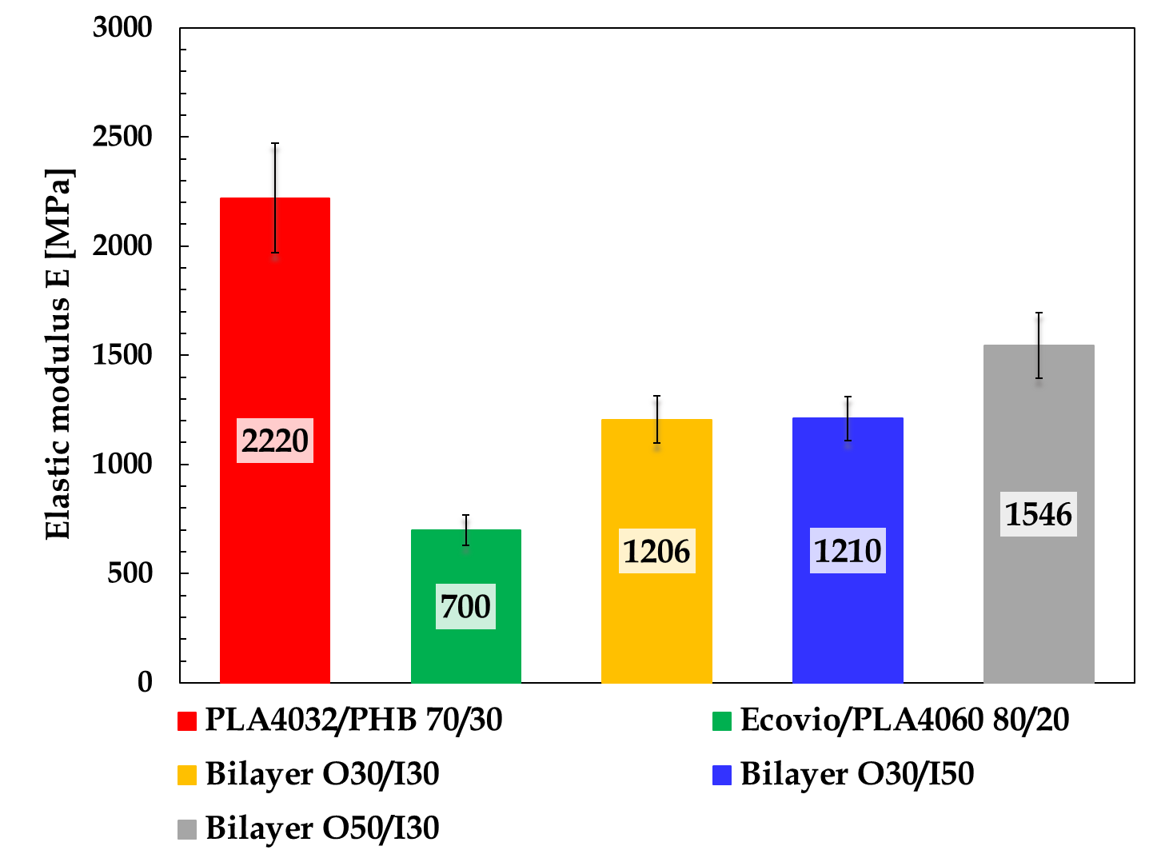 | 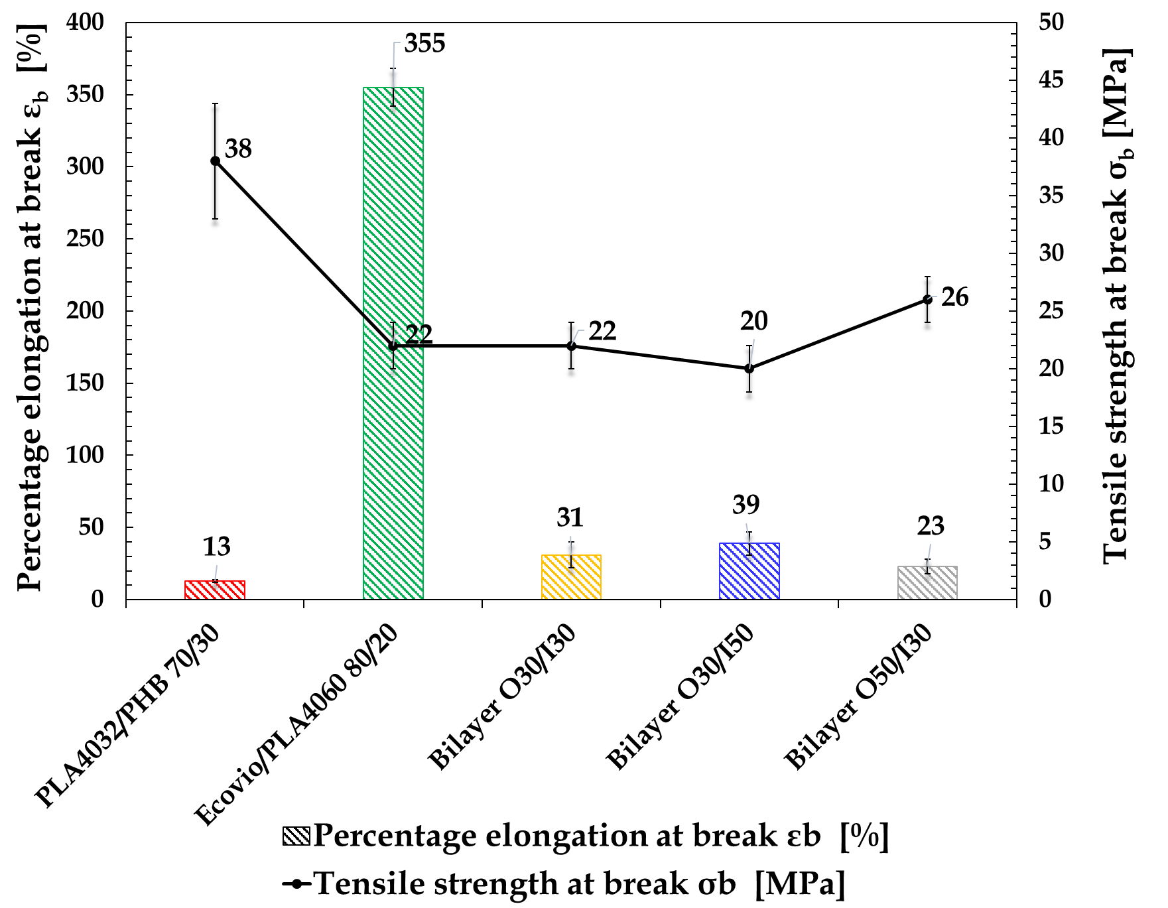
(a) | (b)
Figure 1: (a) Elastic modulus (E) and (b) percentage elongation at break (ε_{b}) and tensile strength at break (σ_{b}) for single outer (PLA4032/PHB 70/30) and inner (Ecovio/PLA4060 80/20) layers and bilayer films.
Conclusions
In this study, coextruded blown films based on PLA/PHB and Ecovio/PLA biodegradable blends were realized by lab-scale co-extrusion plant, with the aim of developing a sustainable structure combining high barrier properties, heat sealability and adequate ductility for food packaging applications.
All the bilayer films exhibited high interlayer adhesion and interfacial compatibility, and a good control of the inner/outer layers relative thicknesses achieved during the coextrusion process.
The Ecovio/PLA inner layer, on its side, was effective in providing good ductility and sealability function within an extended temperature range from 80 to 100 °C, commonly used in the food packaging industry, and a maximum hot tack force of 400 g/15mm. The PLA/PHB outer layer, on its turn, was effective in decreasing the oxygen permeation. The multilayer films had functional performance intermediate with respect to those of single outer and inner layers, and were influenced by the layout of the systems. In particular, the barrier properties and the stiffness increased by increasing the thickness of the outer layer, whereas the ductility increased by increasing the thickness of the inner layer. Among these samples, the best barrier performance was obtained for Bilayer O50/I30 film, exhibiting P_{O2} value equal to 16.8 cm² mm/m² d bar, and a reduction in oxygen permeability of 53 % with respect to the single Ecovio/PLA4060 80/20 inner layer. For this sample, a partial recover in ductility was achieved thanks to the Ecovio/PLA4060 80/20 inner layer, with an increase in the elongation at break of 78 % compared to the single PLA/PHB 70/30 outer layer. The obtained results, overall, underlined that the approach pursued is promising in developing innovative, eco-sustainable films having multiple functional performance through techniques commonly used in the packaging industry.
References
Amabile C., Abate T., De Crescenzo C., Sabbarese S., Capece G., Ciampa R., Chianese S., Musmarra D., 2022, Enhancing Poly(3-hydroxybutyrate) Production Through the Optimization of Reactor Geometry, Chemical Engineering Transactions, 93, 277- 282.
Apicella A., Scarfato P., Di Maio L., Incarnato L., 2018a, Oxygen absorption data of multilayer oxygen scavenger-polyester films with different layouts, Data in Brief, 19, 1530–1536.
Apicella A., Scarfato P., Di Maio L., Garofalo E., Incarnato L., 2018b, Evaluation of performance of PET packaging films based on different copolyester O2-scavengers, AIP Conference Proceedings 1981, 020130.
Apicella A., Scarfato P., D’Arienzo L., Garofalo E., Di Maio L., Incarnato L., 2018c, Antimicrobial biodegradable coatings based on LAE for food packaging applications, AIP Conference Proceedings, 1981, 020010.
Arrieta M.P., Fortunati E., Dominici F., Rayón E., López J., Kenny J.M., 2014, PLA-PHB/cellulose-based films: Mechanical, barrier and disintegration properties, Polymer Degradation and Stability, 107, 139-149.
ASTM D 1434-82. Standard Test Method for Determining Gas Permeability Characteristics of Plastic Film and Sheeting.
ASTM D 7490-13. Standard Test Method for Measurement of the Surface Tension of Solid Coatings, Substrates and Pigments using Contact Angle Measurements.
ASTM F 1921-98. Standard Test Methods for Hot Seal Strength (Hot Tack) of Thermoplastic Polymers and Blends Comprising the Sealing Surfaces of Flexible Webs.
Chen J., Wu D., Pan K., 2016, Effects of ethyl cellulose on the crystallization and mechanical properties of poly(β-hydroxybutyrate), International Journal of Biological Macromolecules, 88,120-129.
Ebnesajjad, S., Landrock, A.H. (3rd ed.), 2015, Adhesives Technology Handbook, William Andrew Publishing, USA.
Galindo S., Ureña-Núñez, F.,2018, Enhanced surface hydrophobicity of poly(lactic acid) by Co60 gamma ray irradiation, Revista mexicana de física, 64, 1-7.
Jost V., 2018, Packaging related properties of commercially available biopolymers–An overview of the status quo, Express Polymer Letters, 12, 429-435.
Leneveu-Jenvrin C., Apicella A., Bradley K., Meile J.C., Chillet M., Scarfato P., Incarnato L., Remize F, 2021, Effects of maturity level, steam treatment, or active packaging to maintain the quality of minimally processed mango (Mangifera indica cv. José). Journal of Food Processing and Preservation, 45, e15600.
Lindner M., Rodler N., Jesdinszki M., Schmid M., Sängerlaub S., 2017, Surface energy of corona treated PP, PE and PET films, its alteration as function of storage time and the effect of various corona dosages on their bond strength after lamination. Journal of Applied Polymer Science, 135, 45842.
Olejnik O., Masek A., Zawadziłło J., 2021, Processability and Mechanical Properties of Thermoplastic Polylactide/Polyhydroxybutyrate (PLA/PHB) Bioblends, Materials, 14, 898.
Olonisakin K., Wen A., He S., Lin H., Tao W., Chen S.,Lin W, LI R., Zhang X.X., Yang W., 2023,The Development of Biodegradable PBAT-Lignin-Tannic Acid Composite Film: Properties, Biodegradability, and Potential Barrier Application in Food Packaging, Food and Bioprocess Technology.
Owens D.K., Wendt R.C., 1969, Estimation of the Surface Free Energy of Polymers, Journal of Applied Polymer Science, 13, 1741–1747.
Padovani G., Carlozzi P., Seggiani M., Cinelli P., Vitolo S., Lazzeri A., 2016, Phb-rich biomass and bioh2 production by means of photosynthetic microorganisms, Chemical Engineering Transactions, 49, 55-60.
Pietrosanto A., Scarfato P., Di Maio L., Incarnato L., 2021, Development of PLA / PHB Blown Films with Improved Performance for Food Packaging Applications, Chemical Engineering Transactions, 87, 91-96.
Plavec R., Hlaváčiková S., Omaníková L., Feranc J., Vanovčanová Z., Tomanová K., Bočkaj J., Kruželák J., Medlenová E., Gálisová I., Danišová L., Přikryl R., Figalla S., Melčová V., Alexy P.,2020, Recycling possibilities of bioplastics based on PLA/PHB blends,Polymer Testing, 92,106880.
Rhim J.W., Park H.M., Ha C.S., 2013, Bio-nanocomposites for food packaging applications, Progress in Polymer Science, 38, 1629-1652.
Wang L.F., Rhim J.W., Hong S.I., 2016, Preparation of poly(lactide)/poly(butylene adipate-co-terephthalate) blend films using a solvent casting method and their food packaging application, LWT - Food Science and Technology, 68, 454-461.
Wu F., Misra M., Mohanty A.K., 2021, Challenges and New Opportunities on Barrier Performance of Biodegradable Polymers for Sustainable Packaging, Progress in Polymer Science, 117, 101395.

