CHEMICAL ENGINEERING TRANSACTIONS  VOL. , 2023 | A publication of
The Italian Association
of Chemical Engineering
Online at www.cetjournal.it

Guest Editors: Laura Piazza, Mauro Moresi, Francesco Donsì
Copyright © 2023, AIDIC Servizi S.r.l.
ISBN 979-12-81206-01-4; ISSN 2283-9216

Development of biodegradable PBS/PVOH-based films and evaluation of performance for food packaging applications
Antonio Barbato, Annalisa Apicella*, Francesco Palmieri, Loredana Incarnato
Università degli Studi di Salerno, Via Giovanni Paolo II, 134, 84084
anapicella@unisa.it
The objective of this work deals with the realization of high O₂-barrier blown films based on novel biodegradable blends of Polybutylene succinate (PBS) and Poly-vinyl alcohol (PVOH) for food packaging applications. Blends at different PBS/PVOH weight ratios (100/0, 80/20, 60/40, 0/100 wt%) were produced and their processability and miscibility was preliminary assessed by means of dynamic shear rheological tests. Afterwards, blown films were realized and then characterized in terms of chemical properties and oxygen barrier performance. The results revealed that, although immiscible, polymers in the blend show some degree of interaction. Moreover, as the concentration of PVOH in the films increased, a significant decrease in oxygen permeability was obtained with respect to the neat PBS film, up to 42% for the PBS/PVOH 60/40 sample. The findings of this study highlighted the promising perspectives of these films as sustainable packaging for sensitive foods with high O₂-barrier requirements.
  - Introduction
Although plastic pollution has become a major issue with important socio-economic implications, plastic employment is continuously increasing, especially in the packaging sector. In this respect, bio-based and biodegradable polymers seem to be ideal candidates for the replacement of fossil-based plastics. Despite their ecological advantages, biopolymers suffer from inherent shortcomings due to their poorer functional properties, which limit their use in food packaging field where high performances are constantly required (Apicella et al., 2018a). For this reason, they need to be functionalized through appropriate techniques, such as deposition of high barrier coatings (Apicella et al., 2022), blending, nanotechnologies or incorporation of antimicrobials (Apicella et al., 2018b) or antioxidants (Apicella et al., 2021), in order to adapt their characteristics for the target application. PBS and PVOH, in particular, are identified as novel biopolymers with peculiar and complementary properties desirable for a food package. PBS is characterized by good tensile strength and toughness, moderate stiffness, a ductility very similar to that of low-density polyethylene (LDPE) and good thermal stability (Samir et al., 2022); it is also suitable for film casting and blowing production (Aliotta et al., 2022). However, its main drawback is related to its poor barrier properties, very similar to that of polylactic acid (PLA) (Wu et al., 2021). PVOH has instead great chemical resistance, good transparency, excellent odor, aroma and gas barrier (Suganthi et al., 2020). Nevertheless, it is extremely brittle, heat and water sensitive and its melting and degradation temperatures are very close, making its processing hard (Tian et al., 2017).
Melt blending technique can represent a valid strategy to overcome PBS and PVOH respective issues and to produce a sustainable multifunctional material combining PBS ductility and processability with PVOH exceptional barrier properties. Several works already report PBS blending with different biopolymers, such as PLA and polyhydroxybutyrate (PHB), to enhance their flexibility, elongation at break and tear resistance (Aliotta et al., 2022). On the other hand, very few research focused instead on blending PVOH with other polymers: some authors reported the melt blending of PVOH with xanthan or gellan to improve its biodegradability features (Kopčilová et al., 2013) or with PLA for the production of compression molded films with improved hydrophobicity in presence of lactoglyceride as plasticizer (Li et al., 2014). To our best knowledge, there are no previous studies in the literature concerning the production and characterization of PBS/PVOH mixtures and the evaluation of performance of blown films based on these blends. In this perspective, the goal of this work was to realize PBS/PVOH blends having different weight ratios (100/0, 80/20, 60/40, 0/100 wt%) by melt-compounding technique. Rheological tests were carried out to study the processability of the pure materials and their blends. Then, blown films based on these blends were produced, and the chemical interaction between the polymer phases was assessed by means of FTIR analysis, while oxygen barrier properties were analyzed to evaluate the films suitability for the packaging of O₂ sensitive foods.
  - Experimental
    - Materials
PBS FZ91 (density=1.26 g/cm³, T_{m} = 115°) was supplied by Mitsubishi Chemical Corporation (Tokyo, Japan). PVOH Mowiflex LP002 (bulk density= 0.6- 0.9 g/cm³, T_{m} =210-220 °C) was supplied by Kuraray Europe GmbH (Hattersheim am Main Germany).
    - Films preparation
Before the extrusion process, PBS and PVOH pellets were dried at 80 °C for 14 h under vacuum. Dried pellets at different PBS/PVOH weight ratios (100/0, 80/20, 60/40, 0/100 wt%) were melt-blended in a Collin ZK 25-48D co-rotating twin extruder (D = 25 mm, L/D = 42) with a screw speed of 200 rpm and a flat temperature profile set at 220°C. The extruded strand was then air-cooled and pelletized. Pure PBS and PVOH polymers and their blends were re-dried in vacuum prior to blown film production. Blown films were produced by means a single screw extruder GIMAC (D=12 mm, L/D= 24) operating with a flat temperature profile equal to 220°C. PBS, PVOH, PBS/PVOH 80/20 and PBS/PVOH 60/40 films, with an average thicknesses of 40 ± 5 µm, were collected at a take-up speed of 3 m/min.
    - Characterization techniques
Dynamic shear rheological tests were conducted on pellets of pure materials and their blends. Pellets were dried at 80 °C for 14 h under vacuum before testing. Frequency sweep tests were carried out with a parallel-plate geometry (d=25 mm) in an angular frequency range of 0.1 to 100 rad/s, at 220 °C under nitrogen atmosphere. During the shear rheological experiments, a strain amplitude equal to 5% was applied to ensure the linear viscoelastic regime for all materials.
Fourier-transform infrared spectroscopy (FTIR) analysis in attenuated total-reflection (ATR) mode was conducted to capture infrared spectra of the films. A Nicolet 600 FT-IR spectrophotometer (Thermo Scientific, Waltham, USA) equipped with the Smart Performer tool was used. The spectra were taken in the frequency range 4000-700 cm⁻¹ with a resolution of 2 cm⁻¹ and averaged across 64 scans. Normalization and peak integration were performed by means Omnic software.
Oxygen transmission rate (OTR) of the films were evaluated using a gas permeabilimeter (GTT, Brugger, Munich, Germany) in accordance with ISO 15105-1. Measurements were carried out in triple at 23 °C and 0% R.H., under pressure difference of oxygen equal to 1 bar, with the oxygen flow rate of 80 mL/min. Oxygen permeability coefficients (P_{O2}) were determined by multiplying the obtained OTR value by the sample thickness (mm).
  - Results and discussion
    - Rheological characterization of the pure materials and of the biodegradable blends
Preliminary rheological analysis were carried on pure PBS, PVOH and on the produced blends to study their processability and collect information about the polymers miscibility. In Figure 1 the complex viscosity (η*) curves (Figure 1 (a)), and the Han plots (Log G’ vs LogG’’) (Figure 1 (b)) are reported.
As shown in Figure 1(a), PBS exhibits the highest viscosity values at low frequencies and is characterized by a pronounced shear thinning behavior, typical of materials suitable for blown film process. On the other hand, PVOH shows a wider Newtonian plateau, up to a frequency of 1 rad/s, and a less pronounced shear thinning behaviour. The complex viscosity curves of the PBS/PVOH blends qualitatively follow the same shear thinning behavior of PBS. However, by increasing the PVOH content, a significant drop in η* values was observed compared to both pure polymers. This behavior is typical of two immiscible phases and is attributable to a slippage between the two polymer phases within the blend, suggesting the PBS and PVOH intrinsic incompatibility (Utracki et al., 1991).
The compatibility of the polymer blend in the melt state was further investigated through a Han plot, which shows a linear correlation in the plot of log G’ (storage modulus) versus log G’’ (loss modulus). According to this, compatible systems observed at various compositions will show the same slope of the pure components. Otherwise, the blend is considered to be immiscible or phase separated (Walha et al., 2015)
Figure 1(b) displays a plot of the neat polymers (PBS and PVOH) and their blends. It is clearly shown that curves of these blends exhibited different slopes which indicates nonmiscibility and incompatibility between these polymers. Moreover, either the pure polymers and their blends plots show a predominant viscous response, exhibiting a liquid-like behavior.

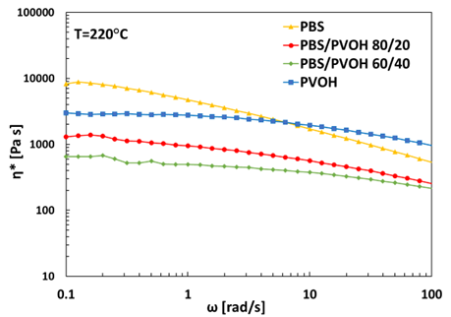
(a)
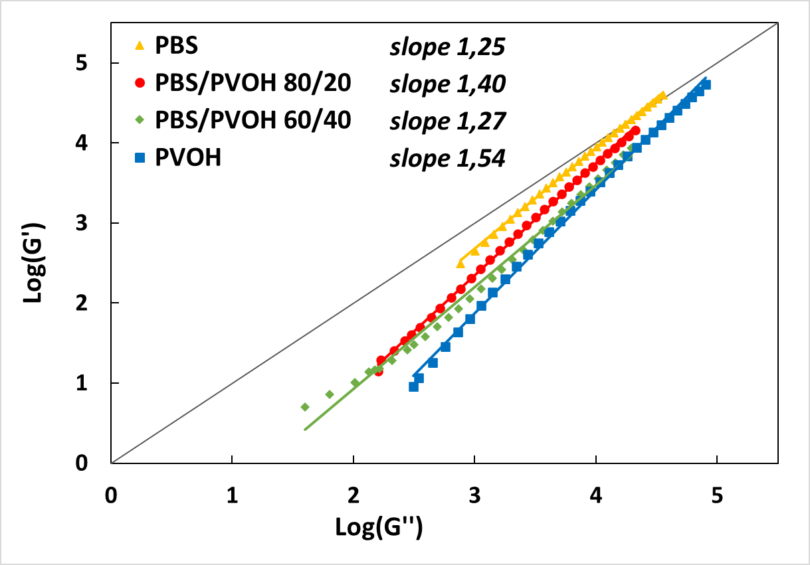
(b)
Figure 1: (a) Complex viscosity and (b) Han plots of neat PBS, neat PVOH pellets and their blends PBS/PVOH 80/20 and PBS/PVOH 60/40.
    - Characterization of the chemical and barrier properties of the produced films
FTIR analysis was conducted on pure and blend-based films to identify the main functional groups characteristic of the polymeric matrices and possible chemical interaction among the two phases. Figure 2 (a) displays the full spectra of PBS, PBS/PVOH 80/20, PBS/PVOH 60/40 and PVOH films, while magnifications are shown in Figure 2 (b), (c) and (d).
Pure films show characteristic peaks of PBS and PVOH polymers. In particular, the ATR-FTIR plot of the PBS film exhibits the principal characteristic absorptions as follows: the C-H asymmetric stretching vibration at 2888-2849 cm⁻¹; the stretching vibration of the carbonyl group C=O in the PBS crystalline phase is located at 1709 cm⁻¹, while the broad shoulder at 1738 cm⁻¹ is attributable to the amorphous phase of the polymer (de Matos Costa et al., 2020); peaks in 1469-1308 cm⁻¹ band are ascribed to CH stretching in CH₂; the asymmetric and symmetric C-O stretching in C-O-C adsorption peaks are noticeable at 1152 and 1044 cm⁻¹, while the C-OH bending in the terminal acid groups is located at 917 cm⁻¹. Absorption characteristic peaks of PVOH film are: -OH stretching at 3272 cm⁻¹; asymmetric and symmetric stretching of CH₂ groups at 2936 and 2902 cm⁻¹ respectively; H-O-H bending of the absorbed water at 1644 cm⁻¹; C=C stretching at 1538 cm⁻¹; CH₂ bending and wagging at 1415 cm⁻¹ and 1324 cm⁻¹, respectively; a peak imputable to the CO stretching is noticeable at 1138 cm⁻¹, and identifies the crystalline sequence of PVOH (Tretinnikov and Zagorskaya, 2012) while the sharp peak at 1086 cm⁻¹, referred to the C-O stretching and the OH bending, identifies the amorphous phase; finally, peaks due to CH₂ rocking and C-C stretching are noticeable at 911 cm⁻¹ and 827 cm⁻¹, respectively (Jipa et al., 2012).
No new absorption bands were detectable in the spectra of the PBS/PVOH blends, although some peak shifts were observed. In particular, the PBS peak related to the stretching of the C = O bond of the crystalline phase shifted from a wavelength of 1709 cm⁻¹ to 1712 cm⁻¹ and 1713 cm⁻¹, for the PBS/PVOH 80/20 and PBS/PVOH 60/40 film samples respectively (Figure 2 (c)), while the characteristic peak of the amorphous phase of PVOH, originally located at 1086 cm^{­1}, moved to 1092 cm^{­1} in PBS/PVOH 60/40 film and to 1096 cm^{­1} in PBS/PVOH 80/20 sample (Figure 2 (b)). In addition, the peak at 827 cm⁻¹ associated with the C-C stretching in PVOH film sample came out downshifted around 850 cm⁻¹ in blend-based films (Figure 2 (d)). These changings in absorption band positions evidenced that the two polymers, despite of their immiscibility, have a certain degree of interaction.

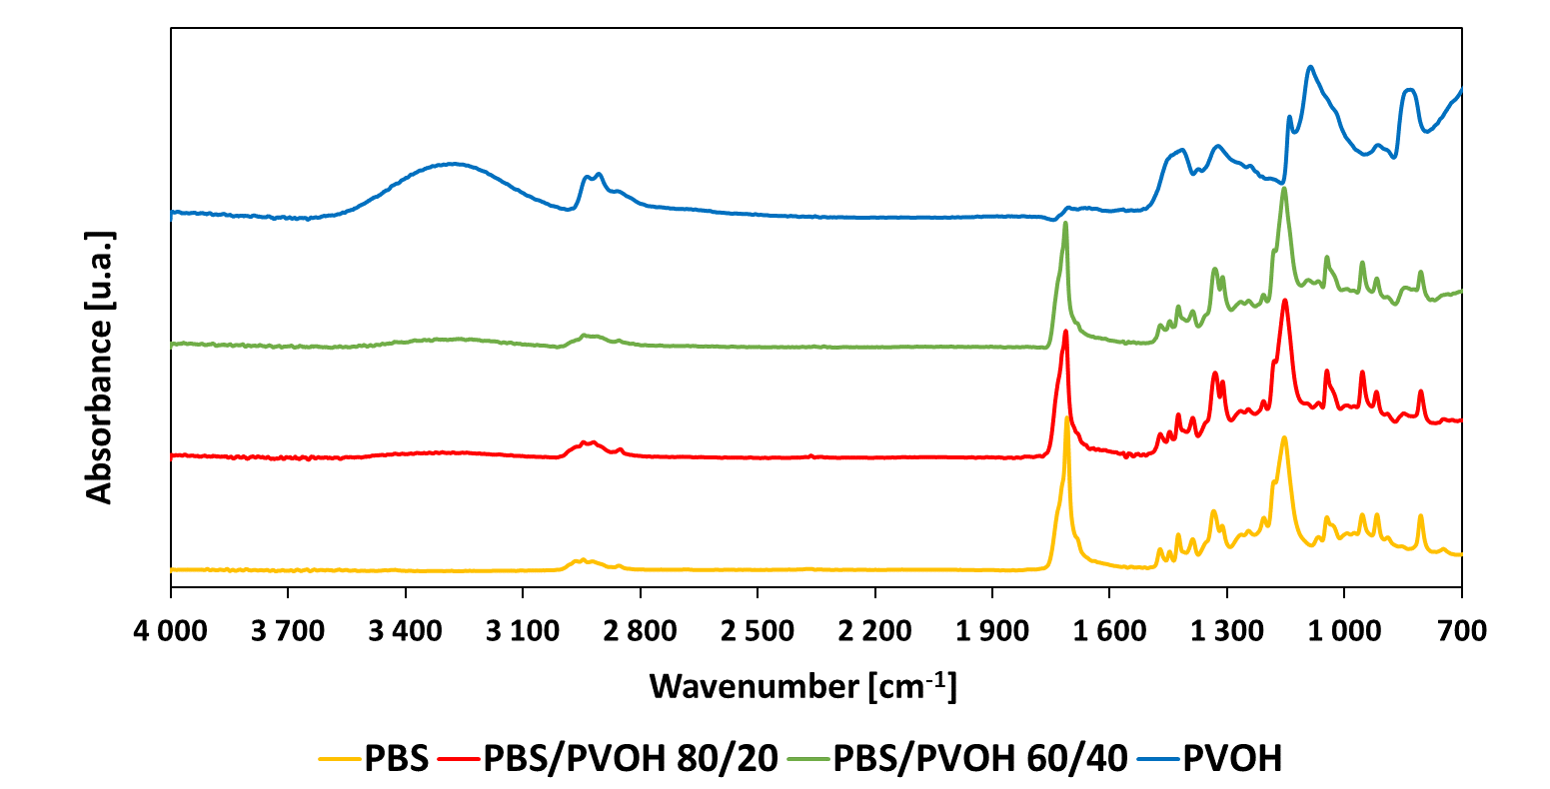
(a)
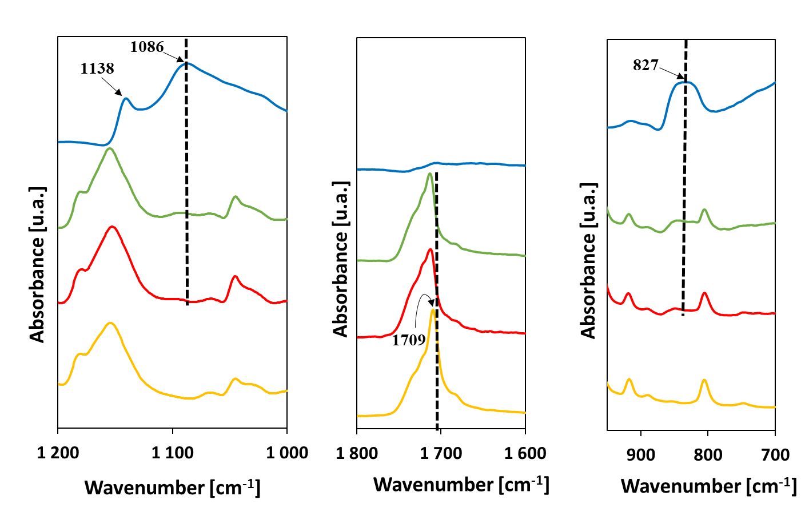
(b) (c) (d)
Figure 2: (a) FTIR-ATR spectra of PBS, PVOH, PBS/PVOH 80/20 and PBS/PVOH 60/40 films. Spectra magnification between (b) 1200 and 1000 cm⁻¹, (c) 1800 and 1600 cm⁻¹, (d) 950 and 700 cm⁻¹.
Oxygen barrier properties are one of key properties to assess the suitability of a film for food packaging applications. This is especially valid for the packaging of specific categories of foods, such as fresh and fatty foods, that require adequate protection against oxidation phenomena, mainly responsible of their quality decay (Robertson, 2013). For this reason, films were characterized in terms of oxygen transport properties and the resulting P_{O2} values are displayed in Figure 3.
The oxygen permeability coefficient related to the pure PBS film is 12.3 ± 0.4 cm³ mm / m² day bar, while that related to PVOH is 0.040 ± 0.004 cm³ mm / m² day bar. These values are comparable with results reported in literature about both PBS (Bumbudsanpharoke et al., 2022) and PVOH matrices (Apicella et al., 2022).
In accordance with the classification made by Wang et al. (2018), PBS has a permeability that falls in the range of 4 to 40 cm³ mm / m² day bar and thus can be classified as a low-barrier polymer; in contrast, PVOH has a PO₂ that falls in the range of 0.040 to 0.40 cm³ mm / m² day bar, thus can be classified as a high-barrier polymer.
As can be observed in Figure 3, the incorporation of PVOH in the blends results in a decrease in the oxygen permeability coefficient, compared with the pure PBS film. Specifically, a reduction in permeability values of 24% is observed for the PBS/PVOH 80/20 sample, and of 42% for the PBS/PVOH 60/40. The O₂ permeability values obtained for PBS/PVOH films are comparable to those of conventional fossil-based packaging films based on laminated polyamide, polyethylene terephthalate (PET)/low density polyethylene (LDPE) or nylon/linear low-density polyethylene (LLDPE) films which oxygen permeability fall within the range 8.15-0.06 cm³ mm / m² day bar, highlighting the suitability of the developed films as biodegradable alternative for the preservation of O₂-sensitive foods, such as seafood or bakery products (Upasen and Wattanachai, 2018).
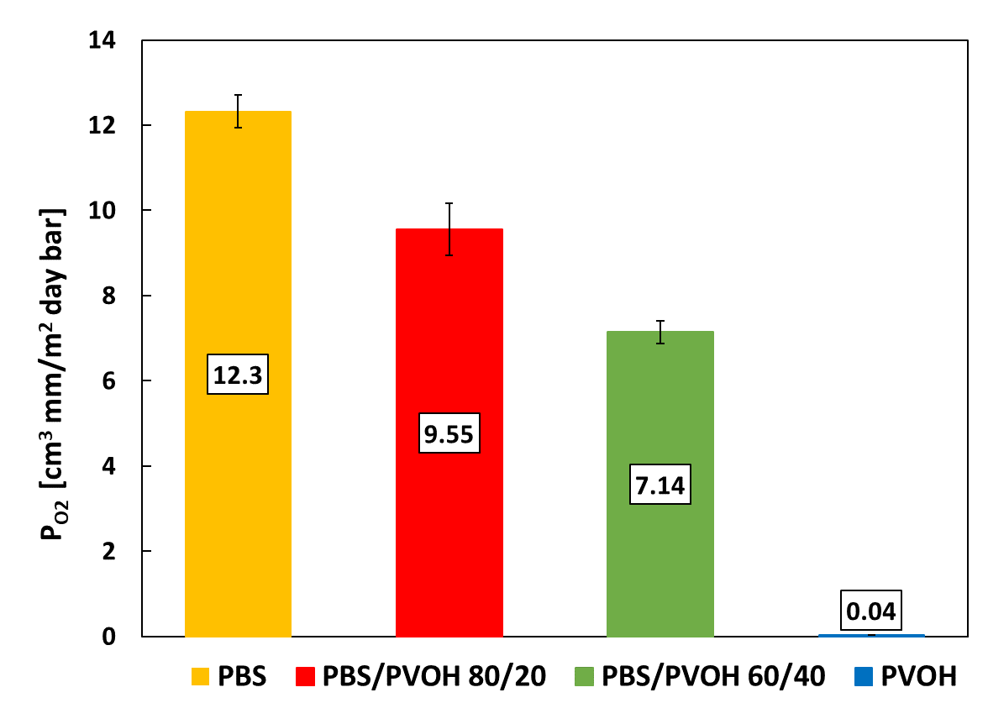
Figure 3: Oxygen permeability coefficients (P_{O2}) of PBS, PVOH, PBS/PVOH 80/20 and PBS/PVOH 60/40 films.
  - Conclusions
In this work, innovative biodegradable films based on PBS/PVOH blends at different weight ratios (100/0, 80/20, 60/40 0/100 wt%) were prepared by blown film extrusion. Rheological analyses, conducted in order to study the processability of the two pure polymers and their blends, revealed a more pronounced shear thinning behavior for PBS with respect to PVOH, and the intrinsic immiscibility of the two polymer phases within the blends.
Despite of their immiscibility, some structural modification of polymeric matrices within the blends occurred, as underlined by the shifts in the FTIR spectra. The oxygen permeability measurements revealed the improvement of the O₂ barrier performance of the PBS/PVOH based films, thanks to the excellent barrier properties of PVOH: in particular, a decrease in PO₂ values equal to 24 % and 42% for PBS/PVOH 80/20 and PBS/PVOH 60/40, respectively, was achieved with respect to neat PBS film. These outcomes pointed out that melt blending of PBS with PVOH is a promising strategy to obtain sustainable packaging films with enhanced barrier performance, suitable for the preservation of O₂-sensitive foods such as seafood or bakery products.
Future prospects will focus on the study of compatibilizers to improve the miscibility of polymers in blends, and on the investigation of their effect on the barrier and mechanical performance of the films.
References
Aliotta L., Seggiani M., Lazzeri A., Gigante V., Cinelli P., 2022, A Brief Review of Poly (Butylene Succinate) (PBS) and Its Main Copolymers: Synthesis, Blends, Composites, Biodegradability, and Applications, Polymers, 14, 844.
Apicella A., Adiletta G., Albanese D., Di Matteo M., Incarnato L., 2021, Biodegradable Films Based on Poly(lactic Acid) Coatings and Natural Olive-wastewater Extracts for Active Food Packaging, Chemical Engineering Transactions, 87, 85–90.
Apicella A., Barbato A., Garofalo E., Incarnato, L., Scarfato P., 2022. Effect of PVOH/PLA + Wax Coatings on Physical and Functional Properties of Biodegradable Food Packaging Films, Polymers, 14, 935.
Apicella A., Scarfato P., D’Arienzo L., Garofalo E., Di Maio L., Incarnato L. ,2018b, Antimicrobial biodegradable coatings based on LAE for food packaging applications, Citation: AIP Conference Proceedings, 1981, 020010.
Apicella A., Scarfato P., Di Maio L., Incarnato, L., 2018a, Oxygen absorption data of multilayer oxygen scavenger-polyester films with different layouts, Data in Brief, 19, 1530–1536.
Bumbudsanpharoke N., Wongphan P., Promhuad K., Leelaphiwat P., Harnkarnsujarit N., 2022, Morphology and permeability of bio-based poly(butyleneadipate-co-terephthalate) (PBAT), poly(butylene succinate) (PBS) and linear low-density polyethylene (LLDPE) blend films control shelf-life of packaged bread, Food Control, 132, 108541.
de Matos Costa A.R., Crocitti A., Hecker de Carvalho L., Carroccio S.C., Cerruti P., Santagata G., 2020, Properties of Biodegradable Films Based on Poly(butylene Succinate) (PBS) and Poly(butylene Adipate-co-Terephthalate) (PBAT) Blends, Polymers, 12, 2317.
Jipa I., Stoica A., Stroescu M., Dobre L.-M., Dobre T., Jinga S., Tardei C., 2012, Potassium sorbate release from poly(vinyl alcohol)-bacterial cellulose films, Chemical Papers, 66.
Kopčilová M., Hubáčková J., Růžička J., Dvořáčková M., Julinová M., Koutný M., Tomalová M., Alexy P., Bugaj P., Filip J., 2013, Biodegradability and Mechanical Properties of Poly(vinyl alcohol)-Based Blend Plastics Prepared Through Extrusion Method, Journal of Polymer and the Environment, 21, 88–94.
Li H.-Z., Chen S.-C., Wang Y.-Z., 2014, Thermoplastic PVA/PLA Blends with Improved Processability and Hydrophobicity, Industrial & Engineering Chemistry Research. 53, 17355–17361.
López-Barrón C.R., Macosko C.W., 2014, Rheology of compatibilized immiscible blends with droplet-matrix and cocontinuous morphologies during coarsening, Journal of Rheology, 58, 1935–1953.
Robertson G.L., Food Packaging: Principles and Practice, 3rd ed.; CRC Press: Boca Raton, FL, USA, 2012.
Samir A., Ashour F.H., Hakim A.A.A., Bassyouni M., 2022, Recent advances in biodegradable polymers for sustainable applications, NPJ Materials Degradation, 6, 68.
Suganthi S., Vignesh S., Kalyana Sundar J., Raj V., 2020, Fabrication of PVA polymer films with improved antibacterial activity by fine-tuning via organic acids for food packaging applications, Applied Water Science 10, 100.
Tian H., Liu D., Yao Y., Ma S., Zhang X., Xiang A., 2017, Effect of Sorbitol Plasticizer on the Structure and Properties of Melt Processed Polyvinyl Alcohol Films: Polyvinyl alcohol films, Journal of Food Science, 82, 2926–2932.
Tretinnikov O.N., Zagorskaya S.A., 2012, Determination of the degree of crystallinity of poly(vinyl alcohol) by FTIR spectroscopy. Journal of Applied Spectroscopy, 79, 521–526.
Upasen, S., Wattanachai, P., 2018, Packaging to prolong shelf life of preservative-free white bread, Heliyon, 4(9), e00802.
Utracki L.A., 1991, On the viscosity‐concentration dependence of immiscible polymer blends, Journal of Rheology, 35,1615-1637.
Walha F., Lamnawar, K., Maazouz, A. & Jaziri M., 2016, Rheological, Morphological and Mechanical Studies of Sustainably Sourced Polymer Blends Based on Poly(Lactic Acid) and Polyamide 11, Polymers, 8. 1-23.
Wang J., Gardner D.J., Stark N.M., Bousfield D.W., Tajvidi M., Cai Z., 2018, Moisture and Oxygen Barrier Properties of Cellulose Nanomaterial-Based Films, ACS Sustainable Chemistry & Engineering 6, 49–70.
Wu F., Misra M., Mohanty A.K., 2021, Challenges and new opportunities on barrier performance of biodegradable polymers for sustainable packaging, Progress in Polymer Science 117, 101395.

