CHEMICAL ENGINEERING TRANSACTIONS  VOL. , 2023 | A publication of
The Italian Association
of Chemical Engineering
Online at www.cetjournal.it

Guest Editors: Paolo Ciambelli, Luca Di Palma
Copyright © 2023, AIDIC Servizi S.r.l.
ISBN 979-12-81206-00-7; ISSN 2283-9216

Andean products in the formulation and preparation of fortified food for children
Abel W. Zambrano-Cabanillasª, Marlitt F. Naupay-Vega^{b}, Elmer Benites-Alfaro^{c,}*
ªFederico Villarreal National University, Faculty of Oceanography, Fisheries, Food Sciences and Aquaculture, Academic Department of Aquaculture, Calle Roma 350, Miraflores, Lima, Peru.
^{b}Federico Villarreal National University, Faculty of Geographical, Environmental and Ecotourism Engineering, Academic Department of Geography and Environment, Avenida Oscar Benavides 450, Cercado de Lima, Lima, Peru.
^{c}César Vallejo University, Av. Alfredo Mendiola 6232 Los Olivos, Lima, Peru.
Corresponding autor: ebenitesa@ucv.edu.pe
Food sustainability in the world requires food with good nutrient characteristics for the population, mainly for the first years of the life of people (children). Peru is a privileged country in the production of varied and nutritionally important foods. The objective of the research was the formulation and preparation of a nutritious food based on Andean products: yellow potato (Solanum tuberosum), kiwicha (Amaranthus caudatus), quinoa (Chenopodium quinoa), tarwi (Lupinus mutabilis) and soybean (Glycine max). Mixit-2 feed formulation software from Agricultural Software Consultants Inc. was used in the formulation of this feed, and it was prepared with the processes of milling, drying, mixing and packaging. The final fortified feed was composed of 25 % yellow potato, 13 % kiwicha, 12 % quinoa, 8% tarwi, 17 % soybean, and additives of sugar, flavoring, stabilizer, antioxidant, and salt. It was verified that the fortified feed complied with the specifications indicated by FAO/WHO/UN and nutrients required by the Peruvian National Health Institute (INS), presented a protein efficiency (PER) of 2.20, digestibility of 88% and chemical computation of 91 %. As for microbiological characteristics, it presented levels within those recommended by FAO. Also, in the test of a panel of children, it was obtained that 78.31 % gave their acceptance and preference for the consumption of the food. Therefore, the fortified food obtained can be used in the feeding of children, constituting an alternative food with a good nutritional level.
  - Introduction
In Latin America, there is chronic malnutrition in 43 % and anemia in 43.5 % of children under 5 years of age, most of them coming from poor households (Barrutia et al. 2021). Child malnutrition is one of the main public health problems in Peru in places of low economic level, the World Health Organization considers acute malnutrition when the prevalence exceeds 20 % (Navarrete et al., 2016), are the preschool or infant population the most vulnerable groups especially in rural areas (Perdomo et al., 2019), since they are children in growth and development, whose energy, protein and other nutrient requirements are relatively high compared to other groups that make up society (Santamaría, 2004). This is the most important stage of the human being because the central nervous system grows and develops until the first five years of life (Arrunátegui-Correa, 2016), influencing the performance and cognitive performance of the brain (Carrero et al., 2018), it is the end of neurological development (Osorio et al., 2018). Therefore, any nutritional disorder or deficiency would cause a significant reduction in the child's physical activity (Ortiz-Andrellucchi et al., 2006), limiting their learning and stimulation possibilities, and causing potentially irreversible negative consequences in physical and mental development (Alonso et al., 2007) which, compromises the future of humanity. Malnutrition is responsible for about 45% of child deaths (WHO, 2021). Malnutrition is responsible for about 45% of child deaths (WHO, 2021), a product of poverty (Flores et al., 2015), low nutritional culture (Sobrino et al., 2014) and food dependence; in Peru, malnutrition exists despite having Andean products with high nutritional potentials such as yellow potato, kiwicha, quinoa, tarwi and soy, which can replace high-cost powdered milk in the food diet (Arrunátegui-Correa, 2016). Twenty - five percent of preschool children are undernourished (INEI, 2015). One of the alternatives to alleviate this nutritional problem is the elaboration of an enriched food using Andean crops of high nutritional value available in the markets of the Sierra region (Collazos et al. 1996), easily digestible and sensorially acceptable (Álvarez et al., 2008), in order to give the children population, the opportunity to improve their quality of life in the short term and to extend this food to other Andean peoples with the same problem. The objective of this research is to obtain food enriched with Andean products and soy to improve the quality of life of preschool children.
  - Methodology
    - Chemical composition of Andean and soybean products
The chemical composition of yellow potato, kiwicha, quinoa, tarwi and soybean was determined using the official methods of the Association of Official Agricultural Chemists - AOAC (AOAC, 2016) expressed in g/100g of product. The essential amino acid composition was determined using FAO/WHO/UNU methods (FAO/WHO/UNU, 1985).
    - Pretreatment of raw materials
Each of the raw materials was pre-treated for its subsequent use, with different processes.
The kiwicha: it was subjected to the processes of weighing, washing, drying (at 40°C for 3 h), pre-toasting (at 100°C for 3 min), milling and packaging.
For quinoa: Weighing, desaponification (washing at 25°C several times), drying (at 60°C for 4 h), pre-roasting (150°C for 3 min), milling and packaging.
For Tarwi: Weighing, sorting and grading, hydration (with a tarwi/water ratio of 1:4), pre-cooking (at 98°C for 45 min), peeling (cooled to 35 to 40°C), debittering (washing with water 1.4 L/min), drying (at 55°C for 8 h), milling and packaging.
For soybeans: Weighing, sorting and cleaning, breaking and dehulling, soaking (1:5 ratio for 8 hours), pre-cooking, drying (at 60°C for 6 h), milling and packaging.
For yellow potatoes: Weighing, sorting and grading, washing, peeling, trimming, cutting, sulphiting (with 0.1% sodium metabisulphite), cooking, pressing and packaging.
    - Fortified food formulation methods
The formulation of the "fortified feed" was carried out using Mixit software in the Mixit-2 version of Agricultural Software Consultants Inc., which since 1979 has been developing formulations of feed diets using linear programming to calculate the lowest cost rations from the available feed and at the same time satisfy the nutritional needs.
    - Elaboration of the fortified food
This process followed the following steps:
2.4.1 Weighing
Each of the components was weighed according to the calculated proportions.
2.4.2 Mixing
The components were homogenized with the addition of cold-boiled water to achieve the total soluble solids calculated for the different mixtures. The amount of water added was calculated with Eq(1)

X$=\frac{\left((HSf(Wp+Wk+Wq+Wt+WS)-(WpHp+WkHk+WqHq+WtHt+WsHs)\right)}{(100-HSf)}$ | (1)
Where: HSf: Moisture content of the final suspension (%)
Wp, Wk, Wq, Wt, Ws: Weight of pressed cooked potato, the weight of kiwicha, quinoa, tarwi and soybean flours, respectively.
Hp, Hk, Hq, Ht, Hs: Moisture content of cooked pressed potato, moisture content of kiwicha, quinoa, tarwi and soybean flours, respectively.

2.4.3 Colloidal Milling
It was carried out with the purpose of homogenizing the particles of the conditioned raw materials determined by several preliminary tests (Cheftel and Cheftel, 1999).

2.4.4 Dehydration
A roller dryer was used. Preliminary tests were carried out to define the drying parameters, evaluating two steam pressures (38 and 40 lb/in² ), two roller rotation speeds at 3 and 3.5 rpm and two total solids concentrations of 18 % and 20 %, respectively, see Figure 1.
The process consisted of taking proportions of potato (25), kiwicha (13), quinoa (13), tarwi (08) and soybean (17) and mixing it, then dividing it into two parts. The first part was taken to the colloid mill with 18% total solids, after which one part was taken to the roller dryer at 30 psig and 3 rpm, and the other at 40 psig and 3.5 rpm; the second part was taken to the colloid mill with 20% total solids and then to the roller dryer at 38 psig and 3 rpm and the rest at 40 psig and 3.5 rpm. In the end all the parts are taken to the roller mill, mixed and packaged.
2.4.5 Milling
The dehydrated products obtained were subjected to fine grinding to form flour in order to uniform the particle size.
2.4.6 Mixing
Once the instant mix was milled, sugar, pre-mix, vitamins and minerals, antioxidants, stabilizer, salt and vanilla flavor were added. A coil mixer with a capacity of 100 kg was used for 10 minutes.
2.4.7 Packaging
The product obtained is immediately filled in 1 kg high density polyethylene bags and sealed with a Thimonier sealer type JT 169, France.
2.4.8 Storage
Product is stored in paper bags.
For a better visualization of the process, Figure 1 is shown.

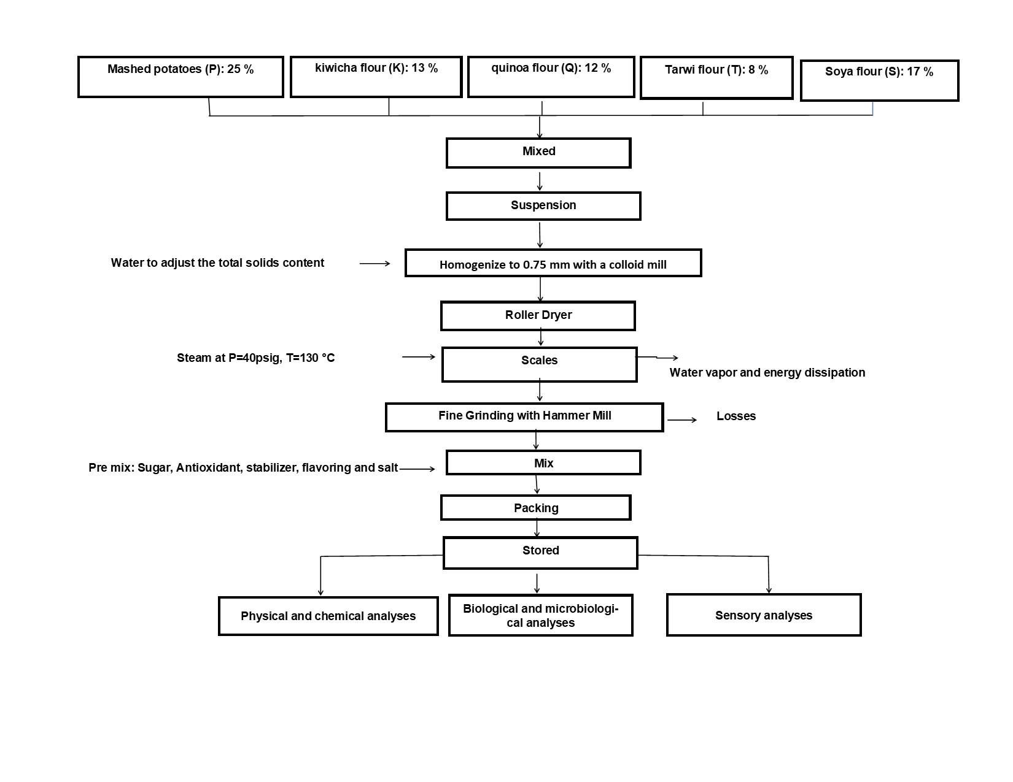
Figure 1: Diagram of the fortified food manufacturing process.
    - Characterization of the fortified processed food
The elaborated product, called "fortified food", was subjected to the characterization of moisture, protein, fat, crude fiber, ash and carbohydrates, following the standard procedures of the AOAC.
The percentage of gelatinization was also determined according to the method of the National Center for Food and Nutrition of Peru-CENAN (CENAN, 2010), using Eq(2).

$$\% Glucose=\frac{mg Glucose in tube A}{mg Glucose in tube B} *100$$ | (2)
Where Tube A : is from the test food and Tube B is from the control food.

The fortified food was also subjected to microbiological analysis related to Escherichia coli (Escherich, 1885), Streptococcus aureus (Rosenbach, 1884) and enumeration of fungi and yeast.
The fortified food was subjected to biological analysis, determining the Protein Efficiency Index (PER), related to the average weight gain of those who consumed the feed for the amount of protein consumed (FAO/WHO/UN, 1985). The PER was calculated using Eq(3).

$$PER=\frac{Weight gain (g)}{Proteins consumed (g)}$$ | (3)
PER: referring to the person consuming the fortified food.

Digestibility analysis of the fortified food: Six 21-day-old male Holtzman rats with a live weight of 73 to 75 g were placed in metabolic cages independently. They were fed 10 g of the experimental diet for seven days, the feces were collected daily and the nitrogen content was determined using Eq(4).

$$D=\frac{N ingested-N fecal}{N ingested} *100$$ | (4)
D= Digestibility, N= Nitrogen

Sensory Analysis: by means of the Facial Hedonic Scale of the final product, the acceptability attributes of the fortified food were consulted. It was presented to untrained panelists, children from 2 to 5 years of age from a Puquio Public Initial Educational Institution, Lucanas Ayacucho – Peru, explaining to them how to mark on the evaluation card, for example marking a happy face indicates acceptability and a sad face indicates non-acceptability (Valencia, 2016).
  - Results and discussion
    - Fortified food formulation
The formulation of the fortified food, carried out by the Mixit-2 software, resulted in the composition shown in Table 1. Similarly, Table 2 shows the result of the analyses of the nutrients of the fortified food.

Table 1: Formulation of the food fortified with Andean products for preschool children, using Mixit-2 software
Components | Percentage (%) | Components | Percentage (%)
Yellow potato | 25.000 | Tricalcium phosphate | 0.500
Kiwicha flour | 13.000 | Pre-mix of vitamins and minerals | 0.208
Quinoa flour | 12.000 | Vanilla flavor (Montana S.A.) | 0.140
Tarwi flour | 8.000 | Antioxidant (Montana S.A.) | 0.002
Soy flour | 17.000 | Stabilizer (Montana S.A.) | 0.050
Sugar | 23.800 | Salt | 0.300
 |  | Total | 100.000
Table 2: Nutrients of the fortified food
Nutrients | Quantity | Nutrients | Quantity
Protein | 18.26 % | Leucine | 4.49 g/100g
Fat | 8.97 % | Lysine | 3.90 g/100g
Fiber | 3.31 % | Met+Cist | 1.47 g100g
Ash | 3.02 % | Threonine | 2.54 g/100g
Nitrogen Free Extract | 66.44 % | Tryptophan | 0.72 g/100g
Metabolizable Energy | 419.50 kcal/100 g | Valine | 3.14 g/100g
Phenyl + Tyrosine | 4.98 g/100 g | Calcium | 500.00 mg/100g
Histidine | 1.44 g/100g | Available Phosphorus | 257.73 mg7100g
Isoleucine | 2.87 g/100g

    - Essential amino acids in fortified food
The amino acid content of the processed food is presented and compared with a standard of these components on a dry basis recommended by FAO (1994), see Table 3.
Table 3: Amino acids of the fortified food, dry basis
Amino acids | Fortified Food  (g aa/100 g protein) | For FAO/WHO/UNU/WHO  (g aa/100 g protein) | Compute  Chemist * (%)
Phenylalanine + Tyrosine | 7.5 | 6.3 | 119
Histidine | 3.0 | 1.9 | 157
Isoleucine | 4.4 | 2.8 | 157
Leucine | 7.0 | 6.6 | 106
Lysine | 5.8 | 5.8 | 100
Methionine + Cystine | 2.2 | 2.5 | 91
Threonine | 3.8 | 3.4 | 112
Tryptophan | 1.1 | 1.1 | 100
Valine | 4.8 | 3.5 | 137
aa: amino acids
* Ratio between the percentage of amino acids of the fortified food with respect to a standard (FAO) (must be greater than 85%).
    - Chemical composition of the fortified food
In the chemical composition of the fortified food, the total energy of 209.0 kcal stands out, presenting a protein level above the requirements of the Peruvian National Health Institute (INS), for its Pre-school Feeding Program; with a fat content very close to that requested, carbohydrates within the range and with a chemical count above the minimum established, see Table 4.
Table 4: Chemical composition of the fortified food
Components | Enriched food | Technical specifications for food mixtures (INS)
Total energy | 209.0 kcal | 200.0 kcal (minimum) and 230.0 kcal (maximum)
Protein | 17.5 % Total energy | 13 - 15% Total energy
Fat | 19.2 % Total energy | 20 - 35% Total energy
Carbohydrates | 63.3 % Total energy | 53 – 70% Total energy
Chemical compute | 91.0 % Total energy | 85.0 % (minimum)

    - Gelatinization, physicochemical, physicochemical, microbiological, and biological characteristics of the fortified food
It was determined that the fortified feed presents the best characteristics when dried by rotary drum at 130 °C with a steam pressure of 40 psig, and at 3.5 rpm of angular speed of the rollers, for 20 % of total solids. It presented 94.5 % gelatinization and 5 % humidity, results very similar to the technical specifications established by the INS of Peru, which indicates 92 % gelatinization as a minimum value and 5 % humidity.
The microbiological analysis reported: viable mesophilic anaerobes 9 x 10² CFU/c, coliforms 2 NMP/g, with the absence of Escherichia Coli, Staphylococcus aureus, molds and yeasts. FAO in its specifications indicates for mesophilic anaerobes the level of 9 x 104 CFU/c, for coliforms 20 NMP/g, and absence of E. coli, S. aureus, molds and yeasts; therefore, the fortified feed complies with these specifications.
Also in the biological evaluation, the formulated fortified feed had a PER of 3.20 higher than casein (standard) which has a PER of 2.54 and a digestibility of 88 %, very close to that of casein which is 91 %.
Regarding sensory acceptance, the result in a panel of children was that 78.3 % of them accepted the fortified feed, similar to the product enriched with acai flour (Amaral et al., 2020).
  - Conclusion
We were able to obtain a fortified food using Andean products composed of potato, kiwicha, tarwi and quinoa supplemented with soy, with optimal nutritional characteristics for feeding students in early school age, and that meet the specifications of the Pre-School Feeding Program of the National Institute of Health of Peru (INS-Peru) and specifications of FAO-WHO. This fortified food is an alternative food in Andean communities due to its low economic cost, thus contributing to achieving one of the sustainable development objectives, for the benefit of the population at an early age.
Acknowledgments
The authors would like to thank the Universidad Nacional Federico Villareal and the Instituto de Desarrollo Agroindustrial de la Universidad Nacional Agraria La Molina.
References
Amaral S., Sous, A., Tavares S., Martins D., Freitas C. y Marque A., 2020), Physical-chemical and sensory evaluation of cookies enriched with acai pulp and stone flour. CHALLENGES Interdisciplinary Journal of the Federal University of Tocantins 7(Special), 72-81, (In Portuguese).
Agricultural Software Consultants, Inc., Least Cost Feed Formulation, <https://www.agriculturalsoftwareconsultants.com/about-us>, accessed 15.02.2023
AOAC Official Methods of Analysis, 2016, International.20th edition, <www.techstreet.com/standards/official-methods-of-analysis-of-aoac-international-20th-edition-2016?product_id=1937367>, accessed 15.02.2023.
Alonso O., González D. I., Abreu G., 2007, Protein-energy malnutrition in children under 5 years of age, Revista Cubana de Pediatria, 79(2). (In Spanish).
Álvarez S.M., Zapico J., De Aguiar J. A., 2008, Adaptation of the facial hedonic scale to measure food preferences of preschool students, Rev.chil.nutr. 35, 38-42. A.
Arrunátegui-Correa V., 20016, Nutrition status in children aged under 5 in San Marcos district , Ancash, Perú, Revista Chilena de Nutrición, 43(2), 155-158. (in Spacnish)
Barrutia L., Ruiz-Camus C., Moncada J., Vargas J., Palomino G., Isuaza A., 2021, Prevención de la anemia y desnutrición infantil en la salud bucal en Latinoamérica, Ciencia Latina, 5(1), 1171-1183.
Carrero C., Orósotegui M., Ruiz L., Barros D., 2018, Childhood anemia: cognitive development and academic performance, Venezuelan Archives of Pharmacology and Therapeutics, 37(4), 411-426, (In Spanish).
CENAN. 2010. Formulation of the Ration of the Glass of Milk Program. Instituto Nacional de Salud (INS). Guide. Lima, Perú. http://bvs.minsa.gob.pe/local/MINSA/1356_INS84.pdf, (in Spanish)
Collazos C., Robles N., Roca A., Alvistur E., Arias M., Fachíng A., Vásquez J., Viñas E., Hernández E., Quiroz A., Urquieta R., Herrera N. y Días C., 1996, Peruvian tables of food composition. National Institute of Health. National Center for Food and Nutrition. Ministry of Health. Institute of Inter-American Affairs, Lima, Perú, <http://bvs.minsa.gob.pe/local/MINSA/1652.pdf>, accessed 07.03.2023, (In Spanish)
Cheftel J.C. y Cheftel H., 1999, Introduction to biochemistry and food technology. Edit. Acriba. Zaragoza, España, https://www.editorialacribia.com/media/acribia/files/pdfcatalog-158.pdf, (In Spanish).
FAO/OMS/UNU, 1985, Energy and protein needs. Report of an Expert Consultative Meeting. Technical Report Series 724, Ginebra, (Ins Spanish).
FAO/OMS, 1994, CODEX Standards for Special Diets for Infants and Young Children, Joint FAO/WHO Program on Food Standards. Alimentary Codex Commission. Rome Italy, (In Spanish)
Flores J., Calderón J., Rojas B., Alarcón E. y Gutiérrez C., 2015, Chronic malnutrition and anemia in children under 5 years of indigenous households of Peru- Analysis of Demographic and Health Survey 2013, Anales de la Facultad de Medicina 76(2),135, (In spanish).
National Institute of Statistics and Informatics. Demographic and Family Health Survey (INEI). ENDES, 2015, Lima, Perú. www.inei.gob.pe, accessed 10.02.2023, (In Spanish).
Navarrete P. J., Velasco J. C., Loayza M. J. y Huatuco Z. A., 2016, Nutritional status of children from three to five years old in three districts of Lima. Perú, Horizonte Medico,16(4), 55-59.
OMS, 2021, Malnutrition, <www.who.int/es/news-room/fact-sheets/detail/malnutrition>, accessed 03.03.2023. (In Spanish).
Ortiz-Andrellucchi A., Peña L., Albino A., Monckeberg F., Serra-Majem L., 2006, Child subnutrición, healt and poverty, integral intervention programme, Nutrición Hospitalaria, 21(4), 533-541, (In Spanish).
Osorio A., Romero G., Bonilla H. y Aguado L., 2018, Socioeconomic context of the community and child chronic malnutrition in Colombia, Revista Saùde Publica, 52, 73, (In Spanish).
Perdomo C., Rodríguez E., Carrasco H., Flores H., Matul S. y Moyano D., 2019, Impact of a community program for child nutrition. Chilean Journal Pediatrics, 90(4), 411-42. (In Spanish)
Santamaría, L., 2004, Nutrition in children under 5 years of age in Peru, Peruvian Journal of Experimental Medicine and Public Health, 21(3),117, (In Spanish).
Sobrino M., Gutiérrez C., Cunha A. J., Dávila M. y Alarcón J., 2014, Child malnutrition in children under 5 years of age in Peru: trends and determinants, Revista Panamericana de Salud Pública, <www.scielosp.org/article/rpsp/2014.v35n2/104-112/>, accessed 07.03.2023.
Valencia, R. F. (20016). Analysis of variance two –way data recorded during a period of time. Anales Cientificos, 77(2), 267-272. http://dx.doi.org/10.21704/ac.v77i2.705.

