CHEMICAL ENGINEERING TRANSACTIONS  VOL. , 2023 | A publication of
The Italian Association
of Chemical Engineering
Online at www.cetjournal.it

Guest Editors:
Copyright © 2023, AIDIC Servizi S.r.l.
ISBN 979-12-81206-XX-X; ISSN 2283-9216

Impact of emulsification time and concentration of modified starch nanoparticles on Pickering stability
Giselle V. C. Ramosª, Aline R. Suzigan^{b}, Samantha C. Pinho^{b}, Izabel C. F. Moraes^{a,b*}
ªPostgraduate Program in Materials Science and Engineering, University of São Paulo (USP), Pirassununga, SP, Brazil.
^{b}Department of Food Engineering, School of Animal Science and Food Engineering (FZEA/ USP), Pirassununga, SP, Brazil
bel@usp.br
The modification of the cassava native starch by heat-moisture treatment (HMT) followed by nanoprecipitation can be worthwhile for obtaining stabilizers of Pickering emulsions as highly stable emulsions and clean label products can be produced. In this study, Pickering emulsions stabilized by different concentrations of modified starch nanoparticles (HSNP), and various emulsification times were evaluated in terms of physical stability, rheological properties (flow curves) and microstructure. All emulsions produced with lower concentrations of HSNP (0.8 and 2.4wt%) destabilized within 24 h, and the emulsions stabilized with 3 and 4wt% HSNP, regardless of emulsification time, remained stable for up to 14 days. As the HSPN concentration increased, the interface became denser, preventing or delaying coalescence. The micrographs of the stable emulsion showed that the shorter the emulsification time (3 min), the larger the average droplet size. The Power Law model was well adjusted to the experimental data (shear stress vs shear rate) (R² ≥ 0.996), and the model constants (pseudoplasticity and consistency index) increased as HSNP concentration increased and emulsification time decreased. Physically modified starch nanoparticles were used as stabilizer of the Pickering O/W (oil in water) emulsion, and the results demonstrate that the microstructure and the rheological properties of these emulsions can be adjusted by particle concentration and emulsification time.
  - Introduction
The application of natural biocolloidal particles is one of the promising alternatives (green label) to produce Pickering emulsions. The production of emulsions without added synthetic surfactants is best suited for various applications such as functional foods, active food coatings, pharmaceutical and cosmetic formulations, as it is already known some surfactants may exert adverse effects (Kim et al., 2015).
Starch is an abundant, non-toxic and low-cost material and is an interesting material to stabilize this type of emulsion, as long as modifications are made to its structure to improve its capacity as a stabilizer of Pickering emulsions (Farooq et al., 2021). The particle used to formulate a Pickering emulsion must be able to penetrate but not to dissolve both in the continuous and dispersed phases, and it must have a sufficiently high interfacial absorption efficiency (Lu and Tian, 2021). Furthermore, the solid particle’s size should be smaller than the desired emulsion droplets (Wang et al., 2017). Several techniques, including acid hydrolysis, octenyl succinic anhydride (OSA) modification, enzymatic hydrolysis, and recrystallization are often employed to alter starch structure (Lu and Tian, 2021), however, most of these methods have some disadvantages, such as the use of chemical reagents and the need of complex operations. Exploring methods to modify starch structure is necessary for its use it as a stabilizer and to improve the Pickering emulsions stability.
Nanoprecipitation is considered to be a green technique, and it can be used to obtain starch particles on a nanometric scale. Some important parameters that influence the size and properties of nanoparticles are the source and size of the native granule, as well as the use of modified starches (Chang et al., 2017). Physical modification starch by HMT, in which low moisture content (<35%) and high temperatures (T > 90°C or higher gelatinization temperature) are applied for a time interval (Li et al., 2011). This process can change the structural and functional properties of starch (Adebowale et al., 2005). Consequently, the use of combined methods (physical modification HMT + nanoprecipitation) may result in starch nanoparticles with more promising characteristics in stabilizing emulsions.
Moreover, under certain emulsification conditions the initial solid particle’s concentration has an important effect on droplet size and emulsion stability (Ramos et al., 2021). An insufficient concentration of particles can lead to instability of the emulsion, and excess Pickering particles can also form a particle network in the continuous phase, which is conducive to long-term stability of the emulsion and generation of solid structures (Li et al., 2020). Given this, modified starch nanoparticles (HSNP) were used as the stabilizer for Pickering emulsion, and the effect of emulsification time (3, 6 and 9 min) and particle concentration (0.8, 2, 4, 3 and 4%) on its stability were investigated.
  - Material and Methods
Canola oil (Liza, Cargil, Mairinque, SP, Brazil) and cassava starch (Siamar, Neves Paulista, SP, Brazil), starch type I, were used. Nile red was purchased from Sigma Aldrich (St Louis, MO, USA). All reagents used in the analyzes were of analytical standard.
    - Starch modification and production of Pickering emulsions
The cassava starch was modified by the HMT process (heat-moisture treatment) as according to Piecyk and Domian (2021) with modifications (20% moisture content). After this step, the modified cassava starch was nano-precipitated following methodology by Lima et al. (2021). Briefly, starch suspensions (5 wt%) were gelatinized (90 °C/30 min), precipitated using ethanol 99.5% (1:1 v/v ethanol/water) and lyophilized.
O/W emulsions were prepared with 20wt% canola oil and 80wt% water phase. Starch nanoparticles were added to the aqueous phase, and the emulsification process was made using a rotor-stator homogenizer (model T25, IKA, Labotechnik, Staufen, Germany) at 14,000 rpm for 3, 6 or 9 min (Souza et al., 2021) at room temperature. In addition, sodium benzoate (0.02 g/ 100 g emulsion) was used to avoid microbiological contamination. The emulsions were produced with modified starch nanoparticles (HSPN) in concentrations of 0.8, 2.4, 3 or 4% (g of SNP/g of emulsion), which were labeled as EH1, EH2, EH3 and EH4, respectively. The investigate parameters were selected, aiming to establish values adequate for emulsion stability.
    - Physical Stability
The emulsion was stored in a glass bottle at 20 °C in an incubator (MA 415, Marconi, Piracicaba, SP, Brazil) for 14 days. To determine the storage stability of the emulsion, the creaming index (CI) was calculated by Equation 1 (Owens et al., 2018). This analysis was made on the 0, 7th and 14 th days.
$$CI\%= \frac{Hs}{Ht}.100$$ | (1)
Where Hs and Ht are the height of the serum layer (if destabilization occurred) and of fresh emulsion, respectively.

Freshly emulsions with higher concentrations of HSPN (3 and 4%) were analyzed in the LumiSizer LS 610 equipment (LUM GmbH, Berlin, Germany) under accelerated conditions at 25 ºC. Instability index values were obtained directly from the SepView v.4.1 software (L.U.M., Germany), and the lower this value, the higher was emulsion stability.
    - Rheological properties
The rheological behavior of the emulsions on the 1st day was determined at 25 ºC using an AR 2000 rotational rheometer (TA Instruments, New Castle, USA) with cone-plate (4º, 60 mm) geometry. The flow curves were obtained by up-down shear rate ramp from 0.1 to 100 s⁻¹ (Daudt et al., 2015). The Advantage/ Universal Analysis (UA) Software v 5.5.24 was used to adjust the rheological models. The Power Law model (Equation 2) was the one that presented the best coefficients of determination (R²).
$$τ=k.{γ̇ }^{n}$$ | (2)
Where 𝜏 is the shear stress; k is the consistency index; 𝛾̇ is the shear rate, and n is the flow behavior index.
    - Microstructure
The microstructure of the emulsions on the 1st day was analyzed by optical microscopy (Leica DM. 500 / ICC 50W, Berlin, Germany). A small drop was placed on a glass slide, covered with a coverslip and observed with a 100x objective. Droplets of Pickering emulsion were observed using an inverted fluorescence microscope (Axiovert.A1, Carl Zeiss, Oberkochen, Germany). Prior to emulsion preparation, canola oil was stained with Nile Red. Nile Red solution (0.1% (w/v)) in ethanol was prepared and 10 µL of this solution/g of lipid was used in the oil phase (Ko and Kim, 2021). Then, the emulsion was prepared according to Section 2.1. A small drop was placed on a glass slide, covered with a coverslip and observed. Nile red was excited at 488 nm.
    - Statistical analysis
The Pickering emulsions and characterization analyses were performed at least in triplicate. Results were subjected to analysis of variance (ANOVA), and means were compared by Tukey test (p <0.05) using SAS (Statistical Analysis System) version 9.4 software.
  - Results and Discussion
    - Physical stability
Figure 1 shows the appearance of emulsions stabilized with different concentrations of HSPN and emulsification times. The visual aspect of the emulsions was clearly influenced by the concentration of HSNP, but the different times (3, 6 and 9 min) did not have a relevant effect on the visual observation of phase separation.
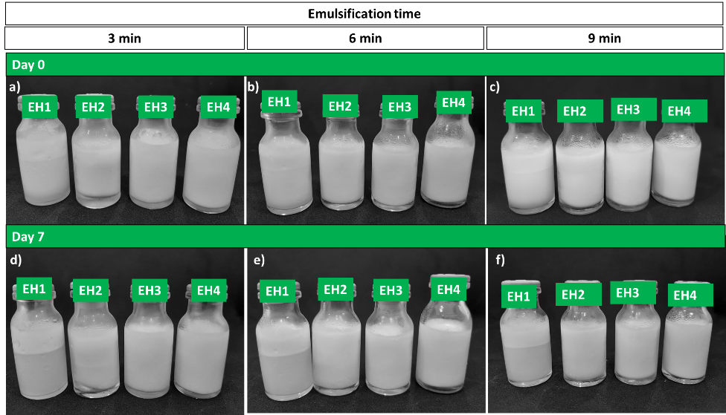
Figure 1: Photos of Pickering emulsions stabilized with HSNP on days 0 and 7 of preparation at concentrations of 0.8, 2.4, 3 and 4% of HSNP and emulsification times of 3, 6 and 9 min.
The stability of Pickering emulsions was evaluated by the creaming index (day 0, 7th and 14th). The higher the CI, the more intense the creaming. The results showed that a lower HSPN concentration may have not provided sufficient coverage of the interface between the oil phase and the aqueous phase, which led to emulsion instability. The formulations with the highest concentrations of nanoparticles (3 and 4%) remained stable (no phase separation, CI ~ 0%) for up to the 14th days of storage for the three emulsification times (Figure 2). Kamwilaisak et al. (2022) reported similar results, in which the emulsion stability with 30% sunflower oil increased with increasing concentration of rice starch nanoparticles (0.5 – 4 wt%) added to the formulation.
Stable emulsions (with 3% or 4% HSNP) were also evaluated in terms of the instability index (Table 1). The instability index (II) varies from 0 to 1, with 1 meaning the highest emulsion instability. All samples showed II lower than 0.29, indicating good stability of the emulsions. The samples with 4% HSNP had the lowest II, with a significant statistical difference in comparison to the emulsions produced with 3% of nanoparticles. A higher HSPN concentration probably ensured that oil droplets were completely covered, thus increasing the emulsion’s stability (Li et al., 2020). For most Pickering emulsions, increasing particle concentration not only decreases the droplet size and improves surface coverage, but also leads to the formation of a network structure around the emulsion droplets (Song et al., 2015).
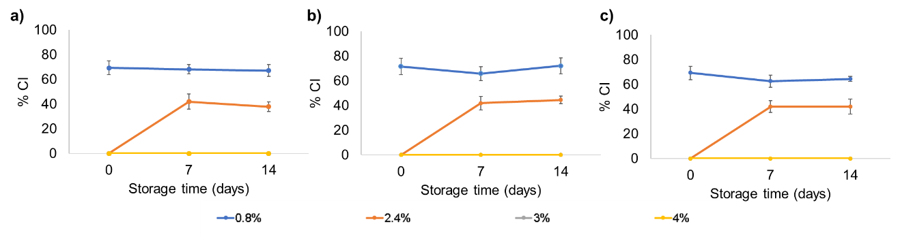
The emulsification time also influenced the II significantly, and the emulsions prepared with 4% of HSNP and emulsification time at 6 or 9 min had higher stability than the sample stirred only for 3 min. Rotation speed and homogenization time are the first parameters to control the emulsion droplet size with a rotor-stator homogenizer (Albert et al., 2019). The higher amount of energy supplied to the system allows the breaking of the oil droplets into smaller sizes, which increases the exposed surface area of the droplets, permitting the HSNP to better adhere to the surface and increasing the stability of the emulsion. On the other hand, if the applied energy is excessive (times that are too long or speeds too high), the opposite process can occur, in which the drops begin to coalesce (Souza et al., 2021). Souza et al. (2021) produced Pickering emulsions with 20% cinnamon oil, 1% cellulose nanocrystals and 3 and 7 minutes of emulsification and reported greater instability in emulsions prepared with longer emulsification times, which corroborates with our results.

Figure 2: Creaming index (CI) of Pickering emulsions stabilized with HSNP on days 0, 7 and 14 of preparation at 0.8; 2.4; 3 and 4% concentrations and emulsification times of 3 (a), 6 (b) and 9 min (c).
    - Rheological behavior
The stable emulsions (on the 1st day) were characterized by rheological assays and showed a non-linear relationship between shear stress and shear rate (Figure 3.a), exhibiting a non-Newtonian fluid behavior. There was an increase in shear stress (Figure 3.a) and apparent viscosity (Figure 3.b) at same shear rate with increasing HSNP concentration. The reason for this might be that particle-particle interactions and particle-liquid interactions were enhanced at higher concentrations, forming a denser network (Schroder et al., 2018). Feng et al. (2020) reported similar results, in which the apparent viscosity of the emulsion increased with increasing concentration of gelatin nanoparticles (0.3 – 2wt%).
Table 1: Instability index (II) and rheological properties (K and n, Power Law model) for Pickering emulsions stabilized with different HSPN concentrations (3 and 4% m/m) and emulsification times (3, 6 and 9 min).
HSPN (%) | Emulsification time (min) | II | n (flow index) | k (Pa.s) | R²
3 | 3 | 0.29 ± 0.00^{a,A} | 0.76 ± 0.01^{a,A} | 0.28 ± 0.02^{a,B} | 0.998
3 | 6 | 0.25 ± 0.00^{b,A} | 0.76 ± 0.01^{a,A} | 0.18 ± 0.03^{b,B} | 0.996
3 | 9 | 0.24 ± 0.01^{b,A} | 0.77 ± 0.01^{a,A} | 0.15 ± 0.02^{b,B} | 0.998
4 | 3 | 0.20 ± 0.02^{c,B} | 0.75 ± 0.01^{a,A} | 0.43 ± 0.02^{c,A} | 0.999
4 | 6 | 0.13 ± 0.01^{d,B} | 0.75 ± 0.00^{a,A} | 0.37 ± 0.04^{c,A} | 0.998
4 | 9 | 0.10 ± 0.01^{d,B} | 0.75 ± 0.00^{a,A} | 0.33 ± 0.02^{c,A} | 0.998
Mean ± standard deviation (n = 3). Values followed by the same lowercase and uppercase letters in the same column do not differ significantly with the emulsification time and the HSPN concentration, respectively (p<0.05).

As summarized in Table 1, the Power-Law (R²>0.99) fits well with the flow curves data in this study. All evaluated emulsions (Table 1) showed pseudoplastic behavior (n < 1), with no difference in pseudoplasticity (n values) with 3 or 4% of HSNP or emulsification times. The consistency index (k) increased with increasing concentration of HSNP and decreased with increasing emulsification time. According to Table 1, the increase of emulsification time improved the liquidity of the dispersed system. There was a reduction in shear stress and apparent viscosity with increasing emulsification time, which can be explained by the production of droplets with smaller sizes in these times (Albert et al., 2019).

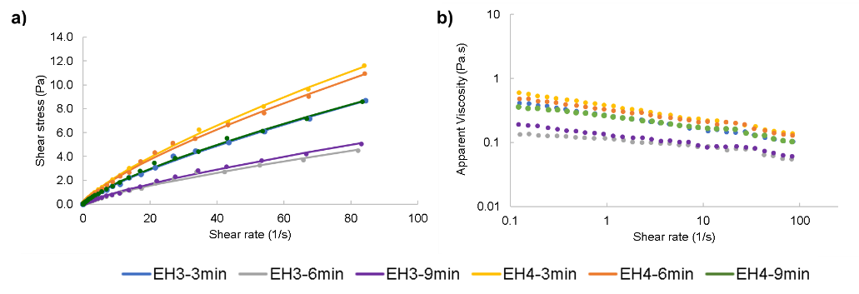
Figure 3. (a) Descending flow curves and (b) Apparent viscosity versus shear rate of Pickering emulsions with different concentrations of HSNPs (3 and 4% m/m) and emulsification times 3, 6 and 9 min. The dots represent the experimental data and the solid lines, the Power Law (LP) model.
    - Morphology of emulsions
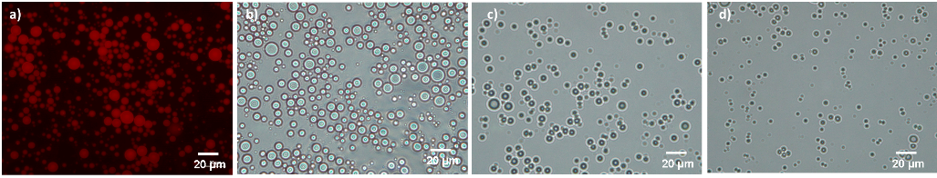
Fluorescence microscopy was performed on emulsion the 1st day with 4% HSNP and 3 min (Figure 4 a), and the oil droplets were observed. Furthermore, the microstructure of the emulsions prepared with 4% HSNP for three emulsification times (Figure 4 b,c,d) indicated that the droplets were spherical and had homogeneous size distribution. The droplet sizes decreased with increasing emulsification time, and the longer the shear time, the higher the breaking of the oil droplets. Souza et al. (2021) reported similar results for Pickering O/W emulsions (20:80 oil:water) stabilized with cellulose nanofiber (1wt%), where the longer emulsification time (7 min) produced emulsions with smaller droplets.
Figure 4: Fluorescence (a) and light microscopies (b,c,d) of emulsions with 4wt% HSNP at 3 (a,b), 6 (c) and 9 (d) min of emulsification time. The oil was colored with Nile Red. Scale bar 20 µm.
  - Conclusions
It has been proven that starch nanoparticles formed from physically modified starch can be used as a stabilizer in Pickering O/W emulsions. The physical stability of these emulsions can be controlled by the HSPN concentration, where higher concentrations (3 and 4 wt%) show greater stability. For stable emulsions, an increase in emulsification time (6 and 9 min) resulted in an increase in the interfacial area. These results are useful in formulating emulsions with predictable stability. In conclusion, the physical stability and rheological properties of Pickering emulsions were affected by the particle concentration and emulsification time.
Acknowledgments
The authors thank Coordination for the Improvement of Higher Education Personnel (CAPES) for the financial support and Master fellowship (Finance code 001) for G.V.C.R.
References
Adebowale, K. O., Afolabi, T. A., and Olu-owolabi, B. I. (2005). Hydrothermal treatments of Finger millet (Eleusine coracana) starch. Food Hydrocolloids, 19, 974–983. https://doi.org/10.1016/j.foodhyd.2004.12.007
Albert, C., Beladjine, M., Tsapis, N., Fattal, E., Agnely, F., and Huang, N. (2019). Pickering emulsions: Preparation processes, key parameters governing their properties and potential for pharmaceutical applications. Journal of Controlled Release, 309, 302–332. https://doi.org/10.1016/J.JCONREL.2019.07.003
Chang, Y., Yan, X., Wang, Q., Ren, L., Tong, J., and Zhou, J. (2017). High efficiency and low cost preparation of size controlled starch nanoparticles through ultrasonic treatment and precipitation. Food Chemistry, 227, 369–375. https://doi.org/10.1016/j.foodchem.2017.01.111
Daudt, R. M., Back, P. I., Cardozo, N. S. M., Marczak, L. D. F., and Kulkamp-Guerreiro, I. C. (2015). Pinhão starch and coat extract as new natural cosmetic ingredients: Topical formulation stability and sensory analysis. Carbohydrate Polymers, 134, 573–580. doi: 10.1016/j.carbpol.2015.08.038
Farooq, U., Di Mattia, C., Faieta, M., Sacchetti, G., & Pittia, P. (2021). Oil-in-water pickering emulsions stabilized with starch particles and formulated with olive oil: Colloidal properties and stability as affected by olive oil phenolic content. Chemical Engineering Transactions, 87, 79–84. https://doi.org/10.3303/CET2187014
Feng, X., Dai, H., Ma, L., Fu, Y., Yu, Y., Zhou, H., Zhang, Y. (2020). Properties of Pickering emulsion stabilized by food-grade gelatin nanoparticles: influence of the nanoparticles concentration. Colloids and Surfaces B: Biointerfaces, 196(2). https://doi.org/10.1016/j.colsurfb.2020.111294
Kamwilaisak, K., Rittiwut, K., Jutakridsada, P., Iamamorphanth, W., Pimsawat, N., Knijnenburg, J. T. N., and Theerakulpisut, S. (2022). Rheology, stability, antioxidant properties, and curcumin release of oil-in-water Pickering emulsions stabilized by rice starch nanoparticles. International Journal of Biological Macromolecules, 214, 370–380. https://doi.org/10.1016/j.ijbiomac.2022.06.032
Kim, H., Park, S. S., and Lim, S. (2015). Preparation, characterization and utilization of starch nanoparticles. Colloids and Surfaces B: Biointerfaces, 126, 607–620. https://doi.org/10.1016/j.colsurfb.2014.11.011
Ko, E. B., and Kim, J. (2021). Application of starch nanoparticles as a stabilizer for Pickering emulsions: Effect of environmental factors and approach for enhancing its storage stability. Food Hydrocolloids, 120, 106984. https://doi.org/10.1016/j.foodhyd.2021.106984
Li, S., Zhang, B., Li, C., Fu, X., and Huang, Q. (2020). Pickering emulsion gel stabilized by octenylsuccinate quinoa starch granule as lutein carrier: Role of the gel network. Food Chemistry, 305, 125476. https://doi.org/10.1016/j.foodchem.2019.125476
Li, S., Ward, R., and Gao, Q. (2011). Effect of heat-moisture treatment on the formation and physicochemical properties of resistant starch from mung bean (Phaseolus radiatus) starch. Food Hydrocolloids, 25(7), 1702–1709.
Lima, K. T. S., Garcez, J., Alves, M. J. S., Monteiro, A. R., and Valencia, G. A. (2021). Physicochemical Properties of modified starches obtained by anti-solvent precipitation containing anthocyanins from jambolan (Syzygium cumini) Fruit. Starch/Staerke, 73(3–4). https://doi.org/10.1002/star.202000221
Lu, H., and Tian, Y. (2021). Nanostarch: Preparation, modification, and application in Pickering emulsions. Journal of Agricultural and Food Chemistry, 69(25), 6929–6942. https://doi.org/10.1021/ACS.JAFC.1C01244/ASSET/IMAGES/MEDIUM/JF1C01244_M001.GIF
Owens, C., Griffin, K., Khouryieh, H., and Williams, K. (2018). Creaming and oxidative stability of fish oil-in-water emulsions stabilized by whey protein-xanthan-locust bean complexes: Impact of pH. Food Chemistry, 239, 314–322. https://doi.org/10.1016/J.FOODCHEM.2017.06.096
Piecyk, M., and Domian, K. (2021). Effects of heat–moisture treatment conditions on the physicochemical properties and digestibility of field bean starch (Vicia faba var. minor). International Journal of Biological Macromolecules, 182, 425–433. https://doi.org/10.1016/j.ijbiomac.2021.04.015
Ramos, D. M., Sadtler, V., Marchal, P., Lemaître, C., Benyahia, L., & Roques-Carmes, T. (2021). Insight into the emulsification process effect on particles distribution in pickering emulsions: A series of rheological and gravimetric tests. Chemical Engineering Transactions, 86, 1291–1296. https://doi.org/10.3303/CET2186216
Schroder, A., Sprakel, J., Schroen, K., Spaen, J. N., and Berton-Carabin, C. C. (2018). Coalescence stability of Pickering emulsions produced with lipid particles: A micro fluidic study. Journal of Food Engineering, 234, 63–72. https://doi.org/10.1016/j.jfoodeng.2018.04.007
Song, X., Pei, Y., Qiao, M., Ma, F., Ren, H., and Zhao, Q. (2015). Preparation and characterizations of Pickering emulsions stabilized by hydrophobic starch particles. Food Hydrocolloids, 45, 256–263. https://doi.org/10.1016/J.FOODHYD.2014.12.007
Souza, A. G., Ferreira, R. R., Aguilar, E. S. F., Zanata, L., and Rosa, D. S. (2021). Cinnamon essential oil nanocellulose-based Pickering emulsions: Processing parameters effect on their formation, stabilization, and antimicrobial activity. Polysaccharides, 2(3), 608–625. https://doi.org/10.3390/polysaccharides2030037
Wang, C., Fu, X., Tang, C. H., Huang, Q., and Zhang, B. (2017). Octenylsuccinate starch spherulites as a stabilizer for Pickering emulsions. Food Chemistry, 227, 298–304. https://doi.org/10.1016/J.FOODCHEM.2017.01.092
Wang, Q., Tang, Z., Li, Z., Luan, Y., Gu, C., Liu, R., Wu, M. (2023). Effects of octenyl succinylation on the properties of starches with distinct crystalline types and their Pickering emulsions. International Journal of Biological Macromolecules, 230, 123183. https://doi.org/10.1016/J.IJBIOMAC.2023.123183

