CHEMICAL ENGINEERING TRANSACTIONS  VOL. , 2023 | A publication of
The Italian Association
of Chemical Engineering
Online at www.cetjournal.it

Guest Editors: Laura Piazza, Mauro Moresi, Francesco Donsì
Copyright © 2023, AIDIC Servizi S.r.l.
ISBN 979-12-81206-01-4; ISSN 2283-9216

A suite of climate-smart decision tools for adaptive microclimate management in agri-food production
Dimitrios Kateris, Dionysis Bochtis*
ª Institute for Bio-Economy and Agri-Technology (iBO), Centre of Research and Technology-Hellas (CERTH), 6th km Charilaou-Thermi Rd., 57001 Thessaloniki, Greece
d.bochtis@certh.gr
This work regards an applied climatic data solution that implements a series of analytics models to support local and regional policy formulation and implementation related to mitigation on microclimate changes. Currently, policy making organizations predominantly utilize their own data, typically limited to their own jurisdiction-administrative area. However, once the policy development process expands the evidence base and data sources beyond the traditional approach, there is need for global data, including meteorological, climatic analysis, and satellite data sources, to improve decision-making processes. A cloud service platform (STARGATE platform) is presented, that includes state-of-the-art numerical weather prediction models and atmospheric data assimilation systems, along with machine learning algorithms and big data analytics, and using high resolution land cover data, topography, earth observation, and in-situ data, able to provide parcel-based climate smart decision support.
  - Introduction
Since the mid-20th century, the Earth’s climate has been rapidly changing. Amongst others, this includes changes of the diurnal temperature, rainfall patterns including the number of wet and dry spells, as well as altered the frequency, duration, and spatial distribution of extreme weather like hailstorms, windstorms, frost, and heat wave events. Agriculture is perhaps the most weather-climate dependent sector of the economy where changes in the weather-climatic patterns are strongly affecting it, in terms of productivity and associated risk. On the other hand, the current farm practices are producing about the 1/4th of the global greenhouse gas emissions annually, contributing and further enhancing the climate change, retaining a continuous cycle of altering the climate and impacting the food production system. The only way to break this cycle, is to change the current farm practices and methods of landscape management, as well as the associated policies, through the development, promotion and adoption of innovative climate smart practices and methods that will help the food production system to adapt to the climate change and become more sustainable.
Agriculture must meet significant challenges in the face of providing technical solutions for increasing production, while the environmental impact decreases by reduced application of agrochemicals and increased use of environmentally friendly management practices. A benefit of this is the reduction of production costs. Technologies of sensors produce tools to achieve the above‐mentioned goals. The explosive technological advances and development in recent years enormously facilitates the attainment of these objectives by removing many barriers for their implementation, including reservations expressed by farmers themselves. Precision Agriculture is an emerging area, where sensor‐based technologies play an important role. Farmers, researchers, and technical manufacturers, all together, are joining efforts to find efficient solutions and improvements in production and into reductions in costs (Pantazi X. E. et al., 2020).
Farmers and stakeholders have difficulties in making proper decisions about agricultural management with the explosive amount of information (e.g., environmental, crop‐related, and economic data). Because it is challenging for them to transfer these data into practical knowledge. Thus, platforms like decision support systems are needed in order to assist them in making evidence‐ based and precise decisions. Smart farming is about supporting the farmer and their professional network, about the management of production and about managing information related to production. The advent of digital agriculture is pushing agricultural decision towards new standards, regarding the complexity and intensity of information handled as inputs or outputs and the optimization of information use to raise agricultural production efficiencies. The term ‘smart’ recognizes that such a move cannot be made without providing the farmer with new tools and a production system that enables increasingly complex decisions and data organization (Castrignanò A., et. al, 2020).
In this direction, the STARGATE cloud service platform is designed in order to help farmers and consultants to improve their productivity and resiliency in the face of a changing climate. Deferent decision tools are used in order to help them making decisions about the agricultural production based on sitespecific climate data, weather forecasts and future outlooks. These tools are using the state‐of‐the‐art precision farming methodologies combining machine‐learning techniques with earth observations and weather forecasts to support scheduling decisions about tillage, planting ‐ seeding, fertilizing, spraying, irrigation and harvesting. Figure 1 presents the flowchart of STARGATE’s cloud service platform. Farmers and agricultural consultants will have access to the system through a web‐based application with basic GIS functionalities or through a reporting system that will send personalized reports.
The medium‐range weather forecasts of STARGATE cloud service platform are useful in giving the weather conditions expected for the next seven to ten days. The forecast will assist in carrying out various agricultural activities (tactical decisions) such as planting, fertilizer application, spraying. These forecasts will also help farmers cope with increasing rainfall variability by adjusting decisions on the timing of planting at short notice.
The short‐range weather forecasts are issued to cover one to three days. These forecasts assist in decisions which may be immediate such as chemical spraying, fertilizer application and frost protection. Delays in responses may limit the effectiveness of the operation, particularly if certain weather conditions are expected in the next few hours, for example:
- The 3‐day forecast indicates strong winds and morning rain/showers, and the farmer wants to
perform spraying.
- The 10‐day forecast indicates heavy rains, and the farmer would like to apply top‐dressing fertilizer.
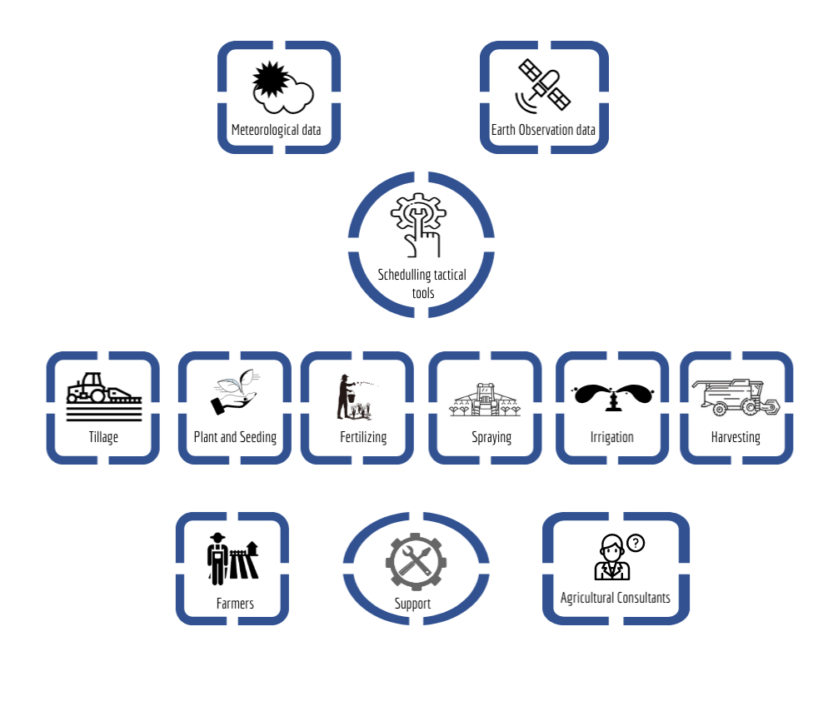
Figure 1. STARGATE’s cloud service platform flowchart (Support scheduling decisions for Tillage, Planting and Seeding, Fertilizing, Spraying, Irrigation, Harvesting)
    - Tillage scheduling algorithm description
Farming operations are associated with mechanical impacts on soils to provide optimum conditions for all processes relevant to plant production. Operations like tillage, seeding, spraying, fertilizing or harvesting are highly mechanized and require agricultural traffic in the field. Soils have to support those operations, but the soil status may include periods that are unsuitable for agricultural traffic and tillage (Müller et al., 2011). The structure of the soil is a key factor and it can often be damaged by excessive loading (Nevens et al., 2003), or by tillage being executed at inopportune times (Edwards et al., 2016).
Trafficability is a significant factor in carrying out farm field operations, especially after rainfall events when poor trafficability can cause delays in planting, cultivating, harvesting, and transporting of field crops (Müller et al., 2011). In order to protect the quality of the soil structure during planting, a decision support tool is needed for estimating and evaluating field conditions to ensure tillage operations are executed at opportune times so that the best outcomes are achieved (Edwards et al., 2016). The desired result will only be achieved if the soil has an appropriate workability. Tillage has many advantages in producing a desirable soil structure but may be harmful also (Müller et al., 2011). Intensive tillage, plowing, decreases soil stability, eliminates organic mulch from the soil surface and diminishes humus content at the soil surface and can cause greater surface crusting and erosion. If the diagnosis of the soil reveals a need for tillage, the soil’s workability becomes relevant. Main possible limitations are due to too wet or too dry soil conditions. The soil moisture status affecting mechanical behavior and aggregate friability, is the most influential factor of workability (Mosaddeghi et al., 2009).
The water content at the inflection point interpreted as the “breakthrough” matric potential of the water retention curve at which air first penetrates through the soil (midpoint between the lower plastic limit and the shrinkage limit) was found to be the optimum for tillage of Rothamsted soils. Dexter and Bird (2001) developed equations for prediction of the optimum water content for tillage, the upper tillage limit and the lower tillage limit. The soil moisture optimal value θ_{opt}, upper θ_{up.lim} and lower θ_{low.lim} values are presented in the following Eq(1‐3) according to Dexter and Bird (2001) using the parameters of the soil water retention curve model of van Genuchten (1980).
$Θ_{opt}=Θ_{r}+\frac{\left(Θ_{s}-Θ_{r}\right)}{{\left(1+\frac{1}{m}\right)}^{m}}$ (1)
$Θ_{up.lim}=Θ_{opt}+\left(Θ_{s}-Θ_{opt}\right)∙0.4$ (2)
$Θ_{low.lim}=2+\frac{Θ_{opt}∙h_{opt}}{h_{low.lim}}$ (3)
Where, h_{opt} (cm) is soil water pressure head at water content θopt, h_{up.lim} (cm) is soil water pressure head at water content θ_{up.lim}.
The tillage tool service provides personalized advice for tillage scheduling based on the computation of the optimum soil moisture conditions. The tool also provides the upper and the lower tillage limit for the best scheduling of tillage.

    - Fertilizing scheduling algorithm description
Precision agriculture comprises the technology to determine the spatial variation of soil and plant features and to transfer this information into site‐specific field operations. Variable rate fertilization within precision agriculture is applied to match spatially distributed nutrient pools and fluxes with fertilizer rates. In comparison, a uniform treatment of fields causes inevitably nutrient surpluses and undersupplies and thus is neither ecologically sound nor economically viable. The fertilizer rate is usually calculated from the balance between the natural supply by soil and environment, the nutrient demand of the crop, and inevitable losses to the environment (Haneklaus and Schung, 2005).
Precision fertilization emphasizes that farmers should use the various fertilization methods, fertilizer species and application rates according to the different types of soil, weather conditions and other factors. Nitrogen management based on remote sensing technologies is one of the most representative examples as nitrogen is found to be one of the most critical nutrients for crop growth. Crop’s nitrogen. Operational applications employ earth observations (EO) techniques, vegetation indices (VI) and algorithms, enabling to monitor their field and acquire advices on the nitrogen application fertilizer.
The STARGATE cloud service platform implements the Nitrogen Fertilization Optimization Algorithm (NFOA) methodology for the calculation of in season nitrogen requirements for three crops (wheat, cotton and corn). NFOA is applied using crop’s pilot data with different planting dates. One of the main components of the NFOA is the in‐season yield prediction using correlation between crop yield and remote sensing data. Specifically, the independent variable is the In Season Estimate of Yield (INSEY) which is obtained by dividing Normalized Difference Vegetation Index (NDVI) by the Growing Degree Days (GDD) or the days after planting (DAP). The projected midseason nitrogen requirement is based on nitrogen demand of the predicted Yield Potential (YP), while taking into account seasonally dependent crop responsiveness to applied nitrogen. The in-season site‐specific crop nitrogen deficiency and requirements can be determined by using the NFO algorithm. The NFOA has been widely applied and confirmed in various climatological regions.
The main step in the development of the NFOA include:
- Prediction of the yield potential with zero‐N fertlization (YP0) using the relationship between actual grain yield and INSEY,
- Prediction of the Response Index at Harvert (RIHarvest) using the NDVI‐based Response Index divided by mean NDVI readings of the pre‐plant nitrogen rate. In order to accomplish this step, NDVI measurements should be collected from particular growth stages,
- Determination of Yield Potential using pre‐plant nitrogen rates (YPN) and the following equation YPN=YP0*RINDVI,
- Prediction of grain nitrogen uptake (GNUP) by multiplying YPN with percent of nitrogen in the grain (PNG),
- Prediction of crop nitrogen uptake (FNUP) based on an exponential relationship between FNUP and NDVI,
- Determination of in‐season nitrogen fertilizer requirement (FNR).

    - Spraying scheduling algorithm description
Spraying in farming is one of the standard methods of applying pest‐control chemicals and other compounds to crops. In spraying, the chemicals to be applied are dissolved or suspended in water or, less commonly, in an oil‐based carrier. Using pesticides incorrectly can put people and the environment at risk. In some cases, you might also damage the treated area. A pest, weed or disease being present does not justify acting against it (DEFRA, 2006).
DEFRA (2006) advices not to apply pesticides in a way which may lead to drift. In order to do that the farmer should always check the direction and speed of the wind (in order not to cause the pesticide to drift away from the target) and also to check and avoid the chance that air movement will carry spray droplets or vapor away from the target area. This is especially important when spraying near sensitive areas. When spraying a typical field crop or grassland, the wind speed at the correct height of the nozzle (an important factor affecting drift) will be roughly half the value measured at 10 meters. If there is no crop (for example, when spraying hard surfaces in amenity areas) the wind speed at the height of the nozzle may be more than half of the value at 10 meters above the ground. As wind speed and direction will be influenced by a variety of local factors (such as the presence of trees and buildings), it is important to assess the suitability of the conditions at the area you intend to treat. The safest conditions in which to spray are when it is cool and humid with a steady wind of 3.2‐6.5 km/hr (light breeze) blowing away from any sensitive areas or neighbors’ land. Avoid spraying in the following weather conditions (DEFRA, 2006):
- when there is little or no wind under a clear sky in the morning or evening, when air layers do not mix, as any drift may hang over the treated area and unexpected air movements may move it to other places,
- when there are low winds on warm sunny afternoons when humidity is low,
- when temperatures are >30 °C, as rising air currents may carry spray droplets and vapor in an unexpected way.
The Table 1 is a guide to assessing wind speed and recommendations for standard field crop sprayers. The relationship between the wind speed at the height of the spray nozzles and the wind speed (according to the Beaufort scale, measured at a height of 10 meters above the ground) assumes that there is a crop covering the ground. If there is no crop or grass cover, the wind speed at the height of the spray nozzle will be higher.
Table 1: Guide to wind speed and using field‐crop sprayers with conventional nozzles (DEFRA, 2006)
Beaufort Scale*  [Description] | Guide for using a standard crop sprayer | Wind speed at the height of the spray nozzle
Force 0 [Calm] | Use only ‘medium’ or ‘coarse’ spray quality | <2 km/hr
Force 1 [Light air] | Acceptable spraying conditions | 2‐3.2 km/hr
Force 2 [Light breeze] | Ideal spraying conditions | 3.2‐6.5 km/hr
Force 3 [Gentle breeze] | Increased risk of spray drift. Avoid spraying herbicides and take special care with other pesticides | 6.5‐9.6 km/hr
Force 4 [Moderate breeze] | Do not spray | 9.6‐14.5 km/hr
* Measured 10 meters above the ground
The STARGATE spraying tool service provides personalized advice for spraying scheduling based on the weather conditions (wind speed and temperature) in order to avoid spraying processes and consequently improve its overall efficiency.

    - Irrigation scheduling algorithm description
The daily amount of the stored soil water is evaluated by the simple soil water balance Eq (4) in the form (all the units are in mm):
${SM}_{i}={SM}_{i-1}+{ET}_{i}-{Pe}_{i}-{IR}_{i} where D_{LAM}≤D_{i}≤D_{FC}$ (4)
Where, S_{Mi} is the soil water depth at day i, SM_{i‐1} is the soil water depth the previous day (i‐1), IR_{i} is the irrigation water, Pe_{i} is the rainfall, ET_{i} is the crop’s evapotranspiration, D_{LAM} is the stored water at the lower available moisture (LAM) limit, D_{i} is the stored water at day i, D_{FC} is the stored water at field capacity (FC) level.
In order to meet crop water demands, SM_{i} should always be greater than D_{LAM}, otherwise when SM_{i} reaches D_{LAM}, the service proposes an irrigation with a water amount equal to the useful moisture, which is computed by the Eq (5) (all units except F are in mm):
${USM}_{i}= \left(D_{FC}-D_{LAM}\right){RD}_{i}=\left[D_{FC}-F\left(D_{FC}-D_{PWP}\right)\right]{RD}_{i}$ (5)
Where, U_{SM}i is the useful moisture ‐ irrigation water amount, D_{pwp} is the stored water at the permanent wilting point moisture level, RD_{i} is the root depth at day i when the irrigation is applied (all units in mm) and F is the soil water depleted fraction [‐] (dimensionless).
The calculation of USM_{i}, the volumetric moisture at field capacity, θ_{FC}, and permanent wilting point, θ_{pwp}, are defined by the soil water retention curve model of van Genuchten (1980):
$θ\left(h\right)=Θ_{r}+\frac{\left(θ_{s}-θ_{r}\right)}{{\left(1+{\left(a\left|h\right|\right)}^{n}\right)}^{m}}$ (6)
Where, θ_{r} (cm³/cm³) is the residual soil moisture, θ_{s} (cm³/cm³) is the soil moisture at saturation, h (cm) is soil water pressure head, α (1/cm) and n are curve shape parameters. The pedotransfer functions used for this purpose were proposed by Vereecken et al. (1992).
For the irrigation scheduling service, the following Eq (7) is selected as it considered the standard in estimation of reference evapotranspiration, ΕΤ_{ο} (mm/day):
${ET}_{o}=\frac{0.408∙Δ∙\left(R_{n}-G\right)+γ∙\frac{900}{Τ+273}∙u_{2}∙\left(e_{s}-e_{a}\right)}{Δ+γ∙\left(1+0,34∙U_{2}\right)}$ (7)
Where, R_{n} net radiation at the crop surface (MJ/m²/day), G soil heat flux density (MJ/m²/day), T mean air temperature (°C), u₂ wind speed (m/s) at 2 m above the ground, es saturation vapor pressure (kPa), e_{a} actual vapor pressure (kPa), (e_{s}‐e_{a}) saturation vapor pressure deficit (kPa), Δ slope vapor pressure curve (kPa/°C), γ psychrometric constant (kPa/°C). The potential ET is calculated by multiplying ET_{o} by the crop coefficient (K_{c}) (Eq 8) (Bos et al., 2009).
$ET=K_{c}∙{ET}_{o}$ (8)
The irrigation scheduling tactical tool contains extensive crop data bases for 37 different crops (8 field crops, 15 tree crops and 14 horticultural crops). Specifically, it contains crop growth stages and the soil water depletion fraction for each crop.

    - Seeding ‐ Planting and Harvesting scheduling algorithm description
The seeding ‐ planting and harvesting scheduling tool in STARGATE cloud service platform make use of mathematical weather forecasting in conjunction with the growth stages using the GDD theory. This scheduling will be made using both short‐range and medium‐range weather forecasts. Table 2 present GDDs with the crop stages for 2 representative crops (Cotton and Maize). This scheduling will be made using both short‐range and medium‐range weather forecasts. Table 2 present GDDs with the crop stages for 2 representative crops (Cotton and Maize). According to these tables, two-time ranges are created at the beginning and end of cultivation period which are considered to be potential days of seeding (for annual cultivations only) and harvesting (for all crops) respectively. In these two-time ranges (seeding and harvesting) and in combination with the weather forecasts alerts will be given to the farmers or consultants in order to avoid or not these two very important cultivation tasks.

Table 2: GDDs for Cotton’s and Maize’s crop growth stages
Crop Stage | GDD  (Tbase=15.5 ºC) | Crop Stage | GDD  (Tbase=10 ºC)
Planting to Emergence | 27 – 34 | Planting to Emergence | 111
Emergence to First Square | 236 – 264 | Planting to 6 Collars | 264
Square to Flower | 166 – 195 | Planting to 12 Collars | 483
Planting to First Flower | 430 – 472 | Planting to Last Tassel | 630
Flower to Open Boll | 472 – 528 | Planting to Silking | 778
Planting to Harvest Ready | 1222 – 1445 | Planting to Harvest Ready | 1500
Planting to Emergence | 27 – 34 | Planting to Emergence | 111
Emergence to First Square | 236 – 264 | Planting to 6 Collars
  - Conclusions
In conclusion, this manuscript presents the methodology of a developed suite of climate smart decision tools that will support CSA (Climate Smart Agriculture) stakeholders in the decision‐making procedure. The purpose of these tools is to answer to a set of questions or to predict future values for some parameters based on weather forecasts (1‐3 and 5 days forecast). These tools were developed using the state‐of‐the‐art of precision farming methodologies using earth observations and weather data, along with crop models and machine learning algorithms in order to support the previous farming procedures. For each output variable the required degree of accuracy was specified with the contribution of stakeholders. During validation process, the output of the tools was compared against real data from the STARGATE project pilot areas. These tools will be used to support farmers and agricultural consultants to use agricultural inputs and energy more efficiently, while reducing the agricultural emissions and preserving the environment.
Acknowledgments
This work was supported by the HORIZON 2020 Project “STARGATE - reSilienT fARminG by Adaptive microclimaTe management” (project code: 818187) financed by the European Union, under the call H2020-SFS-2018-2020 / H2020-SFS-2018-2.
References
Bos M. G., Kselik R. A. L., Allen R. G., Molden D., 2009. Water requirements for irrigation and the environment. Springer.
Castrignanò A., Buttafuoco G., Khosla R., Mouazen A. M., Moshou D., Naud O., 2020, Agricultural internet of things and decision support for precision smart farming. Academic Press.
DEFRA, 2006, Pesticides. Code of practice for using plant protection products.
Dexter A. R. and Bird N. R. A., 2001, Methods for predicting the optimum and the range of soil water contents for tillage based on the water retention curve, Soil and Tillage Research, 57, 4, 203–212.
Edwards G., White D. R., Munkholm L. J. Sørensen C. G. and Lamandé M., 2016. Modelling the readiness of soil for different methods of tillage, Soil and Tillage Research, 155, 339–350.
Haneklaus S. and Schung E., 2005, Precision Agriculture and Fertilization, in Encyclopedia of Soil Science (2nd ed.), R. Lal, Ed. Taylor & Francis Grou, 1364–1366.
Mosaddeghi M. R., Morshedizad M., Mahboubi A. A., Dexter A. R. and Schulin R., 2009, Laboratory evaluation of a model for soil crumbling for prediction of the optimum soil water content for tillage, Soil and Tillage Research, 105, 2, 242–250.
Müller L., Lipiec J., Kornecki T. S., Gebhardt S., Glinksi J. and Horabik J., 2021, Trafficability and workability of soils, Encyclopedia of Agrophysics, 912–924.
Nevens F. and Reheul D., 2003, The consequences of wheel‐induced soil compaction and subsoiling for silage maize on a sandy loam soil in Belgium, Soil and Tillage Research, 70, 2, 175–184.
Pantazi X. E., Moshou D., Bochtis, D., 2020, Intelligent Data Mining and Fusion Systems in Agriculture. Academic Press.
Van Genuchten M. T., 1980. A Closed‐form Equation for Predicting the Hydraulic Conductivity of Unsaturated Soils, Soil Science Society of America Journal, 44, 5, 892, 1980.
Vereecken H., Diels J., Van Orshoven J., Feyen J. and Bouma J., 1992, Functional Evaluation of Pedotransfer Functions for the Estimation of Soil Hydraulic Properties, Soil Science Society of America Journal, 56, 5, 371–1378.

