CHEMICAL ENGINEERING TRANSACTIONS  VOL. , 2023 | A publication of
The Italian Association
of Chemical Engineering
Online at www.cetjournal.it

Guest Editors: Laura Piazza, Mauro Moresi, Francesco Donsì
Copyright © 2023, AIDIC Servizi S.r.l.
ISBN 979-12-81206-01-4; ISSN 2283-9216
Exploring spherification with some foods of the Mediterranean Diet
Vanessa Silvaª, Célia Quintas^{ab,}*, Isabel Ratão^{ab}, Patrícia Nunes^{ab}
ª Instituto Superior de Engenharia, Universidade do Algarve, Campus da Penha, 8005-139 Faro, Portugal
^{b}MED–Mediterranean Institute for Agriculture, Environment and Development & CHANGE–Global Change and Sustainability Institute, Faculty of Sciences and Technology, Universidade do Algarve, Campus de Gambelas, Faro, 8005-139, Portugal
*cquintas@ualg.pt
The eating habits of the Mediterranean Diet (MD) represent a complete and balanced food model with numerous benefits for health. However, these eating models are deteriorating due to the popularization of foods typical of societies that have less healthy habits. As a result, strategies must be developed to bring consumers closer to the ingredients/food of the MD. Science has made available various ingredients and techniques that have allowed the development of new textures and flavours. The objective of the present study was to explore the possibility of applying the spherification technique, using sodium alginate and calcium gluconolactate, to produce changes in the texture of some foods/ingredients of the MD, developing the following food preparations: A) Liquid core hydrogel table olives (LCHTO) using a macerate and their dilutions, by reverse spherification; B) Wine pearls using liqueur wine (reduced and non-reduced); C) Vinegar pearls using local fig and grape vinegars. The reverse spherification method resulted in adequate LCHTO when the most diluted macerate of table olives (1:4) was selected and the best pearls were obtained when spherification was applied to reduced liquor wine and fig vinegar in 1.0% sodium alginate solution.

- Introduction
The Mediterranean Diet (MD) is a sociocultural model based on a set of skills, knowledge, symbols, rhythms, and traditions related to farming, harvests, animal husbandry, fishing, food cooking and sharing and consumption of food. It is a way of life that depends on the sustainable use of environmental resources (Delgado et al., 2022).
Due to Ancel Keys studies, carried out in the twentieth century, the MD has been recognized as a health-promoting “way of eating”, with a common basis associated with the production and consumption of olive products (olive oil and table olives), cereals, and wine, also known as the Mediterranean trilogy (Keys, 1995). This diet pattern is also characterized by an abundant consumption of vegetables, fruits, and legumes as well as reduced consumption of meat and fish (except in places near the coast). One of the important aspects of the Mediterranean way of cooking included acidification with vinegar and lemon, a practice that contributed to the flavour, texture, and preservation of food (Delgado et al., 2022).
Despite the “way of eating” of the MD being healthier, studies carried out in North America, Europe or Oceania (Rosi et al., 2019) including the Mediterranean countries, have shown that the population is moving away from the Mediterranean food habits (Bôto et al., 2021; Mariscal-Arcas et al., 2009). In fact, these food habits are deteriorating mainly due to the popularization of food products and practices characteristic of societies that have less balanced eating habits. It is a fragile heritage important for health, but also for the identity and culture of the regions. Therefore, UNESCO decided to preserve it through the inscription on the Representative List of the Intangible Cultural Heritage of Humanity, with the status of a fragile and valuable asset that needs to be preserved for future generations (Delgado et al., 2022). For this reason, strategies must be developed to bring consumers as close as possible to the ingredients/food of the MD, including the presentation of traditional products in a more appealing way to the consumer.
During the last decades, science and technology have made available to food science a huge amount of ingredients (emulsifiers, gelling agents, stabilizers, and others) and techniques (flash-freezing, froth, spherification, and others) that have allowed the creation of new textures and the combination of unusual flavours (Vega and Ubbink, 2012).
Spherification is a technique used in food science and molecular gastronomy and applied in the present study in order to obtain liquid core hydrogel table olives (LCHTO), and pearls of wines and vinegars. There are two types of spherification, basic spherification and reverse spherification (Kasunmala et al., 2020). In basic spherification, sodium alginate, is mixed with a liquified product and injected into a Ca²⁺ solution. Then, Ca²⁺ enters in the alginate droplets forming calcium alginate bridges from the external to the internal side of the droplets. In the reverse spherification technique, the calcium source (calcium gluconolactate) is incorporated into a liquified product and injected into the alginate solution. Ca²⁺ diffuses out from the droplets to the alginate solution and a calcium alginate coating is formed, which when bitten in the mouth gives a bursting sensation (Lee and Rogers, 2012; Tsai et al., 2017). The great challenge related to spherification is the choice of the correct acidity and calcium concentration, and the most appropriate solution concentration and density of flavouring agents (Vega et al., 2012). Sodium alginate (E401) is an emulsifier, stabilizer, gelling agent and thickener extracted from brown seaweed. As a gelling agent, it acts by forming a gel in the presence of calcium, through a two-phase system consisting of a three-dimensional network that retains a liquid phase in its mesh, allowing spherification. Alginate has also been used in the immobilization of microorganisms and enzymes for the production of food flavors (Padilha et al., 2013) and to encapsulate probiotic bacteria (Spigno et al., 2015). Alginate behaves like dietary fiber, with poor digestibility and a low energy value (Cong et al., 2021).
In the present study, sodium alginate was tested to produce changes in the texture of some foods associated with the MD in order to obtain different applications of those foods and draw attention to these ingredients/foods by increasing their appeal to the population. The food products selected were table olives, liquor wines, and vinegar, all produced locally. Although worldwide wines have a very positive image, table olives have a negative image for many consumers because they are associated with a high-fat content, which olive oil also contains but does not have the same negative image. Fermented table olives are characterized by having a composition rich in essential nutrients that promote health (vitamins, monounsaturated fatty acid, and phenolic compounds, among others) and are recognized as a vehicle for beneficial microorganisms (Pires-Cabral et al., 2019). For these reasons, this work was carried out with a publicly recognized liqueur wine and table olives, a food less accepted by consumers. In addition, local vinegars were also included in the study in order to try to mix flavours. Thus, the objective of the present study was to explore the possibility of applying the spherification technique to develop new formulations using the previously mentioned elements of the MD.
- Material and Methods
Natural green table olives, produced locally were obtained in the market in Faro, Algarve, Portugal. The liqueur wine and vinegars (fig and grape) were purchased from local producers. Materials used to produce the hydrogel table olives and pearls were sodium alginate (Sosa, Spain), and calcium gluconate (Sosa, Spain). All compounds used were food-grade certified.
  - Preparation of liquid core hydrogel table olives (LCHTO)
The LCHTO were produced according to Figure 1. A mass of 4 g of sodium alginate was added to 940 mL of water and mixed continuously at a temperature of 65 °C until complete dissolution of the alginate. Then, the solution rested in the refrigerator at 4 °C for 30 min. A total of 670 g of pitted olives were crushed with a hand blender (Taurus BAPI600W ergonomic, Spain) to form an olive paste and then the pulp was separated from the juice using a strainer. Next, 4 g of calcium gluconolactate were added to 200 mL of olive juice previously obtained and mixed well until a homogeneous mixture was obtained. Dilutions of 1:2 and 1:4 of the juice were also tested. Small portions of the mixtures (alginate with olive juice, olive juice diluted 1:2, and olive juice diluted 1:4) were transferred to the moulds and placed in the freezer. After 90 min, the content of moulds was removed from the freezer and placed directly in an alginate solution (18 ˚C) for 10 s. Then, the LCHTO formed were transferred to a distilled water bath to remove the excess alginate.
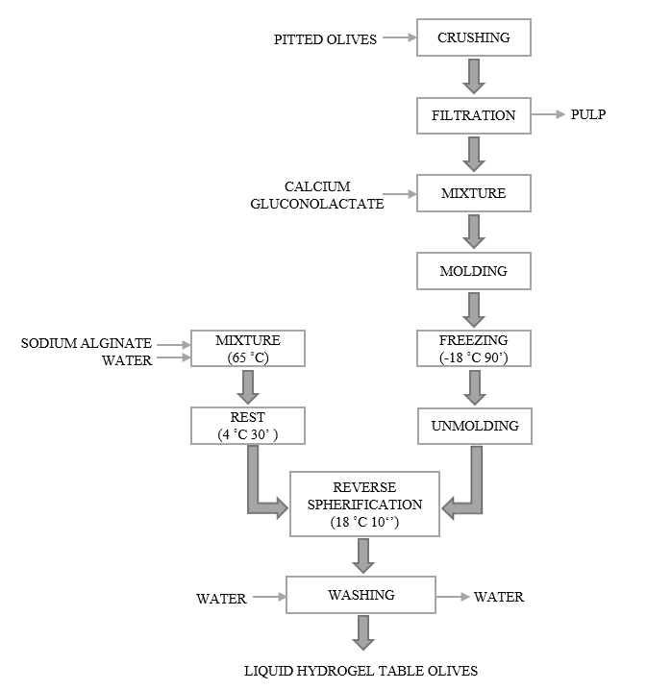
Figure 1. Liquid core hydrogel table olives (LCHTO) production diagram.
  - Preparation of wine pearls
The wine pearls were obtained following the procedure represented in Figure 2. The liqueur wine was divided: one part was boiled for 10 min (reduced) and the other part was not boiled (not-reduced). Then the alginate was dissolved in the previously prepared wines in order to test different concentrations (0.5%, 1.0% and 1.5%, w/v). After the complete dissolution of the alginate in the wines, the solutions were cooled to room temperature. A plastic Pasteur pipette was used to drip the wine and alginate solution (with different concentrations) into the calcium gluconolactate solution (2 %, w/v), allowing wine pearls to form. During the formation of the wine pearls, the calcium solution was stirred continuously to allow their correct spherification. The pearls remained inside the calcium solution while being stirred for 15 min. After the correct gelation, the wine pearls were removed and washed with distilled water to eliminate excessive calcium. The wine pearls were then maintained in a wine solution for up to 3 h, under refrigeration, until plating.
  - Preparation of fig vinegar and grape vinegar pearls
The fig and grape vinegar pearls were prepared similarly to the liqueur wine pearls. The procedure was similar to the one represented in Figure 2, but without the boiling step. Different percentages of sodium alginate (0.5 %, 1.0 % and 1.5%, w/v) were initially dissolved in the vinegars. After the vinegar pearls formed, they were removed and washed with distilled water to eliminate the excessive calcium. The vinegar pearls were maintained in vinegar (6 % of acidity) for up to 3 h, under refrigeration, until plating.
  - Data analysis
All the experiments were done in triplicate. In order to select the most adequate processing, at the end of each method, the products obtained were evaluated for texture and bitterness by a panel of nine people. The texture was evaluated with a sensory scale from very soft (1) to very hard (6) and the bitterness from low bitterness (1) to high bitterness (6). The data obtained were reported as means ± SD, using Microsoft Excel 365.
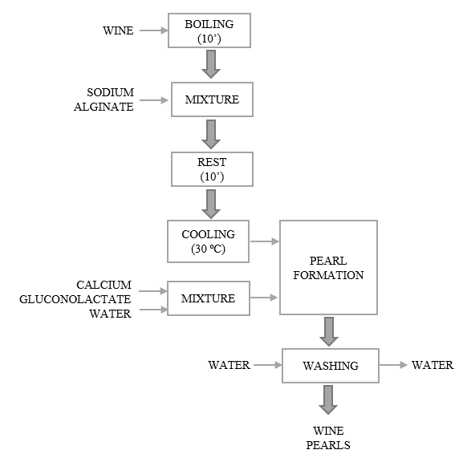
Figure 2. Wine pearls production diagram.
- Results and Discussion
The present study revealed that spherification can be used to produce differential products enclosed in a thin alginate membrane that, when consumed, pops open to release a burst of flavour in the mouth. When the spheres burst, they awaken new sensations and curiosity in consumers. In regards to the experiments of liquid core hydrogel table olives (LCHTO), three formulations were prepared using non-diluted and diluted (1:2 and 1:4) olive juice. Regarding texture, the results were similar for the three formulations (5.44, 5.78, 5,89), and in relation to bitterness, the formula prepared with the diluted (1:4) olive juice got the better evaluation (1.22±0.44) (Table 1) (Figure 3a). The LCHTO obtained with non-diluted and 1:2 dilution natural table olive juice were too bitter and immediately rejected. The olives used in the present work were processed according to the natural type of processing, where olives are brined in saline solutions (NaCl 8%) after harvesting and washing, without going through a NaOH treatment or any other action to debitter, and left to ferment until they lose their bitterness, at least partially. This type of olives “natural green olives” are different from the lye-treated ones (Spanish method), mainly due to their taste and residual bitterness (Pires-Cabral et al, 2018).
Table 1. Texture and bitterness evaluation of the studied products (LCHTO - liquid core hydrogel table olives)
Product | Texture |  | Bitterness
 | Average | SD | Average | SD
Wine pearls (0,5%) | 1,22 | 0,44 | - | -
Wine pearls (1%) | 3,89 | 0,33 | - | -
Wine pearls (1,5%) | 5,67 | 0,71 | - | -
Vinegar pearls (0,5%) | 1,11 | 0,33 | - | -
Vinegar pearls (1%) | 3,67 | 0,71 | - | -
vinegar pearls (1,5%) | 5,78 | 0,44 | - | -
LCHTO (without dilution) | 5,44 | 0,73 | 5,78 | 0,67
LCHTO (dilution 1:2) | 5,78 | 0,44 | 1,44 | 0,53
LCHTO (dilution 1:4) | 5,89 | 0,33 | 1,22 | 0,44

The reverse spherification was also applied successfully in the preparation of liquid core hydrogel spheres using diluted fruit pulp (Kasunmala et al., 2012).
The other products developed were wine pearls and vinegar (fig and grape) pearls. Three different formulations were assayed using different concentrations of alginate (0.5%, 1.0%, 1.5%) and the results of texture evaluation are summarized in Table 1. The wine and fig vinegar pearls produced with 1.0% of alginate presented the best texture (Figure 3b and Figure 3c). Other studies also used 1.0% of alginate to obtain direct and reverse spherification. However, the grape vinegar was not suitable to produce pearls using spherification with alginate, probably because of its low pH (2.8) compared to fig vinegar (3.5). Acidic solutions normally prevent gel formation and spherification of alginate (Moura, 2011). Spherification has various advantages, such as its application in molecular gastronomy, allowing consumers to taste new textures. The size of the spheres, which vary between millimeters and micrometers, will enhance their use in different combinations with foods and drinks. An important application of these spheres is the development of innovative foods and drink formulations (snacks, desserts, juices, cocktails, etc). Spherification requires pH value and calcium content control because of the unpleasant taste when excessive calcium is present on pearls after gelation (Aguilera, 2018; Fu et al., 2014; Sunarharum et al., 2019). Textural properties (hardness, cohesiveness, elasticity and gumminess) of the spheres are also important (Saqib et al., 2022). Bubin et al. (2019) characterized pitaya pearls and concluded that the consumer’s preference is related to the pearls’ texture and these should be soft enough to burst with a pleasurable chewing sensation.
The storage conditions are very important after the formation of pearls before plating. In this study, the best conditions for the pearls (wine and vinegar) during storage were at refrigeration at 4 ˚C for up to 3 h. Other authors obtained similar storage temperatures but for longer period of time (Bubin et al., 2019).
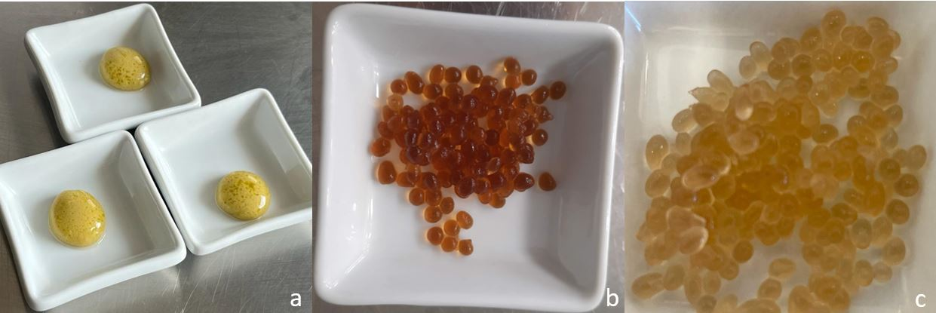
Figure 3. Liquid core hydrogel table olives (LCHTO) (a), wine pearls (b) and fig vinegar pearls (c).
- Conclusion
Reverse spherification was revealed as a technique adequate to produce liquid core hydrogel table olives (LCHTO), and spherification resulted in interesting small spheres (pearls) that could be used to enrich various plates with taste and emotions. LCHTO prepared with the olive juice diluted (1:4) resulted in the most balanced spheres in terms of bitterness (low bitterness: 1.22±0.44) as well as in the best texture (5.89±0,33). The best fig vinegar pearls and reduced wine pearls were obtained with 1.0% (w/v) sodium alginate solution used for spherification, followed by storage at 4 ˚C for a short period of time (for up to 3h). Storage of these new products (LCHTO and pearls) at room temperature (20 ˚C) didn’t preserve texture stability after 30 min of preparation which means that these products must be consumed immediately after their production.
Future studies will be done using the spherification techniques to change the textures of less appreciated food items/ingredients typical of the Mediterranean diet and increase the population's curiosity about their consumption.

Acknowledgments
This research was funded by project 072592 - Hospitality, Sustainability and Tourism Experiences Innovation Lab (HOSTLAB) supported by the program CRESC ALGARVE 2020. The authors would like to acknowledge the support of the Foundation for Science and Technology (FCT) through project MED/UIDB/05183/2020. The authors also acknowledge Instituto Superior de Engenharia, Universidade do Algarve, for the utilization of specific laboratories.

References
Aguilera, J. M., 2018, Relating Food Engineering to Cooking and Gastronomy. Comprehensive Reviews in Food Science and Food Safety,17, 1021-1039.
Bôto, J. M., Marreiros, A., Diogo, P., Pinto, E., Mateus, M.P., 2021, Health behaviours as predictors of the Mediterranean diet adherence: a decision tree approach. Public Health Nutrition, 9,1-13.
Bubin, S. F. A., Shukri, S. M. A. R., Ibadullah, W. Z. W., Ramli, N. S., Mustapha, N. A., Rashedi, I. F. M., 2019, Characterization and stability of pitaya pearls from hydrocolloids by reverse spherification, International Journal of Food Properties, 22,1353-1364.
Cong, L., Zou B., Palacios, A., Navarro, M. E., Qiao, G., Ding, Y., 2021, Thickening and gelling agents for formulation of thermal energy storage materials – A critical review. Renewable and Sustainable Energy Reviews, 155, 111906.
Delgado, A., Cruz, A L, Coelho, N., Romano, A., 2022, The Mediterranean Diet: Fostering a common vision through a multidisciplinary approach. University of Algarve. ISBN 978-989-9023-88-8.
Fu, H., Liu, Y., Adriá, F., Shao, X., Cai, W., & Chipot, C., 2014, From material science to avant-garde cuisine. The art of shaping liquids into spheres. Journal of Physical Chemistry B, 118, 11747–11756.
Kasunmala I. G. G., Bandara Navarathne S., Wickramasinghe I., 2020, Preparation of liquid-core hydrogel beads using antioxidant-rich Syzygium caryophyllatum fruit pulp as a healthy snack. Journal of Texture Studies, 51, 937-947.
Keys, A., 1995, Mediterranean diet and public health: personal reflections. The American Journal of Clinical Nutrition, 61(6, suppl), 1321-1323.
Lee, P., Rogers, M. A., 2012, Effect of calcium source and exposure time on basic caviar spherification using sodium alginate. International Journal of Gastronomy and Food Science, 1, 96–100.
Mariscal-Arcas, M., Rivas, A., Velasco, J., Ortega, M., Caballero, A., Olea-Serrano, F., 2009, Evaluation of the Mediterranean Diet Quality Index (KIDMED) in children and adolescents in Southern Spain. Public Health Nutrition. 12, 1408-1412.
Moura, J., 2011, Cozinha com ciência e arte. Bertrand Editora, Lisboa, Portugal.
Padilha, G. S., de Barros, A., Alegre, R. M., Tambourgi, E. B., 2013, Production of ethyl valerate from Burkholderia cepacia lipase immobilized in alginate. Chemical Engineering Transactions, 32, 1063-1068
Pires-Cabral, P., Barros, T., Nunes, P., Quintas, C., 2019, Physicochemical, nutritional and microbiological characteristics of traditional table olives from Southern Portugal. Emirates Journal of Food and Agriculture, 611-620.
Rosi, A., Paolella, G., Biasini, B., Scazzina, F., 2019, SINU Working Group on Nutritional Surveillance in Adolescents. Dietary habits of adolescents living in North America, Europe or Oceania: A review on fruit, vegetable and legume consumption, sodium intake, and adherence to the Mediterranean Diet. Nutrition, Metabolism and Cardiovascular Diseases, 29, 544-560.
Saqib, Md. N., Khaled, B. M., Liu, F., Zhong., F., 2022, Hydrogel beads for designing future foods: Structures, mechanisms, applications, and challenges. Food Hydrocolloids for Health, 2, 100073.
Spigno, G., Garrido, G. D., Guidesi, E, Elli. M., 2015, Spray-Drying Encapsulation of Probiotics for Ice-Cream
Application. Chemical Engineering Transactions, 43, 49-54.
Sunarharum, W.B., Kambodji, A.D. Nur, M., 2019, The physical properties of coffee caviar as influence by sodium alginate concentration and calcium sources. IOP Conference Series: Earth and Environmental Science, 475.
Tsai, F. H., Chiang, P. Y., Kitamura, Y., Kokawa, M., Islam, M. Z., 2017, Producing liquid-core hydrogel beads by reverse spherification: Effect of secondary gelation on physical properties and release characteristics. Food Hydrocolloids, 62, 140–148.
Vega, C., Ubbink, J., Van der Linden, E., 2012, The Kitchen as Laboratory: Reflections on the Science of Food and Cooking; Columbia University Press: New York.

