CHEMICAL ENGINEERING TRANSACTIONS  VOL. , 2023 | A publication of
The Italian Association
of Chemical Engineering
Online at www.cetjournal.it

Guest Editors: Laura Piazza, Mauro Moresi, Francesco Donsì
Copyright © 2023, AIDIC Servizi S.r.l.
ISBN 979-12-81206-01-4; ISSN 2283-9216

Preparing Chemical Engineering Undergraduates for Food Production with an Elective Course
Margot Vigeantª
ªBucknell University, 1 Dent Drive, Lewisburg PA 17837 USA
mvigeant@bucknell.edu
Chemical Engineering is the engineering discipline that focuses on chemical transformations of lower value raw materials to higher value products. As such, a significant number of graduates work in food process industries, the core of cooking is chemical transformation after all. While the typical Chemical Engineering undergraduate program addresses core concepts common in food processing such as heat transfer, fluid flow, and control systems, it does not necessarily show these concepts within food-related contexts. Further, it is important to introduce students to the regulatory, ethical, and above all cultural context for food processing which is very different from that of typical chemical production contexts. This poster will describe the content, format, and outcomes of a one-semester Applied Food Science and Engineering course for undergraduate engineers which seeks to address these lacks and provide industry-ready graduates who are prepared to produce food products at scale and with an eye to doing so with the health of the public and the environment in mind.

The course is a four-credit-hour course with a laboratory component, taught in a food-safe laboratory. The core audience of the course is senior-level students, although others are also welcome. By the senior year, students are familiar with fluid flow, heat and mass transfer, thermodynamics, reaction kinetics, and are also taking their controls and process design courses. The core food-science related course outcomes are for students to develop: 1) Their understanding of the chemical constituents of foods; 2) A familiarity with the most common reaction families in food production; 3) An understanding of the colloid and surface chemistry that occurs in many food systems; 4) An understanding of approaches to food preservation; 5) Conversant knowledge in the regulatory framework that oversees food and beverage production and finally 6) Their understanding of food processes within the lens of ethics, culture, and sustainability. This ambitious set of goals is undertaken through problem-based learning, wherein the entire course is broken into about six real-world problems. Student teams are challenged to assemble a report that addresses the problem, and spend two weeks researching, experimenting, and discussing aspects of the problem with faculty and each other. Each problem is carefully selected to hit a variety of outcomes from the above list.
  - Introduction

Undergraduate Chemical Engineering students are preparing for a career centred on the conversion of raw materials to value-added products through chemical transformations. For the last century, this has revolved around the petroleum industry and petroleum-derived products. More recently, at our institution, we have seen a broad diversification of industry-sector for student employment. No longer do most students go into petroleum industries, now they are well divided across speciality chemicals, pharmaceuticals, environmental applications, applications outside of the chemical industry, and food and beverage production. In order to better prepare students who see themselves in the food and beverage industry, we began offering an elective course in Applied Food Science and Engineering.
  - Course design
The Applied Food Science & Engineering (AFSE) course is a four credit-hour course, typically meeting in two two-hour blocks weekly. The course meets in a hybrid classroom-laboratory space, so experimentation can be seamlessly blended with lecture and discussion. The course is an upper-level elective taken by 3rd and 4th year undergraduate students in chemical engineering and occasionally by students in other engineering or science disciplines.
    - Course outcomes
Formal overall course outcomes for AFSE are shown in Table 1. These outcomes relate to those specified by United States Engineering College accreditation (ABET) as well as the general education requirements of the university. Outcome 5 embeds learning about food safety and environmental impact. These objectives intentionally omit introductions to a number of food manufacturing processes such as mixing, heating, and extruding because those topics are covered elsewhere in the required chemical engineering curriculum, but not in a food context. This course is intended to layer the food context on top of the disciplinary knowledge the students have already gained.
Table 1: Table title using style [Style: CET Table title]
Outcome # | Outcome text | ABET program educational objective (ABET, 2023)
1 | Become familiar with key aspects of the science of food composition, materials, physicochemistry, preparation, characterization, preservation, and flavour. Develop a unified understanding of food science theory and practice | Criterion 3.1
2 | Explore how food products are prepared at the home, food service, and industrial scales and how and why these processes differ with scale and over the course of history. | Criterion 3.4
3 | Formulate and test hypotheses about food behaviour, collect and analyze results, expose results to peer review and offer peer review of others’ analysis as an approach to demonstrating an understanding of the ways scientific ideas are formulated, modified, and come to be accepted | Criterion 3.6
4 | Design good solutions to several actual food-engineering and food-science problems. | Criterion 3.2
5 | Attain familiarity with current safety, cultural, business, regulatory, political, financial, and ethical implications of food and food production. Reflect on the historical bases for these implications. | Criterion 3.2
6 | Practice persuasive communication, experimental design, and life-long-learning skills such as finding your own information, identifying and addressing potential market needs, and persevering in the face of failure | Criterion 3.3

Item 1 from Table 1 is further subdivided into its specific food-related components: a) Their understanding of the chemical constituents of foods; b) A familiarity with the most common reaction families in food production; c) An understanding of the colloid and surface chemistry that occurs in many food systems; d) An understanding of approaches to food preservation.
    - Pedagogical approach
Problem-based learning (PBL) is an inductive learning approach (Prince and Felder, 2006). A typical lecture-based course is set up in a deductive manner; that is, the instructor lectures on the concepts that lead up to the overall application, and then asks students to apply what they have learned. In PBL, by contrast, students are first presented with a real-world challenge and asked to address it. The problem is constructed in such a way that students must engage with the relevant course concepts in order to craft their solution. For example, a PBL approach to teaching the ideal gas law might be to ask students to design bicycle tires that maintain an equal degree of inflation in summer and winter, requiring them to develop an understanding of the interrelations between pressure, temperature, volume, and amount of air. This approach helps students recall and apply material better than conventional approaches, deepens their conceptual understanding, and helps their metacognition (Prince and Felder, 2006). It also more closely mimics the way problems occur in the industry and therefore is helpful for training future professionals.

The instructor for AFSE developed a table with a column for each course outcome / sub-course outcome, and then put possible problems to drive the course in rows. The goal of this exercise was to ensure that each course outcome was addressed, usually at least twice, over the course of the semester. A typical course offering has five-six large problems driving the work for two weeks of class time each, meaning each problem embeds several course outcomes. A selection of problems used is shown in Section 3.
    - Course schedule
The course schedule is adapted to the PBL approach and runs on a 5-day cycle as shown in Table 2. On the first day, the problem for the next two weeks is introduced. A well-designed problem should be difficult to answer and require knowledge the students don’t have on day one, so this is intentionally a day with some intellectual struggle to it. The students’ first action on this day is to discuss with their peers what they feel they need to know in order to address the problem. The instructor and the students then work together to list and group the questions and come up with a plan to address them all.
The questions asked by the students are sorted into one of three categories: A) questions to be addressed through experimentation B) questions to be addressed by lecture and C) questions to be addressed by readings /media. Over the following days, in addition to the activities in Table 2, the instructor provides the relevant lectures and readings, while the remainder of class time is devoted to conducting the experiments that will help address the remaining questions. Students work in small groups on their hypotheses, experiments, and results, and then share everything they learn with the entire class in a peer-review process. In this way, every student has access to the answer to every question that was raised, which enables them to complete their own answer to the original problem by the fifth class meeting. Then the cycle repeats.
Table 2: Typical weekly schedule
Day # | Daily Goal | Materials Due
1 | Problem start | Questions about the problem
2 | Hypothesis formation | Hypothesis and experimental plan
3 | Conduct experiments | Experimental protocol
4 | Share results & Peer Review | Results of experiments
5 | Report out solution | Report on design problem solution

  - Course content
In order to keep things fresh and fair across different course offerings, the PBL problems used are varied from year to year. A sampling of past problems is shown in Table 3, along with the enumeration of which course outcomes each problem addresses.
Table 3: PBL problems used
Problem Name | Problem Description | Outcomes Addressed (Table 1)
Save Me | Process a fresh fruit or vegetable to make it shelf-stable without refrigeration | 1a, 1d, 2, 3, 5
Chocolate coated | Make a better chocolate-dipped strawberry | 1c, 2, 3, 5
Roasted | Perfectly cook a meat or meat replacement | 1a, 1b, 3, 5
Cracker manufacture | Develop a process for making crackers | 1b, 2, 3, 4, 5, 6
A better ice pop | At the scale of a small business, make “better” ice pops | 1c, 1d, 2, 3, 4, 5, 6
Entrepreneurial freestyle | Identify a market need and propose a product to fill that need along with the process to make that product | 2, 3, 4, 5, 6

Figure 1 shows what students are given to start a problem. Note that there is an intentional lack of detail in the problem statement in order to allow space for students to ask questions and formulate a wide range of solutions. Even though the problem is broad, it does force students to grapple with the relevant course content, in this case, how food preservation works. Other problems behave similarly. For example, the problem of charging students with the production of a “better” ice pop does not define the term “better”. Instead, students must build the case that what they are proposing is indeed better, further contributing to their learning. Figure 2 shows a segment of the course website interface, where students can access the problem statement, upload their own work, and access readings and videos. This website is publicly available after the course ends, please contact the corresponding author for access.
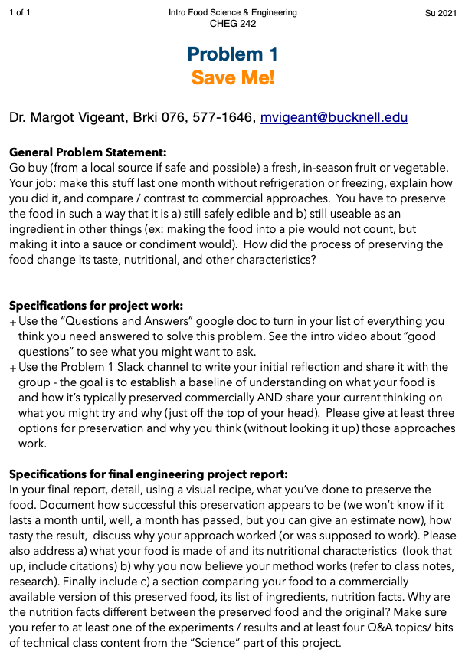
Figure 1: Text of a typical problem statement

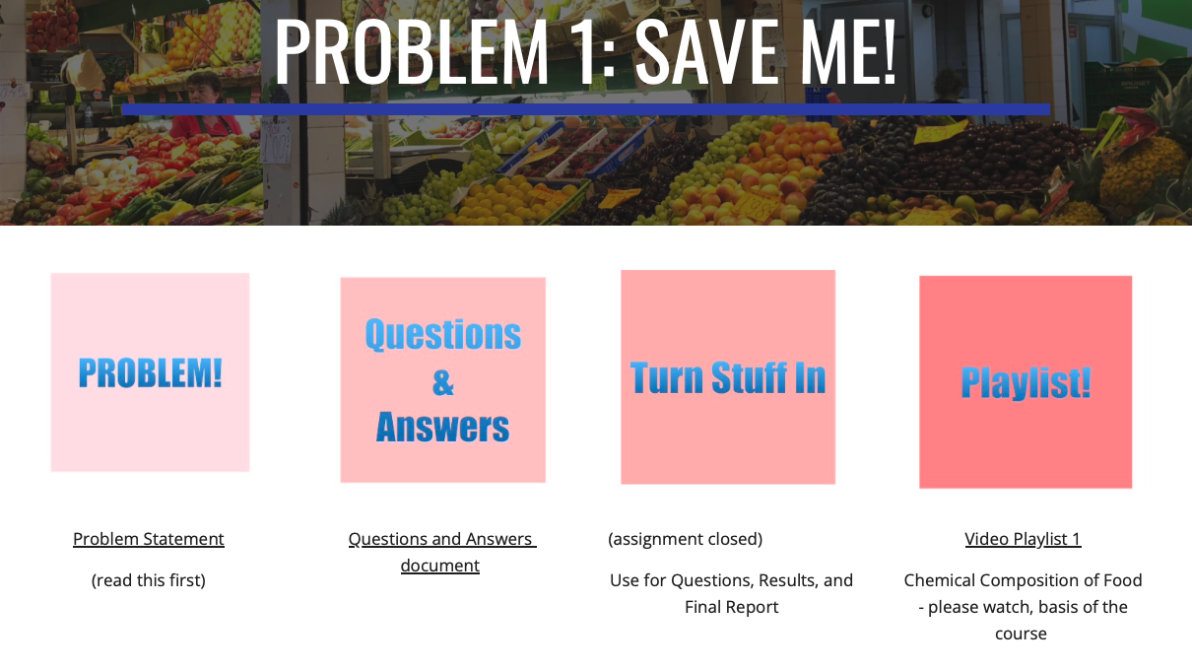
Figure 2: Webpage with an interface for a given problem; reading list to compliment playlist not shown
As an example of what students did as part of the “Save me” problem, the instructor shared lectures on water activity, fermentation, canning, and heat transfer. Students performed experiments on the behaviour of fruits when dried for different times and at different temperatures, when frozen by different approaches, and on how much water could be extracted from fresh vegetables by salting them. Then the final solutions to the problems that students developed ranged from making salted lemons, to tomato sauce, to attempting pickled bananas (the last with mixed success.) In presenting their final problem solution, students are required to report how it “works” – that is, what class concepts contribute to the success of their solution. For example, the student who created salted lemons made a video in which they explained how the salt lowered water activity, contributing to the preservation of the fruit. Figure 3 shows a screenshot from this student’s report (used with permission).

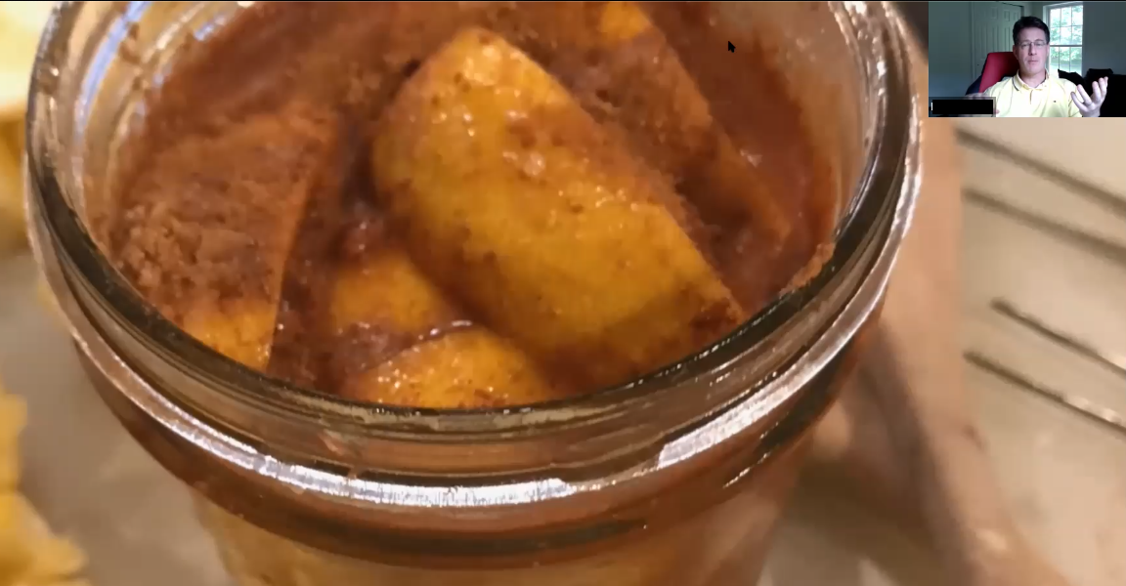
Figure 3: Screenshot of student-report video on the preservation of lemons

In addition to turning in the problem solution in the form of a report, students also completed a shared blog with the answers to all of the questions they asked at the start of the problem cycle. This serves as a stable document for all of the knowledge gained in class through reading, lecture, and experiments and is also available to the public through the course website.
The final problem given in the course (Table 3) is “Entrepreneurial Freestyle” in which students are encouraged to observe their environment and find a food-related problem that needs solving. This final problem results in a wide range of problems and solutions – from identifying the need for a tapas-inspired pre-packaged snack food to drafting a phone app to reduce food waste on campus. By the end of the course, through this portfolio of solved problems and answered questions, students demonstrate attainment of all course objectives more thoroughly than they could if they simply had a mid-term and a final exam.
  - Conclusions
We offer Applied Food Science and Engineering as a potential model course for other food-adjacent majors wishing to make careers in food and beverage production more accessible to their students. It is difficult to demonstrate the change created by this course, because prior to its offering, there was nothing similar offered. But indications that the course has been successful in achieving its educational goals include students’ achievement of competency in the course outcomes, that the course has run at or near its upper capacity limit every time it has been offered, and that a number of students have gone on to work in the food and beverage industry post-graduation. Problem-based learning is a well-documented tool for instruction that is a good fit for this topic area. Further, by working with problems, we naturally invite students to think about the myriad cultural, social, legal, and political implications of food and beverage production.

References

ABET, 2023, Criteria for Engineering Accreditation, ABET < www.abet.org/accreditation/accreditation-criteria/criteria-for-accrediting-engineering-programs-2022-2023> accessed 9.03.2023.
Prince, M. J. and Felder, R. M., 2006, Inductive Teaching and Learning Methods: Definitions, Comparisons, and Research Bases, Journal of Engineering Education, 95(2), 123-138.

