CHEMICAL ENGINEERING TRANSACTIONS  VOL. , 2023 | A publication of
The Italian Association
of Chemical Engineering
Online at www.cetjournal.it

Guest Editors:
Copyright © 2023, AIDIC Servizi S.r.l.
ISBN 979-12-81206-XX-X; ISSN 2283-9216

Impact of ozone on the rheological and morphological properties of quinoa starch
Giselle V. C. Ramosª, Cynthia Ditchfield^{b}, Ivanise G. Branco^{c}, Paulo J. A. Sobral^{b,d}, Izabel C. F. Moraes^{a,b}*
ªPostgraduate Program in Materials Science and Engineering, University of São Paulo, USP/FZEA
^{b}Department of Food Engineering (ZEA), College of Zootechnics and Food Engineering (FZEA), University of São Paulo (USP), Pirassununga, SP, Brazil.
^{c}Department of Biological Sciences (DCB), College of Sciences and Letters (FCL), São Paulo State University (UNESP), Assis, SP, Brazil.
^{d}Food Research Center (FoRC), University of São Paulo, São Paulo, SP, Brazil
bel@usp.br
Native starch has limitations such as low water solubility and high viscosity. Ozone treatment is a green technique that can be used to modify starch by oxidation without generating waste. Quinoa starch suspensions (10wt%, db) were submitted to the modification process by the application of ozone at different times (OGT = 10, 20 and 30 min), with native starch as the control. Morphological, solubility in water (SW), swelling power (SP) and rheological characterizations were carried out to evaluate the properties of native and oxidized starches. SW values were lower (37.4%) and SP values were slightly lower (6.0%) for native starch and starch modified by 10 min of OGT, when compared to starches with 20 and 30 min of OGT. This indicates a weakening of the bonds in the crystalline region with the longest ozonation times influencing the swelling of the granules and allowing them to absorb water more easily. The rheological tests showed that all samples (5 g gelatinized starch/100 g) had pseudoplastic behavior, with increased pseudoplasticity, consistency index and apparent viscosity, with increasing OGT. The increase in rheological properties after ozone treatment can be attributed to the crosslinking effect. On the other hand, the increase in pseudoplasticity can be explained by the partial depolymerization of amorphous and crystalline lamellae compounds during starch oxidation. Frequency scanning sweep indicated that all samples exhibited weak gel behavior (storage modulus G'>G” loss modulus), without crossing of these moduli. Native starch had the highest G’ and G” values when compared to ozonized starches. No difference was observed in gelatinization temperature and granule morphology after ozone treatment. The differences in the flow and viscoelastic properties can be interesting for different applications, such as thickeners in food or cosmetics products.
  - Introduction
Quinoa (Chenopodium quinoa) grain has starch as its main component (30-70 wt%, dry basis) (Wang and Zhu, 2016). Quinoa starch has small granules of the order of 1 to 3 µm (Araujo-Farro et al., 2010), low amylose contents (3.5 to 22.5%) and large amount of amylopectin with short and super long chains (Atwell et al.,1983). Quinoa amylose is often branched (Li and Zhu, 2018). The structure of amylopectin is associated with its different physicochemical properties, low gelatinization temperatures (57-64 °C) and slow retrogradation (Atwell et al., 1983).
Starch in its native form has limitations in its application, presenting low solubility in cold water, high viscosities, low thermal and shear stability (Mendes et al., 2019). Starch modification is interesting to broaden its application spectrum in various industries (Makishi et al., 2017). Modifying starch by ozone consists in oxidizing the molecules, especially in the amorphous region, but without other chemical reagents, therefore it is considered a green technology (Oladebeye et al, 2013). Ozone was recognized in 1997 by the US Food and Drug Administration (FDA) as a safe treatment as well as a powerful, highly reactive oxidizing agent (Castanha, Matta Jr, Augusto, 2017). An advantage of ozone compared to commonly used oxidizing chemicals such as sodium hypochlorite or hydrogen peroxide is that at the end of the process it decomposes into atmospheric oxygen, eliminating the potential residue of hazardous chemicals (Makishi et al., 2017).
The rheological properties of starch suspensions are important to evaluate the possible applications. Determining the flow properties (flow curves) is important for quality control, new product development, correlation with product texture and process engineering calculations involving piping, pump design, heat exchanger design and other equipments. Moreover, the structure and functionality of a macromolecule or component interactions can be evaluated by small oscillatory shear (SAOS) (Steffe, 1996).
Few studies have addressed rheology of native quinoa starch suspension (Li and Zhu, 2018) and no studies have been found so far evaluating the rheology of ozone-modified quinoa starch suspension. Then, the objective of this work was to evaluate the effect of different ozone application times on the functional, morphological and rheological properties of quinoa starch suspensions.
  - Material and Methods
Quinoa starch was extracted from quinoa grains, variety Real, 2016 crop, according to Velásquez-Castillo et al. (2020). The main characteristics of the quinoa starch were determined using classical methods (Velázquez-Castillo et al., 2020): 11.4 ± 0.1% of moisture content, 0.00% of ash, 1.60 ± 0.01% of proteins, 0.17 ± 0.01% of total lipids and ~23% of apparent amylose. All reagents used were of analytical standard.

    - Ozone treatment
The ozone treatment for starch modification was performed according to Makishi et al. (2017) with modification. Ozone was produced by an ozone generator (OzonioBras brand, GOB model - benchtop ozone generator) with a reactor capacity of 2 L. The gas flow in the reactor was kept constant at 1.0 L.min⁻¹ and the concentration of the gas was maintained at 17.4 mg O₃.L⁻¹. Quinoa starch suspensions (10 wt%, dry basis) were prepared and processed with O₃ for 10, 20 and 30 minutes (OGT). Samples remained in the reactor receiving oxygen only for 10 min after processing to eliminate residual ozone. The zero ozonation time sample was the control. Starch was dried in a circulating oven at 30 °C to ~ 10% moisture content. Standardization of starch granulometry was done through 100 mesh sieve.

    - Characterization of functional and structural properties of starch
2.2.1 Solubility in Water and Swelling Power
The solubility in water and swelling power of starches were determined according to Schoch (1964). Suspensions of starch (2.5 wt%) were heated for 30 min in a bath at 60 ºC and maintained under constant cycles of vortexing. The samples were then centrifuged at 5,000xg for 15 minutes (Eppendorf, model 5430R) and the supernatant was dried in an oven at 105 ºC/24 h and then weighed to obtain the mass of the evaporation residue (ER). The sediment remaining in the tubes was weighed to obtain the mass of the centrifuge residue (CR). The solubility in water (SW) and swelling power (SP) were obtained with Equations 1 and 2, respectively.

$SW=\frac{ER}{W}.100$ (1)

$SP=\frac{CR}{W-ER}$ (2)

Where W is the sample weight. All weights were in g.

2.2.2 Morphology
The granules were evaluated using a scanning electron microscope (SEM) (model TM 3000 HITACHI, Japan), configured at 15 kV, with 10000x magnification. The samples were dried in a desiccator with silica gel for 24 h, fixed onto carbon tape and analyzed directly in the equipment without any processing. Moreover, to analyze the structure of the starch granules, a light microscope (LEICA DM 500, 1000x magnification) was used. Native and modified starch granules were dispersed in distilled water (1:3, v/v) and 1 drop was placed on a glass slide. The sample was dragged onto the slide, covered by a glass coverslip, and analyzed.

    - Characterization of rheological behavior
The rheological behavior of the starch suspensions was performed using an AR2000 rotational rheometer (TA Instruments, New Castle, USA), with a peltier system for temperature control. The geometries used were: concentric cylinders (inner radius = 14 mm; outer radius = 15 mm; height = 42 mm and 5920 μm gap) for flow curves and rough plate-plate (40 mm and 1000 μm gap) for small amplitude oscillatory shear analyses (Luciano et al., 2018). Data were obtained directly from Rheology Advantage Data Analysis Software V.5.3.1 (TA Instruments, New Castle, DE, USA).
For stationary tests, starch suspensions (5 wt%, db) were previously shaken and taken to a bath at 95 ºC for 30 minutes, with mechanical stirring, and then cooled to room temperature. And, for temperature sweep analysis, starch suspensions (20 wt%) were stirred for 30 min magnetic agitator before placed in the rheometer geometry.

2.3.1 Flow curves
In the flow curve tests, descending (100 to 0.01 s⁻¹) and ascending (0.01 to 100 s⁻¹) shear rate ramps, at 25 °C, were performed and shear stresses were obtained as a response. The software used to adjust the rheological models was the rheometer software itself (Advantage / Universal Analysis (UA) Software v 5.5.24). The Power Law model (Equation 3) was the one that presented the best coefficients of determination (R²).
$τ=K.{\overset{˙}{γ}}^{n}$ | (3)
Where 𝜏 is the shear stress; K, the consistency index; $\overset{˙}{γ}$, the shear rate; n, the yield behavior index.

2.3.2 Oscillatory shear tests
The linear viscoelasticity regime (LVR) was determined with a strain sweep tests, with amplitude from 0.01 to 100 strain. A strain value was obtained within the LVR to be used in the frequency scan assays. Frequency sweep analysis was performed from 0.1 to 10 Hz at 25 °C and 1% of strain. The responses of these tests were storage (G') and loss modulus (G”) moduli, and phase angle tangent (tanδ = G”/G'). And, for temperature sweep, heating ramps (30 to 90 ºC) were performed at a rate of 2 ºC/ min, frequency of 1 Hz and strain of 1%. The gelatinization temperature was calculated as the peak temperature in the curve of the first G' derivative as a function of temperature.

    - Statistical analysis
The starch oxidation process was performed in duplicate for each ozone generation time. Characterization analyses were performed at least in triplicate. Results were subjected to analysis of variance (ANOVA) and means compared by Tukey test (p <0.05) using SAS (Statistical Analysis System) version 9.4 software.

  - Results and Discussion
    - Solubility in Water (SW) and Swelling power (SP)
Both SP and WS, determined at 60ºC, increased significantly for starches with increase of OGT (20 and 30 min) compared to native starch and starch ozonized for 10 min (Figure 1). The SW increased from 2.59 to 3.56%, while SP increased from 7.25 to 7.68 g.g⁻¹, with the increase in OGT, respectively. The increase in SW and SP in oxidized starches may indicate that there was a weakening of the bonds in the crystalline region with the ozonation process. Furthermore, the introduction of carbonyl/carboxyl groups, that occurred after modification with ozone, increased the repulsion between molecules, which may facilitate water absorption in oxidized starches (Xie et al., 2005). These authors also indicated that oxidized starches can present depolymerization and degradation of amylose, which could influence the swelling of the granules and allow them to absorb more water and swell, increasing their solubility in relation to non-oxidized starches (Xie et al., 2005).
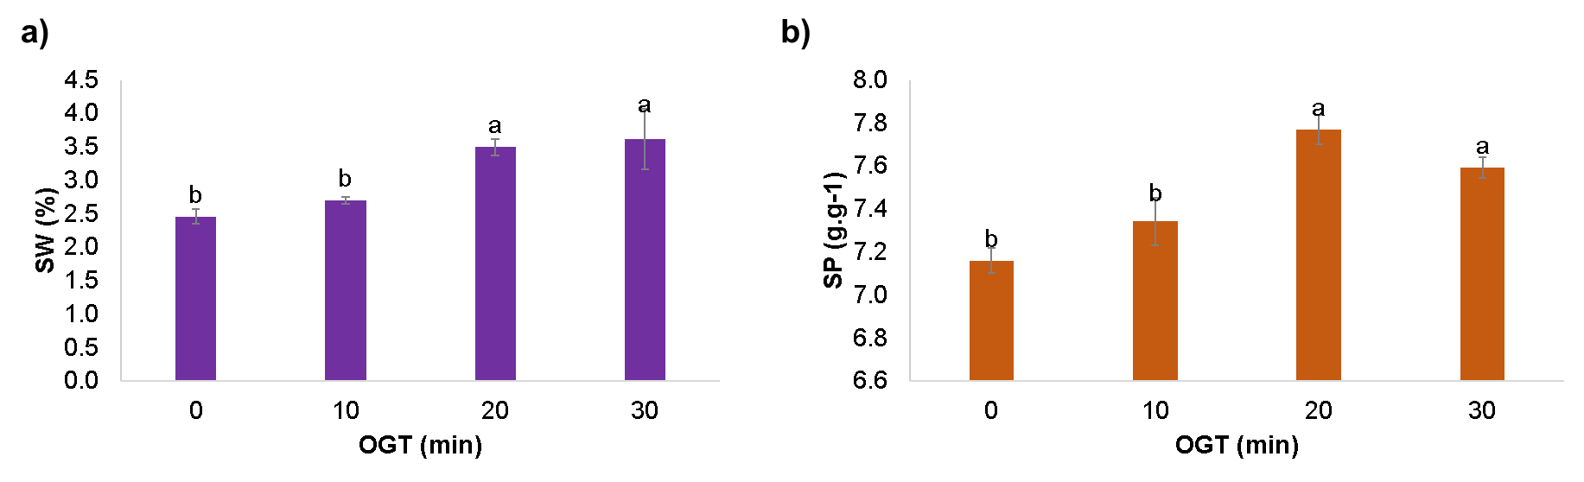
Figure 1. Solubility in Water (SW) and Swelling Power (g.g-1), at 60 ºC, for native and modified quinoa starches with different ozone generation times (OGT).

Oxidized starches show divergent results for SW and SP in the literature. Chan et al. (2009) obtained higher SP values for ozonized corn starch, however, there was a decrease in this parameter for sago and tapioca starches after oxidation. These differences can be attributed to the different rates of depolymerization of the polymeric chain to form a carbonyl group and to the oxidation of the carbonyl group to the carboxyl group in different OGTs. These same authors reported that the SW showed an increase for sago starch and a decrease for tapioca starch after oxidation, and associated the decrease in SW after oxidation to the presence of cross-linking that prevents leaching of the amylopectin molecules.

    - Granule structure
The effect of ozone treatment on starch morphology was observed by SEM (Figure 2a,b,c,d). The native quinoa starch granules were polygonal, angular and irregular, with a small shape, typical of quinoa starch (Li and Zhu, 2018). The surfaces of all samples appeared intact, without holes or cracks, indicating a soft modification by ozone. Optical microscopy (Figure 2e,f,g,h) showed that the granules treated with longer OGT times (20 and 30 min) showed some swelling when compared with the native quinoa starch and the starch treated with 10 min of OGT, which corroborates the swelling power results.

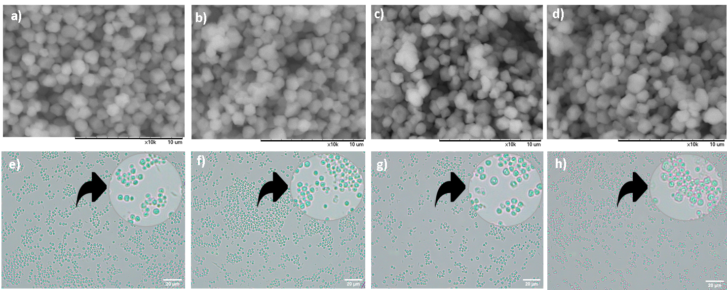
Figure 2. Scanning electron microscopy (SEM, 10 µm scale) and light microscopy (20 µm scale) for native (a,e) and modified quinoa starch by 10 (b,f), 20 (c,g) and 30 (d,h) min of OGT.

    - Rheological behavior
The gelatinized quinoa starch samples showed a nonlinear relationship between shear stress and shear rate (Figure 3), exhibiting a non-Newtonian fluid behavior. An increase in shear stress for the same deformation rate as OGT of modified starch increases was observed (Figure 3a). The viscosity decreased for all samples as the shear rate increased (Figure 3b), which characterizes a shear thinning fluid. The apparent viscosity of samples increased with increasing OGT used for starch modification. These results are in line with Chan et al. (2009), which also found an increase in the viscosity of starches with longer ozone treatment times (above 3 minutes). These authors attributed the increase in apparent viscosity to crosslinking of starch molecules after ozone treatment.
The rheological curves obtained were modeled by the Power Law, which presented good coefficients of determination (Table 1). The samples became more pseudoplastic (lower values of n) and have higher values of consistency index (K) with the increase in OGT. Polymers with shorter chains tend to approach one another to form networks that contribute to increase the flow properties of the oxidized starches, which may explain the higher pseudoplasticity of samples with higher OGT (Chan et al., 2011). This can be due to partial depolymerization of amorphous and crystalline lamellae compounds during starch oxidation with ozone (Sanchez-Rivera et al., 2009). According to Kuakpetoon and Wang (2006), oxidation occurs mainly in amorphous lamellae, and depolymerization of amylose from oxidation occurs in the periphery of starch. Sanchez-Rivera et al. (2009) also observed that oxidized banana starch had a reduction in n values compared to its native form, and Chan et al. (2011) observed an increase in K after corn starch oxidation.

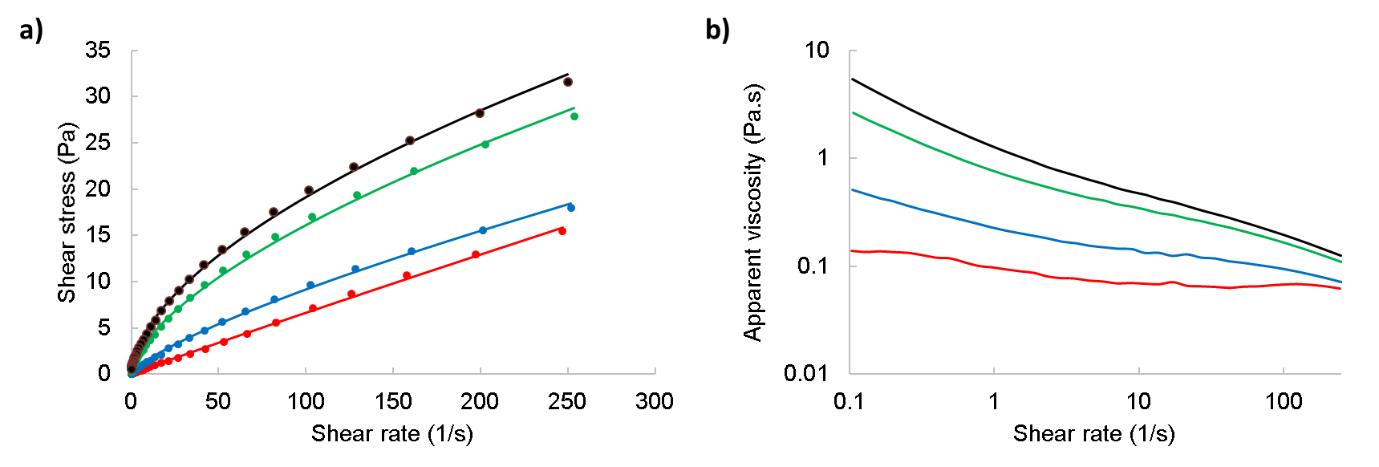
Figure 3. (a) Downward flow curves and (b) Apparent viscosity as a function of shear rate of native (red) and modified starch pastes / gels with different ozone generation times (OGT): 10 min (blue), 20 min (green) and 30 min (black). Points represent the experimental data and continuous lines, the Power Law (LP) model.

Table 1 - Rheological properties (K and n, Power Law model) and gelatinization temperatures (T_{gel}) for native (0 min) and ozonated starch pastes/ gels with different ozone generation times (OGT).
OGT (min) | K (mPa.s^{n}) | n | R² | T_{gel}
0 | 74.7 ± 0.0b | 0.96 ± 0.01a | 0.998 | 57.4 ± 0.4a
10 | 308.1 ± 0.0b | 0.75 ± 0.02b | 0.998 | 56.9 ± 0.4a
20 | 1020.8 ± 0.2a | 0.61 ± 0.01c | 0.998 | 57.0 ± 0.2a
30 | 1175.3 ± 0.2a | 0.58 ± 0.01d | 0.998 | 56.5 ± 1.3a
Mean ± standard deviation (n = 4). Values followed by the same lowercase letters in the same column do not differ significantly (p <0.05).

In the frequency scan (Figure 4), the behaviors of G', G” and tanδ as a function of frequency were obtained. It was observed that, for all samples, the storage modulus (G') remained higher than the loss modulus (G”), indicating gel behavior. Nevertheless, the dependence of the G” on frequency suggest that these gels were weak. The tanδ indicated the viscoelastic state of materials. The modified quinoa starch paste presented less elastic behavior (highest tanδ values) than the native starch paste (Figure 4a). This behavior was similar to the results reported by Nancy et al. (2017), that evaluated the viscoelasticity of ozone modified potato starch suspension. Ozone modification probably introduced carbonyl and carboxyl groups in the starch chain, possibly affecting the creation of junction zones and the 3 -D network formed by amylose in the starch suspensions.

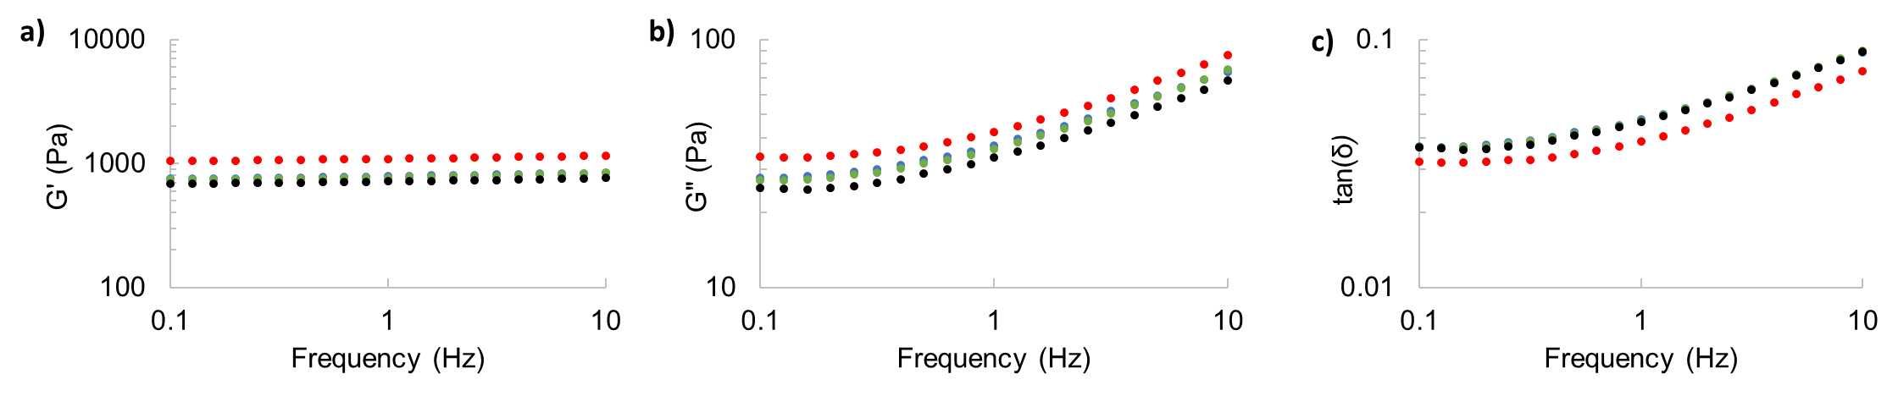
Figure 4 – Storage G' (a) and Loss G” Moduli (b) and tan(δ) (c) as a function of frequency for native (red) and ozonated starch pastes / gels at different ozone generation times (OGT): 10 min (blue), 20 min (green) and 30 min (black).

Temperature sweep tests were performed to evaluate the gelatinization temperature of each sample (Table 1). Gelatinization temperature (T_{gel}) had no significant difference among the starches treated with ozone at different OGTs. The T_{gel} obtained in rheology was closely associated with the melting of crystals and unwinding of the amylopectin double helix (Li and Zhu, 2018). This suggests that process modification conditions did not affect the amylopectin structure, as corroborated by the SP values. Chan et al. (2011) also reported that there were no significant changes in the T_{gel} of corn, sago and tapioca starches with 10min OGTs. Therefore, further analyses are required to determine changes in the interior of quinoa starch granules after ozone treatment.

  - Conclusions
The effect of ozone generation time (OGT) on the functional and rheological properties of oxidized quinoa starch was evaluated. The SW and SP increased with the increase of OGT. No difference on morphology of the granules after the ozone application, studied by SEM, was observed. Ozone treatment increased apparent viscosity and pseudoplasticity but reduced the viscoelasticity of the starch paste. Changes in the properties of modified quinoa starch confirm that it was effectively oxidized by ozone under the conditions applied in this work, and these modified starches could by employed as a thickener in food formulations.
Acknowledgments
The authors thank Brazilian National Council (CAPES) for financial support and scholarship (Financial code 001) for G.V.C.R. (Master's Degree, Engineering and Materials Science Program) (CAPES/PEC-PG).
References
Ahamed, N. T., Singhal, R. S., Kulkarni, P. R., and Pal, M., 1997, Deep fat-fried snacks from blends of soya flour and corn, amaranth and chenopodium starches, Food Chemistry, 58(4), 313–317.
Araujo-Farro, P. C., Podadera, G., Sobral, P. J. A., and Menegalli, F. C., 2010, Development of films based on quinoa (Chenopodium quinoa, Willdenow) starch. Carbohydrate Polymers, 81(4), 839–848. https://doi.org/10.1016/j.carbpol.2010.03.051
Atwell, W. A., Patrick, B. M., Johnson, L. A., and Glass, R. W., 1983, Characterization of quinoa starch. Cereal Chemistry, 60(1), 9–11.
Castanha, N., Matta Jr., M. D., Augusto, P. E. D., 2017, Potato starch modification using the ozone technology, Food Hydrocolloids, 66, 343-356. https://doi.org/10.1016/j.foodhyd.2016.12.001
Chan, H. T., Bhat, R., and Karim, A. A., 2009, Physicochemical and functional properties of ozone-oxidized starch. Journal of Agricultural and Food Chemistry, 8, 5965–5970. https://doi.org/10.1021/jf9008789
Chan, H. T., Leh, C. P., Bhat, R., Senan, C., Williams, P. A., and Karim, A. A. (2011). Molecular structure, rheological and thermal characteristics of ozone-oxidized starch. Food Chemistry, 126(3), 1019–1024. https://doi.org/10.1016/j.foodchem.2010.11.113
Kuakpetoon, D., and Wang, Y. J., 2006, Structural characteristics and physicochemical properties of oxidized corn starches varying in amylose content. Carbohydrate Research, 341, 1896–1915.
Li, G., Zhu, F., 2018, Rheological properties in relation to molecular structure of quinoa starch. International Journal of Biological Macromolecules, 114, 767–775. https://doi.org/10.1016/j.ijbiomac.2018.03.039
Luciano, C.G., Valencia, G. A., Campanella, O. H., Sobral, P.J.A., Moraes, I. C. F. 2018. Influence of Extraction Method on the Rheological Properties of Jackfruit (Artocarpus heterophyllus) Seed Starch Dispersions. Food Biophysics, 13, 155-162. https://doi.org/10.1007/s11483-018-9521-z
Makishi, G. L. A., Amorim, E. S., Gatti, M. W., Ditchfield, C., Branco, I. G., & Moraes, I. C. F. (2017). Physical properties and water vapour permeability of blends produced with gelatin and modified maranta arundinacea starch. Chemical Engineering Transactions, 57, 1855–1860. https://doi.org/10.3303/CET1757310
Mendes, M. P., Vasques, C. T., Silva, D. M. B., Monteiroa, C. C. F., Demiate, I. M., & Monteiro, A. R. G. (2019). Influence of acidity in paste properties of modified corn starch through natural fermentation. Chemical Engineering Transactions, 75, 463–468. https://doi.org/10.3303/CET1975078
Oladebeye, A. O., Oshodi, A. A., Amoo, I. A., and Karim, A. A., 2013, Functional, thermal and molecular behaviours of ozone-oxidised cocoyam and yam starches. Food Chemistry, 141(2), 1416–1423. https://doi.org/10.1016/j.foodchem.2013.04.080
Schoch, T. J., 1964, Swelling power and solubility of granular starches. In R. L. Whistler and M. L. Wolfrom (Eds.), Methods in Carbohydrate Chemistry; Starch (pp. 106–109). New York, London: Academic Press.
Steffe, J. F., 1996, Rheological methods in food process engineering (second edition). Michigan: Freeman Press.
Velásquez-Castillo, L. E. V., Leite, M. A., Ditchfield, C., Sobral, P. J. A., Moraes, I. C. F. 2020. Quinoa starch nanocrystals production by acid hydrolysis: Kinetics and properties. International Journal of Biological Macromolecules, 143, 93-101. https://doi.org/10.1016/j.ijbiomac.2019.12.011
Wang, S., and Zhu, F. (2016). Formulation and quality attributes of quinoa food products. Food and Bioprocess Technology, 9(1), 49–68.
Xie, S. X., Liu, Q.,Cui, S. W., 2005. Starch Modifications and Applications. In S. W. Cui (Ed.), Food Carbohydrates: Chemistry, Physical Properties, and Applications (1 st, pp. 357–406). London, New York, Singapore: Boca Raton.

