|  |  |
| --- | --- |
| cetlogo ***CHEMICAL ENGINEERING TRANSACTIONS***  ***VOL. , 2025*** | A publication of  aidiclogo_grande |
| The Italian Association  of Chemical Engineering  Online at www.cetjournal.it |
| Guest Editors: Laura Piazza, Francesco Donsì, Giorgia Spigno  Copyright © 2025, AIDIC Servizi S.r.l. **ISBN** 979-12-81206-19-9; **ISSN** 2283-9216 | |

Investigation of Spray-Drying for Encapsulation of Antioxidant-Rich Grape Pomace Extracts: A Mathematical and Experimental Approach

Andrea Bassania,\*, Mehri Karimb, Daniele Carulloc, Roberta Dordonia, Milad Fathib, Giorgia Spignoa

aUniversità Cattolica del Sacro Cuore, Department for Sustainbale Food Process (DiSTAS), Via Emilia Parmense 84, 29122 Piacenza, Italy

bDepartment of Food Science and Technology, College of Agriculture, Isfahan University of Technology, Isfahan 84156-83111, the Islamic Republic of Iran

cDepartment of Food, Environmental and Nutritional Sciences (DeFENS), Food Packaging Laboratory, University of Milan, via Celoria 2, Milan, 20133, Italy

[andrea.bassani@unicatt.it](mailto:andrea.bassani@unicatt.it)

This study explores the use of food industry by-products, specifically grape pomace, to recover bioactive compounds and reduce environmental impact. The goal is to optimize the spray-drying process to encapsulate antioxidant-rich extracts, enhancing the stability of phenolic compounds and anthocyanins. Experiments used a 60% ethanol solution for extraction, followed by spray-drying with maltodextrins as encapsulating agents. Parameters such as inlet air temperature (120°C–200°C) and maltodextrin concentrations (0.4–0.8 w/w) were varied. Results showed maximum recovery of total polyphenols (89.2%) and anthocyanins (78.4%) at 140°C with a maltodextrin concentration of 0.6 w/w. Higher temperatures increased degradation rates, highlighting the importance of temperature optimization while the moisture content of the powders was within optimal ranges for industrial applications, with final moisture content below 4%, enhancing stability. In parallel a mathematical model was developed to predict moisture and temperature profiles, aiding in designing efficient drying protocols. This study demonstrates the feasibility of valorizing agro-industrial residues through advanced spray-drying techniques, supporting circular economy initiatives in food processing.

Introduction

The growing demand for sustainable food processing solutions has led to increasing interest in the valorization of agro-industrial by-products (Belaud et al., 2019). Grape pomace, a major by-product of the wine industry, is particularly rich in bioactive compounds, including polyphenols and anthocyanins, which exhibit strong antioxidant properties (Karastergiou et al., 2024). However, the stability and bioavailability of these compounds can be significantly affected by different factors such as temperature, oxygen, and light exposure. In this context, encapsulation via spray-drying has emerged as an effective strategy to enhance the stability of these bioactive compounds, ensuring their potential application in functional foods, active food packaging, and nutraceuticals (Archaina et al., 2017). Spray-drying is widely used in the food and pharmaceutical industries due to its ability to produce stable powders with controlled properties. The success of this technique relies on careful optimization of process conditions, particularly inlet air temperature, drying time, and the choice of encapsulating agents. Maltodextrins are commonly used carriers in spray-drying due to their excellent film-forming abilities and capacity to protect sensitive bioactive compounds from degradation (Sansone et al., 2011). However, achieving the optimal balance between bioactive retention and powder characteristics requires a thorough understanding of the physicochemical interactions, the kinetics, and the energy consumption occurring during the drying process. This study, subsequent development of the previous research of Bassani et al. (2022), aims to investigate and optimize the spray-drying process for the encapsulation of antioxidant-rich grape pomace extracts, using maltodextrins as carrier agents. The research employs a combined experimental and mathematical modeling approach to understand the effects of process variables, such as inlet air temperature and carrier concentration, on the retention of polyphenols and anthocyanins. The development of a predictive mathematical model provides valuable insights into the moisture and temperature profiles during drying, helping to design efficient and sustainable drying protocols. By integrating experimental findings with computational modeling, this study highlights the potential of a cooperative approach to improving encapsulation techniques and advancing sustainable food processing practices. The synergy between experimental validation and predictive simulations allows for process optimization with minimal resource consumption, thereby contributing to the broader goal of enhancing circular economy strategies in the food industry (Bassani et al., 2024). The findings of this work provide a scientific foundation for improving the industrial application of spray-drying, offering practical insights into the design of more effective and environmentally friendly encapsulation methods.

Material and Methods

Figure 1 schematically illustrates the process of extraction and encapsulation of bioactive compounds and related analysis. Briefly, grape pomace samples (*Croatina* variety) were subjected to an ethanol extraction process (Amendola et al., 2010). The obtained extracts were mixed with a carrier (i.e., maltodextrins) and used as raw material for the subsequent spray-drying process. This process was tested under various operating conditions, specifically evaluating different air-drying temperatures and different maltodextrins mass ratios between the grams of maltodextrins and the grams of the raw material dry matter ($w_{md} (g/g$), as shown in Figure 1. The aim was to thoroughly investigate the effect of these operating conditions on the degradation of bioactive compounds. All other parameters (extract flow rate, air flow rate, etc.) were kept constant for all experimental trials. Finally, the dried powders obtained were characterized in terms of moisture, total polyphenols, and anthocyanins, with detailed methods provided later.

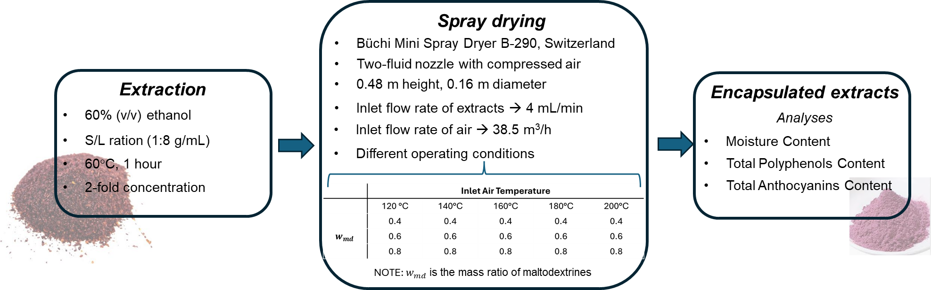

*Figure 1 Extraction and encapsulation process with the related operating conditions and analyses*

**2.1 Moisture content and Mass recovery yield**

The moisture content of the outlet powder from the spray-dryer was evaluated following the traditional procedure reported in different scientific work and also in the previous work of Bassani et al, (2022). Regarding the mass recovery yield, this was calculated as the ratio between the mass recovered in the powder on dry matter and the theoretical amount of solids present in the feed.

**2.2 Total Polyphenols Content (TPC) and Total Anthocyanins Content (TAC)**

All the extracts and powders obtained from spray-drying tests were subjected to TPC and TAC measurements adopting the method proposed by Amendola et al. (2010) (i.e. Folin-Ciocalteau method) and by Lavelli et al. (2016) respectively. The results were expressed as mg of gallic acid equivalent (GAE) per g of dry weight powder (mg /g) regarding the TPC, while as mg of cyanidin-3-glucoside equivalents per g dry product regarding the TAC. Moreover, this work aims to evaluate the effect of drying temperature and carrier mass ratio on bioactive compounds (i.e. polyphenols and anthocyanins) degradation. For this reason, the recovery of polyphenols and anthocyanins was calculated as follows:

|  |  |
| --- | --- |
| $$TPC_{recovery}=\frac{TPC_{powder}^{afterspray}}{TPC_{theoretical}^{afterspray}}$$ | (1) |
| $$TAC_{recovery}=\frac{TAC_{powder}^{afterspray}}{TAC_{theoretical}^{afterspray}}$$ | (2) |

where $TPC_{powder}^{afterspray}$ and $TAC_{powder}^{afterspray}$ are the amount of phenolic compounds and anthocyanins detected in the collected powder, while $TPC_{theoretical}^{afterspray}$ and $TAC_{theoretical}^{afterspray}$ are the theoretical amount of polyphenols anthocyanins that could be found in the powder in the event that degradation effects due to high process temperatures were not present. It is important to point out that the theoretical TPC and TAC were evaluated considering the mass recovery yield of the spray dryer. Indeed, during the spray drying process, part of the content of the extract is lost, so this effect must be taken into account to properly evaluate the correct amount of polyphenols and anthocyanins that are expected to be found after spray drying.

**2.3 Statistical Analysis**

The statistical analysis was carried out using IBM SPSS Statistics 29 software (SPSS Inc, Chicago, USA) to perform ANOVA test to assess the impact of specific process variables on the measured parameters. In case of significant effect was found (99% confidence level), variance homogeneity was verified, and Tukey's post-hoc test was used for mean discrimination (p ≤ 0.01), All experiments and analyses were conducted three times, with the results presented as mean ± standard deviation.

**2.4 Mathematical model of Spray Dryer**

In parallel a mathematical model of the spray drying process has been developed and further validated, starting from the work of Bassani et al. (2022). Specifically, from the previous model, the equations related to momentum, mass and energy balances, and absorption isotherms were taken, while equations to predict the degradation of extracts regarding the reduction of polyphenol and total anthocyanin content were improved and introduced as novel elements into the model. Indeed, as already reported, the development of a validated mathematical model can help in understanding the process and optimizing it, for example, to reduce the degradation of bioactive compounds, which are essential for adding value to the final product obtained. For this reason, the following equations were included in the Bassani et al. (2022) model to evaluate the degradation of polyphenols and anthocyanins in terms of concentration ( $C_{phe}^{out}$ and $C_{ant}^{out}$) as a function of the distance (*h*) from the atomization point:

|  |  |
| --- | --- |
| $$\frac{dC_{phe}^{out}}{dh}=\frac{F_{dry}C_{phe}^{in}-F_{dry}C_{phe}^{out}-r_{phe}}{v_{px}m_{dry}}$$ | (3) |
| $$\frac{dC_{ant}^{out}}{dh}=\frac{F_{dry}C_{ant}^{in}-F_{ant}C_{phe}^{out}-r_{ant}}{v_{px}m_{dry}}$$ | (4) |

Where $F_{dry}$ ​ is the mass flow rate of the dried powders, $m_{dry}$ ​ is the total dry mass of the particles, while $r_{phe}$ ​and $r_{ant}$ ​ refer to the kinetic degradation laws of polyphenols (expressed as mg of GAE per second, mg/s) and anthocyanins, assumed to be first-order for this initial study, and specifically:

|  |  |
| --- | --- |
| $$r_{phe}=A_{0}^{phe}e^{\frac{E_{at_{phe}}}{RT}}C_{phe}^{out}$$ | (5) |
| $$r_{ant}=A_{0}^{ant}e^{\frac{E_{at_{ant}}}{RT}}C_{ant}^{out}$$ | (6) |

Where $A_{0}^{phe}$ ​, $A_{0}^{ant}$ are the pre-exponential factor, and $E_{at_{phe}}$ , $E_{at_{ant}}$ is the activation energy of the two reactions. These parameters will be evaluated through experimental data collected via non-linear regression implemented within MATLAB software.

Results and Discussion

Grape pomace extract was initially analyzed to evaluate the maltodextrin mass ratio accurately and to assess the degradation of phenols and anthocyanins correctly. Specifically, the dry matter present in the liquid extract was measured in an oven at 105 ± 2 °C to constant weight and was found to be 32.15 ± 2.96 g/L, while the density value of the extract was 0.98 ± 0.09 g/mL. Regarding the active compounds, the TPC and TAC content were 166.37 ± 16.57 mg /g, and 398.81 ± 36.71 mg /g respectively. Starting from these initial data and processing them together with the data collected from the analyses related to the encapsulated extract powders, it was possible to obtain the results reported in Table 1 and Table 2 based on the different drying air temperatures and maltodextrin fractions in the encapsulated extract. Additionally, the tables also report the values predicted by the mathematical model developed in this study. Specifically, Table 1 provides further validation of the model developed in the previous work by Bassani et al. (2022) on a different variety of grape pomace, while Table 2 shows the development and validation of the model regarding the degradation of total polyphenols and anthocyanins. As mentioned earlier, the idea is to highlight the potential of an integrated approach between experiments and modeling for a better understanding of the process itself.

Table 1 Experimental spray-dryer mass recovery, outlet air temperature, and powder moisture content. Values were reported as means ± standard deviations. For each investigated temperature, different superscript letters within the same column indicate significant differences among samples (p ≤ 0.05).

|  |  |  |  |  |  |  |  |
| --- | --- | --- | --- | --- | --- | --- | --- |
| Inlet Air Temperature [°C] | $w_{md}$ (g/g) | Initial Moisture content [%] | Mass Recovery [%] | Outlet Air Temperature [°C] | | Outlet Moisture content [%] | |
|  |  |  | Exp | Exp | Model | Exp | Model |
| 120 | 0.4 | 94.78 | 84.24 ± 2.21a | 64.3 ± 0.6a | 65.31 | 7.00 ± 0.30b | 5.86 |
| 0.6 | 91.65 | 82.86 ± 0.72a | 65.7 ± 0.6b | 65.56 | 7.16 ± 0.39b | 5.71 |
| 0.8 | 85.90 | 81.78 ± 2.48a | 66.0 ± 0.0b | 65.98 | 5.43 ± 0.49a | 5.47 |
| 140 | 0.4 | 93.69 | 81.02 ± 1.01a | 74.0 ± 1.0a | 73.90 | 3.76 ± 0.21b | 4.42 |
| 0.6 | 92.61 | 81.47 ± 2.55a | 74.3 ± 0.6a | 73.93 | 3.83 ± 0.17b | 4.41 |
| 0.8 | 87.55 | 85.87 ± 2.59a | 76.3 ± 0.6b | 74.30 | 2.75 ± 0.15a | 4.23 |
| 160 | 0.4 | 94.05 | 78.90 ± 5.34a | 82.3 ± 0.6a | 81.78 | 2.38 ± 0.38a | 3.43 |
| 0.6 | 92.81 | 81.08 ± 7.43a | 85.0 ± 2.6a | 81.83 | 4.41 ± 0.06b | 3.41 |
| 0.8 | 87.25 | 82.88 ± 8.80a | 86.7 ± 1.5a | 82.25 | 3.89 ± 1.00b | 3.25 |
| 180 | 0.4 | 93.69 | 78.55 ± 2.55a | 97.0 ± 1.0a | 89.22 | 1.55 ± 0.15a | 2.67 |
| 0.6 | 92.71 | 83.37 ± 4.30ab | 94.7 ± 2.3a | 89.24 | 2.85 ± 0.16b | 2.67 |
| 0.8 | 87.69 | 88.27 ± 0.92b | 95.3 ± 2.1a | 89.62 | 3.13 ± 0.06b | 2.55 |
| 200 | 0.4 | 93.69 | 73.84 ± 4.07a | 95.0 ± 8.7a | 96.14 | 2.33 ± 0.72a | 2.13 |
| 0.6 | 92.03 | 74.90 ± 4.23a | 96.0 ± 0.0a | 96.23 | 4.02 ± 0.70b | 2.11 |
| 0.8 | 87.11 | 84.86 ± 2.58b | 97.0 ± 1.0a | 96.60 | 3.11 ± 0.58ab | 2.02 |

Entering into the details of the results obtained, regarding the mass recovery of the extracts after the spray-drying process, the results do not show significant differences (about 81.5% recovery) with the only exceptions of the cases with $w_{md}=0.8$ $T_{air}=180°C and 200°C$, where the higher recovery could be related to lower viscosity of the encapsulated extract itself. The outlet temperature of the drying air shows results consistent with expectations.

*Table 2 Experimental TPC and TAC in the outlet powder. Values were reported as means ± standard deviations. For each investigated temperature, different superscript letters within the same column indicate significant differences among samples (p ≤ 0.05).*

|  |  |  |  |  |  |
| --- | --- | --- | --- | --- | --- |
| Inlet Air Temperature [°C] | $w_{md}$ (gmd/gtot) | Total Polyphenols Recovery [%] | | Total Antocians Recovery [%] | |
|  |  | Exp | Model | Exp | Model |
| 120 | 0.4 | 96.88 ± 2.40a | 95.72 | 7.93 ± 0.30b | 3.84 |
| 0.6 | 110.28 ± 4.18a | 98.16 | 11.37 ± 0.39b | 8.78 |
| 0.8 | 107.81 ± 0.44b | 99.17 | 17.99 ± 0.49a | 18.05 |
| 140 | 0.4 | 89.93 ± 1.24a | 94.08 | 5.11 ± 0.21b | 3.83 |
| 0.6 | 109.92 ± 7.00b | 96.57 | 15.04 ± 0.17b | 6.59 |
| 0.8 | 112.03 ± 9.07b | 98.44 | 5.89 ± 0.15a | 13.85 |
| 160 | 0.4 | 89.40 ± 1.72a | 90.41 | 6.85 ± 0.38a | 3.07 |
| 0.6 | 95.92 ± 3.98ab | 94.50 | 10.23 ± 0.06b | 5.48 |
| 0.8 | 97.87 ± 1.85b | 97.60 | 7.67 ± 1.00b | 12.20 |
| 180 | 0.4 | 87.70 ± 2.78a | 86.79 | 6.29 ± 0.15a | 2.80 |
| 0.6 | 90.61 ± 3.16ab | 91.98 | 8.17 ± 0.16b | 4.80 |
| 0.8 | 93.26 ± 2.83b | 96.28 | 5,23 ± 0.06a | 10.33 |
| 200 | 0.4 | 86.44 ± 1.46a | 81.87 | 9.12 ± 0.72a | 2.46 |
| 0.6 | 85.32 ± 1.16a | 89.58 | 9.14 ± 0.70b | 4.59 |
| 0.8 | 91.53 ± 2.82b | 94.90 | 9.81± 0.58ab | 9.53 |

Higher outlet temperatures are associated with higher inlet temperatures, while varying the maltodextrin fraction at the same inlet temperature generally does not result in significant temperature differences.

This is because, despite having a different composition, the amount of extract is still small compared to the airflow rate used. The only slight differences observed (e.g., $w_{md}=0.8$ $T_{air}=140°C$) could be due to different external temperatures encountered during the experimental trial itself. Regarding the prediction of temperatures by the mathematical model, it is in agreement with the experimental data (Figure 2*)*, confirming the trends described above and also highlighting a slight increase in the outlet temperature as the maltodextrin fraction increases. This is additional information provided by the model and not highlighted by the experiments. It is important to note that the heat transfer coefficient, needed by the model, was estimated to be 6.5 W/K following the procedure reported by Hanus and Langrish (2007). The final moisture content of the powders, as expected, decreases with increasing temperature, although above 140°C there does not seem to be a significant decrease. Regarding the maltodextrin content, there does not appear to be a characteristic trend. In fact, it seems to decrease with an increasing maltodextrin fraction at 120°C and 140°C, but this is not true for the other cases. It is worth noting that the final result can be influenced by the strong hygroscopicity of the powders themselves (Bassani et al. 2022). In this case, the developed model can be more helpful as it can highlight some characteristic behaviors of the process.

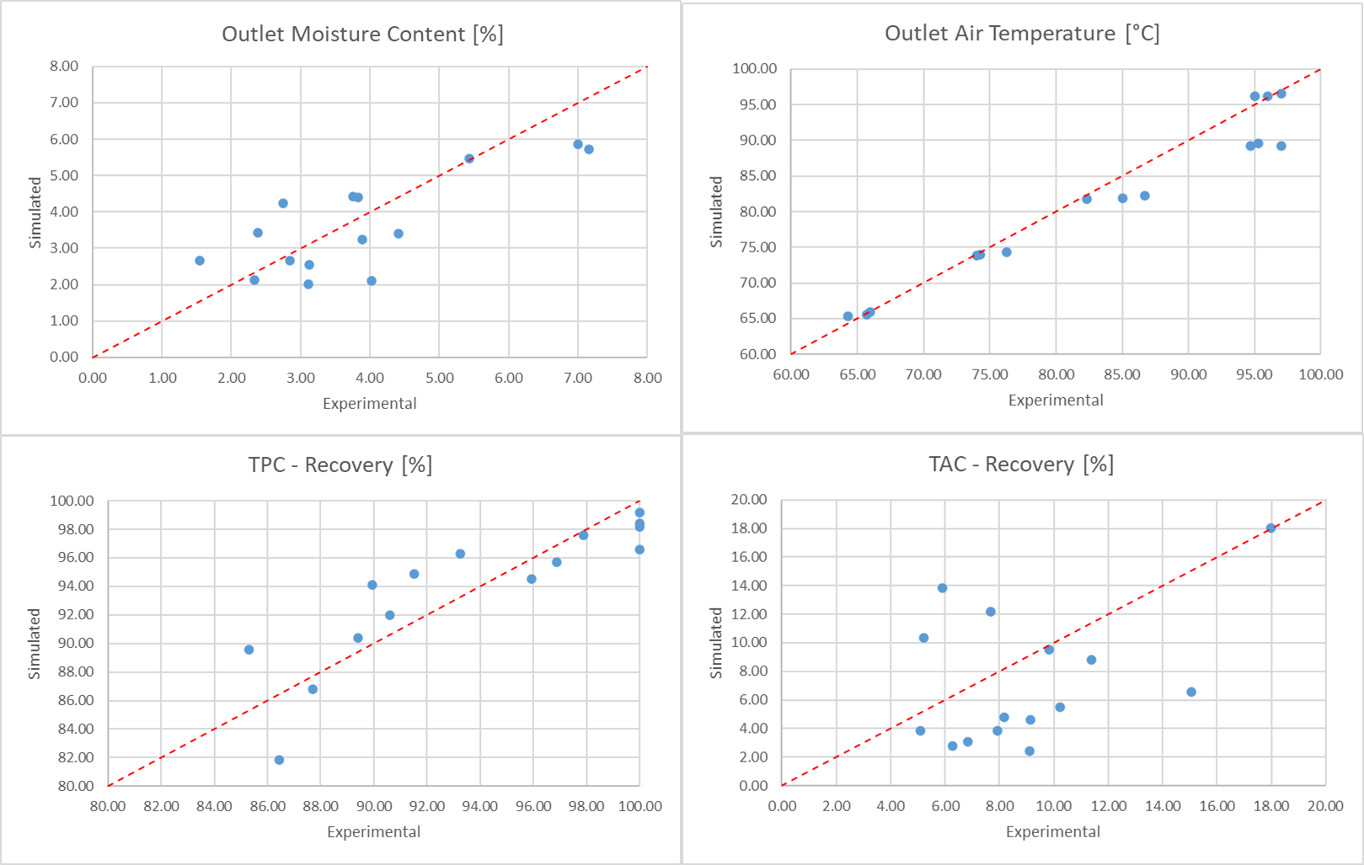

Figure 2 Scatter diagrams to compare simulated and experimental data of: outlet moisture content, outlet air temperature, TPC recovery and TAC recovery.

As shown by the scatter diagram (Figure 2), the model's prediction has good adherence to the experimental data, although there seems to be some discrepancy for certain values. However, it is important to consider that the moisture values are low, so a small experimental error can lead to a poor prediction by the model. As mentioned earlier, the model itself is both able to predict final moisture content and to allow us to highlight how, with increasing maltodextrin content at the same temperature, the final moisture content decreases (Table 1). It is important to note that the parameters of the absorption isotherms, useful for predicting the final moisture content, were kept the same as those obtained in the previous work by Bassani et al. (2022), further validating it on a different variety of grape pomace. Once the model is validated regarding the prediction of the final moisture content of the powders and outlet air temperature, the next step is to verify the actual validity of the new equations introduced in the model to predict the recovery of active compounds (i.e., polyphenols and anthocyanins) at the end of the encapsulation process. The results are reported in Table 2. As expected, maltodextrins significantly influence the concentration of bioactive compounds present in the recovered powders. In fact, maltodextrins protect the bioactive compounds from thermal degradation, leading to a higher recovery of polyphenols and anthocyanins with increasing maltodextrin fraction. Additionally, as expected, higher temperatures lead to greater degradation of active compounds. Regarding polyphenols, a high recovery can be observed even under the worst conditions (i.e., 200°C), where the recovery is still around 80%. However, for the recovery of total anthocyanins, a greater discrepancy is noted at the experimental level compared to the expected trends (i.e., a decrease in recovery with increasing temperature and decreasing maltodextrin fraction). This could be due to the low concentration of anthocyanins in the powders, as in the case of moisture content, or to possible degradation occurring during the period between powder collection and actual analysis. This latter aspect will certainly need to be investigated further in future studies. Regarding the mathematical model, the first step was to regress the kinetic parameters related to the degradation laws of polyphenols and anthocyanins (Eq. 5, 6) using MATLAB routines. The values obtained are as follows: $A_{0}^{phe}=114.66 kg/s$ ​, $A_{0}^{ant}=0.076 kg/s$, $E_{at_{phe}}=60338.39 J/mol$, $E_{at_{ant}}=21957.24 J/mol$. Figure 2 shows the comparison between the experimental and simulated values. For polyphenol recovery, there is good correspondence between the experimental and simulated data, also favoured by the low standard deviations of the experimental samples. The model also reflects the expected trends (Table 2), where an increase in total polyphenol recovery is associated with a decrease in temperature or an increase in the amount of maltodextrins. Regarding total anthocyanins, as expected, the model does not optimally predict the experimental data for the previously described regions. However, the model confirms the trend observed also with polyphenols, namely a reduction in anthocyanin recovery with increasing temperature and decreasing maltodextrin fraction, emphasizing the fundamental role of the model in characterizing the behavoiur of the process. Additional investigation is needed to further improve the model's predictive capabilities.

Conclusions

This study demonstrates the feasibility of using spray-drying as an effective encapsulation technique for preserving bioactive compounds from grape pomace extracts. Experimental findings reveal that process parameters, particularly inlet air temperature and maltodextrin concentration, significantly influence the retention of polyphenols and anthocyanins. Optimal drying conditions (140°C and 0.6 $w_{md}$) achieved the highest recovery rates, minimizing thermal degradation while ensuring appropriate powder moisture content for potential industrial applications. In parallel, the development and validation of a mathematical model provided a deeper understanding of the drying process, accurately predicting moisture content and degradation kinetics of bioactive compounds. The integration of experimental data with modelling approaches demonstrates the advantages of a cooperative strategy. Computational tools aid in optimizing processes by revealing potential behaviours not evident from experiments and reducing the need for extensive trials. This synergy between experiments and modelling enhances encapsulation efficiency and supports sustainability efforts by improving resource utilization and minimizing waste in food processing. Future work may further refine the model by incorporating additional variables, such as different encapsulating agents or alternative drying conditions, to expand the applicability of this approach in food and pharmaceutical industries.

Acknowledgments

Part of the research has received funding from Ecosystem for Sustainable Transition in Emilia-Romagna”, project funded by European Union under the National Recovery and Resilience Plan (NRRP), Mission 04 Component 2 Investment 1.5—NextGenerationEU, Call for tender n. 3277 dated 30/12/2021, Award Number: 0001052 dated 23/06/2022

References

Amendola D., De Faveri D. M., Spigno G., 2010, Grape marc phenolics: Extraction kinetics, quality and stability of extracts, Journal of Food Engineering, 97(3), 384-392.

Archaina D., Leiva G., Salvatori D., Schebor C., 2018, Physical and functional properties of spray-dried powders from blackcurrant juice and extracts obtained from the waste of juice processing, Food Science and Technology International, 24(1), 78-86.

Belaud J. P., Prioux N., Vialle C., Buche P., Destercke S., Barakat A., Sablayrolles C., 2019, Framework for sustainable management of agricultural by-product valorization, Chemical Engineering Transactions, 74(2019).

Bassani A., García‐Roldán A., Spigno G., Jauregi P., 2024, Extraction of phenolic compounds from spent coffee ground using natural deep eutectic solvents: New modeling approach, Journal of Food Process Engineering, 47(3), e14584.

Bassani A., Carullo D., Rossi F., Fiorentini C., Garrido G. D., Reklaitis G. V., Spigno G., 2022, Modeling of a spray-drying process for the encapsulation of high-added value extracts from food by-products, Computers & Chemical Engineering, 161, 107772.

Hanus M. J., Langrish T. A. G. ,2007,. Re‐entrainment of wall deposits from a laboratory‐scale spray dryer, Asia‐Pacific Journal of Chemical Engineering, 2(2), 90-107.

Karastergiou A., Gancel A. L., Jourdes M., Teissedre P. L., 2024, Valorization of grape pomace: A review of phenolic composition, bioactivity, and therapeutic potential, Antioxidants, 13(9), 1131.

Sansone F., Mencherini T., Picerno P., d’Amore M., Aquino R. P., Lauro M. R., 2011, Maltodextrin/pectin microparticles by spray drying as carrier for nutraceutical extracts, Journal of Food Engineering, 105(3), 468-476.