|  |  |
| --- | --- |
| cetlogo ***CHEMICAL ENGINEERING TRANSACTIONS***  ***VOL. , 2025*** | A publication of  aidiclogo_grande |
| The Italian Association  of Chemical Engineering  Online at www.cetjournal.it |
| Guest Editors: Laura Piazza, Francesco Donsì, Giorgia Spigno  Copyright © 2025, AIDIC Servizi S.r.l. **ISBN** 979-12-81206-19-9; **ISSN** 2283-9216 | |

3D Printing of Meat Analogues from Plant Proteins Using Sodium Alginate and Transglutaminase as Cross-linking Agents

Adela Acosta Marchetti\*, Juan J. Juarez García, Misael A. López, Jorge Cardona

Escuela Agricola Panamericana Zamorano

\*aacosta@zamorano.edu

Global meat consumption continues to rise, yet a contrasting trend is observed in developed economies, where the growing demand for plant-based meat analogues is contributing to a stagnation in traditional meat consumption. This shift, coupled with the vulnerability of livestock farming to climate change, underscores the need for improved alternative products. Innovative technologies like additive manufacturing (3D printing) have emerged as promising tools to produce meat analogues with fibrillar structures closely resembling muscle tissue.

In this study, formulations based on soy protein (Glycine max (L.) Merril) and pea protein (Pisum sativum L.) were combined with varying proportions of alginate and transglutaminase as food inks for 3D printing. The composition of ingredients in these formulations significantly influenced printing parameters such as speed and layer height. Pea protein-based formulations exhibited a broader printing window and superior shape fidelity, while soy-based formulations demonstrated minimal deformation over time. Furthermore, the interaction between alginate and transglutaminase as crosslinking agents impacted on key textural attributes, including hardness and cohesiveness. These findings highlight the potential of tailored formulations and crosslinking strategies to enhance the structural properties of 3D-printed meat analogues.

* 1. Introduction

Meat has been a fundamental dietary component since civilization began and remains a key economic sector. In the first half of 2023, the global meat market reached 363.9 million tons, reflecting a 0.4% growth compared to 2022 (FAO, 2023). This demand is primarily driven by population growth, projected to exceed 10 billion by the end of the century (Cleland, 2013), and the expansion of middle-income populations in emerging economies (He, 2024). While demand continues rising in developing countries, developed nations, such as the United States and Europe, show market saturation, leading to stagnation or declines in per capita meat consumption (ODEPA, 2007). Additionally, climate change challenges livestock production, particularly in intensive farming systems vulnerable to environmental fluctuations (Lorente-Saiz, 2010).

These factors have intensified interest in sustainable meat alternatives. Market forecasts predict a 10% annual growth rate for plant-based substitutes by 2029 (Barclays Research, 2019). However, replicating the sensory attributes of conventional meat, especially texture, remains a challenge in meat analogue development (Kyriakopoulou et al., 2019). Emerging technologies, such as 3D food printing, offer a promising solution by enabling the fabrication of complex food structures unattainable through conventional processing.

Early food printing studies focused on chocolate-based structures (Universities of Exeter and Brunel) and pasta printing (Cornell University) (MINCyT, 2015). Today, 3D food printing is a rapidly growing research field, particularly in meat analogue development, where it enables the creation of fibrillar structures that mimic animal muscle (Zhu, 2022).

Sustainable plant-based proteins, such as soy (Glycine max) and pea (Pisum sativum), are widely used in meat analogue formulations due to their low cost and functional properties (Kyriakopoulou et al., 2019). Additionally, oyster mushrooms (Pleurotus ostreatus) provide umami flavor and grow on agricultural byproducts, enhancing environmental feasibility (Singh et al., 2023).

Developing high-quality 3D-printed meat analogues requires understanding food inks and their behavior during printing. Critical parameters include layer height and nozzle speed, which affect print quality (Hao et al., 2010), while post-print deformation impacts structural precision (Liu et al., 2017). Texture is essential for consumer acceptance, influenced by food ink composition, crosslinking agents, and printing conditions (Voon et al., 2019).

This study aimed to: (1) determine the printability window and capacity of food inks formulated with pea and soy protein concentrates using sodium alginate as the primary crosslinking agent, (2) identify the optimal layer height and nozzle speed for selected food inks, and (3) evaluate the texture of printed meat analogues incorporating sodium alginate as the primary crosslinker and transglutaminase as a secondary crosslinking agent.

* 1. Materials and Methods

2.1 Modelling

To establish the logical framework for this study, a 3D model was designed based on the digital reconstruction of a Ribeye steak. The commercial cut was frozen at −20 °C, then transversely sliced into 5 mm thick sections using a bandsaw, for a total of 10 slices, revealing its muscle and fat structure. Images of both sides of each slice were captured using a Nikon D3000 camera positioned 0.63 m away in a controlled photo studio setup with white light at a 90° angle. Image binarization was performed in Google Colaboratory using the scikit-image library and the Otsu method. The binarized images were post-processed and reconstructed in vector format using Autodesk software, applying the multiple profile loft function.

2.2 Printing capacity

The printability of protein formulations was evaluated within a 17%–22% protein range, corresponding to commercial meat analogues. Concentrated soy protein (80% protein, Bob’s Red Mill, Oregon, USA) and concentrated pea protein (84% protein, Anthony’s, California, USA) were used as protein sources. Printing was performed using a Prusa i3 MK2 Reprap model modified for food paste extrusion, equipped with Treela conical nozzles ranging in internal diameter from 140 to 1630 μm. The base formulation included a commercial soybean, palm, and olive oil blend (ACH Foods, Mexico), oyster mushroom flour (26% protein, locally grown and dried and milled by authors) and water. The protein content was adjusted by varying water and protein concentrations, while sodium alginate (1%, Cape Cristal Brand, USA) and transglutaminase (1%, relative to total protein, Moo Gloo, USA) served as crosslinking agents (Table 1).

Table 1: Base formulation for printability tests.

|  |  |
| --- | --- |
| Ingredient | Amount (g) |
| Protein concentrate (soy or pea) | 18.75 |
| Oyster Mushroom | 4.00 |
| Vegetal Oil | 6.50 |
| Alginate | 1.00 |
| Transglutaminase | 0.23 |
| Water | 69.52 |
| Total | 100.00 |

2.3 Printability window

The printability window was defined by four key factors in filament deposition 3D printing: extrusion capacity, filament formation, continuity, and filament separation. A qualitative-quantitative assessment using a binary yes/no scoring system determined compliance with each property. Area graphs were constructed to delineate printability zones, identifying the optimal protein percentage range and nozzle diameter for subsequent experiments.

2.4 Temporal dimension

The influence of time on printability was evaluated using Moo Gloo transglutaminase (100 enzymatic units/g), which decreases the extrusion flow rate through enzymatic crosslinking. The observed reduction in extrusion flow rate over time reflects the increasing rigidity of the formulation, ultimately limiting its printability, to the point of no extrusion. A 1% transglutaminase formulation was tested for both protein types. The extrusion flow rate was measured at 14-minute intervals over 126 minutes to identify the point of flow reduction.

2.5 Fidelity and form retention

Test cubes (3 cm per edge) were printed using pea and soy protein formulations with 0%, 0.5%, and 1% sodium alginate. Initial dimensions were recorded and reassessed after 90 minutes, coinciding with transglutaminase-induced crosslinking onset. Significant treatments underwent digital image correlation for deformation analysis. India ink was sprayed onto the samples, and images were captured every 10 minutes over 70 minutes. The processed images were analyzed in Google Colaboratory using the μDIC library.

2.6 Critical parameters

Correlation graphs were constructed with extruded flow rate as the dependent variable and extrusion speed as the independent variable, assessing formulations with 0.5% and 1% sodium alginate. Twenty milliliters of material were extruded into a water-filled test tube to determine the displaced volume and flow rate by measuring deposition time. Regression analysis was performed to determine the critical parameters of nozzle speed and height, based on the model proposed by Khalil and Sun (2007) Eq(1) and that proposed by Wang & Shaw (2005) Eq(2), respectively.

|  |  |
| --- | --- |
| $$V_{n}=\frac{4Q}{πD_{n}^{2}}$$ | (1) |

Where: Vn= critical nozzle speed in mm/s, Q= flow in mm3 /s and D2n= nozzle diameter in mm.

|  |  |
| --- | --- |
| $$h_{c}=\frac{v_{d}}{V_{n}D_{n}}$$ | (2) |

Where: hc= critical nozzle height in mm, vd, extrusion flow (mm3 /s), Vn =nozzle velocity in mm/s and Dn= nozzle diameter in mm.

2.7 Texture analysis

Texture profile analysis (TPA) was conducted on 12 experimental units of the 3D-printed specimens measuring 2 cm in length, 1.5 cm in width, and 1.5 cm in height using a Brookfield CT3 texture analyzer equipped with a 38.1 mm cylindrical probe (T4A/1000, Brookfield Laboratories Inc.). A double compression cycle was applied at a speed of 2 mm/s, with 50% deformation, an activation load of 67 mN, and a maximum load of 4,500 g.

2.8 Experimental Design and Statistical Analysis

A completely randomized design (CRD) was employed for all experiments. A bifactorial combinatorial arrangement was used for fidelity and shape retention experiments, while a trifactorial combinatorial arrangement was applied to texture analysis, considering the following factors: Protein type (pea or soy); Sodium alginate concentration (0.5% or 1%); Transglutaminase concentration (0.1% or 1.5%)

Data was analyzed using SAS (Statistical Analysis System) software. Analysis of variance (ANOVA) was applied, followed by mean separation tests (LSMEANS and Duncan’s test) at a 95% confidence level.

* 1. Results and discussion

3.1 3D Model generation

The modeling process resulted in a 3D design, as shown in Figure 1, where the fat fraction is represented separately from the muscle fraction. The model accurately replicates and preserves the structure of the original meat cut, making it suitable for multi-material 3D printing. This approach allows for a detailed reconstruction of meat complexity in analog production based on image-based modeling.

*Figure 1: 3D model of the meat cut: (a) side view, (b) top view, (c) muscle fraction, (d) fat fraction.*

3.2 Printing Feasibility

The feasibility of 3D printing is determined by three essential factors in extrusion-based printing: (1) the ability to form coherent filaments from the extruded material, (2) the accuracy of the printed object compared to the digital model, and (3) the shape retention over time.

As shown in Figure 2, pea protein exhibited broader parameter windows for filament formation and shape continuity. However, its filaments tended to merge more extensively, compromising overall printability.

a) 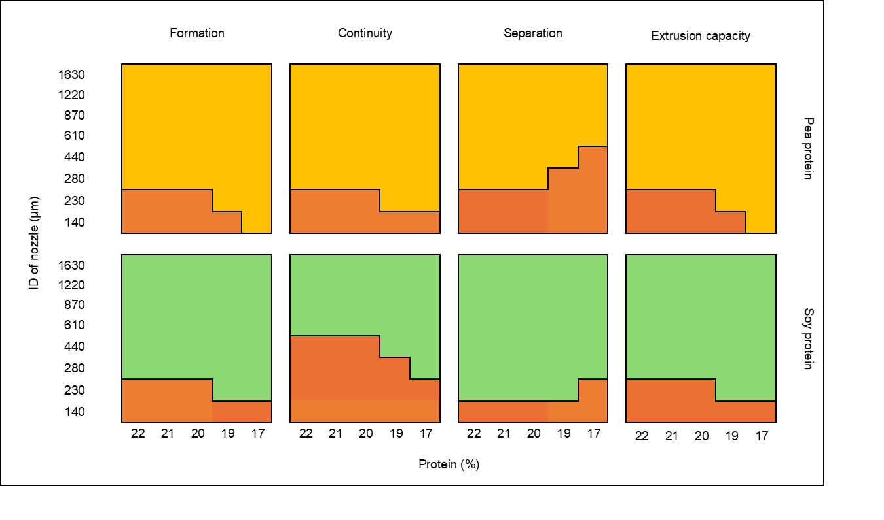 b) 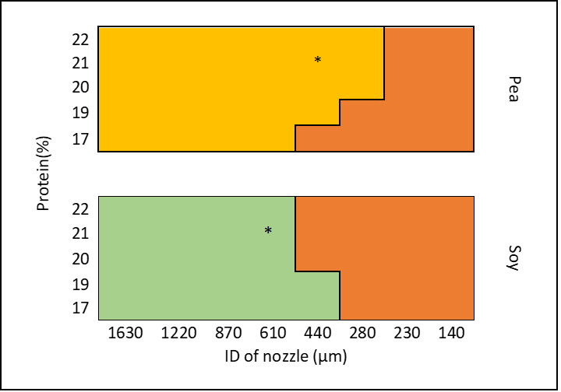

*Figure 2: (a) Parameters for printability assessment for pea and soy protein, (b) Printability window for pea and soy protein.*

The selection of nozzle diameters and protein concentrations for the test samples (Figure 2) was entirely based on meeting the printability criteria for each protein source and nozzle size.

3.3 Temporal Dimension

Preliminary trials revealed a gradual loss of paste flowability through the extruder nozzle over time. This phenomenon was attributed to the onset of crosslinking induced by transglutaminase, which began approximately 90 minutes after preparing the food ink. The crosslinking process resulted from the formation of ε(γ-glutamyl) lysine isopeptide bonds.

3.4 Fidelity and Shape Retention

Statistical analysis (ANOVA, confidence level of 0.95) indicated that soy protein formulations with the lowest alginate concentrations (0% and 0.5%) exhibited the greatest dimensional deviations from the digital model. In contrast, all pea protein formulations maintained a higher degree of dimensional fidelity across all tested alginate levels.

Pea protein exhibited the most significant deformations at the upper section of the printed structures, with a maximum compaction ratio of 0.875 relative to the initial dimensions. The deformation was uniformly distributed as minimal lateral expansion. Conversely, soy protein displayed less deformation, with a maximum compaction ratio of 0.36 compared to its initial proportions, as illustrated in Figure 3.

a)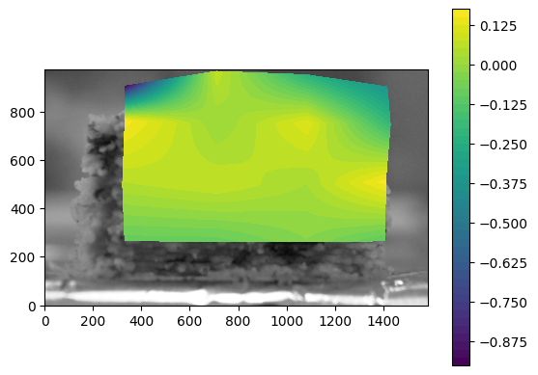 b)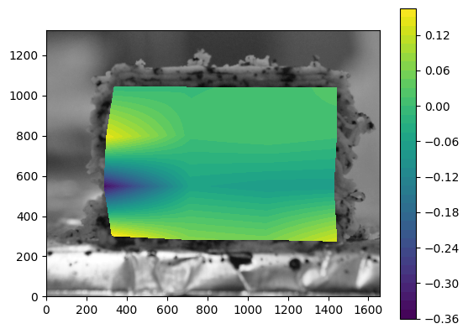

*Figure 3: (a) Deformation of pea protein specimen, (b) Deformation of soy protein specimen.*

3.5 Critical Parameters

The critical parameters obtained for the printing of test specimens are presented in Table 2.

Table 2: Critical parameters for food inks.

|  |  |  |  |  |  |
| --- | --- | --- | --- | --- | --- |
| Protein | | % Alginate | Critical nozzle speed (mm/s) | | Critical nozzle height (mm) |
| Pea | 1 | | | 84 | 0.35 |
| Pea | 0.5 | | | 62 | 0.35 |
| Soy | 1 | | | 58 | 0.48 |
| Soy | 0.5 | | | 30 | 0.48 |

As shown, the critical parameters vary depending on the characteristics of each food ink. The critical velocity can be increased in inks with higher viscosity, for them to flow more effectively through smaller nozzle diameters. This improved flow allows for the formation of finer fibers, thereby reducing the critical nozzle height.

3.6 Texture Analysis

An analysis of variance (ANOVA) at a 95% confidence level revealed that the textural attributes of the test specimens varied depending on the protein source, as shown in Table 3. Soy protein exhibited higher hardness and lower cohesiveness compared to pea protein. This behavior is attributed to differences in the amino acid profile and lysine content of the proteins (Soy: 89.95 mg/g; Pea: 73.2 mg/g) (Pires et al., 2006; Schlangen et al., 2023). Since lysine reacts with transglutaminase to promote crosslinking, these differences influence the final textural properties.

Table 3: Textural attributes by protein source.

|  |  |  |
| --- | --- | --- |
| Protein | Hardness (N) ± S.D. | Cohesiveness\* ± S.D. |
| Soy | 28.20± 8.980a | 0.46± 0.052b |
| Pea | 23.97± 2.531b | 0.53± 0.041a |
| % CV | 14.04 | 10.12 |

\*: Dimensionless. a-b: different lowercase letters following values or bars indicate a statistically significant difference (p < 0.05) between the corresponding treatments. CV: Coefficient of variation.

Table 4 presents the effect of transglutaminase on the textural properties of the test specimens. The results indicate an increase in hardness and a decrease in resistance to disintegration, as evidenced by reduced cohesiveness.

Table 4: Textural attributes by transglutaminase (TG) concentration.

|  |  |  |
| --- | --- | --- |
| TG Concentration (%) | Hardness (N) ± S.D. | Cohesiveness\* ± S.D. |
| 1 | 31.23± 5.84a | 0.39± 0.045b |
| 0.5 | 24.23± 2.61b | 0.53± 0.039a |
| 0 | 22.64± 2.82b | 0.56± 0.055a |
| % CV | 13.89 | 9.85 |

\*: Dimensionless. a-b: different lowercase letters following values or bars indicate a statistically significant difference (p < 0.05) between the corresponding treatments. CV: Coefficient of variation.

The influence of alginate in the formulations was determined based on an increase in hardness and cohesiveness of the specimens, as shown in Table 5. These values exhibited a positive trend with increasing alginate concentrations.

Table 5: Textural attributes by alginate concentration.

|  |  |  |
| --- | --- | --- |
| Alginate Concentration (%) | Hardness (N) ± S.D. | Cohesiveness\* ± S.D. |
| 1 | 32.22± 2.53a | 0.60± 0.048a |
| 0.5 | 19.85± 4.98b | 0.38± 0.046b |
| % CV | 13.82 | 10.79 |

\*: Dimensionless. a-b: different lowercase letters following values or bars indicate a statistically significant difference (p < 0.05) between the corresponding treatments. CV: Coefficient of variation.

The increase in hardness and cohesiveness was observed immediately after alginate crosslinking via immersion in a calcium chloride solution. This crosslinking process enhanced the specimens' ability to withstand external tensile forces.

* 1. Conclusions

The findings indicate that pea protein-based formulations exhibit a broader printability window compared to soy-based formulations, allowing for greater flexibility in protein concentration and nozzle selection. Pea formulations with up to 1% sodium alginate demonstrated high structural fidelity, while soy formulations with lower alginate concentrations showed reduced reliability. Shape retention was optimized at intermediate alginate levels.

Critical processing parameters, such as extrusion speed and layer height, varied depending on the formulation, with higher alginate concentrations supporting faster extrusion speeds. The critical layer heights observed for pea and soy protein formulations suggest the potential to replicate fibrous structures exceeding the maximum fibrillar dimensions reported in conventional meat.

Textural analysis revealed that both transglutaminase and sodium alginate play crucial roles in modulating the mechanical properties of meat analogues. While transglutaminase decreased cohesiveness, sodium alginate increased it, with the strongest cohesive effects observed in formulations containing 1% alginate. These findings provide valuable insights for optimizing 3D-printed meat analogues.

* 1. References

Barclays Research, 2019. Barclays Research highlights: Sustainable & Thematic Investment Food Revolution.

Cleland, J., 2013. World population growth; past, present and future. Environmental and Resource Economics, 55, 543-554.

Food and Agriculture Organization of the United Nations (FAO)., 2023. Food Outlook-Biannual Report on Global Food Markets. FOOD & AGRICULTURE ORG.

Hao, L., Mellor, S., Seaman, O., Henderson, J., Sewell, N. y Sloan, M. 2010. Material characterisation and process development for chocolate additive layer manufacturing. Virtual and Physical Prototyping, 5(2), 57–64.

He, P., 2024. Navigating the global dietary transition and its impact on planetary and human health: The role of middle-income countries. Food Science and Nutrition Cases, p.fsncases20240015.

Khalil, S. and Sun, W., 2007. Biopolymer deposition for freeform fabrication of hydrogel tissue constructs. Materials Science and Engineering: C, 27(3), 469-478.

Kyriakopoulou, K., Dekkers, B. and van der Goot, A.J., 2019. Plant-based meat analogues. In Sustainable meat production and processing. Academic Press. 103-126.

Liu, Z., Zhang, M., Bhandari, B. and Wang, Y., 2017. 3D printing: Printing precision and application in food sector. Trends in Food Science & Technology, 69,83-94.

Lorente-Saiz, A.G., 2010. Cambio climático: una influencia recíproca. GeoGraphos. Revista Digital para Estudiantes de Geografía y Ciencias Sociales, 1(3), 1-22.

Ministerio de Ciencia, Tecnología e Innovación Productiva de Argentina (MINCyT), 2015. Technological surveillance and competitive intelligence study on 3D printing technologies for food (original title in Spanish). Ministerio de Ciencia, Tecnología e Innovación Productiva. Argentina.

Oficina de Estudios y Políticas Agrarias (ODEPA), 2007. Characterization of beef demand and evaluation of substitute goods (original title in Spanish). Ministerio de Agricultura de Chile.

Pires, C.V., Oliveira, M.G., Rosa, J.C. and Costa, N.M.B. 2006. Nutritional quality and chemical score of amino acids of different protein sources (original title in Portuguese). Ciência E Tecnologia De Alimentos, 26(1), 179–187.

Rhim, J.-W. 2004. Physical and mechanical properties of water-resistant sodium alginate films. LWT - Food Science and Technology, 37(3), 323–330.

Schlangen, M., Ribberink, M. A., Taghian Dinani, S., Sagis, L. M.C. and van der Goot, A. J. 2023. Mechanical and rheological effects of transglutaminase treatment on dense plant protein blends. Food Hydrocolloids, 136(2), 108261.

Singh, U., Tiwari, P., Kelkar, S., Kaul, D., Tiwari, A., Kapri, M. and Sharma, S., 2023. Edible mushrooms: A sustainable novel ingredient for meat analogs. Efood, 4(6), 122.

Voon, S.L., An, J., Wong, G., Zhang, Y. and Chua, C.K., 2019. 3D food printing: A categorised review of inks and their development. Virtual and Physical Prototyping, 14(3), 203-218.

Zhu, S., 2022. 3D food printing: from structure to perception', Doctor of Philosophy, Wageningen University, Wageningen.