 CHEMICAL ENGINEERING TRANSACTIONS  VOL. , 2025 | A publication of  
The Italian Association
of Chemical Engineering
Online at www.cetjournal.it

Guest Editors: Laura Piazza, Francesco Donsì, Giorgia Spigno
Copyright © 2025, AIDIC Servizi S.r.l.
ISBN 979-12-81206-19-9; ISSN 2283-9216

Boosting Insect Meal Application in Food by Bioprocessing with Yeasts
Liliana Araujoª, Bruna Diasª, José M. Salgado^{b}, Marlene Lopes^{ac}, Isabel Belo^{ac,}*
ªCEB – Centre of Biological Engineering, University of Minho, Braga, Portugal
^{b}University of Vigo, Campus Auga, Chemical Engineering Department, 32004 Ourense, Spain
^{c}LABBELS, Associate Laboratory, Braga/Guimarães, Portugal
ibelo@deb.uminho.pt
The growing global demand for protein-rich foods requires sustainable alternatives to the conventional animal-based protein systems. In this sense, insect-based proteins, especially from Tenebrio molitor, present a promising nutrient-rich solution with a reduced ecological footprint. Nonetheless, insect meal is composed of chitin and complex proteins, limiting their digestibility. This study aimed to enhance the nutritional quality of insect meal through solid-state fermentation (SSF) using selected proteolytic strains of the yeast Yarrowia lipolytica. Optimal SSF conditions for protease production were obtained using a Box-Behnken design and a quadratic model. These conditions were applied in SSF with insect frass and insect meal of Tenebrio molitor larvae. SSF with Y. lipolytica and its protease application on ISM improved protein solubilization, thus increasing bioavailability.
  - Introduction
The global population is projected to increase rapidly, accompanied by a rising demand for food. Concurrently, shifting consumption patterns toward higher quantities of value-added, protein-rich products underscore the growing need for protein-based food sources (European Commission, 2019).
Protein consumption remains heavily reliant on meat products, with a projected annual increase of 1.4 % (Etter et al., 2024) that poses significant environmental burdens (Hefferon et al, 2023). Thus, the development of alternative protein sources is essential. While numerous plant-based protein alternatives are already established on the market, emerging sources such as insects are gaining increasing attention due to their nutritional potential and sustainability (Jafarzadeh et al., 2024).
Insect-based products as a sustainable protein source have increased in popularity as a trendy new food, which is justified by their high nutritional value with up to 60 % of dietary protein, and because insect rearing presents superior feed-conversion efficiency, reproductive capacity, and low environmental impact. Insect farming uses few resources of land, water, and energy, uses agri-food wastes as feed and produces lesser greenhouse gas emissions than other livestock productions (Castro-López et al., 2020). Insect meal from Tenebrio molitor larvae has gained increased acceptance but is still limited by the low digestibility of the protein (Guiné et al., 2025). Alternatives to insect meal (ISM) processing strategies, such as enzymatic hydrolysis and fermentation, have gained extensive interest over conventional procedures to enhance protein accessibility, bioavailability, and functional properties (Muñoz-Seijas et al., 2024).
In this study, proteases were sourced through a promising approach using Y. lipolytica, a non-conventional yeast widely studied for many industrial applications. Y. lipolytica is also recognised as Generally Recognised As Safe (GRAS) by international food safety organisations, making it suitable for use in food processing and formulation (Colacicco et al., 2022).
  - Materials and methods
    - Microorganisms
Yarrowia lipolytica W29 (ATCC 20460), CBS 2073 and CH 3/4 (Nagy, 2014) were cryopreserved at - 80 °C in 30 % glycerol solution. Prior to experimentation, strains were revived on YPD agar medium plates (glucose 20 g/L, peptone 20 g/L, yeast extract 10 g/L, agar 20 g/L).
For inoculum preparation, yeast cells recovered from an agar plate were inoculated in 200 mL of liquid YPD medium (glucose 20 g/L, peptone 20 g/L, yeast extract 10 g/L) in 500-mL Erlenmeyer flasks. Using an orbital shaker, the cultures were incubated overnight at 27 °C with continuous agitation at 200 rpm.
    - Raw materials
Insect larvae meal (Tenebrio molitor) was purchased from Insect Based Feed & Food, Lda, Portugal. Insect frass was obtained from an insect farm in Galicia, Spain. Wheat Bran (WB) was purchased from Celeiro (Provida), Portugal. All substrates were stored at room temperature until use. The content of crude fiber, total protein and total lipids is depicted in Table 1.
Table 1. Composition of insect meal (supplier), insect frass (Muñoz-Seijas et al., 2024) and wheat bran (supplier). Data (% w/w in dry basis) are the average ± standard deviation of 3 analyses
Component | Insect meal | Insect frass | Wheat bran
Crude fiber | 12.9 ± 0.7ª | 56.8 ± 0.4^{b} | 47.6 ± 0.5^{c}
Total protein | 58.2 ± 2.2ª | 24.3 ± 1.4^{b} | 14.9 ± 0.4^{c}
Total lipids | 18.5 ± 0.1ª | 2.2 ± 0.1^{b} | 4.4 ± 0.9^{c}

Different letters in the same row indicate statistical differences (p<0.05) between samples.
    - Modelling and Optimization of SSF conditions using Box-Behnken Design
A Box-Behnken experimental design was carried out to evaluate the effects of pH, fermentation time, and moisture content on protease production in SSF of WB with Y. lipolytica W29 (Table 2).
SSF was carried out with 5 g of dry substrate placed in 250-mL Erlenmeyer flasks and 0.1 M sodium acetate buffer at different pH values according to the runs, was also added to the solid substrate to achieve the target moisture content. After sterilization (121 °C for 15 min), the substrate was inoculated with the yeast suspension (6 mg of dry cells per g of dry substrate). The fermentation was carried out at 27 °C during the days set for each run. At the end of SSF, the solid was extracted with distilled water (10 mL/g dry substrate). The protease activity was analysed in the supernatant. Experimental data were fitted to a quadratic model (Equation 1) using the Statgraphics Centurion XVI software that also predicts the optimum.
$$Y= β+β_{1}X_{1}+β_{2}X_{2}+β_{3}X_{3}+β_{11}X_{1}^{2}+β_{12}X_{1}X_{2}+β_{13}X_{1}X_{3}+β_{22}X_{2}^{2}+β_{23}X_{2}X_{3}+β_{33}X_{3}^{2}$$ | (1)
Where Y represents the response (protease production), β are the regression coefficients of the model, and X the independent variables, where X₁ is pH, X₂ is fermentation time and X₃ is the moisture content.

    - Production by Y. lipolytica W29 in SSF using insect frass: Application on ISM Treatment
Protease production was evaluated through SSF using insect frass as the sole substrate, and in a mixture of insect frass with WB (1:1 dry mass ratio). The fermentations were carried out as previously described and performed at the optimal conditions selected through the Box-Behnken design.
Enzymatic treatment of ISM of Tenebrio molitor larvae was also tested as a bioprocessing approach, and for that, crude extracts obtained in SSF of insect frass (lyophilised extract with 388 ± 41 U/g of proteases) were applied and compared to the use of commercial proteases 600 U/g (P2143, Merck). Enzymatic treatments were conducted with 5 g of ISM suspended in 45 mL of 0.05 mM sodium acetate buffer (pH 5.5) at 50 °C for 72 h and with different loads of enzyme of 2 %, 4 % and 8 % (mass of enzyme product per dry mass of ISM). The total protein in the remaining solid substrate was measured.
    - SSF of ISM by Y. lipolytica
SSF using Y. lipolytica was tested as a bioprocessing strategy for ISM of T. molitor larvae. SSF was carried out using 10 g of dry ISM in 250-mL Erlenmeyer flasks according to all the conditions described in the previous section. The fermentations were conducted with three strains of Y. lipolytica: W29, CBS 2073, and CH 3/4. After fermentation, total protein and lipid content were analysed in the fermented ISM and protease activity and soluble protein were measured in aqueous extracts of the fermented ISM.
    - Analytical methods
Protease activity in aqueous extracts was quantified by mixing equal volumes of enzymatic supernatant and substrate (0.5 % w/v azocasein in 50 mM sodium acetate buffer, pH 5.5)(Costa et al., 2023). Protease production was expressed as units of protease per g of dry mass of solid substrate. The total protein content in the solid substrate was assessed through an organic elemental analyser, UNICUBE® trace. A nitrogen-to-protein conversion factor of 5.6 (Janssen et al., 2017) was applied for insect meal. The total lipid was quantified using the extraction method described by Ferreira et al. (2020). Soluble protein content was estimated using Bradford’s method (Bradford, 1976), was employed with bovine serum albumin (BSA) as the standard (0–2000 mg/L). Absorbance was measured at 595 nm using a 1 cm path length spectrophotometer. The results were expressed as mg of protein per g of dry ISM.
2.7 Statistical analysis
The results are presented as the average ± standard deviation of three independent replicates. One-way analysis of variance (ANOVA) was used for statistical comparison of the parameters evaluated. The significance was determined at a threshold of p<0.05.
  - Results
    - Optimization of SSF conditions for protease production using Box-Behnken Design
Y. lipolytica W29 was selected as a standard strain to evaluate quantitatively and optimize the protease production in SSF using WB as a standard substrate. A Box-Behnken experimental design was performed to analyse the influence of three factors at three levels on extracellular protease activity, as represented in Table 3.
Table 2. Experimental conditions for each run of the Box-Behnken design and protease activity ± standard error (n=3)
Run | pH (X₁) | Time (X₂) | Moisture (X₃) | Protease activity (U/g)
1 | -1.0 | -1.0 | 0.0 | 64 ± 2.7
2 | 1.0 | 0.0 | 1.0 | 29 ± 1.4
3 | -1.0 | 1.0 | 0.0 | 69 ± 4.2
4 | 0.0 | -1.0 | 1.0 | 39 ± 1.4
5 | 0.0 | 1.0 | 1.0 | 44 ± 3
6 | 1.0 | -1.0 | 0.0 | 37 ± 0.8
7 | -1.0 | 0.0 | -1.0 | 58 ± 14.4
8 | -1.0 | 0.0 | 1.0 | 55 ± 2.8
9 | 0.0 | -1.0 | -1.0 | 57 ± 1.6
10 | 0.0 | 1.0 | -1.0 | 61 ± 2.4
11 | 1.0 | 1.0 | 0.0 | 59 ± 2.8
12 | 1.0 | 0.0 | -1.0 | 41 ± 1.7
13 | 0.0 | 0.0 | 0.0 | 48 ± 5.4
14 | 0.0 | 0.0 | 0.0 | 32 ± 1
Levels of the factors
-1.0 | 5.5 | 2 days | 60 % (w/w)
0.0 | 7 | 3 days | 67.5 % (w/w)
+1.0 | 8.5 | 4 days | 75 % (w/w)

A quadratic model (Equation 2) was fitted to the response, given R² = 0.92 and p = 0.0688, indicating that there is a statistically significant relation, at a 7 % level, between protease activity and the independent variables, being responsible by 92 % of the variation in the results of protease activity.
$$Protease activity (U/g)=52.7-19.8X_{1}+9X_{2}-12.3X_{3}-0.3X_{1}^{2}+9.1X_{1}X_{2}-4.6X_{1}X_{3}+9.2X_{2}^{2}+0.2X_{2}X_{3}-13.6X_{3}^{2}$$ | (2)
The regression coefficient values are directly proportional to the independent variables in the response. The negative linear coefficients X₁ and X₃ suggest an inverse correlation, whereby high levels of pH (more neutral medium) and moisture content led to a reduction in protease production. Conversely, the positive linear coefficient for fermentation time, X₂, indicates a potential enhancement of protease production with prolonged fermentation.
The influence of these variables, individually or in combination with the other variables, can be also analysed by a Pareto diagram (Figure 1), where it is shown the significant (p<0.05) negative effects of pH and moisture on the protease production, and the positive effect of fermentation time, however this last is not significant at a 5 % level. Similarly, all quadratic terms, including binary interactions among factors, were not statistically significant (p > 0.05).
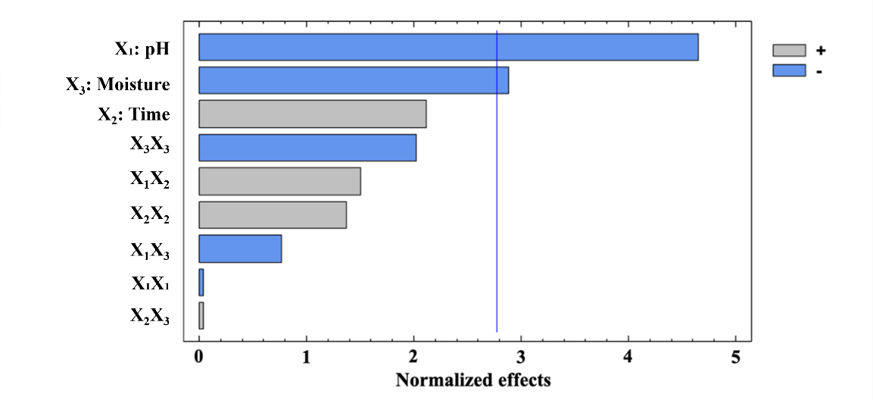
Figure 1. Pareto diagram of the normalized effects.
According to the model described in Equation 1, the optimal conditions for maximizing protease production were determined using the mathematical model. The fitted equation predicted a maximum protease activity of 67.4 U/g at pH 5.5, 67.5% (w/w) moisture content, and 2 days of fermentation. These optimal conditions are identical to the conditions of run 1 (Table 2), where the protease production obtained is statistically identical to that attained in run 3, which only differs in the condition of fermentation time, a variable whose effect was not statistically significant. The optimum value of pH obtained for protease production is the same as the reported one for Y. lipolytica growth in many different culture media (Costa et al., 2023), indicating a direct relation with cell growth and protease biosynthesis.
    - Protease production by Y. lipolytica W29 in SSF using insect frass: Application on ISM Treatment
Insect frass is the major by-product of insect breeding, and this leftover substrate has great potential for valorisation in a circular economy perspective. The chemical and agronomic properties of frass make it an excellent biofertilizer, which is its major application (Leni et al., 2021). However, new approaches may contribute to increasing insect frass valorisation and boost the reintroduction of this insect residual side stream back into the feed/food production chain. SSF of insect frass by filamentous fungi was already reported by Muñoz-Seijas et al., (2024), but to our knowledge, this is the first work on the protease production by Y. lipolytica through insect frass fermentation.
SSF, under the optimized conditions reported above, was carried out with insect frass as a single substrate and as a mixture of 50 % (w/w, dry basis) with WB. The results of enzyme production are depicted in Figure 2 A, where is clear that the higher activity values obtained for protease in SSF with insect frass than with single WB (67.4 U/g). However, the mixture of Insect frass with WB presented a synergic effect on protease production, leading to 1.6-fold increase, compared to using insect frass alone. These findings are in accordance with Muñoz-Seijas et al., (2024) that reported an improvement of protease production by mixing ISM with BSG in SSF with Aspergillus uvarum MUM 08.01.
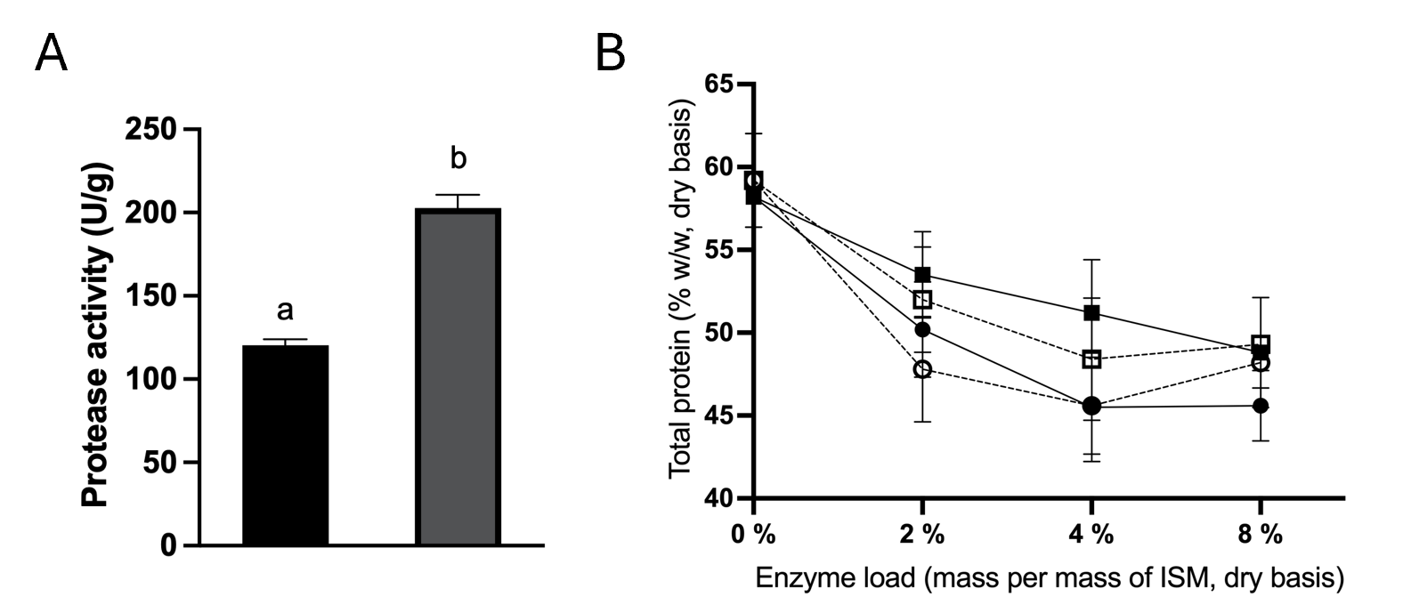
Figure 2. Protease production (A) by SSF with insect frass (black bars) and with a mixture of insect frass and WB (grey bars). Protein content (B) after 24 h (solid line) and 72 h (dashed line) of enzymatic treated ISM with commercial protease (squares) and with crude enzymatic extract (CEE) from SSF of insect frass with Y. lipolytica W29 (circles).
ISM processing technologies include many chemical and physical methods, and more recently, enzymatic treatments have been proposed (Muñoz-Seijas et al., 2025). In this work, ISM was treated with the crude enzymatic extract (CEE) obtained in SSF of insect frass with Y. lipolitica W29 and with a commercial protease. In both cases, a decrease in the content of total protein of ISM was observed (Figure 2B), indicating protein hydrolysis and release from the solid. This reduction of protein content increases with the rise of enzyme load, particularly up to 4 %. In fact, the best result of proteolysis was reached at 4 % of enzyme load with the crude extract and at 24 h of treatment (equal to 72 h), leading to around 13 % of protein solubilization, that is higher than the proteolysis achieved with the same load of commercial enzyme, 7 % at 24 h and 10 % at 72 h of treatment.
The better performance of the crude enzymatic extract than the commercial one is also observed at the lowest load tested, showing the potential of the extracts from SSF of insect frass with Y. lipolytica. Moreover, considering that for the same load of mass of the enzymes the units of protease of commercial enzyme is 1.5-fold higher than the units in CEE, the results obtained indicate the highest specificity of proteases produced by Y. lipolytica in insect frass to ISM proteins compared to the commercial tested in this work of Aspergillus saitoi source.
    - SSF of Insect Meal
Fermenting insect meal improves its nutrition, taste, and shelf life by enhancing flavour and nutrient absorption while reducing anti-nutrients. However, there are still a few reports on ISM fermentation and the available literature is focused on the use of lactic acid bacteria (Castro-López et al., 2020). SSF with protease producing microorganisms may contribute to the hydrolysis of the peptide bonds in protein macromolecules, breaking the structure into more accessible and digestible fractions, thereby improving nitrogen availability and nutrient utilization (Bolton et al., 2021).
The strains Y. lipolytica W29, CBS 2073, and CH 3/4 were, for the first time, applied for SSF in ISM. As can be observed in Figure 3A, all strains were able to produce protease by SSF of ISM of T. Molitor larvae, however, at lower activity values than those previously obtained in insect frass and mixtures. This result was not expected due to the protein content of ISM compared to the other substrates tested. The bioavailability of nutrients to the yeast may be hindered by the chitin present in the ISM and the lack of sugars easily metabolized in ISM necessary for yeast propagation and enzymes expression. Nevertheless, the yeast growth and protease secretion led to protein solubilization (compared to the value of 3.8 ± 0.3 mg/g of soluble protein of ISM) (Figure 3B) that was significantly (p<0.05) higher for Y. lipolytica CBS 2073 than for the other two strains.
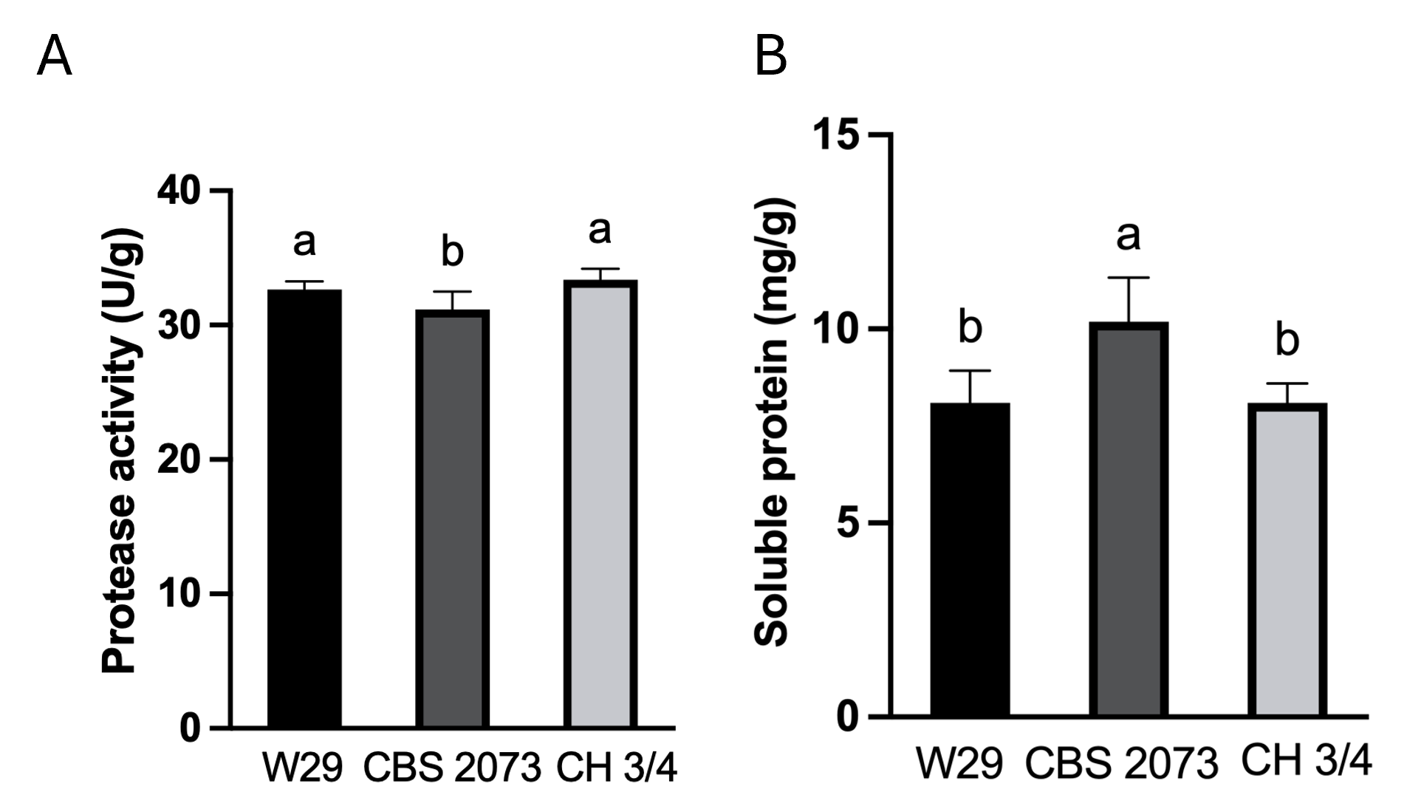
Figure 3. Production of protease (A) and soluble protein content (B) produced through SSF. Bars with different letters indicate statistically significant differences (p<0.05).
Independently of the yeast strain, a decrease of 14 % (w/w, dry basis) of total protein and 11 % of lipid content was observed in ISM after fermentation. Y. lipolytica is recognised by its ability to metabolize oily substrates (Lopes et al., 2020), thus it can also be an interesting alternative to ISM defatting.
  - Conclusion
The findings highlight Y. lipolytica as an effective microbial source of proteases for enhancing the solubilization of Tenebrio molitor meal through SSF and proteolytic treatments. The surface response methodology was applied to model and optimize the conditions for protease production by the yeast. Y. lipolytica was able to grow and produce protease in insect frass, opening new routes for this by-product valorisation. Protease from Y. lipolytica was proven to be effective in ISM treatment and protein solubilization.
Overall, this work presents the first steps of bioprocessing strategies of insect meal using eco-friendly approaches and contributing to the circular economy in insect farming and to the production of new and sustainable insect derived foods.
Acknowledgments
This study was supported by the Portuguese Foundation for Science and Technology (FCT) under the scope of
the strategic funding of UID/04469:Centre of Biological Engineering of the University of Minho, by LABBELS – Associate Laboratory in Biotechnology, Bioengineering and Microelectromechanical Systems, LA/P/0029/2020, and funded project PRODOCE (Agreement for Collaboration between UVigo and UMinho).
References
Bolton, C. M., Muller, N., Hyland, J., Johnson, M. P., Souza Valente, C., Davies, S. J., & Wan, A. H. L. (2021). Black soldier fly larval meal with exogenous protease in diets for rainbow trout (Oncorhynchus mykiss) production meeting consumer quality. Journal of Agriculture and Food Research, 6, 100232.
Bradford, M. M. (1976). A rapid and sensitive method for the quantitation of microgram quantities of protein utilizing the principle of protein-dye binding. Analytical Biochemistry, 72(1–2), 248–254.
Castro-López, C., Santiago-López, L., Vallejo-Cordoba, B., González-Córdova, A. F., Liceaga, A. M., García, H. S., & Hernández-Mendoza, A. (2020). An insight to fermented edible insects: A global perspective and prospective. Food Research International, 137, 109750.
Colacicco, M., Ciliberti, C., Biundo, A., Agrimi, G., & Pisano, I. (2022). Study of Lipase Production by Yarrowia lipolytica Grown in High Concentration of Hydrophobic Carbon Sources. Chemical Engineering Transactions, 93, 247–253.
Costa, A. R., Fernandes, H., Salgado, J. M., & Belo, I. (2023). Solid State and Semi-Solid Fermentations of Olive and Sunflower Cakes with Yarrowia lipolytica: Impact of Biological and Physical Pretreatments. Fermentation 2023, Vol. 9, Page 734, 9(8), 734.
Etter, B., Michel, F., & Siegrist, M. (2024). Which are the most promising protein sources for meat alternatives? Food Quality and Preference, 119, 105226.
European Commission. (2019). Global food supply and demand Consumer trends and trade challenges Content, 16 Retrieved from http://ec.europa.eu/agriculture/markets-and-prices/market-briefs/index_en.htm.
Ferreira, M., Fernandes, H., Peres, H., Oliva-Teles, A., Belo, I., & Salgado, J. M. (2020). Bio-enrichment of oilseed cakes by Mortierella alpina under solid-state fermentation. LWT, 134, 109981.
Guiné, R. P. F., Barroca, M. J., Maciejewska, M., Abrowska, A. D. & Cano-Lamadrid, M. (2025). Sustainable Protein Sources: Functional Analysis of Tenebrio molitor Hydrolysates and Attitudes of Consumers in Poland and Spain Toward Insect-Based Foods. Foods 2025, Vol. 14, Page 333, 14(2), 333.
Hefferon, K. L., De Steur, H., Perez-Cueto, F. J. A., & Herring, R. (2023). Alternative protein innovations and challenges for industry and consumer: an initial overview. Frontiers in Sustainable Food Systems, 7, 1038286.
Jafarzadeh, S., Qazanfarzadeh, Z., Majzoobi, M., Sheiband, S., Oladzadabbasabad, N., Esmaeili, & Timms, W. (2024). Alternative proteins; A path to sustainable diets and environment. Current Research in Food Science, 9, 100882.
Janssen, R. H., Vincken, J. P., Van Den Broek, L. A. M., Fogliano, V., & Lakemond, C. M. M. (2017). Nitrogen-to-Protein Conversion Factors for Three Edible Insects: Tenebrio molitor, Alphitobius diaperinus, and Hermetia illucens. Journal of Agricultural and Food Chemistry, 65(11), 2275–2278.
Leni, G., Caligiani, A., & Sforza, S. (2021). Bioconversion of agri-food waste and by-products through insects: a new valorization opportunity. Valorization of Agri-Food Wastes and By-Products: Recent Trends, Innovations and Sustainability Challenges, 809–828.
Lopes, M., Miranda, S. M., & Belo, I. (2020). Microbial valorization of waste cooking oils for valuable compounds production–a review. Critical Reviews in Environmental Science and Technology, 50(24), 2583–2616.
Muñoz-Seijas, N., Fernandes, H., Fernández, B., Domínguez, J. M., & Salgado, J. M. (2025). Eco-friendly technologies for obtaining antioxidant compounds and protein hydrolysates from edible insect Tenebrio molitor beetles. Food Chemistry, 464, 141726.
Muñoz-Seijas, N., Fernandes, H., Outeiriño, D., Morán-Aguilar, M. G., Domínguez, J. M., & Salgado, J. M. (2024). Potential use of frass from edible insect Tenebrio molitor for proteases production by solid-state fermentation. Food and Bioproducts Processing, 144, 146–155.
Nagy, E. S. (2014). Isolation and diversity of food spoilage Yarrowia yeast strains from meat. Acta Alimentaria, 43(Supplement-1), 101–106.

