 CHEMICAL ENGINEERING TRANSACTIONS  VOL. , 2025 | A publication of  
The Italian Association
of Chemical Engineering
Online at www.cetjournal.it

Guest Editors: Laura Piazza, Francesco Donsì, Giorgia Spigno
Copyright © 2025, AIDIC Servizi S.r.l.
ISBN 979-12-81206-19-9; ISSN 2283-9216

Quercetin-functionalized Biodegradable Coatings for Smart Food Packaging Systems
Annalisa Apicella*, Antonio Barbato, Loredana Incarnato
Dipartimento Ingegneria Industriale, Università degli Studi di Salerno, Via Giovanni Paolo II, 134, 84084
anapicella@unisa.it
This study presents the development of an eco-sustainable smart active packaging system based on a PBS/PVOH biodegradable film coated with a PLA layer functionalized with 3% quercetin, a natural antioxidant. The effects of quercetin incorporation on the thermal properties of the PLA coating, as well as on the mechanical, optical, and barrier properties of the resulting films, were evaluated. Additionally, the release kinetics and antioxidant activity of quercetin were investigated in both aqueous and fatty food simulants. The results showed that quercetin slightly reduced the stiffness of the coating, while flexibility was maintained. The oxygen permeability remained at levels suitable for packaging fresh fruits and vegetables, which require films that allow gas exchange for respiration. Release tests demonstrated a markedly higher and faster release in the fatty simulant, corresponding to greater antioxidant capability, highlighting the influence of food matrix composition on film active performance. These findings support the potential of quercetin-functionalized coatings as a sustainable and effective strategy for active food packaging, particularly for oxidation-sensitive products.
  - Introduction
The food packaging sector is undergoing significant transformation, driven by the growing need for advanced systems capable of improving food quality, safety, and shelf-life (Dörnyei et al., 2023). In this context, smart packaging technologies have emerged as a new frontier, integrating functions that go beyond passive containment (D’Almeida and De Albuquerque, 2024). Among these, active packaging plays a key role, enabling direct interaction with the food or the internal atmosphere of the package (Kuai et al., 2021).This interaction helps reduce spoilage and degradation by limiting oxidative reactions, microbial growth, and other processes that compromise food quality (Baghi et al., 2022). An increasingly investigated approach in active packaging involves the incorporation of functional agents—such as oxygen scavengers, antimicrobials, or antioxidants—directly into the polymer matrix, thereby eliminating the need for separate, visible devices (Lai 2021; Apicella et al., 2018a; Apicella et al., 2018b). Among emerging technologies, functional coatings represent a versatile strategy for incorporating active agents while avoiding thermal degradation, enabling controlled and tunable release, and simultaneously functionalizing the substrate (Apicella et al., 2019; Barbato et al., 2023a).
At the same time, increasing attention to sustainability and circular economy principles has guided research towards the development of materials that are not only smart but also eco-compatible. This has led to growing interest in biodegradable polymers and natural bioactive compounds as sustainable alternatives to synthetic plastics and additives (Cheng et al., 2024; Deshmukh and Gaikwad, 2024).
Among these natural compounds, quercetin, a plant-derived flavonoid, has gained significant attention due to its wide range of biological activities, including antioxidant, antimicrobial, and UV-protective effects (Jakubowska et al., 2023; Roy et al., 2023). In recent years, quercetin has been successfully incorporated into various biodegradable matrices such as chitosan, starch, proteins, and bio polyesters (Aytac et al., 2018; Ezati and Rhim, 2021; Łopusiewicz et al., 2021). These systems have proven effective in mitigating oxidative spoilage and prolonging the shelf life of highly perishable foods, including meat and vegetables (Gupta et al., 2024).
In this work, coating technology was explored as a green strategy to develop a smart, active, and biodegradable packaging material for food preservation. A PLA-based coating layer, incorporating quercetin at a concentration of 3% w/w relative to the PLA content, was applied to a biodegradable substrate composed of a blend of polybutylene succinate (PBS) and polyvinyl alcohol (PVOH), previously formulated to improve both barrier performance, thanks to PVOH, and mechanical strength, thanks to the PBS phase (Barbato et al. 2023b). The effects of quercetin incorporation on the thermal transitions of the PLA matrix were investigated, along with the evaluation of the mechanical, optical, and barrier properties of the coated films. Additionally, the release kinetics of quercetin from the films and its antioxidant activity were evaluated in both aqueous and fatty food simulants, in order to assess its effectiveness in delivering the antioxidant across different food environments.
  - Experimental
    - Materials
PBS FZ91 (density 1.26 g/cm³, Tm 115 °C; Mitsubishi Chemical Corporation, Tokyo, Japan) and PVOH Mowiflex LP002 (density 0.6–0.9 g/cm³, Tm 210–220 °C; Kuraray Europe GmbH, Hattersheim am Main, Germany) were used to produce the biodegradable film (BF) serving as the substrate. The active sealable coatings were formulated using PLA 4060D (amorphous, 12 wt% D-isomer, Mw \~190,000 g/mol, density 1.24 g/cm³; NatureWorks, Minnesota, USA), quercetin (≥95% purity, Mw 302.24 g/mol), and acetone (Sigma-Aldrich, St. Louis, MO, USA). Additional materials, including Tween 80, ethanol, distilled water, DPPH (2,2-diphenyl-1-picrylhydrazyl) and Trolox ((±)-6-Hydroxy2,5,7,8-tetramethylchromane-2-carboxylic acid), were also supplied by Sigma-Aldrich. All solvents were of analytical grade.
    - Films realization
PBS and PVOH granules were pre-dried at 70 °C for 8 hours prior to melt compounding, carried out at an 80/20 wt% ratio using a Collin ZK 25-48D co-rotating twin-screw extruder (screw diameter: 25 mm; L/D ratio: 42) under a flat temperature profile of 220 °C. The resulting blend was subsequently processed into film using a GIMAC blown film line equipped with a single-screw extruder (D = 12 mm, L/D = 24), operating at the same temperature profile and a take-up speed of 3 m/min. The final BF film substrate had a thickness of 33 ± 3 μm.
The PLA coating solution was prepared by dissolving PLA in acetone at approximately 50 °C for 3 h, using a solvent-to-solid ratio of 85:15. Quercetin (Q) was incorporated at 3% w/w_{PLA}, and Tween 80 was added at 1% w/w_{Q} to ensure full solubilization of the active compound. The coating solution was applied to the BF substrate using a K Hand Coater (RK Printcoat Instruments Ltd., UK) equipped with a 0.64 mm stainless-steel wire-wound rod, and the coated films were dried at room temperature overnight.
Two coated films with comparable thicknesses were produced: the BF/PLA film with a PLA-only layer (7 ± 1 μm), and BF/PLA-Q3, the coated film functionalized with quercetin (coating thickness equal to 6 ± 2 μm).
    - Films characterization
Thermal analysis of the coating layers was performed using a Differential Scanning Calorimeter (DSC 822, Mettler Toledo, USA) over a temperature range of 30–110 °C at a heating rate of 10 °C/min under nitrogen flow (50 mL/min).
Tensile properties were evaluated with a SANS CMT 6000 testing machine (MTS, China) using ASTM D882-91. Rectangular specimens (12.7 × 80 mm²), cut along the coating direction, were conditioned (23 °C, 50 ± 5% R.H., 48 h) and tested under the same conditions. Elastic modulus (E) was determined at a crosshead speed of 3 mm/min, elongation at break ($ε_{b}$) were measured at 300 mm/min.
Film transparency was assessed by UV-Vis spectrophotometry (Agilent Cary 60, USA) according to ASTM D1746, recording transmittance at 560 nm.
Oxygen transmission rate (OTR) was measured with a gas permeabilimeter (GTT, Brugger, Germany) following ISO 15105-1 at 23 °C, 50% R.H., oxygen pressure difference of 1 bar, and flow rate of 80 mL/min; oxygen permeability (PO₂) was calculated by multiplying OTR by film thickness.
Release kinetics of Q were studied using a UV-Vis spectrophotometer equipped with an optical probe (Agilent Cary 60, USA) in two food simulants selected according to EC Regulation No. 10/2011: aqueous simulant (A) consisting of 10% ethanol v/v, and fatty simulant (D2) consisting of 95% ethanol v/v. Film samples (0.6 dm²) were immersed in 100 mL of simulant and stored in the dark at room temperature. The concentration of Q was continuously monitored at 376 nm, using the corresponding blank simulant as reference. Antioxidant activity at the release plateau was evaluated by DPPH assay: 50 μL of simulant was mixed with 1.95 mL of DPPH ethanolic solution (6 × 10⁻⁵ M), left in the dark for 30 min, and absorbance was recorded at 517 nm. Results were expressed as μmol Trolox equivalents per liter (μmol Trolox eq/L), based on a Trolox standard curve.
  - Results and discussions
    - Coating layers thermal transitions
DSC analyses were conducted on different coating layers to highlight the effect of Q on the thermal transitions of the PLA matrix, and the results from the heating cycle are displayed in Figure 1.
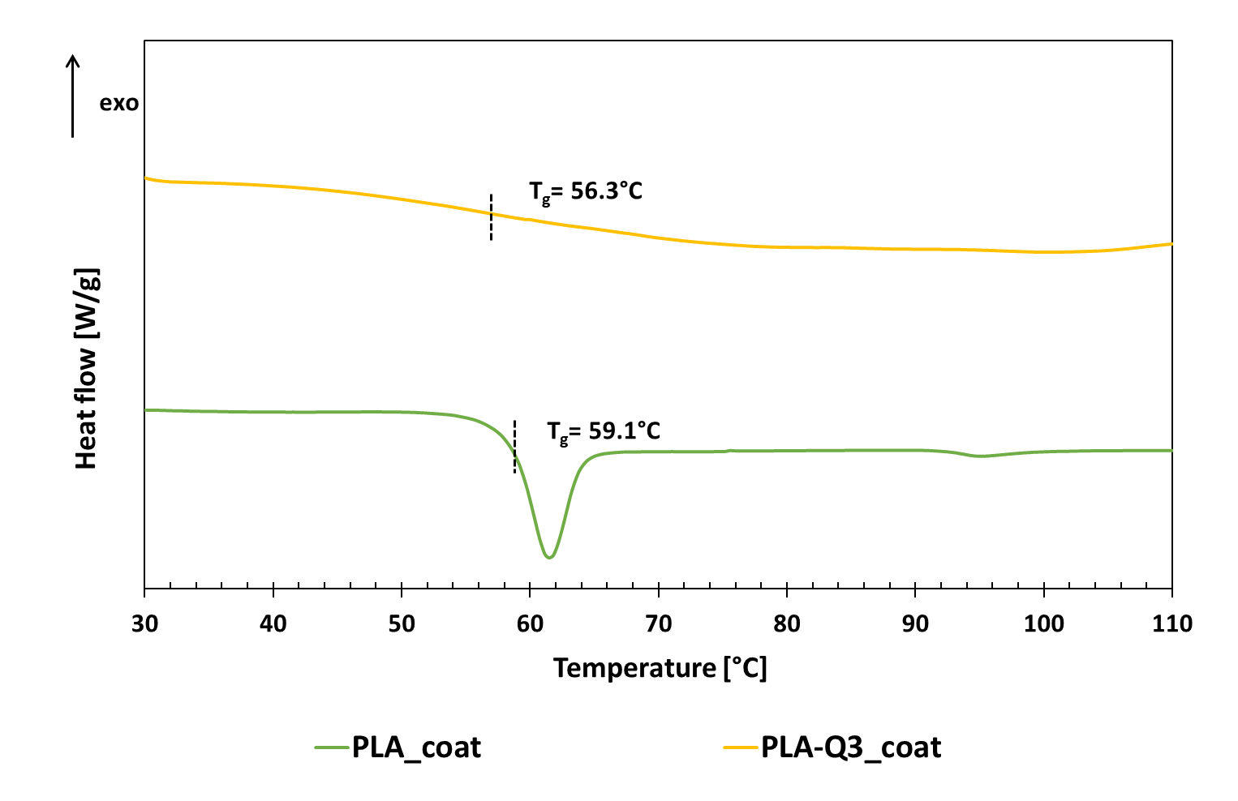
Figure 1: DSC heating thermogram of PLA and PLA-Q3 coating layers.
The thermograms of neat PLA coating layer (PLA_coat) and PLA loaded with 3% wt of Q (PLA-3Q_coat) showed slight shifts in the glass transition temperature (T_{g}) of PLA. The PLA_coat sample exhibited a T_{g} of approximately 59.1 °C, followed by a characteristic enthalpic relaxation associated with physical aging. The incorporation of Q resulted in a reduction of T_{g} in the PLA-3%Q coating sample showing a value of 56.3 °C. This decrease suggests that quercetin disrupted the weak intermolecular interactions within the PLA matrix by increasing chain mobility, in line with findings from other studies on functional biodegradable packaging incorporating quercetin. (Łopusiewicz et al., 2021; Rubini et al., 2020).
    - Evaluation of mechanical, barrier and optical properties
The coated films were evaluated for mechanical properties, oxygen permeability, and optical transparency to assess the impact of the coating layers and quercetin incorporation on the overall performance of the substrate, as these features play a key role in food packaging applications.
Table 1: Elastic modulus (E), elongation at break ($ε_{b})$, oxygen permeability (PO₂) and percentage transmittance at 560 nm (T₅₆₀) for the coated films and the uncoated substrate.
Film sample | E  [MPa] | $$ε_{b}$$  [%] | PO₂  $$\left[\frac{{cm}^{3} mm}{m^{2} day atm}\right]$$ | T₅₆₀  [%]
BF | 636±23ª | 42±3ª | 9.0 ±0.7ª | 6.1ª
BF/PLA | 942±46^{b} | 30±5^{b} | 12.4 ±0.9^{b} | 11.6^{b}
BF/PLA-Q3 | 882 ±64^{c} | 32±6^{b} | 11.4 ±1.0^{b} | 8.9^{c}

The addition of the PLA coating layer to the biodegradable substrate resulted in a stiffer structure, as indicated by the increase in E from 636 MPa (BF) to 942 MPa (BF/PLA), accompanied by a reduction in elongation at break from 42% to 30%. This effect is due to the inherent properties of PLA, which is a rigid and brittle polymer with an elastic modulus ($\sim$2000 MPa) of one order-of-magnitude higher than that of the substrate (Tábi et al., 2021). The incorporation of Q reduced the elastic modulus to 882 MPa in the BF/PLA-Q3 sample, due to a plasticizing effect confirmed by DSC analysis. Ductility was not affected and remained nearly identical to that of the BF/PLA sample.
In terms of oxygen permeability, the amorphous PLA layer offers limited resistance to oxygen transport, owing to its intrinsically low oxygen barrier properties (Wu et al., 2021). The slight increase observed in PO₂ values after coating is primarily due to the normalization based on the total film thickness (Apicella et al., 2019). Despite this, the films maintain PO₂ values that are within the acceptable range for packaging applications involving products that require moderate gas exchange, such as respiring fresh fruits and vegetables (Apicella et al., 2021; Trinh et al., 2023). Moreover, the presence of Q into the PLA coating did not significantly affect oxygen permeability, which remained around 11.4 cm³ mm/m² day atm.
The transparency of the films, expressed as transmittance at 560 nm (T₅₆₀), shows a clear improvement with the addition of the transparent amorphous PLA (Barbato et al., 2023). In particular, T₅₆₀ value nearly doubles passing from 6.1% of neat BF to 11.6% of BF/PLA sample. However, the inclusion of Q slightly reduced transmittance to 8.9%, likely due to its light-absorbing/scattering properties (Gore and Prajapat, 2022; Roy et al., 2023), though transparency remained higher than that of the uncoated BF film.
    - Release kinetics and antioxidant activity of smart coated film in different food simulants
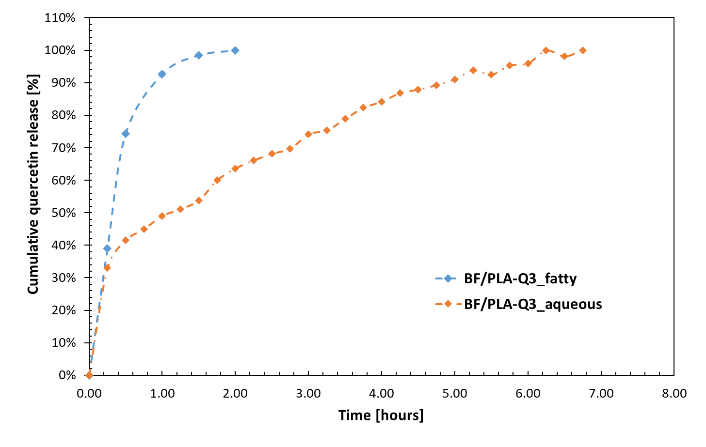
In order to evaluate the smart active performance of the developed films in contact with foods of different compositions, 10% ethanol (aqueous simulant, A) and 95% ethanol (fatty simulant, D2) were selected. Release tests were carried out on the BF/PLA-Q3 sample in both simulant solutions, and the release kinetics are displayed in Figure 2. The amount of quercetin released ($M_{∞})$, release time, and corresponding antioxidant activity (AA) are reported in Table 2.
Figure 2: Release kinetics of the active BF/PLA-Q3 coated film in aqueous (ethanol 10% v/v) and fatty (ethanol 95% v/v) simulants
Table 2: Maximum amount of quercetin released ($M_{∞}$), release time and antioxidant activity (AA) in aqueous and fatty simulants for sample film BS/PLA-Q3.
Simulant | $M_{∞}$  $$\left[\frac{μmol}{L}\right]$$ | Release time [h] | AA  $\left[\frac{{μmol}_{{Trolox}_{eq}}}{L}\right]$
A | 2.63 | 6.75 | 22.6
D2 | 236.4 | 2 | 415.4

Release tests and antioxidant activity were also performed on BF and BF/PLA films, used as reference samples (data not shown). As expected, these controls showed no significant release of active compounds or measurable antioxidant activity.On its side, BF/PLA-Q3 film displayed an initial burst release in both simulants, attributed to the rapid diffusion of quercetin present on the film surface. This initial phase was followed by distinct release patterns depending on the nature of the simulant. In the fatty simulant, Q was released more rapidly and in higher amounts, reaching 236.4 μmol/L within 2 hours. In contrast, the aqueous simulant showed a slower and lower release, with a maximum of 2.63 μmol/L over 6.75 hours.
The faster and higher release in the fatty medium is due to quercetin’s greater affinity for less polar components like ethanol, which enhances its solubility and diffusion (Ezati and Rhim, 2021). As a result, the AA expressed by the film was significantly higher in the fatty simulant (415.4 μmol Trolox eq/L) compared to the aqueous one (22.6 μmol Trolox eq/L), underlining the influence of food composition on film performance.
  - Conclusions
In this study, a PLA coating layer functionalized with 3% quercetin was applied onto a PBS/PVOH substrate with the aim of developing a smart active film with antioxidant properties, suitable for food packaging applications.
The PLA coating increased the stiffness of the substrate, as shown by the rise in elastic modulus from 636 to 942 MPa. The incorporation of quercetin slightly reduced this value to 882 MPa due to a plasticizing effect, confirmed by DSC analysis. Despite the reduction in stiffness, ductility was maintained around 32%, and oxygen permeability (PO₂= 11.4 cm³ mm/m² day atm) remained within a suitable range for packaging fresh food items such as respiring fruits and vegetables.
The release behavior of quercetin was strongly influenced by the polarity of the food simulant. In the fatty less polar simulant, a rapid and consistent release was observed (236.4 µmol/L in 2 h), resulting in high antioxidant activity (415.4 µmol Trolox eq/L). Conversely, in the aqueous simulant, both the amount released (2.63 µmol/L) and the antioxidant activity (22.6 µmol Trolox eq/L) were lower, with a prolonged release time of up to 6.75 hours. These findings highlight the crucial role of the food matrix composition in modulating the functional performance of the film, making it particularly promising for packaging fresh products with a short shelf life, where the release of active compounds over a timescale of a few hours can provide an immediate protective effect.

References

Apicella Annalisa, Adiletta Giuseppina, Albanese Donatella, Di Matteo Marisa, Incarnato Loredana, 2021. Biodegradable Films Based on Poly(lactic Acid) Coatings and Natural Olive-wastewater Extracts for Active Food Packaging. Chemical Engineering Transactions 87, 85–90. https://doi.org/10.3303/CET2187015
Apicella, A., Scarfato, P., Di Maio, L., Incarnato, L., 2019. Sustainable Active PET Films by Functionalization With Antimicrobial Bio-Coatings. Front. Mater. 6, 243. https://doi.org/10.3389/fmats.2019.00243
Apicella, A., Scarfato, P., Di Maio, L., Incarnato, L., 2018a. Oxygen absorption data of multilayer oxygen scavenger-polyester films with different layouts. Data Brief 19, 1530–1536. https://doi.org/10.1016/j.dib.2018.06.024
Apicella A., Scarfato P., Di Maio L., Garofalo E., Incarnato L., Evaluation of performance of PET packaging films based on different copolyester O₂-scavengers, AIP Conference Proceedings, 2018b, 1981, 020130.
Aytac, Z., Ipek, S., Durgun, E., Uyar, T., 2018. Antioxidant electrospun zein nanofibrous web encapsulating quercetin/cyclodextrin inclusion complex. J Mater Sci 53, 1527–1539. https://doi.org/10.1007/s10853-017-1580-x
Baghi, F., Gharsallaoui, A., Dumas, E., Ghnimi, S., 2022. Advancements in Biodegradable Active Films for Food Packaging: Effects of Nano/Microcapsule Incorporation. Foods 11, 760. https://doi.org/10.3390/foods11050760
Barbato, A., Apicella, A., Malvano, F., Scarfato, P., Incarnato, L., 2023a. High-Barrier, Biodegradable Films with Polyvinyl Alcohol/Polylactic Acid + Wax Double Coatings: Influence of Relative Humidity on Transport Properties and Suitability for Modified Atmosphere Packaging Applications. Polymers 15, 4002. https://doi.org/10.3390/polym15194002
Barbato Antonio, Apicella Annalisa, Palmieri Francesco, Incarnato Loredana, 2023b. Development of Biodegradable PBS/PVOH-based Films and Evaluation of Performance for Food Packaging Applications. Chemical Engineering Transactions 102, 97–102. https://doi.org/10.3303/CET23102017
Cheng, J., Gao, R., Zhu, Y., Lin, Q., 2024. Applications of biodegradable materials in food packaging: A review. Alexandria Engineering Journal 91, 70–83. https://doi.org/10.1016/j.aej.2024.01.080
D’Almeida, A.P., De Albuquerque, T.L., 2024. Innovations in Food Packaging: From Bio-Based Materials to Smart Packaging Systems. Processes 12, 2085. https://doi.org/10.3390/pr12102085
Deshmukh, R.K., Gaikwad, K.K., 2024. Natural antimicrobial and antioxidant compounds for active food packaging applications. Biomass Conv. Bioref. 14, 4419–4440. https://doi.org/10.1007/s13399-022-02623-w
Dörnyei K.R., Uysal-Unalan I., Krauter V., Weinrich R., Incarnato L., Karlovits I., Colelli G., Chrysochou P., Fenech M.C., Pettersen M.K., Arranz E., Marcos B., Frigerio V., Apicella A., Yildirim S., Poças F., Dekker M., Johanna L., Coma V., Corredig M., Sustainable food packaging: An updated definition following a holistic approach, Frontiers in Sustainable Food Systems, 2023, 7, 1119052.
Ezati, P., Rhim, J.-W., 2021. Fabrication of Quercetin-Loaded Biopolymer Films as Functional Packaging Materials. ACS Appl. Polym. Mater. 3, 2131–2137. https://doi.org/10.1021/acsapm.1c00177
Gore, A.H., Prajapat, A.L., 2022. Biopolymer Nanocomposites for Sustainable UV Protective Packaging. Front. Mater. 9. https://doi.org/10.3389/fmats.2022.855727
Gupta, D., Lall, A., Kumar, S., Dhanaji Patil, T., K. Gaikwad, K., 2024. Plant-based edible films and coatings for food-packaging applications: recent advances, applications, and trends. Sustainable Food Technology 2, 1428–1455. https://doi.org/10.1039/D4FB00110A
Jakubowska, E., Gierszewska, M., Szydłowska-Czerniak, A., Nowaczyk, J., Olewnik-Kruszkowska, E., 2023. Development and characterization of active packaging films based on chitosan, plasticizer, and quercetin for repassed oil storage. Food Chemistry 399, 133934. https://doi.org/10.1016/j.foodchem.2022.133934
Kuai, L., Liu, F., Chiou, B.-S., Avena-Bustillos, R.J., McHugh, T.H., Zhong, F., 2021. Controlled release of antioxidants from active food packaging: A review. Food Hydrocolloids 120, 106992. https://doi.org/10.1016/j.foodhyd.2021.106992
Lai W.F., Design of Polymeric Films for Antioxidant Active Food Packaging, International Journal of Molecular Sciences, 2021, 23(1), 12.
Łopusiewicz, Ł., Zdanowicz, M., Macieja, S., Kowalczyk, K., Bartkowiak, A., 2021. Development and Characterization of Bioactive Poly(butylene-succinate) Films Modified with Quercetin for Food Packaging Applications. Polymers 13, 1798. https://doi.org/10.3390/polym13111798
Roy, S., Ezati, P., Khan, A., Rhim, J.-W., 2023. New opportunities and advances in quercetin-added functional packaging films for sustainable packaging applications: a mini-review. Critical Reviews in Food Science and Nutrition 1–16. https://doi.org/10.1080/10408398.2023.2200553
Rubini, K., Boanini, E., Menichetti, A., Bonvicini, F., Gentilomi, G.A., Montalti, M., Bigi, A., 2020. Quercetin loaded gelatin films with modulated release and tailored anti-oxidant, mechanical and swelling properties. Food Hydrocolloids 109, 106089. https://doi.org/10.1016/j.foodhyd.2020.106089
Tábi, T., Ageyeva, T., Kovács, J.G., 2021. Improving the ductility and heat deflection temperature of injection molded Poly(lactic acid) products: A comprehensive review. Polymer Testing 101, 107282. https://doi.org/10.1016/j.polymertesting.2021.107282
Trinh, B.M., Chang, B.P., Mekonnen, T.H., 2023. The barrier properties of sustainable multiphase and multicomponent packaging materials: A review. Progress in Materials Science 133, 101071. https://doi.org/10.1016/j.pmatsci.2023.101071
Wu, F., Misra, M., Mohanty, A.K., 2021. Challenges and new opportunities on barrier performance of biodegradable polymers for sustainable packaging. Progress in Polymer Science 117, 101395. https://doi.org/10.1016/j.progpolymsci.2021.101395

