Application of Artificial Neural Networks in Predicting the Operational Behavior of an Indirect Freezing Desalination System

ªUniversity of Campinas, Cidade Universitária Zeferino Vaz Av. Albert Einstein, 500, Zipcode 13083-852, Campinas-SP, Brazil
flaviovs@unicamp.br
Abstract
The current and growing shortage of drinking water is a reality across the planet. More than 97% of the water available on the planet is salty and unfit for human consumption or agricultural use. Desalination processes serve as viable alternatives for supplying drinking water in regions facing water scarcity. Typically, areas most impacted by drought are less technologically developed, which hinders the utilization of highly complex processes, such as the reverse osmosis method. Freeze desalination is presented as a simple, affordable, and viable alternative to saltwater treatment processes in drought-affected areas; however, knowledge about the dynamics of the process remains nebulous. In this context, artificial neural networks were developed to predict the fraction of ice formed in the mixture based on the initial NaCl concentration and the NaCl concentration in the brine. The project results indicate that artificial intelligence techniques are effective in predicting the dynamic behavior of the process with an average error of 1.29%.
Keywords: desalination, freezing, neural networks, artificial intelligence.
  - Introduction
The evolution of global warming and poor water resource management, coupled with the planet’s increasing population and its demand for clean water, has led to a severe water shortage for approximately 4 billion people for at least one month out of the twelve months in a year. (Jafari Shalamzari and Zhang, 2018; Khatibi and Arjjumend, 2019). The risks of water scarcity are associated with two main factors: the intensive use of water, surpassing its natural replenishment capacity, and human activities that harm the hydrological cycle. Water resources are crucial for the sustainable development of countries.
In this regard, in 2015, the United Nations established the Sustainable Development Goals (SDGs) to guide national policies and international co-operation activities for the next 15 years, in line with the 2030 Agenda. The SDGs consist of 17 objectives aimed at the sustainable development of nations. The sixth goal focuses on ensuring access to clean water and sanitation for all people, regardless of their location.
Considering the guidelines established by the United Nations and the imminent threat of water scarcity and rationing for the global population, water desalination methods are being studied worldwide. These water desalination methods involve processing saltwater to transform it into potable water. In 2017, the capacity of water desalination plants reached a volume of 99.8 million cubic meters per day (GWI, 2018). One of these alternatives is freezing desalination, which proves to be an efficient and viable option for implementation. The potability in terms of sodium chloride concentration is defined by the World Health Organization as values below 0.4 gNaCl/100mL. However, starting from 0.2 gNaCl/100mL, the water exhibits an uncomfortable salty taste. In this work, we will define potability as values below 0.4 gNaCl/100mL. (ORGANIZATION et al., 2011). Although studies on freeze crystallization dated back several centuries, the understanding of ice crystallization and growth in a slurry/mushy ice, salt rejection during the process is still chaotic and unsystematic. For instance, the key parameters affecting the freezing time, cooling rate, cooling source temperature, solution composition, and ice quality are not available despite the numerous reports of experimental studies on FD (Janajreh et al., 2023).
An alternative that can be used in remote areas is freezing desalination, which relies on a well-established cooling system and has low energy costs that can be supplied using clean energy sources such as wind or solar power. Water desalination by freezing systems has been studied and developed worldwide (Barma et al., 2021; El Kadi and Janajreh, 2017; Kalista et al., 2018; Mahdavi et al., 2011; Morillo et al., 2014) and proves to be a simple, cost-effective, and viable alternative for implementation in the Brazilian semi-arid region.
Due to being a multivariable and chaotic system, artificial neural networks were employed in constructing the predictive model of NaCl concentration enclosed in ice to determine the best endpoint of the freezing cycle, enabling the methodology to be replicated in indirect freezing desalination equipment.
  - Materials and Methods
    - Curve of Concentration Relation with Conductivity and Temperature.
For the execution of freezing cycles, the MK-70 equipment from MLW. It consists of a 15-liter ultracryostat bath that reaches a temperature of -25°C at the surface of the coil and exchanges heat with the saltwater to be frozen. The equipment has a physical limitation of ice formation of up to 80% to ensure upward mechanical agitation.
The monitoring of brine conductivity during the freezing cycles was carried out using the Orion 3-Star conductivity meter from Thermo Scientific. The probe used provides conductivity data in mS/cm and temperature data in degrees Celsius. The temperature sensor is capable of measuring temperatures above -5°C. The solutions were prepared using deionized water and sodium chloride. To develop the predictive model, ten standard solutions of varying concentrations were prepared: 0.05, 0.1, 0.25, 0.5, 1.0, 2.0, 3.0, 6.0, 9.0, and 12.0 grams of NaCl per 100 mL of deionized water. The temperature of the solutions was varied from 1 to 20°C, with conductivity recorded at each temperature. A curve fitting was performed according to Equation 1 to obtain the parameters a, b, c, and d.
$$C[g/100mLH_{2}O](Cond,T)=a*Cond[μS/cm]^{b}*exp^{(c*T[^{∘}C])}+d$$ | (1)
    - Application of Mass Balance for Determination of Formed Ice Fraction
The initial concentration was varied in 6 ranges: 11, 6.5, 3.4, 1.6, 0.7, and 0.35 grams of NaCl per 100 grams of H2O in fractions ranging from 20% to 80% of ice formation.
Each freezing cycle will provide data on the initial concentration of NaCl, the final concentration of NaCl in the brine, and the final concentration of NaCl enclosed in the ice. From this data, the mass balance of Equation 2 can be applied to obtain the fraction of ice formed in the cycle.
$$\%Ice(C_{0},C_{Ice},C_{Brine})=1-\frac{C_{0}-C_{Ice}}{C_{Brine}-C_{Ice}}$$ | (2)
  - Regressor Artificial Neural Networks Applied to Prediction of Formed Ice Fraction.
The chosen artificial intelligence for building the predictor was the Artificial Neural Network Regressor, which aims to fit the training data provided during training. The model’s goal is to predict the ice fraction based on the initial concentration of the cycle and the radio of the dynamic concentration of sodium chloride in the brine described in equation 3.
$$RSC_{Brine}=\frac{C_{Brine}}{C_{0}}$$ | (3)
  - Application of Mass Balance for Determining NaCl Concentration in Formed Ice
With this information, it is possible to reapply the mass balance and determine the concentration of sodium chloride enclosed in the ice, as described in Equation 4.
$$C_{Ice}(C_{0},C_{Brine},\%Ice)=\frac{C_{0}-(1-\%Ice)*C_{Brine}}{\%Ice}$$ | (4)
  - Regressor Artificial Neural Networks Applied to Prediction of Formed Ice Fraction.
The inputs to the Artificial Neural Network (ANN) are the Initial Concentration of the solution and the Ratio of Salt Concentration in the Brine.
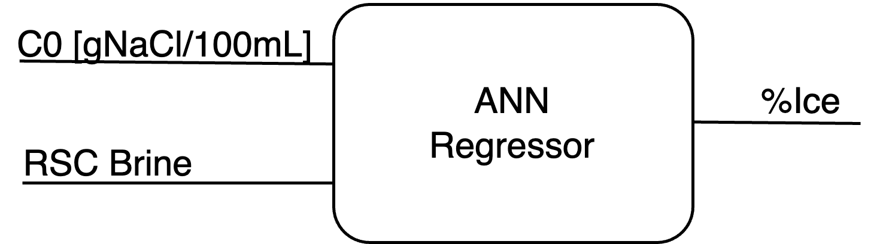
The output of the ANN is the fraction of ice formed and training of the neural network was carried out in Python, using the SciKit-Learn library, based on the block diagram shown in Figure 1. The Scikit-Learn is a machine learning tool known for providing efficient implementations of traditional machine learning algorithms in the Python programming language.
Figure 1 - ANN Regressor Block Diagram
For monitoring the concentration of sodium chloride in the brine during the freezing process, it was necessary to apply Equation 1, this time fitting the curve at temperatures below 0°C and obtaining new values for a, b, c, and d. The curve-fitting data was obtained during the freezing cycles. At the end of the freezing cycles, the brine’s conductivity and temperature data were stored for curve fitting alongside the sodium chloride concentration values.
  - Freezing Cycle Termination Method.
The determination of the termination point for the freezing cycles will be evaluated based on the maximum quotient of the obtained potable water yield and the number of cycles required to achieve it, as per Equation 5.
$$Quotient=\frac{\%Productivity}{Cycles}$$ | (5)

  - Results and Discussions
    - Curve of Concentration Relation with Conductivity and Temperature.
Data was collected by correlating the concentration of NaCl in the solution with conductivity and temperature, and curve fitting was performed according to Equation 1.
The parameters a, b, c, and d were adjusted for two different concentration ranges, one greater than 2 grams per 100 mL of water and the other less than 2 grams per 100 mL of water. Table 1 illustrates the parameters for each model.
Table 1 - Predictor Parameters for Concentration, Models 1, 2, and 3.
 | Model 1 | Model 2 | Model 3
Parameter | C ≤ 2g/100mL | C ≥ 2g/100mL | -5°C ≤ T ≤ 0°C
a | 0.08422454 | 0.02735635 | 0.10068852
b | 1.10092099 | 1.37416940 | 1.02826665
c | -0.02684441 | -0.03232585 | -0.07030928
d | 0.00813535 | 0.59426096 | -0.01505198
The mean percentage errors attributed to models 1, 2, and 3 were 1.427%, 0.963%, and 0.60%, respectively.
  - Regressor Artificial Neural Networks Applied to Prediction of Formed Ice Fraction.
Using the data from partial indirect freezing cycles performed, an artificial neural network with two inputs and one output was designed, as illustrated in Figure 1. The available data was normalized and divided into training and testing datasets, with a ratio of 19.51% (33 for training and 8 for testing). The training of the neural network was conducted using the GridSearch tool to determine the best architecture. The hyperparameters that showed the best performance included three layers with 87, 174, and 87 neurons, respectively, and the rectified linear unit (ReLU) activation function.
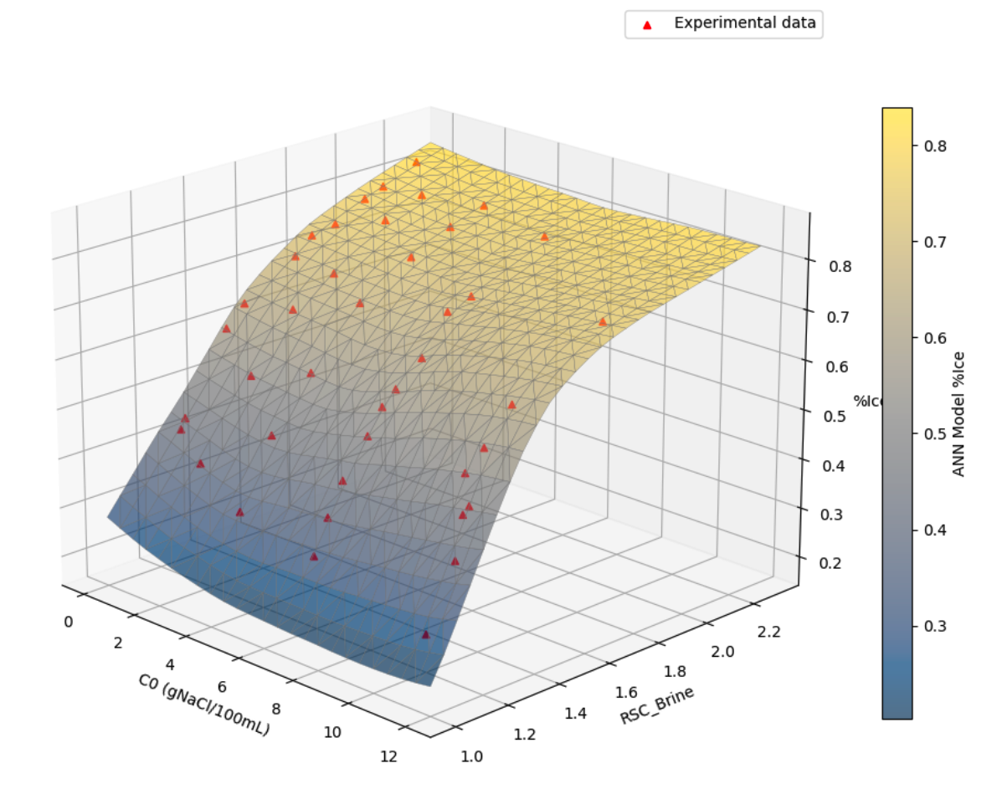
The use of two inputs and one output in building the model allows for the visualization of a response surface in three dimensions within the operating values of the equipment, as shown in Figure 2.
Figure 2 - Response Surface of the Neural Network-Based Model.
It is observed that the network adapted well to the training data without overfitting issues, achieving a mean absolute percentage error of 2.087%.
  - Application of Mass Balance for Determining NaCl Concentration in Formed Ice
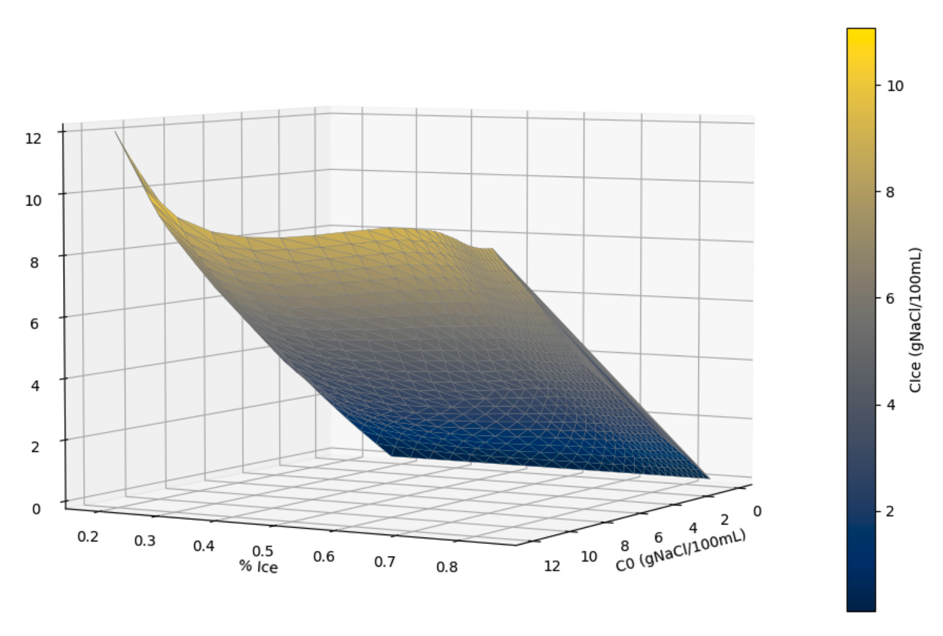
With an understanding of the system’s dynamics, it is possible to determine the moment to conclude the freezing cycle. By applying the mass balance on the response surface of the neural network illustrated in Figure 2, it can be observed in Figure 3 that salt encapsulation is minimally influenced by the increase in the ice fraction produced per cycle.
Figure 3 - Response Surface of NaCl Concentration in Ice.
3.4 Freezing Cycle Termination Method.
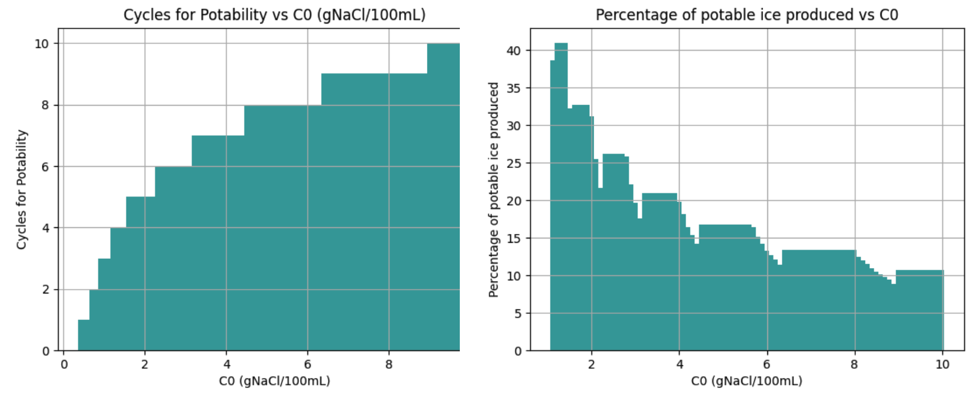
The conclusion of the freezing cycle was defined as the highest possible ice formation value (80%) in cycles that do not achieve potability. From the definition of the freezing cycle termination point, it is possible to predict the number of cycles required to achieve potability and the corresponding total ice fraction obtained by the system at each of the initial concentrations addressed during the neural network training. The data has been illustrated on Figures 4 and 5.
Figure 4 - Number of cycles to achieve potability. Figure 5 - Process Yield.
3.5 Validation Data.
The validation of the model will be carried out through the desalination of a solution with 3.0265 g NaCl/100mL. The model predicted that potability would be reached in 6 cycles, achieving 0.4 g NaCl/100mL with a yield of 19.26%. The freezing cycles were executed on the equipment, Table 2 illustrates the results obtained in each prediction.

Table 2 - Model validation with real freezing data
Cycle | C0 | C Brine | C Ice | % Ice | %Ice Model | % Error
1 | 3.0265 | 6.6983 | 2.1961 | 81.56% | 80.84% | 0.8724%
2 | 2.1786 | 4.7026 | 1.5361 | 79.71% | 80.38% | 0.8467%
3 | 1.5455 | 3.2826 | 1.1319 | 80.77% | 80.22% | 0.6841%
4 | 1.1303 | 2.3821 | 0.8375 | 81.04% | 80.20% | 1.0407%
5 | 0.8239 | 1.7115 | 0.6164 | 81.05% | 79.90% | 1.4228%
6 | 0.5936 | 0.8659 | 0.4176 | 60.74% | 58.99% | 2.8878%
An average percentage error of 1.2924% was observed in the prediction of the ice fraction formed in each cycle. It is valid to state that none of these data were used in the prior training or testing of the model, indicating the robustness of the developed predictor.
  - Conclusions
ANN was effective in predicting the fraction of ice formed, using known input variables such as the initial solute concentration and brine concentration during freezing.
The concentration of sodium chloride enclosed in ice crystals was accurately calculated using the predictive model of the ice fraction and a mass balance.
The obtained neural model was able to determine the number of freezing cycles required to achieve potability levels and the performance of the freeze desalination process with minimal error.
Future work could investigate variations in the coil surface temperature or altering the coil’s geometry. These variables can be incorporated into neural network training and operated dynamically in the desalination process to achieve better results.
Acknowledgments
The authors would like to thank the National Council for Scientific and Technological Development (CNPq) grant number 131644/2021-1.
References
BARMA, M. C.; PENG, Z.; MOGHTADERI, B.; DOROODCHI, E. Freeze desalination of drops of saline solutions. Desalination, v. 517, p. 115265, 2021.
GWI. DESALINATION & REUSE HANDBOOK: International Desalination Association, 2018.
JANAJREH, I., ZHANG, H., EL KADI, K., GHAFFOUR, N., 2023. Freeze desalination: Current research development and future prospects. Water Research 229, 119389.
KADI, K. E.; JANAJREH, I. Desalination by freeze crystallization: an overview. Int. J. Therm. Environ. Eng, v. 15, n. 2, p. 103–110, 2017.
KALISTA, B.; SHIN, H.; CHO, J.; JANG, A. Current development and future prospect review of freeze desalination. Desalination, Elsevier, v. 447, p. 167–181, 2018.
KHATIBI, S.; ARJJUMEND, H. Water crisis in making in iran. Grassroots Journal of Natural Resources, v. 2, n. 3, p. 45–54, 2019.
MAHDAVI, M.; MAHVI, A. H.; NASSERI, S.; YUNESIAN, M. Application of freezing to the desalination of saline water. Arabian Journal for Science and Engineering, Springer, v. 36, p. 1171–1177, 2011.
MORILLO, J.; USERO, J.; ROSADO, D.; BAKOURI, H. E.; RIAZA, A.; BERNAOLA, F.-J. Comparative study of brine management technologies for desalination plants.Desalination, Elsevier, v. 336, p. 32–49, 2014.
SHALAMZARI, M. J.; ZHANG, W. Assessing water scarcity using the water poverty index (wpi) in golestan province of iran. Water, MDPI, v. 10, n. 8, p. 1079, 2018.

