Rational Function-based Approach for Integrated Ionic Liquid Solvent Selection and Extractive Distillation Process Design

Sahil Sethi,a Xiang Zhang,a,* Kai Sundmachera,b

*a Process Systems Engineering, Max Planck Institute for Dynamics of Complex Technical Systems, Sandtorstr. 1, D-39106 Magdeburg, Germany*

*b Chair of Process Systems Engineering, Otto-von-Guericke University Magdeburg, Universitätsplatz 2, D-39106 Magdeburg, Germany*

***\*****zhangx@mpi-magdeburg.mpg.de*

Abstract

The efficacy of an extractive distillation relies significantly on the solvent selection and its detailed process design. Using thermodynamic metrics such as selectivity and capacity at infinite dilution cannot identify the real optimal solvent with minimal process cost. In this work, a novel process-based data-driven approach is developed to screen huge design space of ionic liquid solvents for the separation of ethylbenzene/styrene (et/st). Rational functions were trained with data from quantum chemistry calculations and used as simple surrogates to model vapor-liquid equilibria for facilitating optimal synthesis of extractive distillation processes. Given various process configurations, the real process performance of numerous ionic liquids can be evaluated rapidly. With the strategy of accelerated process synthesis, a multi-level solvent screening framework is adopted. Several ionic liquid solvents are finally identified to compete with the industrial benchmark sulfolane in terms of total annualized cost. This gives promising prospects for improving the efficiency of et/st separation.

**Keywords**: Ionic liquid solvent screening, extractive distillation, process configuration, surrogate modelling, vapour-liquid equilibrium

* 1. Introduction

Separation processes contribute substantially to the global energy usage (Sholl et al., 2016).Despite advancements in many separation methods, distillation is anticipated to persist as the primary separation technology for practical uses in the future. Extractive distillation has gained particular attentions for separating close-boiling and azeotropic liquid mixtures. Utilizing an external solvent, namely entrainer, alters the thermodynamic equilibrium of the initial mixture. This makes the original separation more energy-efficient. However, identifying the promising entrainer remains a challenging task due to the huge design space of potential candidates. Traditional methods for solvent screening rely on simple performance metrics (Momoh, 1991) and shortcut process models (Dong, 2018), which cannot find real optimal solvent and the best process performance.

To fill in the above gap, a novel data-driven optimization approach was recently proposed to screen very many organic solvents for the separation of ethylbenzene/styrene (et/st). Rational Function (RF) and Multivariate Polynomial (MP, a subset of RF) were used to approximate complex vapor-liquid equilibria (VLE) to accelerate optimization-based synthesis of extractive distillation processes. This enables to assess the real process performance of a given solvent within a short period of time (e.g., minutes).

Unlike organic solvents, ionic liquids (ILs) possess negligible vapor pressure, which allows to explore various solvent recovery strategies such as simple evaporation and stripping. This offers additional variations for developing efficient extraction distillation technologies. Taking et/st separation as an example, a superstructure-based optimization approach is developed and applied in this work to screen various ILs and recovery strategies. To simplify the thermodynamics, RFs are still trained as VLE surrogates to expedite the optimization. Regarding two process configurations, the real process performance of numerous ionic liquids are evaluated rapidly. At the end, our automated framework finds multiple IL solvents that can compete against sulfolane (i.e., industrial benchmark for et/st separation) in terms of total annualized cost. This presents a promising prospect for enhancing the efficiency of et/st separation.

* 1. VLE Surrogate Modelling

For the VLE of a 2-component mixture (A and B), six intensive state variables govern the system (i.e., pressure $P$, temperature $T$, liquid molar fractions $x_{A},x_{B}$, and vapour molar fractions $y_{A},y_{B}$). According to the Gibbs phase rule at a fixed pressure, the degree of freedom in the binary system is equal to 1. Treating $x_{B}$ as the independent variable, the other four variables can be expressed as functions of $x_{B}$. RF surrogate model is trained to correlate *T* with $x_{B}$ in Eq. (1.a). MP surrogate model is built to map $y_{B}$ with ( $x_{B}, T)$ in Eq. (1.b).

$T_{pred}=\frac{a_{m}x_{B}^{m}+a_{m-1}x_{B}^{m-1}+…+a_{1}x_{B}+a_{0}}{b_{n}x_{B}^{n}+b_{n-1}x_{B}^{n-1}+…+b_{1}x_{B}+1}$ (1.a)

$y_{B}=\sum_{p=0}^{N}{\sum_{q=0}^{N}{c_{pq}∙x_{B}^{p}∙T_{pred}^{q}}}$ (1.b)

For the instance of styrene/ionic liquid system, its VLE data at two different pressures 1 kPa (very low pressure) and 10 kPa (moderate pressure) can be estimated using COSMO-RS. Specifically, the liquid molar fraction of styrene is treated as an independent variable within [0, 1] and discretized into 100 equal intervals. The corresponding temperatures and vapour molar fractions at equilibrium are computed, resulting into 101 VLE data points. Those data can be directly utilized for surrogate modelling. For many ILs, it was found that the RF models with 1 degree polynomial in numerator and denominator can describe temperature accurately.

Apart from binary mixtures, the VLE of a 3-component mixture (A, B, and S), eight intensive state variables govern the system (i.e., $P, T, x_{A},x_{B},x_{c},y_{A},y_{B,}y_{c}$) where degree of freedom is 2 at a fixed pressure. Considering $x_{A}$ and $x_{B}$ as independent variables, all other variables are expressed as their functions. Similar to binary mixtures, RFs and MPs can be trained for ternary mixtures. For the ethylbenzene/styrene/ionic liquid system, VLE data at 10 kPa is generated using COSMO-RS as well. The liquid molar fractions of ethylbenzene and styrene are set as independent variables and discretized into 100 equal intervals, resulting into 5151 VLE data points. Both RF and MP are found to approximate VLE with great thermodynamic consistency. For many ILs, it was found that RFs for temperature need 3 degree polynomial at numerator and 1 degree polynomial at denominator (Eq. 2.a). MPs for vapor molar fractions needs 4 degree polynomials (Eq. 2.b and 2.c) to achieve desired accuracy.

$T_{pred}=\frac{\sum_{j=0}^{3}{\sum_{k=0}^{3}{a_{jk}∙x_{A}^{j}∙x_{B}^{k}}}}{b_{10}∙x_{A}+b_{01}∙x_{B}+1}$ (2.a)

(2.b)

(2.c)

* 1. Multi-Level Ionic Liquid Screening Framework
     1. Screening via Thermodynamic Properties

696 cations and 500 anions covering different families are collected from the Biovera 2020 COSMO Databank resulting in 348,000 possible ILs for screening. COSMO-RS calculations involve two primary steps. Firstly, screening charge density distributions (σ-profiles) for the involved compounds are derived via standard quantum chemical computations. Secondly, the chemical potentials of the involved compounds are quantified based on the obtained σ-profiles to analyze the molecular interactions. This method enables the prediction of activity coefficients in IL-based systems. The calculation of activity coefficients is given by Eq. (3). Selectivity of ILs (i.e., solvent S) at infinite dilution is in Eq. (4) where i and j are ethylbenzene and styrene, respectively. The selectivity of ethylbenzene over styrene should exceed 1 in Eq. (5). To conduct efficient computations, an auxiliary batch-processing program in COSMOthermX (referred to as CT_CREATE) is used to create template input files. Activity coefficients are calculated based on BP_TZVP_20.ctd parametrization in COSMOtherm.

(3)

(4)

(5)

* + 1. Screening via Ionic Liquid Properties

Melting point ($T_{m}$) of IL candidates are predicted using the BP_TZVP_21_0106.ctd parametrization in COSMOtherm software (U Preiss et. al, 2010). Since solvent should be in liquid state, Eq. (6) is used as a constraint for screening. In addition, the et/st separation is presumably operated at 10 kPa and ILs are recovered at either 1 kPa or 10 kPa based on the recovery strategies. This can ensure the success of IL recovery and prevent the polymerization of styrene.

$T_{m}≤315 K$ (6)

Due to negligible vapor pressure of ILs, it is assumed that ILs are only in liquid form in columns. Since the boiling point of styrene at 10 kPa is 348 K, Eq. (7) is used as the boiling point constraint for ILs.

$T_{b}^{10}≥368 K$ (7)

Viscocity (*ƞ*) is one of the important IL properties and need to be considered from the perspective of practical applications. Here, the COSMO-RS is employed to predict the IL viscosity via a QSPR approach **(**Eiden et al. 2010) and viscosity is constrained using Eq. (8).

$η<150 cP$ (8)

Due to the increasing awareness of potential hazards led by ILs, the assessment of IL toxicity has gained prominence**.** The evaluation involves predicting the EC50 (half-maximal effective concentration) of ILs against IPC-81, a Leukemia rat cell line. This prediction is executed using two machine learning (ML) models, namely feedforward neural network (FNN) and support vector machine (SVM) in the work of Wang et al., (2021). Adhering to the criteria proposed by the UFT research unit at the University of Bremen, Eq. (9) is adopted as a constraint for the EC50 toxicity.

(9)

* + 1. Accelerated ED Process Synthesis Using Multiple Recovery Strategies

After the above screening, the real process performance of the remained solvents are accessed. Based on the previous research (Jongmans et. al 2013), simple evaporation at moderate pressure in combination with either additional evaporation at a very low pressure or stripping are considered here for IL recovery. All the binary and ternary VLE data are sampled via the COSMO-RS calculations to train the RF and MP surrogate models. The obtained surrogates are embedded into the process model and the resulted optimization problem is formulated via Generalized Disjunctive Programming (GDP). DICOPT, CPLEX, and CONOPT4 are employed to solve the optimization problems. Embedding VLE surrogates fasten the convergence and do not rely on perfect initializations owing to the reduced non-linearity. In this way, the real promising ILs and the associated solvent recovery strategy can be quickly identified.

* + 1. Proximity search for rigorous solution using Aspen Plus

Utilizing the optimal solvent, a local search is conducted by employing genetic algorithm and Aspen Plus to validate the obtained results. The requirement for ethylbenzene and styrene purity and recovery are verified and ensured.

* 1. Results

Surrogate VLE modelling results in significant simplicity and interpolative accuracy. For [4-mebupy][BF4],Figure (1.a) illustrates the comparison between RF surrogate and the equilibrium temperatures from COSMO-RS. 3rd and 2nd degree polynomials are used in numerator and denominator, respectively. The R2 score is 0.9981 and the mean absolute error (MAE) is 0.1122, showing the excellent interpolations of the RF model. Similarly, Figure (1.b) is the comparison between MP surrogate and COSMO-RS computations for the vapour mole fraction of styrene. 4th degree MP is trained. The R2 is 0.9999 and almost negligible MAE shows the excellent interpolation of the MP model to map vapor mole fraction to temperature and liquid mole fractions.

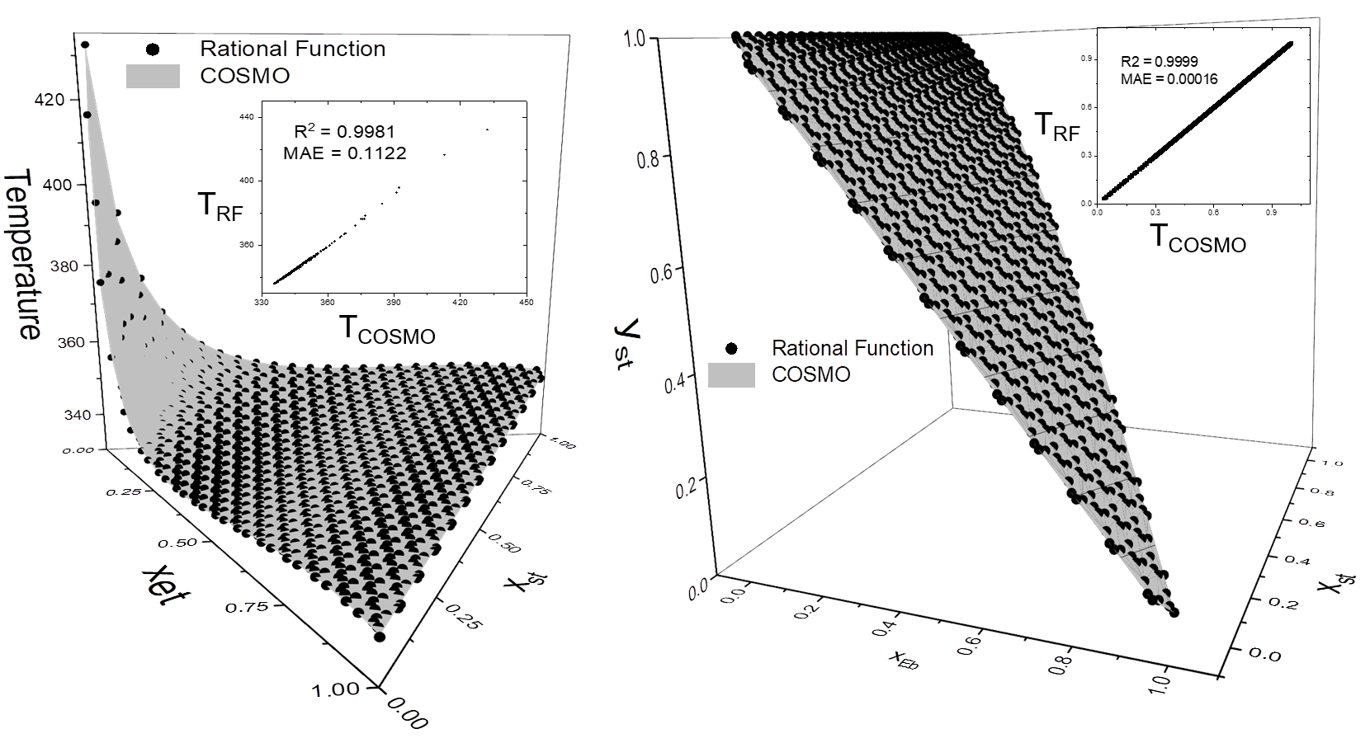

Figure. 1 (a) VLE temperature and (b) styrene vapor molar fraction against liquid molar fractions for ternary system ethylbenzene + styrene + [4-mebupy][BF4]at 10 kPa

Similar calculations for a binary system were performed. Depending on the different configurations, RF models were trained for two different pressures (i.e., 1kPa and 10kPa) as shown in Figure 2.



Figure. 2 VLE temperature against liquid molar fraction for the binary system styrene + [4-mebupy]+[BF4]- at (a) 1 kPa and (b) 10kPa

* 1. Conclusions

This work is an extensions of our recent work for process-based entrainer screening. To explore the huge design space of ionic liquid solvents, a multi-level screening is performed to identify the best solvent and optimal process design including optimal solvent recovery strategy. For expediting process synthesis, rational functions and multivariate polynomials are trained as suitable surrogate models for approximating vapor-liquid equilibrium and ensuring thermodynamic consistency.

References

Sholl D.S. and Lively R.P., 2016. Seven chemical separations to change the world. *Nature*; 532:435-437.

Momoh S.O., 1991. Assessing the accuracy of selectivity as a basis for solvent screening in extractive distillation processes. *Separation Science and Technology*; 26(5):729-742.

Dong Y., Dai C., Lei Z., 2018. Extractive distillation of methylal/methanol mixture using ethylene glycol as entrainer. *Fluid Phase Equilibria*; 462:172-180.

Preiss U., Bulut S., Krossing I., 2010. In silico prediction of the melting points of ionic liquids from thermodynamic considerations: A case study on 67 salts with a melting point range of 337 °C. *The Journal of Physical Chemistry B*; 114:11133-11140.

Wang Z., Song Z., Zhou T., 2021. Machine learning for ionic liquid toxicity. *Processes*; 9:65.

Eiden P., Bulut S., Köchner T., Friedrich C., Schubert T., Krossing I., 2010. In silico predictions of the temperature-dependent viscosities and electrical conductivities of functionalized and nonfunctionalized ionic liquids. *The Journal of Physical Chemistry B*; 115:300-309.

Jongmans M.T.G., Trampé J., Schuur B., Haan de A.B., 2013. Solute recovery from ionic liquids: A conceptual design study for recovery of styrene monomer from [4-mebupy][BF4]. *Chemical Engineering and Processing: Process Intensification*; 70:148-161.