Enhanced Ammonia Cracking Process via Induction Heating for Green Hydrogen Production: A Comprehensive Techno-Economic and Environmental Analysis
Seunggwan Yun^{a,c§}, Junhyuk Lim^{a,b§}, Junghwan Kim^{c}, Hyungtae Choª, Jaewon Lee^{a*}
ªGreen Materials and Processes R&D Group, Korea Institute of Industrial Technology, 55, Jonga-ro, Ulsan, 44413, Korea
^{b}Department of Chemical engineering Engineering, Hongik University, 94, Wausan-ro, Seoul, 04066, Korea
^{c}Department of Chemical and Biomolecular Engineering, Yonsei University, 50, Yensei-ro, Seoul, 03722, Korea

§Yun S. and Lim J. contributed equally to this work as first authors.
*Coressponding author: j.lee@kitech.re.kr
Abstract
Ammonia has been highlighted as a potential liquid organic hydrogen carrier (LOHC) because of its high gravimetric density (17.7wt%) and low boiling point (-33.3°C at 1atm)(“Glob. Hydrog. Rev. 2022,” 2022; Lee et al., 2023). Hydrogen transported in the form of ammonia undergoes conversion into hydrogen through an ammonia decomposition process. Among the ammonia decomposition processes, the induction heating-based process has the advantage of achieving the ultimate goal of green hydrogen production when utilizing renewable energy sources. However, in the existing induction heating-based ammonia decomposition process, 1.65 kmol/h of hydrogen out of the produced 8.25 kmol/h was discarded as PSA off-gas during the purification. This study aims to utilize the discarded hydrogen in the off-gas to enhance the economic feasibility, energy efficiency, and GHG emissions of the induction heating-based ammonia decomposition process. The off-gas consists of 37.5% hydrogen and 62.5% nitrogen. With its high hydrogen content and the inert property of nitrogen, the off-gas can be effectively utilized through methods using an additional unit such as fuel cells, a burner, or a purification unit.
In this study, a case study was conducted by utilizing these methods. In the process with fuel cells, the SOFC and PEMFC were used to generate additional power from the off-gas hydrogen. Consequently, a portion of the power consumed in the induction heating reactor can be generated by the fuel cells. In the case of combusting the off-gas, only water and nitrogen are generated as emissions, and the generated heat is utilized for ammonia preheating, reducing the power load on the induction heating reactor. In the case of employing additional purification unit, the hydrogen recovery rate is increased to enable the production of a greater quantity of hydrogen. For each of these cases, we conducted a technoeconomic analysis (TEA) and a Life cycle assessment (LCA). As a result, the performance of the proposed processes has been improved in above fields compared to the existing induction heating-based ammonia decomposition process. This study is expected to provide valuable insights for proposing improvements in the ammonia-based hydrogen production processes.
Keywords: green hydrogen, ammonia decomposition, induction heating reactor, fuel cell
  - Introduction
As the arising importance of carbon neutrality and clean energy sources, hydrogen has gained significant attention as a clean fuel (Lee et al., 2023). However, according to the International Energy Agency’s (IEA) 2022 Global Hydrogen Review, 99% of the world’s annual hydrogen production is derived from fossil fuels (with refineries contributing 18%, coal 19% and natural gas without CCUS 62%) (“Glob. Hydrog. Rev. 2022,” 2022). This raises substantial concerns regarding the CO₂ emissions associated with hydrogen production, thereby elevating the significance of green hydrogen. Green hydrogen is produced through renewable energy-powered electrolysis. To effectively transition towards a cleaner energy paradigm, it is crucial not only to address hydrogen production but also to conduct research focused on reducing CO₂ emissions during transportation and decomposition processes.
The primary carriers for hydrogen transportation are liquified hydrogen (LH2), compressed hydrogen (CGH2), Liquid Organic Hydrogen Carriers (LOHC), ammonia. The most prevalent methods are CGH2 and LH2. Both options are characterized by high-security requirements due to high pressure and low temperature. Additionally, the necessary conditioning of the hydrogen gas to be stored in the storage device results in a high electricity demand (Niermann et al., 2019).LOHC, such as methanol, toluene, formic acid, stands out for its high energy density and easy transportation, primarily as it remains in a liquid state at ambient temperatures (Wan et al., 2021). Notably, ammonia, only composed of nitrogen and hydrogen, boasts the advantage of emitting no greenhouse gases upon decomposition. It is the second most produced chemical globally, with 490 ammonia production plants operational in 64 countries as of 2021. Given its potential to easily establish a green ammonia supply chain by providing green hydrogen through electrolysis, ammonia holds significant importance as a carrier.
As crucial as the significance of ammonia as a carrier is, the efficient decomposition of ammonia is equally important. Various methods are employed in the ammonia decomposition process, including thermal, microwave, plasma, electric current/electron beam/ion beam, and liquid NH₃ electrolysis. Except for thermal decomposition, which utilizes fossil fuels, all other methods use electrical energy. Thermal decomposition is the most common approach, but it is energy-intensive and has the drawback of emitting carbon dioxide. Processes utilizing electrical energy have the advantage of zero carbon emissions within the process, and when coupled with renewable energy sources, they can significantly reduce the overall carbon footprint. Consequently, it is imperative to enhance the efficiency of electricity-based ammonia decomposition processes to expand low-carbon emission ammonia processes in the future.
A notable drawback of the primary ammonia decomposition process, thermal decomposition, is CO₂ emission. Existing electricity-based ammonia production processes face challenges, such as losing approximately 10-20% of produced H₂ during purification. Moreover, while there has been extensive research on ammonia decomposition catalysts, efforts to enhance the overall efficiency of ammonia processes still need to be made. This study focuses on improving the efficiency of an induction heating-based ammonia decomposition process developed in previous research. This induction heating process involves hydrogen purification through Pressure Swing Adsorption (PSA), discarding around 21% of hydrogen as off-gas. This study addressed the above issues by incorporating units that utilize off-gas into the induction process. In the induction process, PEMFC, SOFC, burner, and Pd-membrane were integrated, and the performance of each process was evaluated through a techno-economic assessment (TEA) and a life cycle assessment (LCA). This approach aims to reduce the loss of hydrogen during the purification to improve overall efficiency. The insights from this study may have broader applicability to other ammonia decomposition process that utilize electricity as an energy source and encounter hydrogen loss in purification.

  - Method
    - Overview of proposed processes
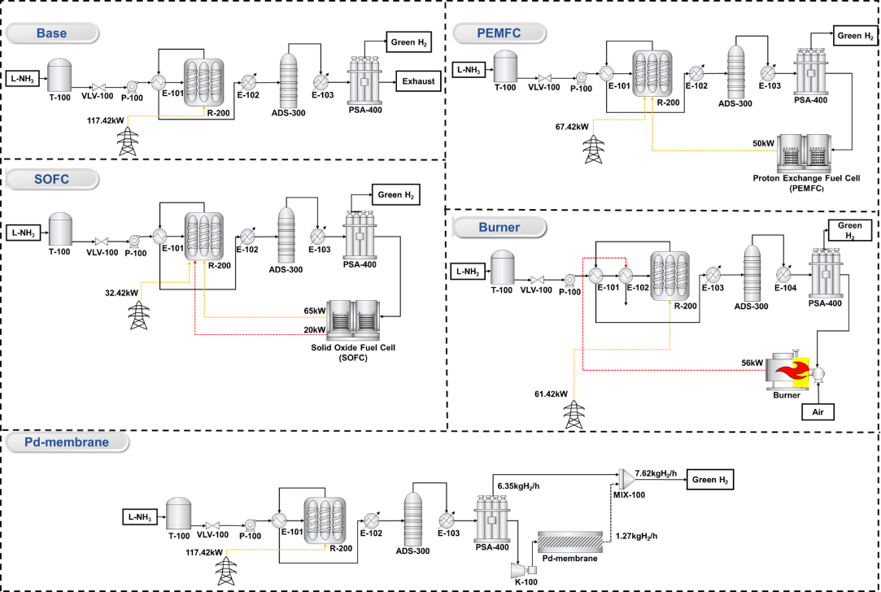
Figure 1 Proposed processes
In Figure 1, the base case is a Ru-based monolith reactor integrated with an induction heating system developed from a previous study (Lee et al., 2023). This process is designed to produce 150 Nm³/h of hydrogen for use in a hydrogen refueling station. The induction heating system uses electricity as an energy source, presenting a notable advantage of zero CO₂ emissions compared to conventional processes that use fossil fuels. Also, the metallic monolith reactor offers advantages such as low-pressure drop per unit area and rapid heating rates.
The base case process addresses the issue of hydrogen being discarded as off-gas during hydrogen purification in PSA. Four improved cases were proposed to utilize this off-gas effectively. Each case was modeled by incorporating several units into the base case to utilize the off-gas effectively.
In the process integrated with the fuel cell, the off-gas is directly utilized as the fuel cell feed for electricity generation. Because the off-gas contains hydrogen and nitrogen, an inert gas, electricity generation is available in the fuel cell. By using the generated electricity from the fuel cell as an auxiliary energy source for the induction reactor, the overall efficiency of the process is enhanced. Two cases were presented, utilizing SOFC and PEMFC, respectively.
The process integrated with a burner mitigates the energy load on the induction reactor by utilizing the exhaust gas generated from the combustion of off-gas for preheating the ammonia feed. In this case, exhaust gas from the combustion of the off-gas only consists of water and nitrogen, causing no environmental impact.
The process integrated with a Pd-membrane is designed to purify the hydrogen within the off gas, enhancing hydrogen recovery.
The base case model was constructed in Aspen HYSYS using actual plant data. Other cases were also modeled based on the base case.

    - Evaluation method
      - Techno-economic assessment
Energy and exergy efficiency were calculated to compare the thermodynamic efficiency of the five cases. Thermal efficiency was calculated using Eq. 1, where ${\text{LHV}}_{H_{2}}$and ${\text{LHV}}_{NH_{3}}$represent the lower heating value of H₂ and NH₃ respectively. $\dot{N}$ is the molar flow rate of each component. $Q_{induction}$ is the amount of external electrical energy used in the induction reactor.
Exergy, defined as the possible amount of useful work a system can perform, provides insights into the quality of energy disintegration during energy transfer and conversion. The exergy efficiency of each process was calculated using Eq. 2. ${\dot{E}x}_{in,total}$ is total exergy input. ${\dot{E}x}_{unused,total}$ is the value sum of exergy destruction and exhaust exergy.
The economic analysis was conducted by calculating the levelized cost of hydrogen (LCOH) using Eq. 3 and Eq. 4. CAPEX is capital expenditure, and OPEX is the operating expenditure of the process. CRF is a capital recovery factor that converts CAPEX to annualized CAPEX. r and t are discount rate and plant lifetime, respectively.

$$η_{energy}=\frac{{\text{LHV}}_{H_{2}}×{\dot{N}}_{H_{2},out}}{{\text{LHV}}_{NH_{3}}×{\dot{N}}_{NH_{3},feed}+Q_{induction}}$$ | Eq. 1
$$η_{Exergy}=\frac{{\dot{E}x}_{in,total}-{\dot{E}x}_{unused,total}}{{\dot{E}x}_{in,total}}=1-\frac{{\dot{E}x}_{unused,total}}{{\dot{E}x}_{in,total}}$$ | Eq. 2
$$LCOH=\frac{CAPEX×CRF+OPEX}{P_{hydrogen}}$$ | Eq. 3
$$CRF=\frac{1-{\left(1+r\right)}^{-t}}{r}$$ | Eq. 4

      - Life cycle assessment
Life Cycle Assessment (LCA) was conducted to compare the environmental burden of each ammonia decomposition process. The LCA adhered to the standards outlined in ISO 14040 and ISO 14044. Greenhouse gas (GHG) emissions were evaluated for each process. The functional unit set to 1 kg H₂ with a purity of 99.9%, consistent with economic evaluation.
The scope of this study is cradle-to-gate, covering all the production steps from raw-material extraction to the hydrogen product.
The ammonia used as a raw material is assumed to be liquid ammonia produced in Australia and transported over a distance of 9000 km via a heavy oil-powered ship. The results of LCA using gray, blue, and green ammonia as raw materials were compared. The electricity source was assumed to be grid electricity.
The CML-IA baseline V3.09 method was used for life cycle impact assessment (LCIA). In this study, only GHG emissions were considered.
  - Result and discussion
    - Techno-economic analysis
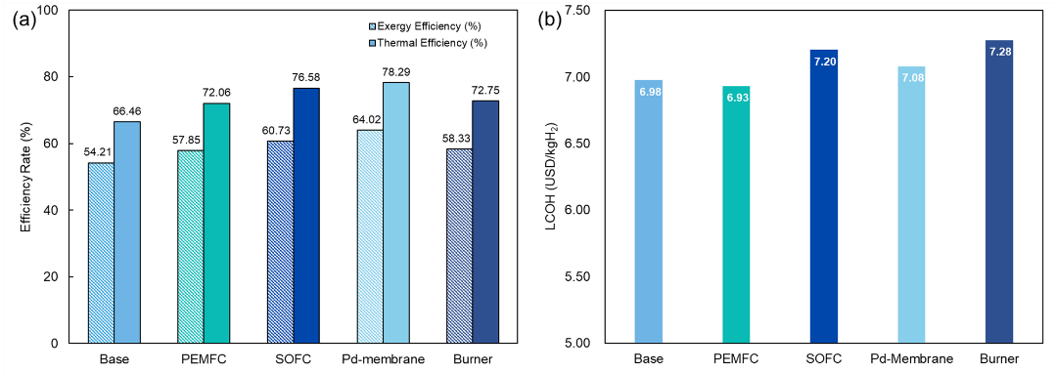
Figure 2 (a) thermal and exergy efficiency (b) LCOH of each process
All proposed cases demonstrated improved efficiency compared to the base case (Figure 2). Due to increased hydrogen recovery, the Pd-membrane case exhibited the highest thermal and exergy efficiencies of 78.29% and 64.02%, respectively. The case with the second highest was the SOFC, which showed thermal and exergy efficiency of 76.58% and 60.73%, respectively. PEMFC and the burner showed similar thermal and exergy efficiencies but demonstrated lower performance than SOFC and Pd-membrane.
In economic analysis, the LCOH for PEMFC was the lowest, at 6.93 USD/kgH₂, indicating a lower cost than the base case with an LCOH of 6.98 USD/kgH₂. For the other cases, the increased cost of the newly added unit was more significant than the economic improvement resulting from the efficiency enhancements, resulting in higher LCOH than the base case. Despite the highest efficiency improvement, the Pd-membrane case had a higher LCOH than the base case.

    - Life cycle assessement
Figure 3 shows an LCA result of each ammonia decomposition process. Excluding the Pd-membrane process, the others have the same amount of ammonia feed and hydrogen product. The Pd-membrane case has the same amount of ammonia feed as other processes and larger hydrogen production, resulting in reduced GHG emissions at the ammonia production stage.
When using gray ammonia, the ammonia production stage accounted for the largest portion of GHG emissions. Thus, the Pd-membrane case shows the lowest GHG emission at 27.87 kgCO₂eq/kgH₂.
However, the SOFC showed the lowest GHG emission of 16.93 and 4.60 kgCO₂eq/kgH₂ when using blue and green ammonia, respectively. When using green ammonia, the decomposition stage constitutes the dominant portion of the overall GHG emissions. Thus, when using green or blue ammonia, processes with lower GHG emissions during the decomposition stage show lower overall GHG emissions. As a result, all four proposed cases exhibit reduced GHG emissions relative to the base case.
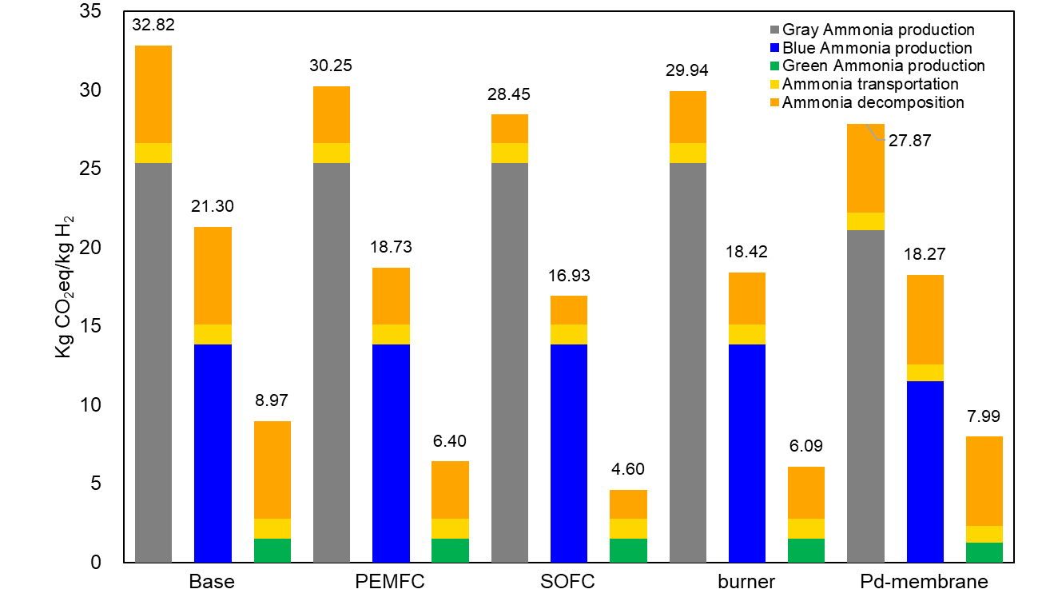
Figure 3 GHG emission result of each case
  - Conclusion
In this study, the induction heating-based ammonia decomposition reactor from the previous study was enhanced by incorporating PEMFC, SOFC, burner, and Pd-membrane units.
The Pd-membrane case showed the highest thermal and exergy efficiencies at 78.29% and 64.82%, respectively. The lowest LCOH was observed for the PEMFC case at 6.93 USD/ kgH₂. GHG emissions were lowest in the SOFC case with green ammonia, at 4.60 kgCO₂/kgH₂.
Across all aspects, the most notable improvements compared to the base case were realized when incorporating PEMFC. Thus, PEMFC emerged as the optimal case. This study is anticipated to be a valuable reference for enhancing other ammonia decomposition processes that generate off-gas.
References
Global Hydrogen Review 2022, 2022. Glob. Hydrog. Rev. 2022. https://doi.org/10.1787/a15b8442-en
Lee, J., Ga, S., Lim, D., Lee, S., Cho, H., Kim, J., 2023. Carbon-free green hydrogen production process with induction heating-based ammonia decomposition reactor. Chem. Eng. J. 457, 141203. https://doi.org/10.1016/j.cej.2022.141203
Niermann, M., Beckendorff, A., Kaltschmitt, M., Bonhoff, K., 2019. Liquid Organic Hydrogen Carrier (LOHC) – Assessment based on chemical and economic properties. Int. J. Hydrogen Energy 44, 6631–6654. https://doi.org/10.1016/j.ijhydene.2019.01.199
Wan, Z., Tao, Y., Shao, J., Zhang, Y., You, H., 2021. Ammonia as an effective hydrogen carrier and a clean fuel for solid oxide fuel cells. Energy Convers. Manag. 228, 113729. https://doi.org/10.1016/j.enconman.2020.113729

