Renewable Energy Integration and Waste Heat Valorization in Aluminum Remelting Mills for the Co-Production of Kerosene and Methanol
Daniel Florez-Orrego^{a,*}, Dareen Dardorª, Meire Ribeiro Domingosª, Reginald Germanier^{b}, François Marechalª

ªIPESE, Federal Polytechnic School of Lausanne, Rue de l’Industrie 17, 1950 Sion, Switzerland.
^{b}School of Minas, National University of Colombia, Av. 80 #65-223, Medellin, Colombia.
*daniel.florezorrego@epfl.ch / daflorezo@unal.edu.co
Abstract
The aluminium sector relies on natural gas for the conversion of recycled scrap into new feedstock, which results in substantial atmospheric emissions. Hydric resources are also impacted, as they serve as heat sinks for the waste heat generated during the casting process. Other chemical industries are also responsible for a large production of waste heat, offgas and environmental emissions, which hinders efforts to decarbonize the sector that depend on them. Methanol and transportation fuels production are examples of those industries. Accordingly, there is a significant potential to decarbonize these productive activities via enhanced waste heat recovery and integration of renewable energy sources. The energy integration of aluminium, methanol and fuels production plants within urban areas also offers major advantages in terms of efficient energy utilization and reduced environmental impact, particularly in situations characterized by uncertain supply chains and fluctuating market prices. Biomass gasification offers an alternative carbon source to fossil fuels, and together with electrification, it may help to diversify and decentralize the energy inputs for industries traditionally dependent on natural gas, establishing resilient and sustainable energy pathways. Carbon abatement, power-to-gas and storage systems provide further advantages by mitigating the effects of seasonal availability and prices of electricity and fuel. Yet, the integration of the various energy technologies and industrial facilities calls for a systematic approach to identify optimal options for meeting the energy demands without significantly compromising the operational feasibility. Therefore, in this work, the most cost-effective technologies with minimum investment that meet the energy demands of the aluminium remelting, methanol and fuels production facilities are studied, aiming to upgrade the industrial waste heat available at low temperature to supply an urban center with variable energy needs. Implementing improved integration strategies shows the potential to reduce overall energy consumption, while achieving net-zero CO₂ emissions compared to conventional scenario.
Keywords: Aluminium, Fischer-Tropsch, Methanol, Waste heat, District heating.
  - Introduction
In aluminium, chemicals and fuels production plants, natural gas is typically used either as feedstock or as fuel to supply the heating demands at high temperatures. As a result, the aluminium sector is responsible for about 2% of the global industrial emissions (IA 2021), followed by the methanol production with 1% (Kapoor 2022). Meanwhile, the transportation sector, and more specifically, the aviation sector is a significant contributor to the global greenhouse gas emissions (30%) (Burli 2023), and its impact is expected to heighten in the coming years, considering that global jet fuel consumption is foreseen to be threefold higher than in 2019 (ICAO 2022). In this regard, more efforts should be done to defossilize these critical industrial sectors on which many others rely, including cargo, food packaging, automotive industry, polymers and chemicals synthesis. Methanol is an intermediate molecule for various chemicals production, such as olefins, amines, acetic acid, dimethyl ether and formaldehyde (Domingos 2022); and it can be also used directly or blended with naphtha. Sustainable aviation fuels are drop-in replacements for conventional jet fuel that can be produced from renewable resources, such as biomass and electricity (ICCT 2022). Although less than 0.1% of the jet fuel consumed by commercial airlines is currently composed of sustainable aviation fuels (Adelung 2022), ReFuelEU aviation regulation proposal introduced blending mandates of min. 5% at EU airports by 2030, which is expected to increase by 63% by 2050 (Burli 2023). As for the aluminium, it has innumerable applications in automotive and aerospace industry, food canning, decoration, among others. However, a largely unexploited byproduct of the secondary aluminium production is waste heat, which can be recovered from stack gases generated in the remelting furnaces or from hot water produced in the aluminium casting (Kumar 2022). In fact, since around 90% of the heating requirements of the residential and service sectors can theoretically be covered by process waste heat (Persson 2012), the reuse of waste heat in industrial plants will play an critical role in the defossilization strategy of those sectors (Yu 2018, Clos 2017) and will enable the energy integration with urban energy systems (Stijepovic 2011, Bertrand 2019). The integration of biomass gasification to industrial plants has the potential to achieve overall negative emissions, if combined with electrification and power-to-gas systems, thus adding flexibility to the energy and carbon management approach (Florez-Orrego 2023). However, as the number of decarbonization options increases, a systemic study is necessary to evaluate the most suitable processes and carbon neutral technologies to supply the energy requirements without impacting the operational conditions and process reliability, even under scenarios of seasonal variations of energy inputs prices and demands. A mixed integer linear problem is addressed using OSMOSE platform to maximize waste heat recovery and define the most economically, thermodynamic and environmentally favorable configuration to integrate the aluminium, fuels and chemicals industries to the urban systems.
  - Process description
    - Aluminium plant
In the remelting plant, scrap and pure aluminium are processes to produce value-added aluminium coils and other products. In the cast house, the first step consists of preheating pure aluminium sows up to 250°C to dry moisture out before it enters the melting furnace. Therein, scrap aluminium is mixed and the metal is heated up to ~700°C. The molten aluminium is transferred to a holder furnace, which acts as a buffer for the downstream direct chill casting process. In the latter, the aluminium is solidified into ingots by using direct cast chilling with cold water, which can achieve temperatures above 50 °C before discarded to the environment. In the rolling plant, the aluminium ingots are superficially processed in a scalper to remove the outer layer. Next, they go through two parallel pusher furnaces, wherein aluminium ingots are thermally treated (annealing) at 550°C during several hours, before they go through a hot rolling followed by a cold rolling process. In this way, coils with millimeter thickness are mechanically formed consuming a large amount of electricity dissipated as heat. Finally, some of the coils are sent to an annealing continuous line (ACL), where they are chemically and thermally treated using alternating heating and quenching processes. Space heating of the aluminium plant must be also considered, due to seasonal environmental conditions. The main energy resource for the aluminium processing is fossil natural gas, while diesel is also consumed in some devices and fork lifts. Currently, the casting water containing a large share of the low-grade waste heat from the aluminium production is directly discarded to the environment, but it could be integrated with an anergy (CO₂) district heating network to satisfy the heating needs of the services and residential sector. Fig. 1 shows the integrated energy system, including the aluminium plant, as well as the chemical and fuels production facilities, and the city.
    - Chemical and fuel production plants
      - Biomass conversion system
Biomass moisture is reduced to 10% in a rotary dryer using waste heat and dry biomass is chipped in a mechanical process that consumes 1-3% of biomass energy (Flórez-Orrego 2019). In the gasifier (900°C), biomass is converted into a syngas rich in CO, H₂, CO₂ and CH₄, among other components, using steam as the gasification agent (S/B ratio 0.75). The indirect gasifier operating at atmospheric pressure burns a fraction of the pyrolysis char with air in a second column to supply the energy demands of the endothermic drying, pyrolysis and reduction reactions, thus avoiding the nitrogen dilution of syngas. After the gasifier, the syngas is cooled down to 400 °C and scrubbed with water, in order to remove the impurities and compressed to 35 bar. A water gas shift reactor increases the hydrogen content, at expense of producing more CO₂. The syngas can be used as feedstock for the methanol and the FT liquids plants, whereas the waste heat could be used for combined heat and power production to balance the aluminium and chemical processes demands in a more versatile way than biomass combustion alone.
      - Methanol plant
The purified syngas is compressed to 90 bar and is heated up by the reactor effluent in a feed-effluent heat-exchanger before it is fed to a methanol synthesis loop. The methanol synthesis occurs in an isothermal reactor operating at 90 bar and 210 °C. The reactor outlet stream is a gaseous mixture of methanol, water and unconverted reactants. This mixture is cooled and flashed twice, first to 30 °C and 45 bar, and then to 3.5 bar, in order to separate the condensable products and the non-condensable reactants (Kiss 2016). The latter are recycled to achieve higher conversions. The condensed stream continues to a distillation column at atmospheric pressure, in which methanol is produced (99% wt.). To avoid the built up of inerts, a fraction of the non-condensable stream is purged.
      - Fischer-Tropsch liquids plant
The low temperature Fischer-Tropsch reactor with iron catalyst (200-240°C) ensures high selectivity for paraffin and high molecular mass linear waxes. A polymerization reaction yields a large variety of products with different carbon chain lengths, including n-olefins, n-paraffins, oxygenated products, and branched chain hydrocarbons. The selectivity of the products depends on several reaction parameters, e.g. temperature, pressure, catalyst and reactor type. The probability of chain growth via addition of a monomer to the initiator is defined by a chain growth probability (α) given by an Anderson-Schulz-Flory (ASF) distribution. A direct product is diesel-cut, whereas hydrocracking of the waxes yields further kerosene- (C₉-C₁₆) and diesel-cut (C₁₅-C₂₀) mixtures. The hydrocarbons in the naphtha range (C₅-C₁₂) are rather straight chain and need further treatment to increase their branching and achieve high-octane rating (Florez-Orrego 2023).
      - Other energy technologies
To capitalize on the waste heat available and manage, store and upgrade industrial wastes into value-added products, ancillary technologies, such as reversible water gas shift units, electrolyzer, methanator, supercritical CO₂ cycle, refrigerator, methanol reforming, air separation unit and anergy (CO₂) district heating network are also integrated. Details on the simulation of these energy systems can be found elsewhere (Florez-Orrego 2023).
  - Methods
The process modeling and simulation is performed in Aspen Plus software integrated to the OSMOSE platform, which minimizes the energy requirement of the integrated industrial plants. In this way, low grade waste heat can be reutilized to supply a district heating network or generate power in a supercritical CO₂ cycle. In addition, the implementation of a seasonal power-to-gas approach, including electrolysis, methanation, reverse water gas shift and carbon abatement technologies, allows to manage the time-varying demands and supply. To this end, a multi-time approach has been used to minimize the capital investment of the seasonal energy storage systems (e.g. tanks). The binary y_{w} and load factor f_{w} optimization variables in Eqs. 1-4 are used to define the best size and arrangement based on assumed prices of material and energy inputs and CO₂ tax. The best combination of energy technologies has been defined to defossilize industrial applications, such as the aluminum remelting, whereas producing value-added fuels. As for the city demands, typical central European zone city is considered for the assumption of the thermal loads of district heating network, including domestic hot water, space heating, air conditioning and refrigeration (Flórez-Orrego 2022). The integration with the surrounding population has been achieved implementing a novel CO₂ district heating network.
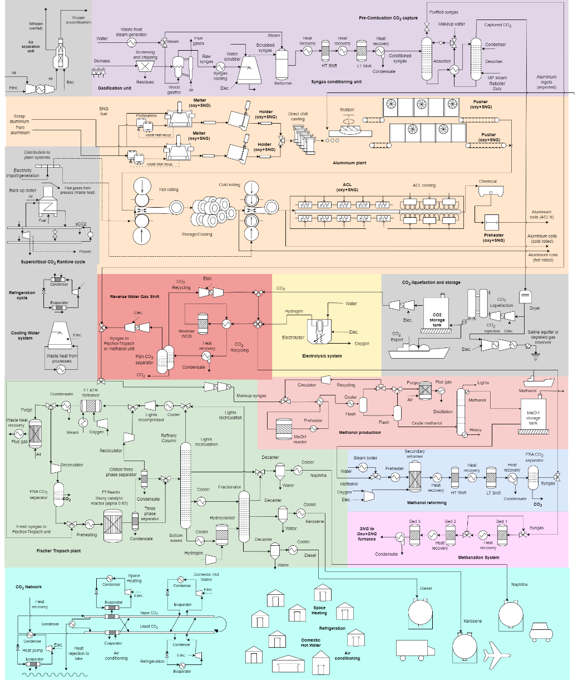
Figure 1. Blocks diagram of the aluminium and chemicals production facility, along with the utility systems (cogeneration, power-to-gas and storage technologies), and the district heating CO₂ network.

(1) (2)
(3)
^ ^ (4)
  - Results and discussion
In this section, selected results for an annual 250 kt/y aluminium processing plant integrated to 4.08 kt/y of diesel, 9.40 kt/y of naphtha, 17.57 kt/y of kerosene (24 MW) and 26.35 kt/y (17 MW) of methanol production sites are discussed. For these production rates, the total biomass energy consumption is 681.77 GWh/y, whereas the total electricity import achieves 1096.52 GWh/y. The diesel consumption in the aluminium plant is 0.23 kt/y. It is worthy to notice that the self-power generation using a sCO₂ cycle for waste heat recovery through the aluminium remelting and the chemical plants is 167.39 GWh/y, which represents around 15% of the total power import. For the sake of comparison, the aluminium plant power consumption is 68.07 GWh/y. Notably, the power demand of the electrolyzer is dominant (1080.76 GWh/y, max. 170 MW), which is explained by the intensive production of hydrogen and the CO₂ conversion to value-added products in a power-to-gas approach. In fact, hydrogen and oxygen production in the electrolyzer amount 19.65 kt/y and 157.20 kt/y, respectively. Oxygen production from an auxiliary air separation unit (24.22 kt/y) is necessary, especially during the winter months, in order to balance the oxygen and hydrogen requirements. In fact, venting of surplus oxygen (77.40 kt/y) and nitrogen (99.55 kt/y) are estimated, even with an intensive oxygen utilization in the oxycombustion furnaces. The CO₂ processed in the reverse water gas shift can be estimated as 95.15 kt/y. Meanwhile, the methanator processes 26.53 kt/y of CO₂ and 4.82 kt/y of hydrogen to yield 134.01 GWh/y of synthetic natural gas, which along with 65.37 GWh/y of synthetic natural gas produced by a methanol reforming unit, supplies the fuel consumption in the oxycombustion furnaces of the aluminium plant. It is worthy to notice that no CO₂ injection or mineralization is necessary, as all the captured and separated CO₂ is processed by the system, and stored to produce value-added products only when the cost of electricity is more favorable during the summer period. A complementary behaviour is observed by the methanol storage tank (see Fig. 2).
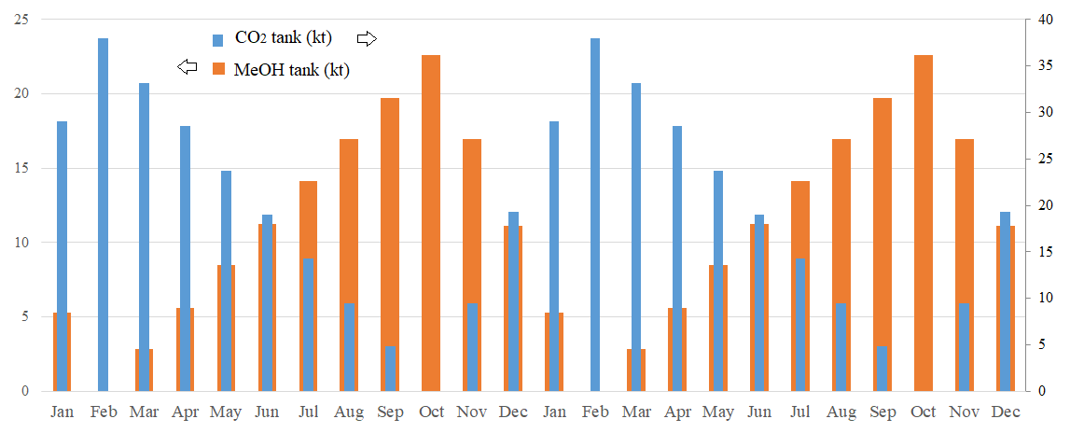
Figure 2. Annual evolution of the storage levels of CO₂ and methanol tanks.

Interestingly, the syngas production for chemicals and fuels production is evenly divided by the reverse water gas shift and the gasification systems, which are respectively 66.40 kt/y and 64.06 kt/y of syngas production, totalizing 130.46 kt/y of syngas. As for the biogenic CO₂ emissions at the gasifier stack (75.12 kt/y), they represent the dominant source of emissions of the integrated energy systems, followed by the also biogenic CO₂ emissions from the offgas flare of the Fischer-Tropsch unit (13.41 kt/y) and the CO₂ emissions from the purge gas flare system in the methanol production unit (3.65 kt/y). The total environmental emissions based on the direct and indirect CO₂ emissions of the integrated system amount 177.50 kt/y. The indirect fossil CO₂ emissions, which arise from the supply chains of the biomass and electricity imports, are estimated as 9.57 and 68.67 kt/y, respectively. In other words, due to an intensive electrification strategy, and considering the emissions intensity of the electricity consumed, a relatively high share of fossil emissions (44% of 177.50 kt/y) could be expected. This fact demonstrates the interrelation between the industrial activities and the need to orchestrate a coordinated decarbonization strategy for all of the energy conversion routes to actually achieve a sustainable net zero target. Provided that the energy inputs are derived from renewable energy resources, the fossil fuel dependency and emissions could be virtually avoided.
  - Conclusions
In this work, via enhanced waste heat valorization and CO₂ management has been proposed to energetically integrate industrial energy systems typically dependent on non-renewable energy resources, i.e. aluminium remelting, methanol synthesis and transport fuel production. Using renewable energy resources, it has been possible to elucidate alternative production routes that enable phasing out fossil fuels utilization, while increasing the electrification, in order to achieve net zero emissions. Yet, indirect emissions still remain the main challenge. In fact, due to intensive electrification, indirect emissions (78 kt/y) related to electricity are expected, but much lower than operating standalone chemical plants.
Acknowledgments
The authors thank Swiss Federal Office of Energy and Suisse Energie for funding the project “Sustainable natural gas (SNG) and aluminium production via biomass gasification and enhanced waste heat recovery in Novelis plant in Sierre City” of the Net Zero Lab consortium.
References
Adelung, S., Dietrich, R. (2022). "Impact of the reverse water-gas shift operating conditions on the Power-to-Liquid fuel production cost." Fuel 317: 123440.
Bertrand, A. et al. (2019). "Regional waste heat valorisation: A mixed integer linear programming method for energy service companies." Energy 167: 454-468.
Burli, P., et al (2023). Assessment of successes and lessons learned for biofuels deployment. Lessons learnt in supply chains: Sustainable biomass supply chains for international markets. T. Ekbom, IEA Bioenergy: 39.
Clos, D., et al (2017). Enabling Efficient Heat Recovery from Aluminium Pot Gas. Light Metals. A. Ratvik, Springer International Publishing: 783-791.
Domingos, M. E. G., et al (2022). "Techno-economic and environmental analysis of methanol and dimethyl ether production from syngas in a kraft pulp process." Computers & Chemical Engineering: 107810.
Florez-Orrego, D., et al. (2023). A systemic study for enhanced waste heat recovery and renewable energy integration towards decarbonizing aluminium industry. ECOS 2023, June 25-30th, Spain.
Florez-Orrego, D., et al (2023). Renewable energy integration and waste heat recovery for the production of sustainable jet fuel and decarbonization of industrial heating applications. AIChE 2023 Annual Meeting, November 5-10, 2023. Orlando (FL), United States.
Flórez-Orrego, D., et al (2022). A systematic framework for the multi-time integration of industrial complexes and urban systems. CPOTE, 20th-23th September, 2022. Warsaw, Poland.
Flórez-Orrego, D., et al (2019). "Comparative exergy and economic assessment of fossil and biomass-based routes for ammonia production." Energy Conversion and Management 194: 22-36.
IA. (2021). "Aluminium Sector GHG Pathways 2050." 25.03.023, From https://international-aluminium.org/resource/aluminium-sector-greenhouse-gas-pathways-to-2050-2021/.
ICAO (2022). Environmental Report - Innovation for a green transition. Montreal, Canada, International Civil Aviation Organization (ICAO).
ICCT. (2022). "Sustainable aviation fuels: what does real leadership look like?" Retrieved 20.05.2023, from https://theicct.org/publications/renewable-jet-fuel-ghg-lca-2019.
Kapoor, K., et al (2022). Green methanol key to energy transition net-zero plans, S&P Global Commodity Insights - Petrochemicals.
Kiss, A., et al (2016). "Novel efficient process for methanol synthesis by CO2 hydrogenation." Chemical Engineering Journal 284(15 January): 260-269.
Kumar, R., et al. (2022). A Method for Recovering the Waste Heat to Achieve Overall Energy Conservation in Aluminum Casting Industries. Recent Advances in Energy Technologies. Springer Nature: 331-342.
Persson, U., et al (2012). District heating in sequential energy supply. Appl Energy 95(123-131).
Stijepovic, M., et al (2011). "Optimal waste heat recovery and reuse in industrial zones." Energy 36(7): 4019-4031.
Yu, M., et al (2018). Waste Heat Recovery from Aluminum Production. Energy Technology 2018, Springer International Publishing: 165–178.

