Glycerol Valorisation to Glycerol Carbonate: Process Synthesis, Design and Control
Prakhar Srivastavaª,Aayush Guptaª, Nitin Kaistha^{a*}
ªChemical Engineering, IIT Kanpur 208016,India
*nkaistha@iitk.ac.in
Abstract
This study outlines a economic process for valorising of glycerol (GLY) to glycerol carbonate (GC) through transesterification with dimethyl carbonate (DMC), generating methanol (MeOH) as a byproduct. The flowsheet, guided by a residue curve map, reveals a pressure-sensitive MeOH-DMC azeotrope exploited through pressure swing for methanol recovery and MeOH-DMC azeotrope recycle. The process incorporates a pressurized reactive distillation (RD) column, followed by three low-pressure distillation columns, with heat integration for enhanced energy efficiency. Optimizing design variables yields an economically optimal steady-state process. Comparative analysis with recent designs—reactive distillation pervaporation (RDPV) and reactive distillation extractive distillation (RDED)—indicates a cost objective reduction of 70% and 24%, respectively. Energy consumption per kilomole of GC product is also reduced by 16% and 10%. The process, easily controlled through a decentralized plantwide system, handles large disturbances, ensuring precise product quality control and smooth flow transitions. This research significantly contributes to the 'green' biodiesel fuel value chain, efficiently transforming glycerol, a biodiesel byproduct, into GC.
Keywords: RD, PSD,Azeotrope,Heat Integration
  - Introduction
Glycerol carbonate (GC) is emerging as a promising avenue to enhance the value of glycerol (GLY), a byproduct resulting from biodiesel production. With biodiesel gaining popularity as a greener alternative to diesel, effective glycerol valorisation becomes crucial for the biodiesel economy. The significance of industrial-grade GC lies in its high market value, attributed to characteristics such as low volatility, low toxicity, high polarity, and biodegradability (H.W. Tan 2013). GC plays a vital role as a raw material for producing polymers, surfactants, and serves as a precursor for glycidol, utilized in pharmaceuticals, cosmetics, plastics, and as an electrolyte in lithium-ion batteries (S. Sahani 2020). The transesterification of glycerol with dimethyl carbonate (DMC) stands out as a highly promising route, ensuring substantial glycerol conversion and GC yield. Under controlled conditions, employing the Zn₄La₁ catalyst, it is recommended to maintain a reactive bed temperature below 140°C to preserve product yield and a DMC to glycerol ratio above 2 to maximize the selectivity.
The development of an economically optimized steady-state design for an industrial-scale plant converting glycerol (GLY) to glycerol carbonate (GC) through transesterification with dimethyl carbonate (DMC) is imperative for advancing the economics of biodiesel manufacturing. In the limited literature on the subject, two distinct approaches come to light: Yu's (Yu 2020) design, incorporating Reactive Distillation with Homogeneous Extractive Distillation (RDED), and Sun et al.'s (Dayu Sun 2022) strategy, which employs Reactive Distillation with a Pervaporation Module (RDPV). Despite both methods presenting reported benefits, Extractive Distillation introduces a third component, impacting product purity and incurring makeup costs. Conversely, pervaporation, a membrane-based technique, introduces challenges like membrane fouling, periodic replacement costs, and the need for electricity-consuming vacuum pumps. These issues, coupled with a lack of control flexibility, suggest that membrane-based techniques like pervaporation should be considered only when distillation proves impractical—a criterion not met in this scenario.
This study introduces a process design based on distillation for the cost-effective production of glycerol carbonate (GC) through the transesterification of glycerol with dimethyl carbonate (DMC). In contrast to existing literature, our design, comprising a reactive distillation (RD) column followed by only three additional columns (a total of 4 columns), proves to be significantly more economical. The article progresses with the synthesis of the process flowsheet, its optimization to minimize the cost objective J, and a comparative analysis with existing designs. A plantwide regulatory control structure is then presented and evaluated for its ability to handle throughput and feed composition changes. The conclusion summarizes the key findings and contributions of the study.
  - Process model
Aspen Plus Dynamics serves as the tool for both steady-state and dynamic process modelling in this study. The thermodynamic package and reaction kinetics outlined in the work by Yu (Yu 2020) are adopted for our simulations. The steady-state design is formulated to achieve a glycerol carbonate (GC) product rate and purity of 10 kmol/h and 99.64 mol%, respectively. Additionally, a methanol (MeOH) co-product purity of 99.5 mol% is targeted. The reaction and kinetic expressions in detailed are given in Table 1 are taken from the Yu (Yu 2020) work. We ensure the fidelity of our simulations by employing the validated binary interaction parameters previously reported by Yu (Yu 2020).
Table 1:Reaction and Kinetics Details
Reaction | Reaction Kinetics
$$GLY+DMC→GC+2MeOH$$ | $$r_{1}=1.31×{10}^{16} exp\frac{(-144000)}{RT}x_{GLY}x_{DMC}$$
$$GC+2MeOH→GLY+DMC$$ | $$r_{2}=6.06×{10}^{4} exp\frac{(-60013)}{RT}x_{GC}x_{MeOH}^{2}$$
$$GC→GLC+CO_{2}$$ | $$r_{3}=1.63×{10}^{9} exp\frac{(-113000)}{RT}x_{GC}$$
r: rate constant in kmol/kg(cat).s x: liquid phase mole fraction of species R:kJ/kmol.K

  - Process Synthesis and Design
The synthesis of a proposed process flowsheet relies on utilizing the residue curve map (RCM) for the four primary components in the main reaction: MeOH, DMC, GLY, and GC. The process begins with the reactive zone, aiming to drive the main reaction rightward while suppressing side reactions. This is achieved by executing the reaction in an excess of DMC, with glycerol as the limiting reactant. Reaction kinetics demand a high temperature and pressure in the reactive zone, introducing the heavier reactant (GLY) at the top and the lighter reactant (DMC) at the bottom within the reactive section of the RD column. Examining the vapor and liquid streams from the reactive zone, the high boiling point of GC leads to a GC-free vapor exit stream, composed of DMC, light MeOH by-product, and traces of vaporized GLY. Rectification of this vapor stream yields the HP MeOH-DMC azeotrope as the column distillate. On the liquid side, catalyst-loaded reactive trays ensure near-complete conversion of GLY, producing a stream primarily composed of DMC, GC, and Glycidol (GLC). The HP MeOH-DMC azeotrope distillate can undergo separation in a low-pressure column, denoted as C1. The resulting distillate is the LP MeOH-DMC azeotrope, featuring a MeOH mol fraction to the left of the HP azeotrope distillate from the RD column. Utilizing a pressure swing, a straightforward LP distillation process recovers MeOH as the bottom product and the LP azeotrope as the top product, which is recycled to the RD column's rectification zone.
Table 2:Degree of freedom and Specification
S.N. | Steady State dof | Specification Variable
1. | Glycerol feed rate | TPM
2. | GC product purity (molar basis) | 99.64%
3. | MeOH co-product purity | 99.5%
4. | GLC Purity | 99%
4. | C2 DMC distillate purity | 99.9%
5. | C2 DMC bottom purity | 10 PPM
6. | RD distillate MeOH mole fraction | 0.911
7. | C1 distillate MeOH mole fraction | 0.862
8. | RD bottom MeOH purity | 1 PPM
9. | Total DMC to fresh feed GLY ratio | 2
10. | RD column liquid distillate CO₂ mole fraction | 10 PPM
Design dof
1. | RD column pressure | 2.45 bar
2. | Co-product column (C1) pressure | 0.48 bar
3. | C2 column (C2) pressure | 0.15 bar
4. | Product column (C3) pressure | 0.1 bar
5. | No. of rectifying trays in RD column | 24
6. | Location of LP azeotrope stream into the RD | Tray no. 12
7. | No. of reactive trays in RD column | 18
8. | No. of trays in C1 column | 21
9. | No. of trays in C2 column | 15
10. | No. of trays in C3 column | 8
11. | FEHE Cooled GC Stream Temperature | 50º C

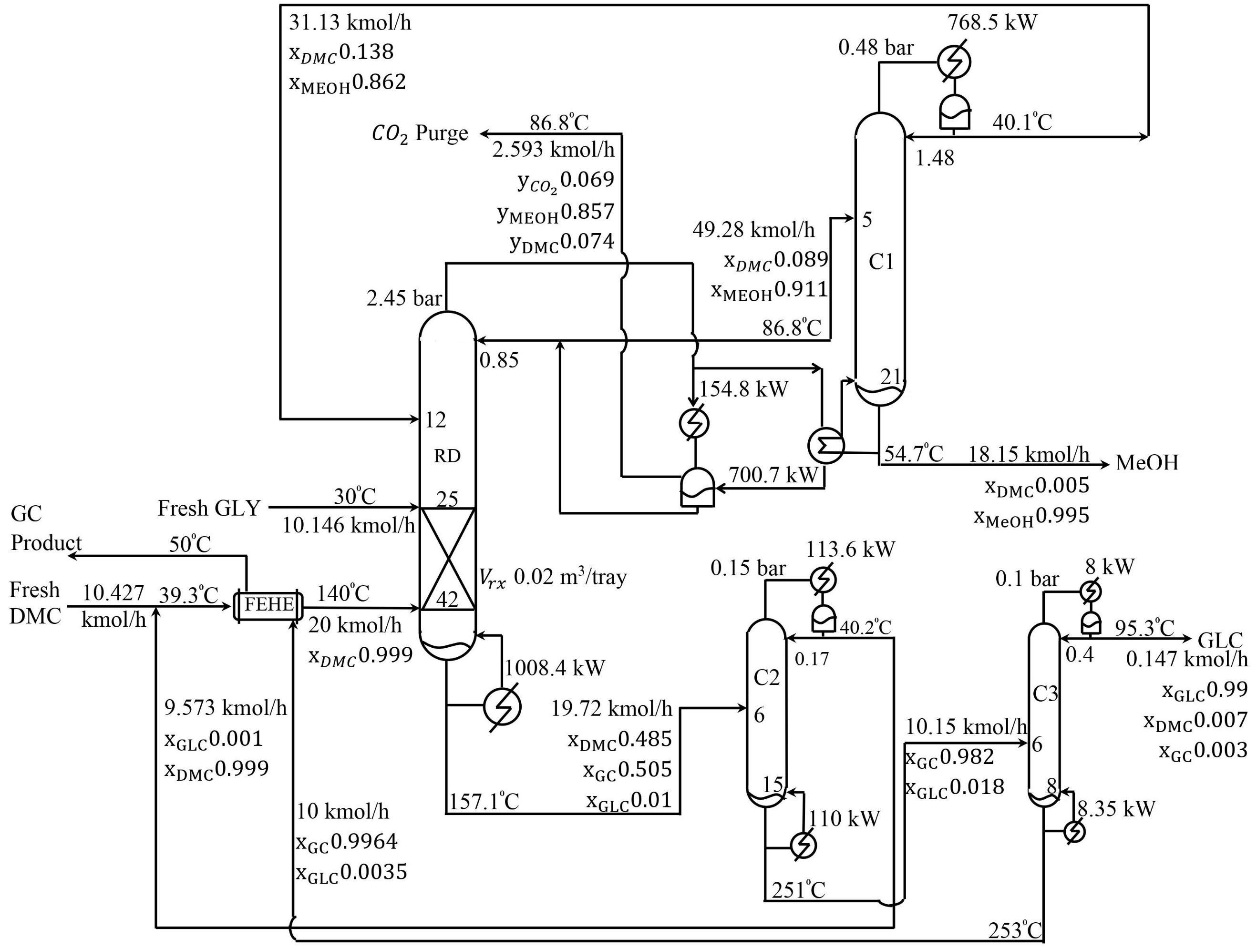
Figure 1:Proposed process with nominal design and operating condition

The C2 column processes RD column bottoms, recovering GC and GLC in the bottom stream and excess DMC in the top stream, recycled to the RD column after blending with fresh DMC. The C3 column specializes in recovering GLC from the top and GC from the bottom. Adjustments may be needed for exit streams of the side-reaction product CO₂. The essential modification involves incorporating a vapor distillate stream from the RD column to facilitate CO₂ exit from the process. Now, the process flow sheet includes the RD column, followed by C1, C2, and C3 columns.
We aim to achieve a near-optimal economic steady-state design to produce 10 kmol/h of glycerol carbonate with a purity of 99.64 mol%. The processing system under scrutiny possesses 10 steady-state operating degrees of freedom (DOFs) and 11 equipment design DOFs. The specification variables corresponding to these DOFs are detailed in the accompanying Table 2. We wish to adjust the specification variables to minimize an economic cost objective, J, subject to process constraints. J is defined as
J = TAC + IMC
where the total annualized cost TAC = Total Capital Cost/PBP + Total Operating Cost
with the payback period (PBP) taken as 3 years.
The incremental material cost IMC term in J accounts for very slight differences in overall plant material balances of the three flowsheets considered. All flowsheet designs are developed for an identical GC product rate of 10 kmol/h and purity of 99.64 mol%. Also, the MeOH co-product purity is fixed at 99.5 mol%.
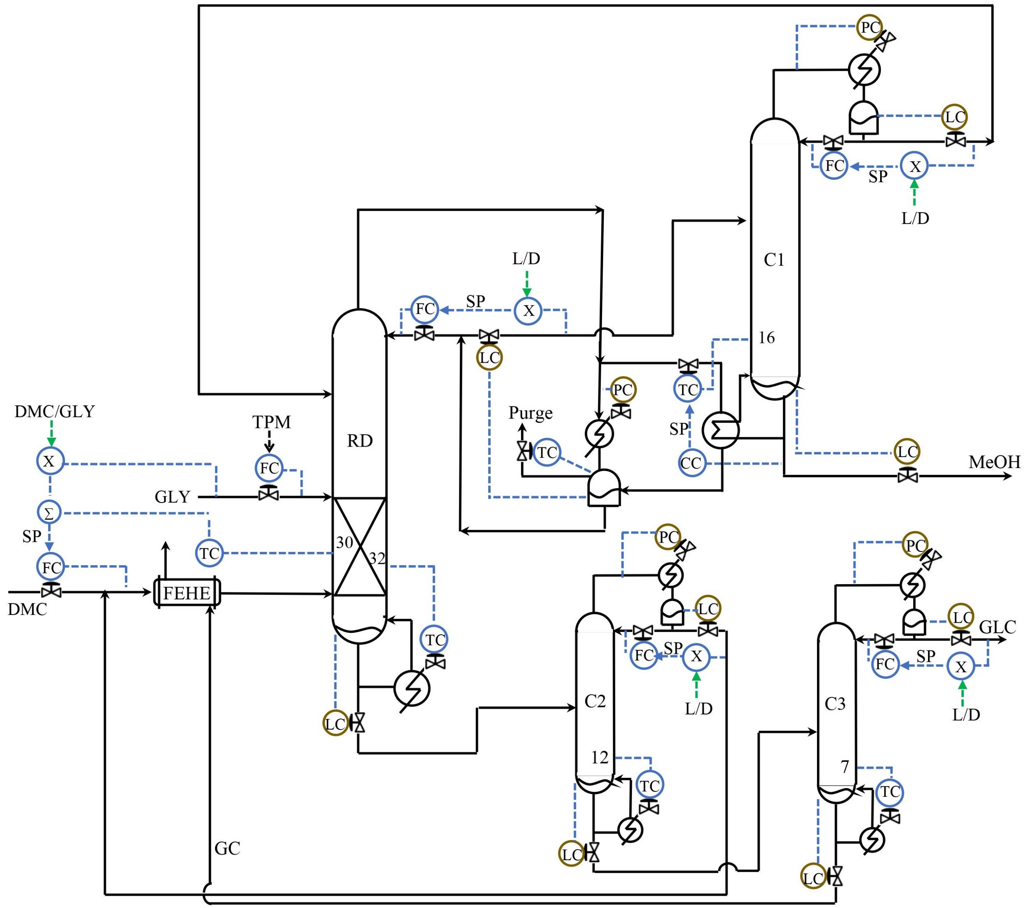
Figure 2: Control Structure of Proposed design

  - Plantwide Control
The evaluation of dynamic controllability for the proposed design involves the development of a conventional decentralized control system, subjected to rigorous dynamic simulations to assess its performance against anticipated principal disturbances. The primary disturbance considered as a flow and composition changes in the throughput manipulator (TPM), with the limiting glycerol reactant fresh feed rate serving as the TPM. Synthesis of regulatory control loops is carried out to effectively close the unit material and energy balances, as well as the overall plantwide material balance, as illustrated in Figure 2. Ensuring stoichiometric balance, the total (fresh + recycle) DMC rate into the RD column reactive zone is maintained in ratio with the fresh glycerol feed rate (TPM). Standard LV control loops are applied across all columns, with the regulation of reflux drum and bottom sump levels achieved through the manipulation of distillate and bottoms rates, respectively. The column pressure is controlled by adjusting the condenser duty. On the RD column, the overhead pressure is managed by manipulating the auxiliary condenser duty, while the condensate temperature is controlled through the manipulation of the vapour distillate rate. Maintaining the RD distillate in proximity to the HP azeotrope involves the maintenance of the reflux rate in ratio with the distillate rate (L/D). To prevent MeOH leakage down the bottoms, the sensitive temperature is controlled. In the MeOH recovery column (C1), the split stream valve on the RD column major overhead vapour is manipulated to regulate a sensitive tray temperature which is in cascade to the MeOH product composition. Finally, on the GC product column (C3), a sensitive tray temperature is controlled by manipulating the reboiler duty.
  - Economic and Sustainability Comparison
The economic and sustainability metrics of the proposed flowsheet design are compared with the existing RD pervaporation (RDPV) flowsheet developed by Sun et al. (Dayu Sun 2022) and the RD extractive distillation (RDED) flowsheet developed by Yu. (Yu 2020) All three flowsheets share the same GC product rate, GC product purity, and MeOH by-product purity, allowing for a consistent comparison. Identical cost correlations and pricing data are used for this analysis. The cost objective J, total energy consumed per kmol GC product, and glycerol and DMC reactants consumed per kmol GC product serve as the economic and sustainability metrics. The results, detailed in Table 3, reveal that the proposed process flowsheet design is the most cost-effective, with a 70% and 24% advantage in cost objective J over the RDPV and RDED designs, respectively. Additionally, the total energy consumption per kmol GC product is significantly lower, with advantages of 16% and 10% compared to RDPV and RDED, respectively. Furthermore, the incremental material cost (IMC) for the proposed design indicates superior material utilization efficiency compared to the alternative designs. Notably, the proposed process design outperforms both the RDPV and RDED designs in terms of economic efficiency, energy usage, and material efficiency. It is worth mentioning that RDPV faces the drawback of periodic membrane replacement, while RDED deals with the periodic makeup for the loss of the aniline entrainer in trace amounts in the product streams during sustained continuous operation.
Table 3:Energy and sustainability comparison of different designs
 | Proposed | RDPV | RDED
GLY/kmol GC Product | 1.0146 | 1.0198 | 1.0265
DMC/kmol GC Product | 1.0427 | 1.0533 | 1.051
ANI/kmol GC Product | 0 | 0 | 0.0032
Energy/kmol GC Product | 112.67 | 131.3 | 124.09
Incremental Material Cost | 0 | 0.0991 | 0.1332
TAC × 10⁶ yr⁻¹ ($) | 0.5341 | 0.8099 | 0.5344
Cost objective (J) | 0.5341 | 0.909 | 0.6666

  - Conclusion
In this study, we have successfully synthesized and designed a 4-column flowsheet for the valorisation of glycerol into glycerol carbonate (GC) through transesterification with dimethyl carbonate (DMC). Our proposed process design proves to be notably superior to the existing alternatives, namely RDPV and RDED process designs, in both economic and sustainability metrics. The cost objective J for the alternative flowsheets is higher by 70% and 24%, respectively, compared to our proposed design. Similarly, the energy consumption per kmol GC product is 16% and 10% higher in the alternative designs. While the material utilization efficiency of our proposed design is marginally better, rigorous dynamic simulations affirm its robust controllability. A conventional decentralized control system adeptly manages principal disturbances, ensuring tight control over product quality. This comprehensive design exhibits the potential to significantly enhance the economics of the biodiesel 'green' fuel value chain.

References
Bor-Yih Yu. 2020. "Development of two plant-wide glycerol carbonate production processes: Design, optimization and environmental analysis." Journal of the Taiwan Institute of Chemical Engineers 19-25.
Dayu Sun, Lijing Gao, Ruiping Wei, Jin Zhang, Xiaomei Pan, and Guomin Xiao. 2022. "Process design ,economic optimization,and enviromental assesment for production of glycerol carbonate via reactive distillation with pervaporation." Industrial & Engineering Chemistry 16552-16564.
H.W. Tan, A.R. Abdul Aziz, M.K. Aroua. 2013. "Glycerol production and its applications as a raw material: A review." Renewable and Sustainable Energy Reviews 27: 118-127.
S. Sahani, S. N.Upadhyay, Y. C Sharma. 2020. "Critical review on production of glycerol carbonate from byproduct glycerol through transesterification." Industrial & Engineering Chemistry Research 33: 67-88.

