Dynamic Modelling Approaches in Life Cycle Assessment: A Case Study for the Evaluation of Power-to-Hydrogen
Laura R. Piñeiro*, Silvia Moreno, Ángel Luis V. Perales, Bernabé A. Fariñas, Pedro Haro
Department of Chemical and Environmental Engineering.
Escuela Técnica Superior de Ingeniería, Universidad de Sevilla.
Camino de los Descubrimientos. Seville, Spain
*lromero4@us.es
Abstract
This study introduces a model developed in MATLAB that uses different analytical approaches to investigate the impact of incorporating temporal considerations in Life Cycle Assessment (LCA), encompassing dynamic Life Cycle Inventory (LCI), the analysis of varied time horizons (TH), and the application of an absolute metric to illustrate the temporal evolution of climate impacts. Results demonstrate that selecting a shorter TH can lead to higher CO₂ equivalent emissions due to the increased impact of methane. However, the variability of the impact of the production of hydrogen from water electrolysis is minimal across different time horizons due to the dominant role of CO₂ emissions.
Keywords: Time-dependent life cycle assessment, Hydrogen, Electrolysis, Greenhouse gas emissions, Global Warming Potential
  - Introduction
LCAs are a widely used methodology for the systematic analysis of the potential environmental impacts of products or services during their entire life cycle. However, in conventional LCA the effect of Green House Gas (GHG) emissions at a certain time in the future is distorted, as emissions released in different times are added, and then, a static characterization factor is applied, usually the Global Warming Potential with a 100-year time horizon (GWP₁₀₀), modelling emissions as if they occur at the start of the analytical time horizon (TH), which fails to bring accurate evaluation values (Zieger, 2020).

Dynamic LCA (DLCA) research is increasingly generating interest, as it provides a more precise method of assessing impacts. Nonetheless, there is currently a lack of methodological guidelines to time incorporation in LCAs. However, the way in which dynamism is applied can considerably affect the environmental impact results.

This work delves into different methodologies for incorporating time in LCA, using as a case study the production of hydrogen via water electrolysis. The electrolyzer technology selected for the case study was an Alkaline electrolyzer, which is well-suited for large-scale hydrogen production in centralized facilities due to their lower capital costs and high production capacity and remain an attractive choice despite having a lower efficiency than Proton Exchange Membrane (PEM) electrolyzers (Senza, n.d.).
  - Methodology
    - Goal and scope

The system boundary was set as cradle to gate and the selected functional unit was 1 kg of hydrogen. All environmental burdens were allocated to hydrogen production, as the only by-product of electrolysis is oxygen, and this gas is usually vented (Bareiß et al., 2019). The impact category considered is climate change and it was based on the major GHG (i.e., CO₂, CH₄ and N₂O). The attributional LCA was implemented in MATLAB, using data of the Ecoinvent 3.8 database from the SigmaPro 9.5 software. The inventory data used was that of reference (Koj et al., 2017). Nevertheless, as the previous study proved that the impact of the construction phase was negligible for the impact category under consideration, only emissions from the operation phase were included in this study.

The Life Cycle Inventory (LCI) of this work integrates factors that vary over the temporal span of the LCA, thereby mirroring more accurately the real-world conditions of the evaluated system. The two variations included were related to technological advances:

- Electricity mix changes were implemented in the inventory data, following the Global Ambition predictions for Spain (TYNDP, 2022), which provides dispatch estimations from 2030 until 2050.
- The increasing efficiency of electrolysers over time was taken into account. In 2030 the efficiency was considered to be 49 kWh/kg H₂ (Deloitte, 2021). On the other hand, as the Oxford Institute for Energy Studies (2022) indicates that the efficiency aimed for Alkaline electrolysers is less than 45 kWh/kg, that was the efficiency implemented for the last year of the study (2050). For the in-between years, a linear evolution was assumed.

    - Static metric

The selected metric for the static approach is the Global Warming Potential, as it is the most frequently used metric (Keller, 2022). It is a normalized metric, meaning that it compares the changes resulting from a substance to those resulting from an equivalent amount of a reference gas, typically CO₂ (Peters et al., 2021), which allows to express emissions as CO₂-equivalents. For the metric GWP, the change measured is the integral of the radiative forcing of a substance over a given TH (IPCC, 2021).

This work firstly conducts a static approach to illustrate the influence of selecting a certain TH in conventional LCA. Two TH were chosen for this case study: the GWP₁₀₀ because this is the TH most commonly used (even if there is no particular reason for selecting this particular time frame (The Guardian, 2011)), as well as 20 years, which is occasionally employed as a substitute for the GWP₁₀₀ (EPA, n.d.). The static model calculates CO₂ equivalent emissions yearly with Eq. (1), by multiplying of the inventory data of the given year by a constant normalized metric (i.e., the GWP₂₀ or the GWP₁₀₀).
$$kg CO_{2-eq}=Inventory×Normalized metric$$ | (1)
    - Dynamic metric

Two dynamic modelling approaches were conducted: one of them using a normalized metric in order to compare the results with the static approach, and the other one applying an absolute metric, with the aim of reflecting the evolution of impacts over time.

      - Normalized metrics of the dynamic approach

The normalized metric used for the dynamic modelling was the GWP with a flexible TH. The use of a changing TH allows to be consistent with the chosen time frame for the evaluation of the results. In this work, the chosen time frame for the evaluation of impacts was 25 years with the purpose of emphasizing the effect of CH₄, as the shorter the TH, the larger becomes the impact of CH₄ because its radiative forcing is much larger than that of CO₂ over a short period of time. Moreover, an evaluation period of a 100 years was also included with the aim of comparing the result with its static counterpart.

In this section, CO₂ equivalent emissions were also calculated with Eq. (1), but the value of the normalized metric changes every year, as its TH varies over time, and it is calculated as the difference between the evaluation period and the year in which emissions are released. For example, for an evaluation period of 25 years, emissions that occur in the first year will be evaluated for 25 years using the GWP₂₅, while emissions released during the second year will be evaluated for 24 years and so forth. This approach contrasts with the common practice applied in static LCA, which considers a fixed TH of 100 years and results in an inconsistency between the chosen TH and the time frame in which impacts are evaluated (e.g., as an emission released in year t when using a fixed TH of 100 years will be evaluated until the year t+100 (Levasseur et al., 2010)).

      - Absolute metrics of the dynamic approach

The absolute metric selected for the dynamic modelling approach was the Absolute Global Temperature change Potential (AGTP). Absolute metrics offer more comprehensive information of climate impacts (Peters et al., 2021) as they elucidate the connection between the moment in which emissions occur and their impact. This impact is expressed in a shared physical property (Ericsson et al., 2013), such as K per kg emitted in the case of the AGTP. Furthermore, absolute metrics allows to differentiate among diverse trajectories that lead to comparable climate impacts, aiding in avoiding adverse consequences, such as surpassing irreversible climate tipping points (Breton et al., 2018).

The AGTP per kg of each GHG was calculated according to the latest version of the IPCC to date (IPCC, 2021). The AGTP in K per kg of hydrogen is obtained by adding the emission of each GHG gas by their respective AGTP.
  - Results and discussion
    - Normalized metric

In this section the effect of changing the TH when using the GWP statically is presented. Moreover, static and dynamic approaches in LCAs are compared to analyze the influence of considering the temporal effects of GHG emissions.

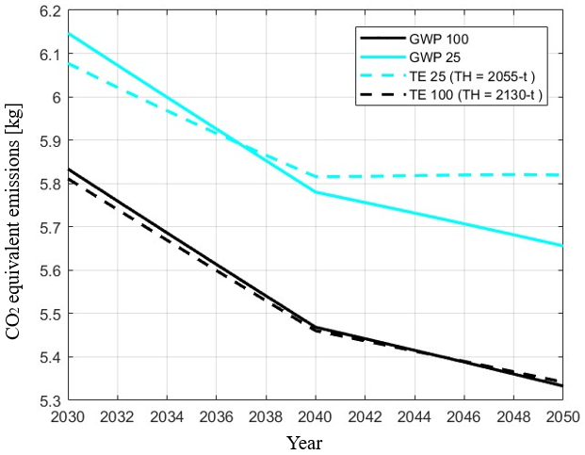
Figure 1. CO₂ equivalent emissions for a changing LCI and static (GWP₁₀₀ and GWP₂₅) and flexible TH (TE₂₅ and TE₁₀₀).

Figure 1 shows that for the same static metric (i.e., the GWP₁₀₀ or the GWP₂₀), CO₂ equivalent emissions decrease with time. This is due to the two technological advances that were considered in this work, which results in a decreased amount of emissions.

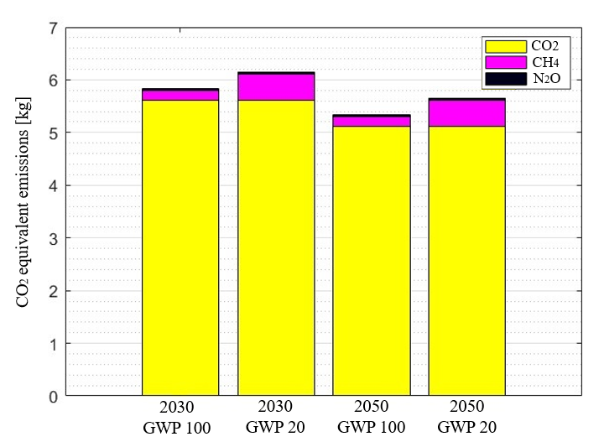
Figure 2. CO₂ equivalent emissions broken down into CO₂, CH₄ and N₂O.

Figure 2 shows that the increased CO₂ emissions each year shown in Figure 1 when using the GWP₂₀ compared to the GWP₁₀₀ is due to the increased impact of methane. As the GWP is calculated dividing the integral of the radiative forcing of a gas by the integral of the radiative forcing of CO₂ (IPCC, 2021) over the selected TH, choosing a short time frame will give a greater weight to short lived emissions like methane, as this gas has a much higher radiative efficiency over a short period of time than CO₂ (IPCC, 2021). This phenomenon also explains why the use of a flexible TH with an evaluation time of 25 years results in higher CO₂ emissions than the GWP₂₀ past 2036 (as the TH is smaller than that of the GWP₂₀ past this point in time). It is also noteworthy that in Figure 1 CO₂ equivalent emissions when using an evaluation time of 25 years are apparently constant past 2040. This is due to two contrasting actions: on the one hand, emissions are lower due to the incorporated technical advances, and on the other hand, the weighting of CH₄ emissions increases the later the emission is released because the TH gets smaller. Notwithstanding, this latter trend is not shown when selecting an evaluation time of 100 years, as CO₂ equivalent emissions remain almost identical to those obtained with the GWP₁₀₀ since the TH is sufficiently large (even in the last year of the evaluation), and thus, the impact of CH₄ does not show much variability.

Figures 1 and 2 show the potential differences in the impacts obtained when conducting a LCA by selecting a certain TH. These changes could be significantly amplified in a system in which CH₄ emissions are more predominant than in this system. Therefore, it can be concluded that the production of hydrogen via water electrolysis is not that sensitive to the chosen TH (as its impacts are mainly due to CO₂ emissions that are not affected by the selected time frame).

    - Absolute metric

The AGTP is an instantaneous metric, meaning that it provides an estimation of the indicator's value at a specific moment in time following an emission (Breton et al., 2018). Two evaluation periods were selected: 25 and 100 years. Since the activity is considered to start in 2030, the AGTP in Figure 3 shows the temperature change in 2055 and 2130 due to the emissions that were released each year for the production of 1 kg of hydrogen and demonstrates that all emissions occurring from 2030 until 2050 have a greater impact on 2055 than on 2130.

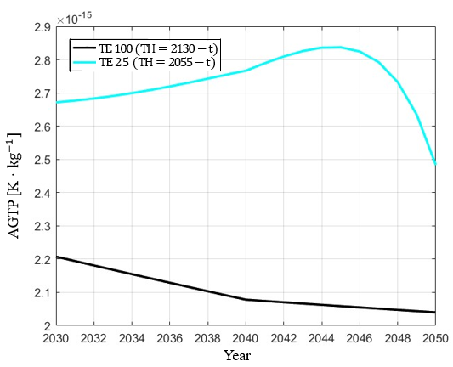
Figure 3. AGTP for this case study.
  - Conclusion
In this study, a variety of analytical approaches were developed in MATLAB for shedding light on the influence of the incorporation of time in LCA. These ranged from the use of a dynamic LCI to the analysis of the effects of selecting different TH. Furthermore, by implementing an absolute metric (i.e., the AGTP), this model illustrated the temporal evolution of climate impacts, which introduces a different approach to incorporating time in LCA practices, instead of opting for expressing emissions as CO₂-equivalents. It was also proven even if a shorter TH results in greater CO₂ equivalent emissions due to the greater impact of methane, the production of hydrogen from water electrolysis does not show a great variability with the selected TH, as CO₂ emissions are predominant.
It can be concluded that this work enhances our understanding of the implications of the inclusion of time into LCAs, which can aid practitioners in delivering more comprehensive LCAs that may well result in more informed conclusions and enhanced decision-making for the development of more effective environmental policies.
Acknowledgements
This study has been supported by grant PID2020-114725RA-I00 of the project GH2T funded by MCIN/AEI/ 10.13039/501100011033 and by the “European Union”.
References
Bareiß K., de la Rua C., Möckl M. and Hamacher T., 2019, Life cycle assessment of hydrogen from proton exchange membrane water electrolysis in future energy systems, Applied Energy, vol 237, Pages 862-872.
Breton, C., Blanchet, P., Amor, B., Beauregard, R., and Chang, W. S., 2018, Assessing the climate change impacts of biogenic carbon in buildings: A critical review of two main dynamic approaches. Sustainability, 10(6).
Deloitte, 2021, Fueling the future of mobility: hydrogen electrolyzers, Hydrogen Articles Collections, Page 5.
EPA, n.d., Understanding Global Warming Potentials, https://www.epa.gov/ghgemissions/understanding-global-warming-potentials.
Ericsson, N., Porsö, C., Ahlgren, S., Nordberg, Å., Sundberg, C., & Hansson, P. A. (2013). “Time‐dependent climate impact of a bioenergy system–methodology development and application to Swedish conditions.” GCB Bioenergy, 5(5), 580-590.
IPCC, 2021, Climate Change 2021: The Physical Science Basis. Contribution of Working Group I to the Sixth Assessment Report of the Intergovernmental Panel on Climate Change [Masson-Delmotte, V., P. Zhai, A. Pirani, S.L. Connors, C. Péan, S. Berger, N. Caud, Y. Chen, L (eds.)]. Cambridge University Press, Cambridge, United Kingdom and New York, NY, USA
Keller M., 2022, Is Hydrogen Production through Natural Gas Pyrolysis Compatible with Ambitious Climate Targets in the United States? A Location-Specific, Time-Resolved Analysis, Environmental Research Letters, vol. 17, no. 12.
Koj J., Wulf C., Schreiber A. and Zapp P., 2017, Site-Dependent Environmental Impacts of Industrial Hydrogen Production by Alkaline Water Electrolysis, Energies, vol. 10, Issue 7.
Levasseur, A., Lesage, P., Margni, M., Deschěnes, L., and Samson, R., 2010, Considering time in LCA: Dynamic LCA and its application to global warming impact assessments, Environmental Science and Technology, 44 (8).
Oxford Institute for Energy Studies, 2022, Cost-competitive green hydrogen: how to lower the cost of electrolysers?, Page 15.
Peters, G. P., Aamaas, B., T. Lund, M., Solli, C., and Fuglestvedt, J. S., 2021, Alternative “global warming” metrics in life cycle assessment: a case study with existing transportation data. Environmental Science and Technology, 45(20), 8633-8641.
SenzaHydrogen, n.d., PEM Hydrogen Generator VS Alkaline Hydrogen Generator. https://senzahydrogen.com/pem-hydrogen-generator-vs-alkaline-hydrogen-generator.html.
The Guardian, What are CO2e and global warming potential (GWP)?, 2011, https://www.theguardian.com/environment/2011/apr/27/co2e-global-warming-potential.
TYNDP, 2022, Scenario Report – additional Downloads. https://2022.entsos-tyndp-scenarios.eu/download/ Accesed 30 Nov. 2023.
Zieger, V., Stenger, A., Breton, C., Blanchet, P., Amor, B., 2020, "Impact of GHGs temporal dynamics on the GWP assessment of building materials: A case study on bio-based and non-bio-based walls," Building and Environment, 107210, DOI: 10.1016/j.buildenv.2020.107210

