Development and Application of a Simplified
Non-Ideal Mixing Model for Semi-Batch Crystallization
Jan Trnkaª, Giovanni Maria Maggioni^{b}, František Štěpánek^{a,}*
ªDepartment of Chemical Engineering, UCT Prague, Technická 3, 16628 Prague, Czech Republic
^{b}Engineering & Technology – PTD, Bayer AG, 51368 Leverkusen, Germany
*Frantisek.Stepanek@vscht.cz
Abstract
In this work, we investigate the effect of mixing intensity on the crystal size distribution (CSD) in a semi-batch crystallizer via population balance modelling. We have coupled balance equations with a simplified model of turbulent mixing developed by
Baldyga et al. (1997). This approach was previously applied to isothermal reactive crystallization by Ståhl and Rasmuson (2009), but its potential was not fully explored. We have extended the model in two directions. First, we have developed an adaptive time step strategy for increased stability of the numerical solution and faster computation. Second, we have implemented the non-isothermal case, thus enabling the study of coupled cooling-antisolvent crystallization. Based on our simulations, we explain how the non-ideality of mixing affects nucleation and why the average crystal size reaches a maximum with increasing mixing intensity.
Keywords: crystallization, modelling, turbulent mixing
  - Introduction
Mathematical modelling plays a crucial role in facilitating effective design and control of crystallization processes. However, most models currently used in industry and academia assume typically perfect mixing, failing to capture the system dependency on mixing dynamics and limiting our understanding of the process. Although the use of computational fluid dynamics (CFD) is possible in principle, this approach is generally too demanding for extensive parametric studies. To mitigate this issue, we present an efficient implementation of a simplified mixing model for semi-batch crystallization.
  - Modelling
    - Turbulent mixing modelling
The model developed and described by Baldyga et al. is based on the description of meso- and micro-mixing phenomena, governed by their corresponding characteristic times $t_{meso}$ and $t_{micro}$ (Eq. (1) and Eq. (2), respectively). The energy dissipation rate in the feed region ($ε_{eff}$) is calculated as a multiple of the specific power input (Eq. (3)). The model describes mixing as an expansion of a discrete feed volume (‘drop’) by engulfment of the bulk volume. The evolution of the volume fraction of mesomixed ($X_{meso}$) and micromixed ($X_{micro}$) regions is then described by Eq. (4) and Eq. (5). It is assumed that a possible reaction occurs in the micromixed volume. The change of molar concentration in the droplet of volume fraction $X_{micro}$ for the species i (c_{i}) is modelled by Eq. (6), where $〈c_{i}〉$ is the bulk concentration. All bulk variables are further denoted in the paper by angle brackets. Bulk concentrations do not change during the drop expansion. This model can be used for the description of mixing in a semi-batch process by discretizing the feed stream into a series of droplets, each described individually.
$$t_{meso}=2{\left(\frac{d^{2}}{ε_{eff}}\right)}^{1/3}$$ | (1)
$$t_{micro}=\frac{1}{E}=12.7{\left(\frac{ν}{ε_{eff}}\right)}^{1/2}$$ | (2)
$$ε_{eff}=k_{ε}\frac{P}{m}=k_{ε}\frac{P_{0}{N_{s}}^{3}D^{5}}{V}$$ | (3)
$$\frac{dX_{meso}}{dt}=\frac{1}{t_{meso}}X_{meso}\left(1-X_{meso}\right)$$ | (4)
$$\frac{dX_{micro}}{dt}=EX_{micro}\left(1-\frac{X_{micro}}{X_{meso}}\right)$$ | (5)
$$\frac{dc_{i}}{dt}= E\left(1-\frac{X_{micro}}{X_{meso}}\right)\left(〈c_{i}〉-c_{i}\right)+r_{i}$$ | (6)
    - Crystallization model equations
During the droplet expansion, each of the two regions (drop and bulk) is described by its own set of equations, coupled via mixing. Crystallization is modelled by a population balance equation (PBE). It is further assumed here that breakage and agglomeration are negligible. However, they could be easily included in the modelling framework. Note that crystal nuclei are assumed to form at negligible size.
      - Expanding drop equations
In the droplet, crystallization is modelled by Eq. (7) (completed by its boundary condition). The concentration of solute product ($c_{Pr}$) changes during the droplet expansion according to Eq. (8), while other mixture components according to Eq. (6). With respect to the model of Ståhl and Rasmuson, we have included the energy balance equation, Eq. (9), omitting here reaction, crystallization, and mixing heat for simplicity.
$$\frac{∂f}{∂t}+G\frac{∂f}{∂L}= E\left(1-\frac{X_{micro}}{X_{meso}}\right)\left(〈f〉-f\right), f\left(0,t\right)=\frac{J}{G}$$ | (7)
$$\frac{dc_{Pr}}{dt}= E\left(1-\frac{X_{micro}}{X_{meso}}\right)\left(〈c_{Pr}〉-c_{Pr}\right)+r_{Pr}-\frac{3k_{v}ρ_{cr}}{M_{Pr}}G\int_{0}^{∞}{L^{2}fdL}$$ | (8)
$$\frac{dT}{dt}=E\left(1-\frac{X_{micro}}{X_{meso}}\right)\frac{ρ_{bulk}}{ρ}\frac{c_{p,bulk}}{c_{p}}\left(〈T〉-T\right)$$ | (9)
      - Equations for bulk
The equations describing the bulk variables are similar to those of the droplet. However, we assume that the intensive variables are not affected by the droplet expansion (i.e., the bulk acts as a reservoir). Thus, no mixing term is present. Note that, for non-isothermal processes, the temperature of the bulk changes due to heat exchange with the jacket at temperature $T_{j}$.
$$\frac{∂〈f〉}{∂t}+G_{bulk}\frac{∂〈f〉}{∂L}= 0, 〈f〉\left(0,t\right)=\frac{J_{bulk}}{G_{bulk}}$$ | (10)
$$\frac{d〈c_{Pr}〉}{dt}=r_{Pr,bulk}- \frac{3k_{v}ρ_{cr}}{M_{Pr}} G_{bulk}\int_{0}^{∞}{L^{2}〈f〉dL}$$ | (11)
$$\frac{d〈T〉}{dt}=\frac{UA\left(T_{j}-〈T〉\right)}{ρ_{bulk}c_{p,bulk}V_{bulk}}$$ | (12)
  - Model implementation and initial conditions
As mentioned, the feed stream is discretized into droplets of volume $∆V=Q∆t$, where $∆t$ is the chosen feed time step. Clearly, we assume here that the feed flow rate ($Q$) is constant. Note that $∆t$ must be greater than the time of drop expansion. The initial state of droplet is equal to pure feed. The model equations are then solved for each droplet individually. The initial value of the volume fractions is defined by Eq. (13). The initial state of the bulk varies for each droplet and is equal to the state of the droplet at the end of previous step as described by Eq. (14-16). The population balance equations are solved via high-resolution finite volume method with Koren flux limiter. The resulting system of ODEs is numerically integrated using an explicit Runge–Kutta method (RK45 in the Python solver implementation). Only primary nucleation and size-independent growth were assumed in the simulations.
$$X_{micro}\left(0\right)=X_{meso}\left(0\right)=∆V/V$$ |  | (13)
$$〈c_{i}〉{\left(0\right)}_{0} =c_{i0},$$ | $$〈c_{i}〉{\left(0\right)}_{k+1} =c_{i}{\left(∆t\right)}_{k}$$ | (14)
$〈f〉{\left(L,0\right)}_{0}=f_{0}$, | $$〈f〉{\left(L,0\right)}_{k+1}=f{\left(L,∆t\right)}_{k}$$ | (15)
$〈T〉{\left(0\right)}_{0} =T_{0}$, | $$〈T〉{\left(0\right)}_{k+1} =T{\left(∆t\right)}_{k}$$ | (16)
We have studied two systems representing a common use of a semi-batch crystallizer: the reactive isothermal precipitation of benzoic acid (BA) (Ståhl and Rasmuson, 2009) and the non-isothermal antisolvent crystallization of aspirin (Lindenberg et al., 2009). For the reactive crystallization, following the original work of Ståhl and Rasmuson, we have assumed a fast, mass transport-limited reaction. The kinetic and thermodynamic data for each system are provided in the respective references.
  - Results
    - General simulation results – benzoic acid
Figure 1A shows the supersaturation in the bulk ($S_{b}$) and the maximal supersaturation reached in each droplet ($S_{d,max}$) over the course of the feeding time. The existence of two “parallel” supersaturation profiles significantly influences the crystallization process. We have identified three distinct nucleation phases, marked on both plots in Figure 1. In the first phase, nucleation is driven by the high supersaturation achieved in the droplet, forming a sharp peak in CSD. In the second phase, the bulk supersaturation is high enough to initiate nucleation in the bulk as well, leading to the formation of second peak. In the third phase the nucleation in the bulk is again negligible. However, the receding drop supersaturation is still high enough to support formation of new nuclei (Figure 1B).
A) | B)
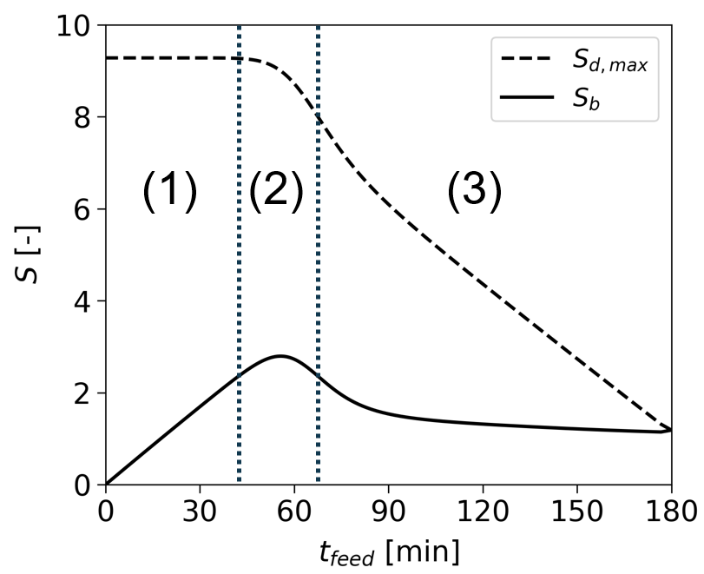 | 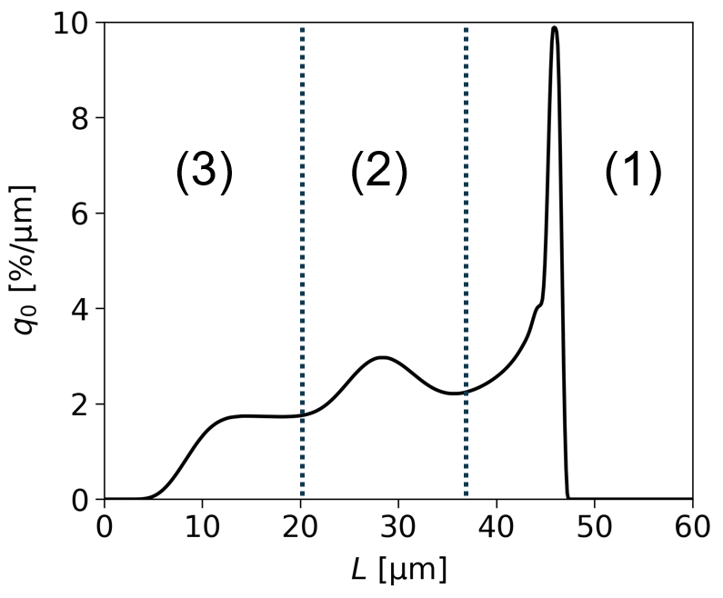
Figure 1: Typical simulation results for BA: A) supersaturation profile, B) population density
    - Numerical stability
Our simulations revealed that an arbitrary choice of both feed and crystal size discretization can result in an oscillating behavior in CSD. Due to discretization of the feed, the final CSD is comprised of crystal “subpopulations” formed in each droplet, typically resulting in a peak in the distribution. However, these peaks lead to oscillations only if their width ${(W}_{i}$) covers multiple lengths of size interval ($∆L$). To quantify this mismatch, we define number $K$ as the number of intervals covered by each droplet peak (Eq. (17), note the identity with the Courant Number), and postulate that $K_{i}≤1, ∀i$ is a sufficient condition to eliminate the oscillation. As a result, the oscillation fade with an increasing number of droplets (shortening of $∆t$) for chosen $∆L$, as we show in Figure 2A.
$$K_{i}= \frac{W_{i}}{∆L}= \frac{\overline{G_{i}}∆t}{∆L}$$ | (17)
By setting the value of $K$ as a constant for every droplet, we can compute the length of an adaptive feed time step from Eq. (17). Since this simple strategy leads to unreasonably long steps at growth rates close to zero (i.e., low supersaturation), we remedy by introducing the heuristic parameter $θ$ (Eq. (18)), which serves as a “limiter” for time step increase. Our simulations indicate that a suitable choice seems $θ=1.1$. Additionally, we assume that the mean growth rate can be well approximated by the value from the previous step. As demonstrated in Figure 2B, this approach presents an optimal use of computational time as better precision is achieved compared to the case of constant time step at discretization of feed into the same number of droplets. We have concluded that for $K=1$, this strategy provides a satisfactory balance between eliminating oscillations, minimizing computational time, and ensuring high accuracy.
$$∆t_{i+1}=min\left( \frac{K∆L}{\overline{G_{i}}},θ∆t_{i}\right)$$ | (18)
    - Effect of mixing intensity
Our simulations indicate that increasing the mixing intensity leads to higher bulk supersaturation, as shown in Figure 3A. This causes two effects: increased overall growth and increased bulk nucleation. The influence of mixing on the final CSD is depicted in Figure 3B. At low $ε_{eff}$, nucleation in the drop being dominant, intensified mixing leads to bigger particles as the effect of increased growth prevails over raise in bulk nucleation. However, once the bulk nucleation gets high enough to form a second peak, further increase of $ε_{eff}$ leads to a shift of the mass of distribution to the second peak at smaller sizes. This transition is reflected in the dependency of volume-based median particle size ($L_{3,50}$) on $ε_{eff}$ (Figure 3C) and explains the existence of maximum in this curve. Note that the maximum is reached when the distribution shifts from unimodal to bimodal.
A) | B)
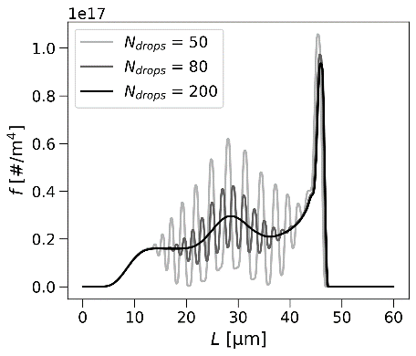 | 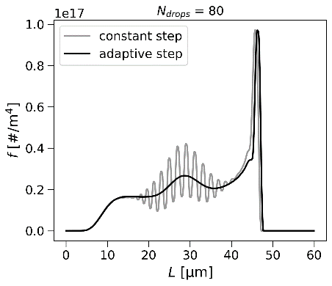
Figure 2: Oscillations in CSD of BA: A) final CSD for various feed discretization levels,
B) comparison of constant and adaptive feed time step results at the same number of droplets
A) | B)
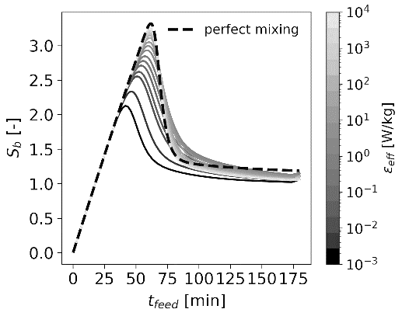 | 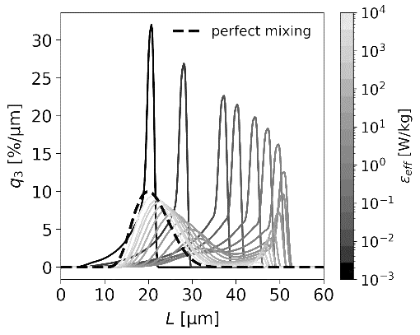
C) | D)
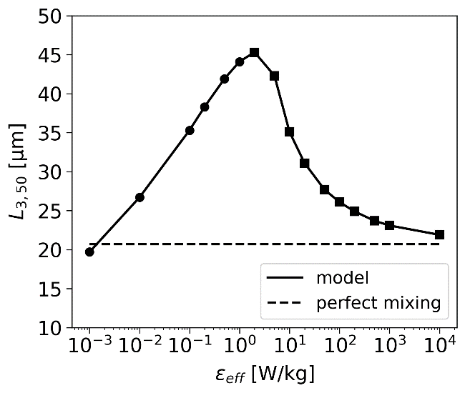 | 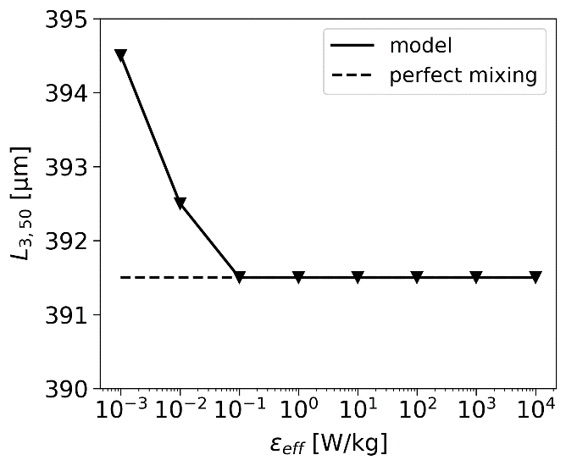
Figure 3: System dependency on mixing intensity: A) bulk supersaturation (BA),
B) final CSD (BA), C) median particle size (BA), D) median particle size (aspirin)
● – only drop nucleation peak, ■ – bimodal distribution, ▼ – only bulk nucleation peak
The maximum in this dependency has been previously experimentally measured, e.g., by Åslund and Rasmuson (1992) for benzoic acid and modelled by Zauner and Jones (2000) for the case of calcium oxalate. However, both studies assumed the crystal size drops at high $ε_{eff}$ solely due to secondary nucleation and breakage caused by high shear forces. We have shown that this behaviour can be qualitatively described only accounting for primary nucleation and size-independent growth. Notably, the model converges to ideal mixing for high $ε_{eff}$, as one would reasonably expect. Note that in the case of aspirin the system approaches perfect mixing already at very low $ε_{eff}$ (Figure 3D), which renders the effect of non-ideal mixing negligible in this system.
  - Conclusions
In this work, we revisited a model of semi-batch crystallization with imperfect mixing, previously introduced in the literature, extending it to the non-isothermal case. Moreover, based on a careful analysis of our simulations, we have developed an adaptive feed time step strategy, which improves on the original model by affording complete control over numerical oscillation and significantly reducing the computational time. Even though a more comprehensive description of real systems requires the incorporation of additional phenomena to the model (e.g., size-dependent growth, secondary nucleation, breakage, or agglomeration), our examinations have shown that the model provides a good qualitative description of real phenomena, in agreement with existing literature. It thus forms the basis for new, more detailed developments, while proposing a new, more efficient, stable implementation. Finally, by focusing solely on primary nucleation and growth, we were able to uncover and analyze in detail the interplay between bulk and drop nucleation and its influence on crystal size, which is particularly relevant for reactive and antisolvent crystallization.
List of symbols (not mentioned in the text)
$$c_{p}$$  $$d$$  $$f$$  $$k_{v}$$  $$k_{ε}$$  $$q_{0}$$  $$q_{3}$$  $$r$$  $$D$$  $$E$$ | specific heat capacity, $\text{J }{\text{K}}^{\text{-1}}\text{ k}{\text{g}}^{\text{-1}}$  feed pipe diameter, $m$  population density function, ${\# m}^{-4}$  volume shape factor, $-$  local energy dissipation coefficient, $-$  norm. number-based density, $m^{-1}$  norm. volume-based density, $m^{-1}$  reaction rate, ${mol m}^{-3} s^{-1}$  impeller diameter, $m$  engulfment constant, $s^{-1}$ | $$G$$  $$J$$  $$M_{Pr}$$  $$N_{s}$$  $$P_{0}$$  $$Q$$  $$T$$  $$V$$  $$ρ_{cr}$$  $$ν$$ | overall growth rate, $m s^{-1}$  nucleation rate, ${\# m}^{-3} s^{-1}$  molar mass of product, ${kg mol}^{-1}$  stirring rate, $s^{-1}$  power number, $-$  feed flow rate, $m^{3} s^{-1}$  temperature, $K$  system volume, $m^{3}$  crystal density, $kg m^{-3}$  kinematic viscosity, $m^{2} s^{-1}$
References
B. L. Åslund, Å. C. Rasmuson, 1992, Semibatch reaction crystallization of benzoic acid, AIChE journal, 38, 3, 328-342
J. Bałdyga, J. R. Bourne, S. J. Hearn, 1997, Interaction between chemical reactions and mixing on various scales, Chemical Engineering Science, 52, 4, 457-466
C. Lindenberg, M. Krättli, J. Cornel, M. Mazzotti, J. Brozio, 2009, Design and optimization of a combined cooling/antisolvent crystallization process, Crystal Growth and Design, 9, 2, 1124-1136
M. Ståhl, Å. C. Rasmuson, 2009, Towards predictive simulation of single feed semibatch reaction crystallization, Chemical Engineering Science, 64, 7, 1559-1576
R. Zauner, A. G. Jones, 2000, Scale-up of continuous and semibatch precipitation processes, Industrial & engineering chemistry research, 39, 7, 2392-2403

