Sustainability Assessments of Styrofoam Waste Recycling for Styrene Monomer Recovery: Economic and Environmental Impact
Eprillia Intan Fitriasariª, J. Jay Liu*ª
ªDepartment of Chemical Engineering, Pukyong National University, 48513 Busan, South Korea.
jayliu@pknu.ac.kr
Abstract
The use of styrofoam has increased in various industries, including packaging and food, leading to a short lifecycle and the generation of large amounts of waste. Styrofoam waste poses a significant problem due to its non-biodegradable nature and the difficulties associated with its processing and disposal. However, there have been efforts to address this issue, including chemically recycling styrofoam waste. In this work, sustainability assessments were conducted to evaluate the economic and environmental performance of chemically recycling styrofoam waste to recover its styrene monomer. Three scenarios were developed based on the feed pretreatment and monomer quality. The process model was performed based on experimental results in simulation software. The outcomes of the process modelling were employed as input data for economic analysis and life cycle assessment. According to the economic analysis results, the scenario for high-quality styrene monomer recovery, with a minimum selling price of $ 1.52/kg, emerged as the most economically viable option. Furthermore, all scenarios demonstrated lower carbon emissions compared to the production of petroleum-based styrene, with scenario 1 being the most environmentally friendly, achieving an 89% reduction in carbon emissions.
Keywords: plastic recycling, techno-economic analysis, life cycle assessment, carbon emissions.
  - Introduction
Over the past decades, global plastic production has soared from 2 million tons in 1950 to 368 million tons in 2019, with an expected doubling in the next two decades (Geyer et al., 2017). Plastic, widely used in diverse applications, has seen increased demand, particularly in packaging, accounting for 39.6% in 2019 (Plastic Europe, 2020). Despite recycling efforts, only 14% of plastic waste is collected, and projections suggest that by 2050, only 27% will be recycled, with most incinerated or landfilled (Geyer et al., 2017). Implementing circular economy principles, particularly through chemical recycling, offers a potential solution to these challenges, aiming to prevent plastic waste and create economic opportunities while reducing environmental impact. At present, mechanical recycling stands as the dominant method. However, its scope is largely limited to retrieving lower-grade products. Chemical recycling, especially catalytic degradation, emerges as a promising alternative to traditional mechanical recycling, producing higher-quality recycled materials and reducing environmental impact. This process aims to recover styrene monomer from styrofoam waste, a crucial step in advancing circular economy goals. However, despite advancements, challenges remain, including economic viability and environmental impact assessment, necessitating comprehensive analyses to ensure the success of these chemical recycling technologies at a global industrial scale. This study conducts in-depth techno-economic and life cycle assessments, critically evaluating the potential of catalytic degradation in creating a sustainable circular economy for styrofoam waste, examining economic viability and environmental friendliness to meet sustainability criteria.
  - Methodology
    - Process Description
A process model for recovering styrene monomer from styrofoam waste was developed using Aspen Plus V11. This model served as the foundation for economic analysis and environmental impact assessment. Three scenarios were modeled based on feedstock pre-treatment process and product purity: Scenario 1 – liquefaction in heat as pre-treatment with a target product purity of 95%, Scenario 2 – feedstock dissolution as pre-treatment with a target product purity of 95%, and Scenario 3 – liquefaction in heat as pre-treatment with a target product purity of 99.6%. The process was designed with a feedstock composition derived from the analysis of polystyrene waste, taken from the research detailed by Oh et al (2018). The feedstock was sourced from a local facility that recovers styrofoam waste to pellet, assumed to have undergone initial sorting, shredding, melting, ingot caking and ingot pelleting processes. According to Korea Environment Corporation (2021), the price of recycled polystyrene pellets from styrofoam waste is $ 0.74/kg, which was used as the feedstock cost in the model. We considered 300 kg/h of styrofoam waste pellets as the feedstock, operating for 8,000 h annually. The degradation of styrofoam waste to recover styrene monomer followed the optimal conditions from an experimental study using a base catalyst, as reported by Liu et al (2016). This degradation occured in the reactor, which was modeled as Ryield reactor in the model, yielding 85 wt% of styrene monomer.
The flowsheet illustrating the process flow for modeling three scenarios is depicted in Figure 1. This process is divided into three primary sections: pre-treatment, catalytic degradation, and product separation and recovery. The process initiates with the pre-treatment of the feedstock. Polystyrene pellets and catalyst are blended in a mixer. In Scenario 2, Tetrahydrofuran (THF) is introduced as a solvent into the mixer alongside polystyrene pellets and catalyst, facilitating the dissolution of polystyrene. The mixture undergoes heating to 370ºC in pre-heater and HE-1, causing EPS and THF to transform into a gaseous state. Following pre-treatment, the gas mixture and catalyst are introduced into the catalytic degradation reactor (REACTOR), operating at 370ºC, 0.08 MPa pressure, and 30 minutes of residence time. A separator (SEP1) is utilized to segregate products from catalysts and solid. The product is conveyed to the product separation and recovery section via a compressor (COMP). Through a sequence of heat exchangers and separators, the products undergo separation for heavy hydrocarbon. Flash-type separators are used to segregate the mixture based on their distinct phases. The product separation procedure start by passing the products through SEP2. SEP3 yields heavy hydrocarbon as the bottom product, sent for wastewater treatment, while light gas is also separated in SEP4 and used for energy recovery. To attain the desired purity level of styrene monomer, the product from separation section undergoes multiple processes depending on the scenario. In Scenario 1, the product is transported to the styrene recovery section, aiming for a 95% purity via distillation in DISTL1. Recovered styrene monomer is obtained as the bottom product, and the top product is recycled to maximize the yield. In Scenario 2, the product goes to DISTL1, which separates the THF from the product achieving 99% of THF to be recycled back to the pre-treatment section. The products is further purified in the DISTL2 to obtain recovered styrene monomer with 99% purity. In Scenario 3, two distillation columns (DISTL1 and DISTL2) are utilized in the product recovery section to achieve styrene monomer at a purity of 99.6%, with the remaining light gases used for energy recovery. The used catalyst is recovered in a separate section using a calcination process at 600°C and by utilizing the produced light gas as fuel.
    - Economic Analysis
Initially, the equipment cost is estimated in order to conduct techno-economic analysis. Each equipment cost is determined by factors such as its type, size, capacity, and power or duty, as modeled in Aspen Plus. The catalytic degradation reactor equipment cost was computed using correlations provided by Turton et al (2009), while the cost of other equipment was based on literature from analogous studies in plastic waste processing. The equipment cost is adjusted using the equation:
$$C_{n}=C_{o}\left(\frac{CEPCI_{n}}{CEPCI_{o}}\right){\left(\frac{Z_{n}}{Z_{o}}\right)}^{n}$$ | (1)
Here, C_{n} is the updated cost of equipment at the new capacity, C_{o} is the cost in the baseline year, Z_{n} is the new capacity, Z_{o} is the baseline capacity, and n is the scaling exponent. The unit price of other material and utility used in operating cost were sourced from various publications. THF cost is taken from reference at $ 3.28/kg, while the catalyst cost was estimated based on SBA-15 modification at $ 70/kg. Utility expenses, including makeup water, electricity, and natural gas, were obtained from reports by United States Energy Information Administration and National Renewable Energy Laboratory. Total capital investments were calculated following the methodology by Turton et al (2009), which factors in total direct cost (TDC) and total indirect cost (TIDC). The assumptions used for economic analysis is listed in Table 1. Following the computation of all costs, a discounted cash flow analysis is conducted to estimate the minimum selling price (MSP) of recovered styrene monomer at which zero net present value (NPV) is generated for the entire process over a 30-years project life.
Table 1: Assumptions for economic analysis
Parameter | Value
Depreciation year | 7 years
Tax rate | 20%
Salvage value | 0
Project life | 30 years
Internal rate of return (IRR) | 10%
Plant start-up year | 1
Operating hours | 8,000 h
    - Life Cycle Assessment
Life cycle assessment (LCA) was performed to evaluate the environmental impact of recovering styrene monomer from styrofoam waste. The LCA was conducted according to ISO 14040/44:2006 standard. The goal of this assessment is to compare the carbon emissions of the recovered styrene monomer with conventional styrene derived from fossil-based raw material. The life cycle impact assessment was carried out using SimaPro 9.4.0.2, employing CML-IA baseline 3.07 method. Global warming potential (GWP 100a) was selected as the impact category to measure the carbon emissions. Ecoinvent v3.8 served as the life cycle inventory (LCI) database. The LCI was defined based on material and energy balance results from process modeling, and the functional unit was set at 1 kg of recovered styrene monomer. The LCA was conducted from gate-to-gate, with the system boundary illustrated in Figure 2. The feedstock was assumed to be transported using truck over a distance of 100 km.
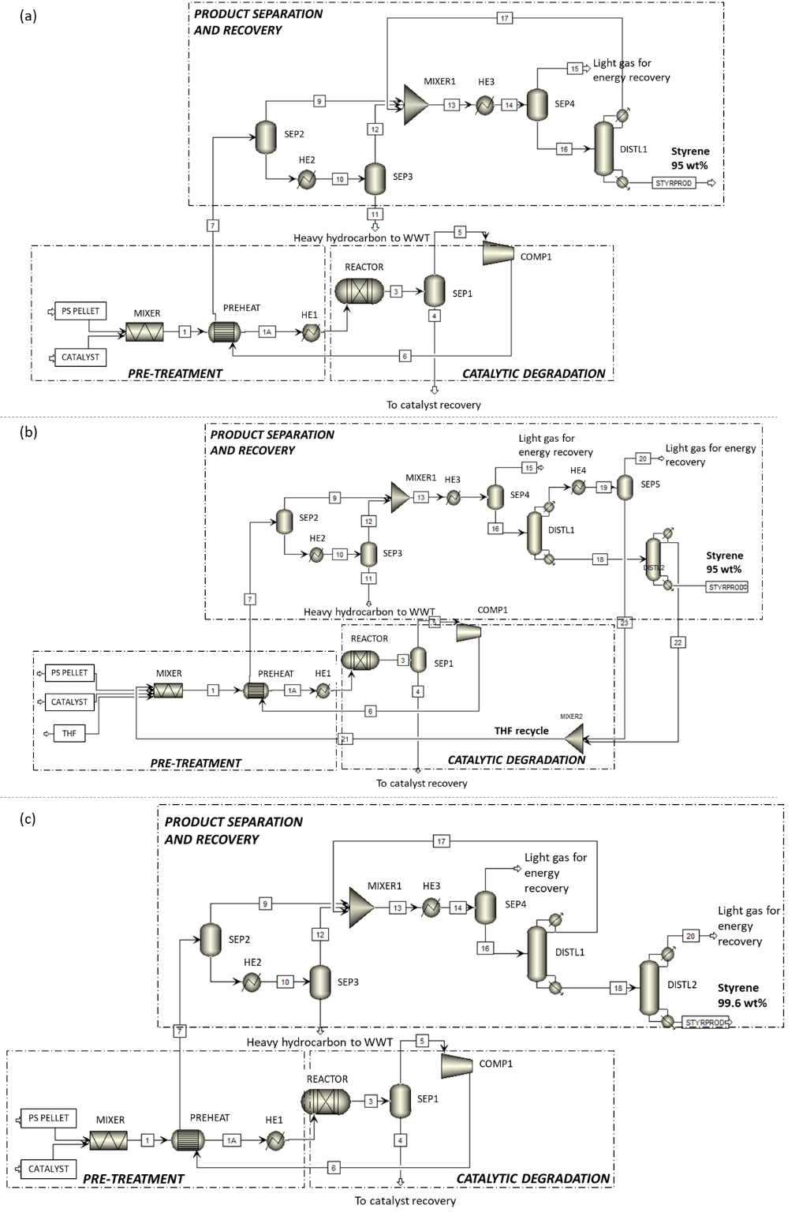
Figure 1: Process flowsheet of styrene monomer recovery from styrofoam waste through catalytic degradation for (a) Scenario 1, (b) Scenario 2, and (c) Scenario 3.
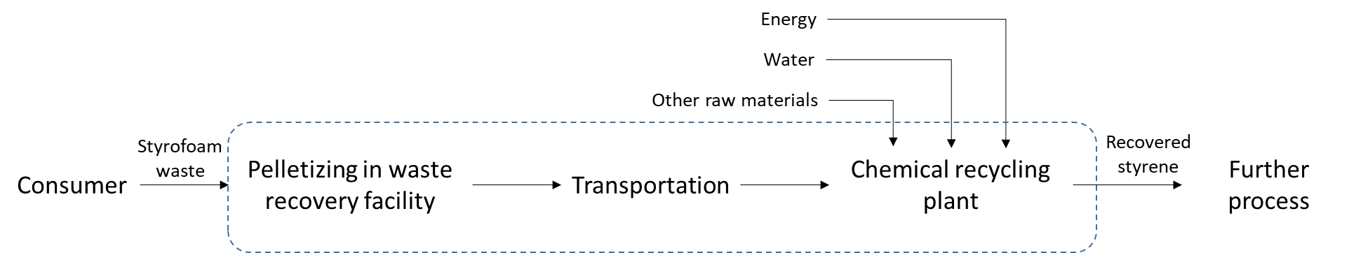

Figure 2: System boundary for LCA
  - Results
The mass and energy balance results from the process simulation are summarized in Table 2. It is evident from the table that Scenario 2 employs THF for dissolution. The optimal ratio between polystyrene and THF solvent is 0.5 to ensure complete dissolution of all polystyrene. Considering a 99% recycling rate, the required amount of THF stands at 3 kg/h. Additionally, with a ratio of 0.02 between catalyst and polystyrene pellets, the process requires a total of 6 kg/h of catalyst. As observed in the table, Scenario 1 demonstrates the highest yield among the scenarios. This can be attributed to the increased possibility of product loss in Scenarios 2 and 3 due to the presence of more separation equipment. Scenarios 2 and 3 necessitate more makeup water because additional columns require increased cooling water for the total condenser. Furthermore, Scenarios 2 and 3 require more steam to meet the heating requirements for the reboiler. The electricity is sourced from the grid, and the heat requirement is fulfilled by natural gas.
Table 2: Mass and energy balance for all scenarios
Parameter | Scenario 1 | Scenario 2 | Scenario 3
Feedstock
Polystyrene pellet (kg/h) | 300 | 300 | 300
THF (makeup) (kg/h) | - | 3 | -
Catalyst (kg/h) | 6 | 6 | 6
Products
Styrene monomer (kg/h) | 262 | 251 | 248
Utilities
Makeup water (t/h) | 13.38 | 36.89 | 87.01
Steam (t/h) | 0.11 | 0.28 | 0.88
Heat (MMBtu/h) | 0.075 | 0.22 | 0.075
Electricity (kW) | 53.25 | 53.44 | 54.37
The results of the economic analysis show the MSP of recovered styrene detailed in Figure 3 (a). The MSP for Scenario 1, 2, and 3 are $ 1.15/kg styrene, $ 1.40/kg styrene, and $ 1.52/kg styrene, respectively, with feedstock cost being the major contributing factor. The conventional styrene price ($ 0.93/kg styrene) is taken from IHS market (2021). It is evident that Scenario 1 offers the most competitive price in comparison to conventional styrene. However, Scenario 3, with a product purity of 99.6%, may have better market acceptance due to its equivalent purity to conventional styrene. The results of LCA are depicted in Figure 3 (b). As shown in the figure, all scenarios exhibit lower carbon emissions than conventional styrene, with a GWP result of 0.36 kgCO₂-eq/kg styrene, 0.57 kgCO₂-eq/kg styrene, and 0.54 kgCO₂-eq/kg styrene for Scenario 1, 2, and 3, respectively. Scenario 1 shows the lowest carbon emissions, accounting for 89% lower emissions compared to conventional styrene. Notably, the energy requirement contributes significantly to the carbon emissions of recovered styrene monomer from styrofoam waste.

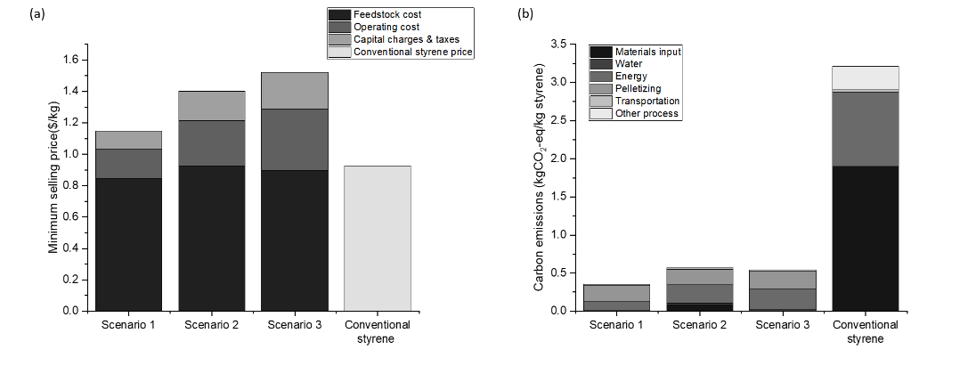
Figure 3: (a) The minimum selling price (MSP) breakdown and (b) carbon emissions breakdown of recovered styrene for all scenario relative to conventional styrene.
  - Conclusions
This study examined the recycling of styrofoam waste to recover styrene monomer using catalytic degradation to address environmental challenges linked to plastic waste. Demonstrated across three scenarios, varying in pre-treatment process and product purity, the TEA reveals Scenario 3, yielding an MSP of $ 1.52/kg styrene as the most viable option. This pricing aligns with conventional styrene monomer and have advantage similar purity, offering a solution to recycled material quality concerns. The LCA indicates that recovered styrene from styrofoam waste production across scenarios is more environmentally friendly than conventional styrene, with Case 1 showcasing an 89% reduction in GWP result at 0.36 kgCO₂-eq/kg styrene. Energy consumption during styrofoam waste recycling significantly contributes to carbon emissions, suggesting potential avenues for further reduction through renewable energy utilization and lower-temperature degradation catalyst development.
Acknowledgement
This research was supported by Basic Science Research Program through the National Research Foundation of Korea (NRF), funded by the Ministry of Science and ICT (2019R1A2C2084709 and 2021R1A4A3025742). This work was also supported by the Korea Institute of Energy Technology Evaluation and Planning (KETEP) and the Ministry of Trade, Industry & Energy (MOTIE) of the Republic of Korea (RS-2023-00233414).
References
D. Oh, H.W. Lee, Y.M. Kim, Y.K. Park, 2018, Catalytic pyrolysis of polystyrene and polyethylene terephthalate over Al-MSU-F, Energy Procedia, 144,111–117.
PlascticsEurope, Plastics-The Facts 2020: An analysis of European plastics production, demand and waste data, 2021.
R. Geyer, J.R. Jambeck, K.L. Law, 2017, Production, use, and fate of all plastics ever made, Science Advances, 3, 25–29.
R. Turton, R.C. Bailie, W.B. Whiting, J.A. Shaeiwitz, Analysis, Design and Synthesis of Chemical Processes, 2009.
X. Liu, L. Li, X. Song, F. Liu, S. Yu, X. Ge, 2016, Degradation of Polystyrene Using Base Modified Mesoporous Molecular Sieves K2O/BaO-SBA-15 as Catalysts, Catalytic Letters, 146, 1910–1916.

