Techno-Economic and Life Cycle Assessments of the Utilization of Carbon-Free Energy Sources as an Alternate Fuel in Naphtha Cracker
Eprillia Intan Fitriasariª, J. Jay Liu*ª
ªDepartment of Chemical Engineering, Pukyong National University, Busan 48513, South Korea
jayliu@pknu.ac.kr
Abstract
Ethylene, a key intermediate chemical in petrochemicals, is predominantly produced through naphtha cracking, requiring intense energy inputs at 800°C. This conventional process relies on methane and natural gas combustion, generating carbon emissions. As carbon-free energy sources, green ammonia and hydrogen are potential fuels to address this environmental issue. This study proposes using green ammonia and green hydrogen as alternative fuels in an existing naphtha cracker to cut carbon emissions in South Korea. The Aspen Plus software simulated the proposed processes, and a thorough techno-economic and life cycle assessment evaluated economic feasibility and environmental impact. Economic analysis identified additional production costs, while the life cycle assessment revealed reduced carbon emissions compared to the conventional process. Integrating economic and environmental results, a blend of 50% green hydrogen and 50% methane emerges as a potentially more economically viable solution, with a cost of avoiding carbon at $148.48/t CO₂.
Keywords: Decarbonization, green ammonia, green hydrogen, techno-economic analysis, life cycle assessments.
  - Introduction
In recent years, the global focus on decarbonizing industrial processes has intensified due to the escalating carbon emissions contributing to global warming and climate change. According to United States Environmental Protection Agency (U.S. EPA) (2021), industries account for 25% of carbon emissions, primarily from fossil fuel combustion. Thiel et al (2020) suggested various approaches to decarbonization, including the use of carbon-free fuels, upgraded heat distribution systems, electrification, and improved heat management technologies. Ethylene (C₂H₄) plays a crucial role as an intermediate chemical in the petrochemical industry worldwide. It is mostly manufactured via naphtha cracking, a process that consumes 26-31 GJ/t C₂H₄, with 65% of the energy focused on the furnace (Ren et al., 2006). This demand is conventionally met by burning methane, leading to carbon emissions. Gu et al (2022) conducted research on electrifying naphtha cracking furnaces to meet energy demand. However, electrification faces challenges, such as higher electricity costs and the need for significant upgrades in electricity transmission and distribution. To overcome these issues, we aim to decarbonize naphtha cracking plant in South Korea by introducing carbon-free fuels—imported green ammonia and domestically-produced green hydrogen. These fuels can directly substitute for fossil fuels without requiring substantial modifications to existing furnace infrastructure, offering a straightforward transition for industries reliant on traditional fuel sources. Additionally, they provide high energy density and easier storage compared to electricity in large-scale industrial operations. We conducted an evaluation focusing on economic performance, carbon emission reduction, and the cost of avoiding carbon across various case studies: Case 1 - utilizing methane (conventional naphtha cracking plant), Case 2a - 100% imported green ammonia, Case 2b - a blend of 50 vol% imported green ammonia and 50 vol% methane, Case 3a - 100% green hydrogen, and Case 3b - a blend of 50 vol% green hydrogen and 50 vol% methane.
  - Methods
    - Process Description
The feedstock for this study is naphtha from crude oil refinery. The composition of naphtha consists of n-Paraffins (36.13 wt%), isoparaffins (36.62 wt%), olefins (0.21 wt%), napthenes (21.06 wt%), and aromatics (5.98 wt%) following literature data (Zimmerman and Walzl, 2012). The design capacity for this study is 1,000,000 t/y of ethylene production. The annual feedstock requirement is approximately 3,019,397 t/y of naphtha with an expected 8,406 operating hours per year (96% plant availability). The naphtha cracking plant is modelled in the Aspen Plus V14 process simulator to investigate the material and energy balance for all cases. Peng-Robinson equation of state is used to describe the thermodynamic properties of the components.
- Case 1: Conventional naphtha cracking plant
Figure 1 illustrates the simplified process flow diagram of the naphtha cracking plant. The naphtha cracker furnace operates at 359.19 t/h of naphtha and 179.59 t/h of steam, achieving a 0.5 steam-to-naphtha ratio. Split into convection and radiation sections, the furnace preheats the feed in the convection zone without initiating reactions. The radiation section maintains an 800°C temperature and 1 atm, providing heat for cracking through fuel combustion, modeled in an RStoic reactor. Yield data is sourced from Zimmerman and Walzl (2012). After rapid quenching at 350°C, heavy hydrocarbons are removed using a primary fractionator, and further cooling eliminates residual heavy hydrocarbons. A multistage compression system raises gas pressure to 40 bar. At the intermediate compressor stage, a drying unit (molecular sieve column) and an acid gas removal unit (caustic wash unit) operate under high pressure. Refrigeration system drops the gas stream's temperature to -95°C. Distillation columns separate light fractions from heavy fractions, producing highly pure ethylene and propylene. Light gas are separated in the de-methanizer then directed to pressure swing adsorption to separate methane and hydrogen, with methane used as furnace and boiler fuel, and hydrogen directed to the deacetylenizer. The de-ethanizer separates acetylene, ethane, and ethylene, converted in the deacetylenizer to ethylene, further distilled via a C2-splitter. The de-propanizer purifies C3+ components, while the C3-splitter recovers valuable propylene. The debutanizer further separates C4 materials, C5 materials, and aromatics. A steam cycle integrated into the plant produces and distributes steam. Heat from the quenching process is used for feed steam and power generation.
- Case 2: Imported green ammonia
In Case 2, imported green ammonia serves as an alternative fuel to replace methane. The combustion of fuel is modeled in two scenarios: (a) 100 vol% green ammonia and (b) 50 vol% green ammonia+50 vol% methane. Any remaining methane is assumed to be marketed as byproduct. The imported green ammonia is assumed to be stored in a refrigerated ammonia storage vessel for 14 days. The tip of naphtha cracking furnace is modified to allow access of green ammonia as fuel. Green ammonia is combusted with excess air in the furnace. De-NOx unit is installed to remove the NOx emission from ammonia combustion. The De-NOx unit utilizes selective catalytic reduction (SCR) technology and is designed by assuming the amount of NOx on flue gas is 250 ppm. In this study, green ammonia is imported from Australia, with production and the transportation processes based on literature data (Akhtar et al., 2021). The transportation involves shipping the green ammonia from Western Australia to the Busan port in South Korea, covering a distance of 7,161 km using semi-refrigerated and fully refrigerated gas carriers. Upon arrival at the South Korea port, the green ammonia is transferred to the naphtha cracking plant via a 5 km pipeline.
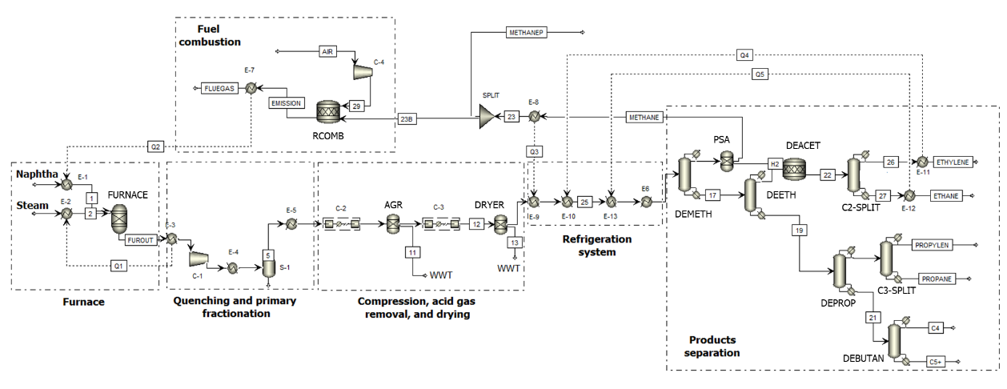
Figure 1: Process flow diagram of naphtha cracking plant
- Case 3: Green hydrogen
In Case 3, green hydrogen is employed as an alternative fuel. The green hydrogen is generated through water electrolysis powered by solar PV power plants at a centralized location in South Korea, following procedures outlined in literature (Akhtar et al., 2021). Fuel combustion is modeled in two scenarios: (a) 100 vol% green hydrogen and (b) 50 vol% green hydrogen+50 vol% methane. Any remaining methane is assumed to be sold as byproduct of the naphtha cracking plant. The produced green hydrogen is then transported via pipeline to the naphtha cracking plant, covering a distance of 100 km. The hydrogen is assumed to be stored in naphtha cracking plant using pressurized storage vessel at 700 bar with storing time 3 days.
    - Economic Analysis
Based on the process design and simulation, we can identify additional equipment and operating cost for Case 2 and Case 3. To calculate the capital expenditure (CAPEX) of additional equipment, the nth plant analysis was employed to perform the economic analysis of the process. CAPEX were determined by employing fundamental chemical engineering cost computation methods (CEPCI and scaling coefficients). Data from reference is used to calculate the additional operating cost (OPEX) based on the material and energy balance results. In Case 2, the additional CAPEX includes a furnace tip modification, estimated at 10% of the furnace price ($19.61 MM), a green ammonia storage vessel cost assumed at $0.81/kg NH₃ (Nayak-Luke at al., 2021), and a DeNOx unit costing $58.5 MM (Jiang et al., 2020). The OPEX of Case 2 encompasses additional costs of $0.609/kg for green ammonia (IHS Markit, 2023), $0.056/kg for shipping it from Australia to South Korea (Akhtar et al., 2021), $149/t NH₃/y for the refrigeration system (Nayak-Luke et al., 2021), and $0.491/t-flue gas for DeNOx operating costs (Jiang et al., 2020). In Case 3, the additional CAPEX comprises a furnace tip modification (10% of the furnace price, $19.61 MM) and green hydrogen vessel storage estimated at $460/kg H₂ (Nayak-Luke et al., 2021). For the OPEX of Case 3, an extra cost of $17.32/kg is required for green hydrogen (Akhtar et al., 2021).
    - Life Cycle Assessments
Life cycle assessment (LCA) represents a systematic method to assess a product's or process's environmental impacts within a specified system boundary. The LCA, conducted according to the ISO 14040/44:2006 standard methodology, encompassed the entire life cycle from cradle to gate. Life cycle impact assessment calculations were executed using SimaPro 9.4.0.2 software, employing the CML-IA baseline 3.07 method. Global warming potential (GWP) is selected as the representative impact category to calculate carbon emissions. Data used for LCA simulation was sourced from Ecoinvent v3.8 and other publications. According to Akhtar et al (2021), the GWP result for green ammonia and green hydrogen in South Korea are 0.144 kg CO₂-eq/kg NH₃ and 5.35 kgCO₂-eq/kg H₂, respectively. The functional unit considered was the production of 1 kg of ethylene. The system boundary is illustrated in Figure 2. The naphtha was assumed to be transported from petroleum refinery at a distance of 5 km. The life cycle inventory (LCI) of naphtha cracking center was obtained from process simulation results. The electricity generated in the process would be used internally in naphtha cracking plant. The co-products were allocated based on their mass.
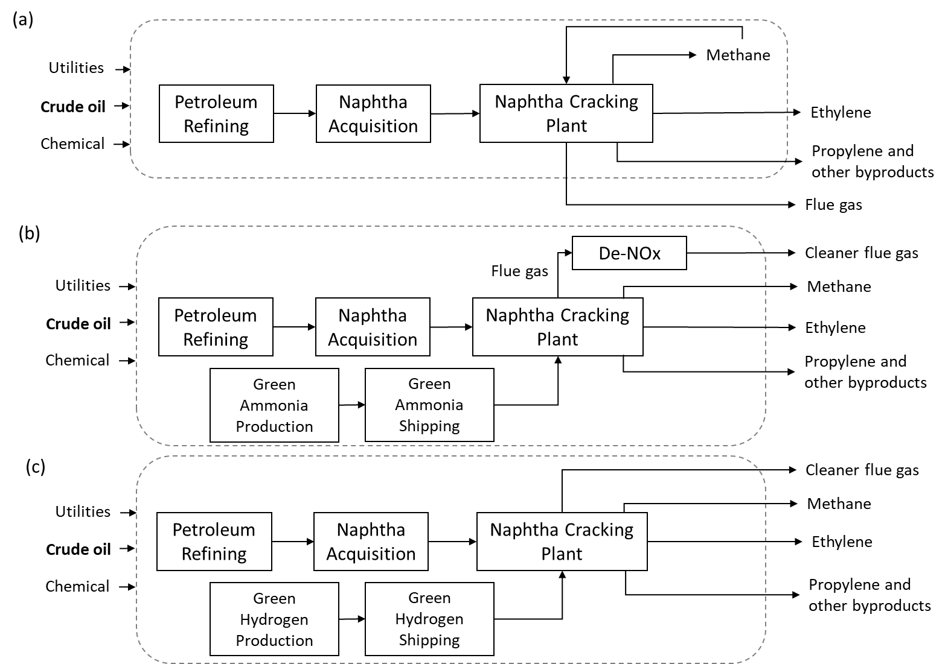
Figure 2: System boundary of cradle to gate LCA for naphtha cracking plant (a) Case 1, (b) Case 2, and Case 3.
    - Cost of Avoiding Carbon
To ensure cost competitiveness with the conventional 100% methane-based fuel naphtha cracking plant, the costs of avoiding carbon for Case 2a, Case 2b, Case 3a, and Case 3b were calculated using the following equation:
$$Cost of avoiding carbon= \frac{(Total annual additional cost/ethylene capacity)}{Carbon emissions of base case -Carbon emissions new case}$$ | (1)
To calculate the total annual additional cost, the additional CAPEX is divided by the plant’s life, assumed to be 30 years. The additional annual CAPEX is thereby determined. The total annual additional cost is then obtained by summing up the additional annual CAPEX and OPEX.
  - Results
Initially, the Aspen Plus software was used to develop the process simulation model for the standard naphtha cracking plant. Validation of this simulation involved comparing its results to data from a typical naphtha cracking plant (Ren et al., 2006). Ethylene and propylene are the primary products, accounting for 33.20% and 14.62% yields, respectively. The plant's total energy consumption stands at 3,546 GJ/h, with 64.8% consumed by the naphtha cracking furnace. Analyzing the furnace's energy needs helps determine the necessary alternative fuel amount for each case. Green hydrogen in Case 3 has the lowest flow rate among methane and green ammonia, owing to its higher heating value, while green ammonia exhibits the highest flow rate. In Case 2 and Case 3, any remaining methane, resulting from energy needs met by imported green ammonia and green hydrogen, is treated as a by-product. Electricity is generated in the plant and is assumed to be utilized internally. The major material and energy balance were described in Table 1.
Table 1: Major material and energy balance in naphtha cracking plant.
Parameter | Case 1 | Case 2a | Case 2b | Case 3a | Case 3b
Feedstock
Naphtha (kg/h) | 359,195 | 359,195 | 359,195 | 359,195 | 359,195
Product
Ethylene (kg/h) | 118,962.90 | 118,962.90 | 118,962.90 | 118,962.90 | 118,962.90
Propylene (kg/h) | 52,381.06 | 52,381.06 | 52,381.06 | 52,381.06 | 52,381.06
Methane (kg/h) | - | 56,801.95 | 42,601.46 | 56,801.95 | 45,441.56
Ethane (kg/h) | 13,204.01 | 13,204.01 | 13,204.01 | 13,204.01 | 13,204.01
Propane (kg/h) | 6,701.56 | 6,701.56 | 6,701.56 | 6,701.56 | 6,701.56
Butanes (kg/h) | 32,749.06 | 32,749.06 | 32,749.06 | 32,749.06 | 32,749.06
Fuel oil (C5+) (kg/h) | 77,481.61 | 77,481.61 | 77,481.61 | 77,481.61 | 77,481.61
Fuel consumption
Methane (kg/h) | 17,697 | - | 14,200 | - | 13,916
Green NH₃ (kg/h) | - | 65,000 | 13,878 | - | -
Green H₂ (kg/hr) | - | - | - | 7,374 | 1,595
Economic analyses were conducted to determine the additional unit ethylene production costs. Case 1 serves as the base case for the naphtha cracking plant. Figure 3 (a) displays the additional CAPEX and OPEX results for Case 2 and Case 3. In this comparison, Case 3a incurred the highest CAPEX, totalling $ 263.83 MM, while Case 3b has the lowest CAPEX at $ 72.44 MM. This significant difference is influenced by the quantity of green hydrogen consumed in Case 3a and Case 3b, as well as the high cost associated with hydrogen storage vessels. The economic analysis also indicates that Case 3a demonstrated the highest OPEX at $ 1,073.55 MM, whereas Case 2b demonstrated the lowest OPEX at $ 83.48 MM. The substantial difference arises from the considerably higher domestic-centralized production cost of green hydrogen, approximately 26 times more expensive than green ammonia. Figure 3(b) presents the LCA results for each case, revealing carbon emissions of 1.49 t CO₂-eq/t C₂H₄ for Case 1, 0.91 t CO₂-eq/t C₂H₄ for Case 2a, 0.99 t CO₂-eq/t C₂H₄ for Case 2b, 1.15 t CO₂-eq/t C₂H₄ for Case 3a, and 0.97 t CO₂-eq/t C₂H₄ ethylene for Case 3b. Notably, Case 2a emerges as the most environmentally friendly alternative, reducing carbon emissions by up to 0.58 t CO₂-eq/t C₂H₄. By integrating the economic analysis and LCA results, the cost of avoiding carbon were calculated. The result reveals that Case 2a, 2b, 3a, and 3b have cost of avoiding carbon at $ 640.31/t CO₂, $ 148.48/t CO₂, $ 3,187.51/t CO₂, and $ 464.11/t CO₂, respectively. The findings indicate that Case 2b has the lowest cost of reducing carbon emissions, positioning it as the most cost-effective strategy for reducing emissions among other cases.
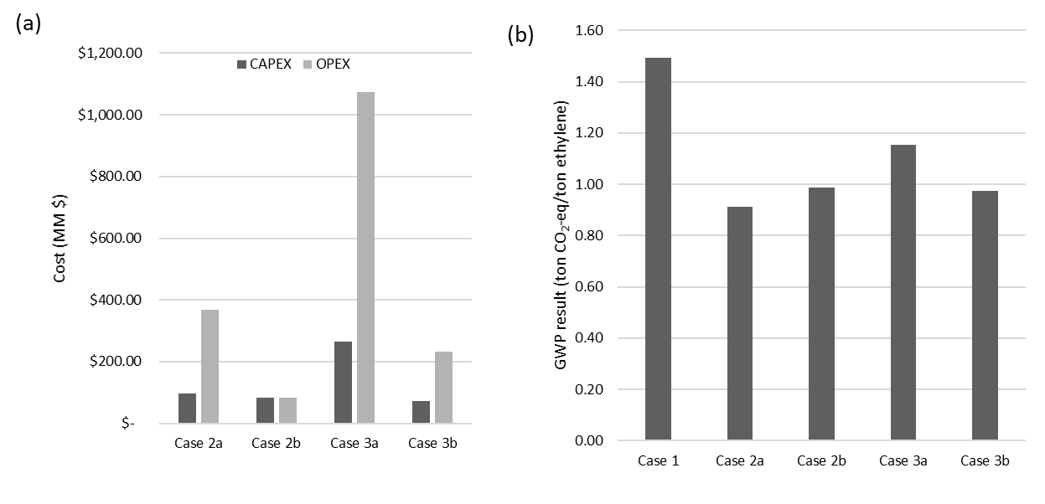
Figure 3: (a) Additional CAPEX and OPEX in Case 2 and Case 3, (b) GWP results of all cases.
  - Conclusions
In this study, we proposed green ammonia (Case 2) and domestic-produced green hydrogen (Case 3) as alternative fuels for decarbonizing a South Korean naphtha cracking plant. Alongside the conventional process (Case 1), each alternative had a 50 vol% fuel blending scenario. Using Aspen Plus, we modelled process designs to analyze material and energy balances, aiding techno-economic and LCA evaluations. The integration of economic analysis and LCA results facilitated the calculation of cost of avoiding carbon. Regarding the LCA results, all the proposed cases demonstrated the potential to reduce carbon emissions in naphtha cracking plant. Overall, considering the cost of avoiding carbon emissions, Case 2b emerges as a more cost-effective approach for curbing carbon emissions, suggesting its viability as a more economically sound solution for emission reduction. Future work aims to explore more decarbonization strategies for naphtha cracking plants.
Acknowledgements
This research was supported by Basic Science Research Program through the National Research Foundation of Korea (NRF), funded by the Ministry of Science and ICT (2019R1A2C2084709 and 2021R1A4A3025742). This work was also supported by the Korea Institute of Energy Technology Evaluation and Planning (KETEP) and the Ministry of Trade, Industry & Energy (MOTIE) of the Republic of Korea (RS-2023-00233414).
References
G.P. Thiel, A.K. Stark, 2021, To decarbonize industry, we must decarbonize heat, Joule, 5, 3, 531-550.
H. Zimmermann and R. Walzl, 2012, Ethylene, Ullmann’s Encyclopedia of Industrial Chemistry, Vol. 13, 465-529.
K. Jiang, H. Yu, L. Chen, M. Fang, M. Azzi, A. Cottrell, K. Li, 2020, An advanced, ammonia-based combined NOx/SOx/CO₂ emission control process towards a low-cost, clean coal technology, Applied Energy, 260, 2020, 114316.
J. Gu, H. Kim, H. Lim, 2022, Electrified steam cracking for a carbon neutral ethylene production process: Techno-economic analysis, life cycle assessment and analytic hierarchy process, Energy Conversion and Management, 270, 116256.
M.S. Akhtar, R. Dickson, H. Niaz, D.W. Hwang, J.J. Liu, 2021, Comparative sustainability assessment of a hydrogen supply network for hydrogen refueling stations in Korea-a techno-economic and lifecycle assessment perspective, Green Chemistry, 23, 9625-9639.
R.M. Nayak-Luke, C. Forbes, Z. Cesaro, R. Bañares-Alcántara, K.H.R. Rouwenhorst, 2021, Techno-Economic Aspects of Production, Storage and Distribution of Ammonia, Techno-Economic Challenges of Green Ammonia as an Energy Vector, Academic Press, 191-207.
T. Ren, M. Patel, K. Blok, 2006, Olefins from conventional and heavy feedstocks: Energy use in steam cracking and alternative processes, Energy, 31, 425–451.

