Digital Twins of Waste Particles for Waste Bulk Simulations
Karim Khodier,^{a*} Alisa Rizvanª
ªChair of Waste Processing Technology and Waste Management, Montanuniversitaet Leoben, Franz-Josef-Strasse 18, 8700 Leoben, Austria
karim.khodier@unileoben.ac.at
Abstract
Targets for reduced greenhouse gas emissions and mandatory future recycling rates, as defined in the European Union’s circular economy package require more effective and efficient (mechanical) waste treatment processes, and therefore a better understanding of the processes and affordable metrology for material flow monitoring. Digital twins of waste particles can make a significant contribution by enabling the calibration of more complex discrete element method simulations and the generation of artificial training data for vision-based monitoring. Concrete implementation concepts for these applications are presented in this work. Furthermore, first results on the generation of particle twins, the collection of reference data for intensive DEM properties, and the digitisation of particle geometries are discussed: the former still poses significant challenges, while the latter has already been successfully implemented for some test particles using photogrammetry.
Keywords: Digital twin, DEM, solid waste, mechanical processing, photogrammetry
  - Introduction
Approximately half of global greenhouse gas emissions are caused by the extraction of natural resources (Hellweg et al., 2019). Substituting them with recycled materials can significantly reduce these emissions (Kroell et al., 2023), with a current circularity rate of material use of only 11.5% in the European Union in 2022 (Eurostat, 2023).
The European Union aims to exploit the positive potential of recycling, having set gradually increasing mandatory recycling rates for particular waste streams, for example, a final rate of 65% for municipal waste in 2035 and 70% for packaging waste in 2030 (European Union, 2018). It thus contributes to the achievement of the United Nations (2023) Sustainable Development Goals (SDGs) 11, 12 and 13 (sustainable cities and communities, responsible consumption and production, climate action).
Achieving these increased recycling rates while ensuring economic viability and controlling the emissions from waste management (which itself is responsible for 3% of greenhouse gas emissions; state 2017, acc. Eurostat, 2020), requires more effective and more efficient treatment processes. Improving these processes requires better knowledge of the effects of process parameters (Khodier et al., 2021). This knowledge is still limited for mechanical processing – the first stage of solid waste treatment. Furthermore, approaches aiming at dynamic waste-adaptive processing, such as material-adaptive smart waste factories (Khodier et al., 2019) or digital twins of waste sorting plants (Kroell et al., 2023), require reliable and affordable metrology for material flow monitoring.
While there is an increasing number of empirical studies on mechanical waste processing machines (e.g., Khodier and Sarc, 2021; Küppers et al., 2021; Möllnitz et al., 2021), and material flow monitoring (cf. Kroell et al., 2022), simulation studies on this topic are scarce. One reason is the heterogeneity and diversity of waste particles, which limits simulation to bulk behaviour (Wissing et al., 2017) or specific waste fractions (Anglou et al., 2023).
However, the representation of waste particles in simulations – in the sense of digital twins – is desirable: it enables more sophisticated physical simulations, providing potentially valuable insights into processes that cannot be obtained from data-driven methods. It also enables simulation-based training data generation for machine learning-based metrology and process control.
This work depicts two application concepts, one for calibrating discrete element method (DEM) simulations and one for generating training data for machine learning-based material flow monitoring. Recent results on creating digital waste particle twins for these applications are also presented.
  - Discrete Element Method Calibration
Data-driven models are advancing in the mechanical treatment of solid waste, providing insights and predictions for these processes. While their potential is still being exploited (Sarc et al., 2019), some of their limitations are clear a priori: they cannot cover what is not in the data. Thus, they cannot provide information on machine geometries that have never been built or on plant configurations (in terms of selection and order of processing machines) that do not exist. Physical models, on the contrary, can do just that. And for particles processing, like mechanical waste treatment, DEM is the method of choice.
DEM simulations require calibration of the processed materials. Due to the complexity of this calibration (Coetzee, 2017), typically, only a few material classes are used or the bulk is calibrated as a whole and represented by spheres. This approach does not seem promising for the variety of waste particle shapes and their behavior – for example, on a screen. Representation of the variety of material classes, and particularly shapes, seems necessary. It is also likely to be computationally feasible, given the relatively large particle sizes in waste mechanical waste processing (greater than 30 to 60 mm for many processing steps) and the relatively low particle numbers compared to, for example, powder processes.
The challenge is to collect information on the variety of particles in a waste stream for model calibration. A machine learning-assisted approach has been conceptualised (Figure 1) and is being investigated (Khodier et al., 2023). The idea is to predict particle geometries (e.g., using the Pixel2Mesh approach, Wang et al., 2018) and DEM parameters (e.g., Young’s modulus, friction coefficients) from sensor measurements (e.g., RGB, near-infrared, laser-triangulation, induction) of a monolayer of singled particles, comparable to the situation on a sensor-based sorter, using suitable infrastructure, like the Digital Waste Research Lab at the Chair of Waste Processing Technology and Waste 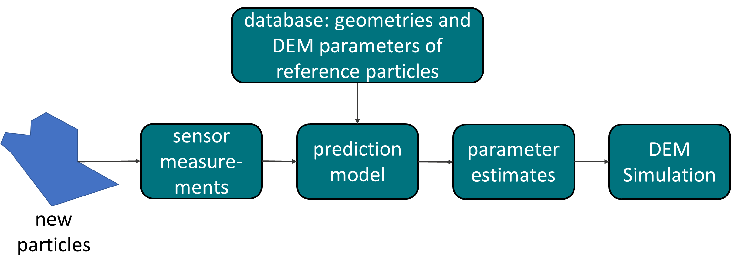
Figure 1: DEM calibration workflow for new particles (Khodier et al., 2023)
Management, Montanuniversitaet Leoben (2023). They can then be used immediately in simulations. The prediction is based on a database of intensive DEM parameters and geometries of known reference particles.
  - Machine Learning-based Material Flow Monitoring
Information on the state of the processed materials at different positions in the processing plant is essential for understanding the processes and their parameters’ influences and for developing plants towards dynamic control and utilising digital twins.
To date, the characterisation of material classes is often done using near-infrared sensors (e.g., for polymers, Kroell et al., 2022). However, these sensors are too expensive to justify positioning one for each stream within the plant. In addition, they only see the surface of multilayered bulk materials on transport belt conveyors and hence only provide surface composition data. Therefore, machine learning-based material flow monitoring, using much cheaper RGB cameras, and training the models with bulk mass composition information is desirable. However, current studies focus mainly on spectroscopy (e.g., Zinchik et al., 2021) and applications to monolayers of singled particles (e.g., Kandlbauer et al., 2021).
A fundamental obstacle for bulk applications that aim to predict the mass composition of the bulk, rather than just the surface, is the accessibility of reliable training data. While capturing an image – the features in a machine learning model – is already feasible, providing trustworthy labels, in terms of mass composition, that match the bulk below the surface visible in the image is challenging: there are no reference sensors for this. And extracting matching increments of waste streams for manual analysis is difficult (cf. Khodier et al., 2019), let alone doing so tens or hundreds of thousands of times per measurement position to satisfy the data hunger of deep learning models.
A digital training data generation concept (Figure 2) was therefore developed, again using waste particle twins. In this case, geometry, optical texture, and particle mass information are required. These twins are used in a simulation environment for generating digital bulks in twins of actual measurement setups – e.g., on a belt conveyor. In contrast to DEM simulations, a physics engine (currently in Blender) is used to reduce the computational effort for the multitude of runs (generating many training data rows) and keep texture information to obtain realistic feature sets. The loss in modelling accuracy, compared to a DEM simulation, is assumed to be negligible since realistic bulks but not realistic bulk behaviour simulations are required.
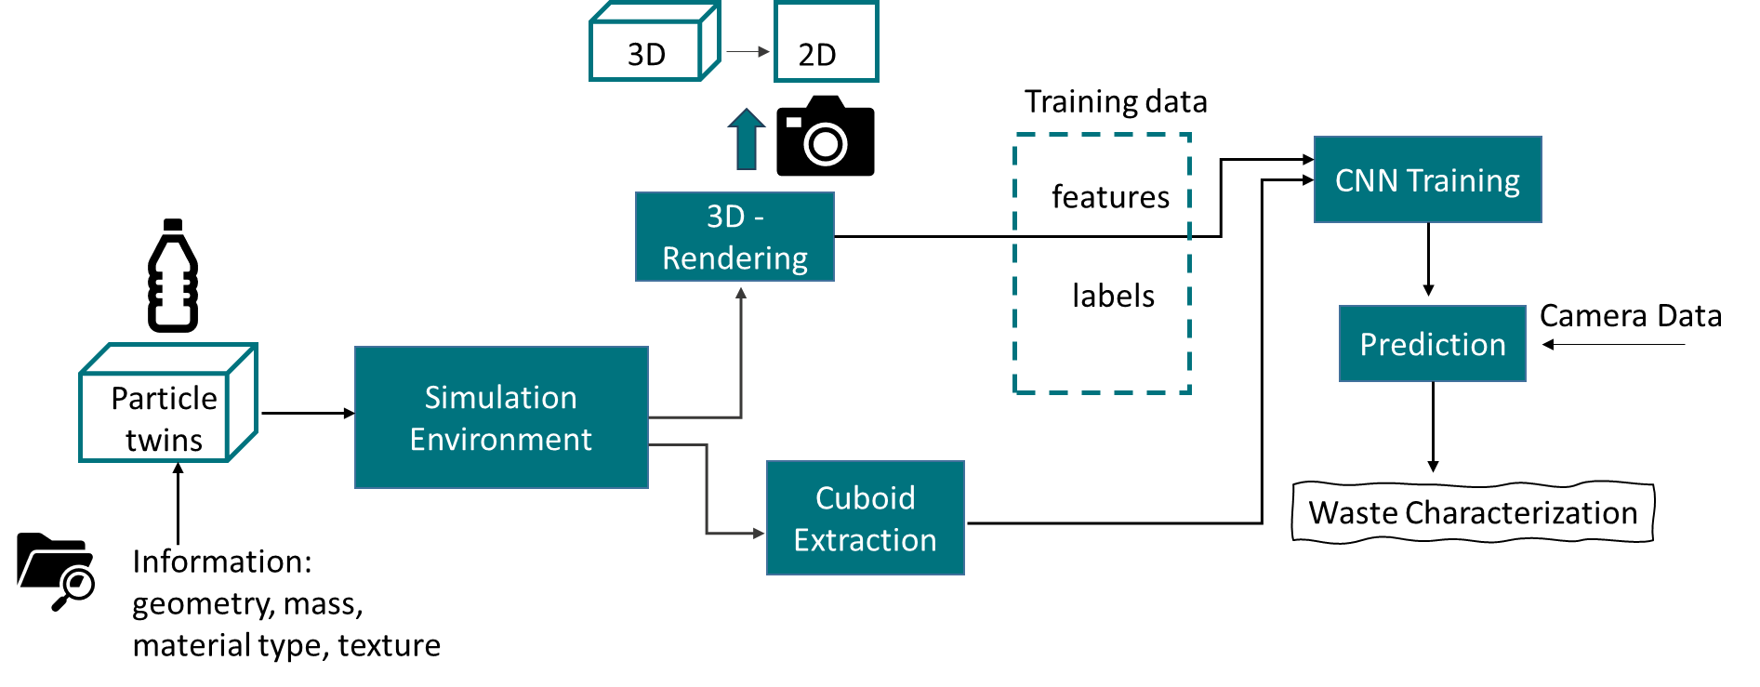
Figure 2: Concept for simulation-based training data generation for material flow monitoring

From these digital bulks, features are extracted by digitally photographing 3D renderings created in the simulation environment. Labels are also obtained by capturing the mass composition within the virtual cuboid under the virtual camera. These feature-label pairs are then used to train a Convolutional Neural Network (CNN) to predict mass composition in real measurement situations.
  - Results and Discussion on the state of Particle Twin Generation
Digitising information about the mass and material type of a particle is trivial. Therefore, research has focused on obtaining information on the intensive DEM parameters of reference particles and digitising particle geometries.
The first approach was to use bulk calibration methods, such as static and dynamic angle of repose (cf. Coetzee, 2017), using different subsets of a total batch of reference particles, and calibrating the intensive particle DEM parameters so that the simulated angles match experimental ones for all subsets. In practice, the entanglement of the waste particles – which causes them not to behave as typical bulk – resulted in unclear angles in the experiments (Figure 3).
Therefore, a new approach has been defined, which is still under evaluation: separation experiments, e.g., drum screening, are performed several times with all reference particles. Their intensive DEM parameters are then calibrated so that the probability of each particle ending up in one or the other fraction (here: coarse or fine fraction) is the same in the experiments and the simulations.
    - Particle Geometries
A method for digitising particle geometries – including their texture – has been successfully developed using photogrammetry: 40–50 partially overlapping photos of the particle are taken from different positions around and from above the particle (Figure 4 left). The particle is turned over, and another set of photos is taken. From each set, a model (with a flat bottom) is created in Autodesk Recap Photo, with the size adjusted based on a manual length measurement along one axis, that yields an accuracy of ±5 mm for the other two axes. The resulting two models are then merged into one particle model in Blender. For DEM simulations, the particle meshes are then imported into a DEM simulation environment. In this study, Ansys Rocky was used.
The method has worked well for the first test objects (see Figure 4 right). Well-lit objects with clear contours and simple geometries work better, while more complex objects in terms of geometry, gloss and transparency – such as a deformed PET bottle – still pose a challenge.
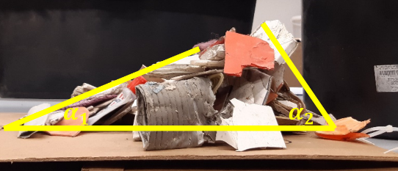
Figure 3: Static angle of repose test with two possible angle interpretations

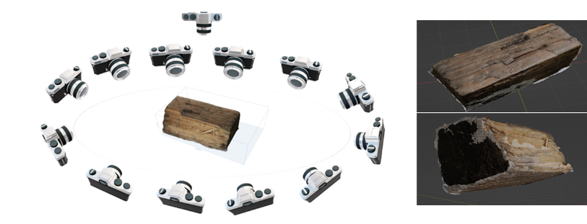
Figure 4: Schematic representation of the camera positions for photogrammetry (left) and a particle 3D model from two perspectives (right)
  - Conclusion and Outlook
The determination of the intensive DEM parameters is still an open question. Here, the presented updated approach, which is based on the probability of the particles ending up in a particular output stream, is examined next. This requires the digitisation of a sufficiently large amount of particle geometries, which is in progress. In addition, a study of the sensitivity of DEM results to particle mesh resolution is underway to enable informed decisions to be made about on the investment of computational costs. Also, once a large number of particle geometries are available, tests on predicting new particles’ geometries using an artificial neural network are planned.
Concerning the training data generation for material flow monitoring, first artificial bulks have been created in Blender. Work is currently focused on extracting the labels (the material composition in the imaginary cuboid under the photographed surface). A study has also just started on predicting the mass and volume of particles from singled particle streams, based on training data generated using digital waste twins.
In conclusion, the variety of promising application scenarios for digital twins of waste particles is huge, while much research is still needed to bring them to market.
Acknowledgements
Partial funding for this work was provided by the project Calibration of Discrete Element Simulation Models using Particle Sensor Data and Artificial Intelligence – acronym KalKIDEM – funded by the office of the regional government of Styria within UFO – Unconventional Research.
Partial funding for this work was also provided by: The Center of Competence for Recycling and Recovery of Waste for Future (acronym ReWaste F) (contract number 882 512) under the scope of the COMET – Competence Centers for Excellent Technologies – financially supported by BMK, BMAW and the federal state of Styria, managed by the FFG.
References
E. Anglou, Y. Chang, A. Ganesan, S. Nair, C. Sievers, F. Boukouvala, 2023, Discrete element simulation and economics of mechanochemical grinding of plastic waste at an industrial scale, Computer Aided Chemical Engineering (52), doi: 10.1016/B978-0-443-15274-0.50382-6
C.J. Coetzee, 2017, Review: Calibration of the discrete element method, Powder Technology (210), doi: 10.1016/j.powtec.2017.01.015
European Union, 2018, Directive (EU) 2018/851 of the European Parliament and of the Council of 30 May 2018 amending Directive 2008/98/EC on waste.
Eurostat, 2020, Greenhouse gas emissions from waste, https://ec.europa.eu/eurostat/web/products-eurostat-news/-/DDN-20200123-1
Eurostat, 2023, Circular Economy – material flows, https://ec.europa.eu/eurostat/statistics-explained/index.php?title=Circular_economy_-_material_flows (accessed 22/11/2023)
S. Hellweg, S. Pfister, L. Cabernard, H. Droz-Georget, A. Foemelt, M. Haupt, J. Mehr, C. Oberschelp, E. Piccoli, T. Sonderegger, A. Sudheshwar, C. Walker, Z. Wang, 2019, Environmental Impacts of Natural Resource Use, Global Resources Outlook 2019, pp. 64–97, ISBN: 978-92-807-3741-7
L. Kandlbauer, K. Khodier, D. Ninevski, R. Sarc, 2021, Sensor-based particle size determination of shredded mixed commercial waste based on two-dimensional images, Waste Management (120), doi: 10.1016/j.wasman.2020.11.003
K. Khodier, A. Curtis, R. Sarc, M. Lehner, P. O’Leary, P. Pomberger, 2019, Smart solid waste processing plant: vision and pathway, proceedings of the 29th ISWA world congress, Bilbao, 7th-9th October 2019.
K. Khodier, C. Feyerer, S. Möllnitz, A. Curtis, R. Sarc, 2021, Efficient derivation of significant results from mechanical processing experiments with mixed solid waste: Coarse-shredding of commercial waste, Waste Management (121), doi: 10.1016/j.wasman.2020.12.015
K. Khodier, R. Sarc, 2021, Distribution-independent empirical modeling of particle size distributions – coarse-shredding of mixed commercial waste, Processes (9/3), doi: 10.3390/pr9030414
K. Khodier, A.L. Krabichler-Mark, I. Werner, A. Rizvan, Y. Varsh, 2023, Efficient calibration of discrete-element-method simulations for waste applications using particle sensor data and artificial intelligence, proceedings of the 19th international symposium on waste management and sustainable landfilling, Sardinia, 9th–13th October 2023.
N. Kroell, C. Xiaozheng, K. Greiff, A. Feil, 2022, Optical sensors and machine learning algorithms in sensor-based material flow characterization for mechanical recycling processes: A systematic literature review, Resources, Waste Management (149), doi: 10.1016/j.wasman.2022.05.015
N. Kroell, A. Maghmoumi, T. Dietl, X. Chen, B. Küppers, T. Scherling, A. Feil, K. Greiff, 2023, Towards digital twins of waste sorting plants: Developing data-driven process models of industrial-scale sensor-based sorting units by combining machine learning with near-infrared-based process monitoring, Resources, Conservation & Recycling (200), doi: 10.1016/j.resconrec.2023.107257
B. Küppers, I. Seidler, G. Koinig, R. Pomberer, D. Vollprecht, 2020, Influence of throughput rate and input composition on sensor-based sorting efficiency, Detritus (9), doi: 10.31025/2611-4135/2020.13906
S. Möllnitz, B. Küppers, A. Curtis, K. Khodier, R. Sarc, 2021, Influence of pre-screening on down-stream processing for the production of plastic-enriched fractions for recycling from mixed commercial and municipal waste, Waste Management (219), doi: 10.1016/j.wasman.2020.10.007
Montanuniversitaet Leoben, 2023, Digital Waste Research Lab, https://www.avaw-unileoben.at/de/forschung-geraete_und_technikum-digital_waste_research_lab/ (accessed 23/11/2023)
R. Sarc, A. Curtis, L. Kandlbauer, K.E. Lorber, R. Pomberger, 2019, Digitalisation and intelligent robotics in value chain of circular economy oriented waste management – A review, Waste Management (95), doi: 10.1016/j.wasman.2019.06.035
United Nations, 2023, The sustainable development goals report: special edition, ISBN: 978-92-1-101460-0
N. Wang, Y. Zhang, Z. Li, Y. Fu, W. Liu, Y.-G. Jiang, 2018, Pixel2Mesh: Generating 3D mesh models from single RGB images, Computer Vision – ECCV 2018
F. Wissing, S. Wirtz, V. Scherer, 2017, Simulating municipal solid waste incineration with a DEM/CFD method – Influences of waste properties, grate and furnace design, Fuel (206), doi: 10.1016/j.fuel.2017.06.037
S. Zinchik, S. Jiang, S. Friss, F. Long, L., Høgstedt, V.M. Zavala, E. Bar-Ziv, 2021, Accurate characterisation of mixed plastic waste using machine learning and fast infrared spectroscopy, ACS Sustainable Chemistry & Engineering (9), doi: 10.1021/acssuschemeng.1c04281

