Dynamic model of the esterification reaction with disappearing second liquid phase
Volodymyr Kozachynskyi^{a*}, Dario Staubachª, Erik Escheª, Lorenz T. Biegler^{b}, Jens-Uwe Repkeª
ªTechnische Universität Berlin, Process Dynamics and Operations Group, Berlin, Germany
^{b}Chemical Engineering Department, Carnegie Mellon University, Pittsburgh, PA 15213, USA
*volodymyr.kozachynskyi@tu-berlin.de
Abstract
Modeling of appearance and disappearance of liquid phases is a challenging task. Methods that predict the phase dis-/appearance in steady state models are usually based on minimization of Gibbs free energy. When such methods are not applicable, graphical methods can be used. These commonly use different modes and switches, which are not supported by most dynamic system solvers. In this work we propose a reformulation of an existing graphical modelling approach that does not require any integer variables or equation switches. The smoothed formulation is used to model an esterification reaction in a batch reactor with liquid phase dis-/appearance. Suggested reformulation of the liquid phase dis-/appearance is robust and can be used with any differential algebraic equation solver.
Keywords: Phase Dis-/Appearance, Liquid-Liquid Equilibria, Dynamic Modelling
  - Introduction
Appearance and disappearance of phases is a challenging aspect for modeling in many chemical engineering applications, particularly of interest for start-up, shutdown or change in operation points of distillation, extraction, and multiphasic reactive systems. There exist different ways to model a dynamic process with vapor-liquid equilibria (VLE) where phases can appear or disappear. Most methods are based on Gibbs free energy minimization, such as the relaxed Karush-Kuhn-Tucker (KKT) approach (Gopal and Biegler, 1999) and usually require solution of an optimization problem to find phase configuration and compositions.
However, whenever a second liquid phase is of interest, as in liquid-liquid (LLE) or vapor-liquid-liquid equilibria (VLLE), Ploch et al. 2018 showed that the KKT approach is not always applicable. They proposed their own hybrid continuous model, which can be categorized as a graphical based approach (Guo et al., 2004). Their modeling approach requires a solver that can handle continuous and discrete variables, a feature, that is not supported by most integrators of differential equations. An LLE formulation without discrete variables is the focus of this contribution.
  - Methodology
To apply a standard differential algebraic equation (DAE) solver in simulation of a dynamic system, the new, reformulated equation system should consist only of continuously differentiable nonlinear equations. The originally proposed method (Ploch et al., 2019) can be described by an upper and a lower automaton and thus represents a hybrid system. The upper automaton serves as a switch between one and two existing phases. In the lower automaton, the location of the coexisting phase is constrained to one of four possible modes. Contrary to the original formulation, the upper automaton is implemented using complementary conditions (Gopal and Biegler, 1999) with a smoothed maximum function (Eq. 1, Eq. 2) and the lower automaton is reformulated as a nested smoothed minimum function (Eq. 3) (Chen and Mangasarian, 1996).

$$β=\left(σ_{1}-σ_{2}\right), σ_{1}=max⁡(0, σ_{1}-σ_{2})$$ | (1)
$$smoothmax\left(x,y,ϵ\right)=\frac{x+y- \sqrt{{(x-y)}^{2}+ϵ^{2}}}{2}$$ | (2)
$$smoothmin\left(x,y,ϵ\right)=\frac{x+y+ \sqrt{{(x-y)}^{2}+ϵ^{2}}}{2}$$ | (3)

where $σ_{1}$ and $σ_{2}$ are two modes that cannot be active at the same time, $β$ is a switching variable indicating existence of a second phase by its sign, and $ϵ$ is a smoothing parameter.
  - Results
To test the new formulation, it is used as a part of a dynamic model that describes the esterification reaction of 1-propanol in batch operation mode. When the reaction is started from the product side, with only water and propyl acetate, a second, water-rich liquid phase exists. After some time, during the hydrolysis reaction 1-propanol and acetic acid are produced, and the second phase disappears. In Figure 1 the simulated trajectory as described above is presented. At the start of the reaction, water and ester separate into two liquid phases, water concentration of both phases is shown as dashed lines. During first four hours 1-propanol and acetic acid are generated, so the height of the second phase start to decrease. After four hours, the second, water-rich liquid phase disappears.
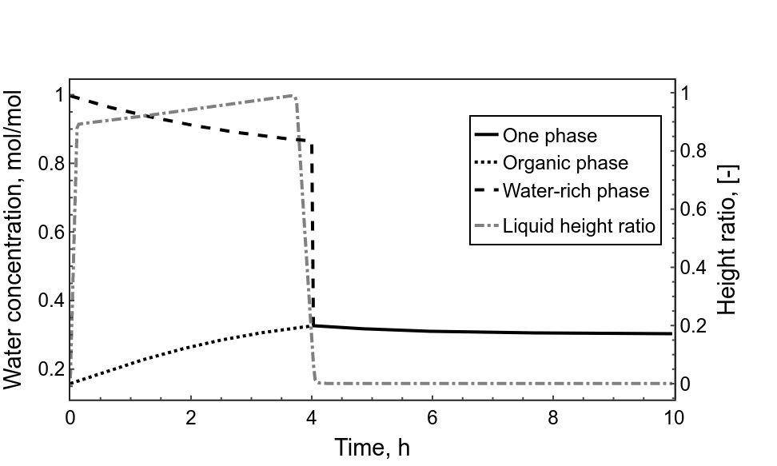
  - Conclusions
Figure 1: Change of water concentration and liquid height ratio over time
Different modelling methods for liquid phase dis-/appearance exist, each having their own advantages and disadvantages. In this work a fully smoothed reformulation of an existing method is proposed. Contrary to the original method, smoothed mode switches can be directly used as part of a system of differential-algebraic equations (DAEs). The dynamic model with phase dis-/appearance is at least once continuously differentiable and can be solved by most DAE solvers. Real experiments are planned to validate the model of the esterification reaction with phase dis-/appearance by comparing the predicted and the measured liquid height ratio of two separated liquids.
Acknowledgement: Funded by the Deutsche Forschungsgemeinschaft (DFG, German Research Foundation) – 466397921.
References
Chen, C., Mangasarian, O.L., 1996. A class of smoothing functions for nonlinear and mixed complementarity problems. Computational Optimization and Applications 5, 97–138. doi:10.1007/BF00249052.
Gopal, V., Biegler, L.T., 1999. Smoothing methods for complementarity problems in process engineering. AIChE Journal 45, 1535–1547. doi:10.1002/aic.690450715.
M. Guo, S. Wang, J.-U. Repke, and G. Wozny, “A simultaneous method for two‐ and three‐liquid–phase stability determination,” AIChE Journal, vol. 50, no. 10, pp. 2571–2582, Sep. 2004, doi: 10.1002/aic.10256.
T. Ploch, M. Glass, A. M. Bremen, R. Hannemann-Tamás, and A. Mitsos, “Modeling of dynamic systems with a variable number of phases in liquid-liquid equilibria,” AIChE Journal, vol. 65, no. 2, pp. 571–581, Nov. 2018, doi: 10.1002/aic.16447.

