Comparative Assessment of Flexible Natural Gas Monetisation Processes to Products Under Uncertainties: Agent-Based Modelling Approach
Noor Yusuf,ª Ahmed Al-Nouss,ª Tareq Al-Ansari^{a*}

ªCollege of Science and Engineering, Hamad Bin Khalifa University, Qatar Foundation, Doha 34110, Qatar
Talansari@hbku.edu.qa
Abstract
With the increased demand for cleaner energy resources, natural gas is a bridging fuel for smoothening the transition to renewables. Power, liquified natural gas (LNG), ammonia, and urea have attracted significant attention among the various monetisation routes. The different monetisation routes differ regarding production technologies, associated energy and utilities requirements, released emissions, and operational flexibility. Despite the estimated demand growth in product demand, each natural gas monetisation process is subject to exogenous market uncertainties. This work evaluates the flexibility of natural gas monetisation processes to LNG, ammonia, urea, and power by investigating plant design configurations and natural gas production allocation to different production routes. The commercial software Aspen HYSYS is used for process modelling and simulation, followed by identifying the operational flexibility of each process. The simulation results and forecasted price and demand data are then used as input into an agent-based model to identify the optimal annual natural gas allocation to different processes subject to environmental and economic objectives. Overall, the study provides decision-makers with a systematic approach to evaluate the effectiveness of flexible natural gas allocation to different processes based on technical, economic, and environmental aspects. The results of Qatar’s case study demonstrate the importance of prioritising Power and LNG production to maximise profitability and hedge against risks. On the other hand, ammonia production is maximised to offset environmental emissions and tackle CO₂ emissions.
Keywords: Natural gas, Agent-Based Modelling, Uncertainties, Operational Flexibility.
  - Introduction
Since 2020, the countries involved in the multilateral process after the Paris Agreement for climate change have been submitted national climate action plans, reflecting the timeline of actions taken to tackle emissions, including switching from coal to natural gas and increasing share for renewables. Hence, countries with abundant natural gas reserves must consider the needs of different markets when planning natural gas supply chains. Raw natural gas can be physically or chemically monetised into value-added products to enhance the economic value of natural gas when targeting international markets. Amongst the different investigated natural gas monetisation routes, liquified natural gas (LNG), compressed natural gas (CNG), synthetic fuels produced via gas-to-liquids process (GTL), methanol, ammonia, and ethylene have proved to have significant interest in the international markets, supported by industrial, transport, agricultural, and household needs. The selection of monetisation routes is a strategic decision-making problem that involves multiple parameters, including the geographic location of the natural gas field (i.e., onshore or offshore), the composition of produced natural gas, the climate of the producing country, the distance to the targeted markets, and the demand in final markets.

To meet the increased demand for natural gas, producing countries proactively responded by assessing the feasibility of expanding new natural gas projects or deploying new ones. Yet, market shifts supported by demand fluctuations due to changes in market preferences and the emergence of decarbonisation policies had jeopardised the expansion of projects, especially during the COVID-19 pandemic, when the growth of fossil-based commodities declined dramatically. From another perspective, renewables have attained attention in the last few years, supported by decarbonisation and diversification objectives. For example, European countries accelerated the efforts to switch to renewable resources for power generation after the Russian-Ukrainian conflict. This raises the importance of operational flexibility in energy management so that producing countries can proactively react to market changes. In addition to sustaining economic profitability, operational flexibility allows natural gas-producing companies to meet environmental targets and utilise resources effectively. In the literature, operational flexibility for single-product natural gas systems has been explored intensively at a process-based level by evaluating the acceptable system operating boundaries at fixed equipment sizes (Bhosekar & Ierapetritou, 2020; Verleysen et al., 2021; Yusuf et al., 2022). Yet, a gap has been identified in exploring how different flexible production systems react in an integrated multi-product natural gas supply chain. This study builds on previous work by Yusuf et al., (2023) by investigating the optimal annual natural gas capacity to four monetisation routes using agent-based modelling: power, LNG, ammonia, and urea, subject to technical, economic, and environmental aspects. Hence, this work provides decision-makers with a holistic approach to assessing the optimal natural gas allocation strategy.
  - Methodology and Data
The model built as part of this study includes an agent-based model (ABM) to undertake sustainable planning in Qatar's energy sector. The developed framework is a decision-making tool that enables the prediction of portfolio decisions for the downstream natural gas industry as a response to meet rapidly changing demand. The advantage of production flexibility allows the evaluation of natural gas allocation based on economic and environmental scenarios.

2.1 ABM simulation
An agent is a self-contained unit with a set of characteristics and behaviours. Particular rules govern its interactions with other agents and the environment in which it resides (Lopez-Jimenez et al., 2018). In this study, two major groups of agents interact to meet the demand for LNG, power, ammonia and urea while adhering to economic and environmental limitations. The proposed ABM model replicates the yearly choices of the energy sector over a period of 34 years (n=34), with the primary agent, represented by the natural gas generating system NG, interacting with Di, i$ϵ$D, where D is the set of downstream industries. Both agents interact in response to the local and global economy.

Table 1: Characteristics of agents.
Agent | Attributes | Behaviours
NG system (NG) | - Total NG capacity C (billion cubic meters-BCM).  - Yearly NG distribution capacities Cng (BCM)  - Yearly NG allocation to Power Qp, LNG Qn, Ammonia Qa, and Urea Qu.  - Global Warming Potential from generating each product (kg CO₂–eq) | - Allocate NG to Power (p), LNG (n), Ammonia (a), and Urea u.
Downstream Industries (Di) | - Yearly production capacities Q_{Di} (kg)  - Yearly power local demand Pi (kWh) | - Determine the best production sinks (S).

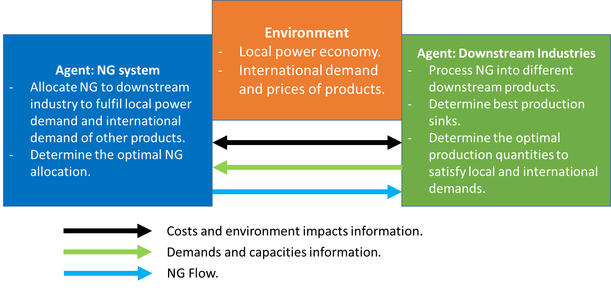
Figure 1: Representation of ABM elements.

2.1.1 Agents
Agent: NG System
The natural gas system NG is the model's central element because it is the agent that ensures the allocation of yearly extracted NG capacities Cng. To accomplish this goal, the NG grid allocates NG to 4 sinks: LNG, power, ammonia and urea, so that the total grid capacity C is allocated. The sink is selected using one of two strategies: 1) allocate NG to satisfy local power production demand (p) or 2) find the optimal allocation of NG to LNG (n), Ammonia (a), and Urea u based on international demands. Each decision is influenced by the economic and environmental factors discussed in section 3 and the operations and characteristics associated with the downstream industries Di.

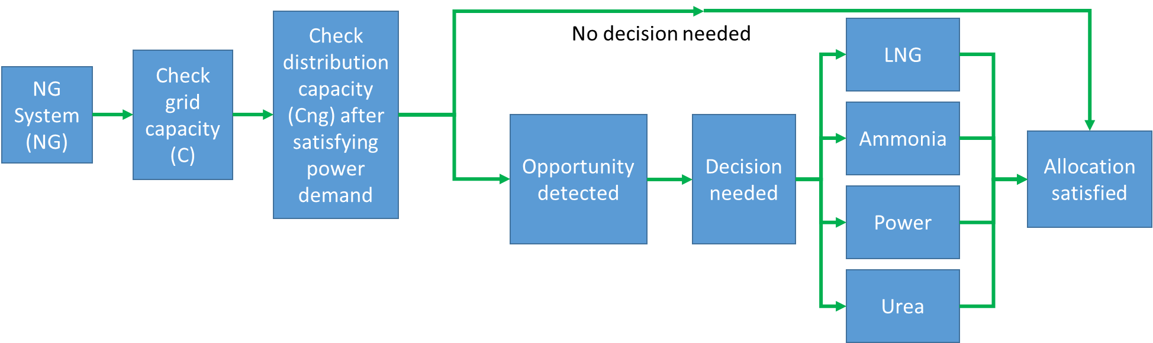
Figure 2: NG system behavior.

Agent: Downstream Industries System
This analysis considers four downstream industries as agents Bi, including LNG, ammonia, power and urea production. As part of their behaviour, power is satisfied first based on the local demand. Then, the ideal NG allocation blend to the downstream industries sink is identified. The amounts allocated from the NG grid to downstream industries are determined by the yearly production capacity of each industry Di, power local demand Pi, and minimum flexibility production of each industry Dmin. Figure 3 demonstrates the downstream industries system behaviour.
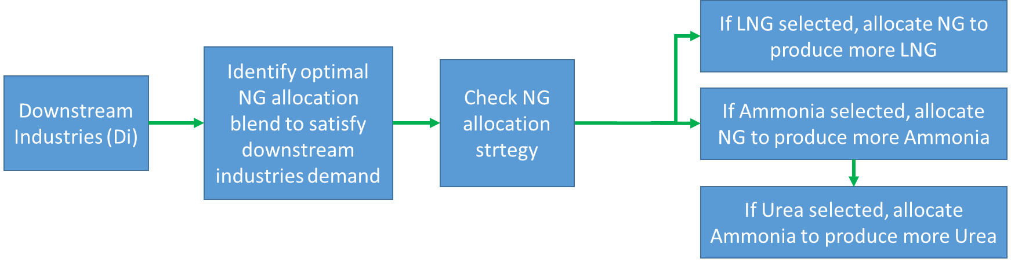
Figure 3: Downstream industries system behaviour.

To analyse the performance of NG and Di, economic EC and environmental EI indicators for each strategy are computed at each time step n using the following equations (1-4):

Strategy (NG):
$EC= Q_{i,NG}×$ $c_{i,NG}$ where $i= p \left(Power\right), n \left(LNG\right), a \left(Ammonia\right), and u (Urea)$ (1)
$EI=Q_{i,NG} ×$ $e_{i,NG}$ where $i= p \left(Power\right), n \left(LNG\right), a \left(Ammonia\right), and u (Urea)$ (2)
such that $Q_{i,NG}$ is the yearly NG allocation to downstream products in BCM, and $c_{i,NG}$ is the net cost from this allocation in $/BCM based on HYSYS simulation. Whereas $e_{i,NG}$ is the unit of environmental impact quantified as the global warming potential (GWP) associated with the generation of downstream products estimated through HYSYS simulation.

Strategy (Di):
$EC= Q_{i,D}×$ $c_{i,D}$ where $i= p \left(Power\right), n \left(LNG\right), a \left(Ammonia\right), and u (Urea)$ (3)
$EI=Q_{i,D} ×$ $e_{i, D}$ where $i= p \left(Power\right), n \left(LNG\right), a \left(Ammonia\right), and u (Urea)$ (4)
such that $Q_{i,D}$ is the yearly generation of downstream products from natural gas in kWh for power and in MMTPA for others and $c_{i,D}$ is the net profit of generating downstream products in $/kWh for power and in $/MT for others. Whereas, $e_{i,D}$ is the GWP associated with generating downstream products. Both $c_{i,D}$ and $e_{i,D}$ are estimated using Process Economic Analyzer and Energy Analyzer in Aspen HYSYS. The minimum production flexibility of each downstream industry is considered, as per Table 2, to meet committed demand and allow flexible switchover between industries.

Table 2: Minimum production flexibilities.
Process | LNG | Ammonia | Urea
Minimum production flexibility (MMTPA) | 5 | 3.8 | 5.6
  - Results
Two scenarios were developed to evaluate the flexibility of allocating NG to downstream industries within Qatar's energy industry. The first scenario considers the economic expenses associated with each downstream industry as a decision-making criterion. Under this scenario, the ABM model assigns percentages of NG allocation to each industry, with the cheapest technology receiving the greatest share. The second scenario makes judgments based on each industry’s environmental performance, independent of the profit generated. Although the economic and environmental components are the primary selection criteria, the agents' behaviour is significantly influenced by shifting yearly capabilities and varying demands and prices.
Scenario 1: Economic restrictions
To meet local demands of power and international demands of downstream products, the NG allocation system recommends a poly allocation strategy under the economic scenario. Nonetheless, LNG is given the highest proportion after satisfying local power demand, with partial participation from ammonia in some years (figure 4-5). This distribution is owing to the cheap cost of producing electricity from natural gas.

Figure 4. NG allocation mix to downstream industries under scenario 1.

Figure 5. Downstream industries net profit and emissions indicators under scenario 1.

Scenario 2: Environmental restrictions
Under environmental constraints, the NG allocation system continues to use a poly allocation strategy for LNG and ammonia and domination of power generation (figure 6). Compared to the preceding scenario, the contribution of LNG is reduced dramatically (figure 7). This decline is primarily due to the significant emissions it generates compared to the ammonia-urea route. In this scenario, the ammonia-urea route is more dominant, allowing urea production to participate. Compared to the prior scenario, the environmental case presents an intriguing environmentally friendly option that decreases average GWP emissions by 4%. However, deploying the requires a 55% rise in prices.

Figure 6. NG allocation mix to downstream industries under scenario 2.

Figure 7. Downstream industries net profit and emissions indicators under scenario 2.
  - Conclusions
With increased uncertainties in final markets, natural gas supply chains must respond proactively to market changes. This work investigated flexible annual natural gas allocation to power, ammonia, LNG, and urea subject to economic and environmental objectives using ABM. In the economic scenarios, the agent decided on the allocation share based on the costs. The simulation resulted in the dominance of LNG production with an allocated NG share of more than 40% throughout the studied time horizon. Meanwhile, the environmental scenario prioritised processes with low CO₂ emissions. This resulted in increasing the share of the ammonia-urea route and reducing the share of NG allocation to LNG by 12%, influenced by the high CO₂ emissions associated with LNG production. The environmental criterion resulted in a reduction of GWP emissions by 4%. However, this route comes with the expense of a 55% increase in deployment prices. Hence, the optimal allocation based on the two decision criteria is based on a cost-emissions trade-off. Overall, the presented approach provides decision-makers with a holistic approach to decision-making during times of uncertainty. It integrates technical knowledge along with market data for prompt decision-making.
References
Bhosekar, A., & Ierapetritou, M. (2020). Modular design optimization using machine learning-based flexibility analysis. Journal of Process Control, 90, 18–34.
Lopez-Jimenez, J., Quijano, N., & Wouwer, A. Vande. (2018). On the Use of Agent-Based Modeling for Smart Farming. In 2018 22nd International Conference on System Theory, Control and Computing (ICSTCC) (pp. 348–353). IEEE.
Verleysen, K., Parente, A., & Contino, F. (2021). How sensitive is a dynamic ammonia synthesis process? Global sensitivity analysis of a dynamic Haber-Bosch process (for flexible seasonal energy storage). Energy, 232, 121016.
Yusuf, N., AlNouss, A., & Al-Ansari, T. (2023). State of the Art Flexibility Analysis for Natural Gas Monetization Production Processes Under Uncertainties. In Computer Aided Chemical Engineering (Vol. 52, pp. 1615–1621). Elsevier.
Yusuf, N., Govindan, R., & Al-Ansari, T. (2022). Techno-economic analysis of flexible AP-X LNG production process under risks and uncertainties. In Computer Aided Chemical Engineering (Vol. 51, pp. 367–372). Elsevier.

