A hybrid evolutionary algorithm for multi-energy system planning under uncertainty
Hagen Seeleª, Florian Seibelª, Dörthe Franzisca Hagedornª, Christiane Reinertª, Niklas von der Assen^{a,*}
ªInstitute of Technical Thermodynamics, RWTH Aachen University, Schinkelstr. 8,
52062 Aachen, Germany
*niklas.vonderassen@ltt.rwth-aachen.de
Abstract
The transition from fossil-based to renewable energy systems is accompanied by many uncertainties. Thus, reliable decision-making tools for energy system planners are vital. This paper introduces a hybrid evolutionary algorithm (HEA) for energy system planning while considering multiple sources of uncertainty. The HEA minimizes the expected total annualized cost of a sector-coupled energy system by solving a two-stage stochastic program. The algorithm combines an evolutionary algorithm for the first-stage investment decisions with global optimization for second-stage operational decisions. Our HEA contains three key developments: (i) a graph-based representation of energy systems rendering the definition of a superstructure obsolete, (ii) a subsystem recombination operator for refining design candidates, and (iii) an extendable mutation operation based on a so-called energy conversion hierarchy. We evaluate the HEA in terms of computational performance and solution quality within a case study. The case study focuses on designing an industrial energy system. As a benchmark approach, we use a superstructure-based design optimization. We compare the approaches for design tasks of increasing complexity, i.e., we increase the number of scenarios for the two-stage stochastic programs. We find that the HEA can identify designs of slightly lower total annualized cost compared to the superstructure-based optimization. Furthermore, we find that the computational time of the HEA increases less strongly when considering a higher number of scenarios. Thus, the HEA can be a promising alternative to superstructure-based approaches for identifying energy system designs under uncertainty.
Keywords: Synthesis, Distributed multi-energy systems, Multiple uncertainties, Graph-based representation.
  - Introduction
Transitioning from fossil-based to renewable energy systems necessitates prompt investments in complex infrastructure, despite facing uncertainties (Roald et al., 2023). Here, process system engineering techniques as reviewed by Pistikopoulous et al. (2021), can aid solving design tasks regarding synthesis and design decisions. For example, superstructure-based optimization has been successfully applied to energy system planning problems. To consider uncertainty in energy system planning, various methods exist, e.g., stochastic programming (Fodstad et al., 2022). However, developing feasible solution strategies can be challenging as superstructure-based optimization models often yield large-scale non-convex optimization problems which can be hard to solve (Mencarelli et al., 2020). To deal with the potentially prohibitive computational burden of solving the design task, evolutionary algorithms (EAs) can be a valuable search heuristic. Zhou et al. (2013) develop a superstructure-based hybrid EA adopting an EA for chemical batch scheduling and apply it to an energy system planning problem. However, the loss in computational performance did not outweigh the benefits of considering uncertainty in their case study. Furthermore, defining superstructures can already be a cumbersome task. Voll et al. (2012) develop a sophisticated superstructure-free approach featuring a problem-specific EA for solving the design task; however, without the consideration of uncertainty. In this paper, we build upon their superstructure-free approach by considering uncertainty with a two-stage stochastic program and using a two-stage decomposition like Zhou et al. (2013). As the EA of Voll et al. (2012) does not address component sizing, adopting their approach is non-trivial: We extend the mutation operator of Voll et al. (2012) to also adjust component capacities, introduce a recombination operator, and propose a graph-based representation. Besides, we note that our approach adopts an evolution strategy and parameter control, both being outlined by Eiben and Smith (2015). In the following, we present our superstructure-free hybrid evolutionary algorithm for energy system planning under uncertainty.
  - Method: Hybrid evolutionary algorithm for energy system planning
    - Overview
Our hybrid evolutionary algorithm (HEA) aims to solve a two-stage stochastic program with recourse for energy system planning under uncertainty. Here, uncertainty is represented by a set of probability-weighted scenarios. The HEA aims to identify the individual, i.e., energy system design, with the highest fitness. We measure the fitness of an individual by the expected total annualized cost to be able to rank designs candidates. The key idea of our HEA for solving the stochastic program is to address the investment decision variables with an EA and the operational decision variables with global optimization: an EA addresses the first stage of the here-and-now decisions while the second stage of the wait-and-see decisions is addressed by solving mixed-integer linear programs (MILPs). As a consequence, we can define independent MILPs for determining operational expenditure for each scenario removing the ties between the scenario subproblems. This decoupling reduces subproblem complexity and allows for parallel computation.

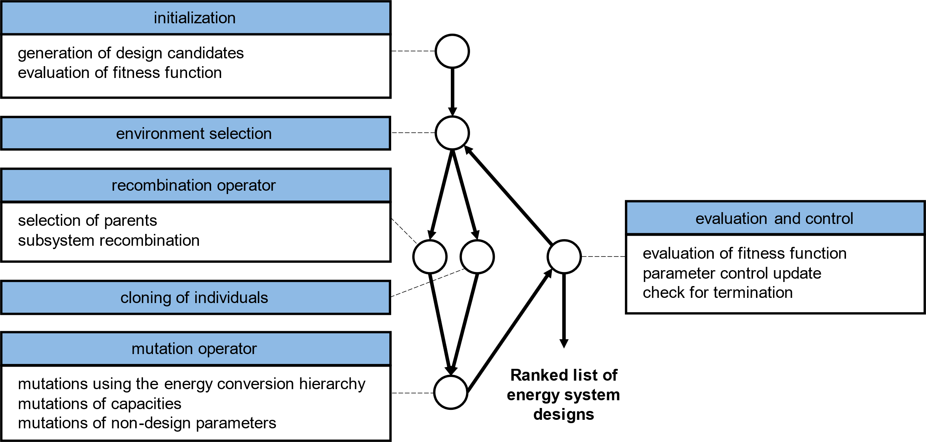
Figure 1: Steps of the hybrid evolutionary algorithm.
Figure 1 shows the steps of our HEA explained in the following. To approach the design task, the HEA starts off with an initialization step. The initialization randomly generates a large set of individuals, evaluates their fitness, and conducts a tournament selection to obtain the initial population of a predefined size. The fitness evaluation involves determining capital expenditure using cost correlations and solving MILPs for determining operational expenditure for the considered scenarios. The population, i.e., a set of individuals representing energy system designs, is updated in each iteration of the HEA. To update a population, the HEA performs environment selections constraining the population size, recombinations, mutations, and fitness evaluations until reaching a predetermined number of iterations or a time limit. Ultimately, the HEA yields the design with the lowest expected total annualized cost identified during its runtime.
    - Novel key components
The three key components introduced in this work are the graph-based representation, the recombination operator, and the extended mutation operator. We define a graph-based representation using a weighted graph $G=(V, E,l_{V})$ and graph weight $l_{G}$ to specify an individual. The graph $G$ encodes an energy system design as well as additional parameters influencing the HEA’s behavior during runtime. Each vertex in the set of vertices $V$ of the graph corresponds to one component of the energy system. The vertex weight $l_{V}$ defines the type and capacity of each component as well as a parameter influencing the strength of capacity mutations. The graph weight $l_{G}$ defines parameters influencing the frequency of mutations resulting in the removal, exchange, or addition of components. For encoding designs, we assume lossless connections for each energy carrier and thus an implicit definition of component connections. Consequently, the set of edges $E$ remains empty. By using this graph-based representation, the HEA does not require the cumbersome definition of a superstructure. For superstructure-based approaches, problem complexity can increase exponentially with the number of equipment considered in the superstructure. As our graph-based representation puts no restrictions on the types and number of components, we classify our approach as superstructure-free.
Building upon the work of Voll et al. (2012), we develop an EA for investments decisions by extending their mutation operator and introducing a recombination operator. Alike the graph-based representation, the two variation operators (i.e., recombination and mutation operator) are adapted to the energy system planning problem. Adapting the variation operators to the design task aims to enhance the performance of the HEA by incorporating problem-specific knowledge. Our recombination operator seeks to combine beneficial properties from two distinct individuals using a subsystem recombination approach and is inspired by Emmerich et al. (2001). Furthermore, the recombination operator addresses the issue that common recombination operators cannot be applied to graphs. For recombining, the components of an individual are assigned to a subsystem according to their main function (e.g., a heat pump is assigned to the heating subsystem). The recombination operator randomly chooses for each subsystem which individual ought to provide the respective components, i.e., component type and capacity. Certain other parameters of the HEA, i.e., the parameters influencing the HEA’s behavior, are recombined either similarly or by determining the arithmetic mean. As recombining individuals can reduce diversity of a population, the recombination operator is bypassed at times and individuals are cloned instead. The extended mutation operator aims to allow exploring the solution space and escaping local optima by addressing the four principles for the design of mutation operators also considered by Voll et al. (2012): scalability, reachability, locality, and symmetry. The mutation operator of Voll et al. (2012) utilizes an energy conversion hierarchy (ECH) offering an easily definable yet rational component replacement strategy but does not adjust the capacity of components. Our extended mutation operator uses an ECH and additionally alters component types as well as component capacities.
  - Results
We evaluate the developed HEA in terms of computational performance and solution quality using a case study adapted from the literature. The case study is based on the work of Sass et al. (2020) and aims for designing an industrial energy system to fulfill heating, cooling, and electricity demands. We construct probability-weighted scenarios similarly to Mavromatidis et al. (2018). The scenarios $s∈S$ occurring with the probability $π_{s}$ exhibit different energy demands, electricity prices, and gas prices. As a benchmark approach, we use a superstructure-based design optimization. The benchmark solves the same two-stage stochastic programs directly while also minimizing the expected total annualized cost as given in Eq. (1). Both approaches use identical component models and identical model parameters to determine the capital expenditure $CAPEX$, the operational expenditure $OPEX$, and the expected total annualized cost $TAC$.
$\min{E(TAC)}=\underset{expected total annualized cost}{\underbrace{\underset{\begin{aligned}capital \\ expenditure\end{aligned}}{\underbrace{CAPEX}}+\underset{\begin{aligned}expected operational \\ expenditure\end{aligned}}{\underbrace{\sum_{s∈S}{π_{s}⋅{OPEX}_{s}}}}}}$ | (1)
We compare the HEA with the benchmark approach for design tasks of increasing complexity: we set up four two-stage stochastic programs with 1, 4, 16, and 64 scenarios, respectively. Figure 2 shows the observed solution quality over time for multiple algorithm runs. All runs are terminated after 40 hours, and we repeat runs to examine the stochastic nature of the HEA. For the cases of 1, 4, and 16 scenarios, both approaches yield similar high-quality solutions. For the case of 16 scenarios, the HEA yields a design with slightly lower expected total annualized cost (i.e., -0.1 % compared to benchmark solution; remaining optimality gap of benchmark: 1.1 %). As expected, increasing the number of scenarios considered severely lowers the computational performance of both approaches. However, even though the HEA matches the benchmark in terms of solution quality, the HEA’s convergence rate is worse in three of the four cases and the superstructure-based approach excels particularly for the easier design tasks (e.g., the benchmark approach finds the final design approx. 100 times faster than the HEA when only one scenario is considered). Nevertheless, notably, both approaches show a comparable increase in solution quality over time for the hardest design task. This trend indicates that the HEA is less penalized by an increased problem difficulty suggesting that the HEA can be a promising solution strategy for design tasks of elevated complexity. Furthermore, we observe a consistent convergence behavior for the cases in which we run the HEA multiple times, in spite of the stochastic nature of EAs. However, no general statements regarding the HEA’s reliability to find high-quality solutions can be made, as we consider only a limited set of problem instances. Besides, it is worth noting that our preliminary results indicate that adding promising design candidates to the initialization, e.g., designs obtained by a superstructure-based optimization considering only one scenario, can significantly improve the overall performance.

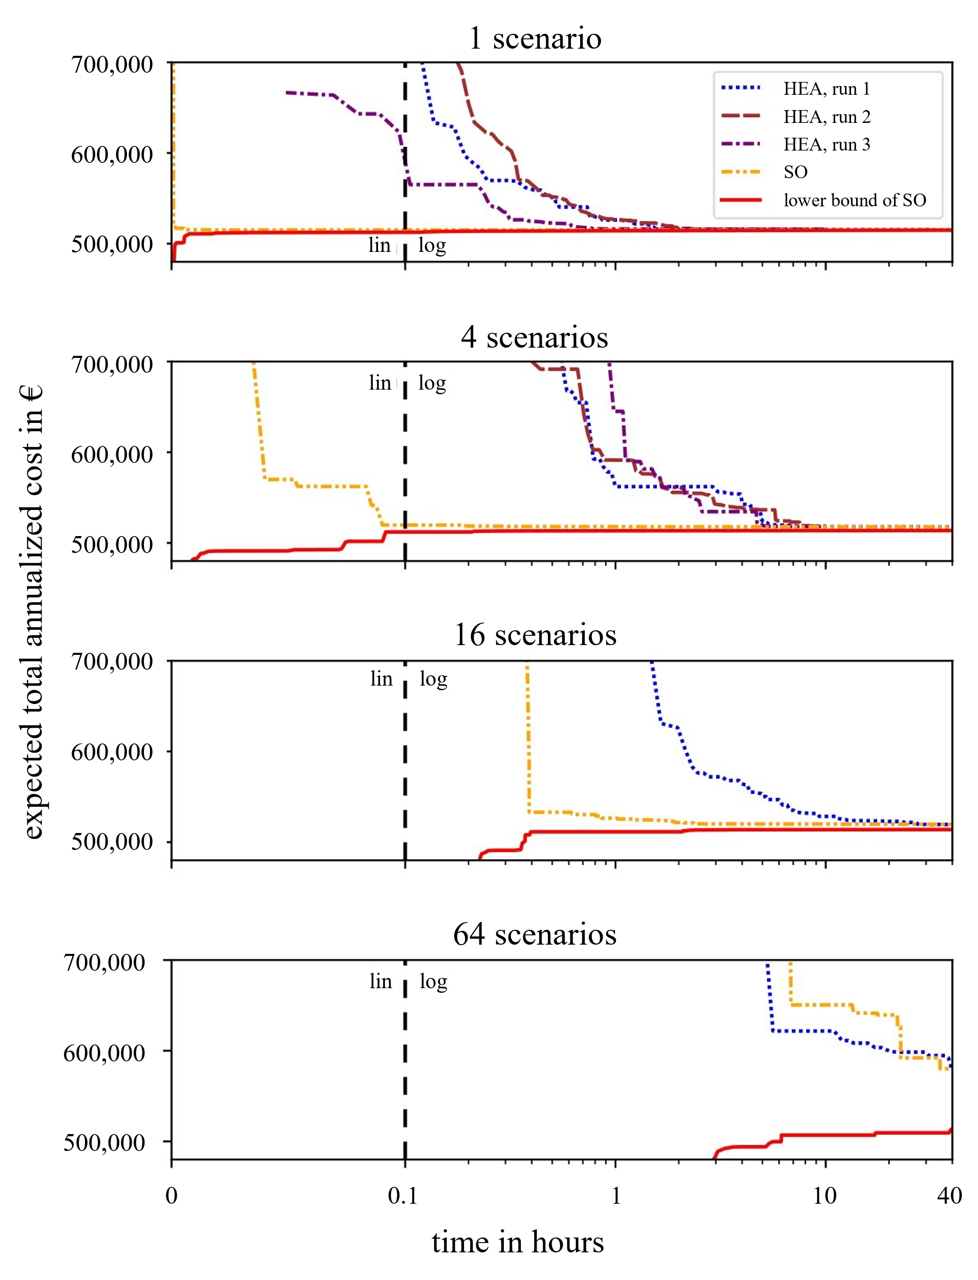
Figure 2: Progress of the developed hybrid evolutionary algorithm (HEA) in comparison to the upper and lower bound of the superstructure-based optimization (SO) as reference.
  - Conclusions
Prompt investments in energy infrastructure are required despite multiple sources of uncertainty (e.g., due to uncertain energy prices, demands, availability of renewables, extreme events, potential component or grid outages, future technology parameters, investment costs, or policies). Uncertainties increase the complexity of design tasks underscoring the need for reliable energy system planning methods. In this work, we present a superstructure-free hybrid evolutionary algorithm (HEA) for designing energy systems under uncertainty. The HEA utilizes stage decomposition enabling parallel computing and reducing subproblem complexity. The three key components of the developed approach are (i) the graph-based representations making the algorithm superstructure-free; (ii) the subsystem recombination enabling the usage of a recombination operator for refining the solution quality; and (iii) the extended mutation operator featuring an energy conversion hierarchy (ECH). The developed components aim to avoid the generation of invalid design candidates and thus to increase computational performance. In a case study adapted from the literature, we compare the HEA with a superstructure-based design optimization using four design tasks of increasing difficulty. We show that the HEA can reach similar or, in certain cases, a slightly better solution quality than the benchmark. As expected, the complexity added by considering uncertainty impedes the computational performance of both approaches. In the case study, the HEA can match the computational performance of the benchmark approach for the most difficult design task. Furthermore, the comparisons shows that the HEA is less affected by an increased design task difficulty. However, the benchmark outperforms the HEA in three of four cases. Nevertheless, the demonstrated ability to generate high-quality solutions, the flexible graph-based representation, the extendable variation operators, and the HEA’s ability to improve upon existing solutions renders the algorithm to be a promising approach for energy system design under uncertainty, i.e., complex design tasks. To seize the HEA’s potential, future work could aim for improving the convergence rate either by addressing the initialization phase or by using surrogate models to approximate the fitness function. Additionally, applying the HEA to more difficult design tasks, e.g., by considering different kinds of uncertainties or seasonal storages, might allow demonstrating the HEA’s beneficial properties.
Acknowledgements
This study is funded by the German Federal Ministry of Economic Affairs and Energy (ref. no.: 03EN2031A). The support is gratefully acknowledged.
References
A.E. Eiben, J.E. Smith, 2015. Introduction to Evolutionary Computing, Natural Computing Series. Springer Berlin Heidelberg, Berlin, Heidelberg. https://doi.org/10.1007/978-3-662-44874-8
M. Emmerich, M. Grötzner, M. Schütz, 2001. Design of Graph-Based Evolutionary Algorithms: A Case Study for Chemical Process Networks. Evolutionary Computation 9, 329–354. https://doi.org/10.1162/106365601750406028
M. Fodstad, P. Crespo del Granado, L. Hellemo, B.R. Knudsen, P. Pisciella, A. Silvast, C. Bordin, S. Schmidt, J. Straus, 2022. Next frontiers in energy system modelling: A review on challenges and the state of the art. Renewable and Sustainable Energy Reviews 160, 112246. https://doi.org/10.1016/j.rser.2022.112246
G. Mavromatidis, K. Orehounig, J. Carmeliet, 2018. Design of distributed energy systems under uncertainty: A two-stage stochastic programming approach. Applied Energy 222, 932–950. https://doi.org/10.1016/j.apenergy.2018.04.019
L. Mencarelli, Q. Chen, A. Pagot, I.E. Grossmann, 2020. A review on superstructure optimization approaches in process system engineering. Computers & Chemical Engineering 136, 106808. https://doi.org/10.1016/j.compchemeng.2020.106808
E.N. Pistikopoulos, A. Barbosa-Povoa, J.H. Lee, R. Misener, A. Mitsos, G.V. Reklaitis, V. Venkatasubramanian, F. You, R. Gani, 2021. Process systems engineering – The generation next? Computers & Chemical Engineering 147, 107252. https://doi.org/10.1016/j.compchemeng.2021.107252
L.A. Roald, D. Pozo, A. Papavasiliou, D.K. Molzahn, J. Kazempour, A. Conejo, 2023. Power systems optimization under uncertainty: A review of methods and applications. Electric Power Systems Research 214, 108725. https://doi.org/10.1016/j.epsr.2022.108725
S. Sass, T. Faulwasser, D.E. Hollermann, C.D. Kappatou, D. Sauer, T. Schütz, D.Y. Shu, A. Bardow, L. Gröll, V. Hagenmeyer, D. Müller, A. Mitsos, 2020. Model compendium, data, and optimization benchmarks for sector-coupled energy systems. Computers & Chemical Engineering 135, 106760. https://doi.org/10.1016/j.compchemeng.2020.106760
P. Voll, M. Lampe, G. Wrobel, A. Bardow, 2012. Superstructure-free synthesis and optimization of distributed industrial energy supply systems. Energy 45, 424–435. https://doi.org/10.1016/j.energy.2012.01.041
Z. Zhou, J. Zhang, P. Liu, Z. Li, M.C. Georgiadis, E.N. Pistikopoulos, 2013. A two-stage stochastic programming model for the optimal design of distributed energy systems. Applied Energy 103, 135–144. https://doi.org/10.1016/j.apenergy.2012.09.019

