Improved Deep Learning Architectures for the Decomposition of Mixed Integer Optimization Problems
Niki Triantafyllou^{a,b}, Maria M. Papathanasiou^{a,b,*}
ªThe Sargent Centre for Process Systems Engineering, Imperial College London, London, United Kingdom, SW72AZ
^{b}Department of Chemical Engineering, Imperial College London, London, United Kingdom, SW72AZ
*maria.papathanasiou11@imperial.ac.uk
Abstract
End-to-end supply chain optimization dictates synchronized, multi-scale, decision-making across various functions, stakeholders, and levels of planning in an organization. This usually leads to NP-hard problems. To tackle the computational challenges posed by large-scale supply chain models, we propose a deep learning-based decomposition methodology of Mixed Integer Linear Programming (MILP) models. Specifically, we train a Convolutional Neural Network (CNN) multi-label classifier with previous solutions of the target MILP model and we use the CNN to approximate the solution of a user-defined complicating variable. We apply our methodology to a MILP model that characterizes investment planning and patient scheduling in the field of personalized immunotherapies. From a modeling perspective, the patient-specific nature of these therapeutics leads to NP-hard problems as the demand increases. We achieve a classifier test set sample-level accuracy for the approximation of the binary variable responsible for investment planning decisions of 89.35%, meaning that the CNN leads to the global optimum solution in 89.35% of the instances in the test set. The results showcase a reduction of up to 81% and 83% in the number of constraints and binary variables for all scenarios examined, respectively.
Keywords: MILP, decomposition, deep learning, supply chain
  - Introduction
A major challenge for end-to-end supply chain optimization is the synchronized, multi-scale, decision-making across the various functions in an organization, the geographically distributed stakeholders, and the different levels of planning; namely strategic, tactical, and operational (Shah, 2005; Grossmann 2005). Holistic supply chain models are usually large, multi-scale, non-linear, and often computationally expensive to solve. Such models are inherently combinatorial due to the many discrete and logical decisions involved. They are typically described as NP-hard problems, which suggests that their solution time increases exponentially with the problem size in the worst case. Optimizing such problems requires effective mathematical formulations, tailored decomposition solution strategies that may compensate global optimality for tractability, and efficient utilization of computational resources (Pistikopoulos et al., 2021).
Machine learning can be leveraged to tackle mixed integer optimization problems by employing various techniques and algorithms. State-of-the-art algorithms often rely on manually crafted heuristics (a) to make decisions (e.g. cutting plane selection on branch-and-bound, or linking variables for full space decomposition approaches), (b) to perform expensive computations (Bengio et al., 2021). Consequently, machine learning emerges as a promising alternative to enhance these decisions more efficiently. Machine learning can contribute to algorithm improvement in two primary ways: (a) by replacing expensive computations with fast approximations (Bertsimas & Stellato, 2022; Triantafyllou et al., 2023) and (b) by addressing algorithmic decisions that heavily depend on expert knowledge and intuition, which may result in suboptimal outcomes (Bonami et al., 2022; Mitrai & Daoutidis, 2023).
In this study, we introduce a decomposition algorithm that leverages Convolutional Neural Networks (CNNs) to approximate the complicating binary variable $y_{m}$, $m∈M$, responsible for investment planning decisions in a personalized medicine supply chain.
  - Methodology
    - Decomposition algorithm
The deep-learning-based decomposition algorithm presented here (Figure 1), introduces a novel approach to address computational complexity in Mixed-Integer Linear Programming (MILP) models. The primary objective of the CNN model is to approximate one of the complicating binary variables, reducing computational complexity. The algorithm initiates by taking the MILP model of interest and generating a set of random N problem instances. Subsequently, the MILP is solved for each instance, establishing a comprehensive dataset comprising inputs and corresponding outputs. This dataset is then used for training the CNN classifier.
Once trained, the CNN is employed to make predictions for a target problem instance, approximating the complicating binary variable. The resulting approximation can be leveraged to either fix the variable or reduce the associated relevant set, a decision left to the modeler. Subsequently, the reduced MILP is optimized, and the optimal solution is obtained.
It is important to note, however, that similar to many decomposition approaches, the algorithm does not provide a guarantee of global optimality.
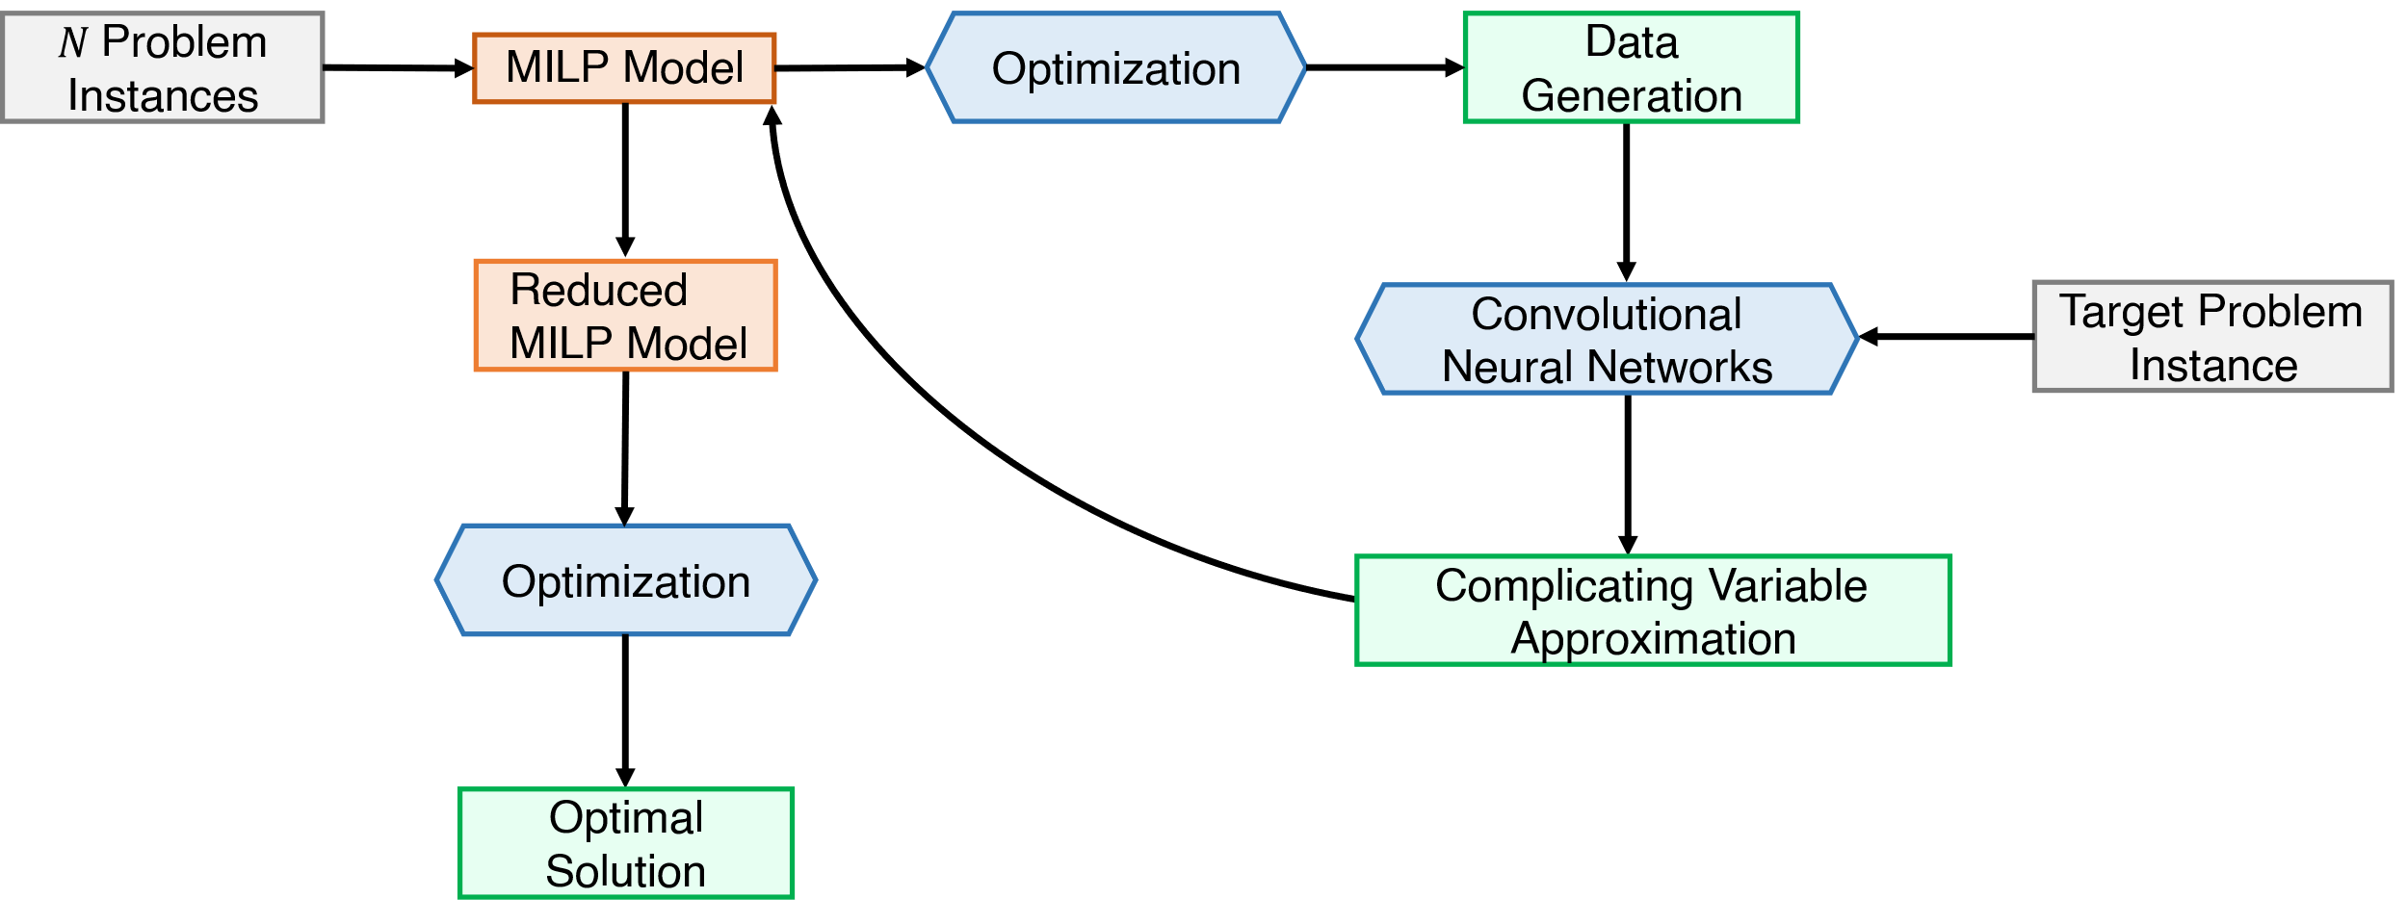
Figure 1. Proposed deep learning-based decomposition algorithm.
    - The problem case
To showcase the algorithm’s capabilities, an in-house MILP model that describes the CAR T-cell therapy supply chain is used (Triantafyllou et al., 2022). The supply chain superstructure consists of 4 nodes–leukapheresis center, manufacturing site, Quality Control (QC), and hospital. CAR T-cell manufacturing starts at the leukapheresis center, where T-cells are isolated from the patient’s bloodstream and are cryopreserved before further processing. The leukapheresis sample is then shipped to the manufacturing facility, where it is genetically engineered. Lastly, the therapy undergoes in-house QC and once product quality and safety are ensured, it is shipped back to the hospital for administration to the patient. We consider 4 leukapheresis sites and 4 hospitals in the UK and 6 manufacturing sites located in the UK, US, and Europe. The manufacturing facilities m have a capacity of 4 (m₁ and m₄), 10 (m₃ and m₆), or 31 (m₂ and m₅) parallel lines. The model considers demand uncertainty by utilizing randomized demand profiles with different probability distributions (Triantafyllou et al., 2023), manufacturing capacity limitations, patient-specificity, and time and location constraints, whilst the objective is to minimize the total supply chain cost. Finally, the total turnaround time is expressed as a non-monetary supply chain metric modeled as a constraint.
    - Data Generation
To train and test the CNN multi-label classifier, a comprehensive dataset through the solution of the original MILP model is generated. To train the CNN for global optimality, the MILP is always solved for an optimality gap of 0%. For this, High-Performance Computing (HPC) (Imperial College London) is used, leveraging parallel computing capabilities where the problems are solved over multiple CPUs. The dataset comprises 8,970 problem instances, each representing a unique demand scenario. Patient demands, ranging from 10 to 2400 per year, were solved to optimality with the CPLEX solver to reflect real-world variability. The only parameter that varies throughout the instances is the demand scenario parameter (INC_{p,c,t}), where each patient p is assigned to a leukapheresis center c at a specific time point t. For each patient demand, a total of 15 randomized demand profiles were generated, considering splitting equally across: uniform, left triangular, and right triangular distribution. The dataset, incorporating different probability distributions in demand profiles, serves as a robust training ground for ensuring the adaptability and efficacy of our algorithm to demand uncertainty.
    - Multi-label classifier
Here, CNNs are responsible for strategic planning by forecasting the optimal supply chain network configuration based solely on the annualized demand (Figure 2). Specifically, the CNN model is designed to forecast both the quantity and the strategic placement of manufacturing facilities to efficiently meet the demand. Employing a multi-label classification approach is crucial for our objectives, as it enables the prediction of multiple manufacturing facilities for each instance, allowing for the consideration of highly decentralized supply chain networks when necessary. Additionally, the model can predict infeasibilities, introducing an extra label for the classifier, in addition to the six candidate manufacturing facilities. By doing this demand profile instances that cannot be fulfilled
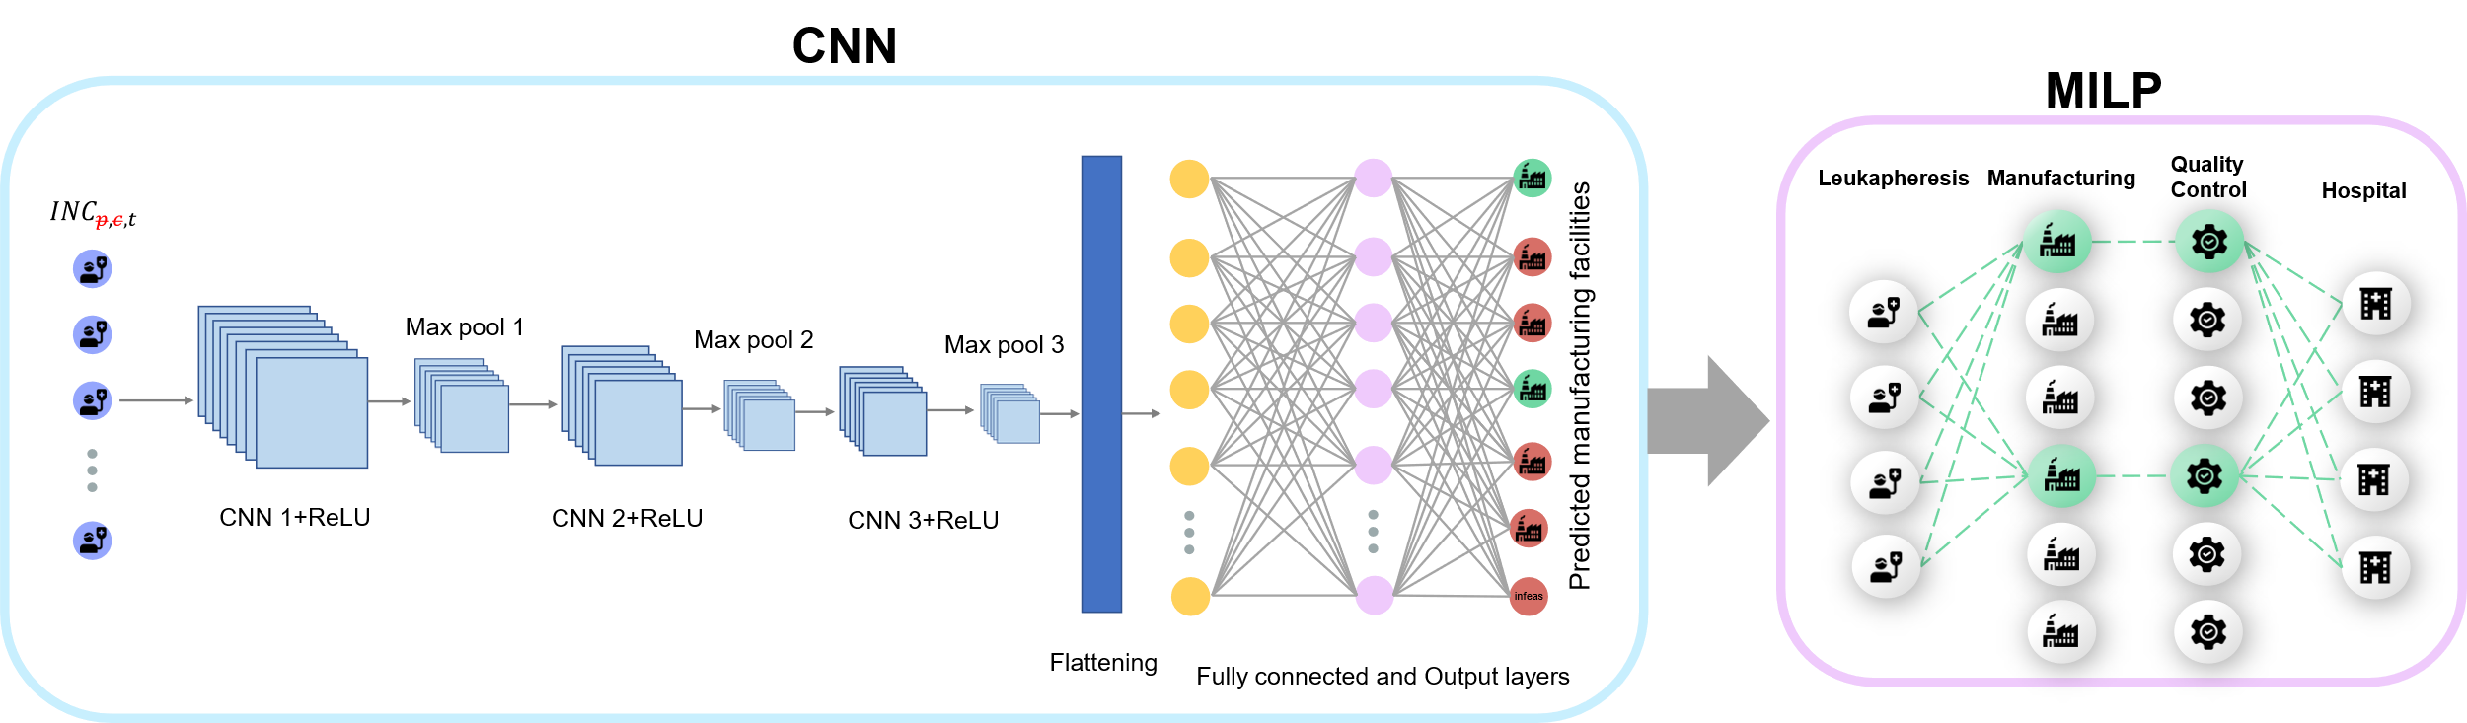
Figure 2. Proposed convolutional neural network architecture for the decomposition of the CAR T-cell supply chain MILP model.
with the available capacity are identified, and therefore the computational expense is decreased by bypassing the construction and solution of infeasible instances.
    - Network Architecture
Building upon previous work (Triantafyllou et al., 2023), we employ CNN architectures for improved predicting capabilities. The input features considered for the CNN are the total daily demands for a quarter of a year (90 days), assuming a recurrent demand profile per trimester. The proposed CNN architecture comprises three convolutional layers followed by max-pooling, and two fully connected layers for multi-label classification (Figure 2). Key specifications include:
- 1st Convolutional layer: 32 filters, kernel size 10, followed by max-pooling.
- 2nd Convolutional layer: 64 filters, kernel size 5, followed by max-pooling.
- 3rd Convolutional layer: 128 filters, kernel size 3, followed by max-pooling.
- Fully Connected layers: 256 neurons, ReLU activation, dropout 0.1; 128 neurons, ReLU activation, dropout 0.1.
- Output layer with 7 neurons, where the labels are the 6 manufacturing facilities and the possibility of infeasible solutions due to limited facility capacity as seen in Figure 2.
    - Training
The model undergoes training utilizing the Adam optimizer with a learning rate of 0.0001. Binary Cross Entropy with Logits is employed as the loss function. Dropout is applied for regularization. The dataset is partitioned into three subsets: 80% for training, 10% for testing, and 10% for validation. The training process spans 5000 epochs.
  - Results
    - Classifier evaluation
The overall performance of the multi-label classification CNN model is measured by sample level accuracy and additional extracted metrics from the confusion matrix, i.e. precision, recall, and F-score for each class. The ordinary 2-dimensional confusion matrix used in multi-class classification is undefined when it comes to multi-label classification, where each instance can be labeled with more than one class. To overcome this, the multi-label confusion matrix with one extra row (No True Label-NTL) and one extra column (No Predicted Label-NPL) is used.
Sample-level accuracy provides the ratio of totally correctly classified instances to the total number of samples. It is a straightforward metric that gives a general overview of a model's performance and specifically the classifier’s performance regarding global optimum complicating variable approximations. For such types of problems usually imbalanced datasets are an inherent challenge that needs to be tackled. In such cases, other metrics such as that account for partial correctness such as the Hamming Loss and the Jaccard Index might provide a more comprehensive evaluation of a model's performance. The evaluation metrics for the trained CNN appear in Table 1. It should be noted that the multi-label classification model is trained with three different demand distributions to better cope with demand uncertainty. This can lead to different supply chain structures for the same yearly demands. Therefore, there is a possible trade-off between model accuracy and robustness to demand uncertainty.
Table 1. Evaluation metrics for the test set.
Label-level accuracy (%) | Sample-level accuracy (%) | Jaccard Index (%) | Hamming Loss (%)
97.29 | 89.35 | 97.38 | 2.71
    - Infeasibility and suboptimality
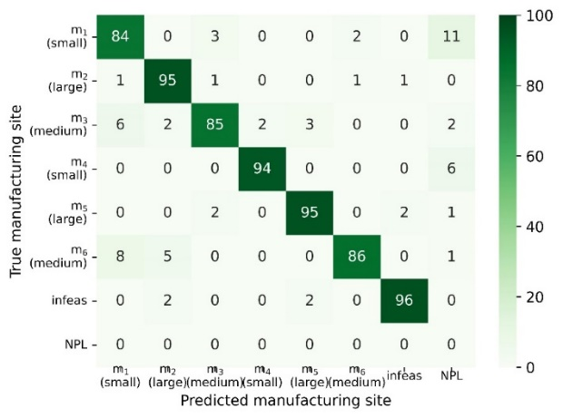
By looking at the confusion matrix in Figure 3, the classifier overall predicts very well. However, in a few cases, it overpredicts the required manufacturing capacity to fulfil the demand by assigning bigger manufacturing facilities than the ones required and sometimes it underpredicts by choosing a smaller facility or failing to add an extra facility. In the former case, the decomposition methodology leads to local optimum solutions, whereas in the latter case, it leads to infeasible solutions. While the model predicts correctly in 86% of the instances that m6 belongs to the optimal supply chain configuration, in 8% of the instances it confuses facilities m6 (10 parallel lines) and m₁ (4 parallel lines) (infeasible solution) and in 5% of the instances, it leads to local optimum solutions by predicting facility m₂ (31 parallel lines) instead of m₆.
Figure 3. Normalized multi-label confusion matrix with one extra row for No True Labels (NTL) and one extra column for No Predicted Labels (NPL).
    - Computational complexity reduction
The reduced MILP model is solved considering only the subset of manufacturing facilities chosen by the CNN, becoming a subproblem of the original planning and scheduling MILP model. Therefore, the reduced MILP accounts only for detailed scheduling in the supply chain, which entails optimal transport modes for the node-to-node connections, optimal allocation of patient samples in the manufacturing facilities and hospitals, and the optimal utilization of the available parallel lines in the manufacturing sites with the scope of minimizing the therapy cost and return time.
In Figure 4, we present a comparative analysis of the performance between the reduced MILP obtained from the deep learning-based decomposition algorithm and the original MILP. The evaluation is conducted across 12 distinct randomized demand scenario instances from our validation set (100, 200, 500, 1000, and 2000 patients annually), with 4 scenarios for each distribution.
For uniform demand distributions (Figure 4a), the decomposition algorithm consistently achieves the global optimum solution, accompanied by a noteworthy reduction of up to 81% and 83% in the number of constraints and binary variables across all examined scenarios. In the case of the left triangular distribution (Figure 4b), the decomposition algorithm performs very well, yielding global optimum solutions in all instances. Notably, for the instance involving 2,000 patients per year, the CNN classifier deems the problem infeasible, resulting in no solution attempts (Figure 4b) therefore reduced computational time.
Moving to the right triangular distribution (Figure 4c), the decomposition algorithm generates infeasible solutions for the 200 and 500 patient demand scenarios per year, despite the actual feasibility of the problems. This discrepancy is attributed to underpredictions, where smaller facilities than required are assigned. Interestingly, for the
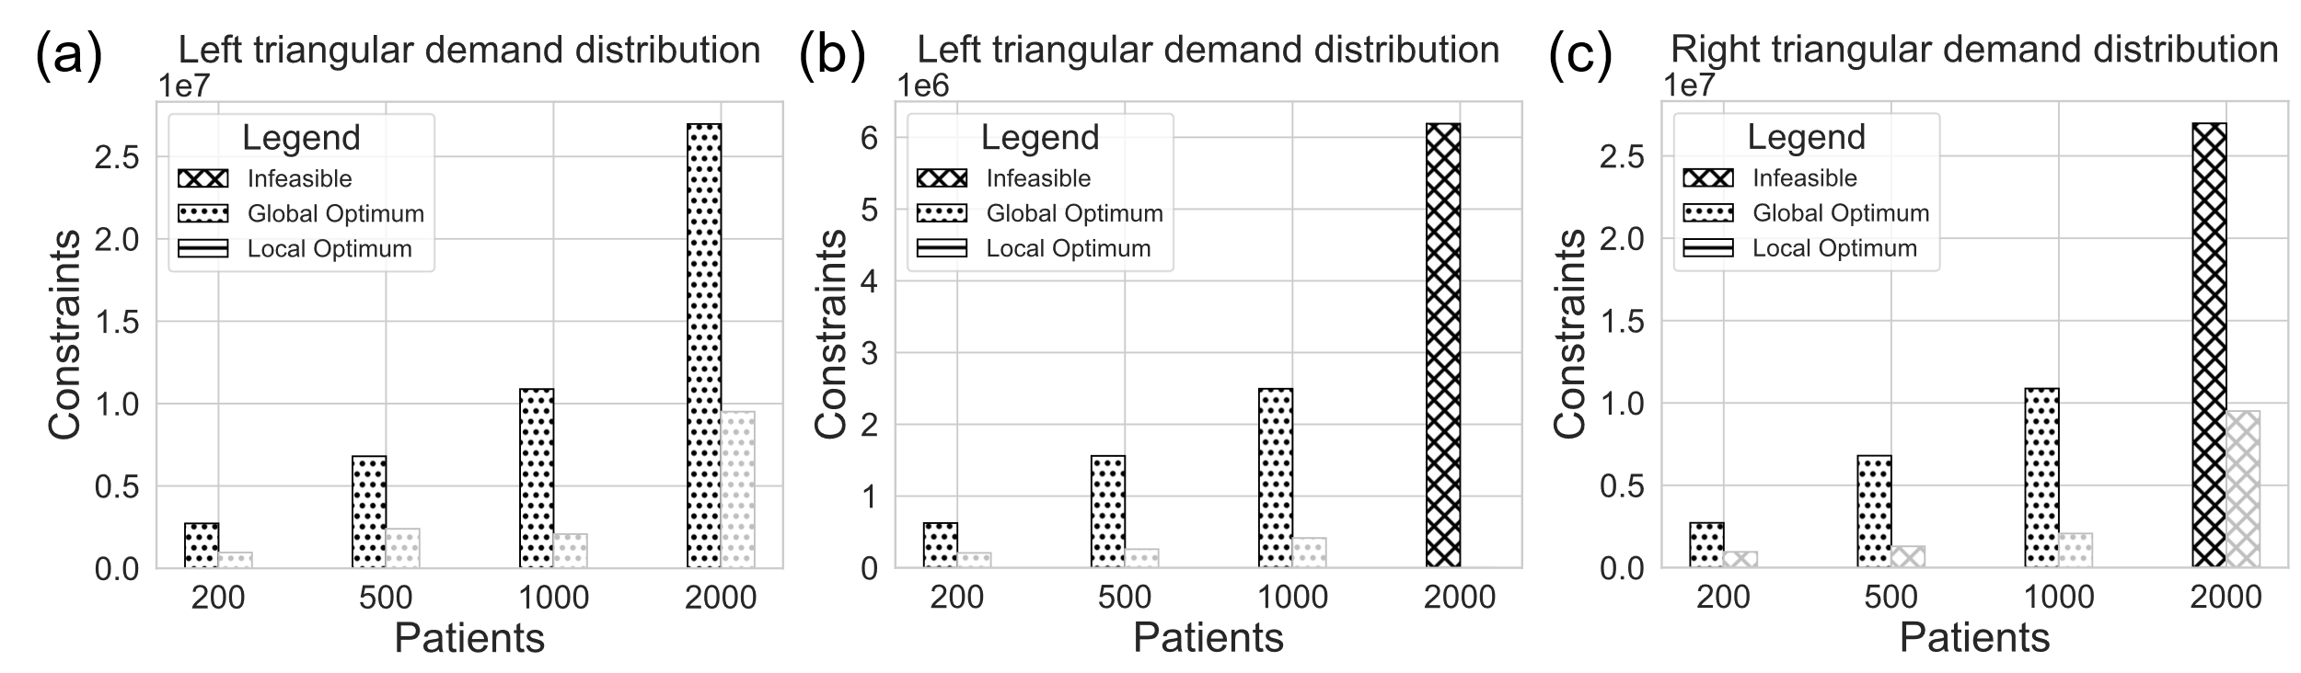
Figure 4. Performance of the deep learning-based decomposition algorithm in comparison to the original MILP model.
scenario with 2,000 patients per year, the classifier predicts feasibility, leading to a 64.7% reduction in the number of constraints. However, upon solving the reduced model, the optimizer (CPLEX) determines the model to be infeasible (Figure 4c).
  - Conclusions
In this study, we employ a deep learning-based decomposition algorithm utilizing a Convolutional Neural Network (CNN) multi-label classifier to address the computational complexity of large-scale supply chain models, exemplified through a personalized medicine supply chain case study. The classifier achieves a sample-level accuracy of 89.35%, signifying the attainment of the global optimum in 89.35% of the random scenarios within the test set. Computational complexity benchmarking between the original MILP and the reduced MILP, generated by the decomposition algorithm, reveals a substantial reduction of up to 81% in the number of constraints. However, the algorithm yields suboptimal or infeasible solutions in 10.65% of the random scenarios within the test set, highlighting the need for future improvements such as the prediction of the k-most likely labels or the introduction of integer cuts.
References
Y. Bengio, A. Lodi, and A. Prouvost, 2021. Machine learning for combinatorial optimization: a methodological tour d’horizon. European Journal of Operational Research, 290(2), 405-421.
D. Bertsimas, B. Stellato, 2022. Online Mixed-Integer Optimization in Milliseconds. INFORMS Journal on Computing, 34(4), 2229-2248.
P. Bonami, A. Lodi, and G. Zarpellon, 2022. A classifier to decide on the linearization of mixed-integer quadratic problems in CPLEX. Operations Research, 70(6), 3303-3320.
I. Grossmann, 2005. Enterprise-wide optimization: A new frontier in process systems engineering, AIChE Journal, 51(7), 1846–1857.
I. Mitrai, and P. Daoutidis, 2023. A graph classification approach to determine when to decompose optimization problems, Computer Aided Chemical Engineering, 52, 655-660.
E. N. Pistikopoulos, A. Barbosa-Povoa, J. H. Lee, R. Misener, A. Mitsos, G. V. Reklaitis, V. Venkatasubramanian, F. You, R. Gani, 2021. Process systems engineering – The generation next?, Computers & Chemical Engineering, 147, 107252.
N. Shah, 2005. Process industry supply chains: Advances and challenges’, Computers and Chemical Engineering, 29(6), 1225–1235.
N. Triantafyllou, A. Bernardi, M. Lakelin, N. Shah, M. M. Papathanasiou, 2022. A digital platform for the design of patient-centric supply chains, Scientific Reports, 12, 17365.
N. Triantafyllou, S. Papaiakovou, A. Bernardi, M. Lakelin, N. Shah, A. Kokossis, M. M. Papathanasiou, 2023. Machine learning-based decomposition for complex supply chains, Computer Aided Chemical Engineering, 52, 1655-1660.

