State-Based Shrinkage Behavior for Waste Incineration Modeling
Lionel Sergent^{a,b}*, Abderrazak M. Latifiª, François Lesageª, Jean-Pierre Corriouª and Alexandre Grizeau^{b}
ª Université de Lorraine, CNRS, LRGP, F-54000 Nancy, France
^{b} SUEZ, F-67590, Schweighouse-sur-Moder, France
lionel.sergent@univ-lorraine.fr
Abstract
Waste incineration reduces the volume of incoming solid material by up to 90%. Thus, the shrinkage behavior must be addressed in the modeling of incinerators. Most common mathematical representations of shrinkage express the volume of the representative particle as a direct function of its composition. Although simple, this approach does not work well with solid mixing when included in a global model. A new approach was developed which considers two additional distributed state variables, namely contraction and internal porosity. Both follow their own partial differential equation, governed by reaction rates and mixing. This allows to keep the waste bed model fully described by a set of partial differential and algebraic equations, solvable via classical techniques. The new shrinkage sub-model is used in a complete waste bed behavior model and allows to analyze bed thickness.
  - Introduction
Within the EU, roughly 30% of household trash is incinerated, most commonly with grate kilns as depicted in figure 1. Despite their wide industrial use, their design and operation still raise several problems mainly due to the complex phenomena involved: the heterogeneity of the waste, the complex nature of pyrolysis, the stiff dynamics of combustion, the radiatiave heat exchanges, the disordered granular solid mass movement on the grate, and the lack of local measurements. Specifically, solid shrinkage cannot be neglected, as bed thickness is a crucial operational parameter. Additionally, volume reduction indirectly influences heat and mass transfers. The understanding of the phenomena involved is important to develop fine models intended to enhance energy recovery, improve pollution control and reduce maintenance costs.
The objective of this paper is to develop an approach to address the problem of solid shrinkage in the modeling of an industrial incinerator. The developed approach may be adapted to other reactive shrinking or expanding porous media.
  - Literature Review
    - Principle of the Most Common Approach
A first thoroughly studied example of similar solid volume reduction can be found in food dehydration (Qiu et al., 2015), or in ceramic drying. Semi-empirical equations are developed to link bulk density, internal porosity, shrinkage and moisture content.

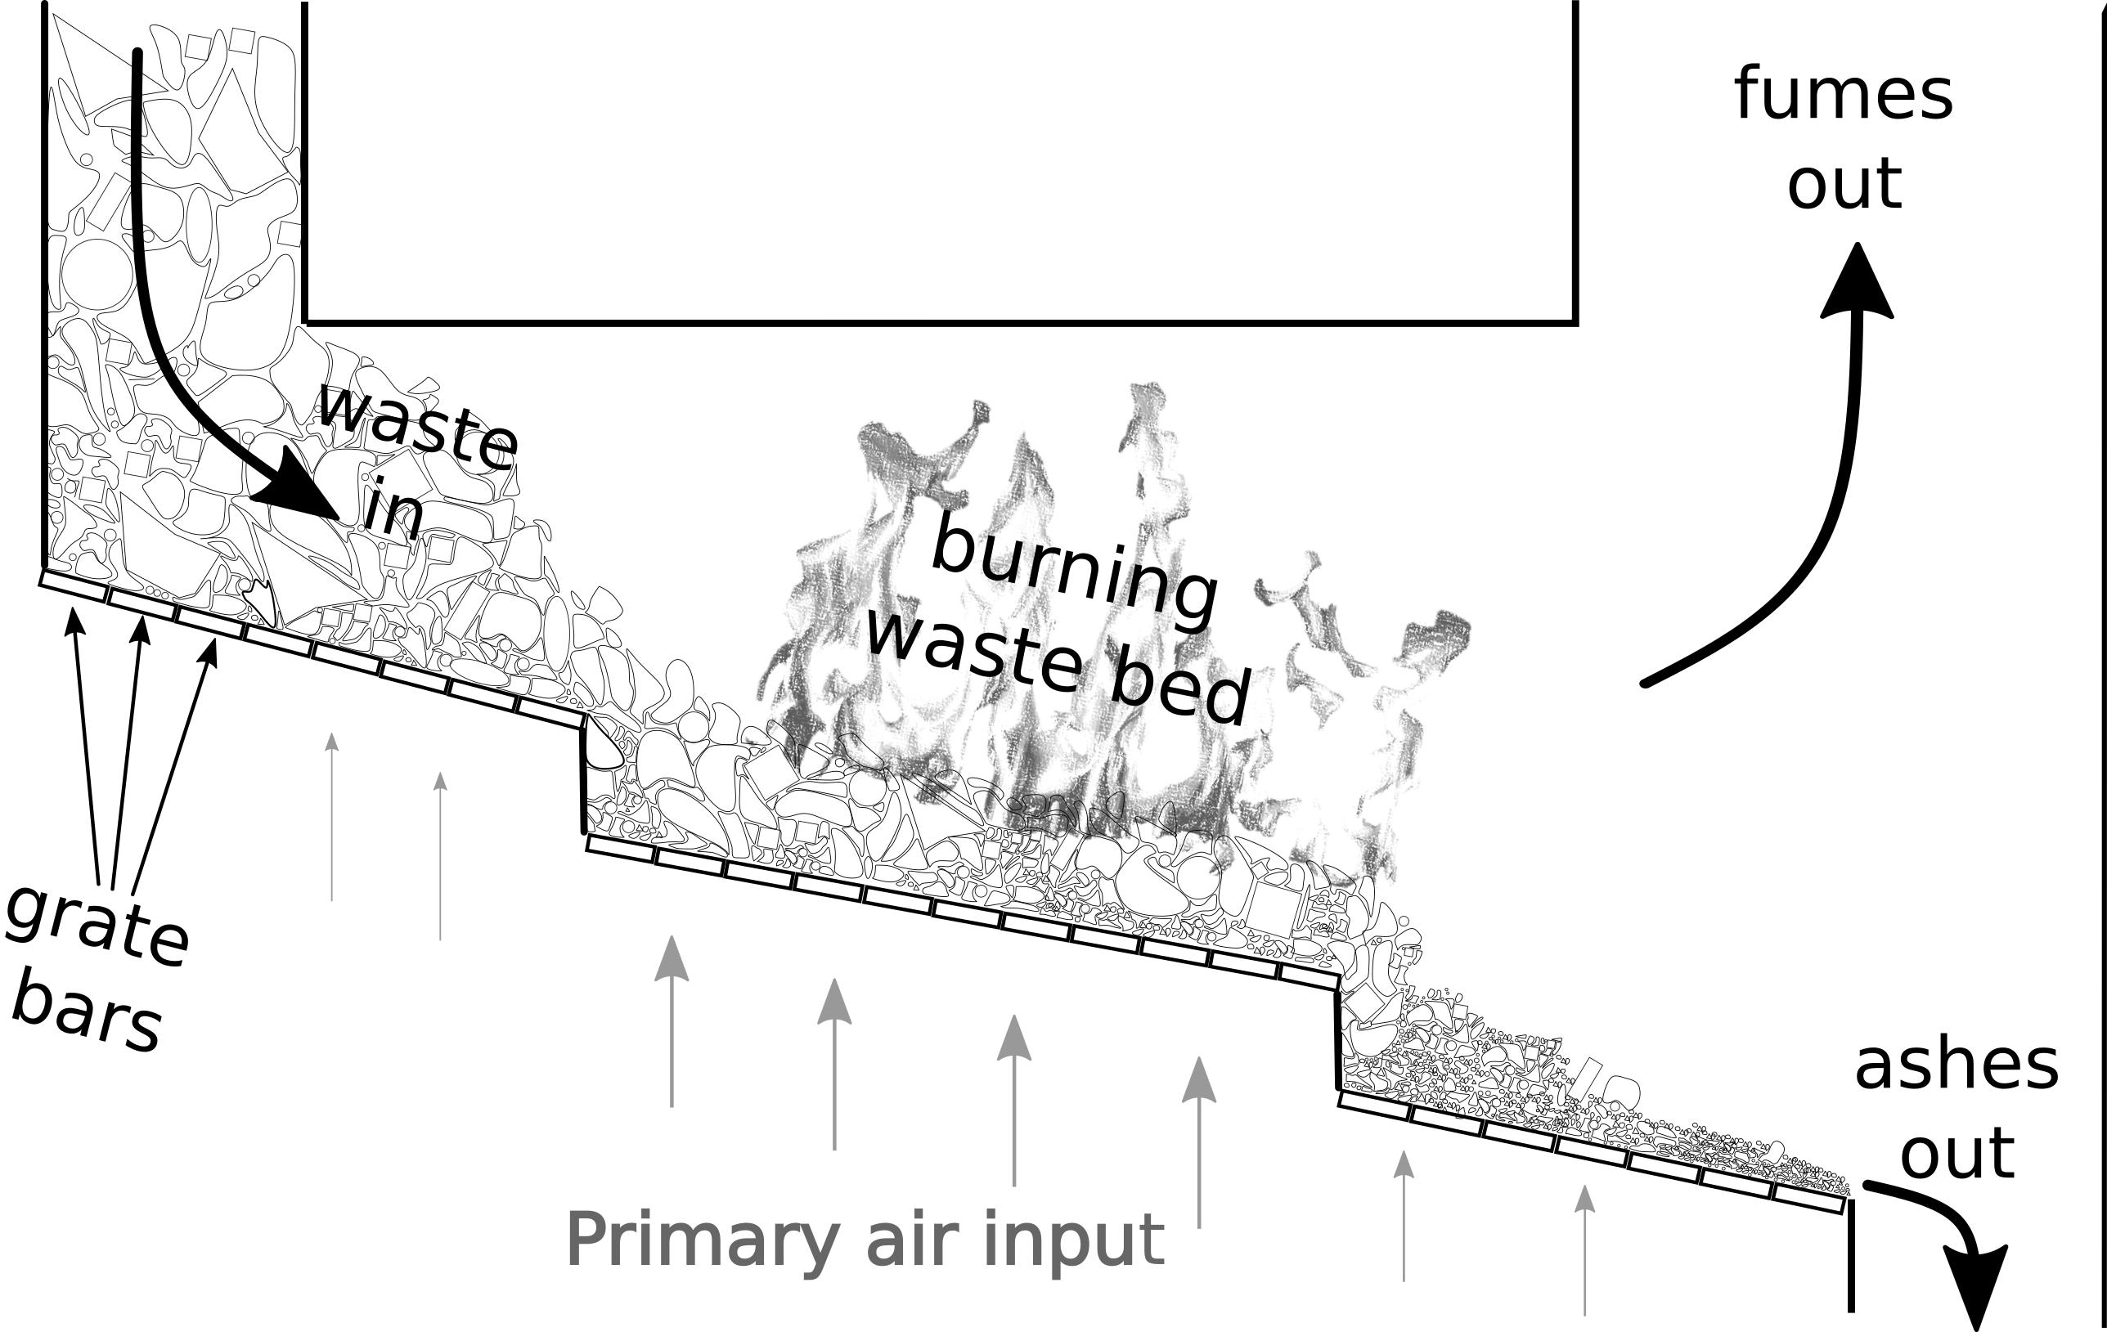
Figure 1: Schematic view of a typical grate incinerator
Especially, some equations have the general form:

(1)

where is the volume of a representative particle, is its initial volume, and expresses the shrinkage as a function of the moisture content .

The models used for solid combustion are often similar in nature, but generally use the fixed carbon, organic matter and moisture contents as arguments for the shrinkage function. The rationale is that moisture and organics mostly leave internal pores in the particle as they escape, leaving a structure of fixed carbon i.e. char. Once that fixed carbon consumes, the internal pores are liberated to extra-particular space, and the volume of the particle decreases drastically. Assuming no initial internal porosity, this process is described in figure 2.
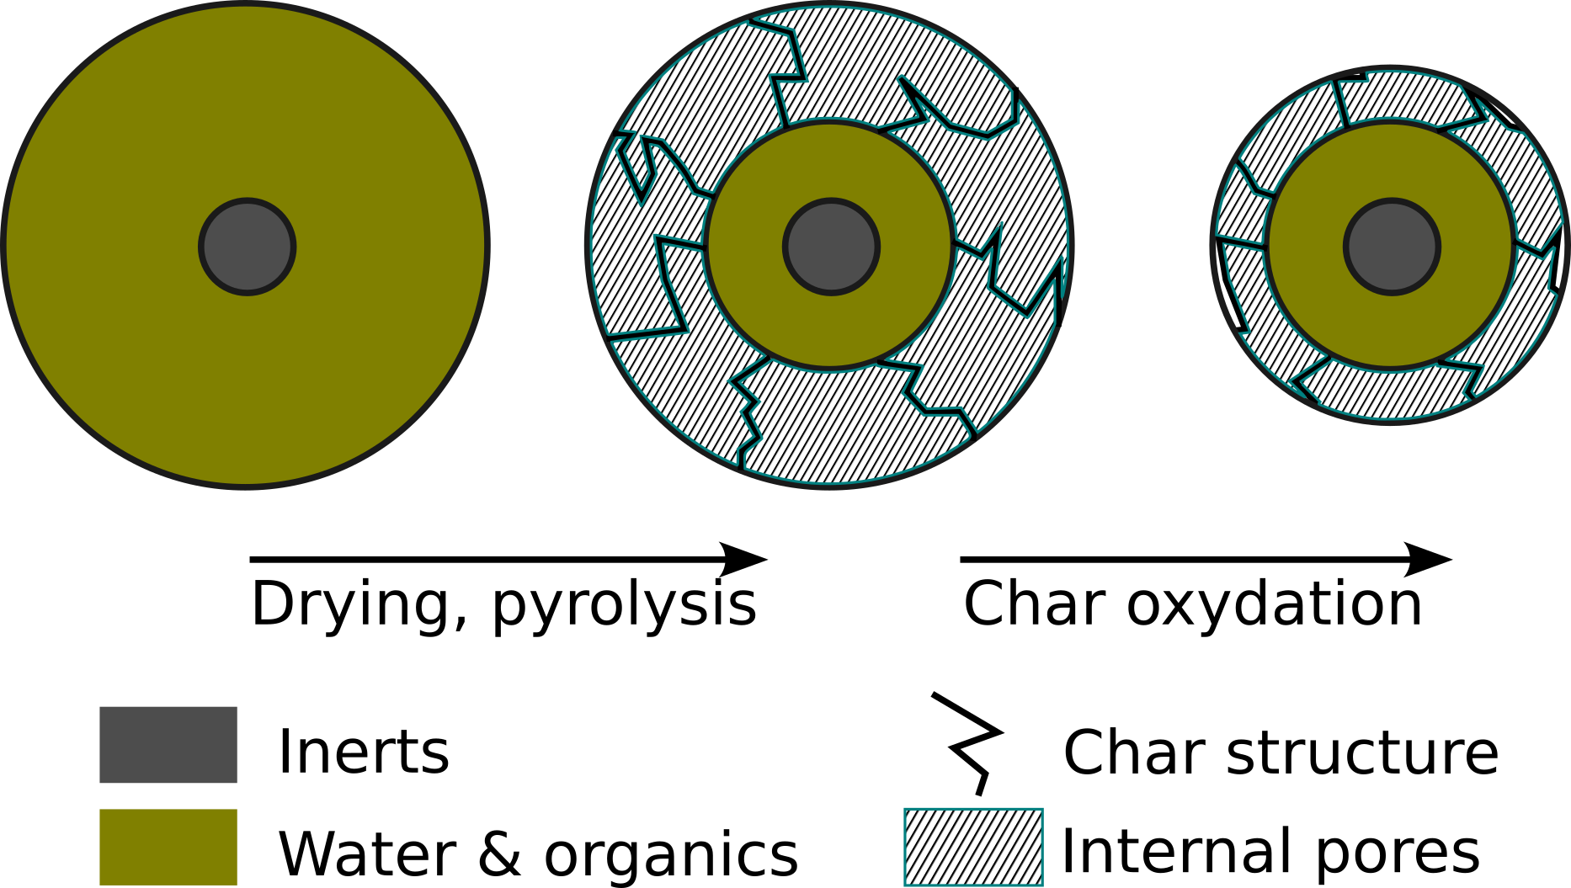
Figure 2: Model of a volume reduction of a particle undergoing drying, pyrolysis and carbon oxidation.
The expression of the shrinkage function becomes quite complex (Menard, 2003), but follows the principle of Eq. (1).
    - Limitations
This formulation describes quite well the volume reduction effect at a particle level and is therefore suitable for discrete element modeling (Brosch et al., 2014). However, it does not suit continuous porous medium approaches. For instance, within a finite volumes simulation, if a cell with very low fixed carbon content receives some fixed carbon from an adjacent cell, the receiving cell will experience a non-physical sharp increase in internal porosity. This has pushed continuous medium modelers to simulate mixing by periodically exchanging (shrinking) finite volume cells (Menard, 2003) or by implementing elaborate collapse mechanisms (Hermansson and Thunman, 2011). These approaches may be justified by the discontinuous nature of mixing. However, they do not express the mixing inside the partial differential equations. The mixing is instead treated by events within the numerical integration. Hoang et al. (2022) also reported numerical instabilities.
  - Proposed Approach
    - Assumptions and Principle
The proposed approach does not change the physics described but is rather a slight paradigm change. We introduce two new state variables: contraction and internal porosity . The contraction represents how much local material has shrunk compared to a reference state and is calculated as:

(2)

where is a reference volume, for instance the initial volume of the particle. For simplicity, external porosity is assumed constant and spatial variation is assumed to be 1-dimensional along the vertical axis . For reasons explained by Shin and Choi (2000), these assumptions are reasonable for combustion happening on a grate.

Reactions may induce a change in local internal porosity. Therefore, we assume that for each reaction there exists a coefficient, denoted , called internal porosity production factor, in of internal pore created per kg of solid material reacted, such that:

(3)

where is a control volume, is the volume of internal pores within that control volume, is the local rate of reaction in and is a set indexing for all considered chemical and physical transformations. The internal porosity production factors depend on the state variables. We can translate the process given in figure 2 into the following new relations:

(4)
(5)
(6)
where represents the true density of solid while represents its apparent density. is the coefficient of production of char (fixed carbon) through pyrolysis in kg of char produced per kg of organic material pyrolyzed.

    - Resulting Equations
Working out the partial mass balance on an elementary control volume yields:

(7)

is the source term due to reactions. Eq. (3) reduces to:

(8)

Since the volume of a particle is the sum of the volume of its solid constituents and internal pores, the evolution of contraction may be derived from Eq. (2):

(9)
(10)

where is a set indexing for the considered solid constituents. The appear naturally when deriving the contraction evolution and may be termed contraction factor of reaction .

    - Mixing
Mixing may be modeled by a dispersion term. The mass flux of constituent is defined by analogy with the first Fick’s law as:

(11)

where is a dispersion coefficient (assumed constant) and are the mass fractions. Working out the updated Eq. (7-9) yields the following final form:

(12)
(13)
(14)

which have the advantage of representing both mixing and shrinkage within a system of transport partial differential equations, solvable for instance with shrinking finite volumes techniques (interface tracking methods). Alternatively, a fixed grid may be used, but it would require the use of interface capturing methods (with a solid vertical velocity).
  - Application to Solid Combustion
    - Fixed Packed-Bed
The developed model of volume reduction has been embedded in a general combustion model described in (Sergent et al., 2023). For a dynamic pipe-bowl combustion, the temporal profiles obtained at mid-height in the packed bed are represented in figure 3.
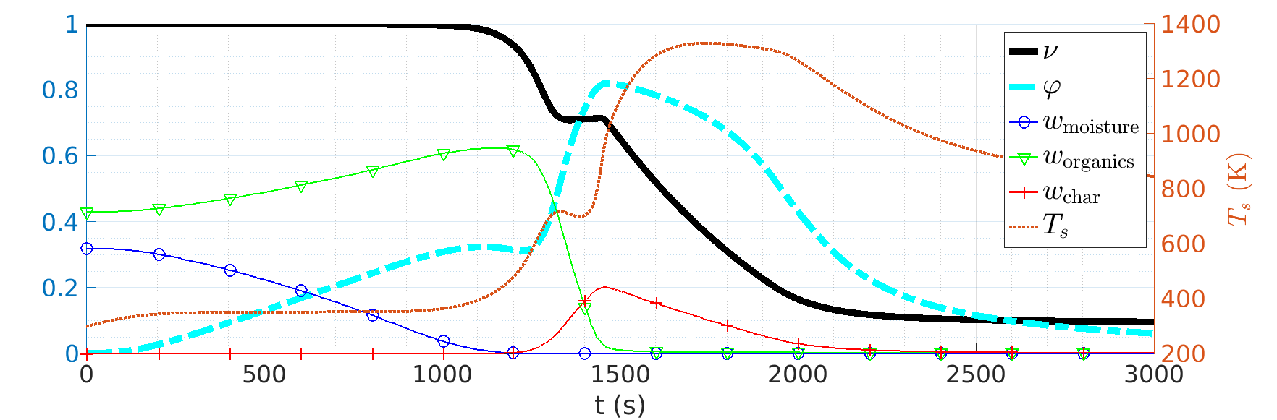
Figure 3: Temporal profiles of local variables describing the solid at mid-height during fixed pipe-bowl combustion. The scale for the solid temperature is given on the right.

After a brief initial heating phase of roughly 100 s, the temperature stabilizes at 100°C (373 K on the graph), moisture slowly dries up, internal porosity increases and the contraction remains at 1. At 1100 s, internal porosity experiences a slight decrease under the effect of mixing (which tends to homogenize the different layers of material), becoming apparent while no intense reaction is taking place. Between 1200 and 1400 s, organic materials get pyrolyzed under increasing temperature. A small portion of the produced char consumes right away while the rest accumulates. This explains why contraction starts decreasing while internal porosity keeps on increasing and is a direct consequence of the assumptions made for the internal porosity production factors . At 1400 s, contraction increases slightly because of mixing. After 1500 s, the char burns away, bringing intense heat, liberating internal porosity and contracting the combustible bed. After 2500 s, only inerts remain and the system settles towards a thermal equilibrium between the overhead flame radiative heating and the convective cooling from the provided combustion air.

    - Grate Waste Burning
Together with the walking column approach (Shin and Choi, 2000), a model for the horizontal solid movement, and a model for the gas phase, the presented volume reduction approach may be used to study the evolution of bed thickness on graphs such as the one presented in figure 4.

The bed thickness variations produced by the simulation are in overall accordance with visual observation made on a real incinerator in France. Shortly after 5 meters from the waste input there is a hotspot associated with a low bed thickness zone. This corresponds to observed abnormal degradation of grate bars. The increases in bed thickness after 6 and 8 meters are due to a slow-down of the grate bars towards the end of the kiln to ensure complete combustion.
Figure 4: Side view of a burning waste bed on a grate, flattened for visualization. The vertical bars correspond to different primary air zones. See figure 1 for context.
  - Conclusion and Perspectives
A new mathematical formulation for shrinkage effects in a reacting packed-bed of granular is developed. It requires the addition of two new local dynamic state variables but allows the expression of non-trivial volume reduction combined with mixing within partial differential equations. This approach is used to model a burning waste bed on a traveling grate and study its thickness.

This formulation also opens perspectives towards the description of the continuous medium with dynamic statistical distributions, including particle diameter distributions, which would be much better suited to take into account the extremely heterogeneous nature of waste.

References

Brosch, B., Scherer, V., Wirtz, S., 2014. Simulation of municipal solid waste incineration in grate firing systems with a particle based novel Discrete Element Method. VGB Powertech 75–83.
Hermansson, S., Thunman, H., 2011. CFD modelling of bed shrinkage and channelling in fixed-bed combustion. Combustion and Flame, 158, 988–999.
Hoang, Q.N., Van Caneghem, J., Croymans, T., Pittoors, R., Vanierschot, M., 2022. A novel comprehensive CFD-based model for municipal solid waste incinerators based on the porous medium approach. Fuel, 326, 124963.
Menard, Y., 2003. Modélisation de l’incinération sur grille d’ordures ménagères et approche thermodynamique du comportement des métaux lourds. PhD, Institut National Polytechnique de Lorraine, France.
Sergent, L., Lesage, F., Latifi, A.M., Corriou, J.-P., Grizeau, A., 2023. Dynamic modeling of a waste incinerator furnace in view of supervision, Computer Aided Chemical Engineering, 52, 589–594.
Shin, D., Choi, S., 2000. The combustion of simulated waste particles in a fixed bed. Combustion and Flame, 121, 167–180

